Supplementary Materials I

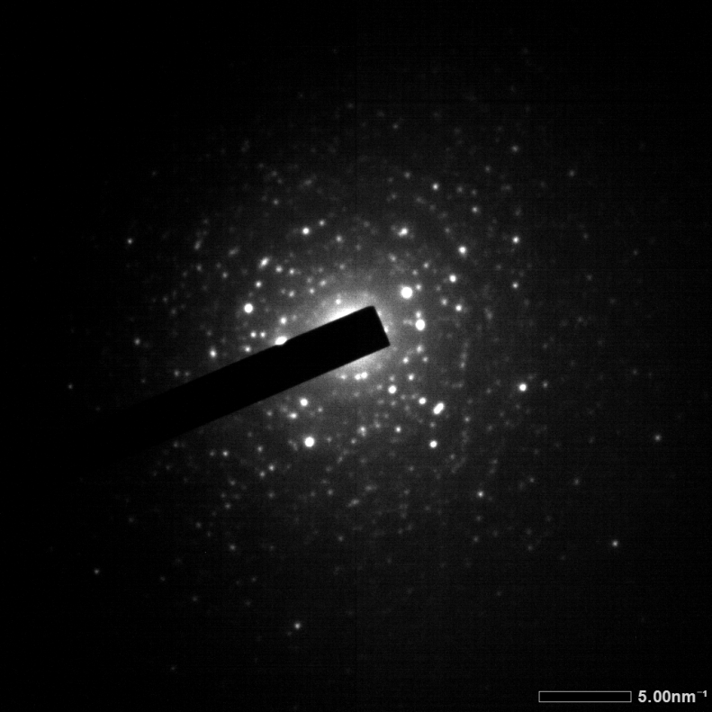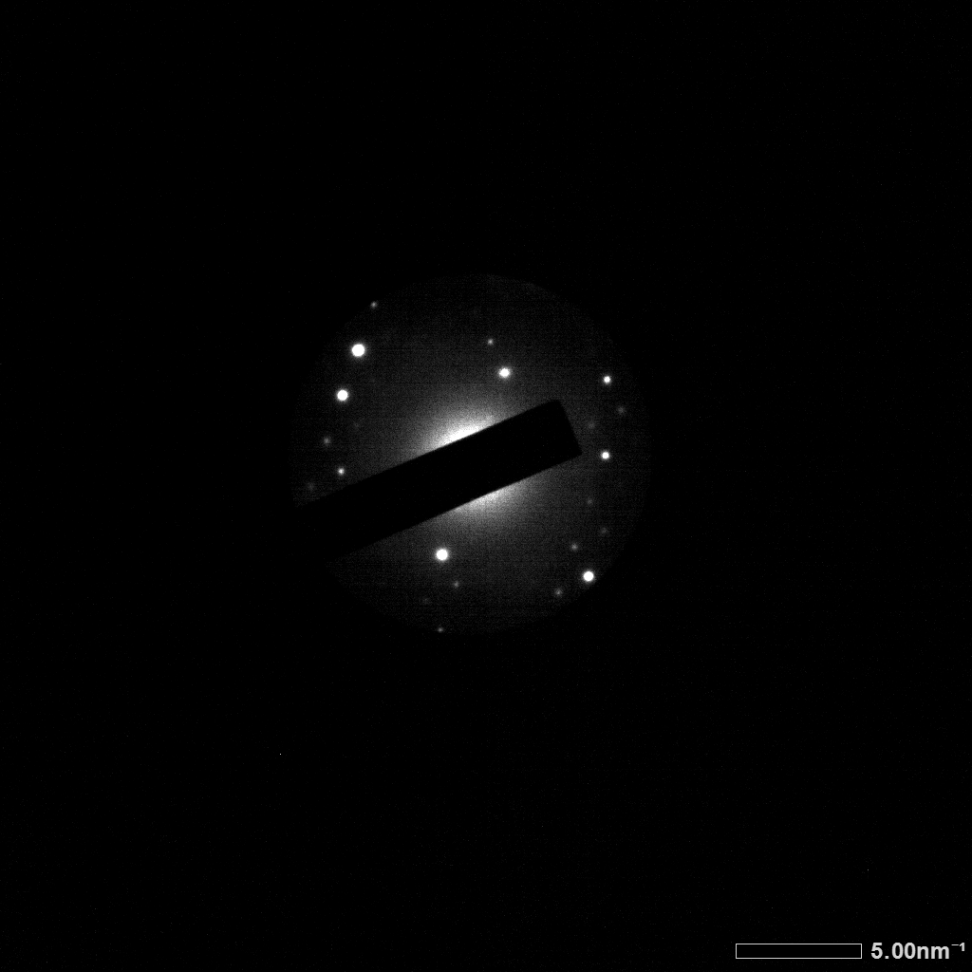
(a)
(b)
5 nm⁻¹
5 nm⁻¹

Fig.S1 The SAED images of (a) nanowire (b) nanorod.

Supplementary Materials II

In the metal oxides, the double binding energy of O 1s is very common, which corresponds to the two kinds of chemical states of oxygen ions in material surface, oxygen sufficiency and oxygen deficiency. The double binding energy presents in ITO nanowires (Fig.S1a), but there is only one binding energy in ITO nanorods (Fig.S1b). Which shows the oxygen deficient sate does not exist in ITO nanorods. For the transparent conductive oxide, the oxygen deficiency state means the generation of oxygen vacancies.

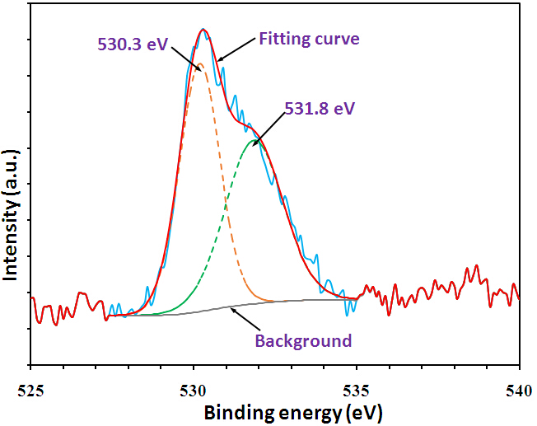
(a)
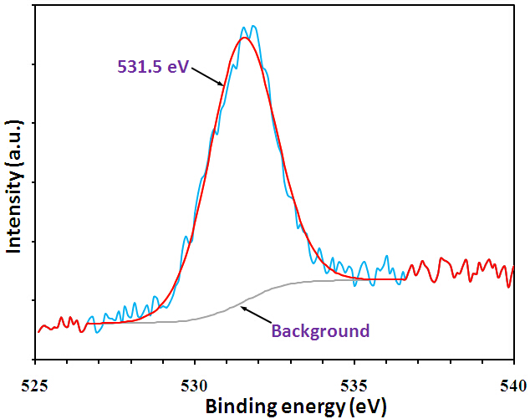
(b)

Fig.S2 The O 1s spectrum from (a) ITO nanowires and (b) ITO nanorods.

