Supporting Information

Graphene oxide coated popcorn-like Ag nanoparticles for reliable sensitive SERS detection of drug residues
Maofeng Zhang,*ª Zhexue Chen,ª Zhuoer Wang,ª Zhiyuan Zheng,ª Dapeng Wang,*^{b}
- School of Materials Science and Engineering, Hefei University of Technology, 193 Tunxi Road, Hefei, 230009, P. R. China
- Institute of Intelligent Machines, Chinese Academy of Sciences, 350 Shushanhu Road, Hefei, 230031, P. R. China
*E-mail: mfzhang@hfut.edu.cn (M. F. Zhang), dpwang@iim.ac.cn (D. P. Wang)

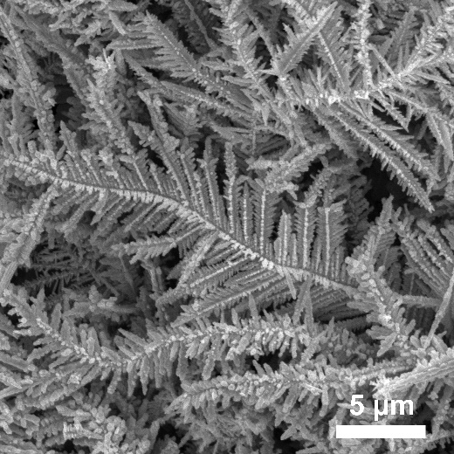
Figure S1. SEM image of Ag/Cu hybrid without using of Sn²⁺.
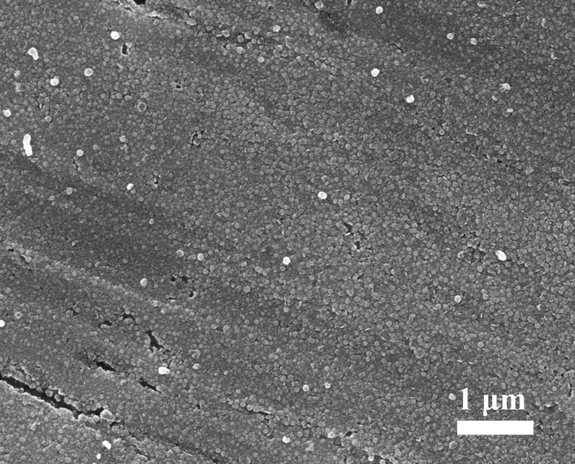
Figure S2. SEM image of Ag nanoparticles on Cu substrate prepared with 1 min reaction time.

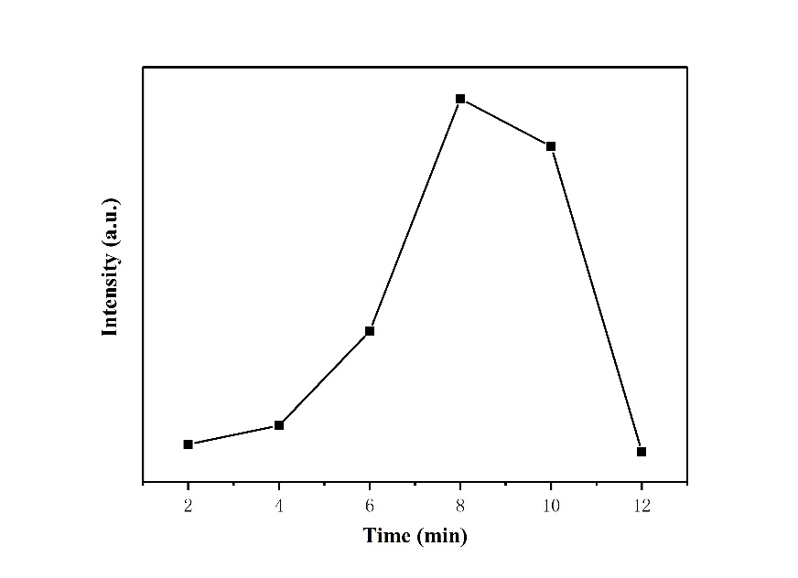
Figure S3. Raman intensity of CV at 1174 cm⁻¹ as a function of the reaction times.

Calculation of SERS enhancement factor (EF)

To quantify the enhancement contribution from graphene, we calculated the enhancement factor (EF) based on the following formula:
EF = (I_{SERS} /I_{BULK})×(N_{BULK} /N_{SERS} )
where I_{SERS} and I_{BULK} represent the intensities of SERS and normal Raman scattering, whereas N_{SERS} andN_{BULK}, respectively, denote the numbers of corresponding CV molecules effectively excited by a laser beam. According to the above formula, the EF for the AgNPs/Cu substrate is calculated to be 1.56 × 10⁵. Similarly, the EF is calculated to be 1.20 × 10⁶ for the GO/AgNPs/Cu substrate. As a result, the EF for the GO/AgNPs/Cu substrate shows a 7.69-fold enhancement compared to the AgNPs/Cu substrate.
N_{BULK} = (Laser spot area/Diffusion area) * (N_{A} * Volume_{BULK} * Concentration_{BULK})
N_{SERS} = (Laser spot area/Substrate area) * (N_{A} * Volume_{SERS} * Concentration_{SERS})
Diffusion area=π(d/2)²=0.5027cm²
Substrate area=0.09cm²
Volume_{BULK} =Volume_{SERS}
Concentration_{BULK} = 10⁶ * Concentration_{SERS}
N_{BULK} /N_{SERS}= (0.09/0.5027)×10⁶=1.79×10⁵
I = intensity of the 1174 cm⁻¹ peak
I_{BULK}=599 a.u.
I_{SERS,Ag} =521 a.u.
I_{SERS,Ag} /I_{BULK}=0.87
EF_{Ag} = (I_{SERS} /I_{BULK})×(N_{BULK} /N_{SERS} ) = 1.56×10⁵
I_{SERS,GO/Ag} =4015 a.u.
I_{SERS,GO/Ag} /I_{BULK}=6.70
EF_{GO/Ag}= (I_{SERS} /I_{BULK})×(N_{BULK} /N_{SERS} ) = 1.20×10⁶
The EF for the GO/AgNPs/Cu substrate shows a 7.7-fold enhancement compared to the AgNPs/Cu substrate

