Supporting Information

Hexagonal Close Packed High Entropy Alloy Formation under Extreme Processing Conditions

R. Devanathan^{1,a}, K. Kruska¹, W. Jiang¹, M. A. Conroy^{1,b}, T. C. Droubay², J. M. Schwantes³

Table 1. Properties of experimentally synthesized HCP HEAs and computationally predicted HCP HEAs (rows with grey background, ref. 19,21) calculated using the Alloy Search and Predict tool of King and McGregor.⁴⁴ The cost is relative to that of CoCrFeMnNi, which is one of the least expensive HEAs known. Predicted structure shown as intermediate refers to multi-phase systems.

Composition | δr(%) | VEC | ΔHss (kJ/mol) | ΔSss (J/mol/K) | Tm (K) | Ω | Φ | Cost | Predicted Structure | Ref
Mo0.34 Tc0.073 Ru0.421 Rh0.044 Pd0.122 | 1.64 | 7.54 | -5.738 | 10.943 | 2585 | 4.93 | 0.80 | 66.07 | INTERMEDIATE | 36
Mo0.302 Tc0.086 Ru0.34 Rh0.064 Pd0.208 | 1.55 | 7.79 | -5.443 | 11.989 | 2498 | 5.50 | 0.84 | 75.43 | INTERMEDIATE | 36
Mo0.275 Tc0.08 Ru0.34 Rh0.065 Pd0.24 | 1.52 | 7.92 | -5.170 | 12.007 | 2465 | 5.72 | 0.81 | 74.57 | INTERMEDIATE | 36
Mo0.388 Tc0.099 Ru0.36 Rh0.107 Pd0.046 | 1.69 | 7.32 | -5.822 | 11.182 | 2632 | 5.05 | 0.84 | 84.58 | INTERMEDIATE | 37
Mo0.27 Tc0.152 Ru0.483 Rh0.048 Pd0.047 | 1.57 | 7.45 | -5.531 | 10.649 | 2612 | 5.03 | 0.88 | 98.77 | INTERMEDIATE | 37
Mo0.382 Tc0.142 Ru0.334 Rh0.077 Pd0.065 | 1.64 | 7.30 | -6.064 | 11.525 | 2621 | 4.98 | 0.86 | 94.69 | INTERMEDIATE | 31-33
Mo0.414 Tc0.111 Ru0.285 Rh0.087 Pd0.103 | 1.63 | 7.35 | -6.326 | 11.752 | 2600 | 4.83 | 0.92 | 83.61 | INTERMEDIATE | 31-33
Mo0.381 Tc0.211 Ru0.342 Rh0.038 Pd0.028 | 1.61 | 7.12 | -6.106 | 10.703 | 2655 | 4.65 | 0.82 | 112.61 | INTERMEDIATE | 31-33
Mo0.26 Tc0.082 Ru0.515 Rh0.068 Pd0.075 | 1.59 | 7.62 | -5.404 | 10.594 | 2589 | 5.08 | 0.91 | 77.76 | INTERMEDIATE | 31-33
Mo0.252 Tc0.082 Ru0.437 Rh0.078 Pd0.151 | 1.55 | 7.79 | -5.211 | 11.629 | 2523 | 5.63 | 0.88 | 79.35 | INTERMEDIATE | 31-33
Mo0.451 Tc0.127 Ru0.324 Rh0.098 | 1.72 | 7.07 | -6.273 | 10.094 | 2685 | 4.32 | 0.83 | 90.16 | INTERMEDIATE | 29
Mo0.375 Tc0.125 Ru0.375 Rh0.125 | 1.70 | 7.25 | -5.423 | 10.439 | 2654 | 5.11 | 0.78 | 97.94 | INTERMEDIATE | 29
Mo0.445 Tc0.178 Ru0.345 Rh0.032 | 1.67 | 6.96 | -6.543 | 9.519 | 2702 | 3.93 | 0.78 | 96.92 | INTERMEDIATE | 29
Mo0.212 Tc0.172 Ru0.489 Rh0.127 | 1.48 | 7.53 | -4.331 | 10.339 | 2600 | 6.21 | 0.78 | 122.96 | INTERMEDIATE | 30
Mo0.4 Re0.1 Ru0.3 Rh0.05 Pd0.15 | 1.58 | 7.45 | -5.824 | 11.576 | 2672 | 5.31 | 0.90 | 34.87 | INTERMEDIATE | 38
Li2 Mg Al2 Sc2 Ti3 | 4.66 | 2.80 | 17.664 | 12.947 | 1316 | 0.96 | 0.00 | 41.37 | INTERMEDIATE | 24
DyGdHoTbY | 0.89 | 9.80 | 1.000 | 13.382 | 1685 | 22.54 | 0.02 | 10.21 | INTERMEDIATE | 20
DyGdTbTmLu | 1.24 | 13.00 | 1.000 | 13.382 | 1730 | 23.14 | 0.02 | 42.60 | INTERMEDIATE | 22
DyGdTbLuY | 1.33 | 10.60 | 1.000 | 13.382 | 1725 | 23.08 | 0.02 | 28.72 | INTERMEDIATE | 22
GdHoLaTbY | 2.09 | 8.00 | 1.080 | 13.382 | 1587 | 19.66 | 0.02 | 10.07 | INTERMEDIATE | 23
Ru 0.19 Rh0.20 Re0.21 Os0.21 Ir0.19 | 0.83 | 8.18 | -0.994 | 13.373 | 2878 | 38.74 | 4.09 | 83.91 | FCC | 18
CoCrFeMnNi | 1.12 | 8.00 | -3.333 | 13.382 | 1790 | 7.19 | 1.12 | 1.00 | FCC | 25
CoFeReRu | 3.93 | 8.00 | 1.197 | 11.526 | 2410 | 23.22 | 1.95 | 17.06 | FCC | 19
CoReRuV | 3.40 | 7.25 | -6.691 | 11.526 | 2499 | 4.30 | 0.49 | 17.70 | INTERMEDIATE | 19
CoCrReRu | 3.62 | 7.50 | 0.369 | 11.526 | 2491 | 77.79 | 0.79 | 17.38 | INTERMEDIATE | 19
CoOsReRu | 3.47 | 8.00 | 1.769 | 11.526 | 2783 | 18.13 | 4.63 | 39.86 | FCC | 19
CoPtReRu | 3.92 | 8.50 | -1.435 | 11.526 | 2469 | 19.83 | 1.37 | 47.53 | FCC | 19
CrIrMoRh | 2.96 | 7.50 | -6.806 | 11.526 | 2496 | 4.23 | 0.56 | 65.32 | INTERMEDIATE | 19
CrIrRhW | 2.96 | 7.50 | -4.206 | 11.526 | 2695 | 7.39 | 0.66 | 67.41 | INTERMEDIATE | 19
CrMoOsRu | 2.94 | 7.00 | -1.656 | 11.526 | 2734 | 19.03 | 0.79 | 35.89 | INTERMEDIATE | 19
CrOsRuW | 2.94 | 7.00 | 0.508 | 11.526 | 2934 | 66.52 | 0.93 | 37.98 | INTERMEDIATE | 19
CoPtReRu | 3.92 | 8.50 | -1.435 | 11.526 | 2469 | 19.83 | 1.37 | 47.53 | FCC | 19
IrMoPdRu | 1.36 | 8.25 | -5.377 | 11.526 | 2513 | 5.39 | 0.54 | 31.65 | INTERMEDIATE | 19
IrMoRhW | 1.60 | 7.50 | -6.951 | 11.526 | 2887 | 4.79 | 0.63 | 67.31 | INTERMEDIATE | 19
IrMoPtRu | 1.52 | 8.25 | -9.592 | 11.526 | 2567 | 3.08 | 0.48 | 51.47 | INTERMEDIATE | 19
MoOsRuW | 1.67 | 7.00 | -2.179 | 11.526 | 3125 | 16.53 | 0.90 | 37.87 | INTERMEDIATE | 19
MoPtRhRu | 1.75 | 8.25 | -8.455 | 11.526 | 2446 | 3.33 | 0.45 | 99.75 | INTERMEDIATE | 19
CoCrFeReRu | 3.61 | 7.60 | 0.700 | 13.382 | 2354 | 44.98 | 0.86 | 13.91 | INTERMEDIATE | 19
CoFeOsReRu | 3.75 | 8.00 | 0.963 | 13.382 | 2588 | 35.97 | 2.47 | 31.90 | FCC | 19
CoIrOsReRu | 3.20 | 8.20 | 0.290 | 13.382 | 2771 | 127.69 | 3.44 | 38.48 | FCC | 19
CoNiOsReRu | 4.12 | 8.40 | 1.904 | 13.382 | 2572 | 18.08 | 4.97 | 32.55 | FCC | 19
CoOsPdReRu | 3.33 | 8.40 | 2.190 | 13.382 | 2592 | 15.84 | 1.37 | 40.42 | FCC | 19
CoOsPtReRu | 3.52 | 8.40 | -0.777 | 13.382 | 2635 | 45.35 | 1.65 | 56.28 | FCC | 19
CoOsReRhRu | 3.12 | 8.20 | 1.112 | 13.382 | 2674 | 32.17 | 5.30 | 77.10 | FCC | 19
CoOsReRuTc | 3.24 | 7.80 | 1.302 | 13.382 | 2722 | 27.98 | 5.37 | 112.80 | FCC_PLUS_BCC | 19
CrIrMoRhW | 3.00 | 7.20 | -4.619 | 13.382 | 2735 | 7.92 | 0.65 | 54.11 | INTERMEDIATE | 19
CrMoOsRuW | 3.00 | 6.80 | -0.199 | 13.382 | 2926 | 196.38 | 0.93 | 30.57 | INTERMEDIATE | 19
CeNdPmPr | 0.41 | 5.50 | 1.000 | 11.526 | 1222 | 14.09 | 0.01 | 103.62 | INTERMEDIATE | 19
CeLaPmPr | 1.10 | 4.75 | 1.000 | 11.526 | 1196 | 13.79 | 0.01 | 103.59 | INTERMEDIATE | 19
CeLaNdPr | 1.23 | 4.50 | 1.000 | 11.526 | 1192 | 13.73 | 0.01 | 3.25 | INTERMEDIATE | 19
CeLaNdPm | 1.20 | 5.00 | 1.000 | 11.526 | 1218 | 14.04 | 0.01 | 103.80 | INTERMEDIATE | 19
LaNdPmPr | 1.15 | 5.25 | 1.000 | 11.526 | 1253 | 14.45 | 0.01 | 103.29 | INTERMEDIATE | 19
CeLaNdPmPr | 1.10 | 5.00 | 1.000 | 13.382 | 1216 | 16.27 | 0.02 | 83.51 | INTERMEDIATE | 19

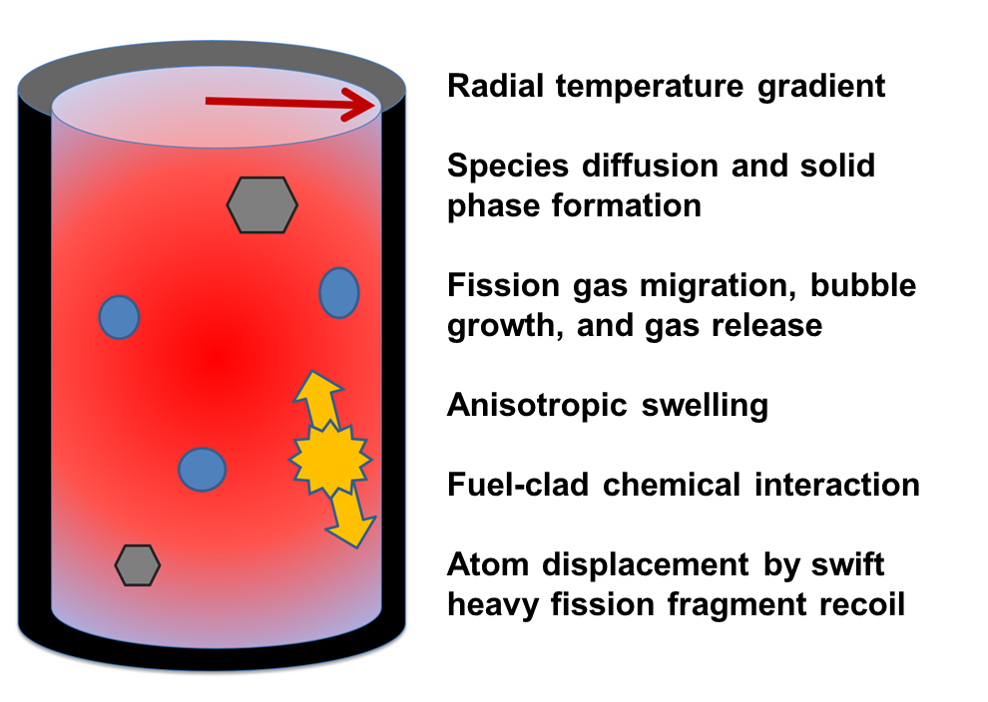

Figure S1. Schematic diagram of irradiated nuclear fuel pellet surrounded by cladding (black outer layer) showing the processes occurring under extreme conditions of irradiation and high temperature. The hexagonal alloy particles are distributed in a ceramic matrix, namely UO₂. CeO₂ was used as a non-radioactive surrogate for UO₂ in this work and particles were produced by extreme processing in this work under conditions representing those governing HEA particle formation in nuclear fuel. Previous results show that the HCP HEA particles were typically 20-100 nm in size in portions of the ceramic that experienced 900 ºC, while regions that experienced higher temperatures of 1700 ºC had alloy particles that were 3-10 μm in size. Ref. L.E. Thomas, C.E. Beyer, and L.A. Charlot, Microstructural analysis of LWR spent fuels at high burnup, Journal of Nuclear Materials 188, 80 (1992).

