Supplementary Material
For
Highly efficient solar steam generation by hybrid plasmonic structured TiN/mesoporous anodized alumina membrane

Yue Bian^{1,2}, Kun Tang^{1,2,*}, Zhonghua Xu^{1,2}, Jingrui Ma^{1,2}, Yang Shen^{1,2}, Licai Hao^{1,2}, Xuanhu Chen^{1,2}, Kuiying Nie^{1,2}, Jing Li^{1,2}, Tongchuan Ma^{1,2}, Shunming Zhu^{1,2}, Jiandong Ye^{1,2}, Xiang Xiong³, Yi Yang^{1,2}, Rong Zhang^{1,2}, Youdou Zheng^{1,2}, and Shulin Gu^{1,2,**}

¹ School of Electronic Science and Engineering, Nanjing University, Nanjing 210093, China
² Collaborative Innovation Center of Solid-State Lighting and Energy-Saving Electronics, Nanjing University, Nanjing 210093, China
³ National Laboratory of Solid State Microstructures and School of Physics, Nanjing University, Nanjing 210093, China
E-mail: * ktang@nju.edu.cn;
** slgu@nju.edu.cn

Contents

S1. Numerical simulation of the absorption and scattering efficiencies for TiN nanospheres by the Mie theory
S2. X-ray powder diffraction patterns of the TiN powders
S3. Size distribution of the TiN nanoparticles in water measured by dynamical light scattering (DLS)
S4. Calculation of the solar-to-heat conversion efficiency
S5. Thermal stability of the TiN nanoparticles in air
S6. Calculation of evaporation efficiency
S7. Hydrophilic treatment to the AAM
S8. Relationship between the thickness of the TiN layer and the amount of the filtrated TiN
S9. Optical photos of the hydrophilic AAM-based device exposed to different light illumination
S10. Effects of pore size of the AAM on the solar steam generation efficiency
S11. Different heating behaviors of pure water, TiN-AAM device and TiN nanofluid
References

S1. Numerical simulation of the absorption and scattering efficiencies of TiN nanospheres by the Mie theory
A commercial software package (Lumerical FDTD Solution software) was used to perform the three-dimensional FDTD simulation on the TiN nanospheres with different radius. The computational space was defined by perfectly-matched-layer (PML) boundary conditions. The mesh size at the material interface is always kept much smaller than the nanosphere size.
Table SI. Growth parameters of the TiN thin film
Base pressure  /Pa | Growth  Pressure  /Pa | Ar flow rate  /sccm | N₂ flow rate  /sccm | RF power  /w | Substrate temperature  /℃ | Growth time  /h | Distance between target and substrate  /cm
3.5×10⁻⁴ | 0.3 | 20 | 6 | 150 | 100 | 4 | 12

FIG. S1. XRD pattern of the TiN thin film grown on c-plane sapphire.

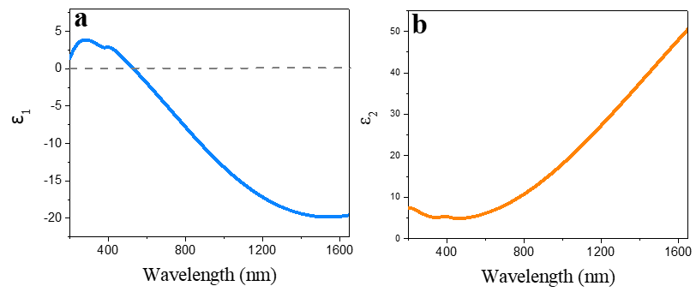
FIG. S2. (a) Real and (b) imaginary part of dielectric functions of TiN used for numerical simulation.
The dielectric permittivity for running the simulation was retrieved from a TiN thin film. The thin film was fabricated by a RF magnetron sputtering technique with a commercial Ti target (99.99% purity, 101.6 mm in diameter, and 5 mm in thickness) on Al₂O₃ (c-sapphire) substrate. The growth parameters are summarized in Table SI. The thickness of the thin film was about 51 nm. Fig. S1 shows the XRD pattern of the thin film. The <111>-oriented growth was confirmed from the observed diffraction peaks of the TiN (111) and (222) together with the sapphire (006) peak. The dielectric function of the TiN thin film was examined by using a variable-angles spectroscopic ellipsometor. The dielectric permittivity was modelled by one Drude and two Lorentz terms¹. Fig. S2 shows the dielectric permittivity retrieved from the grown thin film sample and employed in simulations. The dielectric permittivities used for the simulations are taken from the grown thin films, because it is impossible to directly obtain the dielectric constants of the nanoparticles. The rationality of this is as follows. Figure S3 shows the extinction spectra of TiN nanoparticles with the radius of 19 nm in air obtained from Mie calculation. The extinction valley and peak located at 418 and 543 nm, respectively, is observed. As a comparison, the absorption spectra of the TiN nanofluids shows an absorption valley at around 457 nm and a broad absorption band from 550 nm to 1400 nm, as shown in Figure 2(a) in the manuscript. Compared with the simulation results, the red shift of the absorption valley and peak of the TiN nanofluid is due to the changes of dielectric constant of the hosts (1.0 for air and 1.33 for water) and the broad peak is due to the lossy plasmon resonances. That is, the simulation results and the experimental results can be mutually verified, indicating that it is reasonable to use the dielectric permittivities of the film to do the simulation.
FIG. S3. The extinction spectra of TiN nanoparticles with the radius of 19 nm obtained from Mie calculation.
S2. X-ray powder diffraction patterns of the TiN powders
FIG. S4. X-ray powder diffraction patterns of the TiN powder, revealing face-centered cubic crystalline TiN NPs. The TiN NPs exhibit peaks that are assigned to (111), (200), (220), (311) and (222) diffraction at angles of 36.66°, 42.72°, 61.88°, 74.18° and 78.26°, respectively.

S3. Size distribution of the TiN nanoparticles in water measured by dynamical light scattering (DLS)
The size distribution of the TiN nanoparticles was measured by DLS, as shown in Fig. S5. The majority of the nanoparticles are smaller than 95 nm with a peak around 44.5 nm and the average size of the particle is about 52 nm, indicating the agglomeration of small nanoparticles.
FIG. S5. Histogram of the TiN nanoparticle diameter in water by DLS measurement.

S4. Calculation of the solar-to-heat conversion efficiency
A theoretical model was employed to analyze the solar-to-heat conversion progress and to determine the solar-to-heat conversion efficiency. The model is based on the energy balance of the TiN nanoparticles during the photothermal heating progress. The solar-to-heat conversion efficiency $η_{ext}$ of the TiN nanoparticles is defined as the ratio of the generated heat of TiN nanoparticles ($Q_{TiN}$) over the irradiation energy ($Q_{solar}$) on the material, written as
${ η}_{ext}=\frac{Q_{TiN}}{Q_{solar}}$ (1)
Given a defined solar irradiation power, the continuum energy balance can therefore be expressed as
$m_{TiN}×C_{TiN}×\frac{dT_{TiN}}{dt}=Q_{TiN}-Q_{loss}$ (2)
where the $m_{TiN}$and $C_{TiN}$are the mass and heat capacity of TiN sample, respectively, $T_{TiN}$ is the temperature of the material, t is the time, $Q_{TiN}$is the generated heat of the material under irradiation, and $Q_{loss}$is the energy dissipated by transferring the generated heat to surrounding air atmosphere. In this equation, the $Q_{loss}$ is considered as linearly proportional to the temperature change, which gives
${ Q}_{loss}=h×s×(T_{TiN}-T_{surr})$ (3)
where h is the heat transfer coefficient, s is the surface area of the material for heat dissipation and $T_{surr}$ is the temperature of the surrounding. It is easy to understand that the maximum temperature of the TiN $T_{TiN}^{max}$ under a given solar irradiation could be reached when the heat dissipated to the surrounding is equal to the heat generated from conversion of absorption, at which time the temperature of the surrounding also increases to its maximum $T_{surr}^{max}$, expressed as
$Q_{loss}^{max}=Q_{TiN}=h×s×(T_{TiN}^{max}-T_{surr}^{max})$ (4)
According to Eq. 2, the time-dependent temperature change function can be expressed as
$\frac{dT_{TiN}\left(t\right)}{dt}=\frac{Q_{TiN}-Q_{loss}}{m_{TiN}×C_{TiN}}=\frac{Q_{TiN}}{m_{TiN}×C_{TiN}}-\frac{h×s}{m_{TiN}×C_{TiN}}×(T_{TiN}\left(t\right)-T_{surr}(t))$ (5)
where the first item on the right of the equation($\frac{Q_{TiN}}{m_{TiN}×C_{TiN}}$) can be considered as the amount of heat input, $\frac{h×s}{m_{TiN}×C_{TiN}}$ can be recognized as the rate of the energy loss $w_{TiN}$ of TiN to the surrounding environment, written as
$w_{TiN}=\frac{h×s}{m_{TiN}×C_{TiN}}$ (6)
Similarly, if the irradiation energy is cut off after the maximum temperature of TiN has been reached，at time t=0, we would get $Q_{TiN}=0$ and $T_{TiN}\left(0\right)=T_{TiN}^{max}$, and Eq. 5 changes into
$\frac{dT_{TiN}\left(t\right)}{dt}={-w}_{TiN}×(T_{TiN}\left(t\right)-T_{surr}(t))$ (7)
There is no doubt that the temperature of the surrounding environment$T_{surr}(t)$ would also decrease similarly, expressed as
${ T}_{surr}\left(t\right)=\left(T_{surr}^{max}-T_{surr}^{∞}\right)×e^{-w_{surr}×t}+T_{surr}^{∞}$ (8)
where $w_{surr}$is the rate of the energy loss of the surrounding environment similar to $w_{TiN}$, and $T_{surr}^{∞}$represents the stable room temperature under investigation. By solving Eqs 7 and 8, we can get the following expression of $T_{TiN}\left(t\right)$
$T_{TiN}\left(t\right)=A×e^{-w_{TiN}×t}+Be^{-w_{surr}×t}+T_{surr}^{∞}$ (9)
where
A$=T_{TiN}^{max}-B-T_{surr}^{∞}$, $B=\frac{w_{TiN}}{w_{TiN}-w_{surr}}×(T_{surr}^{max}-T_{surr}^{∞})$
Eq. 9 can be used to fit the experimental results. The $T_{TiN}^{max}$ and $T_{surr}^{∞}$ can be directly determined from the measured temperature of TiN and the environment. Moreover, by fitting the cooling trace of the experimental results with Eq. 9, $w_{TiN}$, $w_{surr}$, $T_{surr}^{max}$ can be obtained, which could be used to calculate the generated heat of TiN nanoparticles ($Q_{TiN}$) using Eq. 4 and 6, and finally the solar-to-heat conversion efficiency $η_{ext}$.
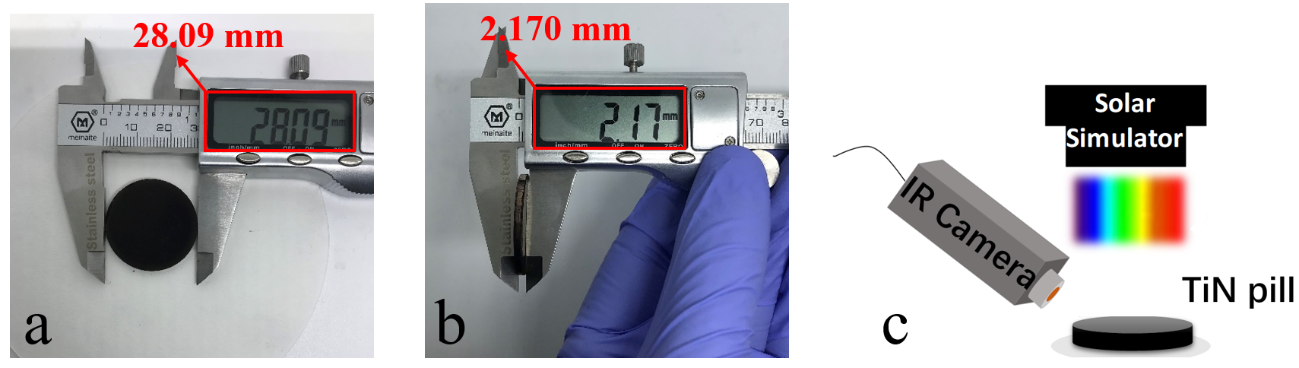
FIG. S6. (a) Diameter and (b) thickness measurement of the TiN pill. 1.969 g TiN nanoparticles was compressed into a round pill with the diameter of 28.09 mm and thickness of 2.170 mm.(c) The experimental setup for extracting the solar-to-heat efficiency of the TiN pill.
A TiN pill was prepared with a diameter of 28.09 mm and a thickness of 2.17 mm as shown in Fig. S6(a) and (b). During the experiment, a sun simulator (standard Air Mass 1.5G) is placed on top of the TiN pill with the irradiation flux of 0.75 kW/m². An IR camera was used to record the temperature change during the heating and cooling process, as shown in Fig. S6(c). The heat capacity $C_{TiN}$ 0.599 J/ g℃ of TiN was taken out from a previous literature.² We determined the $T_{TiN}^{max}-T_{surr}^{max}$ of TiN sample to be ≈25.6℃，and the value of $h×s$ was found to be ≈17.2 mW/℃ by fitting the temperature cooling stage. The external photothermal conversion efficiency $η_{ext}$ was calculated to be 94.8 %.
S5. Thermal stability of the TiN nanoparticles in air
The thermal stability of the TiN nanoparticles was studied by annealing the powders under air atmosphere at different temperatures. The annealing duration was kept same (2 hours) for all experiments. Fig. S7(a) shows the optical photos of the powders after annealing at different temperature. The color changes from dark black to gray (450 ℃), light yellow (500 ℃) and pure white (600 ℃) with increasing annealing temperature. The nanocrystals transfer from face-centered cubic crystalline TiN to rutile TiO₂ at temperature above 450 ℃ as can be seen from the XRD patterns in Fig. S7(b).
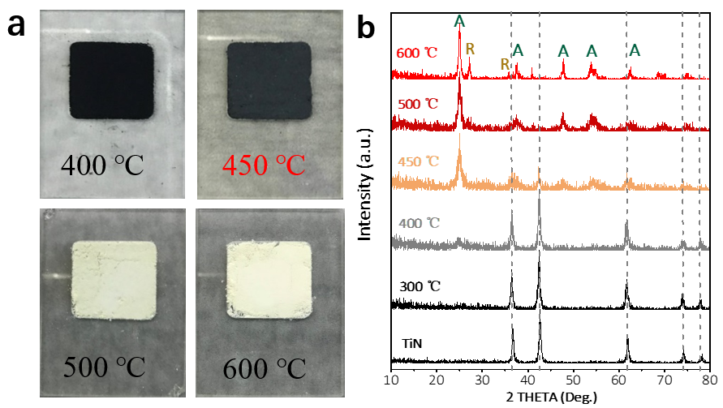
FIG. S7. Optical photos (a) and X-ray powder diffraction patterns (b) of the TiN powder after annealing at different temperatures under air atmosphere for 2 h (A=anatase, R=rutile).
S6. Calculation of evaporation efficiency
The evaporation efficiency (EF) was calculated by the efficiency formula:
$$Q_{evp}=\frac{dm×Lv}{dt}=v×Lv$$
$$EF=\frac{Q_{evp}}{Q_{solar}}$$
where $Q_{evp}$is the energy consumed for water evaporation, $Q_{solar}$is the incident simulated solar light power (kW/m²) on the device surface, m is the mass of evaporated water which was recorded by the balance (with dark evaporation rate 88 mg m⁻² h⁻¹ subtracted), Lv is the latent heat of evaporation of water, which was calculated based on the following equation(for the range 273 K to 323 K):
$Lv\left(T\right)=1.91846×{10}^{6 }$(${\frac{T}{T-33.91})}^{2}$ J/Kg (10)
where T is the temperature of evaporation³. Note that Lv was taken as 2260 kJ/kg for the calculation of $Q_{evp}$ when higher illumination intensity was used for solar steam generation due to the high temperature of evaporation is far beyond the scope of above formula.
Taking the TiN nanofluid (mass concentration:3 mg/ml) as an example, the mass change as a function of the irradiation time is shown in Fig. S8.
FIG. S8. Time-dependent water evaporation rate under 3.73 sun light irradiation of TiN nanofluid (3mg/ml). The inset shows the optical photo of the nanofluid.
We consider the evaporation rate reaches the steady state after 900 s irradiation and thus the evaporation rate is 0.00124 kg m⁻² s⁻¹. Note that the surface temperature of water extracted via a thermocouple was 60.7 ℃. Thus, Eq. 10 is no longer applicable. So,
$EF=\frac{Q_{evp}}{Q_{solar}}=\frac{（0.00124-\frac{88×{10}^{-6}}{3600}）× kg m^{-2}s^{-1}×2260 kJ/kg}{3.733 kW m^{-2} }×100\%=$73.65%

S7. Hydrophilic treatment to both sides of the AAM
The AAM was immersed in hydrogen peroxide (30 wt%) overnight at room temperature to obtain the OH group. Hydroxyl (OH) groups on the AAM surface helped to form hydrogen bonds between the water and the bottom surface of the AAM, making it hydrophilic.
The hydrophilicity of the AAM was verified by measurements of surface contact angle, as shown in Fig. S9. The volume of the water droplet was kept the same (10 μL) for all measurements. Increased hydrophilicity can be observed on both sides of the AAM with pore diameter of 400-500 nm, as can be seen from Fig. S9(c), (d) and Fig. S9(a), (b). Note that the droplet put onto the back of the hydrophilic treated AAM with pore diameter of 400-500 nm spread over the surface, indicating the super hydrophilicity of the H₂O₂ treated membrane, as can be seen from Fig. S9(d), the AAM with pore diameter of 20 nm also shows good hydrophilicity with a low contact angle of less than 15° on both sides of the AAM.
The better evaporation performance of the hydrophilized device was confirmed by filtering the same amount of TiN nanoparticle on templates with and without H₂O₂ treatment and comparing the evaporation rate, as shown in Fig. S10. The amount of the filtered TiN was 72 mg and the AAM with the pore size of 400-500 nm was chosen. A 13.3% increment of the evaporation rate was achieved by the hydrophilized device.
FIG. S9. Optical photos of a drop of water on the front (a, c, e) and back (b, d, f) of AAM with mesoporous diameter of 400-500 nm (a, b, c, d) and 20 nm (e, f) before (a, b) and after (c, d, e, f) hydrophilic treatment for contact angle measurements. Note that the front and back of AAM were defined by the pore diameter with a smaller diameter refer to the back, which shows a smaller contact angle and is in direct contact of the water surface when used for solar steam generation.
FIG. S10. The mass change of TiN-AAM device with and without hydrophilic treatment.

S8. Relationship between the thickness of TiN layer and the amount of the filtrated TiN

FIG. S11. Average thickness of the TiN layer as a function of the amount of the filtrated TiN nanoparticle.

S9. Optical photos of the hydrophilic AAM-based device exposed to different light illumination
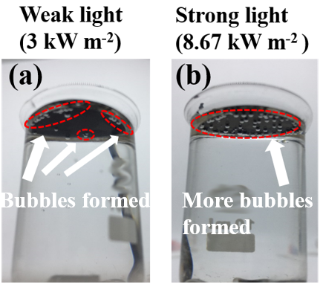
FIG. S12. Optical photos of the hydrophilic AAM-based device exposed to weak (a) and strong (b) light illumination for 3600s. Small bubbles formed on the edge of the bottom surface of the AAM under weak light illumination, and more bubbles formed all over the bottom surface under higher light illumination, indicating a deficient water replenishment of the device under higher solar irradiation. That is, the amount of the filtered TiN should be optimized when applied to different illumination conditions.
S10. Effects of pore size of the AAM on the solar steam generation efficiency

FIG. S13. a) The mass change of water and water with different TiN-AAM (pore diameter: 400-500 nm) devices as a function of the radiation time. (b) The mass change of TiN (72 mg)-AAM (D:400-500 nm) device and TiN (30 mg)-AAM (D:20 nm). Note that the two devices are compared here because the thickness of the TiN layer are similar (about 250 μm).
FIG. S14. SEM images of the AAM with pore size of 400-500nm(a-d) and 20nm (e-h). (a and e) Images of the back sides which are in direct contact with the water surface in the solar steam generation progress. (b and f) Images of the side view of the templates showing vertical tubes which act as the water supply channels. (c and g) Images of the front sides which are in direct contact with filtered TiN nanoparticles. (d) Image of the front side of AAM(400-500nm) template after removing the filtered TiN nanoparticles by ultrasonic, showing some channels blocked by TiN nanoparticles. (h) Top view of the TiN-AAM (20 nm) device.

S11. Different heating behaviors of pure water, TiN-AAM device and TiN nanofluid
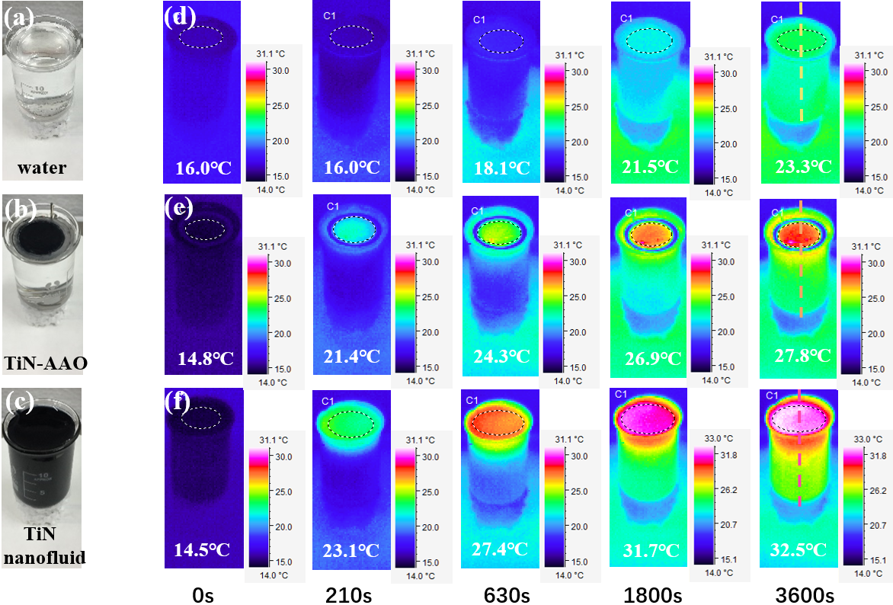
FIG. S15. (a-c) Optical photographs of 10 mL beakers with water inside, TiN nanoparticle (20mg) based thin film on top of the water surface and TiN nanoparticle solution (3mg/ml), respectively. (d-f) Infrared photos of the pure water, TiN-AAM device and TiN nanofluid (the inserted numbers are the corresponding average surface temperature). The photos, in order from left to right, correspond to t=0, 210, 630, 1800, and 3600 s after illumination. The light illumination intensity is 1.21 kW m⁻². Beakers (with only a piece of round polystyrene foam on bottom for thermal insulation) are used in this experiment. Ambient temperature is ~16℃ and the humidity is 43%. Temperature profiles of the marked lines in the corresponding 3600s IR photos are drawn in the manuscript.

References
1. E. Langereis, S.B.S. Heil, d.S. Van, M. C. M and W.M.M. Kessels: In situ spectroscopic ellipsometry study on the growth of ultrathin TiN films by plasma-assisted atomic layer deposition. Journal of Applied Physics 100, 261 (2006).
2. C.H. Shomate: Specific Heats at Low Temperatures of TiO, Ti2O3, Ti3O5, and TiN. J.am.chem.soc. 68, 2340 (2002).
3. B. Henderson-Sellers: A new formula for latent heat of vaporization of water as a function of temperature. Quarterly Journal of the Royal Meteorological Society 110, 1186 (1984).

