Supporting Information for:
A Combined Computational and Experimental Study of the Adsorption of Sulfur Containing Molecules on Molybdenum Disulfide Nanoparticles
Tao Yang, Junpeng Feng, Xingchen Liu,, Yandan Wang, Hui Ge, Dongbo Cao, Hao Li, Qing Peng, Manuel Ramos, Xiao-Dong Wen, and Baojian Shen

Table of Content
Name | Content | Page No.
1. | The top and side view of the Mo₂₇S_{x} nanoparticles | 1
1.1 Figure-S1 | The Mo₂₇S₄₈ cluster used to accommodate site-5 and site-6 | 2
1.2 Figure-S2 | The Mo₂₇S₅₀ cluster used to accommodate site-3 | 2
1.3 Figure-S3 | The Mo₂₇S₅₀ cluster used to accommodate site-4 | 3
1.4 Figure-S4 | The Mo₂₇S₅₁ cluster | 3
1.5 Figure-S5 | The Mo₂₇S₅₄ cluster used to accommodate site-1 | 4
1.6 Figure-S6 | The Mo₂₇S₅₅ cluster used to accommodate site-2 | 4
2. | Cartesian coordinates of the Mo₂₇S₅₄ nanoparticle | 5-6
3. Table-S1 | Bond lengths (Å) for free sulfur molecules and adsorption sulfur molecules on different adsorption sites | 7

1. The top and side view of the Mo₂₇S_{x} nanoparticles used for the adsorption studies

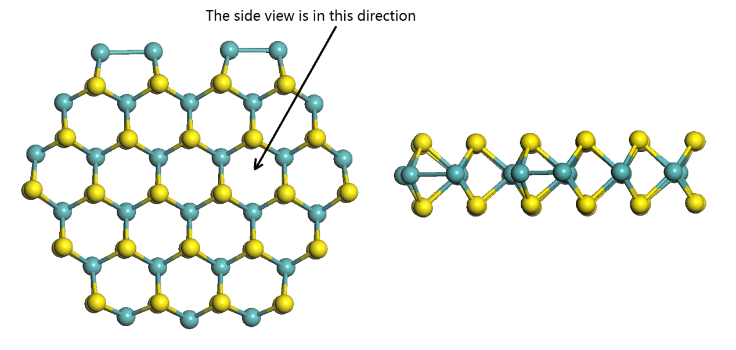
Figure S-1. The top (left) and side (right) of the Mo₂₇S₄₈ cluster used to accommodate site-5 and site-6.
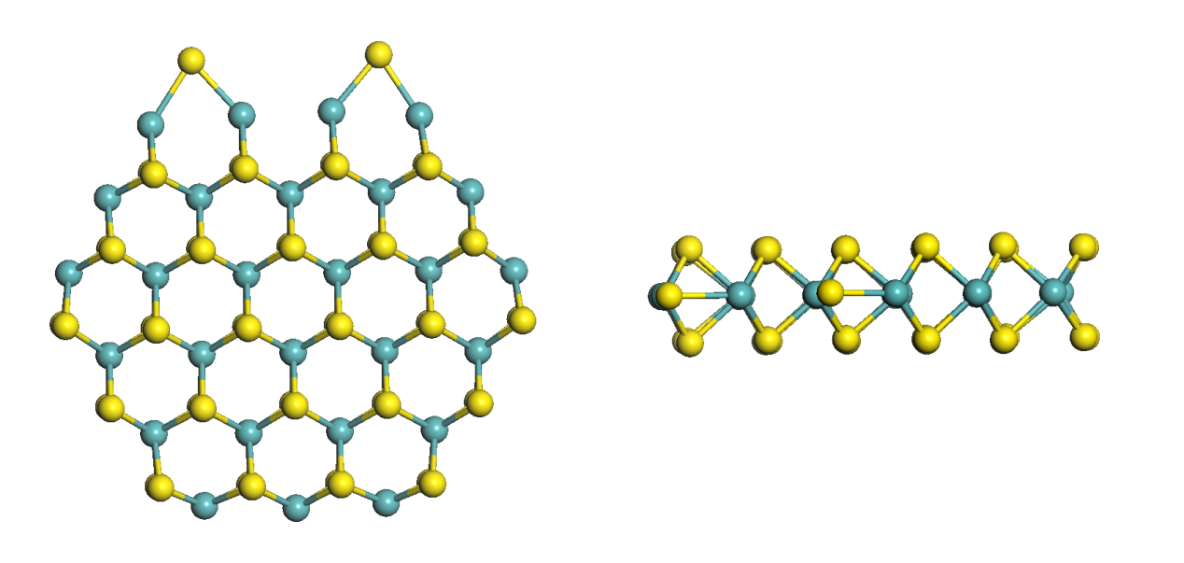
Figure S-2. The top (left) and side (right) of the Mo₂₇S₅₀ cluster used to accommodate site-3

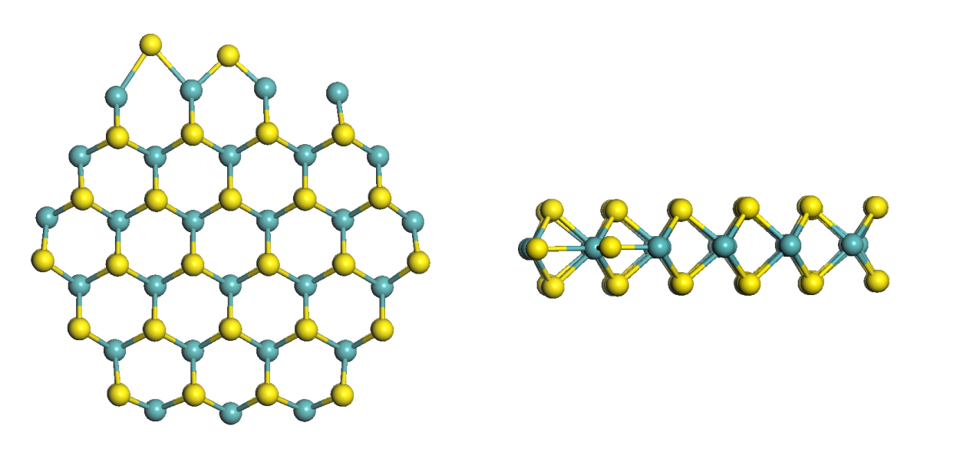
Figure S-3. The top (left) and side (right) of the Mo₂₇S₅₀ cluster used to accommodate site-4

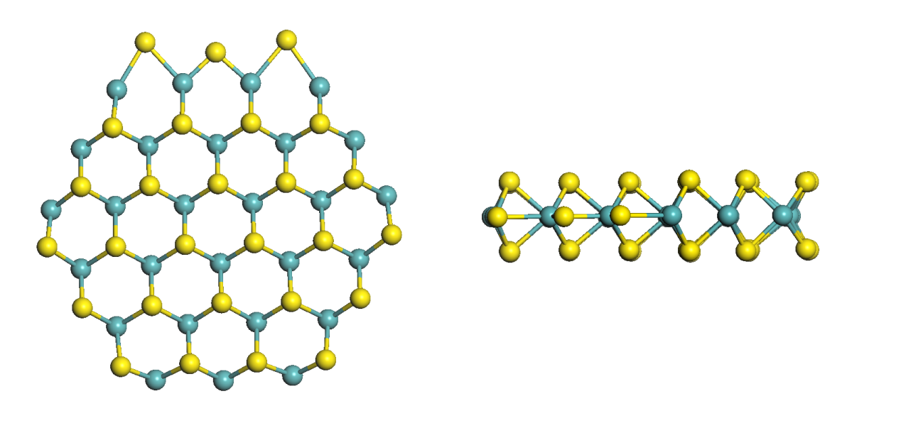

Figure S-4. The top (left) and side (right) of the Mo₂₇S₅₁ cluster

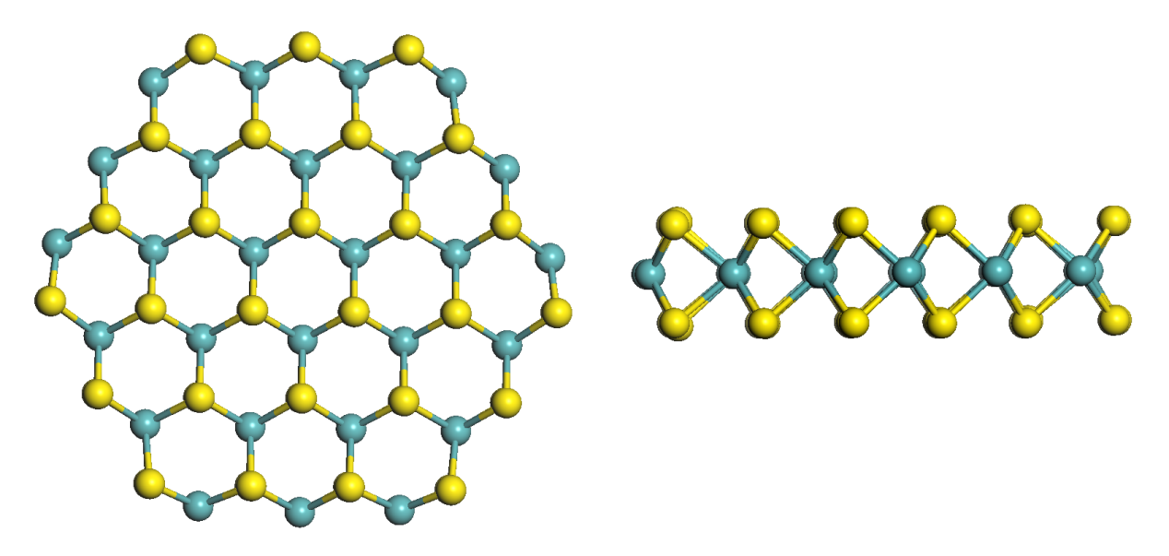
Figure S-5. The top (left) and side (right) of the Mo₂₇S₅₄ cluster used to accommodate site-1
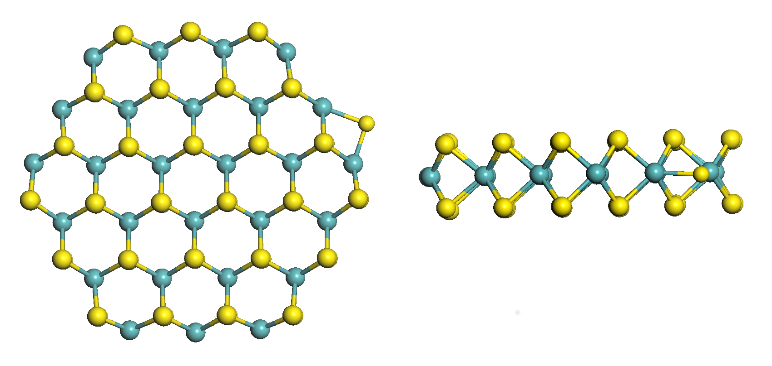
Figure S-6. The top (left) and side (right) of the Mo₂₇S₅₅ cluster used to accommodate site-2

2. Cartesian coordinates of the Mo₂₇S₅₄ nanoparticle
Mo 5.6809452310 0.0300310040 -0.0658687350
Mo 5.5584153990 3.1611163320 -0.0060518810
Mo 5.6705660120 6.2933622300 0.0410838770
Mo 8.1891029620 -1.7084881460 -0.1007020830
Mo 8.1964319070 1.5789930820 -0.0163172540
Mo 8.1923814400 4.7491229610 0.0152482760
Mo 8.1714482510 8.0469821850 0.0459215250
Mo 10.9220871100 -3.2743797230 0.1239870550
Mo 10.9602576530 -0.0172168120 -0.0301791680
Mo 10.9664400980 3.1711091090 -0.0127847640
Mo 10.9504793770 6.3604733310 0.0222605750
Mo 10.8884838380 9.6093752990 0.0546598630
Mo 13.7166500030 -4.5163551690 0.1093736170
Mo 13.7471491660 -1.5826999480 -0.0382459070
Mo 13.7045189230 1.5989581350 -0.0409864290
Mo 13.7038466600 4.7575717120 -0.0058988490
Mo 13.7282340240 7.9428980450 0.0255242460
Mo 13.6610815730 10.9117670330 0.0473860650
Mo 16.4227212740 -3.0081342290 -0.0162572500
Mo 16.4432217770 -0.0097861890 -0.0694786260
Mo 16.4689908740 3.1685141930 -0.0176424340
Mo 16.4690352630 6.3559608280 -0.0022638150
Mo 16.4215674820 9.4305680180 0.0056940620
Mo 18.9396851400 -1.4608549390 0.1564007160
Mo 19.2647683860 1.5599410790 0.0904447530
Mo 19.3065606580 4.7118281600 -0.0999073110
Mo 19.0763321860 7.7620079320 -0.0655876800
S 6.3439391220 -1.5331346980 -1.6715901140
S 6.3239535440 -1.6121184730 1.4578980640
S 6.3781270680 1.6543827290 -1.6620972620
S 6.3542874760 1.5923187060 1.6068196010
S 6.3610981290 4.7270717270 -1.6180971020
S 6.3637404360 4.6773688710 1.6508283480
S 6.3118540390 7.9149282160 -1.5106627090
S 6.3234534930 7.8789260160 1.6202523820
S 9.0742399690 -3.3170455180 -1.5104190460
S 9.1136663350 -3.2793334370 1.5642095270
S 9.1131211720 -0.0213813170 -1.5874742400
S 9.0964533480 -0.0869427510 1.5080542000
S 9.1333804530 3.1834737080 -1.5748075820
S 9.1409476030 3.1492908120 1.5653297420
S 9.0885275320 6.4022609210 -1.5166207710
S 9.0978532690 6.3718627390 1.5744829340
S 9.0754441120 9.6154925090 -1.4992009010
S 9.0902139850 9.5897358930 1.6165305690
S 11.9682549630 -4.8611450370 -1.3893652940
S 12.0402847480 -4.7102538300 1.7316116840
S 11.8374535050 -1.7003863820 -1.5354771590
S 11.9128356730 -1.5807981240 1.5454392840
S 11.8629065880 1.5814324510 -1.6145135900
S 11.8787400450 1.5689863090 1.5538091720
S 11.8626465820 4.7880548310 -1.5819083630
S 11.8733116700 4.7564812570 1.5837190610
S 11.8519972600 7.9956631210 -1.5115861130
S 11.8685799180 7.9659485040 1.5802617960
S 11.9377063380 11.1449839270 -1.5075372890
S 11.9515564200 11.1271068410 1.6209515470
S 14.7132252550 -3.2222269150 -1.6393002750
S 14.7505634530 -3.0328164620 1.6711750500
S 14.6164006270 0.0216757220 -1.6359227330
S 14.6338819120 0.0287806110 1.5277153290
S 14.6361879550 3.1927780010 -1.6063420050
S 14.6321880870 3.1667188120 1.5599866680
S 14.6166280230 6.3498449040 -1.5656471700
S 14.6358409410 6.3232280980 1.5779813430
S 14.6651795690 9.5210616510 -1.6050608940
S 14.6982034290 9.4969439450 1.6582262670
S 17.3987802800 -1.6211479860 -1.6932659480
S 17.1924265570 -1.5079193480 1.1373503910
S 17.4663737280 1.5969996530 -1.5678198820
S 17.3381942170 1.5453332570 1.5534525190
S 17.3873055770 4.7676939100 -1.5797299330
S 17.4604513990 4.7444280480 1.5244004320
S 17.3167680050 7.9662636720 -1.6501571700
S 17.3879286620 7.9569760180 1.6139805810
S 20.1692289770 -0.1559164860 -1.3614432080
S 19.8781325260 -0.1693076280 1.7861692340
S 20.2345355890 3.1438839660 -1.5349619830
S 20.2101994990 3.0955720800 1.5372088310
S 20.0699388600 6.3977602190 -1.6791495160
S 20.1853474890 6.3676508510 1.4413316390

Table S-1. Bond lengths (Å) for free sulfur molecules and adsorption sulfur molecules on different adsorption sites. (μ2 coordination on site-2, site-3 and site-4 and π-Face coordination on Mo edge).
Bond | S-C(DBT) |  | S-C(4,6-DMDBT) |  | S-C(3,7-DMDBT) |  | S-C(2,8-DMDBT)
Free | 1.762 | 1.762 | 1.763 | 1.763 | 1.763 | 1.763 | 1.762 | 1.762
Site-2 | 1.792 | 1.794 | 1.819 | 1.819 | 1.791 | 1.791 | 1.787 | 1.799
Site-3 | 1.798 | 1.78 | 1.808 | 1.809 | 1.800 | 1.799 | 1.794 | 1.794
Site-4 | 1.796 | 1.796 | 1.807 | 1.808 | 1.797 | 1.795 | 1.791 | 1.791
Mo edge | 1.778 | 1.820 | 1.795 | 1.794 | 1.790 | 1.790 | 1.787 | 1.788

