FIG. S1. (a) ADF-STEM image and (b) corresponding SADP of electron-irradiated matrix of FeCoCrMnNi; (c) ADF-STEM image and (d), (e) corresponding SADPs (along different zone axes) of electron-irradiated matrix of FeCoCrNiPd ¹ (Reprinted with permission from Ref. 1).

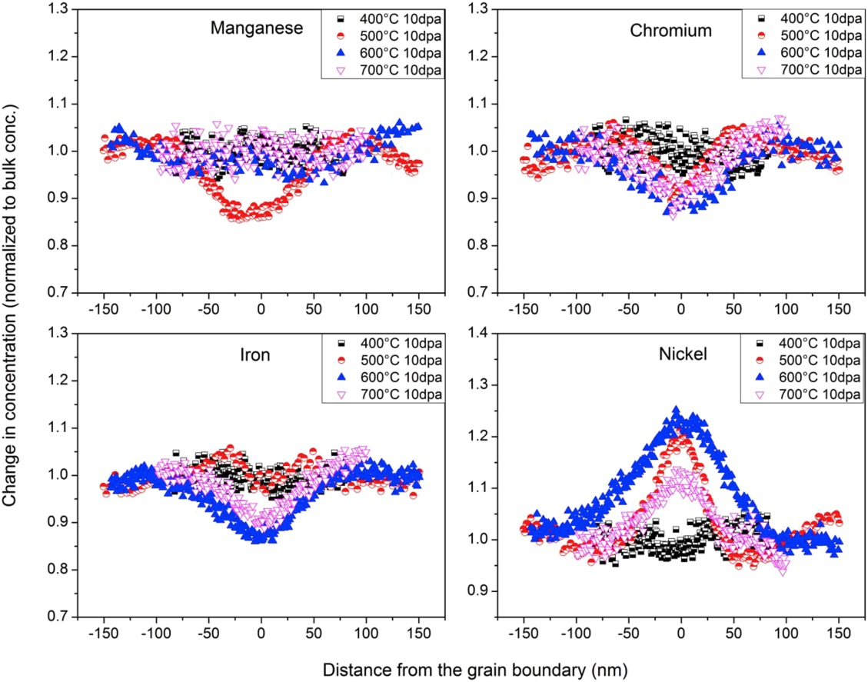
FIG. S2. EDX measurements of irradiation-induced segregations at grain boundary in FeNiMnCr HEA irradiated with 5.8 MeV Ni ions up to 10 dpa at 400, 500, 600 and 700 ºC ² (Reprinted with permission from Ref. 2).

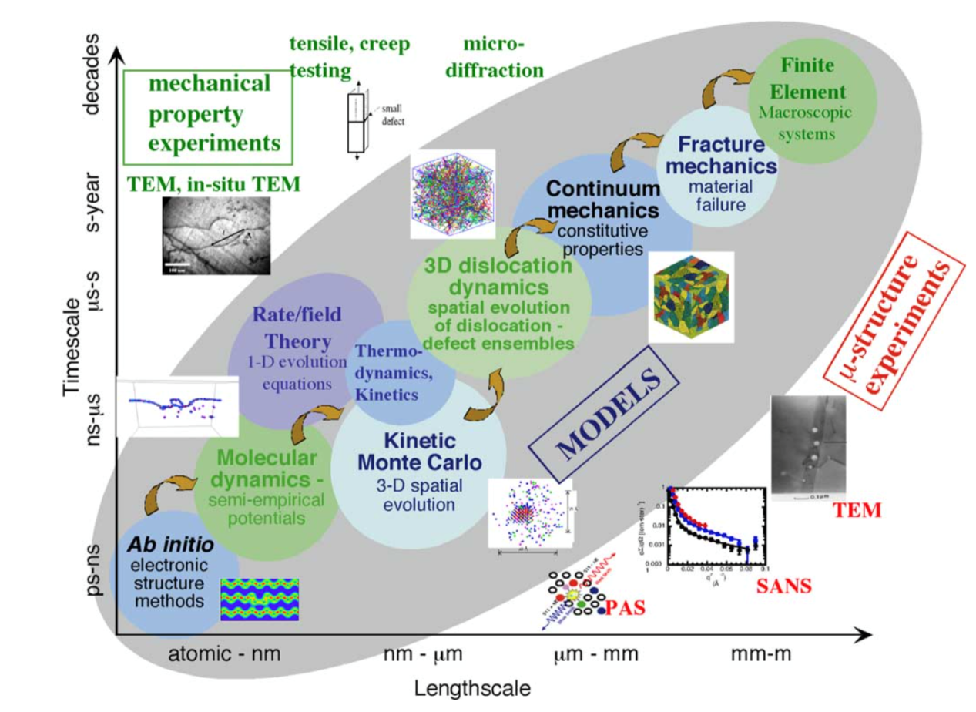
FIG. S3. Hierarchy modeling approach for simulating irradiation effects in materials. Modeling techniques at different time- and length-scale build up on each other through the inter-connecting information flow (yellow arrows). This hierarchy approach enables understanding and prediction of properties of irradiated materials from experiment. Note that the current hierarchy is based on knowledge of metals and conventional alloys and does not include the unique physics in SP-CSAs ³ (Reprinted with permission from Ref. 3).

1. M.-R. He, S. Wang, S. Shi, K. Jin, H. Bei, K. Yasuda, S. Matsumura, K. Higashida
and I.M. Robertson: Mechanisms of radiation-induced segregation in CrFeCoNi-based single-phase concentrated solid solution alloys. Acta. Mater. 126, 182 (2017).
2. N.A.P.K. Kumar, C. Li, K.J. Leonard, H. Bei and S.J. Zinkle: Microstructural stability and mechanical behavior of FeNiMnCr high entropy alloy under ion irradiation. Acta. Mater. 113, 230 (2016).
3. B.D. Wirth, G.R. Odette, J. Marian, L. Ventelon, J.A. Young-Vandersall and L.A. Zepeda-Ruiz: Multiscale modeling of radiation damage in Fe-based alloys in the fusion environment. J. Nucl. Mater. 329-333 (Part A), 103 (2004).

