Supplementary Material

N-doped Order Mesoporous Carbon Prepared by Solid-solid Grinding for Supercapacitor

Juan Dua), Ran Liu, Yifeng Yu, Yue Zhang

College of Chemical and Pharmaceutical Engineering, Hebei University of Science and Technology, 70 Yuhua Road, Shijiazhuang 050018, China.

Yexin Zhangb)

Ningbo Institute of Materials Technology & Engineering, Chinese Academy of Sciences, 1219 Zhongguan West Road, Ningbo 315201, China.

Aibing Chenc)

College of Chemical and Pharmaceutical Engineering, Hebei University of Science and Technology, 70 Yuhua Road, Shijiazhuang 050018, China.[1]

(c)

(d)

(a)

(b)

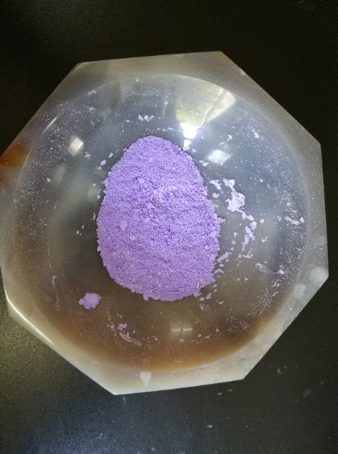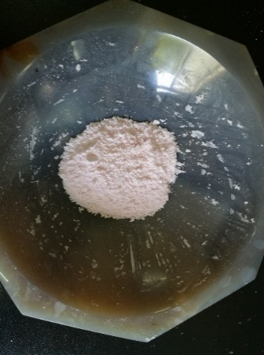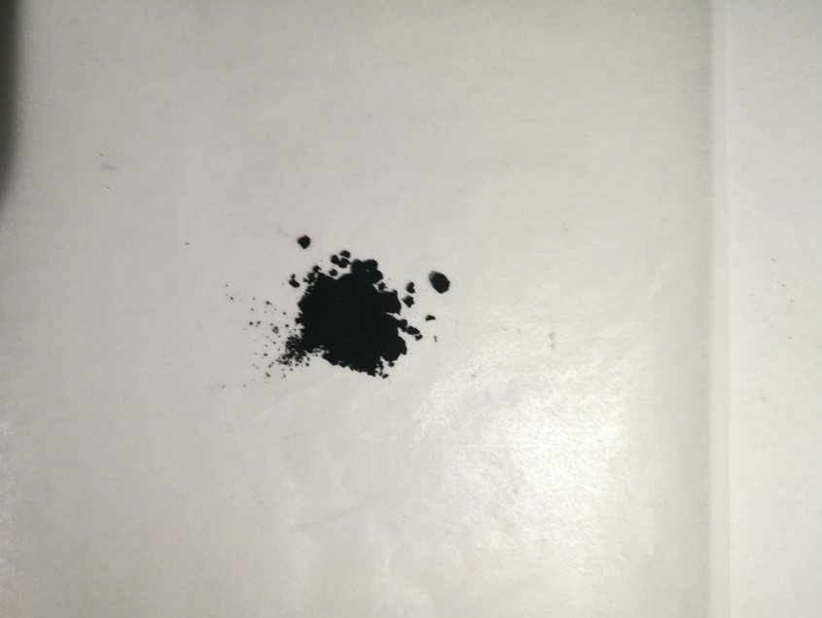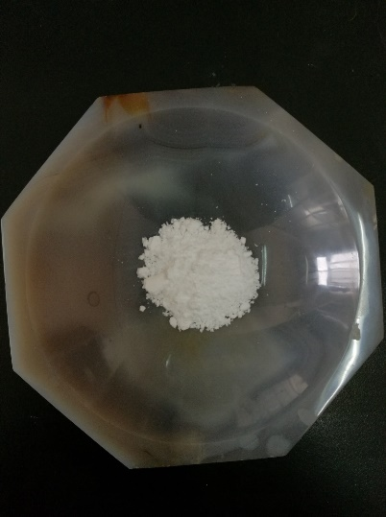

**FIG. S1.** Digital photographs of preparing the composites of N-OMC: SBA-15 (a), composite of SBA-15 and Co(NO3)2·6H2O (b), ZIF-67/SBA-15 (c) and N-OMC (d).



**FIG. S2.** FT-IR spectra of ZIF-67-S, ZIF-67-G and ZIF-67/SBA-15 (a), small angle XRD patterns of SBA-15 and ZIF-67/SBA-15 (b), wide angle XRD patterns of ZIF-67-G and ZIF-67/SBA-15 (c) and TGA curves of Hmim, ZIF-67-G and ZIF-67/SBA-15 (d).



**FIG. S3.** Nitrogen isothermal adsorption-desorption and pore size distribution (inset) of porous carbon obtained by carbonization of ZIF-67-S.



**FIG. S4.** TEM images of N-OMC.



**FIG. S5.** CV curves from 40 to 200 mV s-1 (a) and GCD curves (b) from 3 to 20 A g-1 of N-OMC in three-electrode system.



**FIG. S6.** GCD curves at different current density of N-OMC and porous carbon obtained by carbonization of ZIF-67-S.



**FIG. S7.** CV (a) and GCD (b) curves of N-OMC in two-electrode system.

**Table SⅠ** Comparison in charge/discharge cycling stability of N-OMC with previously reported mesoporous carbon materials.

|  |  |  |  |  |  |
| --- | --- | --- | --- | --- | --- |
| Synthesis method | Cycles | Retention (%) | Current density  (A g-1) | Electrolyte | Ref. |
| Hard template | 10 000 | 99.97 | 5 | 6 M KOH | This work |
| Microwave-assisted | 5000 | 85.8 | 5a | 6 M KOH | 1 |
| Hard template | 5000 | 96.2 | 10 | 1M H2SO4 | 2 |
| Soft template | 1000 | 91 | 10b | 6 M KOH | 3 |
| Soft template | 1000 | 98.2 | 0.5 | 6 M KOH | 4 |
| Soft template | 1000 | 91.5 | 0.5c | 1M H2SO4 | 5 |
| Hard template | 1000 | 90.4 | 1c | 1M H2SO4 | 6 |
| Soft template | 10 000 | 70 | 0.5 | 6 M KOH | 7 |
| Hard template | 5000 | 91 | 200a | 6 M KOH | 8 |
| Hydrothermal emulsion | 500 | 90 | 1 | 6 M KOH | 9 |
| Hard template | 200 | 85 | 1.25 | 2 M KOH | 10 |
| Hard template | 1800 | 88 | 1c | 1M Et4BF4 | 11 |
| Soft template | 10 000 | 98 | 3c | 1M H2SO4 | 12 |
| Hard template | 300 | 98 | 1 | 6 M KOH | 13 |
| Hard template | 700 | 96.6 | 3c | 6 M KOH | 14 |
| Soft template | 10 000 | 93 | 2 | 1M H2SO4 | 15 |

amV s-1; bmA cm-1; cElectrochemical experiments were tested by two-electrode.

**REFERENCES**

1. U.B. Nasini, V.G. Bairi, S.K. Ramasahayam, S.E. Bourdo, T. Viswanathan and A.U. Shaikh: Phosphorous and nitrogen dual heteroatom doped mesoporous carbon synthesized via microwave method for supercapacitor application *J. Power Sources.* **250**, 257 (2014).

2. Y.H. Dai, H. Jiang, Y.J. Hu, Y. Fu and C.Z. Li: Controlled synthesis of ultrathin hollow mesoporous carbon nanospheres for supercapacitor applications *Ind. Eng. Chem. Res..* **53**, 3125 (2014).

3. M. Li and J.M. Xue: Integrated Synthesis of Nitrogen-Doped Mesoporous Carbon from Melamine Resins with Superior Performance in Supercapacitors *J. Phys. Chem. C.* **118**, 2507 (2014).

4. X.L. Yu, J.G. Wang, Z.H. Huang, W.C. Shen and F.Y. Kang: Ordered mesoporous carbon nanospheres as electrode materials for high-performance supercapacitors *Electrochem. Commun..* **36**, 66 (2013).

5. Y.F. Yan, Q.L. Cheng, Z.J. Zhu, V. Pavlinek, P. Saha and C.Z. Li: Controlled synthesis of hierarchical polyaniline nanowires/ordered bimodal mesoporous carbon nanocomposites with high surface area for supercapacitor electrodes *J. Power Sources.* **240**, 544 (2013).

6. Y.F. Yan, Q.L. Cheng, G.C. Wang and C.Z. Li: Growth of polyaniline nanowhiskers on mesoporous carbon for supercapacitor application, *J. Power Sources* **196**, 7835 (2011).

7. X.L. Dong, Z.Y. Guo, Y.F. Song, M.Y. Hou, J.Q. Wang, Y.G. Wang and Y.Y. Xia: Flexible and Wire-Shaped Micro-Supercapacitor Based on Ni(OH)2-Nanowire and Ordered Mesoporous Carbon Electrodes *Adv. Funct. Mater..* **24**, 3405 (2014).

8. Q.W. Wang, J. Yan, T, Wei, J. Feng, Y.M. Ren, Z.J. Fan, M.L. Zhang, and X.Y. Jing, Two-dimensional mesoporous carbon sheet-like framework material for high-rate supercapacitors, Carbon 60 (2013) 481-487, J. Yan, T. Wei, J. Feng, Y.M. Ren, Z.J. Fan, M.L. Zhang and X.Y. Jing: Two-dimensional mesoporous carbon sheet-like framework material for high-rate supercapacitors *Carbon.* **60**, 481 (2013).

9. M.X. Liu, L.H. Gan, W. Xiong, F.Q. Zhao, X.Z. Fan, D.Z. Zhu, Z.J. Xu, Z.X. Hao and L.W. Chen: Nickel-Doped Activated Mesoporous Carbon Microspheres with Partially Graphitic Structure for Supercapacitors *Energy Fuels.* **27**, 1168 (2013).

10. J.W. Lang, X.B. Yan, X.Y. Yuan, J. Yang and Q.J. Xue: Study on the electrochemical properties of cubic ordered mesoporous carbon for supercapacitors *J. Power Sources.* **196**, 10472 (2011).

11. D. Bhattacharjya, M.S. Kim, T.S. Bae and J.S. Yu: High performance supercapacitor prepared from hollow mesoporous carbon capsules with hierarchical nanoarchitecture *J. Power Sources* **244**, 799 (2013).

12. D.D. Zhou, W.Y. Li, X.L. Dong, Y.G. Wang, C.X. Wang and Y.Y. Xia: A nitrogen-doped ordered mesoporous carbon nanofiber array for supercapacitors *J. Mater. Chem. A..* 8488 (2013).

13. Y.Y. Lv, F. Zhang, Y.Q. Dou, Y.P. Zhai, J.X. Wang, H.J. Liu, Y.Y. Xia, B. Tu and D.Y. Zhao: A comprehensive study on KOH activation of ordered mesoporous carbons and their supercapacitor application *J. Mater. Chem .* **22**, 93 (2012).

14. Z.B. Lei, N. Christov, X.S. Zhao and L.L. Zhang: Mesoporous carbon nanospheres with an excellent electrocapacitive performance *J. Mater. Chem..* **21**, 2274 (2011).

15. Z. Li, Z.W. Xu, X.H. Tan, H.L. Wang, C.M.B. Holt, T. Stephenson, B.C. Olsen and D. Mitlin: Mesoporous nitrogen-rich carbons derived from protein for ultra-high capacity battery anodes and supercapacitors *Energy Environ. Sci..* **6**, 871 (2013).

1. b)Corresponding Authors:E-mail: [zhangyexin@nimte.ac.cn](mailto:zhangyexin@nimte.ac.cn)

   c) [chen_ab@163.com](mailto:chen_ab@163.com)