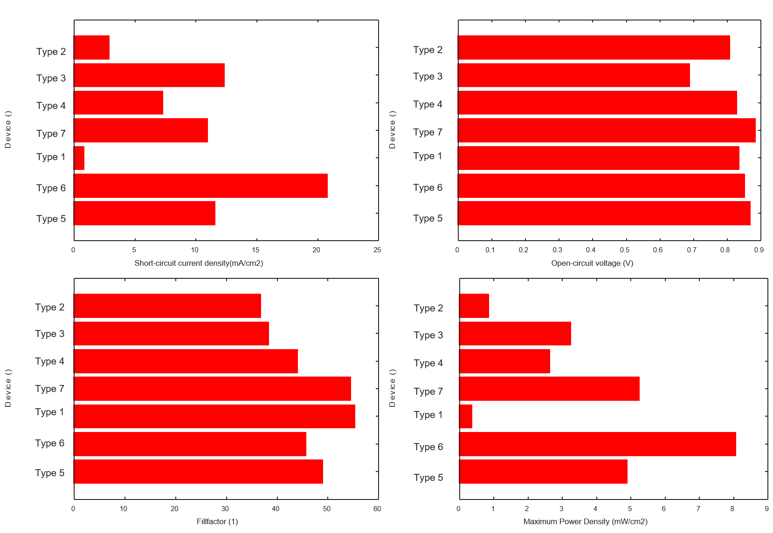
Figure S1. Snapshot of initial FOMs of selected devices of each Type.
Figure S2. Stabilized time of the devices against Mw.

Table S1. Summary of the device types under study
Identifier | Architecture | Area (cm²) | Cell stack layers [thickness] | Encapsulation
Type 1 | Standard | 0.24 | ITO + PEDOT:PSS [40 nm] + PCDTBT:PC61BM [90 nm]+ Ca [20 nm] + Al [100 nm] | Glass + Delo-Katiobond (LP655)  UV
Type 2 | Inverted | 3.75 | ITO + ZnO [30 nm] +PCDTBT:PC70BM [250 nm] + PEDOT:PSS [100 nm] + Ag [100 nm] | Metal lid + Araldite epoxy
Type 3 | Standard | 0.16 | ITO + PEDOT:PSS [??] + PCDTBT:PC60BM [250 nm]+ Ca [20 nm] + Al [100 nm] | Glass + Araldite epoxy
Type 4 | Inverted | 0.1 | ITO + PEIE [10 nm] +PCDTBT:PC70BM [70 nm] + MoO₃ [5 nm] + Ag [100 nm] | Glass + parafilm
Type 5 | Standard | 0.045 | ITO + PEDOT:PSS [40 nm] + PCDTBT:PC70BM [90 nm]+ LiF [0.3 nm] + Al [100 nm] | Glass + Ossila epoxy glue
Type 6 | Standard | 0.04 | ITO + PEDOT:PSS [30] + PCDTBT:PC60BM [80 nm]+ Ca [5] + Al [100 nm] | Glass + epoxy  UV
Type 7 | Standard | 0.09 | ITO + PEDOT:PSS [30] + PCDTBT:PC60BM [90 nm]+ Ca [25 nm] + Ag [100 nm] | Glass + glue (LOCTITE 358)  UV

Table S2. Details of the active layer composition and fabrication parameters
Identifier | PCDTBT:PCBM ratio | Blend concentration (mg/ml) | Spin coating speed (rpm)/time(s) | Annealing temperature /time
Type 1 | 1:2 | 12 | 1600/15 + +1800/45 | 110°C/5 min
Type 2 | 1:4 | 15 | 1000/60
Type 3 | 1:4 | 30 | 1500/60 | Vacuum dry/  20 min
Type 4 | 1:4 | 40 | 2400/14 | Vacuum dry/  1 h
Type 5 | 1:4 | 20 | 750/100
Type 6 | 1:4 | 20 | 1200/110 | 60oC / 3 min (inert atmosphere)
Type 7 | 1:4 | 9 | 1000/60 | 120°C/20 min

Table S3. Details of HTL and ETL fabrication parameters
Identifier | HTL | Deposition parameters | HTL annealing | ETL | Deposition
Type 1 | PEDOT:PSS | SC @ 1800 rpm, 55’’ | 125°C 10 ‘ | Ca | Thermally evaporated
Type 2 | PEDOT:PSS | SC @ 1000 rpm, 60´´ | 120°C 10’ | ZnO | SC @ 1000 rpm, 60’’
Type 3 | PEDOT:PSS | SC @ 3500°C, 30’´ | 140°C 30’ | Ca | Thermally evaporated
Type 4 | MoO3 | Thermally  Evaporated |  | PEIE | SC @ 5000 rpm, 60’’+ annealing 120°C, 10’
Type 5 | PEDOT:PSS | SC | 120°C 20’ | LiF | Thermally evaporated
Type 6 | PEDOT:PSS | SC @6000 rpm, 60’´ | 120°C 20’ | Ca | Thermally evaporated
Type 7 | PEDOT:PSS | SC @4500rpm 30’’+3500 rpm, 30’’ | 120°C 20’ | Ca | Thermally evaporated

Table S4. Active layer blend constituents
 | PCDTBT supplier | Mn (kDa) | Mw (kDa) | PDI | Fullerene | PCBM supplier | Active layer thickness
1 | Aldrich | Not provided | 100-140 | Not provided | [60]PCBM | Solenne | 90 nm
2 | SJPC | 28.9 | 126.9 | 4.4 | [70]PCBM | nano-C | 250 nm
3 | SJPC | 28.9 | 126.9 | 4.4 | [70]PCBM | Solenne | 250
4 | SJPC | 28.9 | 126.9 | 4.4 | [70]PCBM | Solenne | 70 nm
5 | Ossilla | 19.0 | 39.0 | 2.05 | [70]PCBM | Solenne | 90 nm
6 | Solaris Corp. | 38.1 | 80.0 | 2.1 | [70]PCBM | Solenne | 80 nm
7 | 1-Material | 17.2 | 43.0 | 2.5 | [70]PCBM | Solenne | 90 nm

Table S5. Lifetime parameters of the tested devices, extracted from measurements at different degradation conditions
 | T80 (h) | Ts (h) | PCE (Ts) (norm.) | Ts80 (h) | PCE (Ts80) (norm.)
Type 2
D1 | 820 | 1870 | 0.74 | -- | 0.59
L1 | 46 | 680 | 0.47 | -- | 0.38
L2 | 7 | 690 | 0.38 | -- | 0.31
O1 | 6 | 83 | 0.60 | -- | 0.48
Type 3
D1 | 84 | 187 | 0.77 | 1303 | 0.61
L1 | 7 | 490 | 0.42 | -- | 0.34
L2 | 3 | 325 | 0.76 | 660 | 0.61
O1 | 2 | 32 | 0.41 | -- | 0.33
Type 4
D1 | 210 | 1340 | 0.39 | 5143 | 0.31
O1 | 1 | 53 | 0.23 | 70 | 0.19
Type 5
L1 | 94 | 610 | 0.48 | 894 | 0.38
L2 | 9 | 116 | 0.60 | 184 | 0.48
O1 | 0.3 | 5 | 0.77 | 91 | 0.61
Type 6
D1 | 1130 | 1345 | 0.75 | 1800 | 0.60
L1 | 115 | 200 | 0.77 | 1044 | 0.61
L2 | 39 | 302 | 0.67 | 780 | 0.54
O1 | 2 | 36 | 0.34 | -- | 0.28
Type 7
D1 | 375 | 866 | 0.35 | --
L1 | 39 | -- | --

