Supplementary Information

Uranyl peroxide nanoclusters at high pressures

Katlyn M. Turner^{1*}, Jennifer E.S. Szymanowski², Fuxiang Zhang³, Yu Lin^{1,4,5}, Brendan T. McGrail², Wendy L. Mao^{1,4}, Peter C. Burns^{2,6}, & Rodney C. Ewing¹

- Department of Geological Sciences, Stanford University
- Department of Civil & Environmental Engineering & Earth Sciences, University of Notre Dame
- Department of Earth & Environmental Sciences, University of Michigan
- Stanford Institute for Materials and Energy Sciences, SLAC National Accelerator Laboratory
- Department of Chemistry, Stanford University
- Department of Chemistry and Biochemistry, University of Notre Dame
*e-mail correspondence to: katlynmt@stanford.edu

Table of Contents

Figure S1…………………………………………………………………………………2
Figure S2…………………………………………………………………………………3

Figure S1. Calculated and indexed powder diffraction pattern of Li₆₈K₁₂(OH)₂₀[UO₂(O₂)(OH)]₆₀(H₂O)₃₁₀ at ambient pressure

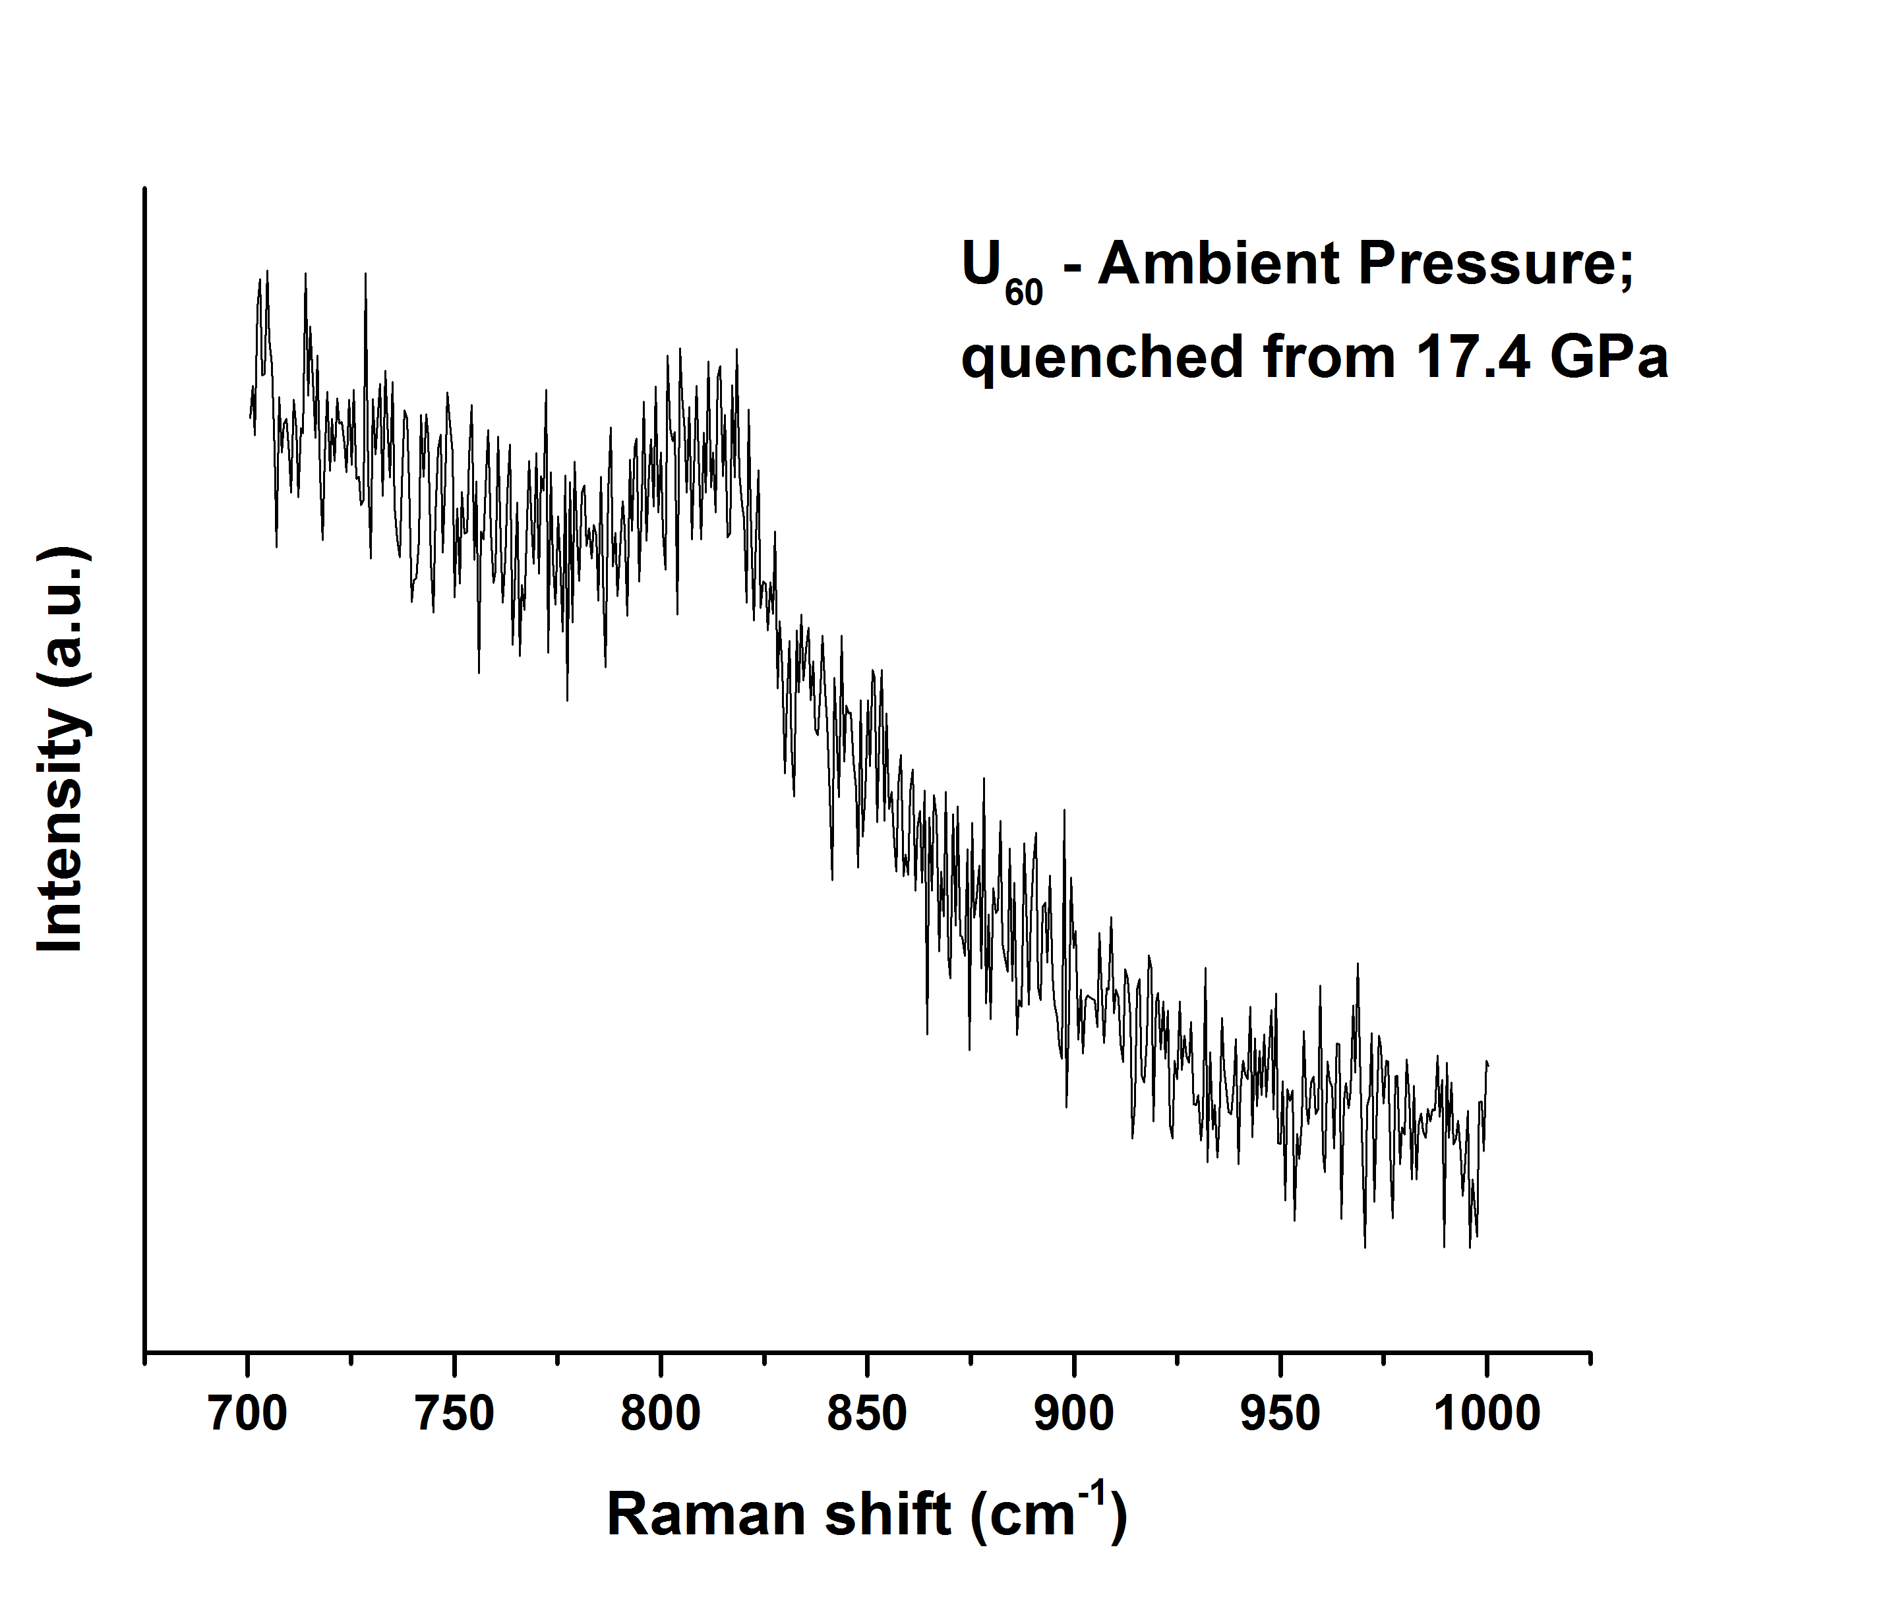
Figure S2. In situ Raman spectroscopy of U₆₀ quenched to ambient pressure from 17.4 GPa

