Supporting Information

Gold Nanoshell Arrays-Based Visualized Sensors of pH : Facile Fabrication and High Diffraction Intensity

D.D. Men, F. Zhou, H.L. Li, L.F. Hang, X.Y. Li, D.L Liu, W.P. Cai,
Key Lab of Materials Physics, Anhui Key Lab of Nanomaterials and Nanotechnology, Institute of Solid State Physics, Chinese Academy of Sciences, Hefei 230031, P. R. China

D.D. Men
Collegeof Chemistry Chemical Engineering and Materials Science, HanDan University, Hadan, 056005, P. R. China

L.M. Qi
College of Chemistry, Peking University, Beijing 100871, P. R. China

L.B. Li
National Synchrotron Radiation Lab and College of Nuclear Science and Technology, CAS Key Lab of Soft Matter Chemistry, University of Science and Technology of China, Hefei, 230026, P. R. China

Y. Li
Key Lab of Materials Physics, Anhui Key Lab of Nanomaterials and Nanotechnology, Institute of Solid State Physics, Chinese Academy of Sciences, Hefei 230031, P. R. China
E-mail: yueli@issp.ac.cn
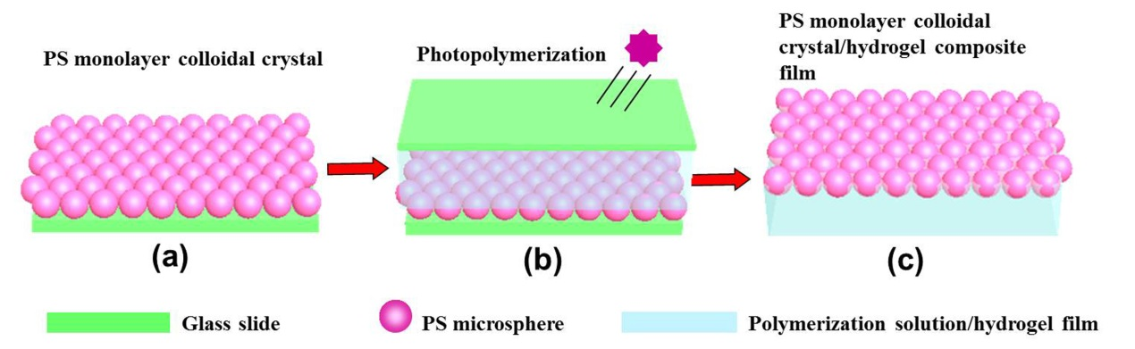
FIG. S1. Preparation of the 2D PS colloidal crystal/hydrogel composite film: (a) 2D PS microsphere colloidal crystal was fabricated on a cleaned glass slide by an air/water interfacial self-assembly method; (b) Polymerization solution was cast on the 2D PS microsphere colloidal crystal and then photopolymerized into hydrogel by UV light; (c) A free-standing 2D PS colloidal crystal/hydrogel composite film was obtained by peeling it off from the substrates.

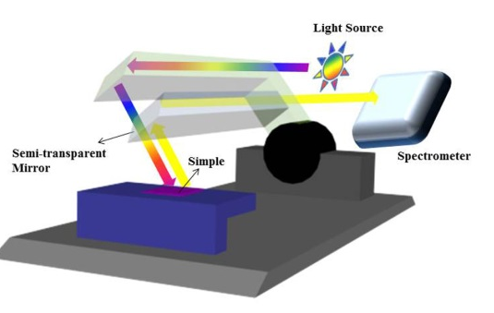
FIG. S2. Schematic of diffraction spectra measurement.

