Supplementary data
Superfluous Oxygen Diffusion Induced Amorphization of ZrC_{0.6}O_{0.4} and Transformation of Amorphous Layer under Electron Beam Irradiation
Xiaopu Li, Wentao Hu *
State Key Laboratory of Metastable Materials Science and Technology, Yanshan University, Qinhuangdao 066004, China
Corresponding author: hwt@ysu.edu.cn
Abstract: On the powder surface of oxygen-ordered ZrC_{0.6}O_{0.4} obtained via isothermally heating of vacancy-ordered ZrC_{0.6} at 300ºC, an amorphous ZrC_{0.6}O_{y>0.4} layer in nanoscaled thickness is found to form if the heating lasts long enough. With the help of HRTEM and SAED measurements, the amorphous formation is recognized to originate from diffusion of superfluous oxygen atoms into Zr-tetrahedral centers in the surface area, thus leading to severe distortion of lattice. In situ investigation of HRTEM, SAED, and EELS demonstrates that under electron irradiation of sufficient dose, the amorphous ZrC_{0.6}O_{y>0.4} layer transforms to a cubic ZrO₂ layer with the same orientation as the underlying ordered ZrC_{0.6}O_{0.4}.
Keywords: Compound; Oxidation; Transmission electron microscopy(TEM)
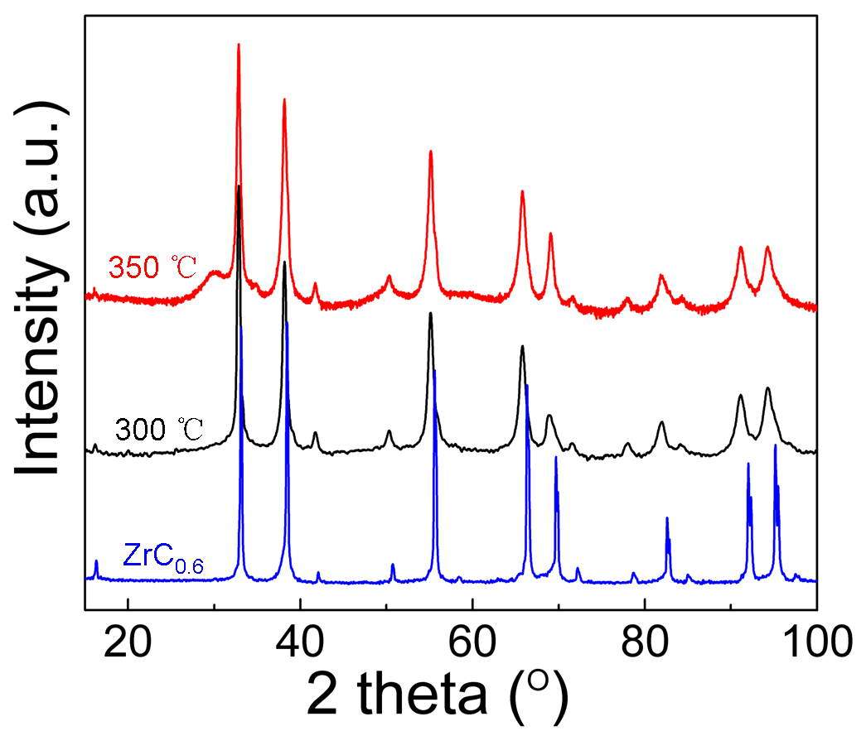

Figure S1. The XRD patterns at room temperature for the ordered ZrC_{0.6} and the samples obtained after the isothermally heating treatments of the ordered ZrC_{0.6} in air at 300 ºC for 1000 min and 350 ºC for 400 min.

