Supplementary Materials

A large scale of CuS nano-networks: Catalyst-free morphologically controllable growth and their application as efficient photocatalysts
Jingwen Qian^{1,2}, Zengying Zhao³, Zhenguang Shen^{1,2}, Guoliang Zhang¹, Zhijian Peng^{1,*}, Xiuli Fu^{2,*}
¹ School of Engineering and Technology, China University of Geosciences, Beijing 100083, PR China
² State Key Laboratory of Information Photonics and Optical Communications, and School of Science, Beijing University of Posts and Telecommunications, Beijing 100876, P. R. China
³ School of Science, China University of Geosciences, Beijing 100083, PR China

Financial support from the National Natural Science Foundation of China (grant nos. 61274015, 11274052 and 51172030), Excellent Adviser Foundation in China University of Geosciences from the Fundamental Research Funds for the Central Universities, and Fund of State Key Laboratory of Information Photonics and Optical Communications (Beijing University of Posts and Telecommunications) is gratefully acknowledged.

Jingwen Qian, et al, Journal of Materials Research, Figure S1
Fig. S1 Typical SEM-EDS spectrum of the as-prepared networks.

Jingwen Qian, et al, Journal of Materials Research, Figure S2
(b)
(a)
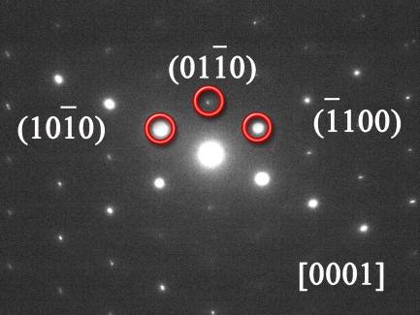
Fig. S2 Typical HRTEM image (a) and SAED pattern (b) of the as-prepared networks.

Jingwen Qian, et al, Journal of Materials Research, Figure S3
Fig. S3 Decolorization effect on MB under ultraviolet irradiation: (a) by the as-prepared CuS nano-networks, and (b) without any catalyst. And (c) decolorization effect on RhB under visible irradiation by the as-prepared CuS nano-networks.

