Supporting Information

Preparation of Magnetic and Photocatalytic Cenosphere Deposited with Fe₃O₄/SiO₂/Eu-doped TiO₂ Core/Shell Nanoparticles
Hui Zhang*, Junli Zhang, Runjun Sun, and Yingxue Zhou

School of Textile & Materials, Xi’an Polytechnic University, Xi’an 710048, China
*Corresponding author

S1. FESEM images of the original and Fe₃O₄ coated cenospheres and EDX spectrum of the Fe₃O₄ coated cenosphere
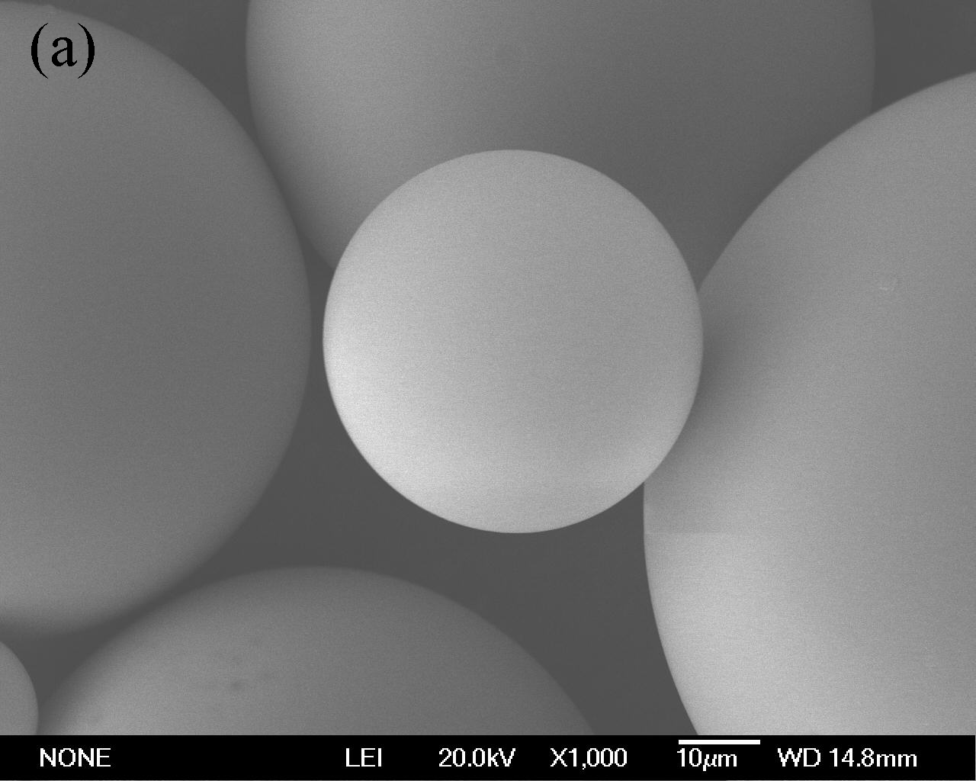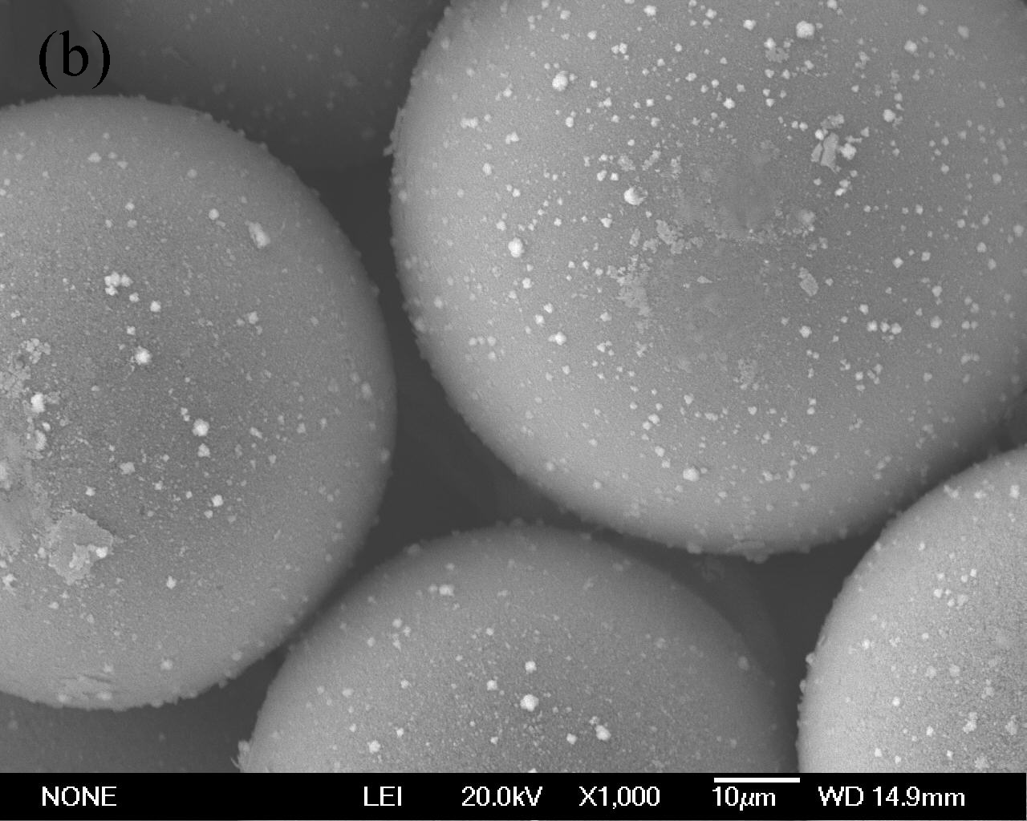
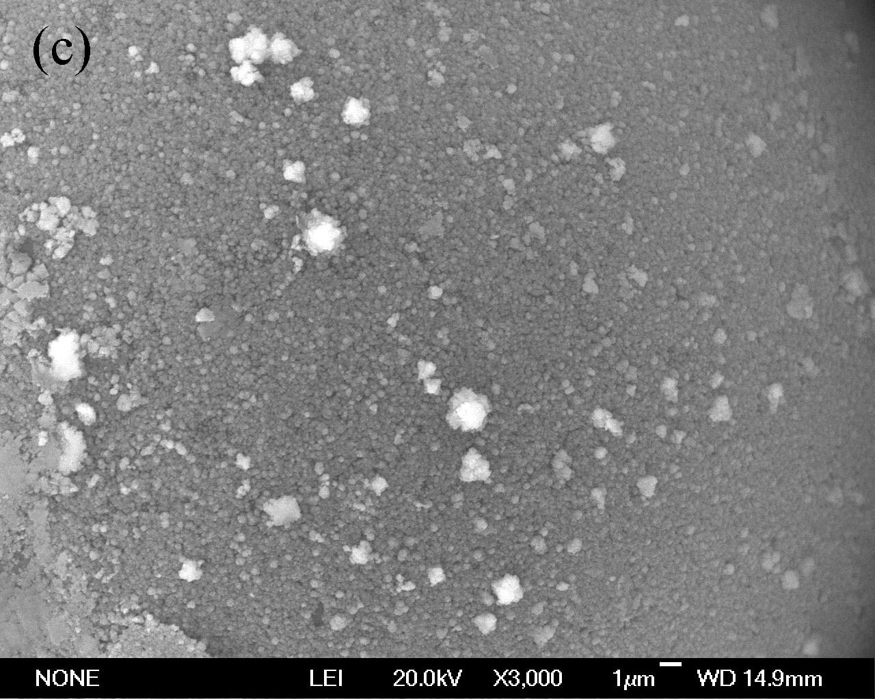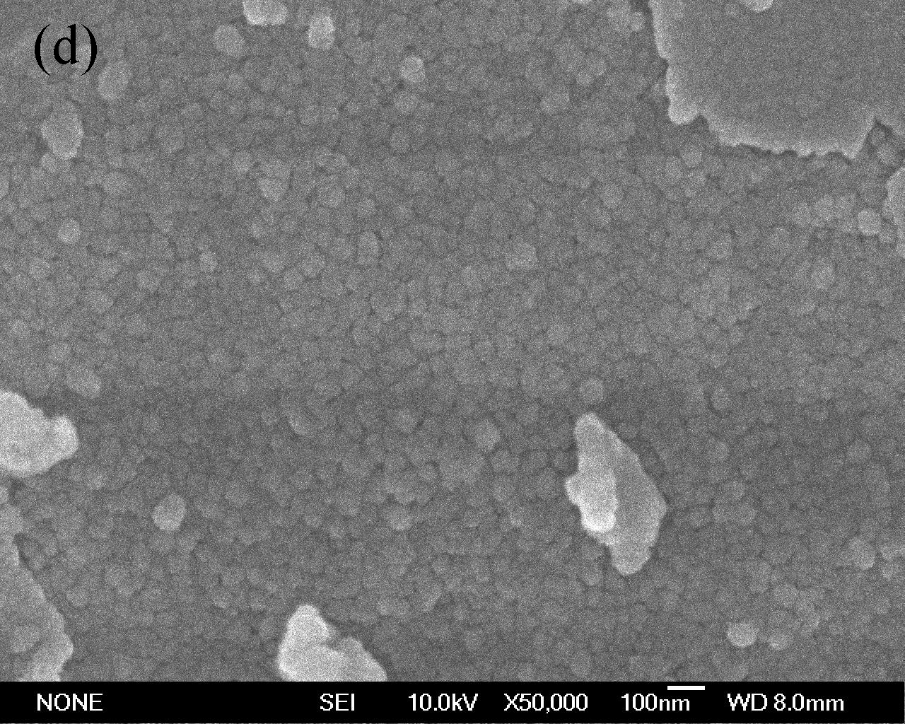
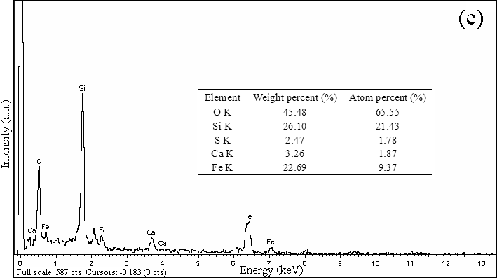
Figure S1 Surface morphology of the original and Fe₃O₄ coated cenospheres and EDX spectrum of the Fe₃O₄ coated cenosphere
S2. Element mapping of the Fe₃O₄ coated cenospheres
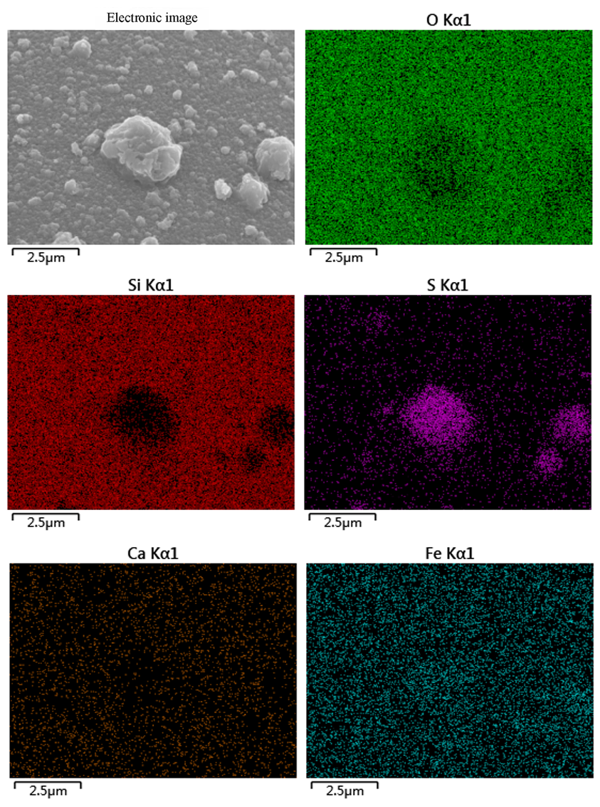
Figure S2 Element mapping for the Fe₃O₄ coated cenospheres
S3. FESEM images, line scanning map, and EDX spectrum of the Fe₃O₄/SiO₂ coated cenospheres
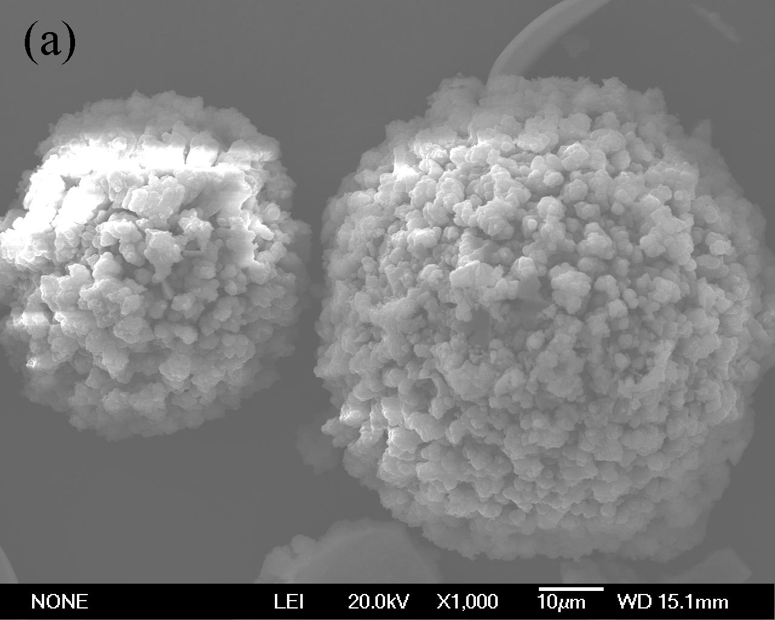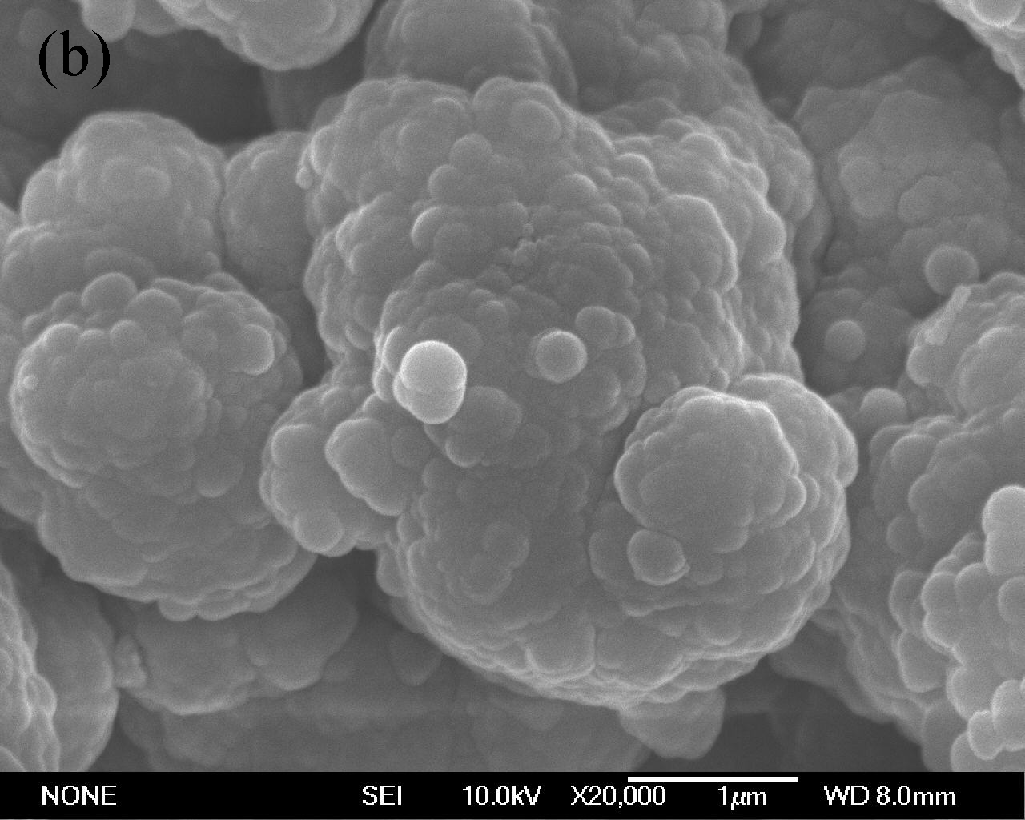
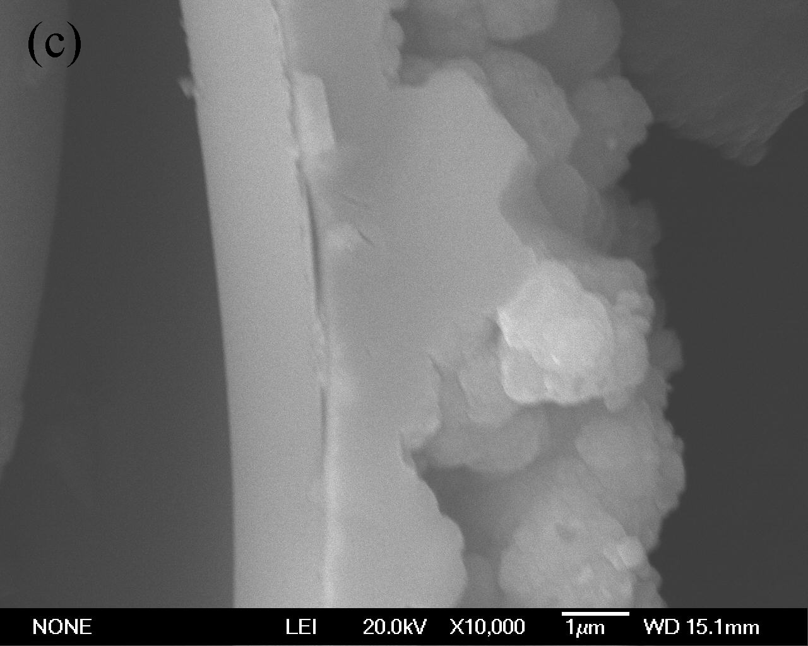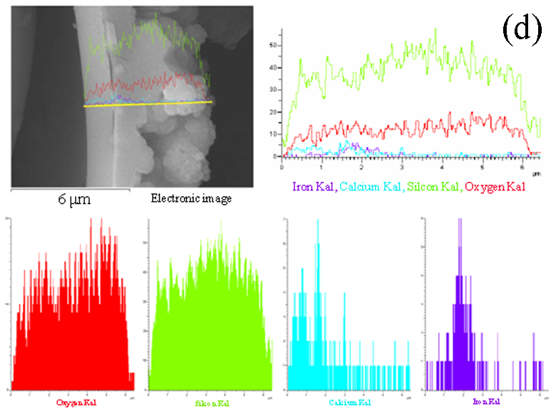
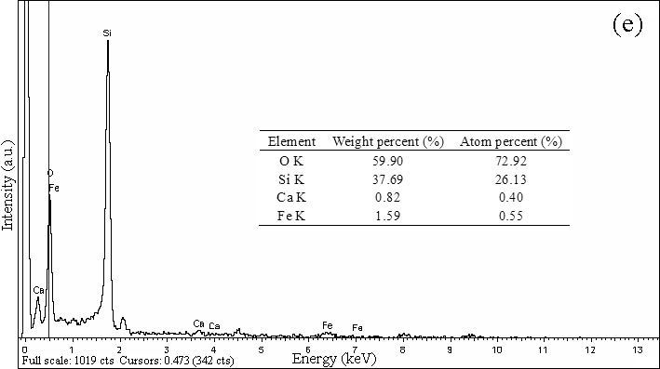
Figure S3 Surface and cross-section morphologies, line scanning map, and EDX spectrum of the Fe₃O₄/SiO₂ coated cenospheres
S4. FESEM images, line scanning map, and EDX spectrum of the Fe₃O₄/SiO₂/TiO₂ coated cenospheres
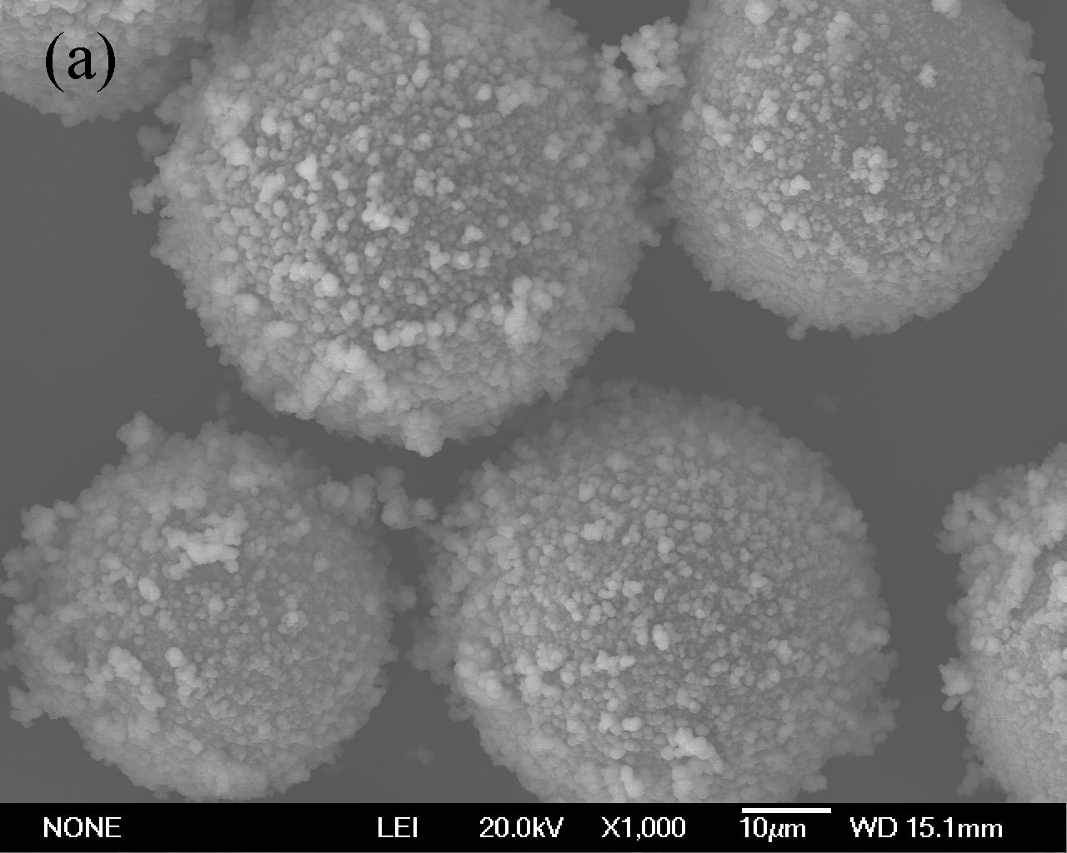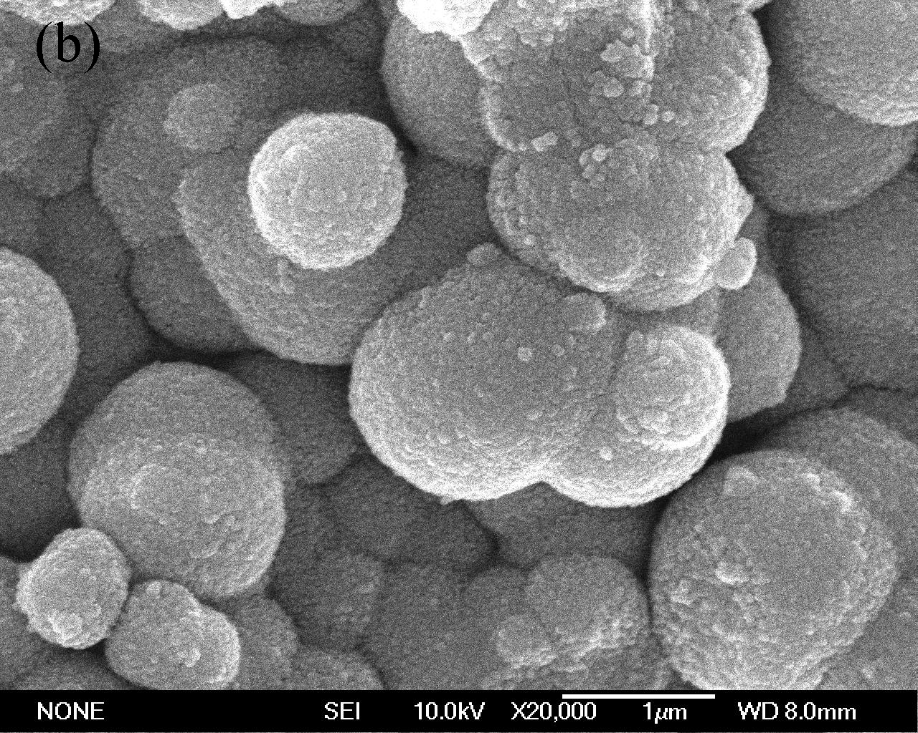
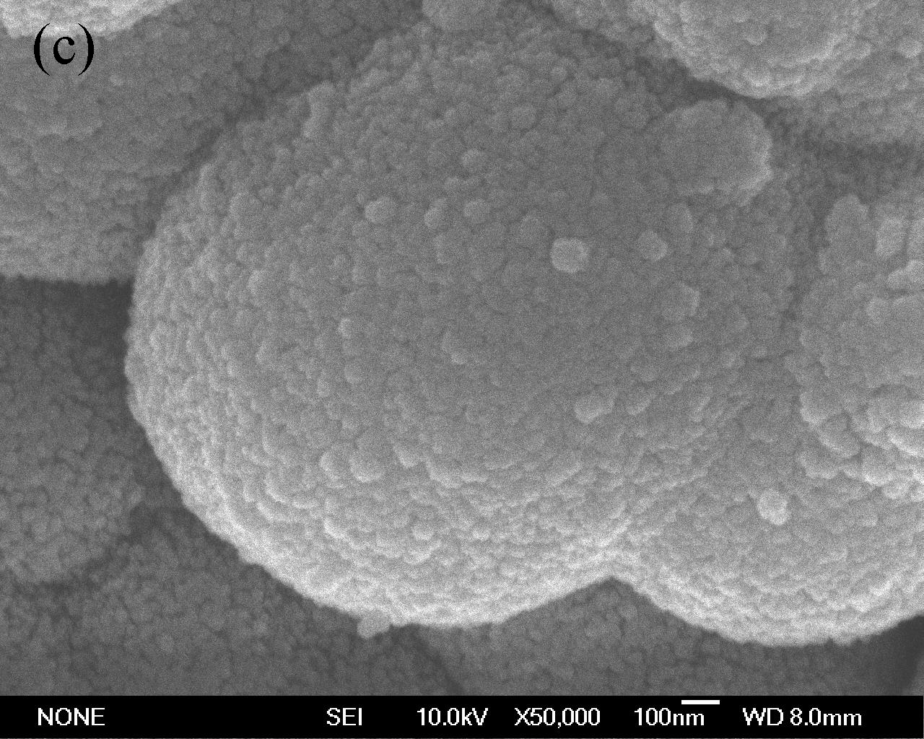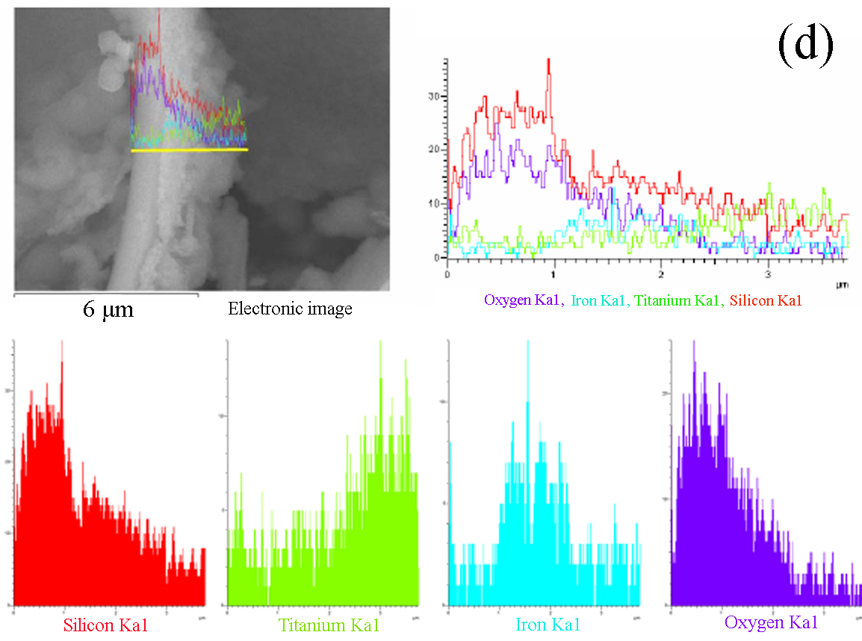
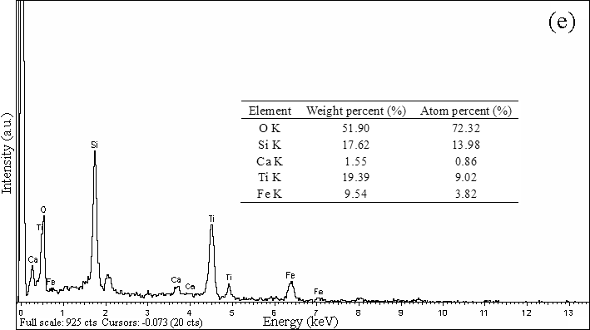
Figure S4 Surface morphology, line scanning map, and EDX spectrum of the Fe₃O₄/SiO₂/TiO₂ coated cenospheres
S5. FESEM images, line scanning map, and EDX spectrum of the Fe₃O₄/SiO₂/Eu-doped (0.1%) TiO₂ coated cenospheres
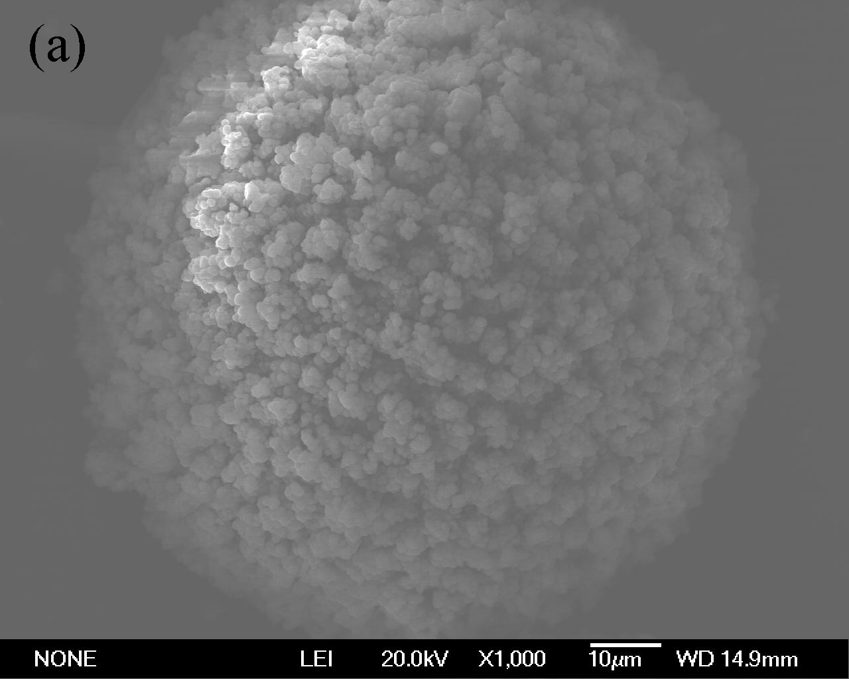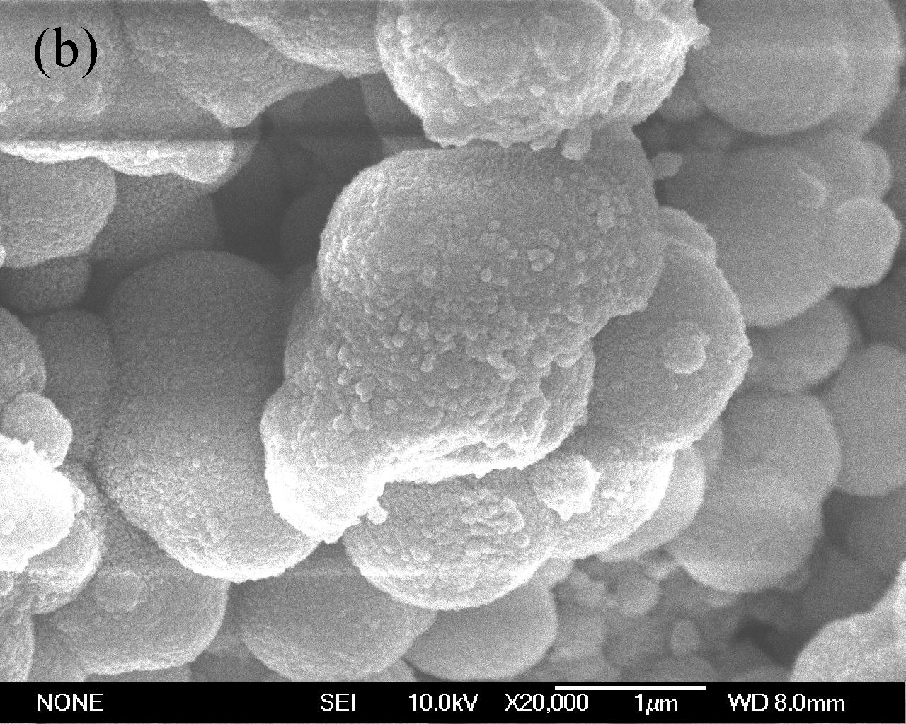
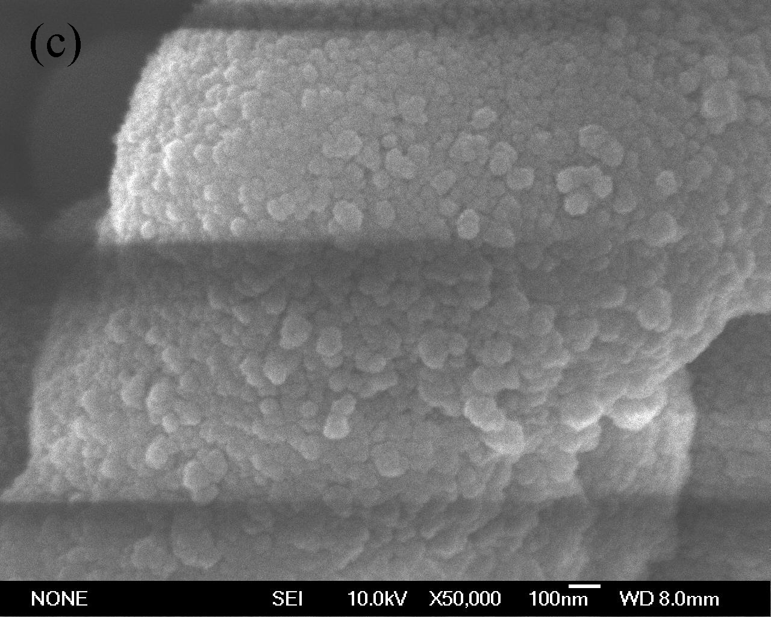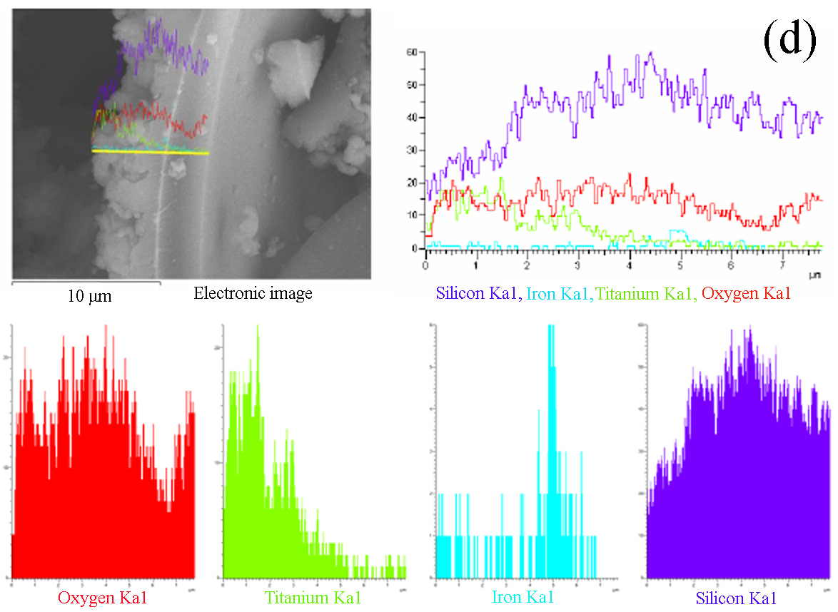
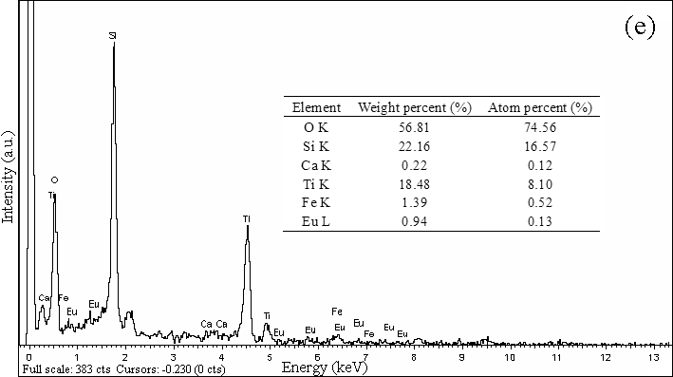
Figure S5 Surface morphology, line scanning map, and EDX spectrum of the Fe₃O₄/SiO₂/Eu-doped (0.1%) TiO₂ coated cenospheres
S6. TG and DSC curves
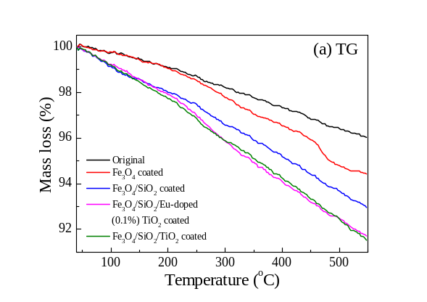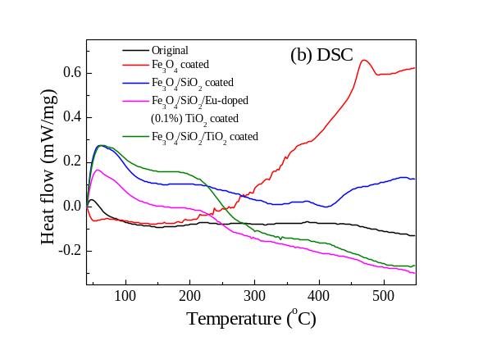
Figure S6 TG (a) and DSC (b) curves of the as-prepared cenospheres
S7. XPS spectra
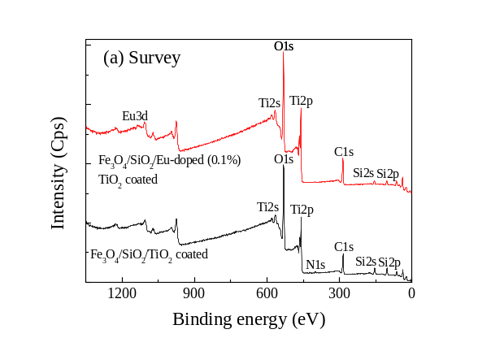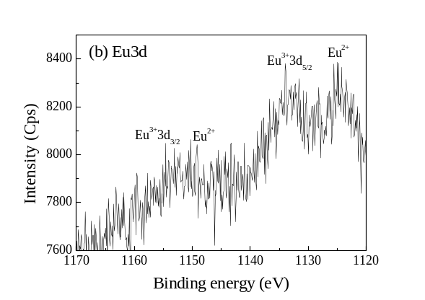
Figure S7 XPS survey spectra of the Fe₃O₄/SiO₂/TiO₂ coated and Fe₃O₄/SiO₂/Eu-doped (0.1%) TiO₂ coated cenospheres (a) and XPS spectrum of Eu 3d core-level deconvolution (b).
S8. Results of XPS elemental analysis
Table S1 The results of XPS elemental analysis for the Fe₃O₄/SiO₂/TiO₂ coated and Fe₃O₄/SiO₂/Eu-doped (0.1%) TiO₂ coated cenospheres
Cenosphere | Name | Peak BE (eV) | FWHM (eV) | Area (CPS.ev) | Atom percentage (%)
Fe₃O₄/SiO₂/TiO₂ coated | C_{1s} | 284.66 | 2.02 | 10502.01 | 25.86
Fe₃O₄/SiO₂/TiO₂ coated | O_{1s} | 530.08 | 2.05 | 49028.51 | 47.25
Fe₃O₄/SiO₂/TiO₂ coated | Ti_{2p} | 458.61 | 1.47 | 35586.85 | 12.17
Fe₃O₄/SiO₂/TiO₂ coated | Si_{2p} | 103.22 | 2.83 | 4573.18 | 12.67
Fe₃O₄/SiO₂/TiO₂ coated | N_{1s} | 400.11 | 0.98 | 1416.2 | 2.06
Fe₃O₄/SiO₂/Eu-doped (0.1%) TiO₂ coated | C_{1s} | 284.59 | 1.94 | 12240.42 | 28.81
Fe₃O₄/SiO₂/Eu-doped (0.1%) TiO₂ coated | O_{1s} | 530.14 | 2.28 | 53263.26 | 49.08
Fe₃O₄/SiO₂/Eu-doped (0.1%) TiO₂ coated | Ti_{2p} | 458.83 | 1.67 | 44706.93 | 14.62
Fe₃O₄/SiO₂/Eu-doped (0.1%) TiO₂ coated | Si_{2p} | 102.62 | 3.21 | 2469.83 | 6.54
Fe₃O₄/SiO₂/Eu-doped (0.1%) TiO₂ coated | Eu_{3d} | 1133.37 | 6.23 | 14126.69 | 0.95
S9. PL spectra
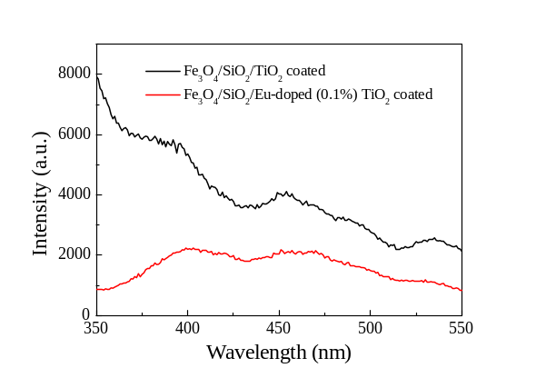
Figure S8 PL spectra of the Fe₃O₄/SiO₂/TiO₂ coated and Fe₃O₄/SiO₂/Eu-doped (0.1%) TiO₂ coated cenospheres
S10. Photo-decolorization rate constant (k value) of MB solution
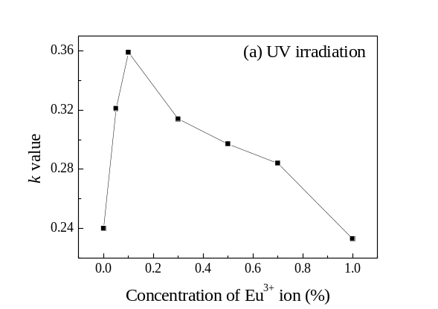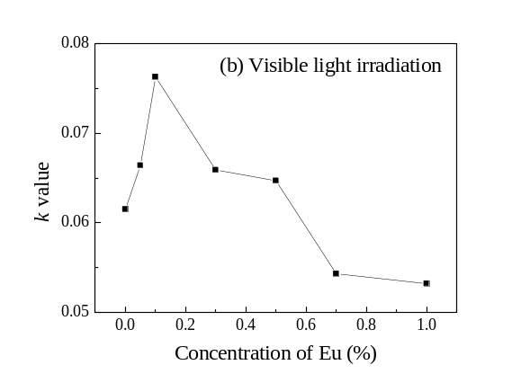
Figure S9 Effect of Eu³⁺ doping concentration on the photo-decolorization rate constant (k value) of MB solution for the TiO₂ coated and Eu-doped TiO₂ coated cenospheres under (a) UV and (b) visible light irradiation
S11. Effect of UV irradiation time on the photocatalytic degradation of MB solution
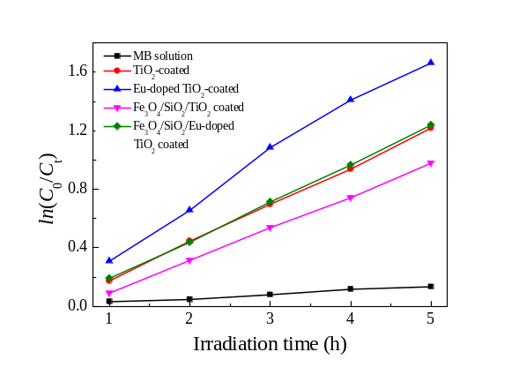
Figure S10 Effect of UV irradiation time on the photocatalytic degradation of MB solution for the as-prepared cenospheres
S12. Repeated photocatalytic degradation of MB solution
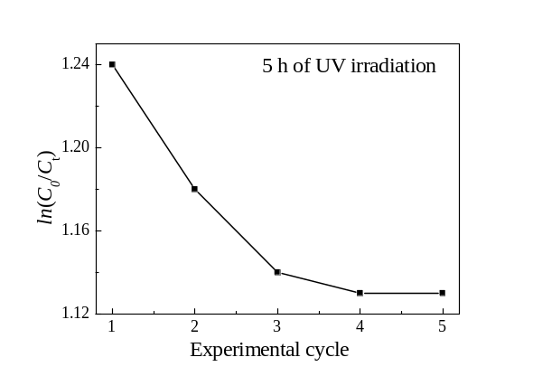
Figure S11 Effect of experimental cycle on the photocatalytic degradation of MB solution for Fe₃O₄/SiO₂/Eu-doped (0.1%) TiO₂ coated cenospheres

