**Supplementary Materials**

Table of Contents

Participants 2

Demographics 2

Gender 2

Age (in years) 2

Race/Ethnicity 2

Education 2

Political Party Affiliation 2

Religiosity 3

Indices and Scales 4

Science Literacy (Ordinary Science Intelligence) 4

Items 4

Results from Item Response Theory Analysis 4

Other Scale Characteristics 5

Ordinary Science Intelligence Scores by Sample: Flat Earth Conference Attendees & Online Panel 5

Conspiracy Mentality 6

Items 6

Results from the Item Response Theory Analysis 7

Other Scale Characteristics 11

Conspiracy Mentality Scores by Sample: Flat Earth Conference Attendees and the Online Panel 11

Limitations of the Index 11

Dependent Variables 12

Scientific facts 12

Deceptive Claims. 12

Item 1: “A cure for most types of cancer has already been found, but medical circles prefer to keep getting research funding from governments and keep their findings secret.” 12

Item 2: “Agricultural biotechnology companies like Monsanto are trying to cover up the fact that genetically-modified organisms (GMOs) cause cancer.” 13

Item 3: “the Zika virus was caused by the genetically-modified mosquito.” 13

Item 4: “Childhood vaccinations are unsafe and cause disorders like Autism.” 14

RQ1. *Who* rejects well supported scientific theories? 15

H1. Conspiracy mentality predicts the rejection of well-supported scientific theories 15

RQ2. What is the relationship between conspiracy mentality & *acceptance* of fake science news? 24

H2a. Conspiracy mentality will predict evaluating claims made by “fake” science news as true. 24

H2b: Individuals’ priors (i.e., science literacy, political affiliation and religiosity) will predict their endorsement of the fake science news headlines, above what’s accounted for by conspiracy mentality. 24

Item 1: Claim that the cure for cancer is being suppressed 24

Item 2: Claim that GMOs cause cancer and corporations are covering it up 26

Item 3: Claim that that the Zika virus was caused by a genetically-modified mosquito 28

Item 4: Claim that childhood vaccines are unsafe and cause disorders like Autism. 29

LMG Analysis 30

# **Participants**

## **Demographics**

### **Gender**

The Research Now sample’s gender distribution does not differ significantly from the census distribution, χ2(1)=1.55, *p*= 0.212.

|  |  |  |  |
| --- | --- | --- | --- |
|  | **Flat Earth** | **Research Now** | **Census** |
| **Male** | 9 (43%)* | 222 (43%)* | 49.7% |
| **Female** | 7 (33%)* | 287 (56%)* | 50.8% |
| **No Response** | 5 (24%)* | 4 ( 1%)* |  |
| **Total** | 21 | 513 | 100% |

*approximate percentages in parentheses

### **Age (in years)**

|  |  |  |
| --- | --- | --- |
|  | **Flat Earth** | **Research Now** |
| **Mean** | 38.62 | 48.98 |
| **Median** | 36.5 | 50 |
| **Range** | 21 to 64 | 18 to 80 |
| **n** | 16 | 509 |

### **Race/Ethnicity**

|  |  |  |  |
| --- | --- | --- | --- |
|  | **Flat Earth** | **Research Now** | **Census** |
| **White (Non Hisp)** | 18 | 381 (74%) | 77% |
| **Black (Non Hisp)** | 1 | 25 (5%) | 13% |
| **Asian** | 0 | 26 (5%) | 6% |
| **Native American** | 0 | 2 (0.4%) | 1% |
| **Hawaiian PI** | 0 | 1 (0.2%) | 0.2% |
| **Latino/Hispanic** | 1 | 54 (11.5%) | 18.1% |

### **Education**

|  |  |  |
| --- | --- | --- |
|  | **Flat Earth** | **Research Now** |
| **Grade 8 or lower** | 0 (0%) | 2 (0.39%) |
| **Some High School** | 0 (0%) | 11 (2%)* |
| **High School Graduate (or equal)** | 2 (12.5%) | 75 (15%)* |
| **Some College** | 4 (25%) | 74 (14.54) |
| **2-year Degree** | 1 (6%)* | 112 (22%)* |
| **Bachelor’s Degree** | 7 (44%)* | 93 (18.27%) |
| **Graduate Degree** | 2 (12.5%) | 142 (27.9%) |
| **Total** | 21 | 513 |

*approximate percentages in parentheses

### **Political Party Affiliation**

To capture political party affiliation (i.e., party), we asked participants, “generally speaking, you consider yourself a …” with nine possible response options: strong Democrat, Democrat, Independent, Republican, strong Republican, other, and “I choose not to answer.” Because many of the flat earth conference attendees, who we interviewed in person for a separate study, vociferously rejected affiliating with any political party, we realized the importance of including “unaffiliated” (or no answer and refusal to answer) as a possible response option , particularly when sampling conspiracy-minded individuals who are suspicious of institutions like political parties. Therefore, we treated party as a categorical variable. To reduce the number of comparison groups, we combined strong Democrat and Democrat into one response level, combined strong Republican and Republican into one response level, kept Independent as one response level, and combined other (n = 30) and ‘I prefer not to answer’ (n = 44, including people who left the item blank) into one response level. The resulting variable was categorical with four levels: Democrat, Independent, Republican, and unaffiliated/other. Among the national sample, 31% were coded as Democrat (n=157), 33% were coded as Independent (n=169), 25% were coded as Republican (n=129), and 11% were coded as unaffiliated/other (n=58). Among the FE sample, only one was coded as Democrat (5%), one was coded as Republican (5%), 3 were coded as Independent(14%), and 16 were coded as unaffiliated/other (76%). A chi-square goodness of fit test shows that the distribution across the different party affiliations differs between the two samples, χ2 (3)=91.47, p< .001.

|  |  |  |
| --- | --- | --- |
|  | **Flat Earth** | **Research Now** |
| **Democrat** | 1 | 157 |
| **Independent** | 3 | 169 |
| **Republican** | 1 | 129 |
| **Unaffiliated/Other** | 16 | 58 |
| **Total** | 21 | 513 |

### **Religiosity**

Religiosity was assessed by asking participants how much guidance faith or religion provide in their day-to-day lives (0 =not religious, 1= none at all, 2 = a little, 3 = a moderate amount, 4 = a lot, 5 = a great deal). The median religiosity response for the FE sample was “a lot,” (FE: *Mean* = 3.0, *SD* = 1.89), whereas the national sample’s median was “a moderate amount” (*national*: *Mean* =2.61, *SD* = 1.69). An independent samples non-parametric test suggests that the two samples did not differ statistically in their religiosity (W=4276, *p*=.362).

|  |  |  |
| --- | --- | --- |
|  | **Flat Earth** | **Research Now** |
| **Not religious** | 3 | 86 |
| **None at all** | 0 | 39 |
| **A little** | 3 | 119 |
| **A moderate amount** | 1 | 95 |
| **A lot** | 4 | 66 |
| **A great deal** | 4 | 97 |
| **No Answer** | 6 | 11 |
| **Total** | 21 | 513 |

# **Indices and Scales**

## **Science Literacy (Ordinary Science Intelligence)**

Scientific literacy was measured using a shortened version of the Ordinary Science Intelligence (OSI 2.0) scale (Kahan, 2017). Our shortened version of the scale includes six items (see below) that were chosen based on their difficulty and discriminatory power from a previous item response theory analysis with a nationally-representative population. We ran an IRT analysis (2PL model) with the current sample as well to check the difficulty and discrimination scores to see whether the scale performed as expected.

Items were scored so that correct answers received 1 point and incorrect answers (and no response) received 0 points. On average, participants answered 2.54 questions out of 6 correctly (*SD*=1.57, *Median*=2).

### **Items**

**Antib - True or False: Antibiotics kill viruses as well as bacteria. [False]**

dat$ANTIB = as.vector(Recode(dat$antib, "1=1; else=0"))

**Gas - Which gas makes up most of the Earth's atmosphere? [Nitrogen]**

dat$GAS = as.vector(Recode(dat$gas, "1=1; else=0"))

**Cop2 - How long does it take the earth to go around the sun? [1 year]**

dat$COP2 = as.vector(Recode(dat$cop2, "1=1; else=0; NA=0"))

**Die - Out of 1,000 rolls, about how many times will a die come up as an even number? [500]**

dat$DIE = as.vector(Recode(dat$die, "500=1; else=0; NA=0"))

**Sweep - If the chances of winning are 1 in 1,000 what percent of tickets will win? [.01%]**

dat$SWEEP = as.vector(Recode(dat$sweep, ".01=1; else=0; NA=0"))

**lily - If it takes 48 days for the patch to cover the entire lake, how many days will it take to cover half the lake? [47 days]**

dat$LILY = as.vector(Recode(dat$lily, "47=1; else=0; NA=0"))

### **Results from Item Response Theory Analysis**

Consistent with prior research, the scale was evaluated and scored using item response theory (using a 2PL model). Then, scores were centered so that the average was 0 (SD = 0.75); the scores ranged from -1.26 to 1.35. Note that there was no significant difference between the mean science literacy scores of the two samples[1], *t*(21.05)=0.40, *p*=.696, *Cohen’s d* = 0.09, 95% CI[-0.35, 0.53].

**Table 1.** Item parameters from the current Item Response Theory Analysis. Items are sorted by the difficulty parameter with the “easiest” item on top (die, -0.787) and the most difficult item at the bottom (sweep, 5.915). Note that this sample had more difficulty with the sweep item than prior samples.

|  |  |  |  |  |
| --- | --- | --- | --- | --- |
|  | **Prior Data** | | **Current Analysis** | |
|  | **Difficulty** | **Discrimination** | **Difficulty** | **Discrimination** |
| **Die** | -0.44 | 1.77 | -0.787 | 1.589 |
| **Antib** | -0.81 | 1.12 | -0.480 | 1.279 |
| **Cop2** | -0.62 | 1.36 | -0.236 | 1.186 |
| **Lily** | 0.66 | 3.21 | 0.598 | 3.283 |
| **Gas** | 0.90 | 1.00 | 0.881 | 1.361 |
| **Sweep** | 0.70 | 2.26 | 5.915 | 0.415 |

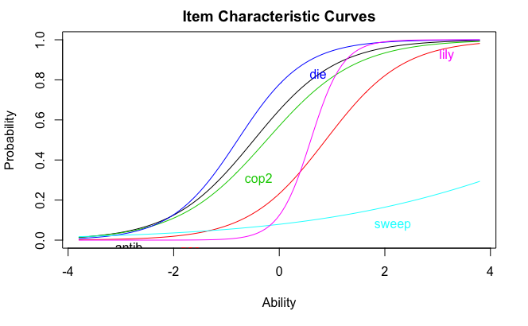

**Figure 1.** Graph of the difficulty and discrimination item parameters. Item difficulty is represented by its position on the X axis, which reflects the theta score on the Ordinary Science Intelligence Scale. Item discrimination is reflected by the slope of each item; steeper slopes are indicative of items that more strongly discriminate between participants with OSI scores above and below the difficulty level of that particular item. The y-axis is the probability of answering the item correctly. Each line, then, represents the probability of answering the item correctly for each level of the OSI scale.

### **Other Scale Characteristics**

Cronbach’s Alpha = 0.62, 95% CI [0.57, 0.67]

### **Ordinary Science Intelligence Scores by Sample: Flat Earth Conference Attendees & Online Panel**

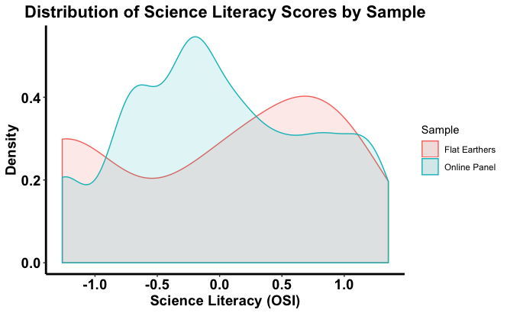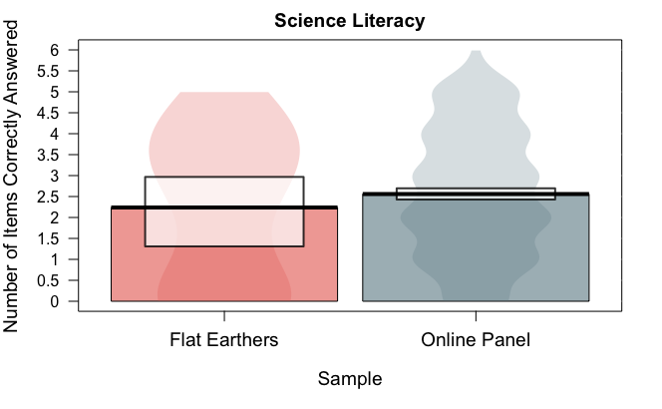

**Figure 2a & 2b.** Scores on the Ordinary Science Intelligence score are not normally distributed. Therefore, to test the differences between the two samples, we conducted a Welch Two-sample t-test. The flat earth sample (M = -0.08) and research now sample (M = 0.00) do not differ significantly on their average science literacy score (t = -0.40, df = 21.05, p-value = 0.696, Cohen’s d = 0.09). The figure on the right depicts the average number of items answered correctly (white bars are Bayesian high density intervals), whereas the figure on the left depicts the distribution of scores from the item response theory analysis.

## **Conspiracy Mentality**

To measure conspiracy mentality, we used a modified version of the Conspiracy Theory Questionnaire (Bruder & Manstead, 2009). Our scale consisted of 8 conspiracy theories ranging from prototypical conspiracies (e.g., the Apollo program never landed on the moon) to more recent ones (e.g., Obama was not born in the U.S.). The items are listed below.

Participants were asked to rate each item on a 4-point scale (1 = definitely false, 2 = likely false, 3 = likely true, 4 = definitely true).

### **Items**

**polit. Politicians usually do not tell us the true motives for their decisions.**

dat$POLIT = as.vector(Recode(dat$polit, "9=NA"))

**hiv. Governments have deliberately spread HIV amongst minorities**

dat$HIV = as.vector(Recode(dat$hiv, "9=NA"))

**mlk. U.S. government agencies were involved in the assassination of MLK, jr.**

dat$MLK = as.vector(Recode(dat$mlk, "9=NA"))

**oil. Better alternative energy options have been developed but oil and gas companies have prevented them from being used commercially.**

dat$OIL = as.vector(Recode(dat$oil, "9=NA"))

**obama. President Barack Obama was not born in the US**

dat$OBAMA = as.vector(Recode(dat$obama, "9=NA"))

**apollo. The Apollo space program never landed on the moon**

dat$APOLLO = as.vector(Recode(dat$apollo, "9=NA"))

**ads. Subliminal advertising (as being shown so fast we don't notice them) exists and influences people to a large extent**

dat$ADS = as.vector(Recode(dat$ads, "9=NA"))

**vote. The government can find out how I voted in elections**

dat$VOTE = as.vector(Recode(dat$vote, "9=NA"))

On average, the national sample rated items around “likely false” (*M* = 2.31, *SD*=0.46) and the FE sample rated items around “likely true” (*M*=3.36, *SD* = 0.30).

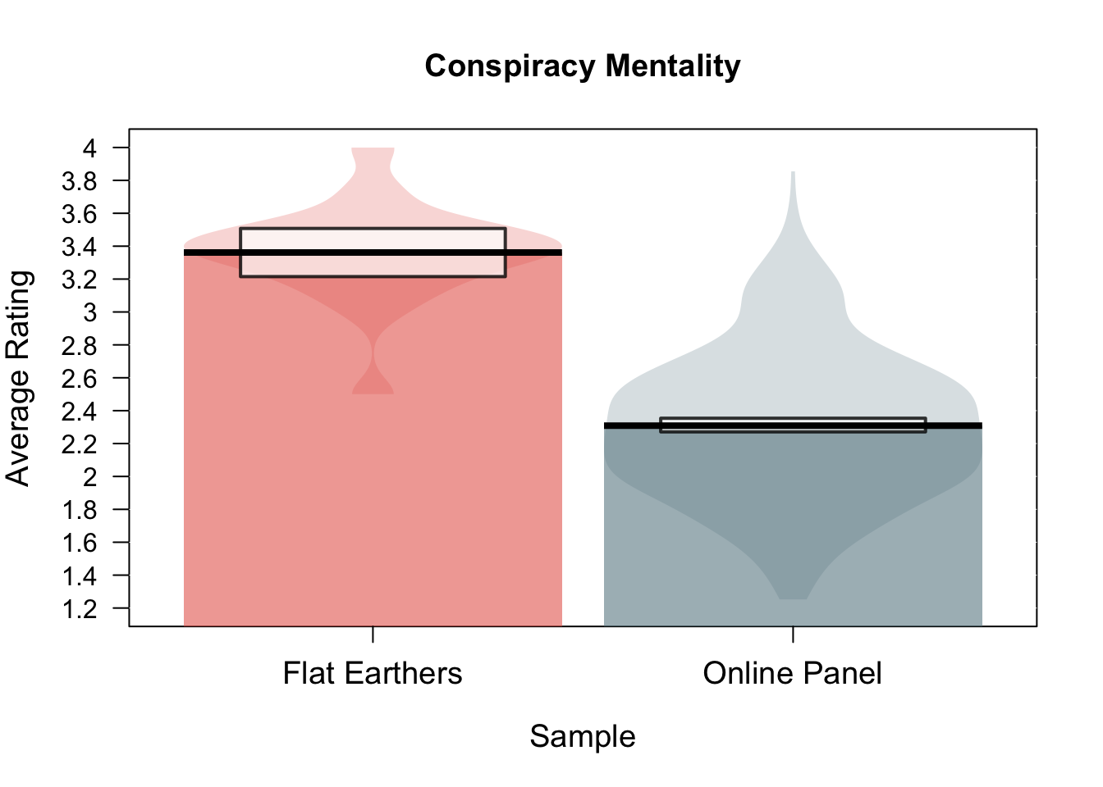

Figure 3. Average rating of conspiracy theory items by sample. The black bar is located at the mean endorsement rating and the white boxes indicate Bayesian high density confidence intervals.

### **Results from the Item Response Theory Analysis**

Unlike for the ordinary science intelligence questionnaire (for which we used a 2PL model), we used a graded response model (i.e., GRM analysis, using the “ltm” package in R; Rizopoulos, 2006) to calculate participants’ conspiracy mentality scores. Like the 2PL model, item parameters are calculated. However, each question in a GRM model has multiple response levels, leading to item response curves for each possible response. The best performing items will have all response levels represented across the different levels of ability (or, for this analysis, conspiracy mentality score). However, for a few items, even low levels of conspiracy mentality were mostly likely to choose higher response levels (e.g., 3 or 4), such as the polit item:

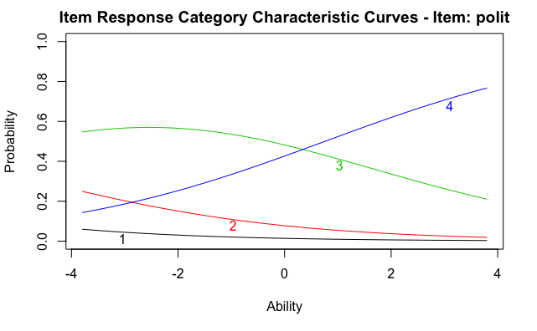

**Figure 4.** Most people, even those with lower conspiracy mentality, thought that it was likely or definitely true that politicians do not tell us the true motivations for their decisions. Therefore, those with lower than 0 conspiracy mentality score (or ability) were most likely to choose 3, or “likely true”, whereas those with higher than 0 conspiracy mentality score were likely to choose 4, or “definitely true”.

We provide the item response curves for the remaining conspiracy items below.

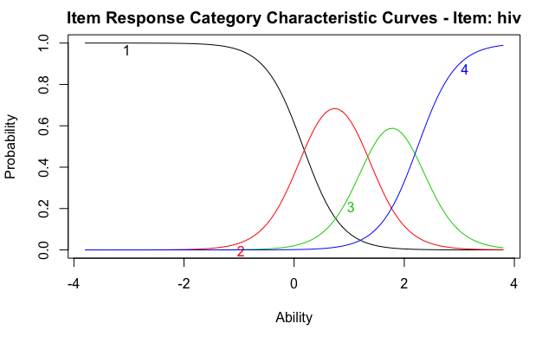

**Figure 5.** “Governments have deliberately spread HIV among minorities.” This item is considered “more difficult” in that the majority of the sample selected “definitely false”. The different response levels, then, distinguished most strongly between those of higher conspiracy mentality.

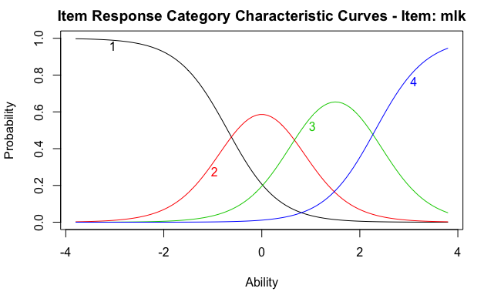

**Figure 6.** U.S. government agencies were involved in the assassination of MLK, jr.

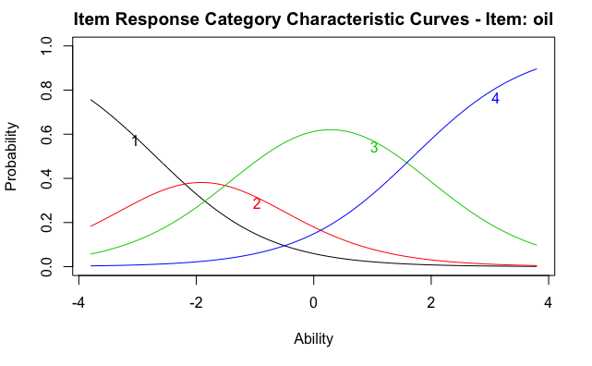

**Figure 7.** Better alternative energy options have been developed but oil and gas companies have prevented them from being used commercially.

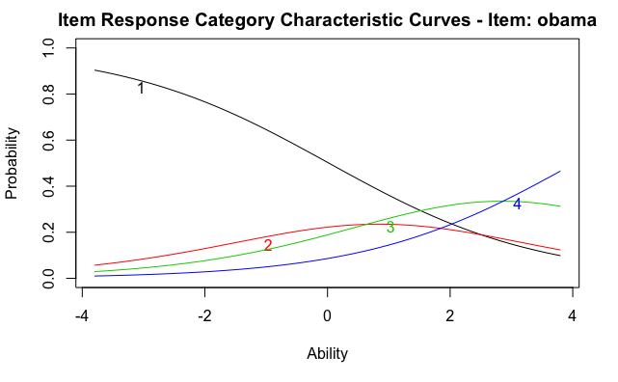

**Figure 8.** President Obama wasn’t born in the United States. Very few people, and only those with the highest conspiracy mentality, rated this conspiracy as likely to be true.

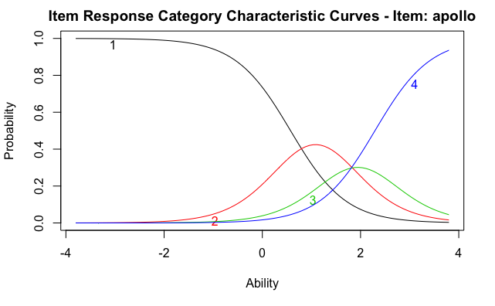

**Figure 9.** The Apollo Space Program never landed on the moon.

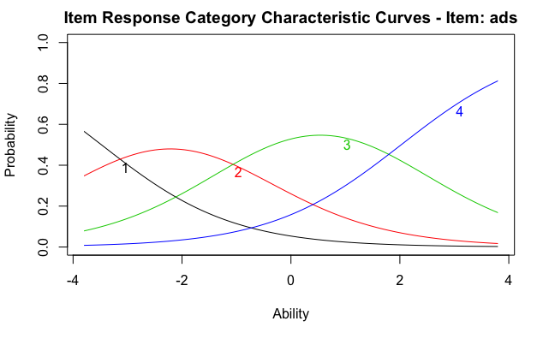

**Figure 10.** Subliminal advertising (as being shown so fast we don't notice them) exists and influences people to a large extent.

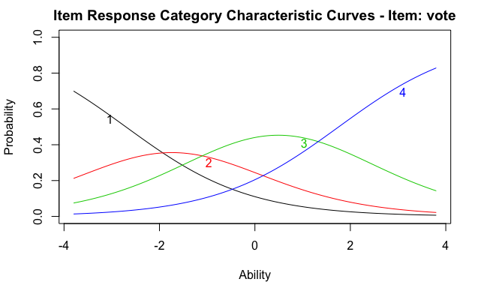

**Figure 11.** The government can find out how I voted in elections.

Scores were calculated using the IRT model and then were centered. Scores ranged from -2.11 to 2.48 (*M* = 0.0, *SD* = 0.85) with higher numbers indicating stronger conspiracy mentality.

### **Other Scale Characteristics**

Cronbach’s Alpha = 0.69, 95% CI [0.65, 0.73]

### **Conspiracy Mentality Scores by Sample: Flat Earth Conference Attendees and the Online Panel**

As anticipated, the FE sample (M=1.54, SD=0.59) scored much higher in conspiracy mentality than the RN sample (M=-0.06, SD=0.79), t(23.07) = 11.99, p<.001, Cohen’s d = 2.67, 95% CI[2.21, 3.14], “Large” effect.

### **Limitations of the Index**

The items we used for this scale did not perform as well as we would have hoped. The difficulty scores for the obama and apollo items were too high and the polit item was too loo (i.e., too easy). Although we were limited in the number of items we could ask due to space and time constraints, we could test a larger number of items in the future to find a better array of conspiracy items. However, for future studies, we also are considering using the generalized Conspiracy mentality items put together by Bruder et al (2013).

# **Dependent Variables**

## **Scientific facts**

We asked participants whether climate change is real and human caused (a. true, b. false: not human caused, c. false: not happening) and whether humans evolved from earlier species of animal (true or false). Items were coded so that responses that align with consensus (i.e., true) were scored as 0, or accepting the fact, and those against the consensus (i.e., false or ‘I prefer not to answer’) were scored as 1, or as rejecting the fact. These items were embedded in the science literacy section of the survey. A greater proportion of the FE sample rejected climate change and evolution than the RN sample. All of the participants in the FE sample rejected anthropogenic climate change whereas only about 36% of the RN sample did, χ2(1)=34.26, p<.001. Moreover, 100% of the FE sample rejected human evolution compared to only about 37% of the RN sample, χ2 (1)=33.73, p<.001.

## **Deceptive Claims.**

In addition to rejection of science facts, we also measured whether participants evaluated deceptive claims about science as more likely to be true or false. For each of these items, participants were asked whether they thought the statement was definitely true (4), likely true (3), likely false (2) or definitely false (1). These items were embedded in the “beliefs” section of the survey, which also included the conspiracy theory items.

### **Item 1: “A cure for most types of cancer has already been found, but medical circles prefer to keep getting research funding from governments and keep their findings secret.”**

There are many myths surrounding cancer, and this one in particular combines the myth that there is a miracle cure for cancer out there and the myth that researchers, particularly those at pharmaceutical companies and government agencies, are suppressing it. The FE sample (M=3.42, Median=3 ‘likely true’, SD=0.61) more strongly endorsed this claim as true than the national sample (M=2.09, Median=2 ‘likely false’, SD=1), t(21.95) =9.12, p<.001, Cohen’s d=2.13, 95% CI[1.65, 2.61], “large”.

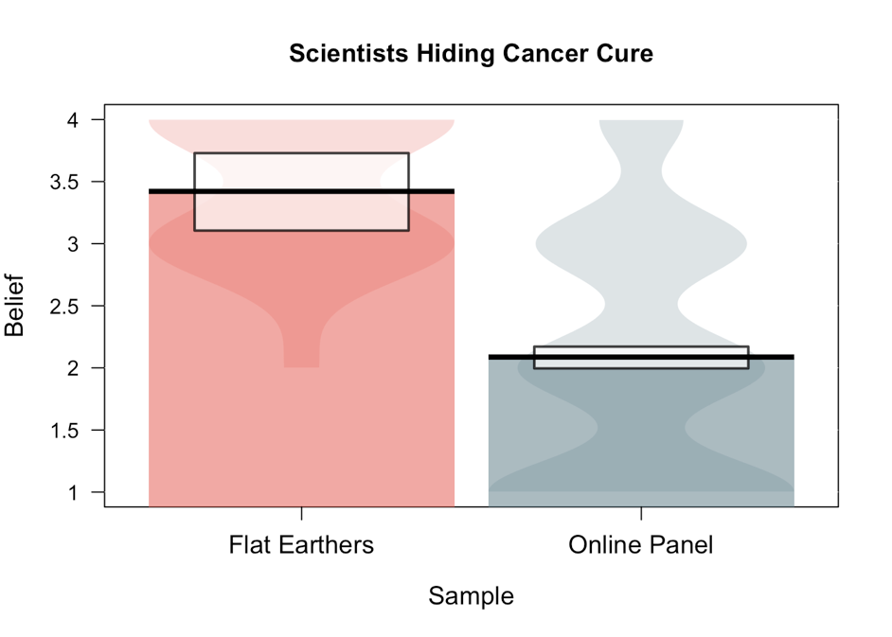

Figure 12. Average rating for the cancer cure item based on Sample.

### **Item 2: “Agricultural biotechnology companies like Monsanto are trying to cover up the fact that genetically-modified organisms (GMOs) cause cancer.”**

This item comes from the website, thetruthaboutcancer.com, in which Jeffrey Smith, a self-described expert on GM foods, charges Monsanto with covering up the “fact” that there are “two deadly poisonous ingredients found in GMOs based on proven research that causes[sic] cancerous tumors to form in rats”. This article, which includes a video, has been shared over 31,700 times on social media. That GMOs cause cancer is also fake news: a review by the National Academies of Sciences, Engineering, and Medicine found “no substantiated evidence of a difference in risks to human health between currently commercialized genetically engineered (GE) crops and conventionally bred crops” and the Society of Toxicology reports that “data to date have identified no evidence of adverse health effects from commercially available GE crops or the foods obtained by them”. The FE sample (M=3.40, Median=3 ‘likely true’, SD=0.82) more strongly endorsed this headline than the national sample (M=2.56, Median=3 ‘likely true’, SD=0.87), t(22.18)=6.01, p<.001, Cohen’s d=1.37, 95% CI[0.92, 1.83], “large”.

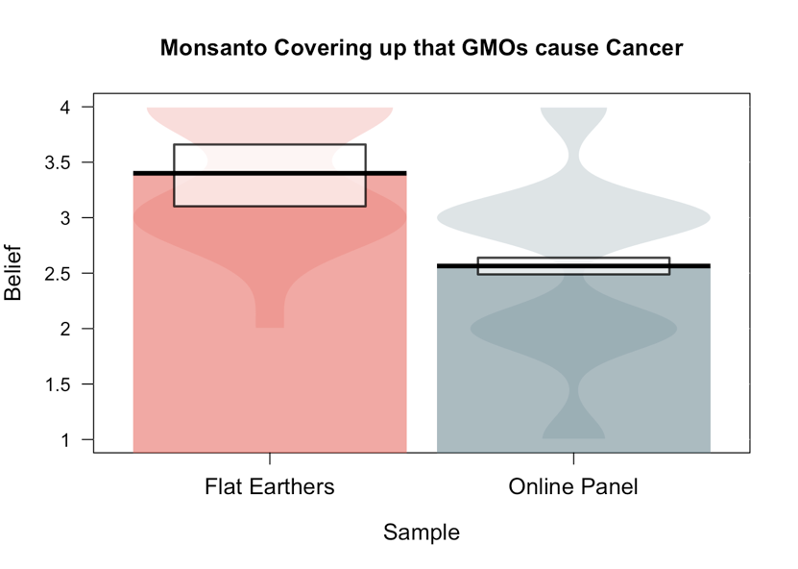

Figure 13.. Average rating for the GMO item based on Sample.

### **Item 3: “the Zika virus was caused by the genetically-modified mosquito.”**

This claim comes from a 2016 article posted on NaturalNews.com, which can also be traced back to an article posted on RT.com. This theory of how Zika came about is inaccurate: Factcheck.org debunked the claim one month after it first appeared. The FE sample (M=2.88, Median= ‘Likely true’, SD=0.72) more strongly endorsed this headline than the national sample (M=2.09, Median=’Likely false’, SD=0.87), t(16.52)=4.27, p<.001, Cohen’s d=1.09, 95% CI[0.58, 1.59], “large”.

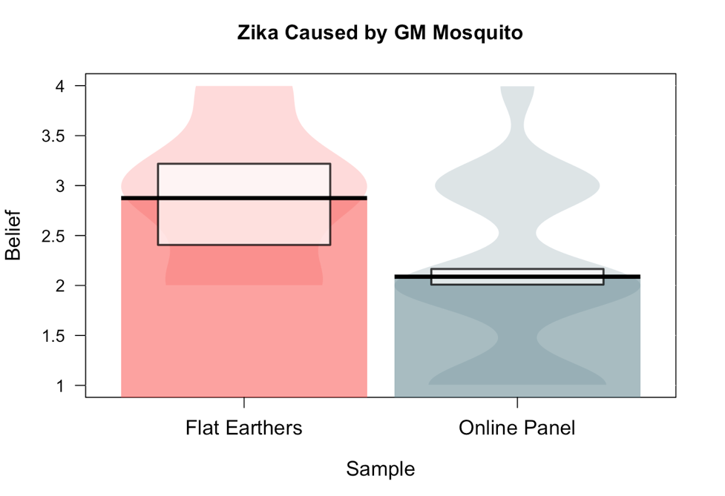

Figure 14.. Average rating for the Zika item based on Sample.

### **Item 4: “Childhood vaccinations are unsafe and cause disorders like Autism.”**

Despite being debunked over and over , many deceptive sites including naturalnews.com continue to propagate this misinformation. The FE sample (M=2.88, Median= ‘Likely true’, SD=0.72) more strongly endorsed this claim than the national sample (M=2.09, Median=’Likely false’, SD=0.87), t(19.33)=9.02, p<.001, Cohen’s d=2.11, 95% CI[1.63, 2.59], “large”.

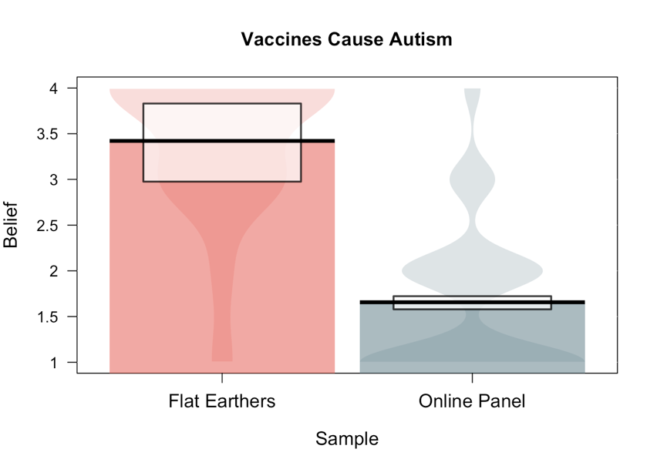

Figure 15.. Average rating for the vaccine item based on Sample.

# **RQ1. *Who* rejects well supported scientific theories?**

## **H1. Conspiracy mentality predicts the rejection of well-supported scientific theories**

After controlling for scientific literacy, political party affiliation, and religiosity.

To examine this, we start with creating an initial model of rejection of climate change that does not include conspiracy ideation. Then, we create a model that does include conspiracy mentality. Finally, we see whether adding conspiracy mentality improves the model/increases the explanatory power.

#### **H1a. Rejection of Anthropogenic Climate Change**

Model 1: (logistic)

Rej_cc ~ Sample + scienceLiteracy + factor(Party) + religiosity + scienceLiteracy:factor(Party) + scienceLiteracy:religiosity

**Table 2.** MODEL 1. Results of GLM predicting rejection of climate change without conspiracy mentality. Type III reported.

|  |  |  |  |  |
| --- | --- | --- | --- | --- |
| **Rejection of Climate Change** | **LR Chisq** | **Df** | ***p*** |  |
| Sample | 28.77 | 1 | <.001 | *** |
| Science Literacy | 1.87 | 1 | .172 |  |
| Party | 73.36 | 3 | <.001 | *** |
| Religiosity | 8.21 | 1 | .004 | ** |
| Science Literacy X Party | 14.75 | 3 | .002 | ** |
| Science Literacy X Religiosity | 0.00 | 1 | .939 |  |

Model 2: (logistic)

Rej_cc ~ Sample + scienceLiteracy + factor(Party) + religiosity + conspiracyMentality + scienceLiteracy:factor(Party) + scienceLiteracy:religiosity + factor(Party):conspiracyMentality

**Table 3.** MODEL 2. Results of GLM predicting rejection of climate change with conspiracy mentality. Type III sums of squares reported.

|  |  |  |  |  |
| --- | --- | --- | --- | --- |
| **Rejection of Climate Change** | **LR Chisq** | **Df** | ***p*** |  |
| Sample | 35.28 | 1 | <.001 | *** |
| Science Literacy | 1.21 | 1 | .271 |  |
| Political Party | 72.52 | 3 | <.001 | *** |
| Religiosity | 8.45 | 1 | .004 | ** |
| Conspiracy Mentality | 0.16 | 1 | .686 |  |
| Science Literacy X Party | 14.03 | 3 | .003 | ** |
| Science Literacy X Religiosity | 0.00 | 1 | .999 |  |
| Conspiracy Mentality X Party | 8.39 | 3 | .039 | * |

**Table 4.** Estimate values and significance.

|  |  |  |  |  |
| --- | --- | --- | --- | --- |
| **Rejection of Climate Change** | **b** | **exp(b)** | ***p*** |  |
| *Intercept* | *16.76* |  | .977 |  |
| Sample | -19.18 | 0.00 | .973 |  |
| Science Literacy | -0.49 | 0.61 | .277 |  |
| Political Party (ref = Democrat) |  |  |  |  |
| Independent | 1.30 | 3.66 | <.001 | *** |
| Republican | 2.49 | 12.11 | <.001 | *** |
| Unaffiliated/Other | 1.29 | 3.65 | .003 | ** |
| Religiosity | 0.20 | 1.22 | .004 | ** |
| Conspiracy Mentality | 0.13 | 1.14 | .687 |  |
| Science Literacy X Party (Ref =Demo) |  |  |  |  |
| X Independent | -0.07 | 0.93 | .867 |  |
| X Republican | 1.25 | 3.47 | .008 | ** |
| X Unaffiliated | 0.71 | 2.03 | .231 |  |
| Science Literacy X Religiosity | 0.00 | 1.00 | .999 |  |
| Conspiracy Mentality X Party (ref = Demo) |  |  |  |  |
| X Independent | -0.41 | 0.67 | .292 |  |
| X Republican | 0.05 | 1.05 | .910 |  |
| X Unaffiliated | -1.56 | 0.21 | .018 | * |

When comparing the models, there is a marginal difference in their explanatory power.

**Table 5.** Results of comparing the two models for rejection of climate change.

|  |  |  |  |  |  |  |
| --- | --- | --- | --- | --- | --- | --- |
|  | **Residual Deviance** | **Residual Df** | **df** | **Deviance** | ***p*** |  |
| Model 1 | 543.92 | 506 |  |  |  |  |
| Model 2 | 534.53 | 502 | 4 | 9.39 | 0.052 | *t* |

##### **Conditional Effect (based on Party) of Science Literacy on the Rejection of Climate Change (*p* = .003)**

##### **Republicans and Unaffiliated individuals appear to be likely to reject climate change with increasing science literacy, whereas Democrats and Independents appear to be more likely to accept climate change with increasing science literacy.**

The oft cited science literacy by political affiliation interaction was found and was significant, supporting prior research.

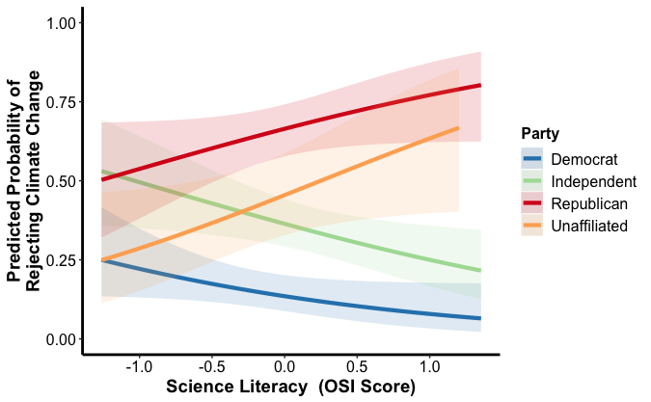

**Figure 16.** Significant interaction of science literacy and political party on rejection of climate change.

**Change in Log Odds**

###### **Among those in our sample with lower science literacy (when OSI = -1), the odds of Republicans rejecting climate change were 248.56 percent greater than those of Democrats. In contrast, among those in our sample with higher science literacy (when OSI = +1), the odds of Republicans rejecting climate change were 4105.07 percent greater than Democrats.**

**Simple Effects Tests**

Is there a relationship between science literacy and rejection of climate change for each of the party affiliation groups? To correct for multiple comparisons the cut-off p value to indicate significance is .013 (.05 divided by 4 analyses).

Data was split by party affiliation and a simple logistic regression was conducted with rejection of climate change as the outcome variable and science literacy as the predictor. With the correction, none of the party affiliations have a significant relationship between science literacy and climate change rejection.

|  |  |  |  |
| --- | --- | --- | --- |
| **Party Affiliation** | **b** | **Significance** | |
| Democrat | -0.71 | .026 | t |
| Republican | 0.48 | .093 |  |
| Independent | -0.51 | .026 | t |
| Unaffiliated/Other | 0.02 | .941 |  |

##### **Conditional Effect (based on Party) of Conspiracy Mentality on the Rejection of Climate Change (*p* = .039)**

##### **Republicans and Unaffiliated individuals appear to be likely to reject climate change with increasing science literacy, whereas Democrats and Independents appear to be more likely to accept climate change with increasing science literacy.**

**Simple Effects Tests**

Is there a relationship between conspiracy mentality and rejection of climate change for each of the party affiliation groups? To correct for multiple comparisons the cut-off p value to indicate significance is .013 (.05 divided by 4 analyses).

Data was split by party affiliation and a simple logistic regression was conducted with rejection of climate change as the outcome variable and conspiracy mentality as the predictor. With the correction, none of the party affiliations have a significant relationship between science literacy and climate change rejection.

|  |  |  |  |
| --- | --- | --- | --- |
| **Party Affiliation** | **b** | **Significance** | |
| Democrat | 0.51 | .067 |  |
| Republican | 0.06 | .814 |  |
| Independent | 0.01 | .964 |  |
| Unaffiliated/Other | 0.26 | .327 |  |

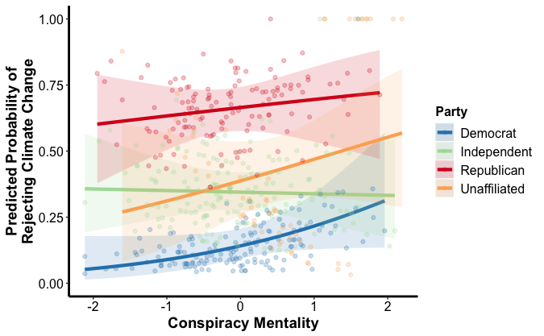

**Figure 17.** Significant interaction between conspiracy mentality and political party on rejection of climate change.

##### **Supplementary Analysis Requested by Reviewer 2**

Question Text:

*True or False: The earth is getting warmer mostly because of human activity (such as burning fossil fuels)*

1. *True (n = 326)*
2. *False – The earth is not getting warmer (n = 34)*
3. *False – The earth is getting warmer, but it’s mostly due to natural patterns in the Earth’s environment (n = 150)*
4. *I prefer not to answer (n = 16)*

We combined the “false” and prefer not to answer responses in part because this is what has been done in previous studies where this question has been asked (see work by Kahan) and also because the sample sizes were so small for “the earth is not getting warmer” and people who prefer not to answer. We question whether it makes sense to analyze these as separate responses. However, we will do so for this supplementary analyses.

**Compared to choosing that climate change is real and human caused, what is the relationship between conspiracy mentality and the other response options?**

*Multinomial logistic regression with “true” as the referent*

Step 1. Only using conspiracy mentality as a predictor (collapsing across other factors)

***Effect of Conspiracy Mentality***

|  |  |  |  |  |
| --- | --- | --- | --- | --- |
| Ref = True | b | SD | exp(b) | p value |
| False-NotWarmer | 0.48 | 0.22 | 1.61 | .028 |
| False-NotHuman | -0.02 | 0.12 | 0.98 | .840 |
| No Answer | 0.34 | 0.31 | 1.41 | .265 |

Without controlling for other variables, conspiracy mentality is significant only when predicting the belief that climate change is NOT occurring. Note that this response level was only chosen by 34 participants as opposed to the 150 who chose that climate change is occurring but it’s not caused by humans.

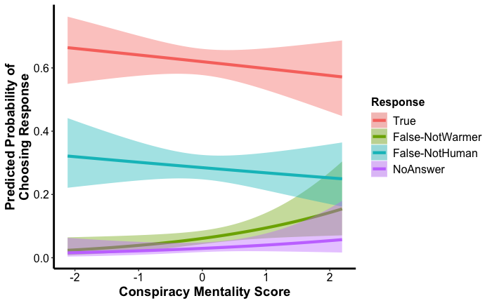

Step 2. After controlling for Political Party (with Democrat as the referent)

***Effect of Conspiracy Mentality***

|  |  |  |  |  |
| --- | --- | --- | --- | --- |
| Ref = True | b | SD | exp(b) | p value |
| False-NotWarmer | 0.54 | 0.23 | 1.71 | .018 |
| False-NotHuman | 0.05 | 0.13 | 1.05 | .729 |
| No Answer | 0.25 | 0.32 | 1.28 | .440 |

#### **H1b. Rejection of Human Evolution**

Model 1:

Rej_evo ~ Sample + scienceLiteracy + factor(Party) + religiosity + scienceLiteracy:factor(Party) + scienceLiteracy: Religiosity

**Table 6.** MODEL 1. Results of GLM predicting rejection of human evolution without conspiracy mentality. Type III tests reported.

|  |  |  |  |  |
| --- | --- | --- | --- | --- |
| **Rejection of Evolution** | **LR Chisq** | **Df** | ***p*** |  |
| Sample | 30.82 | 1 | <.001 | *** |
| Science Literacy | 1.53 | 1 | .216 |  |
| Political Party | 11.15 | 3 | .011 | * |
| Religiosity | 95.03 | 1 | <.001 | *** |
| Science Literacy X Party | 0.25 | 3 | .970 |  |
| Science Literacy X Religiosity | 0.76 | 1 | .385 |  |

Model 2:

Rej_evo ~ Sample + scienceLiteracy + factor(Party) + religiosity + conspiracyMentality+ scienceLiteracy:factor(Party) + scienceLiteracy :Religiosity + conspiracyMentality:factor(Party)

**Table 7.** Results of GLM predicting rejection of human evolution with conspiracy mentality included in the model.. Type III sums of squares reported

|  |  |  |  |  |
| --- | --- | --- | --- | --- |
| **Rejection of Evolution** | **LR Chisq** | **Df** | ***p*** |  |
| Sample | 14.90 | 1 | <.001 | *** |
| Science Literacy | 1.84 | 1 | .175 |  |
| Political Party | 15.06 | 3 | .002 | ** |
| Religiosity | 95.31 | 1 | <.001 | *** |
| Conspiracy Mentality | 0.10 | 1 | .756 |  |
| Science Literacy X Party | 0.13 | 3 | .988 |  |
| Science Literacy X Religiosity | 0.92 | 1 | .337 |  |
| Conspiracy Mentality X Party | 10.33 | 3 | .016 | * |

**Table 8.** Estimate values and significance based on type I (sequential) tests.

|  |  |  |  |  |
| --- | --- | --- | --- | --- |
| **Rejection of Evolution** | **b** | **exp(b)** | ***p*** |  |
| *Intercept* | *14.89* |  | .985 |  |
| Sample | -17.90 |  | .982 |  |
| Science Literacy | -0.62 |  | .180 |  |
| Political Party (ref = Democrat) |  |  |  |  |
| Independent | 0.31 |  | .281 |  |
| Republican | 1.14 |  | <.001 | *** |
| Unaffiliated/Other | 0.13 |  | .788 |  |
| Religiosity | 0.70 |  | <.001 | *** |
| Conspiracy Mentality | -0.09 |  | .755 |  |
| Science Literacy X Party (Ref =Demo) |  |  |  |  |
| X Independent | 0.02 |  | .969 |  |
| X Republican | -0.05 |  | .911 |  |
| X Unaffiliated | 0.16 |  | .785 |  |
| Science Literacy X Religiosity | 0.10 |  | .341 |  |
| Conspiracy Mentality X Party (ref = Demo) |  |  |  |  |
| X Independent | 0.01 |  | .975 |  |
| X Republican | 0.85 |  | .036 | * |
| X Unaffiliated | 1.51 |  | .031 | * |

When comparing the models, there is a significant difference in their explanatory power.

**Table 9.** Results of comparing the two models for rejection of human evolution.

|  |  |  |  |  |  |  |
| --- | --- | --- | --- | --- | --- | --- |
|  | **Residual Deviance** | **Residual Df** | **df** | **Deviance** | ***p*** |  |
| Model 1 | 509.46 | 506 |  |  |  |  |
| Model 2 | 496.19 | 502 | 4 | 13.27 | .010 | * |

###### **There is a significant increase in explanatory power when adding conspiracy mentality and the interaction between party and conspiracy mentality to the model. The effect of conspiracy mentality on rejection of evolution is conditional on party affiliation. The relationship between conspiracy mentality and rejection of evolution is different between Democrats and Republicans and between Democrats and the Unaffiliated/Other.**

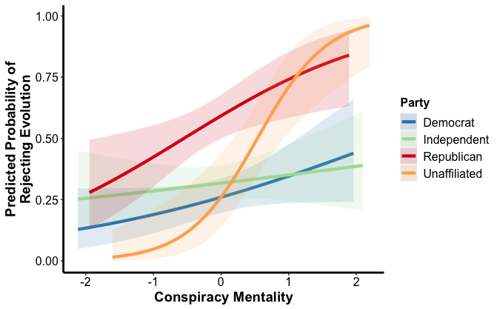

**Figure 18.** Interaction effect of party and conspiracy mentality on the rejection of human evolution.

**Simple Effects Tests**

Is there a relationship between conspiracy mentality and rejection of evolution for each of the party affiliation groups? To correct for multiple comparisons the cut-off p value to indicate significance is .013 (.05 divided by 4 analyses).

Data was split by party affiliation and a simple logistic regression was conducted with rejection of evolution as the outcome variable and conspiracy mentality as the predictor. With the correction, Republicans trend toward having a significant positive relationship between Conspiracy mentality and rejecting evolution. The relationship for the unaffiliated/Other group is significant.

|  |  |  |  |
| --- | --- | --- | --- |
| **Party Affiliation** | **b** | **Significance** | |
| Democrat | 0.41 | .067 |  |
| Republican | 0.57 | .018 | t |
| Independent | 0.19 | .350 |  |
| Unaffiliated/Other | 1.36 | <.001 | *** |

###### **Simple effects tests with Bonferroni correction (adjusting the cut-off p value to .013) suggest that the effect of conspiracy mentality on rejecting evolution is marginally significant for Republicans (b = 0.57, p = .018) and significant for unaffiliated/other (b = 1.66, p < .001), but is not significant for Democrats (b = 0.41, p = .067) or Independents (b = 0.19, p = .350).**

**Change in Log Odds**

###### **Among those in our sample with lower conspiracy mentality (scores = -1), the odds of Republican rejecting evolution were 32.87% greater than those of Democrats. In contrast, among those with higher conspiracy mentality (scores = +1), the odds of Republicans rejecting evolution are 855.53% greater than those of Democrats.**

# **RQ2. What is the relationship between conspiracy mentality & *acceptance* of fake science news?**

## **H2a. Conspiracy mentality will predict evaluating claims made by “fake” science news as true.**

## **H2b: Individuals’ priors (i.e., science literacy, political affiliation and religiosity) will predict their endorsement of the fake science news headlines, above what’s accounted for by conspiracy mentality.**

### **Item 1: Claim that the cure for cancer is being suppressed**

A common deceptive claim is that a cure for most types of cancer has already been found, but medical circles prefer to keep getting research funding from governments and keep their findings secret.

* Greater conspiracy mentality and lower science literacy predicted endorsing this claim as more likely to be true.
* There was also a marginal interaction effect of science literacy and political party: the relationship between science literacy and evaluating the claim as true was conditional on political party with Republicans being marginally different than Democrats and the unaffiliated/other being significantly different than Democrats.
  + Follow-up simple effects tests show that for Democrats and Independents, greater scientific literacy leads to endorsing the claim as more likely to be *false* (Democrats: *b*=-0.66, *p*<.001; Independents: *b*=-0.50, *p*<.001).
  + In contrast, science literacy does not significantly predict endorsement of the claim for the unaffiliated/other (*b*=0.04, *p*=.809), and for Republicans, the negative relationship is marginal (*b*=-0.25, *p*=.062)

|  |  |  |  |  |  |  |
| --- | --- | --- | --- | --- | --- | --- |
| **Cancer Cure Conspiracy Claim** | ***b*** | **SS** | **df** | **F** | ***p*** |  |
| **Sample** | **-0.35** | **0.89** | **1** | **1.32** | **.251** |  |
| **Conspiracy Mentality** | **0.58** | **19.60** | **1** | **28.97** | **<.001** | **\*\*\*** |
| **Science Literacy** | **-0.42** | **12.67** | **1** | **18.72** | **<.001** | **\*\*\*** |
| **Party Affiliation (ref = Democrat)** |  | **3.57** | **3** | **1.76** | **.154** |  |
| *Independent* | *0.14* |  |  |  | *.133* |  |
| *Republican* | *0.22* |  |  |  | *.032* | * |
| *Unaffiliated* | *0.03* |  |  |  | *.808* |  |
| **Religiosity** | **0.03** | **0.76** | **1** | **1.13** | **.288** |  |
| **Conspiracy Mentality X Science Literacy** | **0.01** | **0.02** | **1** | **0.03** | **.866** |  |
| **Science Literacy X Party** |  | **4.74** | **3** | **2.33** | **.073** | ***t*** |
| *X Independent* | *0.09* |  |  |  | *.486* |  |
| *X Republican* | *0.26* |  |  |  | *.075* | ***t*** |
| *X Unaffiliated* | *0.41* |  |  |  | *.022* | * |
| **Conspiracy Mentality X Party** |  | **0.75** | **3** | **0.37** | **.777** |  |
| *X Independent* | *0.00* |  |  |  | *.968* |  |
| *X Republican* | *0.10* |  |  |  | *.459* |  |
| *X Unaffiliated* | *0.13* |  |  |  | *.470* |  |
| **Conspiracy Mentality X Religiosity** | **-0.01** | **0.19** | **1** | **0.28** | **.599** |  |
| *Residuals* |  | *328.92* | *486* |  |  |  |

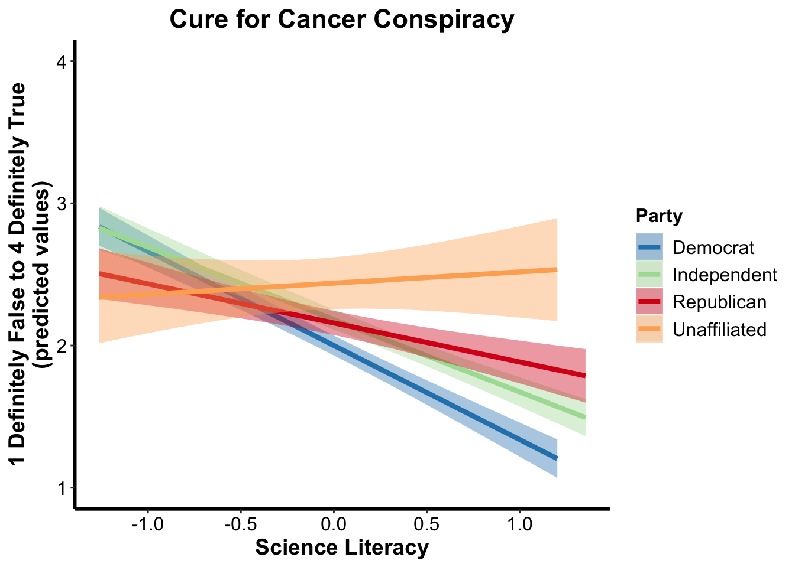

**Figure 19.** Marginal interaction effect of science literacy and political party on evaluating the cure for cancer claim as likely to be true.

**Simple Effects Tests**

Is there a relationship between science literacy and evaluating the cure for cancer claim as likely to be true for each of the party affiliation groups? To correct for multiple comparisons the cut-off p value to indicate significance is .013 (.05 divided by 4 analyses).

Data was split by party affiliation and a simple regression was conducted with evaluation (CURE) as the outcome variable and science literacy as the predictor. With the correction, Democrats and Independents have a significant negative relationship where more science literacy means less likely to evaluate the claim as true. The relationship between science literacy and evaluating the claim as true for the unaffiliated/Other and Republican groups are not significant.

|  |  |  |  |
| --- | --- | --- | --- |
| **Party Affiliation** | **b** | **Significance** | |
| Democrat | -0.66 | <.001 | *** |
| Republican | -0.25 | .062 |  |
| Independent | -0.50 | <.001 | *** |
| Unaffiliated/Other | -0.03 | .857 |  |

### **Item 2: Claim that GMOs cause cancer and corporations are covering it up**

Another common deceptive claim propagated by untrustworthy websites is that GMOs cause cancer and agricultural biotechnology corporations, such as Monsanto, are covering it up.

* For this item, conspiracy mentality indeed predicted evaluating this claim as likely true.
* Moreover, there was a significant interaction of conspiracy mentality and science literacy.
* Examining the data suggests that among those with lower conspiracy mentality, higher science literacy predicts evaluating the claims as more likely to be false. Among those with higher conspiracy mentality, higher science literacy predicts evaluating the claims as more likely to be true.

|  |  |  |  |  |  |  |
| --- | --- | --- | --- | --- | --- | --- |
| **GMO Conspiracy Claim** | **b** | **SS** | **df** | **F** | ***p*** |  |
| **Sample** | **0.22** | **0.36** | **1** | **0.70** | **.405** |  |
| **Conspiracy Mentality** | **0.36** | **7.48** | **1** | **14.57** | **<.001** | **\*\*\*** |
| **Science Literacy** | **0.09** | **0.57** | **1** | **1.10** | **.294** |  |
| **Party Affiliation (ref = Democrat)** |  | **0.51** | **3** | **0.33** | **.802** |  |
| *Independent* | *-0.01* |  |  |  | *.930* |  |
| *Republican* | *-0.04* |  |  |  | *.690* |  |
| *Unaffiliated* | *-0.12* |  |  |  | *.348* |  |
| **Religiosity** | **0.03** | **1.43** | **1** | **2.80** | **.095** | ***t*** |
| **Conspiracy Mentality X Science Literacy** | **0.14** | **2.93** | **1** | **5.71** | **.017** | **\*** |
| **Science Literacy X Party** |  | **2.23** | **3** | **1.45** | **.228** |  |
| *X Independent* | *-0.12* |  |  |  | *.334* |  |
| *X Republican* | *-0.15* |  |  |  | *.246* |  |
| *X Unaffiliated* | *-0.32* |  |  |  | *.044* | *\** |
| **Conspiracy Mentality X Party** |  | **2.44** | **3** | **1.59** | **.192** |  |
| *X Independent* | *0.00* |  |  |  | *.972* |  |
| *X Republican* | *0.15* |  |  |  | *.206* |  |
| *X Unaffiliated* | *0.28* |  |  |  | *.085* | ***t*** |
| **Conspiracy Mentality X Religiosity** | **0.02** | **0.25** | **1** | **0.49** | **.485** |  |
| *Residuals* |  | 235.51 | 459 |  |  |  |



**Figure 20.** Predicting endorsement of the claim that GMOs cause cancer and corporations are covering this up on a scale from definitely false (1) to definitely true (4).

### **Item 3: Claim that that the Zika virus was caused by a genetically-modified mosquito**

Another deceptive claim contends that the genetically-modified mosquito, which was developed at least in part to help *curb* the spread of diseases like Zika[2], is actually the underlying cause of the Zika virus.

* As expected, higher conspiracy mentality and lower science literacy strongly predicted believing the claim that the Zika virus was caused by the GM mosquito.
* No other effects or interactions were significant.

|  |  |  |  |  |  |  |
| --- | --- | --- | --- | --- | --- | --- |
| **GM Mosquito Cause Zika Claim** | ***b*** | **SS** | **df** | **F** | ***p*** |  |
| **Sample** | **0.11** | **0.08** | **1** | **0.14** | **.710** |  |
| **Conspiracy Mentality** | **0.37** | **7.68** | **1** | **13.58** | **<.001** | **\*\*\*** |
| **Science Literacy** | **-0.27** | **5.22** | **1** | **9.23** | **.003** | **\*\*** |
| **Party Affiliation (ref = Democrat)** |  | **0.81** | **3** | **0.48** | **.699** |  |
| *Independent* | *0.03* |  |  |  | *.714* |  |
| *Republican* | *-0.06* |  |  |  | *.572* |  |
| *Unaffiliated* | *-0.10* |  |  |  | *.464* |  |
| **Religiosity** | **0.03** | **1.21** | **1** | **2.14** | **.144** |  |
| **Conspiracy Mentality X Science Literacy** | **0.00** | **0.01** | **1** | **0.02** | **.890** |  |
| **Science Literacy X Party** |  | **1.33** | **3** | **0.78** | **.503** |  |
| *X Independent* | *-0.14* |  |  |  | *.243* |  |
| *X Republican* | *-0.16* |  |  |  | *.257* |  |
| *X Unaffiliated* | *0.02* |  |  |  | *.887* |  |
| **Conspiracy Mentality X Party** |  | **1.72** | **3** | **1.02** | **.386** |  |
| *X Independent* | *-0.05* |  |  |  | *.663* |  |
| *X Republican* | *0.02* |  |  |  | *.903* |  |
| *X Unaffiliated* | *0.24* |  |  |  | *.149* |  |
| **Conspiracy Mentality X Religiosity** | **0.00** | **0.03** | **1** | **0.06** | **.809** |  |
| *Residuals* |  | *263.39* | *466* |  |  |  |

### **Item 4: Claim that childhood vaccines are unsafe and cause disorders like Autism.**

One of the most common assertions about vaccinations among deceptive websites is that childhood vaccinations are unsafe and cause disorders such as Autism.

* As with the previous items, greater conspiracy mentality and lower science literacy significantly predicted evaluations that this claim was likely to be true.
* In addition, people who reported stronger religiosity were also likely to evaluate this claim as more likely to be true.
* This was also the only claim for which sample remained a significant predictor after accounting for other effects.

|  |  |  |  |  |  |  |
| --- | --- | --- | --- | --- | --- | --- |
| **Vaccines Cause Autism Claim** | **b** | **SS** | **df** | **F** | ***p*** |  |
| **Sample** | **-1.07** | **8.66** | **1** | **15.81** | **<.001** | **\*\*\*** |
| **Conspiracy Mentality** | **0.30** | **5.29** | **1** | **9.66** | **.002** | **\*\*** |
| **Science Literacy** | **-0.19** | **2.55** | **1** | **4.65** | **.031** | **\*** |
| **Party Affiliation (ref = Democrat)** |  | **0.47** | **3** | **0.28** | **.837** |  |
| *Independent* | *0.06* |  |  |  | *.502* |  |
| *Republican* | *0.08* |  |  |  | *.412* |  |
| *Unaffiliated* | *0.08* |  |  |  | *.562* |  |
| **Religiosity** | **0.09** | **9.94** | **1** | **18.15** | **<.001** | **\*\*\*** |
| **Conspiracy Mentality X Science Literacy** | **0.09** | **1.17** | **1** | **2.14** | **.144** |  |
| **Science Literacy X Party** |  | **1.82** | **3** | **1.11** | **.344** |  |
| *X Independent* | *0.19* |  |  |  | *.103* |  |
| *X Republican* | *0.19* |  |  |  | *.143* |  |
| *X Unaffiliated* | *0.09* |  |  |  | *.580* |  |
| **Conspiracy Mentality X Party** |  | **0.40** | **3** | **0.25** | **.864** |  |
| *X Independent* | *0.07* |  |  |  | *.513* |  |
| *X Republican* | *-0.01* |  |  |  | *.908* |  |
| *X Unaffiliated* | *-0.01* |  |  |  | *.936* |  |
| **Conspiracy Mentality X Religiosity** | **0.01** | **0.18** | **1** | **0.34** | **.562** |  |
| *Residuals* |  | *268.95* | *491* |  |  |  |

### **LMG Analysis**

Test of relative importance

Here, we use the lmg method proposed by Lindemann, Merenda & Gold (1980, pg 119ff) in which the R2 values are partitioned by averaging over the different orderings of the variables in the regression. The table below gives the lmg proportion of variance accounted for by each of the predictors for each of the dependent variables (claims).

|  |  |  |  |  |
| --- | --- | --- | --- | --- |
| **Predictors** | **Cure** | **GMOs** | **Zika** | **Vaccines** |
| Sample | 0.012 | 0.006 | 0.003 | 0.049 |
| Conspiracy Mentality | 0.121 | 0.099 | 0.070 | 0.165 |
| Science Literacy | 0.034 | 0.006 | 0.055 | 0.015 |
| Party Affiliation | 0.006 | 0.004 | 0.003 | 0.013 |
| Religiosity | 0.008 | 0.003 | 0.010 | 0.038 |
| Conspiracy Mentality X Science Literacy | 0.000 | 0.001 | 0.000 | 0.004 |
| Science Literacy X Party | 0.008 | 0.006 | 0.003 | 0.005 |
| Conspiracy Mentality X Party | 0.001 | 0.003 | 0.001 | 0.003 |
| Conspiracy Mentality X Religiosity | 0.000 | 0.001 | 0.000 | 0.000 |
| Total Variance Accounted for (%) | 36.39% | 26.62% | 28.11% | 29.23% |
| Total Response Variance | 1.03 | 0.68 | 0.76 | 0.75 |



1. Because the distributions of scores are not normal, we also conducted the non-parametric Wilcoxon rank sum test, which similarly showed no significant difference between the two samples, W=5423, *p*=0.959.
2. See https://www.oxitec.com/friendly-mosquitoes/