Conservation of common-pool resources on small island communities with endogenous time preferences and migration

Supplemental Information:
Overview of ABM

The ABM presented in this paper is a gridded model of CPR use across multiple independent systems, where outcomes become interdependent due to the potential for agents to migrate between CPRs. There are three major moving parts, or “submodels,” including: 1) a model of the individual CPR, 2) a model of how agent discount rates change endogenously, and 3) a model of migration between CPRs. The model is coded in R and is available upon request for interested readers.

A model of resource use
Any given grid in the model represents a single CPR, where, at each time step, agents make decisions to harvest a certain number of units from a shared resource. This is modeled as a collective action problem in the sense that agents may make decisions that are cooperative (or not), and the payoffs from these decisions are dependent upon the decisions of all other agents in the CPR.

CPR-level (grid-level) variables
At the CPR level, we keep track of the following variables. Each of these grid-level variables may vary over time:

S_{t}, resource stock at time t. This is the total number of resource units available for harvesting and is a function of the initial stock (declared by the user), the growth rate of the resource, as well as prior harvesting decisions by agents.
g_{t} = g, growth rate of the resource stock at time t. Resource growth rates are assumed to be static over time, and across grid cells.
N_{t}, number of agents in grid at time t. On model initialization, a fixed number of agents (declared by the user) are allocated uniformly and at random to grid cells. The number of agents may change as a result of migration, or births and deaths (births and deaths are yet to be implemented).
m_{t} = m, the monitoring parameter. This value is the expected loss of a defector’s harvest if they are caught. More explanation is given below; it should be noted that this one value has several possible interpretations, including the strength of monitoring and the severity of sanctions.
a_{t} = a, the altruism parameter /in [0,1]. This parameter makes cooperation more likely even if the benefits of non-cooperation are large. See below for more details.

Agent-level variables
Within the CPR we also have a number of agent-level variables (varying by agent and over time) that must be kept track of. These include:
c_{i,t}, cooperative decision of the ith agent at time t. This variable takes on a binary value, either c_{i,t}=1 if the agent cooperates or c_{i,t}=0 if the agent defects (does not cooperate).
d_{i,t} = d_{t}, the discount rate of the ith agent at time t. This value indicates the degree to which the agent de-values future payoffs as explained further below. While this is allowed to change over time (see the second submodel focused on changing discount rates), at the moment discount rates are assumed to be shared across all agents. So discount rates are currently time-varying, but invariant across agent.
h^{max}_{i,t} = h^{max}, the maximum number of units the ith agent is able to take out of the CPR at time t. For simplicity this is currently assumed to be a static, global variable – the same for all agents, over time and over grid cells. The maximum harvest represents technological limitations faced by agents, and also acts as a constraint to keep defectors from (unrealistically) depleting the entire resource too quickly.
k_{i,t} = k, the subsistence cost of the ith agent at time t. This is the cost of living; the minimum harvest that one must gain such that one’s wealth does not decrease. Currently this is assumed to be the same for all agents, over time, and across CPRs.
w_{i,t}, wealth of the ith agent at time t. This is the total of all prior harvesting decisions made (i.e., harvesting a single resource unit always increases an agent’s wealth by one—so the resource units in this model are direct representations of “wealth”), minus the subsistence cost that must be paid in each time step.

Model initialization
With these variables in place we are ready to examine the behavior of the model—that is, transitions between time steps. At model initialization the following tasks are performed:
1) The user specifies a number of grids, and a total number of agents.
2) Agents are assigned uniformly at random to grids (yielding a random outcome for N₀ across grids).
3) The CPR in each grid is “initialized” by setting (according to user input):
3.1) Initial resource stock (S₀),
3.2) Resource growth rate (g),
3.3) Monitoring (m), static over time and grid cell,
3.4) The altruism parameter (a), making cooperation more likely ceteris paribus,
3.5) The initial discount rate for all agents across all CPR grids (d₀),
3.6) The maximum harvest (h^{max}),
3.7) Subsistence cost (k),
4) Further, the following initial values are assumed:
4.1) c_{i,0} = 1 for all i. In the decision functions discussed below, expectations of other agent’s behavior are based on behavior in the prior round. Setting this initial value to cooperate for all agents starts simulations off on the right foot; agents will generally assume that others will “play nice.”
4.2) w_{i,0} = 0 for all i. This means that agents must work to pay their subsistence cost!

Model dynamics: What happens, in what order?
At each time step the following occur, in this order:
1) Agents make harvesting decisions based on expected payoffs,
2) Agents extract from the resource and add to their existing wealth – note that payoffs may differ from harvesting decisions if the resource is completely depleted,
3) Agents pay their subsistence cost.
4) Optionally, discount rates are updated.
5) Optionally, migration occurs.
6) Each resource grows at the established rate.

These steps are explained in turn, focusing in on a particular CPR grid.

To cooperate or not cooperate?
We begin with a definition of the maximum sustainable yield, MSY, of a resource. The MSY of a given CPR is the total amount that may be extracted such that the amount available tomorrow (time t+1) is the same as the amount available today (time t). A fully cooperative group of agents will seek to collectively extract exactly the MSY at any given time step. Extracting more would be unsustainable, while extracting less would be inefficient in that agents lose an opportunity to live better than mere subsistence.
What is the MSY? We start by noting again that MSY_{t} is the optimal harvest at time t, and each cooperator will gain an equal share of MSY such that:
${MSY}_{t}=\sum_{i}{h_{i,t}^{*}}$ (1)
where h*_{i,t} is the optimal cooperator’s harvest for agent i at time t.
Since MSY_{t} gives a sustainable resource yield, after extracting the MSY at time t we should have (after resource growth) the amount available in time t+1 as was available at time t, such that S_{t+1} = S_{t}. However, let us not forget discounting! Due to the discount rates of the agents, future stocks are de-valued such that S_{t+1} may be less than S_{t} for “sustainability” to be achieved. This gives our sustainability criterion:
$S_{t+1}=\frac{S_{t}}{1+d_{t}}$ (2)
where d_{t} is the agents’ collective discount rate at time t.
Due to the growth rate of the resource (g), extracting MSY_{t} at time t will yield the following resource stock at time t+1:

$S_{t+1}={(S}_{t}-{MSY}_{t})+g*{(S}_{t}-{MSY}_{t})$, or
$S_{t+1}={(1+g)(S}_{t}-{MSY}_{t})$. (3)
Applying (1) to (3) gives:
$S_{t+1}={(1+g)(S}_{t}-\sum_{i}{h_{i,t}^{*}})$. (4)
We can now apply to sustainability criterion (2) to equation (4) to solve for the optimal cooperator’s harvest h* as a function of existing resource stock (S_{t}), growth rate (g), current discount rate (d_{t}), and the number of agents in the system (N_{t}):
$\frac{S_{t}}{1+d_{t}}={(1+g)(S}_{t}-\sum_{i}{h_{i,t}^{*}})$, or
$\frac{S_{t}}{1+d_{t}}={(1+g)(S}_{t}-N_{t}h_{i,t}^{*})$, since cooperators get equitable payoffs, or
$h_{i,t}^{*}={\left(\frac{S_{t}}{N_{t}}\right)\left(1-\frac{1}{(1+d_{t})(1+g)}\right)}_{}$. (5)
Equation (5) gives the optimal sustainable harvest for all agents i at time t.
Now we are ready to evaluate payoffs for a given harvesting decision. We assume that agents will either cooperate (c_{i,t}=1) or defect (c_{i,t}=0) and cooperators will attempt to harvest h*_{i,t} while defectors will attempt to harvest as much as their technology will allow, h^{max}. If the resource is plentiful then they will actually harvest what they attempt to harvest. However, if the resource is depleted then agents may not be able to harvest what they attempt to harvest. More formally, let h_{i,t} be the actual harvesting decision made by each agent i at time t. Then the payoff to agent i in time t is P_{i,t} such that:
$P_{i,t}(c_{i,t})=\left\{\begin{aligned}h_{i,t}^{*}-ω, c_{i,t}=1 \\ h^{max}-p-ω, { c}_{i,t}=0\end{aligned}\right.$ , where $ω=\left\{\begin{aligned}0, \sum_{i}{h_{i,t}}≤S_{t} \\ \frac{\sum_{i}{h_{i,t}}-S_{t}}{N_{t}}, \sum_{i}{h_{i,t}}>S_{t}\end{aligned}\right.$, (6)
and where p (for “punishment”) is the result of a random draw, where h^{max} is drawn with probability m and 0 is drawn with probability 1-m. In this case, m may be interpreted as the probability that a defector will be caught and forced to pay sanction h^{max} (such that their payoff in that round is zero, notably less than the subsistence cost).
From the above payoff function, agents will typically get either the equitable, sustainable yield if they cooperate, or the maximum harvest if they defect. If the total harvest exceeds the stock (e.g., if many agents defect), then the deficiency will be shared equally by all the agents. That is, no agent is able to move before all the other agents and capture the whole resource.
How do agents choose their strategy? Each agent will begin by assessing their expected payoff if they choose defect, and their expected payoff if they choose cooperate. Since these expected payoffs are conditional on the strategies of others, agents will use strategies from the prior round as assumptions about how agents will behave in the current round. The difference between the expected payoffs from defection and cooperation is called the marginal benefit of defection, or MBD. The choice to cooperate is a stochastic decision, where the probability of defection is proportional to the ratio of MBD and the expected payoff of cooperation:
$Pr(c_{i,j}=1)=\frac{1}{e^{(1-a)\left(\frac{MBD}{P_{i,t}(1)}\right)}}$ . (7)
This probability is also affected by the altruism parameter a. As a tends towards one, then the negative effect of MBD on making defection a tempting option will be attenuated – that is, larger values of a have the effect of shrinking the perceived MBD. If a=1, then all agents are unconditional cooperators. The following gives a sense of how likely cooperation is, given different marginal benefits of defection in a “purely rational” world where a=0:

Table S1: Probabilities of cooperation given varying expected payoffs of cooperation and defection

Expected payoff of cooperation | Expected payoff of defection | MBD | How much larger is the marginal defection payoff? | Probability of cooperation without altruism (a=0)
1 | 1 | 0 | 0 | 1.00
1 | 1.5 | 0.5 | 50% | 0.61
1 | 2 | 1 | 100% | 0.37
1 | 2.5 | 1.5 | 150% | 0.22
1 | 3 | 2 | 200% | 0.14

A model of endogenous discount rates
In this model it is possible to assume discount rates that are endogenous to the agent, and that change over time. In the models presented in the main paper, agents are assumed to start in a world where all discount rates are zero; in other words, agents’ sustainability criterion is to maintain a given resource stock indefinitely.
To model the effect of discount rates changing during this process for a select group of agents, the user is able to specify a “shock” to be applied to one grid cell, selected uniformly and at random, where discount rates will become non-zero for all agents in that cell. In simulations presented in the main paper, discount rates for the affected agents are changed to 0.05, such that resources in the next time step are only valued at 95% of current resources. After this shock occurs, the simulation proceeds normally as described above.

A model of migration
It is also possible to assume that agents are free to move between grid cells. While the effects of changing discount rates are relatively predictable from equations (5) and (7), adding migration to the model can potentially introduce complex dynamics of resource growth and exploitation throughout the entire system.
In this model, migration is introduced as a follow-on the shock introduced in one random grid cell, where agents in that cell increase their discount rates. If migration is to be modeled, then those same agents are allowed to migrate to other grid cells—chosen uniformly and at random by each agent—at some time step after the change in discount rates. This will have the effect of reducing CPR pressures on the grid cell where discount rates were increased, however it will also distribute a population of agents with relatively higher discount rates throughout the system.
Introducing migration raises at least two important questions related to the migration decision, and the effect of migration on one’s behavior. The first question is whether or not the model assumes that agents incur a cost of migration, (and if so, how much this migration cost is); the second question is whether agents adjust their discount rates after moving to a new grid cell. These situations may be dealt with as special cases in the model.

Migration special case #1: Migration is costly
In the real world, migration may involve significant transaction costs. Not only does this mean that agents may have to pay a cost of migration—in the language of this model, agents may choose to trade some of their wealth in order to migrate—but in many cases the option of migration may not be available to some agents if they cannot pay the associated cost.
In this model, it is possible to assume that agents must pay a cost of migration by specifying a logical indicator that “invokes” this special case, as well as a constant migration_factor that specifies the cost of migration. If the special case is invoked, two steps are added to the model when agents in a given grid cell are allowed to migrate. First, they assess the cost of migration in terms of their own wealth. If an agent’s wealth at the time migration is allowed is less than migration_factor times the subsistence cost k, then the agent has no migration option. Second, if the agent can pay the migration cost, and if they choose a grid cell that is not their own grid cell to migrate to, then the migration cost is subtracted from their overall wealth before moving to the new grid.

Migration special case #2: Agents change their discount rates after migration
As noted above, it is possible that migration can have a negative effect on resource conservation due to the effect of increasing average discount rates across all individual CPRs. This assumes that agents with higher discount rates due to some information shock will keep these higher discount rates even after they depart their affected CPR. On the other hand, it is possible that agents will adopt the “better” discount rates of the destination CPR—that is, that agents will conform to the average behaviors in their new home. So while resource stress will increase due to increasing populations, this stress will not be compounded by the higher discount rates of migrant agents.

Figure S1 provides an illustration of how both special cases in the migration process alter system-level outcomes. In this figure, red lines show changing resource stocks (vertical axis) over time (horizontal axis) for a typical simulation, when agents are assumed to have fixed discount rates and do not migrate between CPRs (a “baseline” scenario). The orange lines represent deviation from the baseline scenario when agents in one randomly-selected CPR experience an information shock that leads them to increase their discount rates (the “endogenous discounting” scenario). Yellow lines represent deviation from the endogenous discounting scenario when agents who increased their discount rates are allowed to then migrate later in the process (the “migration” scenario).
These simulation results illustrate how both special cases result in the same general pattern, however with an attenuated amount of resource decay after migration occurs. This is expected since both special cases should have the effect of slowing down overall resource extraction. For instance, requiring that agents pay a cost of migration will effectively reduce the overall levels of migration in the system, putting less population pressure on other CPR grids. Allowing migrating agents to adopt the lower discount rates of their destination CPRs will keep overall discounting low, leading to more sustainable, future-minded resource harvesting behaviors. And unsurprisingly, combining both special cases results in an even slower depletion of resources than the baseline case.

Figure S1: Typical simulation results for special cases in migration
 |  | Does migration incur a cost?
 |  | NO | YES
Do agents adopt the discount rate of the CPR they migrate to? | NO | 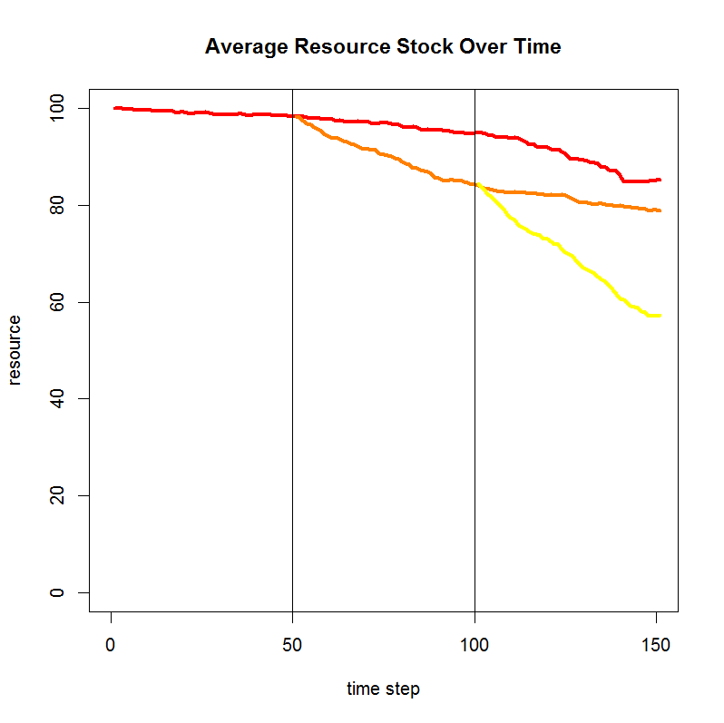 | 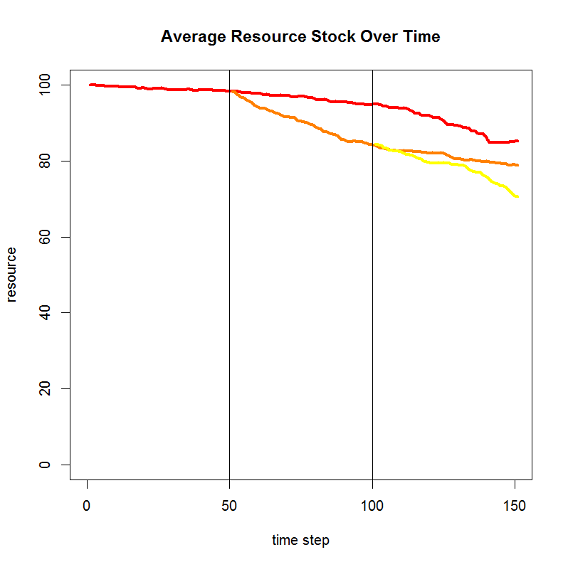
 | YES | 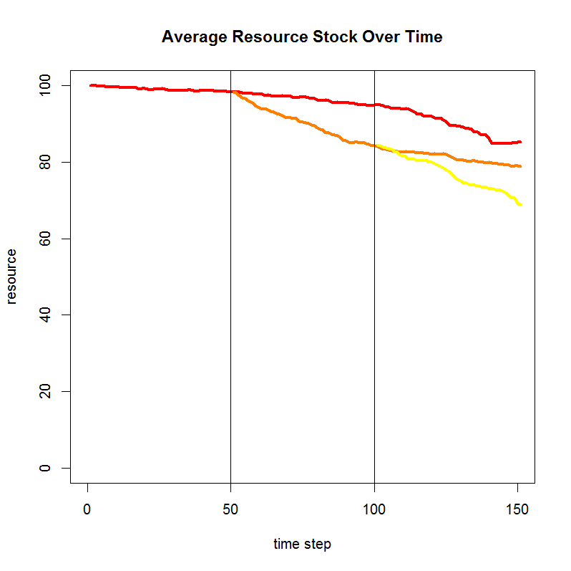 | 