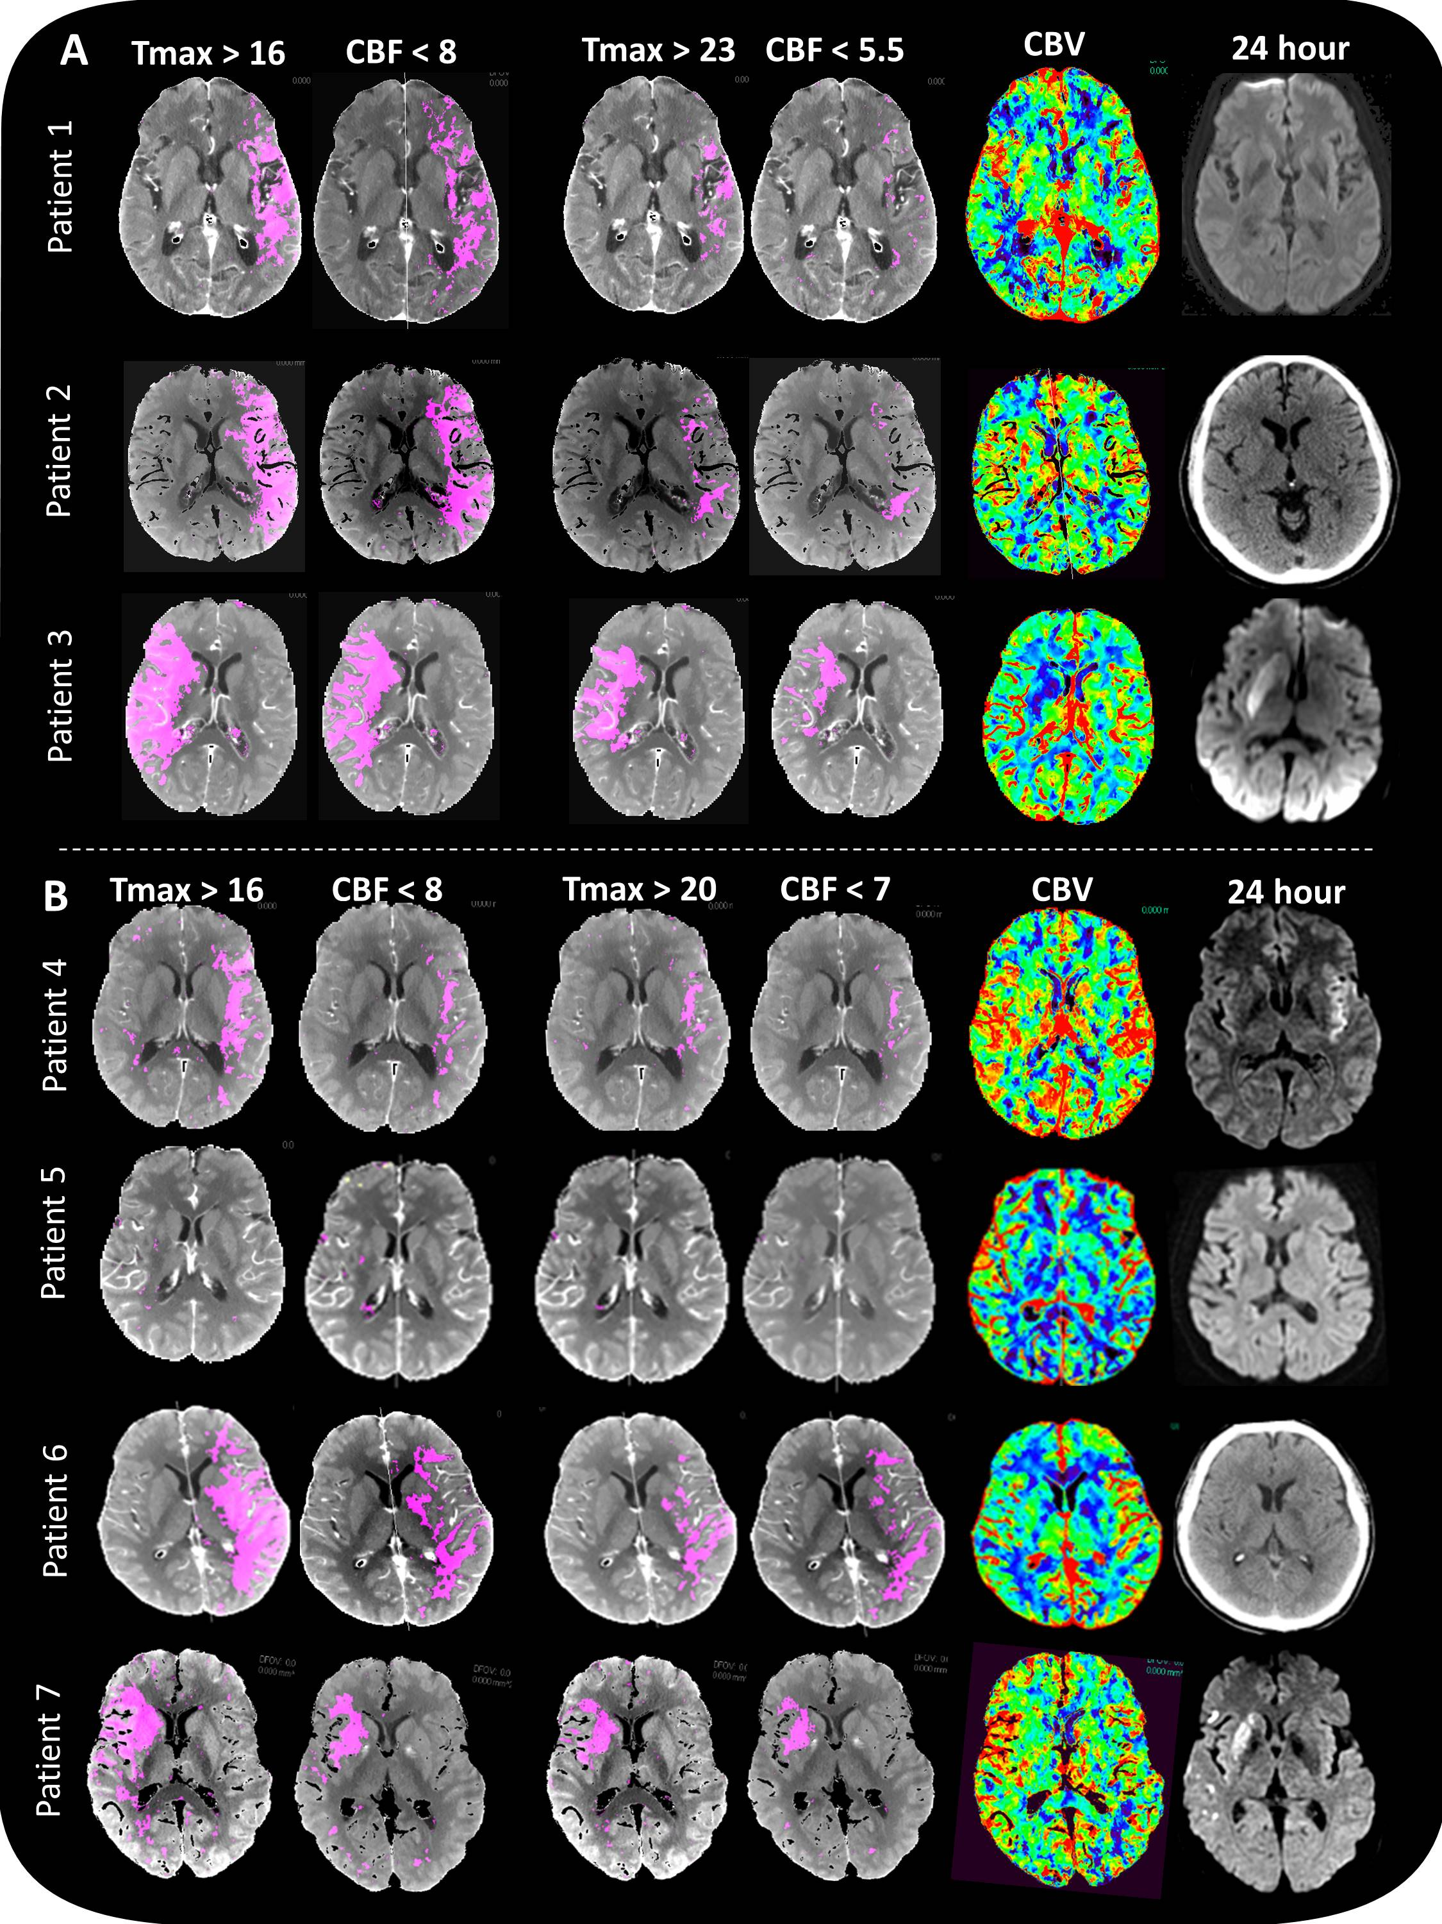

Supplemental Figure. (A) Ultra-early presenters (onset to CTP ≤60 minutes; Golden hour). CT Perfusion thresholds predicting follow-up infarction if reperfused ~90 minutes using previously published thresholds² and thresholds derived herein. Only patient 3 contains a final infarct volume (caudate, lentiform). (B) Early presenters (onset to CTP 60-180 minutes). CT Perfusion thresholds predicting follow-up infarction if reperfused ~90 minutes using previously published thresholds² and thresholds derived herein.

