SUPPLEMENTAL DATA
Supplemental Figure Legend
Figure 1: Memorandum of Understanding for Medical Redirect and Repatriation of Acute Stroke Patients within Toronto and Accompanying Material
Figure 2: Stroke Bypass/ Repatriation and Walk-In Stroke Protocol Reporting Form

Figure 3: Medical Redirect and Repatriation Acute Stroke MOU RSC Stroke Repatriation
Communication for Receiving Hospital

Figure 1: Memorandum of Understanding for Medical Redirect and Repatriation of Acute Stroke Patients within Toronto and Accompanying Material

ADDENDA
1. Addendum (EMS protocol)

Parties to the Memorandum:

Effective October 1st 2012 “local hospitals” are classified as follows:

Regional Stroke Centres
St Michael’s Hospital
Sunnybrook Health Sciences Centre
University Health Network – Toronto Western Hospital

Stroke Unit Hospitals
Humber River Regional Hospital – Church site
The Scarborough Hospital - General
Toronto East General Hospital
North York General Hospital
St. Joseph’s Health Centre
Rouge Valley Health System – Centenary

Non Stroke Unit Hospitals
Mount Sinai Hospital
Humber River Regional Hospital – Finch site
University Health Network – Toronto General Hospital
William Osler Health Centre – Etobicoke Campus
The Scarborough Hospital - Birchmount

Elements of the Memorandum of Understanding
The Definition of Home hospital is revised as follows:
The ‘Home Hospital’ is defined as the Stroke Unit Hospital serving the community where the patient resides (based on postal code) or the facility where the patient’s most responsible physician has admitting privileges IF active medical issues are best served at another hospital and when in the patients best interest.

Patients eligible for repatriation:
- Brought to RSC as a patient redirect under the EMS Stroke Bypass Protocol (“bypass patients”)
- Sent to RSC as “code STROKE” from non-RSC emergency department

Patients NOT eligible for repatriation:
- Those who used personal transport to arrive at a RSC (“walk-ins”)

Repatriation of Admitted Patients from Regional Stroke Centres to Local Hospital
- Repatriation of admitted patients are based on “like to like bed transfers” (i.e. ward to ward, critical care to critical care). The MRP to determine when the patient is medically stable.
- The ‘home hospital’ will prioritize patients transferring from the RSC to ensure that an inpatient bed is available within 24 hours of notification from the RSC, 7 days per week. Every attempt will be made to repatriate the patient between 07:00 and 22:00.
- Appropriate documentation will be transferred with the patient. (see Appendix A)
- Each home hospital is responsible for developing a process of care to facilitate the transfer of patients from the RSC within the outlined timeframe.
- Stroke patients will not be repatriated between RSC’s unless active medical issues are best served at another RSC and when in the patient’s best interest.
- There will be direct communication between MRP/designate from the RSC with the accepting physician at the home hospital prior to patient transfer

Repatriation of Non-admitted Patients from Regional Stroke Centre to Local Hospital
The following statement supersedes the section “Repatriation of Non-admitted Patients from Regional Stroke Centre to Local Hospital” on page 3 of the MOU
- Medically stable (stroke/TIA and confirmed non stroke) patients who were redirected to the RSC under the EMS Stroke Bypass Protocol but who do not require admission to the RSC will be transferred within 6-8 hours to their home hospital, 7 days per week.
- The Stroke Team case manager/physician will contact the designated contact person(s) at the home hospital with a verbal report to transfer.
- The ‘home hospital’ will agree to receive stroke patients who were redirected to the RSC within 6-8 hours from the time notified by RSC a patient is ready for repatriation.
- Appropriate documentation will be transferred with the patient (see Appendix A).
- Each home hospital is responsible for developing a process of care to facilitate the transfer of patients from the RSC within the outlined timeframe.
- Patients (stroke and non-stroke) will not be repatriated between RSC’s unless active medical issues are best served at another RSC and when in the patient’s best interest.

2. Addendum (Walk-in Protocol)
Medical Redirect of Acute Stroke Patients to Regional Stroke Centre
Patients arriving at their local hospital and subsequently transferred to a RSC under Code Stroke (Walk-in) are eligible for repatriation back to the sending facility once the services of a RSC are no longer required. Stroke patients will be repatriated back to the sending hospital if it is a stroke unit hospital and if not, to the nearest appropriate stroke unit hospital.
Patients who are determined to be non-stroke on arrival at RSC will be repatriated to the sending hospital.
If patient has active medical issues being managed at another RSC, consideration may be given for repatriation to the alternate RSC if in the patient’s best interest.

Evaluation of Agreement
- Data collected through the Ontario Stroke Network will be analyzed to monitor the effectiveness of the medical redirect and repatriation arrangements within the Toronto area.
- The Greater Toronto Stroke Coordinating Committee will evaluate this memorandum of understanding on an annual basis along with Toronto Emergency Services.

New Paramedic Prompt Card effective August 1, 2011.
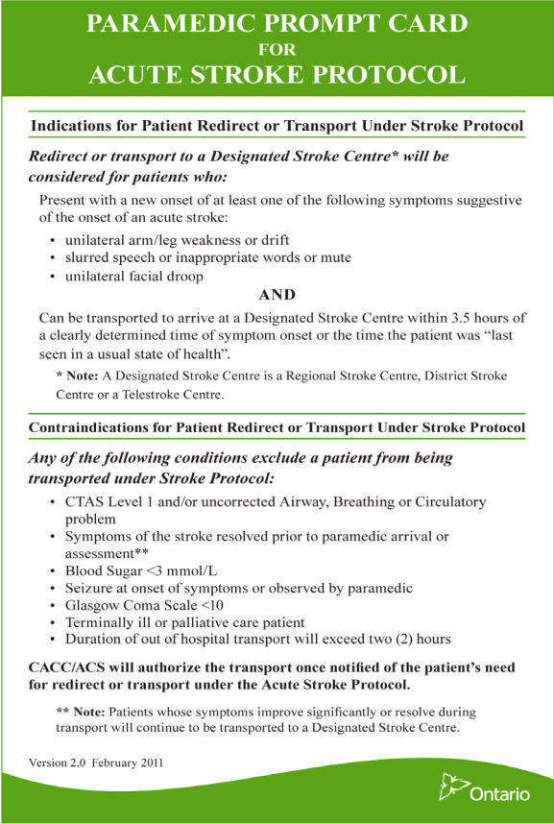
If the patient meets eligibility criteria, Ambulance Dispatch is to notify Regional/District Stroke
Centre that the patient meets Acute Stroke Protocol criteria and is being transported to them.
Ambulance personnel to report BP systolic >185 and diastolic >110 in order that stroke team may treat BP when patient arrives in ER.

Dispatch assigns Delta response as per MPDS
Stroke Onset: Patient/Family activates EMS

Patient stable and meets the inclusion criteria on the Paramedic Prompt Card for Acute Stroke Protocol
Transport to closest Regional Stroke Centre Code 4 (CTAS level 2)
Immediate notification to Stroke Centre Emergency Department

Stroke Centre Emergency Department contacts Stroke Team

On arrival at Stroke Centre Emergency Department patient triaged emergent and assessed by Stroke Team STAT (CTAS Level 2)

Stroke Team to determine if patient is eligible for repatriation and notify home hospital of potential transfer

Course of treatment?

Admit for stroke investigation and treatment OR recommendations forwarded to home hospital/family physician. Arrange secondary prevention services.

Admit to Stroke Centre. Investigations performed/treatment initiated.
D/C to home hospital when appropriate. Arrange secondary prevention services.
Investigations and treatment recommendations documented and forwarded to home hospital. If TIA or mild stroke arrange secondary prevention clinic appointment

Repatriate back to home hospital or home using the appropriate transport service

TORONTO STROKE NETWORKS ACUTE STROKE PROTOCOL ALGORITHM
Transport to closest Stroke Unit Hospital Emergency Department

Patient TIA, mild stroke (not requiring admission), stroke mimic
Patient receives t-PA and/or requires tertiary care
Patient moderate to severe stroke. Non t-PA
No
Yes
Provide required services. Reassess in 24 hours
Does patient require services of RSC?
Did patient arrive from a community ED under walk-in stroke protocol?
Is patient under EMS stroke prompt card protocol?

No
Yes
No
Did patient bypass another hospital?

Does patient require stroke unit care?
Provide required services
Provide required services
For Confirmed Non-stroke Patients
IF walk-in protocol repatriate to sending community hospital ED
IF EMS bypass protocol determine home hospital.

Home hospital is defined as the hospital:
- Facility closest to patients residence (based on postal code)
- Facility where patients most responsible physician has admitting privileges IF active medical issues are best served at another hospital and when in the patients best interest
IF walk-in protocol repatriate to sending ED if community hospital has stroke unit OR determine home stroke unit hospital.
IF EMS bypass protocol determine home stroke unit hospital.

Home Stroke Unit Hospital is defined as:
- Facility closest to patients residence (based on postal code)
- Facility where patients most responsible physician has admitting privileges IF active medical issues are best served at another hospital and when in the patients best interest

No
No
No
Yes
Yes
Yes
Yes
Patients (stroke and non-stroke) will not be repatriated between RSC’s unless active medical issues are best served at another RSC and when in the patient’s best interest.

Notify receiving hospital of repatriation and confirm acceptance. Time to repatriation:
- 6-8 hours for non-admitted patients, 7 days a week,
- 24 hours, 7 days a week, 0700 – 2200 hours for admitted patients

Algorithm for Repatriation under MOU for Medical Redirect and Repatriation of Acute Stroke Patients in Toronto

Figure 2: Stroke Bypass/ Repatriation and Walk-In Stroke Protocol Reporting Form

Stroke Bypass / Repatriation and Walk-in Stroke Protocol Reporting Form
Please complete this Toronto Stroke Networks tracking form if there are concerns regarding the EMS/ED Walk-in Code Stroke Protocol and/or repatriation of stroke patients under the Addendum for the Memorandum of Understanding for Medical Redirect, Bypass and Repatriation (dated Nov 13th, 2012). This form should be used to capture any issues arising with transportation of a stroke patient from/to your facility under these protocols. If an issue arises please address this issue directly with the organization prior to sending this form to the Stroke Networks. The Toronto Stroke Network will be providing summary reports to organizations on a regular basis.

Issue related to: Walk-in protocol Bypass Protocol Repatriation Process

Reporting Hospital/Stroke Center:
Reporting Facility: | Date:
Contact Name: | Telephone:

Patient Information
Date: | Age: | Male Female
Triage Time: |  | Date of Transfer:

EMS transport information (as required):
Date: | Run Number (If known):
Pick-up Location: | Vehicle Number (If known):

Receiving hospital information (as required):
Receiving Facility: | Date:
Person Contacted: | Telephone:

Brief Description of Issue Arising:
Patient did not meet walk-in protocol criteria. Please explain
Patient did not meet bypass protocol criteria. Please explain
Pre-notification not received by Regional Stroke Center (RSC) ED
Patient met bypass protocol criteria but arrived at RSC under walk-in protocol.
Missing transfer documents
Challenges associated with repatriation. Please explain
Other (please explain)

Action/Resolution Taken Between Organizations:
Send completed forms to:
Administrative Assistant  South East Toronto Stroke Network  St. Michael's Hospital | Ph: XXX-XXX-XXXX  Email:

Figure 3: Medical Redirect and Repatriation Acute Stroke MOU RSC Stroke Repatriation Communication for Receiving Hospital
______________________________________________________________________________
Sending Regional Stroke Centre: SMH SHSC TWH
Patient Location: Emergency Department Inpatient Ward_______________________________
Reason for Repatriation:
The patient is being repatriated to ___________________________________ because the patient was considered to be an ineligible candidate for rt-PA or an interventional procedure and therefore the patient is most appropriately medically cared for at/near their home hospital.
The patient was initially admitted for acute stroke treatment/investigations and is now deemed ready for repatriation back to bypassed or home hospital.
Notification of Receiving Hospital: | Date/Time:
□ Accepting Physician Notified (inpatient repatriations)
□ Repatriation initiated
□ Bed coordinator notified (if applicable)
□ EMS notified
□ Hospital unit notified (if applicable)
□ Nursing Report: Sending RN: | Receiving RN:

Documentation/Information Provided: | If applicable:
□ Transfer plan outlining plan of care  □ Neuro Imaging: ____________________________________ | □ Discharge Summary  □ Inpatient Chart
□ Vascular Imaging: __________________________________
□ Stroke (Neurology) Consultation Notes
□ ED Chart Copy | □ Tor-BSST: Pass_____Fail_____  □ SPC Follow up  Instructions:_________________________
□ ECG
□ Labs
□ List of Current Medications

Sending Staff Physician (print) | Tel #:(MD/Inpatient unit)
Sending NP (print if applicable) | Tel #:

Receiving Staff Physician (print)

Date of Transfer:
¹This agreement has been authorized under the memorandum of understanding signed by the MOHLTC, Regional Stroke Centers (GTA), Community hospitals and Toronto EMS (policy number 03.06.38). ²The ‘Home Hospital’ is defined as the Stroke Unit Hospital serving the community where the patient resides (based on postal code) or the facility where the patient’s most responsible physician has admitting privileges when there are active medical issues and in the patients best interest.

