Appendix 1

Social Attitudes Questionnaire

- What ethnic group (e.g., Québécois, Anglophone Quebecer, Vietnamese, Black Canadian, Afro-American, Chinese, Inuit, Mohawk, Ukrainian and so on) do you consider yourself to be a member of?
___________________________________________________________________________

- What is your ethnic language? ___________________________________________________________________________

- Please rate how well each of the following labels describes you.

Not at all Perfectly
Canadian 1 2 3 4 5 6 7 8 9
French Canadian 1 2 3 4 5 6 7 8 9
Québécois 1 2 3 4 5 6 7 8 9
Anglophone Quebecer 1 2 3 4 5 6 7 8 9
Other: (please specify): ______________ 1 2 3 4 5 6 7 8 9
Other: (please specify): ______________ 1 2 3 4 5 6 7 8 9

- Indicate the degree to which each of these statements accurately reflects how you feel.
Disagree Agree
PRIDE FOR ETHNIC GROUP
- I am proud to be a member of my ethnic group. | 1 2 3 4 5 6 7 8 9
- I am proud to let people know that I belong to my ethnic group. | 1 2 3 4 5 6 7 8 9
- I am proud of the achievements of my ethnic group. | 1 2 3 4 5 6 7 8 9
- I feel proud to see symbols of my ethnic group (such as a flag) displayed around me. | 1 2 3 4 5 6 7 8 9
- I am proud to be able to speak the language of my ethnic group. | 1 2 3 4 5 6 7 8 9
ENGLISH IN QUEBEC
- Anglophone Quebecers do not have considerable economic power in Quebec. | 1 2 3 4 5 6 7 8 9
- Anglophone Quebecers do not have considerable political power in Quebec. | 1 2 3 4 5 6 7 8 9
- In my daily life (for example, in a restaurant, shop, doctor’s office), I should have the right to speak English in Quebec. | 1 2 3 4 5 6 7 8 9
- I should have the freedom to choose if I want my children to be educated in English in Quebec. | 1 2 3 4 5 6 7 8 9
- Anglophone Quebecers’ contribution to Quebec is not recognized or valued. | 1 2 3 4 5 6 7 8 9
ATTITUDES TOWARDS IMMIGRANTS
- The influx of immigrants is lowering the standard of living of people in Quebec. | 1 2 3 4 5 6 7 8 9
- Laws, customs, and traditions that are specific to immigrant groups should not be imposed on the Quebec society as a whole. | 1 2 3 4 5 6 7 8 9
- Immigrants should adopt the Quebec way of life and values to replace their traditional way or life and values. | 1 2 3 4 5 6 7 8 9
- Immigrants are bringing conflicts in their home countries into Quebec. | 1 2 3 4 5 6 7 8 9
- Immigrants benefit a lot from being in Quebec so they should be loyal to Québec. | 1 2 3 4 5 6 7 8 9
PERSONAL RELATIONS WITH OTHER GROUPS
- I feel accepted and respected by other ethnic groups in Quebec. | 1 2 3 4 5 6 7 8 9
- Members of other ethnic groups do not mind me living in close proximity to them. | 1 2 3 4 5 6 7 8 9
- Members of other ethnic groups would not object to my children marrying their children. | 1 2 3 4 5 6 7 8 9
- Children who grow up in an ethnically diverse Quebec are more prepared to live in today’s world. | 1 2 3 4 5 6 7 8 9
- Children growing up in an ethnically diverse Quebec are more tolerant of other groups. | 1 2 3 4 5 6 7 8 9

Category labels were not presented to participants. Questionnaire is based on materials from: Gatbonton, E., & Trofimovich, P. (2008). The ethnic group affiliation and L2 proficiency link: Empirical evidence. Language Awareness, 17, 229–248. https://doi.org/10.1080/09658410802146867

Appendix 2
Scripts for the Manipulation of Social Bias Orientation

Negative
I’m sorry. I just have to vent about something. You’re a native English speaker, so you’ll get where I’m coming from. I just went to grab some food from the Copper Branch down the street. I can’t believe they don’t provide adequate service in English! I mean, the person I placed my order with was clearly a French speaker who had never bothered to learn English very well. I could barely understand her! Her accent was awful and her grammar didn’t even make sense. You know – Canada has two official languages, so everyone should be able to speak English—at school, at work, everywhere! I can’t believe there are French speakers who haven’t bothered to become fluent in English after spending a lifetime in Canada! It’s ridiculous.

Positive
I just have to share something with you that I’ve been thinking about all day. You’re a native English speaker who probably speaks some French, so you’ll get where I’m coming from. So, I went to the Copper Branch down the street earlier to get something to eat and I was so impressed that they provide such good service in English! The person I placed my order with was obviously a native speaker of French, but her English was really good! I mean, she had an accent, but it still sounded good and her grammar wasn’t bad, either. You know – Canada has two official languages, so everyone should be able to use English—at school, at work, everywhere! I am just so impressed that some French speakers make such an effort to learn English. It’s tough learning a new language!

Appendix 3
Final Debrief Questionnaire

Please rate your experience in today’s session by putting an X in the appropriate spot on the scale.

- How pleasant was your experience in this rating session?
Very pleasant
Very unpleasant

- How helpful was the researcher during the session?
Very helpful
Not helpful at all

- How difficult was the rating task for you?
Very difficult
Very easy

- How confident are you in your ratings?
Not confident at all
Fully confident

- Did any part of your interaction with the researcher affect your ratings?
________________________________________________________________________________________________________________________________________________________________________________________________________________________________________________________________________________________________________________________

Appendix 4
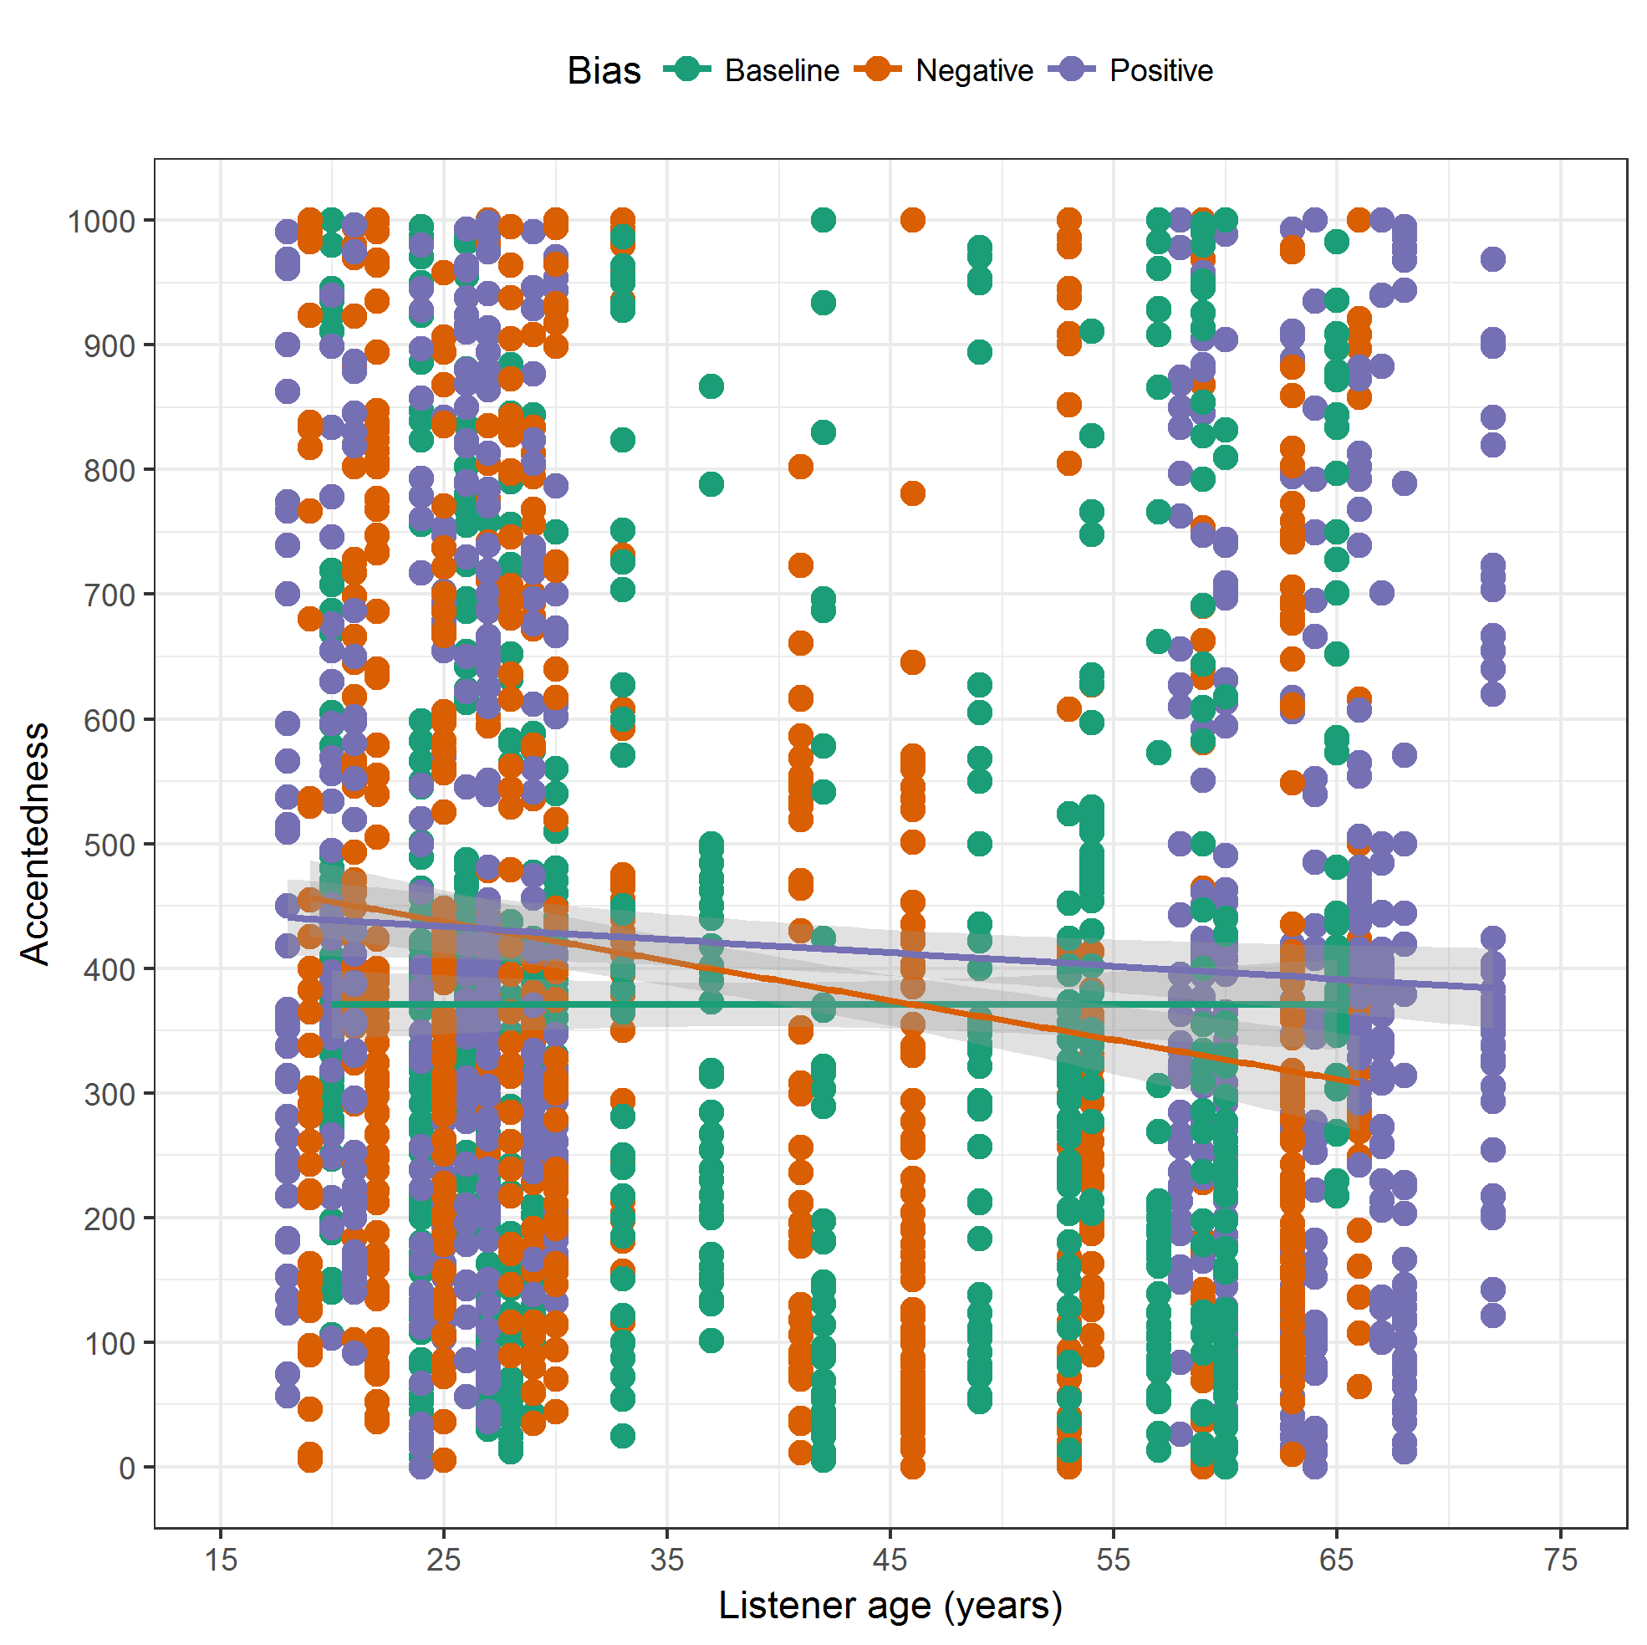
Figure A1. Scatterplot of accentedness ratings as a function of listeners’ age, with regression lines depicting the best linear fit for each listener group and shaded areas encompassing 95% confidence intervals.

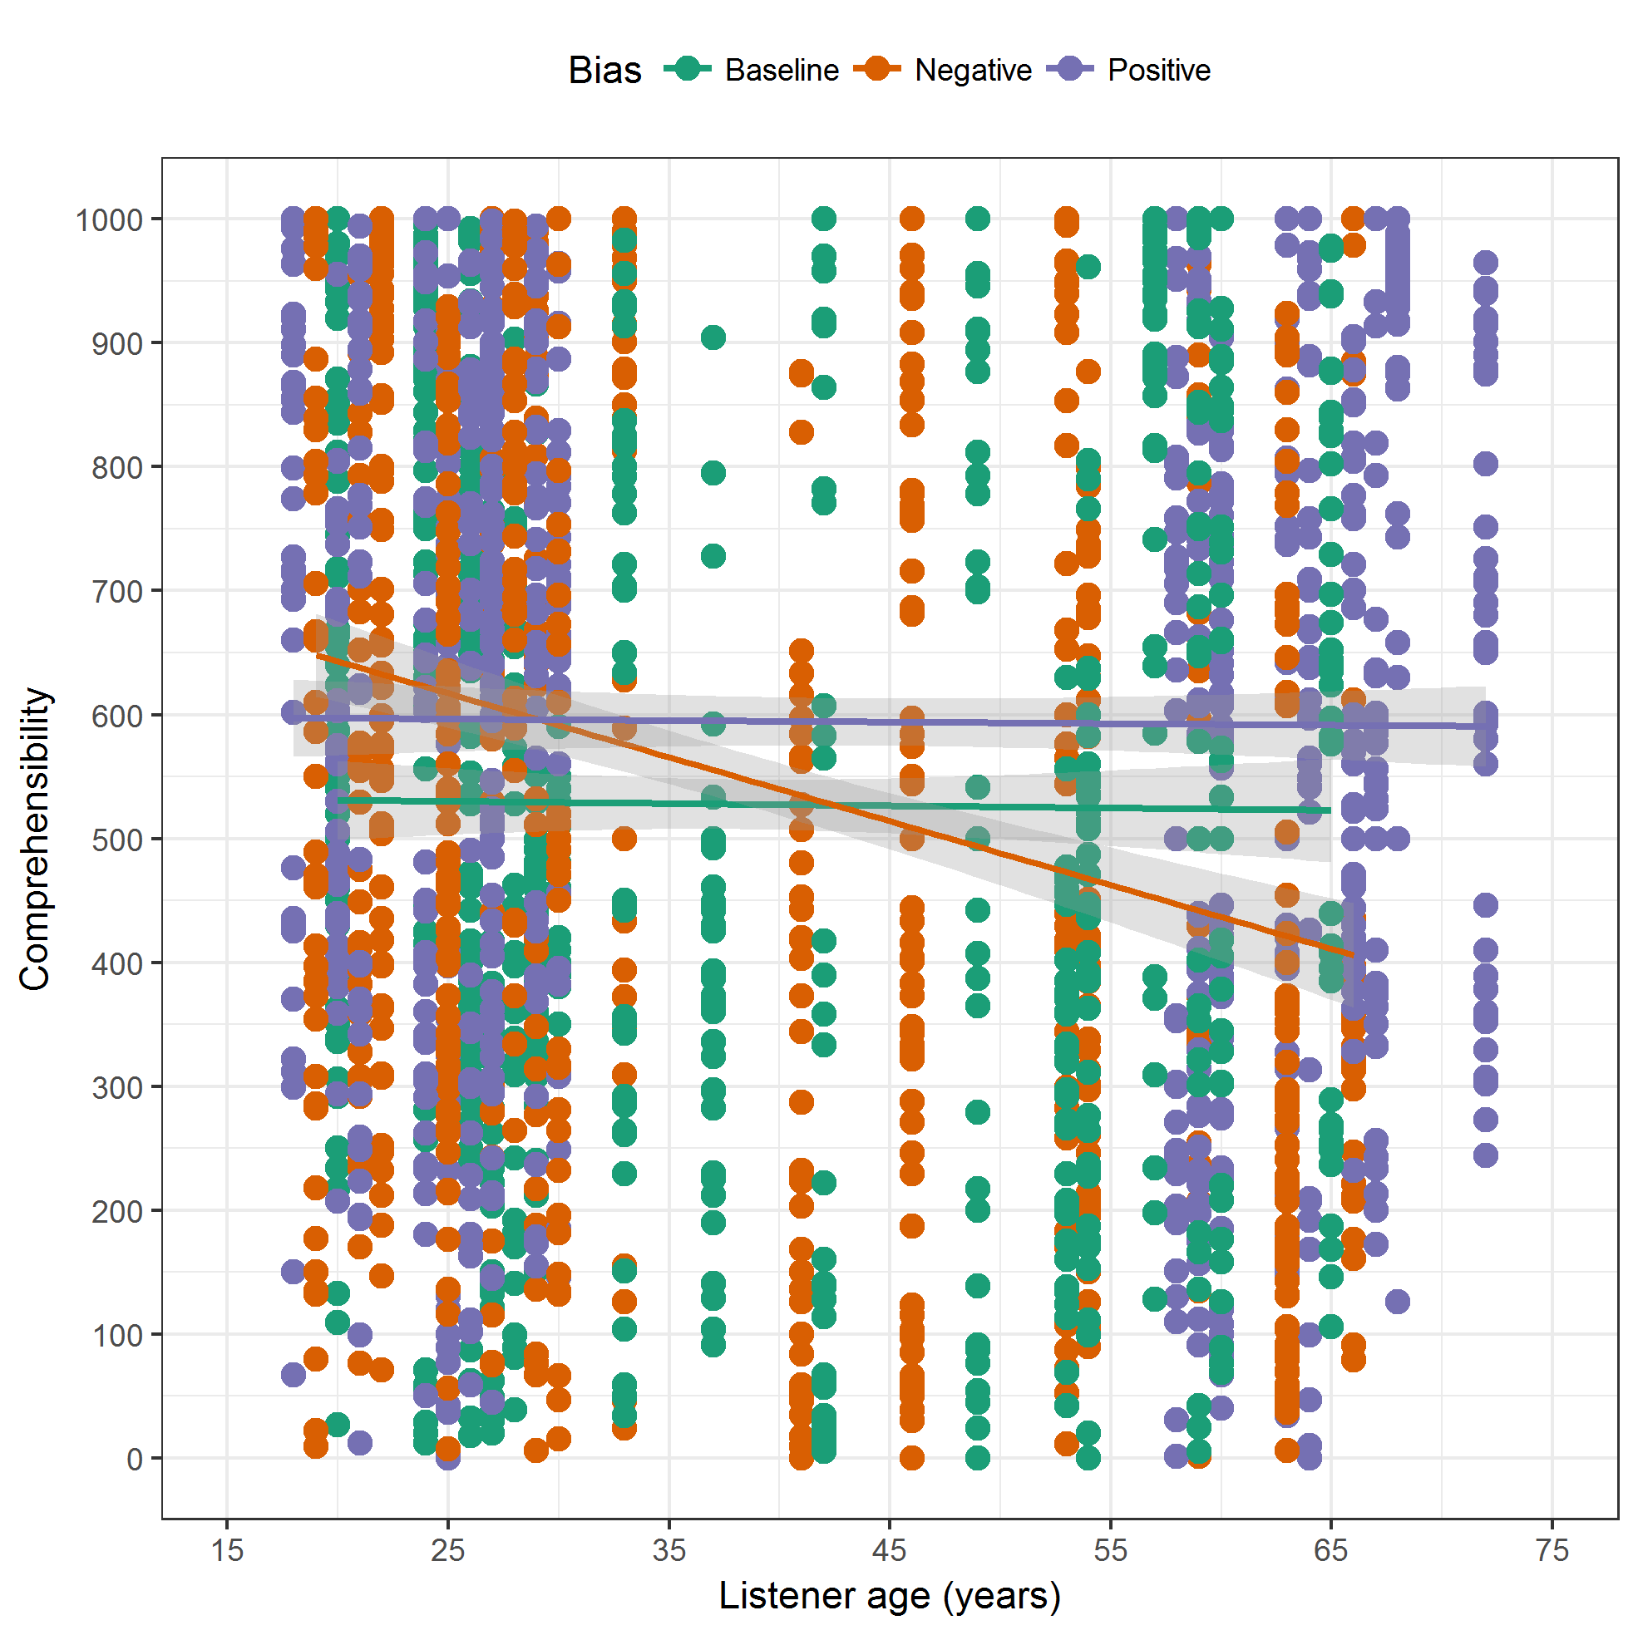
Figure A2. Scatterplot of comprehensibility ratings as a function of listeners’ age, with regression lines depicting the best linear fit for each listener group and shaded areas encompassing 95% confidence intervals.

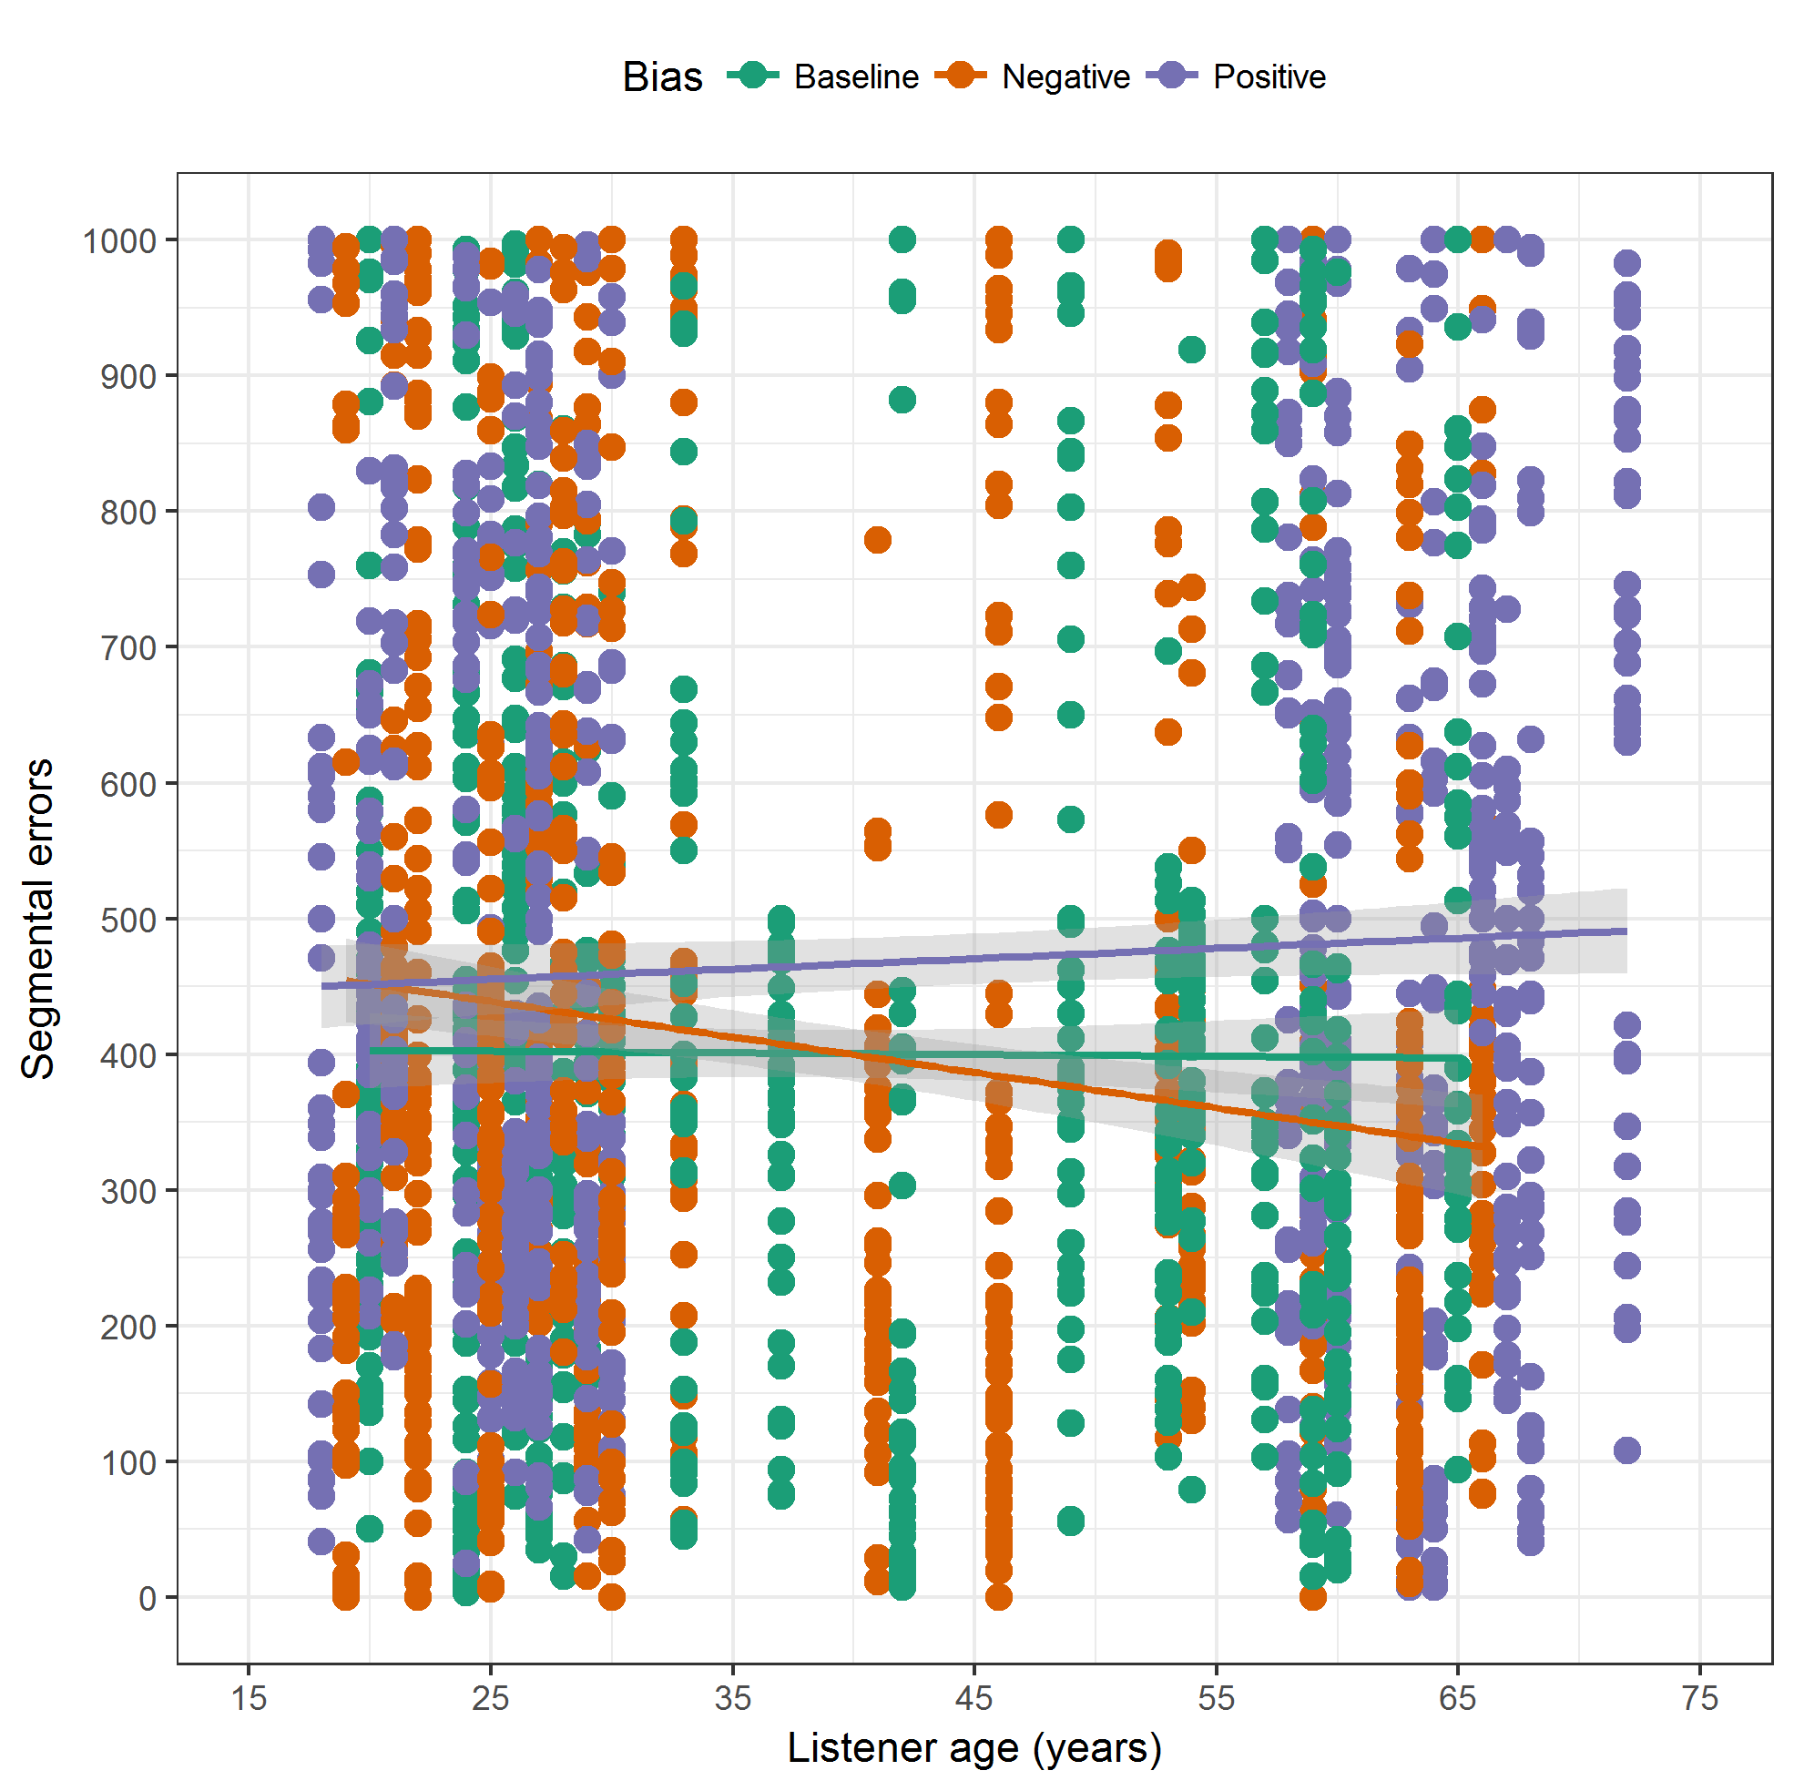 Figure A3. Scatterplot of ratings of segmental errors as a function of listeners’ age, with regression lines depicting the best linear fit for each listener group and shaded areas encompassing 95% confidence intervals.
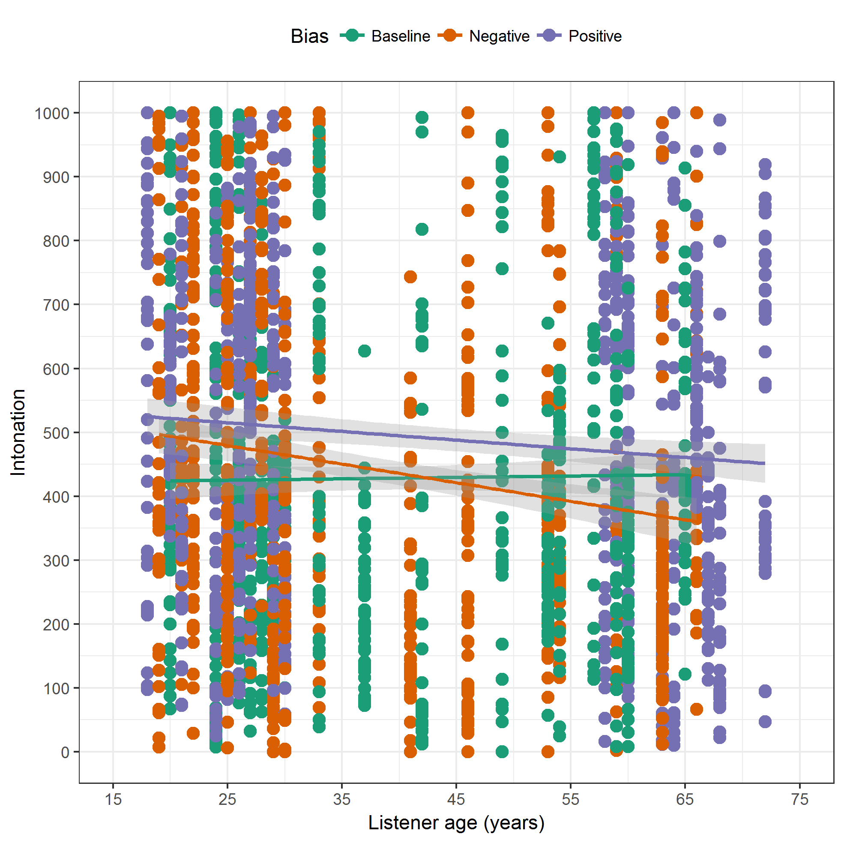 Figure A4. Scatterplot of intonation ratings as a function of listeners’ age, with regression lines depicting the best linear fit for each listener group and shaded areas encompassing 95% confidence intervals.
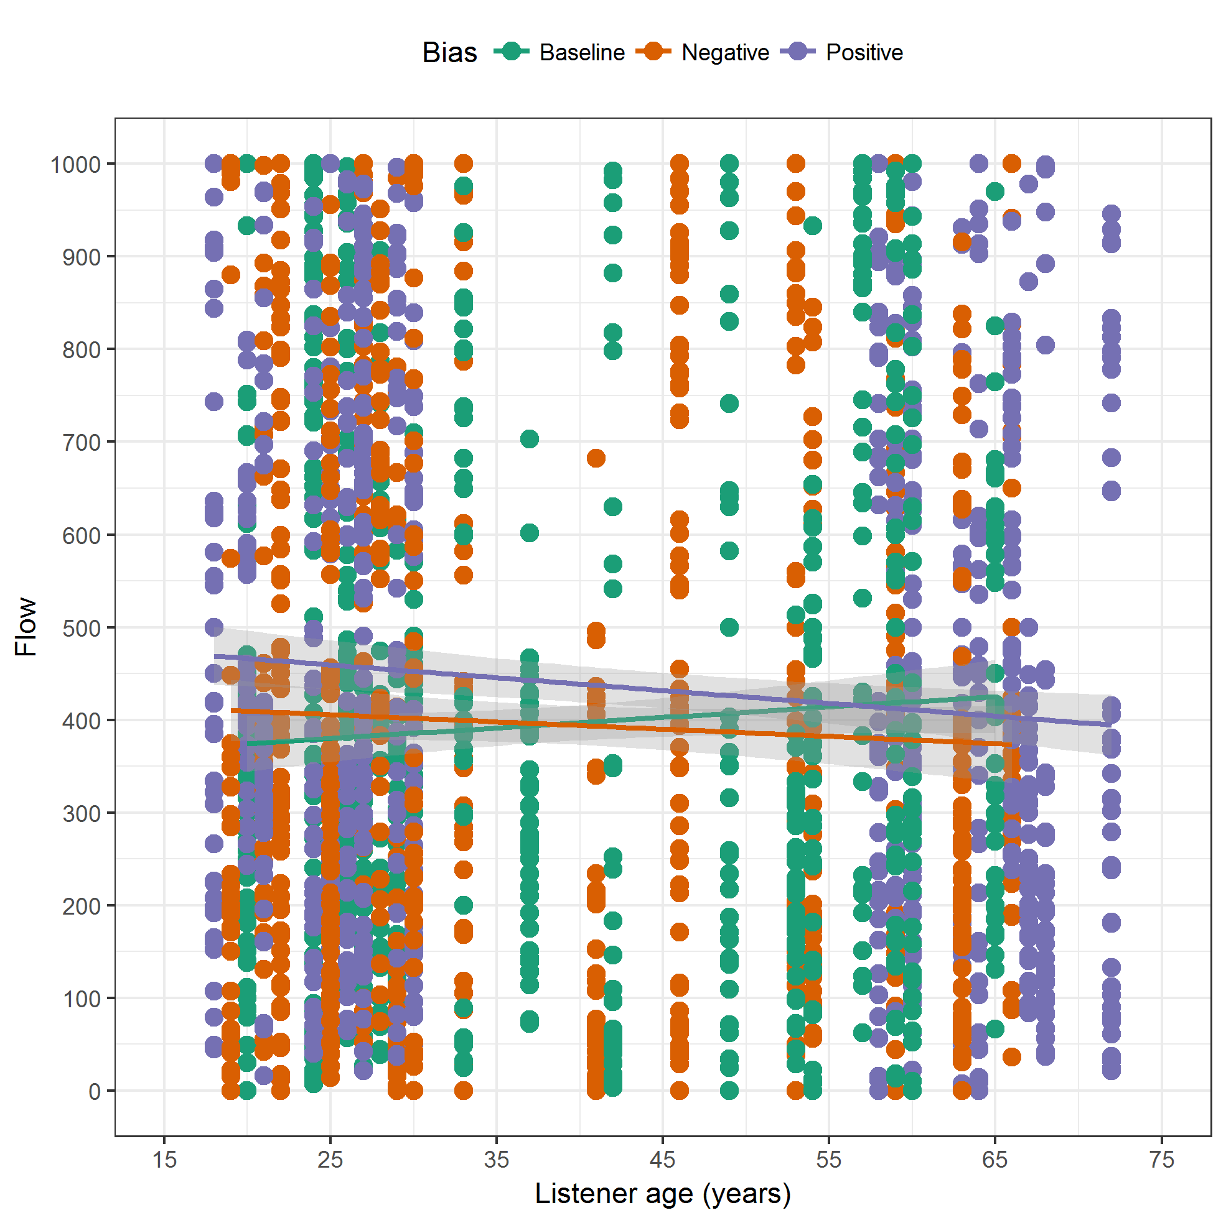 Figure A5. Scatterplot of flow ratings as a function of listeners’ age, with regression lines depicting the best linear fit for each listener group and shaded areas encompassing 95% confidence intervals.

Appendix 5
Table A1 Final model for accentedness with baseline group used as the reference level
Parameter | b | SE | 95% CI | t | p
(Intercept) | 428.08 | 59.78 | [311.18, 544.98] | 7.16 | < .0001
Positive vs. baseline | 93.25 | 25.18 | [44.01, 142.50] | 3.70 | .0002
Negative vs. baseline | 84.97 | 26.30 | [33.53, 136.40] | 3.23 | .0013
Listener age | –1.53 | 0.48 | [–2.46, –0.60] | –3.21 | .0013
Positive × Listener age | –1.39 | 0.55 | [–2.47, –0.30] | –2.50 | .0126
Negative × Listener age | –1.75 | 0.62 | [–2.96, –0.55] | –2.84 | .0045
Familiarity with French accent | –5.73 | 4.69 | [–14.90, 3.44] | –1.22 | .2219
French use | –2.11 | 0.28 | [–2.65, –1.57] | –7.62 | < .0001
French use with native speakers | 0.41 | 0.13 | [0.15, 0.66] | 3.09 | .0020
Pride in Anglophone group | 2.44 | 0.39 | [1.67, 3.21] | 6.18 | < .0001
Role of English in Quebec | –2.17 | 0.48 | [–3.12, –1.23] | –4.49 | < .0001
Attitudes towards immigrants | 3.65 | 0.48 | [2.71, 4.58] | 7.62 | < .0001
Feelings towards other groups | –0.32 | 0.55 | [–1.40, 0.75] | –0.59 | .5575
Random effects | SD | Information criteria |  | Estimate
Speakers (intercept) | 177.38 | Log-likelihood |  | –14930.51
Positive bias (slope) | 37.03 | AIC |  | 29913.02
Negative bias (slope) | 40.76 | BIC |  | 30062.05
Listeners (intercept) | 172.96
Positive bias (slope) | 113.69
Negative bias (slope) | 122.74
Notes. AIC = Akaike information criterion, BIC = Bayesian information criterion.
Table A2 Final model for comprehensibility with baseline group used as the reference level
Parameter | b | SE | 95% CI | t | p
(Intercept) | 532.52 | 70.86 | [393.95, 671.09] | 7.51 | < .0001
Positive vs. baseline | 100.49 | 29.23 | [43.32, 157.65] | 3.44 | .0006
Negative vs. baseline | 244.77 | 31.09 | [183.97, 305.57] | 7.87 | < .0001
Listener age | 1.21 | 0.57 | [0.11, 2.32] | 2.14 | .0322
Positive × Listener age | –0.66 | 0.66 | [–1.95, 0.63] | –1.00 | .3176
Negative × Listener age | –5.54 | 0.75 | [–7.00, –4.08] | –7.42 | < .0001
Familiarity with French accent | –4.41 | 5.67 | [–15.49, 6.67] | –0.78 | .4366
French use | 0.44 | 0.33 | [–0.21, 1.09] | 1.32 | .1871
French use with native speakers | –0.16 | 0.16 | [–0.47, 0.15] | –1.02 | .3098
Pride in Anglophone group | 1.79 | 0.48 | [0.86, 2.73] | 3.74 | .0002
Role of English in Quebec | –2.09 | 0.59 | [–3.24, –0.94] | –3.55 | .0004
Attitudes towards immigrants | –1.53 | 0.58 | [–2.66, –0.39] | –2.64 | .0085
Feelings towards other groups | –0.05 | 0.66 | [–1.34, 1.25] | –0.07 | .9434
Random effects | SD | Information criteria |  | Estimate
Speakers (intercept) | 195.25 | Log-likelihood |  | –15363.62
Positive bias (slope) | 9.26 | AIC |  | 30779.23
Negative bias (slope) | 22.14 | BIC |  | 30928.26
Listeners (intercept) | 204.28
Positive bias (slope) | 176.01
Negative bias (slope) | 284.37
Notes. AIC = Akaike information criterion, BIC = Bayesian information criterion.
Table A3 Final model for segmental errors with baseline group used as the reference level
Parameter | b | SE | 95% CI | t | p
(Intercept) | 625.99 | 64.59 | [499.68, 752.29] | 9.69 | < .0001
Positive vs. baseline | 29.53 | 26.29 | [–21.88, 80.94] | 1.12 | .2615
Negative vs. baseline | 64.42 | 27.05 | [11.52, 117.31] | 2.38 | .0173
Listener age | –0.81 | 0.49 | [–1.77, 0.15] | –1.65 | .0992
Positive × Listener age | 0.76 | 0.59 | [–0.39, 1.92] | 1.29 | .1961
Negative × Listener age | –1.74 | 0.65 | [–3.02, –0.46] | –2.65 | .0081
Familiarity with French accent | –27.65 | 5.10 | [–37.62, –17.68] | –5.42 | < .0001
French use | –0.61 | 0.31 | [–1.21, 0.00] | –1.97 | .0493
French use with native speakers | 0.26 | 0.14 | [–0.02, 0.54] | 1.85 | .0646
Pride in Anglophone group | 1.22 | 0.42 | [0.39, 2.05] | 2.88 | .0040
Role of English in Quebec | –1.70 | 0.53 | [–2.74, –0.67] | –3.21 | .0014
Attitudes towards immigrants | 2.16 | 0.53 | [1.14, 3.19] | 4.12 | < .0001
Feelings towards other groups | 0.07 | 0.59 | [–1.08, 1.23] | 0.12 | .9006
Random effects | SD | Information criteria |  | Estimate
Speakers (intercept) | 192.99 | Log-likelihood |  | –15122.58
Listeners (intercept) | 163.23 | AIC |  | 30277.16
 |  | BIC |  | 30368.87
Notes. AIC = Akaike information criterion, BIC = Bayesian information criterion.

Table A4 Final model for intonation with baseline group used as the reference level
Parameter | b | SE | 95% CI | t | p
(Intercept) | 745.05 | 66.46 | [615.09, 875.01] | 11.21 | < .0001
Positive vs. baseline | 166.01 | 28.13 | [111.01, 221.00] | 5.90 | < .0001
Negative vs. baseline | 153.49 | 28.93 | [96.91, 210.07] | 5.30 | < .0001
Listener age | –0.15 | 0.53 | [–1.18, 0.88] | –0.28 | .7808
Positive × Listener age | –2.29 | 0.63 | [–3.53, –1.05] | –3.62 | .0003
Negative × Listener age | –3.25 | 0.70 | [–4.62, –1.88] | –4.64 | < .0001
Familiarity with French accent | –22.19 | 5.45 | [–32.86, –11.53] | –4.07 | < .0001
French use | –0.80 | 0.33 | [–1.45, –0.16] | –2.44 | .0149
French use with native speakers | 0.03 | 0.15 | [–0.27, 0.32] | 0.17 | .8662
Pride in Anglophone group | 1.15 | 0.45 | [0.26, 2.03] | 2.52 | .0117
Role of English in Quebec | –2.96 | 0.57 | [–4.08, –1.85] | –5.22 | < .0001
Attitudes towards immigrants | 2.15 | 0.56 | [1.06, 3.25] | 3.84 | .0001
Feelings towards other groups | –3.28 | 0.63 | [–4.52, –2.05] | –5.20 | < .0001
Random effects | SD | Information criteria |  | Estimate
Speakers (intercept) | 168.56 | Log-likelihood |  | –15268.26
Listeners (intercept) | 175.28 | AIC |  | 30568.52
 |  | BIC |  | 30660.23
Notes. AIC = Akaike information criterion, BIC = Bayesian information criterion.

Table A5 Final model for flow with baseline group used as the reference level
Parameter | b | SE | 95% CI | t | p
(Intercept) | 527.83 | 64.64 | [401.43, 654.23] | 8.17 | < .0001
Positive vs. baseline | 200.31 | 26.19 | [149.10, 251.53] | 7.65 | < .0001
Negative vs. baseline | 148.40 | 28.36 | [92.95, 203.85] | 5.23 | < .0001
Listener age | 1.72 | 0.49 | [0.75, 2.68] | 3.48 | .0005
Positive × Listener age | –3.90 | 0.58 | [–5.05, –2.76] | –6.69 | < .0001
Negative × Listener age | –3.44 | 0.67 | [–4.76, –2.13] | –5.11 | < .0001
Familiarity with French accent | –7.41 | 5.11 | [–17.39, 2.58] | –1.45 | .1470
French use | 0.12 | 0.30 | [–0.48, 0.71] | 0.38 | .7018
French use with native speakers | –0.73 | 0.14 | [–1.01, –0.45] | –5.09 | < .0001
Pride in Anglophone group | 1.83 | 0.43 | [0.99, 2.67] | 4.25 | < .0001
Role of English in Quebec | –3.39 | 0.54 | [–4.43, –2.34] | –6.31 | < .0001
Attitudes towards immigrants | 0.94 | 0.52 | [–0.08, 1.96] | 1.80 | .0723
Feelings towards other groups | –2.47 | 0.59 | [–3.63, –1.31] | –4.16 | < .0001
Random effects | SD | Information criteria |  | Estimate
Speakers (intercept) | 188.67 | Log-likelihood |  | –15142.58
Positive bias (slope) | 24.63 | AIC |  | 30337.17
Negative bias (slope) | 34.17 | BIC |  | 30486.20
Listeners (intercept) | 177.41
Positive bias (slope) | 48.80
Negative bias (slope) | 31.01
Notes. AIC = Akaike information criterion, BIC = Bayesian information criterion.

