Supplementary Figure 3. Cost-effectiveness plane showing the results of the probabilistic sensitivity analysis
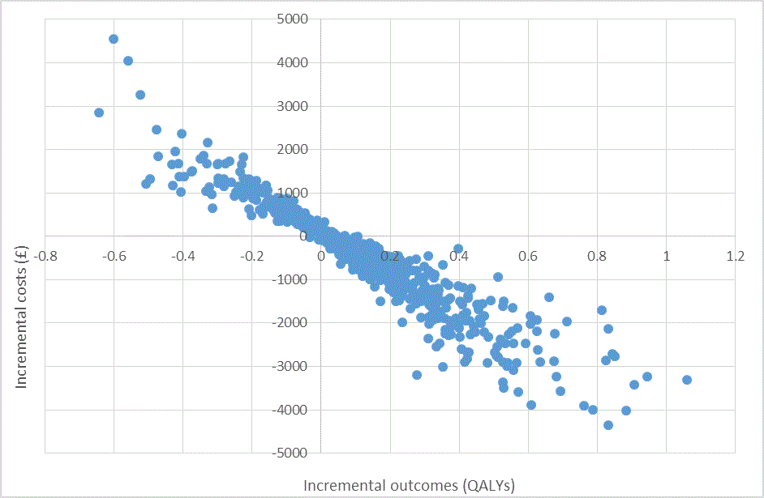 QALY: quality-adjusted life year

