Supplementary Figure 2: Typology of Public and Patient Involvement in HTA

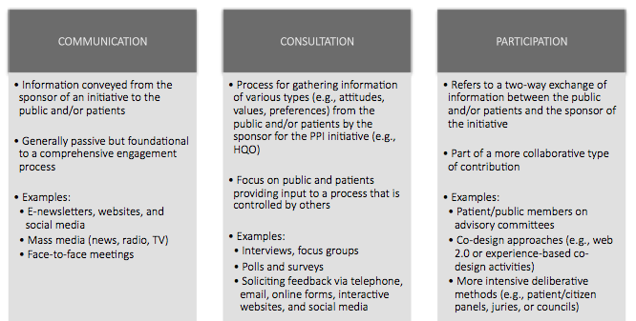
Adapted from Rowe, G. & Frewer, LJ. A typology of public engagement mechanisms. Science, Technology & Human Values. 2005;30(2):251-90. HQO, Health Quality Ontario; PPI, Public and Patient Involvement

