Supplementary material

Appendix A
Table A1: Randomisation order and readiness ratings
Site | Intervention Start (2013) | Readiness Assessment
Colchester | 28 Jan | Ready to go live
Chelmsford | 25 Feb | Ready to go live
Harlow | 2 Apr | Ready to go live
Clacton | 29 Apr | Almost ready
Harwich | 29 Apr | Almost ready
Canvey | 28 May | Almost ready
Rayleigh | 28 May | Almost ready
Grays | 1 Jul | Almost ready
Basildon | 29 Jul | Not yet ready
Braintree | 2 Sep | Not yet ready
Witham | 2 Sep | Not yet ready
Southend | 1 Oct | Not yet ready

Table A2: Robustness checks: Effect of treatment on off-flow at 13 weeks, with readiness interactions, Experiment 2 (LPM)

 | (1) | (2)
Treatment | 0.034*** | 0.028***
 | (0.006) | (0.007)
Readiness 2 x Treatment |  | 0.014
 |  | (0.008)
Readiness 3 * Treatment |  | 0.006
 |  | (0.010)
Time Trend | 0.00 | 0.001
 | (0.001) | (0.001)
Constant | 0.564*** | 0.567***
 | (0.005) | (0.005)
Cluster Fixed Effects | Yes | Yes
Time Trend | Yes | Yes
Readiness Controls | Yes | Yes
N | 88,033 | 88,033
* p < 0.05, ** p < 0.01, *** p < 0.001, Clustered standard errors in parentheses
Table A3: Investigating the effect of displacement on control participants (LPM)
 | (1)
Treatment | 0.029***
 | (0.008)
Last Control | 0.001
 | (0.008)
Readiness 2 * Treatment | 0.014
 | (0.008)
Readiness 3 * Treatment | 0.006
 | (0.010)
Time Trend | 0.001
 | (0.001)
Constant | 0.567***
 | (0.006)
Cluster Fixed Effects | Yes
Time Trend | Yes
Readiness Controls | Yes
N | 88,033
* p < 0.05, ** p < 0.01, *** p < 0.001, Clustered standard errors in parentheses
Appendix B: Figures

Figure B1: The 5C Framework
Title | Content
Co-create | The commitments are created with advisers and jobseekers. These should be specific and explicit. It is wise when discussing commitments to anchor jobseekers’ responses. Instead of ‘How many applications can you do this week?’ try ‘For every 100 CVs you send out, you can expect one response; can you get through 50 in the next week?’
Commit | Once the commitments have been agreed, these should be handwritten into the form. The formulation of the commitments is also very important. Commitments should be associated with an activity the jobseeker will do anyway (eating breakfast, walking the dog etc.) so that the activity reminds the jobseeker of the commitment. In other work, encouraging ‘implementation intention’ has been shown to make participants much more likely to follow through on their commitments. Advisers should photocopy these commitments.
Complete | Jobseekers should complete their commitments in between adviser meetings. The commitment pack should be used to empower jobseekers to undertake activities on their own. They should then write down the outcomes of the commitments and bring anything they would like to discuss to their next meeting. Jobseekers can also log any activities they have undertaken that were not listed as commitments. Advisers should create an expectation that jobseekers will bring examples of what they have done in order to give feedback.
Check | Every time a jobseeker comes in for a meeting, their adviser should go through the previous set of commitments; give feedback on CVs, applications etc.; and agree new commitments for the following meeting.
Congratulate | Advisers should tick off items on the Jobseeker Journey as they are completed. The Jobseeker Journey should be on the back of the booklet containing past commitments. Jobseekers’ efforts should be positively reinforced, particularly if they have completed actions that they did not commit to in the previous meeting, in addition to their commitments. In principle, if jobseekers are not fulfilling their commitments, it is the same as missing actions on the action plan – second chances can be followed by directions (specific disciplinary instructions on behaviour that must change) and then sanctions as appropriate.

Figure B2: An image of the commitment pack
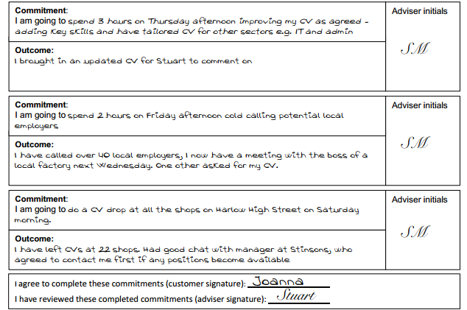
Figure B3: Content of Jobseeker Journey
Activity | Completed
Getting started
I have completed my benefit claim
I have completed the ‘About Me’ profile
I have agreed job goals with my personal adviser
I can find jobs on/in:
Employer websites
Newspapers/magazines and online newspaper websites
Job/recruitment websites
Jobcentre terminals
Getting going
I have an appropriate email account and voicemail
I have got access to the Internet
I have updated my CV
I have registered on job websites
I have signed up with recruitment agencies
I have established a job-searching routine
I have identified and contacted local employers
I have researched local transport
I have written a covering letter
I have produced tailored CVs and covering letters for different sectors
Keeping going
I have practised my interview skills
I have identified my personal strengths
I have completed the expressive writing exercises
I have undertaken volunteering, work experience or training
I have secured interviews
I have got feedback on my interviews
Moving on
I have secured a job
I have signed off from benefits
Please come back and tell us about your success.
The Jobcentre could help you with financial barriers once you have been offered a job.

Appendix C: Randomisation inference code
ritest treat _b[treat], reps(1000) seed(22022019) :reg flowoff13 treat clusterid1-clusterid12 month1, cluster(centre) robust

