**Supplementary Material for**

**Pivotal Politics and the Ideological Content of Landmark Laws**

**Appendix 1 – Summary Statistics**

**Table A1-1. Summary Statistics**

|  |  |  |  |  |  |
| --- | --- | --- | --- | --- | --- |
| Variable | Mean | Median | Std. Dev. | Min | Max |
| *Landmark Laws* | 9.94 | 9.50 | 3.63 | 4 | 19 |
| *Ideological Landmark Laws* | 5.85 | 5.50 | 2.83 | 2 | 12 |
| *Non-Ideological Landmark Laws* | 4.09 | 4.00 | 2.19 | 1 | 12 |
| *CS DW-NOMINATE Gridlock Interval* | 0.44 | 0.42 | 0.11 | 0.24 | 0.65 |
| *Unified Government* | 0.38 | 0 | 0.49 | 0 | 1 |
| *Policy Mood* | 63.68 | 63.42 | 4.13 | 56.57 | 72.41 |
| *GDP Growth* | 3.17 | 3.28 | 1.71 | -0.15 | 6.55 |
| *War* | 0.29 | 0 | 0.46 | 0 | 1 |
| *CS DW-NOMINATE Partisan Polarization* | 0.63 | 0.61 | 0.10 | 0.50 | 0.87 |
| *Proportion of Landmark Laws that are Ideological* | 0.58 | 0.58 | 0.16 | 0.14 | 0.89 |
| *Adjusted ADA Score Gridlock Interval* | 42.9 | 41.35 | 11.13 | 24.84 | 66.29 |

**Figure A1-1. Policy Mood Over Time**



**Figure A1-2. GDP Growth Over Time**



**Figure A1-3. Average Senate and House Polarization on First-Dimension Common Space**

**DW-NOMINATE, 80th – 113th Congresses**



**Figure A1-4. Ideological Landmark Laws as a Percentage of All Landmark Laws,**

**80th – 113th Congresses**



**Figure A1-5. Cartel Blockout Interval on the Policy Line, 80th – 113th Congresses**

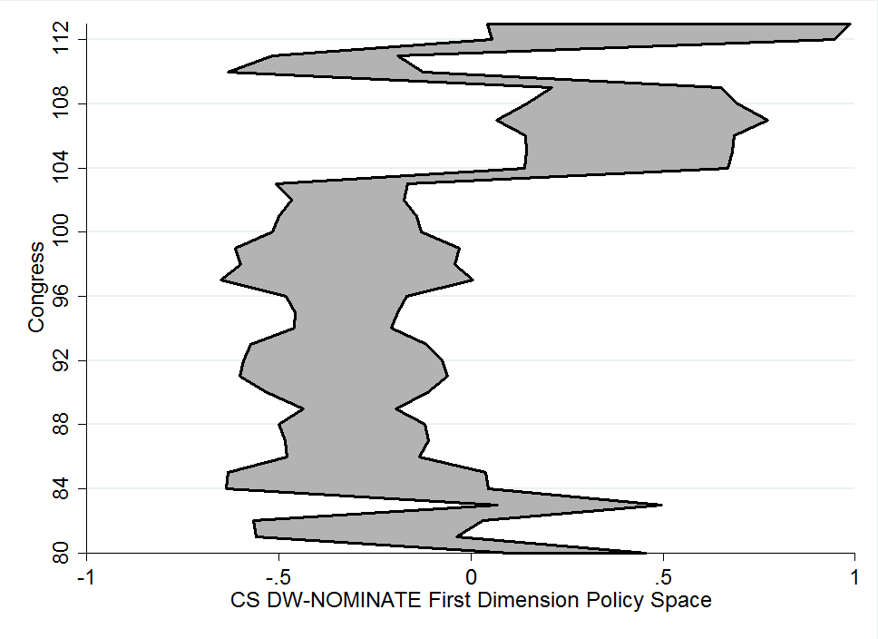

**Figure A1-6. Cartel-Plus-Pivots Blockout Interval on the Policy Line,**

**80th – 113th Congresses**

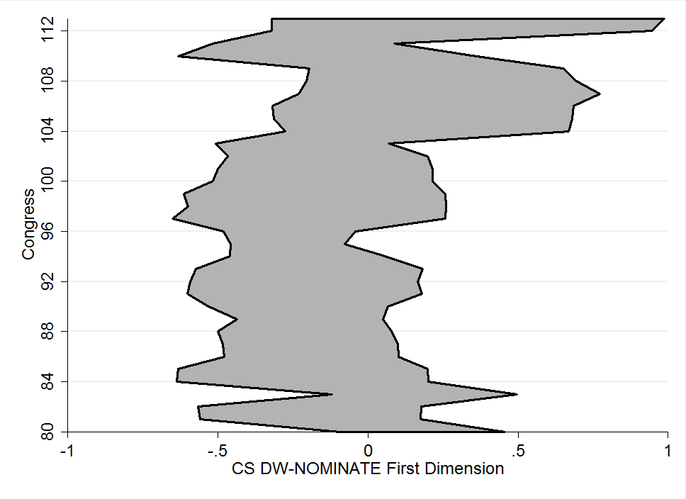

**Appendix 2 - Extension to Partisan Polarization**

While our focus in the main text is on Pivotal Politics, and the composition and impact of the gridlock interval, we believe that our arguments may apply to other studies of legislative productivity that rely on measures of ideological preferences. One such area of research is on the effect of partisan polarization. A logical question is whether polarization – the increasing ideological divide between the two parties – leads to gridlock and limits legislative productivity. McCarty, Poole, and Rosenthal (2006) found a negative relationship between partisan polarization in the House and the number of significant enactments in the post-War period, while McCarty (2007) uncovered a similar negative relationship in the pre-War period. Yet, this framework suffers from the same problems that we have identified in testing Pivotal Politics. Specifically, it relies on aggregated law counts and ideological preference measures.

In Table A2-1, we present the results of three OLS regression models that replicate those found in Tables 1 and 2, except that we replace **Gridlock Interval** with **Partisan Polarization**,[1] measured as the average of the interparty mean distances in the House and the Senate in first-dimension Common Space DW-NOMINATE scores.[2] We test the impact of partisan polarization on the production of all landmark laws (first model), all ideological landmark laws (second model), and all non-ideological landmark laws (third model). We expect that partisan polarization is negatively related to the production of ideological landmark laws, but make no prediction regarding its relationship to non-ideological landmark laws or total landmark laws.

[Table A2-1 about here]

The results in Table A2-1 generally match those reported in Tables 1 and 2.[3] When the dependent variable is all landmark laws, the coefficient for partisan polarization is not statistically significant.[4] When we separate the dependent variable by landmark law type, a familiar pattern emerges: partisan polarization is negatively associated with the production of ideological landmark laws, but positively associated with the production of non-ideological landmark laws. A one-standard-deviation increase in the level of partisan polarization corresponds to 3.66 *fewer* expected ideological landmark laws and 3.05 *more* expected non-ideological landmark laws. These effect sizes exceed those that we reported for changes in the gridlock interval (Table 2), though with greater uncertainty.[5]

Overall, these results show that our argument carries over to other literatures that focus on legislative productivity and incorporate ideological-preference measures. In this case, partisan ideological polarization has the predicted (negative) effect on the production of ideological laws – but *not* on the production of non-ideological laws.

References:

McCarty, Nolan. 2007. “The Policy Consequences of Political Polarization.” In Paul Pierson and Theda Skocpol, eds. *The Transformation of the American Polity.* Princeton: Princeton University Press.

McCarty, Nolan, Keith T. Poole, and Howard Rosenthal. 2006. *Polarized America: The Dance of Political Ideology and Unequal Riches*. Cambridge, MA: MIT Press.

**Table A2-1. Impact of Partisan Polarization on Ideological and Non-Ideological**

**Landmark Laws, 80th – 113th Congresses**

|  |  |  |  |  |
| --- | --- | --- | --- | --- |
| Variable | *Expectation* | *All*  *Landmark Laws* | *Ideological Landmark Laws* | *Non-Ideological Landmark*  *Laws* |
| Partisan Polarization | *n.a.* / $-$/ *n.a.* | -12.93  (17.05) | -34.86*  (15.29) | 29.06*  (10.91) |
| Unified Government | *n.a.* / $+$/ *n.a.* | 1.33  (1.02) | 0.31  (1.02) | 0.86  (0.73) |
| Policy Mood | *n.a.* / $+$/ *n.a.* | 0.17  (0.16) | 0.06  (0.15) | 0.17  (0.09) |
| GDP Growth | *n.a.* / $-$/ *n.a.* | -0.27  (0.33) | -0.13  (0.30) | -0.19  (0.25) |
| War | *n.a.* / $+$/ *n.a.* | 3.82*  (1.48) | 2.53*  (1.13) | 1.84  (0.95) |
| Constant |  | -16.03  (19.18) | -13.90  (16.69) | -3.16  (6.96) |
| N |  | 32 | 32 | 32 |
| R2 |  | 0.44 | 0.37 | 0.38 |
| Durbin-Watson Statistic |  | 1.84 | 1.73 | 1.99 |
| Durbin’s Alternative Test (F) |  | 0.07 (*p*<0.80) | 0.63 (*p*<0.44) | 0.00 (*p*<0.99) |

Note: Numbers in cells are Ordinary Least Squares regression coefficients with Newey-West standard errors in parentheses. Each model includes a time trend and a one-Congress lagged version of the dependent variable. One-tailed tests are used for all coefficients with a specified directional prediction. Two-tailed tests are used for all other coefficients.

\**p*<0.05, \*\**p*<0.01.

**Appendix 3 – Replications Using Alternative Model Choices**

**Table A3-1. Impact of Gridlock Interval on Landmark Laws,**

**80th – 113th Congresses;**

**Negative Binomial Results (Replicating Table 1)**

|  |  |  |  |
| --- | --- | --- | --- |
| Variable | *Expectation* | *(1)* | *(2)* |
| Gridlock Interval (NOM) | $$-$$ | -0.24  (0.62) | -0.52  (0.82) |
| Unified Government | $$+$$ |  | 0.08  (0.11) |
| Policy Mood | $$+$$ |  | 0.02  (0.02) |
| GDP Growth | $$-$$ |  | -0.02  (0.03) |
| War | $$+$$ |  | 0.38**  (0.14) |
| Constant |  | 1.36*  (0.60) | 0.06  (1.64) |
| N |  | 33 | 32 |
| Pseudo R2 |  | 0.02 | 0.09 |

Note: Numbers in cells are negative binomial regression coefficients with robust standard errors in parentheses. Both models include a time trend and a one-Congress lagged version of the dependent variable. One-tailed tests are used for all coefficients with a specified directional prediction. Two-tailed tests are used for all other coefficients.

\**p*<0.05, \*\**p*<0.01.

**Table A3-2. Impact of Gridlock Interval on Ideological and Non-Ideological Landmark Laws, 80th – 113th Congresses;**

**Negative Binomial Results (Replicating columns one and two of Table 2)**

|  |  |  |  |
| --- | --- | --- | --- |
| Variable | *Expectation* | *Ideological Landmark*  *Laws* | *Non-Ideological Landmark*  *Laws* |
| Gridlock Interval (NOM) | $-$/ *n.a.* | -3.57**  (1.08) | 4.27**  (1.28) |
| Unified Government | $+$/ *n.a.* | -0.26  (0.16) | 0.52**  (0.17) |
| Policy Mood | $+$/ *n.a.* | 0.03  (0.02) | 0.02  (0.02) |
| GDP Growth | $-$/ *n.a.* | -0.01  (0.04) | -0.06  (0.05) |
| War | $+$/ *n.a.* | 0.59***  (0.14) | 0.19  (0.17) |
| Constant |  | -1.51  (2.05) | -0.41  (1.71) |
| N |  | 32 | 32 |
| Pseudo R2 |  | 0.11 | 0.13 |

Note: Numbers in cells are negative binomial regression coefficients with robust standard errors in parentheses. Both models include a time trend and a one-Congress lagged version of the dependent variable. One-tailed tests are used for all coefficients with a specified directional prediction. Two-tailed tests are used for all other coefficients.

\**p*<0.05, \*\**p*<0.01, \*\*\**p*<0.001

**Table A3-3. Impact of ADA-Based Gridlock Interval on Ideological and Non-Ideological Landmark Laws, 80th – 112th Congresses;**

**Negative Binomial Results (Replicating Table 4)**

|  |  |  |  |  |
| --- | --- | --- | --- | --- |
| **Variable** | **Expectation** | **All Landmark Laws** | **Ideological Landmark**  **Laws** | **Non-Ideological Landmark**  **Laws** |
| Gridlock Interval (ADA) | *n.a.* / $-$/ *n.a.* | 0.00  (0.08) | -0.02*  (0.01) | 0.04**  (0.02) |
| Unified Government | *n.a.* / $+$/ *n.a.* | 0.14  (0.09) | -0.07  (0.17) | 0.41  (0.22) |
| Policy Mood | *n.a.* / $+$/ *n.a.* | 0.02  (0.02) | 0.02  (0.02) | 0.03  (0.02) |
| GDP Growth | *n.a.* / $-$/ *n.a.* | -0.03  (0.04) | -0.00  (0.05) | -0.10  (0.07) |
| War | *n.a.* / $+$/ *n.a.* | 0.35*  (0.14) | 0.53**  (0.19) | 0.24  (0.23) |
| Constant |  | 0.52  (1.69) | -0.98  (1.98) | -0.55  (2.34) |
| N |  | 31 | 31 | 31 |
| Pseudo R2 |  | 0.09 | 0.09 | 0.13 |

Note: Numbers in cells are negative binomial regression coefficients with robust standard errors in parentheses. Both models include a time trend and a one-Congress lagged version of the dependent variable. One-tailed tests are used for all coefficients with a specified directional prediction. Two-tailed tests are used for all other coefficients.

\**p*<0.05, \*\**p*<0.01.

**Table A3-4. Impact of Partisan Polarization on Ideological and Non-Ideological Landmark Laws, 80th – 113th Congresses;**

**Negative Binomial Results (Replicating Table A2-1)**

|  |  |  |  |  |
| --- | --- | --- | --- | --- |
| **Variable** | **Expectation** | **All Landmark Laws** | **Ideological Landmark**  **Laws** | **Non-Ideological Landmark**  **Laws** |
| Partisan Polarization | *n.a.* / $-$/ *n.a.* | -1.50  (1.82) | -6.82*  (2.98) | 7.10**  (2.30) |
| Unified Government | *n.a.* / $+$/ *n.a.* | 0.12  (0.08) | 0.07  (0.13) | 0.18  (0.16) |
| Policy Mood | *n.a.* / $+$/ *n.a.* | 0.02  (0.01) | 0.01  (0.02) | 0.04  (0.02) |
| GDP Growth | *n.a.* / $-$/ *n.a.* | -0.02  (0.03) | -0.02  (0.04) | -0.04  (0.05) |
| War | *n.a.* / $+$/ *n.a.* | 0.35**  (0.13) | 0.40**  (0.15) | 0.41*  (0.16) |
| Constant |  | -0.20  (1.66) | -1.84  (2.35) | -0.28  (1.40) |
| N |  | 32 | 32 | 32 |
| Pseudo R2 |  | 0.09 | 0.09 | 0.10 |

Note: Numbers in cells are negative binomial regression coefficients with robust standard errors in parentheses. Both models include a time trend and a one-Congress lagged version of the dependent variable. One-tailed tests are used for all coefficients with a specified directional prediction. Two-tailed tests are used for all other coefficients.

\**p*<0.05, \*\**p*<0.01.

**Table A3-5. Impact of Gridlock Interval and Partisan Polarization on Proportion of Landmark Laws that Are Ideological, 80th – 113th Congresses;**

**(Extending the results of Tables 4 and A2-1)**

|  |  |  |
| --- | --- | --- |
| **Variable** | **Model 1** | **Model 2** |
| Gridlock Interval (ADA) | -0.01***  (0.00) | -- |
| Partisan Polarization | -- | -3.67**  (4.39) |
| Unified Government | -0.11  (0.06) | -0.04  (0.05) |
| Policy Mood | 0.00  (0.01) | -0.01  (0.01) |
| GDP Growth | 0.02  (0.02) | 0.01  (0.02) |
| War | 0.12  (0.07) | 0.04  (0.01) |
| Constant | 0.20  (0.92) | -0.18  (0.87) |
| N | 31 | 32 |
| Pseudo R2 | 0.30 | 0.30 |

Note: Numbers in cells are Ordinary Least Squares regression coefficients with robust standard errors in parentheses. Adjusted ADA scores cover the period from the 80th to 112th Congresses, while Partisan Polarization scores extend to the 113th Congress. Both models include a time trend and a one-Congress lagged version of the dependent variable. All tests are two-tailed.

\**p*<0.05, \*\**p*<0.01, \*\*\**p*<0.001

**Table A3-6. Impact of Gridlock Interval and Partisan Polarization on Proportion of Landmark Laws that Are Ideological, 80th – 113th Congresses;**

**Fractional Logistic Regression Results (Replicating column three of Table 2 and columns one and two of Table A3-5)**

|  |  |  |  |
| --- | --- | --- | --- |
| **Variable** | **Model 1** | **Model 2** | **Model 3** |
| Gridlock Interval (NOM) | -8.34***  (1.42) | -- | -- |
| Gridlock Interval (ADA) | -- | -0.05***  (0.01) | -- |
| Partisan Polarization | -- | -- | -15.32***  (4.39) |
| Unified Government | -0.91**  (0.27) | -0.46  (0.23) | -0.16  (0.23) |
| Policy Mood | 0.01  (0.03) | 0.00  (0.04) | -0.02  (0.03) |
| GDP Growth | 0.06  (0.07) | 0.10  (0.07) | 0.05  (0.08) |
| War | 0.45  (0.22) | 0.48*  (0.24) | 0.05  (0.24) |
| Constant | -0.77  (3.11) | -1.37  (3.50) | -2.87  (3.31) |
| N | 32 | 31 | 32 |
| Pseudo R2 | 0.04 | 0.03 | 0.02 |

Note: Numbers in cells are fractional logistic regression coefficients with robust standard errors in parentheses. NOMINATE and Adjusted ADA scores cover the period from the 80th to 112th Congresses, while Partisan Polarization scores extend to the 113th Congress. All three models include a time trend and a one-Congress lagged version of the dependent variable. Model 1 includes an additional two-Congress lagged version of the dependent variable. All tests are two-tailed.

\**p*<0.05, \*\**p*<0.01, \*\*\**p*<0.001

**Appendix 4 – Model Results Including a Measure of “Newly Ungridlocked” Policy Space**

In this paper, we analyze pivotal politics as a static, one-shot game, and assume a uniform distribution of status quo points at the start of that game. This is a substantial simplification on the reality of thousands of votes over more than fifty years. One possible implication of a dynamic, repeated version of pivotal politics is the warping of the starting distribution. As status quos are enacted into law, they are moved into the gridlock interval, where they are captured. In theory then, the space previously gridlocked should be disproportionately saturated with status quos. Thus, when the policy space transitions from being within the gridlock interval to without, an extra amount of status quos becomes newly movable. One plausible outcome is that the size of this newly movable space should be *positively* related to the production of ideological laws.

We do not favor a strict version of this interpretation, in which this “newly ungridlocked space” is the predominant policy space from which new laws can come. Potential legislation is in sufficient quantity, legislating time is sufficiently limited, and policy positions sufficiently dynamic over time, that each Congress likely begins with movable status quo points both within and without the newly ungridlocked space. If we assume that not every status quo is moved in a time-limited Congress, and we recognize that Pivotal Politics does not provide a theory of agenda or voting order, then there is no reason to expect that this newly ungridlocked space is special. Despite our reservations about this interpretation, we test it here for a fuller analysis of the Pivotal Politics theory and the ways it is interpreted in the literature.

To test the implication that newly ungridlocked policy space is the strongest indicator of legislating potential in this appendix, we include a measure of **Newly Ungridlocked Space**, which is the amount of space on the policy line that is not gridlocked in the current Congress but *was* gridlocked in the preceding Congress. Note that this is not the same as the net change in the gridlock interval from one Congress to the next. This is easily illustrated by imagining a gridlock zone from -0.5 to 0.5 and another in the next time period from -0.25 to 0.75 on a [-1,1] policy line. The net change of the gridlock zone’s size is 0. Yet a space of 0.25 (from -0.5 to -0.25) is freshly ungridlocked by the change in the location of pivotal actors. In this appendix, we focus on the 0.25. This 0.25 may be deemed of special value because policies may have been moved into this space in previous congresses and become trapped there, but are now free to be moved. The size of this newly ungridlocked space for each Congress is presented in Figure A3-1. When this space is larger, we expect more laws to be passed.

[Figure A4-1 about here.]

We estimate these relationships using negative binomial regressions, with a different dependent variable in each of three models. The outcome in Model 1 is all landmark laws. In Model 2, it is landmark ideological laws. And in Model 3, it is landmark non-ideological laws. In table A4-1, we present a model with New Ungridlocked Space entered in place of the absolute size of the gridlock zone. In Table A4-2, we add the absolute size of the gridlock zone back into the model, to test how they perform together. The two variables (the new space and the absolute size) are correlated at -0.35.

[Table A4-1 about here.]

[Table A4-2 about here.]

Table A4-1 provides some initial support for a reading of Pivotal Politics that focuses on the “specialness” of the newly opened space. When included by itself, the size of this space is positively associated with an increase in significant ideological law production, as Pivotal Politics predicts. Consistent with other results in the main manuscript, Models 1 and 3 in Table A4-1 show no significant relationship with overall significant law productivity, and a negative relationship with non-ideological significant law productivity. Despite these results, Table A4-2 provides a clearer picture. When the absolute size of the gridlock interval is added back into the model, newly ungridlocked space measure is no longer significant. It appears that the success of the newly ungridlocked space measure in Table A4-1 is primarily due to its ability to partially stand in for the absolute size of the gridlock interval (given the correlation of -0.35). This suggests that the newly ungridlocked space is not special, in that it either does not contain a substantial excess of policy status quos or at least that these positions are not given any special priority in the agenda.

This implies limitations in treating the theory rigidly, especially when imagining it in a repeated-game format. In this paper, we focus on the broader implication of Pivotal Politics: namely, that the amount of ideological space blocked off by pivotal actors is indicative of the ease of passing legislation. The support for this appears to be robust and contradicts alternative theories and popular narratives about unified partisan control of Congress and the presidency. More specific expectations that rely on exacting assumptions about precisely where policies are moved to, how much they move once they are legislated on, and what portion of the available status quos are acted on in a given time period may not hold up, as shown in this appendix.

**Figure A4-1. Size of Newly Ungridlocked Policy Space, 80th – 113th Congresses**



**Table A4-1. Impact of Newly Ungridlocked Space on Productivity of Landmark Laws,**

**80th – 113th Congresses**

|  |  |  |  |  |
| --- | --- | --- | --- | --- |
| Variable | *Expectation* | *All Landmark Laws* | *Ideological Laws* | *Non-Ideological Laws* |
| Newly Ungridlocked Space | *n.a.* / $+$/ *n.a.* | -0.47  (0.66) | 1.99*  (1.02) | -2.51*  (1.09) |
| Unified Government | *n.a.* / $+$/ *n.a.* | 0.14  (0.09) | -0.04  (0.15) | 0.33**  (0.15) |
| Policy Mood | *n.a.* / $+$/ *n.a.* | 0.01  (0.02) | 0.02  (0.02) | 0.02  (0.02) |
| GDP Growth | *n.a.* / $-$/ *n.a.* | -0.03  (0.03) | -0.01  (0.05) | -0.06  (0.05) |
| War | *n.a.* / $+$/ *n.a.* | 0.36**  (0.13) | 0.38*  (0.16) | 0.39*  (0.19) |
| Constant |  | 0.62  (1.45) | -0.31  (2.11) | -1.39  (1.47) |
| N |  | 32 | 32 | 32 |
| Pseudo R2 |  | 0.09 | 0.08 | 0.12 |

Note: Numbers in cells are negative binomial regression coefficients with robust standard errors in parentheses. Both models include a time trend and a one-year lagged version of the dependent variable. One-tailed tests are used for all coefficients with a specified directional prediction. Two-tailed tests are used for all other coefficients.

\**p*<0.05, \*\**p*<0.01.

**Table A4-2. Impact of Newly Ungridlocked Space on Productivity of Landmark Laws,**

**80th – 113th Congresses**

|  |  |  |  |  |
| --- | --- | --- | --- | --- |
| Variable | *Expectation* | *All Landmark Laws* | *Ideological Laws* | *Non-Ideological Laws* |
| Gridlock Interval | *n.a.* / $-$/ *n.a.* | -1.11  (0.95) | -3.56**  (1.22) | 3.01*  (1.19) |
| Newly Ungridlocked Space | *n.a.* / $+$/ *n.a.* | -1.07  (0.71) | 0.01  (0.97) | -2.51*  (1.09) |
| Unified Government | *n.a.* / $+$/ *n.a.* | 0.07  (0.11) | -0.26  (0.16) | 0.51**  (0.16) |
| Policy Mood | *n.a.* / $+$/ *n.a.* | 0.02  (0.02) | 0.03  (0.02) | 0.02  (0.02) |
| GDP Growth | *n.a.* / $-$/ *n.a.* | -0.02  (0.03) | -0.01  (0.04) | -0.07  (0.05) |
| War | *n.a.* / $+$/ *n.a.* | 0.42**  (0.15) | 0.59**  (0.15) | 0.26  (0.18) |
| Constant |  | 0.17  (1.55) | -1.51  (2.03) | -0.09  (1.57) |
| N |  | 32 | 32 | 32 |
| Pseudo R2 |  | 0.10 | 0.11 | 0.14 |

Note: Numbers in cells are negative binomial regression coefficients with robust standard errors in parentheses. Both models include a time trend and a one-year lagged version of the dependent variable. One-tailed tests are used for all coefficients with a specified directional prediction. Two-tailed tests are used for all other coefficients.

\**p*<0.05, \*\**p*<0.01.

1. The correlation between the NOMINATE-based gridlock interval measure and the partisan polarization measure is 0.8.
2. These same models, estimated using a Negative Binomial regression, are presented in Appendix 3, Table A3-4. All results for the Partisan Polarization variable are consistent with those found using OLS.
3. The polarization measure also has a negative effect on the percentage of landmark laws that are ideological – mirroring the result found with the gridlock interval in Table 2 of the main text. This result is presented in Table A3-5, column 2 (OLS), and replicated in Table A3-6, column 3 (fractional logit).
4. This is a different result than McCarty, Poole, and Rosenthal (2006) and McCarty (2007) report. One reason is that both sets of authors construct their dependent variable by combining Mayhew’s Sweep One and Sweep Two laws. This is problematic for a number of reasons. First, as Howell et al. (2000) argue, the two Sweeps are very different, and their combination makes it difficult to make appropriate time-series corrections. Second, Sweep Two has been very unevenly applied, and not at all in recent years. This biases the overall count down in later years, when only Sweep One is included. Since polarization has increased in that period, combining the two Sweeps biases the results *toward* finding a negative effect for polarization. Sweep Two laws may also be substantively misleading. Laws deemed significant only in retrospect may have become so due to events that are largely unrelated to the initial purpose of the legislation, such as the way courts and agencies subsequently interpreted them, policy drift, or shocks to the system that made a trivial policy significant. It is unlikely that policies that were not seen as significant at the time drove the kind of partisan-ideological conflict imagined by polarization theories. McCarty (2007) sought to solve this problem by including a dummy variable to distinguish between Mayhew’s pre- and post-publication techniques, including the Sweep Two differences. However, given the methodological problems posed by their combination and the dubious substantive value of these Sweep Two laws, we believe that excluding them is the most justifiable option. Ultimately, we report results consistent with McCarty, Poole, and Rosenthal (2006) and McCarty (2007), but only after narrowing the dependent variable to include just ideological legislation.
5. Note also that the polarization-model fits, as measured by R2, are poorer than the gridlock-interval-model fits: 0.37 vs. 0.44 (ideological landmark laws) and 0.38 vs. 0.45 (non-ideological landmark laws).