Supplementary materials
Supplementary materials A: Experimental materials
Sentences and comprehension questions used in the study. “_” indicated which words were presented in one frame.

Wh-conditions
“what” version is in a; “whether” version is in b.
1a. The_nurse asked what the_doctor prescribed the_medicine for after the_patient_left.
Did the nurse ask about the prescription? Y
1b. The_nurse asked whether the_doctor prescribed the_medicine for the flu after the_patient_left.
Did the nurse ask about the prescription? Y
2a. The_student wondered what the_professor created the_assignment for at the_end_of_the_year.
2b. The_student wondered whether the_professor created the_assignment for the course at the_end_of_the_year.
3a. The_writer wanted_to_know what the_publisher approved the_article for after the_meeting.
Did the writer approve the article? N
3b.The_writer wanted_to_know whether the_publisher approved the_article for the journal after the_meeting.
Did the writer approve the article? N
4a. The_reporter asked what the_player caught the_ball with to block_the_shot.
Did the player drop the ball? N
4b. The_reporter asked whether the_player caught the_ball with his hands to block_the_shot.
Did the player drop the ball? N
5a. The_guard asked what the_thief broke the_glass with to get_into_the_museum.
Did the thief break the glass? Y
5b. The_guard asked whether the_thief broke the_glass with a brick to get_into_the_museum.
Did the thief break the glass? Y
6a. The_guide wondered what the_tourist recognized the_street from during the_bus_tour.
Did the tourist take a bus tour? Y
6b. The_guide wondered whether the_tourist recognized the_street from the magazine during the_bus_tour.
Did the tourist take a bus tour? Y
7a. The_builder wondered what the_worker repaired the_leak with before going_home.
Did the worker repair the leak? Y
7b. The_builder wondered whether the_worker repaired the_leak with some tape before going_home.
Did the worker repair the leak? Y
8a. The_biker wanted_to_know what the_worker blocked the_road for during the_day.
8b. The_biker wanted_to_know whether the_worker blocked the_road for the construction during the_day.
9a. The_supervisor wondered what the_employee reached the_shelf with to get_to_some_boxes.
Did the supervisor reach the shelf? N
9b. The_supervisor wondered whether the_employee reached the_shelf with a ladder to get_to_some_boxes.
Did the supervisor reach the shelf? N
10a. The_operator asked what the_caller requested the_ambulance for on the_college_campus.
10b. The_operator asked whether the_caller requested the_ambulance for the accident on the_college_campus.
11a. The_employer asked what the_company produced the_parts for because nobody_could_say.
11b. The_employer asked whether the_company produced the_parts for the machine because nobody_could_say.
12a. The_man wondered what the_firefighter saved the_documents from when the_alarm_sounded.
Did the firefighter save the man? N
12b. The_man wondered whether the_firefighter saved the_documents from the fire when the_alarm_sounded.
Did the firefighter save the man? N
13a. The_colleague wanted_to_know what the_scientist invented the_procedure for after the_presentation.
Did the colleague invent the procedure? N
13b.The_colleague wanted_to_know whether the_scientist invented the_procedure for the analysis after the_presentation.
Did the colleague invent the procedure? N
14a. The_director asked what the_worker unlocked the_door with that Monday_morning.
Did the director unlock the door? N
14b. The_director asked whether the_worker unlocked the_door with the key that Monday_morning.
Did the director unlock the door? N
15a. The_parent wanted_to_know what the_child watched the_movie about on TV_last_night.
Did the child watch a movie? Y
15b. The_parent wanted_to_know what the_child watched the_movie about on TV_last_night.
Did the child watch a movie? Y
16a. The_woman wondered what the_maid washed the_shirt with to get_rid_of_the_stains.
Did the woman wash the rug? N
16b. The_woman wondered whether the_maid washed the_shirt with some soap to get_rid_of_the_stains.
Did the woman wash the rug? N
17a. The_scientist asked what the_assistant analyzed the_data for in the_lab.
17b. The_scientist asked whether the_assistant analyzed the_data for the experiment in the_lab.
18a. The_assistant wondered what the_host cancelled the_event for after the_call.
18b. The_assistant wondered whether the_host cancelled the_event for the company after the_call.
19a. The_manager asked what the_musician carried the_guitar in on the_tour.
Did the musician bring the guitar? Y
19b. The_manager asked whether the_musician carried the_guitar in the case on the_tour.
Did the musician bring the guitar? Y
20a. The_customer wanted_to_know what the_banker checked the_account for after the_call.
20b.The_customer wanted_to_know whether the_banker checked the_account for a problem after the_call.
21a. The_director wondered what the_assistant controlled the_lights with during the_play.
21b. The_director wondered whether the_assistant controlled the_lights with a switch during the_play.
22a. The_neighbor asked what the_boy crossed the_street for in spite_of_the_traffic.
Did the neighbor cross the street? N
22b. The_neighbor asked whether the_boy crossed the_street for his dog in spite_of_the_traffic.
Did the neighbor cross the street? N
23a. The_nanny wondered what the_boy destroyed the_toy with while he_was_playing.
Did the nanny destroy the toy? N
23b. The_nanny wondered whether the_boy destroyed the_toy with his hands while he_was_playing.
Did the nanny destroy the toy? N
24a. The_guest wanted_to_know what the_waiter lit the_candle with for the_diners.
Did the waiter light the candle? Y
24b.The_guest wanted_to_know whether the_waiter lit the_candle with a match for the_diners.
Did the waiter light the candle? Y
25a. The_customer wondered what the_jeweler needed the_metal for to sell_in_the_store.
Did the jeweler need the metal? Y
25b. The_customer wondered whether the_jeweler needed the_metal for the ring to sell_in_the_store.
Did the jeweler need the metal? Y
26a. The_buyer asked what the_artist painted the_wall with at the_event.
26b. The_buyer asked whether the_artist painted the_wall with a brush at the_event.
27a. The_boy wondered what the_teacher solved the_problem with when it_was_discussed_in_class.
Did the boy solve the problem? N
27b. The_boy wondered whether the_teacher solved the_problem with a calculator when it_was_discussed_in_class.
Did the boy solve the problem? N
28a. The_programmer asked what the_teenager updated the_software for on the_computer.
Did the programmer update the software? N
28b. The_programmer asked whether the_teenager updated the_software for the app on the_computer.
Did the programmer update the software? N
29a. The_student wanted_to_know what the_instructor reviewed the_essay for since no_grades_were_posted.
Did the student review the essay? N
29b. The_student wanted_to_know whether the_instructor reviewed the_essay for the contest since no_grades_were_posted.
Did the student review the essay? N
30a. The_designer asked what the_actor wore the_hat to the other_night.
Did the actor wear the hat? Y
30b. The_designer asked whether the_actor wore the_hat to the party the other_night.
Did the actor wear the hat? Y
31a. The_customer wondered what the_worker removed the_battery from at the_store.
Did the worker remove the battery? Y
31b. The_customer wondered whether the_worker removed the_battery from the phone at the_store.
Did the worker remove the battery? Y
32a. The_passenger wanted_to_know what the_pilot delayed the_flight for but nobody_knew.
Did the pilot delay the flight? Y
32b. The_passenger wanted_to_know whether the_pilot delayed the_flight for the luggage but nobody_knew.
Did the pilot delay the flight? Y
33a. The_engineer asked what the_assistant damaged the_computer with late last_night.
33b. The_engineer asked whether the_assistant damaged the_computer with the virus late last_night.
34a. The_stranger wondered what the_beggar accepted the_money for at the_bus_stop.
Did the beggar accept the money? Y
34b. The_stranger wondered whether the_beggar accepted the_money for some food at the_bus_stop.
Did the beggar accept the money? Y
35a. The_researcher wanted_to_know what the_professor attended the_conference for when they_met.
35b. The_researcher wanted_to_know whether the_professor attended the_conference for the_talk when they_met.
36a. The_policeman asked what the_driver examined the_car for after the_crash.
36b. The_policeman asked whether the_driver examined the_car for any scratches after the_crash.

Coordination-conditions
“and” version is in a; “but” version is in b.
101a. The_biologist studied the_plant and its_flower was very hard to see.
101b. The_biologist studied the_plant but its_flower was very hard to see.
102a. The_woman advertised the_concert and the_festival was completely sold_out last week.
102b. The_woman advertised the_concert but the_festival was completely sold_out last week.
103a. The_maid folded the_blanket and the_laundry was put in a_big basket.
Did the maid fold the sheet? N
103b. The_maid folded the_blanket but the_laundry was put in a_big basket.
Did the maid fold the sheet? N
104a. The_magician performed the_trick and the_joke was later used in a_TV_show.
104b. The_magician performed the_trick but the_joke was later used in a_TV_show.
105a. The_woman baked the_cake and the_pie was made by her daughter.
Did the woman bake the pie? N
105b. The_woman baked the_cake but the_pie was made by her daughter.
Did the woman bake the pie? N
106a. The_sports_fans watched the_match and the_commentary was shown on another channel.
106b. The_sports_fans watched the_match but the_commentary was shown on another channel.
107a. The_man purchased the_painting and the_drawing was bought by his wife.
107b. The_man purchased the_painting but the_drawing was bought by his wife.
108a. The_businessman replied_to the_email and the_phone_call was answered by his secretary.
Did the businessman return the call? N
108b. The_businessman replied_to the_email but the_phone_call was answered by his secretary.
Did the businessman return the call? N
109a. The_trainer planned the_workout and the_schedule was made by the coach.
Did the coach determine the schedule? Y
109b. The_trainer planned the_workout but the_schedule was made by the coach.
Did the coach determine the schedule? Y
110a. The_candy_maker filled the_bowl and the_jar was completely filled with chocolate_bars.
110b. The_candy_maker filled the_bowl but the_jar was completely filled with chocolate_bars.
111a. The_boy rolled_up the_carpet and the_rug was moved by the girl.
Did the girl move the rug? Y
111b. The_boy rolled_up the_carpet but the_rug was moved by the girl.
Did the girl move the rug? Y
112a. The_chef stirred the_soup and the_sauce was stirred by the assistant.
Did the chef stir the soup? Y
112b. The_chef stirred the_soup but the_sauce was stirred by the assistant.
Did the chef stir the soup? Y
113a. The_dog buried the_bone and the_stick was left behind the doghouse.
Did the dog bury the stick? N
113b. The_dog buried the_bone but the_stick was left behind the doghouse.
Did the dog bury the stick? N
114a. The_driver delivered the_package and the_letter was brought by the mailman.
Did the driver deliver the package? Y
114b. The_driver delivered the_package but the_letter was brought by the mailman.
Did the driver deliver the package? Y
115a. The_clerk sold the_phone and the_iPad was sold by his colleague.
Did the clerk sell the iPad? N
115b. The_clerk sold the_phone but the_iPad was sold by his colleague.
Did the clerk sell the iPad? N
116a. The_servant cleaned the_table and the_floor was cleaned by the the_maid.
Did the servant clean the floor? N
116b. The_servant cleaned the_table but the_floor was cleaned by the the_maid.
Did the servant clean the floor? N
117a. The_worker organized the_shed and the_garage was emptied to prepare for_renovations.
117b. The_worker organized the_shed but the_garage was emptied to prepare for_renovations.
118a. The_teacher graded the_exam and the_homework was checked by the assistant.
Did the assistant check the homework? Y
118b. The_teacher graded the_exam but the_homework was checked by the assistant.
Did the assistant check the homework? Y
119a. The_girl chased the_cat and the_dog was chasing the little bunny.
Did the girl chase the cat? Y
119b. The_girl chased the_cat but the_dog was chasing the little bunny.
Did the girl chase the cat? Y
120a. The_architect printed the_design and the_map was drawn by the assistant.
Did the assistant draw the map? Y
120b. The_architect printed the_design but the_map was drawn by the assistant.
Did the assistant draw the map? Y
121a. The_zookeeper fed the_giraffe and the_monkey was entertained by the trainer.
Did the zookeeper entertain the monkey? N
121b. The_zookeeper fed the_giraffe but the_monkey was entertained by the trainer.
Did the zookeeper entertain the monkey? N
122a. The_man built the_table and the_bench was carved by the artist.
Did the artist build the table? N
122b. The_man built the_table but the_bench was carved by the artist.
Did the artist build the table? N
123a. The_tutor explained the_question and the_answer was given in the textbook.
Did the tutor explain the question? Y
123b. The_tutor explained the_question but the_answer was given in the textbook.
Did the tutor explain the question? Y
124a. The_pirate hid the_silver and the_gold was kept in the ship.
Did the pirate hide the gold? N
124b. The_pirate hid the_silver but the_gold was kept in the ship.
Did the pirate hide the gold? N
125a. The_professor wrote the_paper and the_book was published by the journalist.
Did the professor publish the book? N
125b. The_professor wrote the_paper but the_book was published by the journalist.
Did the professor publish the book? N
126a. The_boy received the_card and the_gift was delivered a few_days later.
126b. The_boy received the_card but the_gift was delivered a few_days later.
127a. The_waiter served the_meal and the_dessert was presented by the chef.
Did the chef present the meal? N
127b. The_waiter served the_meal but the_dessert was presented by the chef.
Did the chef present the meal? N
128a. The_man read the_note and the_letter was mailed to the office.
128b. The_man read the_note but the_letter was mailed to the office.
129a. The_scientist mixed the_powder and the_liquid was poured in the bucket.
Did the scientist mix the powder? Y
129b. The_scientist mixed the_powder but the_liquid was poured in the bucket.
Did the scientist mix the powder? Y
130a. The_child planted the_flower and the_tree was planted by the gardener.
Did the gardener plant the tree? Y
130b. The_child planted the_flower but the_tree was planted by the gardener.
Did the gardener plant the tree? Y
131a. The_nanny prepared the_snack and the_drink was left in the fridge.
131b. The_nanny prepared the_snack but the_drink was left in the fridge.
132a. The_customer signed the_form and the_contract was signed by the manager.
Did the customer sign the contract? N
132b. The_customer signed the_form but the_contract was signed by the manager.
Did the customer sign the contract? N
133a. The_musician played the_piano and the_violin was tuned by the director.
Did the director tune the violin? Y
133b. The_musician played the_piano but the_violin was tuned by the director.
Did the director tune the violin? Y
134a. The_engineer sent the_code and the_password was changed in the system.
Did the engineer send the code? Y
134b. The_engineer sent the_code but the_password was changed in the system.
Did the engineer send the code? Y
135a. The_seller advertised the_product and the_discount was applied at the register.
135b. The_seller advertised the_product but the_discount was applied at the register.
136a. The_officer stamped the_passport and the_form was inspected by a_second officer.
136b. The_officer stamped the_passport but the_form was inspected by a_second officer.

Distractor Items
301. The_tourist wondered when the_train would arrive from Paris.
302. The_servant asked when the_suite in the_hotel might be ready so_the_guest_could_check_in.
303. The_advisor wanted_to_know when the_grade from the_exam could be sent to_the_administrators.
304. The_librarian told_us when the_book from the_collection might be returned.
305. The_child wondered when the_cookie from the_jar was eaten.
306. The_student asked when the_meeting for the_group would be held that_day.
307. The_lifeguard wondered why the_pool in the_neighborhood was closed since_nobody_knew.
Was the pool open? N
308. The_artist asked_ why the_supplies were missing from the studio.
Were the supplies in the studio? N
309. The_guide wanted_to_know why the_tour for the_castle would be delayed that_afternoon.
Was the tour on time? N
310. The_photographer told_us why the_photograph in the_album was ripped.
Was the photograph ripped? Y
311. The_customer wanted_to_know why the_cost for the_trip would increase after the break.
312. The_driver told_us why the_bus for the_students was late at_the_bus_stop.
313. The_man wondered how the_decision for the_trial would be made given_the_lack_of_evidence.
314. The_mathematician asked how the_solution in the_manual was described since_he_was_curious.
315. The_guard wanted_to_know how the_alarm in the_museum could be turned off.
316. The_biker told_us_ how the_trail was designed to avoid traffic.
317. The_policeman wondered how the_car in the_garage was stolen last night.
Was the car stolen? Y
318. The_manager asked how the_necklace in the_store disappeared from the_table.
319. The_nanny told_us that the_cake had been in the_oven for_an_hour but_it_was_still_raw.
320. The_assistant mentioned that the_mouse had escaped from the_cage this_morning.
Did the mouse escape from the cage? Y
321. The_director said that the_actress apologized for the_mistake during the_play.
322. The_businessman saw that the_meeting had ended with an_agreement.
323. The_doctor told_us that the_disease had gotten worse over the_years.
Did the disease get worse? Y
324. The_seller mentioned that the_statue sold for thousands of dollars.
325. The_journalist said that the_event took place while it was raining.
Was it raining during the event? Y
326. The_pilot saw that the_weather was too stormy for the_plane to take_off.
327. The_farmer told_us that the_cow had been frightened by the_lightning last_night.
328. The_nanny mentioned that the_show had been playing all day on television.
329. The_buyer said that the_sign fell apart by the_stand next to the_snacks.
Did the sign fall apart? Y
330. The_staff saw that the_supply decreased since the_last time the_store opened.
331. The_programmer told_us that the_network crashed after the_storm last night.
Was the network working after the storm? N
332. The_woman mentioned that the_artwork was broken after someone knocked it over.
333. The_reporter said that the_sun rose earlier than usual this morning.
334. The_gardener saw that the_tree had grown a_lot since last_month.
335. The_mother told_us that the_boy was bitten by a_spider.
Did a bee sting the boy? N
336. The_friend mentioned that the_girl fell off the_bike while playing outside.
Did the girl fall off the scooter? N
401. The_deer ran into the_forest after the_hunter tried to shoot it.
402. The_baby played on the_blanket while the_grandmother sipped her coffee.
403. The_worker knocked on the_door before the_director invited him in.
Did the worker knock on the door? Y
404. The_speaker explained the_idea as the_people listened to the_speech.
405. The_stylist complained about the_price while the_assistant nodded her head in_agreement.
Did the assistant complain? N
406. The_client sat in the_chair as the_man cut his hair.
407. The_athlete trained in the_gym while the_trainer planned his meals.
Did the athlete plan his meals? N
408. The_dentist looked over the_x-ray as the_patient worried about the_cost.
409. The_mother laughed at the_story while the_child looked unhappy.
410. The_surgeon appeared at the_hospital after the_nurse arranged the_equipment for the_surgery.
411. The_engineer gazed at the_plan after the_architect explained the_notes on the_layout.
Did the architect explain the plan? N
412. The_man had just reached the_shelter as the_wind blew the_roof off the_building.
413. The_girl was_worried about her_grades while her_friend ignored the_test_scores.
Did the friend ignore the scores? Y
414. The_student graduated from the_university as his_parents attended the_ceremony.
415. The_daughter helped with the_dinner while the_mother prepared the_table for the_family.
Did the daughter prepare the table? N
416. The_boss paid for the_coffee while the_employee checked his calendar.
417. The_city recovered from the_earthquake as the_workers fixed the_roofs of the_buildings.
418. The_banker responded to the_alert while the_bank prevented the_robbery.
Was the bank robbed? N
419. As the_rabbit was eating the_carrot the_fox came closer.
Did the rabbit come closer? N
420. While the_family was enjoying the_dinner the_pet stared at its_bowl.
421. While the_boy practiced the_song the_relatives listened with excitement.
Were the relatives excited? Y
422. As the_parent started packing the_clothes the_children offered to help.
423. After the_students had handed_in the_test the_teacher explained the answers.
424. Even_though the_man was using a_map he managed to get lost.
425. When the_family planned the_wedding a_friend agreed to take pictures.
426. While the_child was holding the_fork the_parents watched with excitement.
427. As the_celebrity was walking the_streets his_guards formed a_circle around him.
428. While the_cat was climbing the_tree the_kids shouted for its attention.
429. As the_diver approached the_water the_crowd watched in amazement.
Was anyone watching the diver? Y
430. While the_man was testing the_machine his_friend made a_suggestion.
431. As their_son studied abroad the_parents worried about his_safety.
432. Although the_girl wanted a_pony her_parents ignored her wish.
Did the girl wish for a pony? Y
433. Even_though the_actor forgot his_lines the_director hired him for the_play.
434. Although the_boy took the_exam the_teacher could not pass him.
Did the boy fail? Y
435. While the_worker was opening the_window the_man looked confused.
436. While the_man was visiting the_city his_friends suggested a restaurant for lunch.

Supplementary materials B: Analysis using non-transformed raw reading times
The analysis reported in the main text uses log-transformed residual reading times. Below we report analyses using non-transformed raw reading times. We used the same cutoff procedure as in the main text, in which we first omitted all data points that were shorter than 100 ms or longer than 5000, and then omitted data points exceeding the mean plus 2.5 standard deviations for each individual. The main differences with the analysis reported in the main text are that, first, in the analysis on the raw reading times, an adaptation effect was seen in the wh-conditions (interaction of Condition by Number of What items seen); this effect was also present in the by-group analysis of the native English group, but not in the L2 group. Second, in the coordination conditions the triple interaction of Condition by Language Group by Number of And items was weaker. See footnote 2 in the main text for discussion.

Figure SB.1
Raw reading times for selected word positions for the native English and L2 group, wh conditions. The critical position is position 6. Note that the y-axis starts at different points for the two groups.

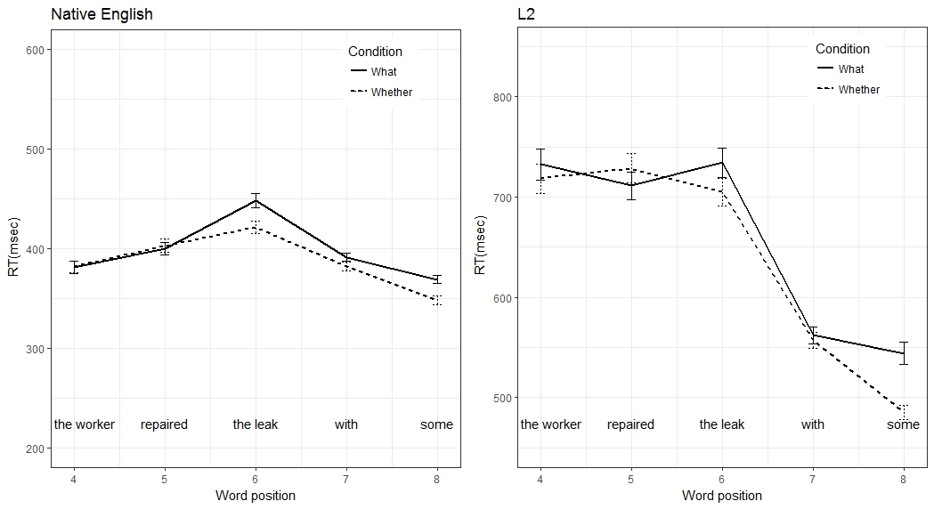
Figure SB.2
Raw reading times for position 6 in the wh-condition as a function of the number of what sentences seen, for the native English and L2 groups.
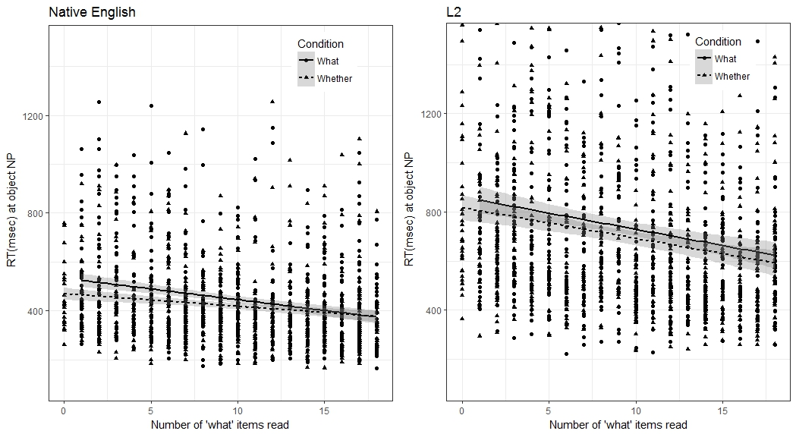

Figure SB.3
Raw readings time for selected word positions for the native English and L2 group, coordination-conditions. The critical position is position 6. Note that the y-axis starts at different points for the two groups.

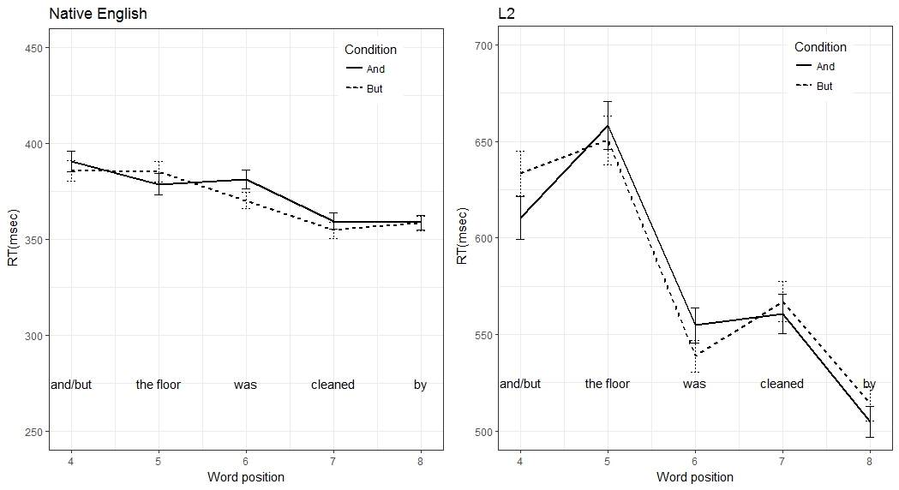
Figure SB.4
Raw reading times for position 6 in the coordination-conditions as a function of the number of and-sentences seen, for the native English and L2 groups. Note that the y-axis starts at different points for the two groups.

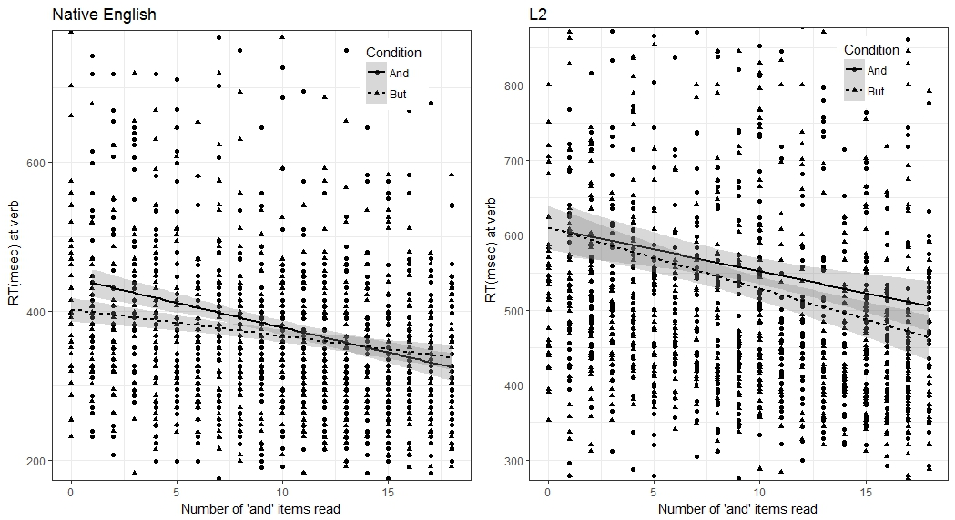

Table S1. Results from the linear mixed effects model using raw reading times for critical word position, wh-conditions
 | Estimate | SE | T-value | p-value
(Intercept) | 580.389 | 20.379 | 28.480 | 0.000***
Condition | 39.494 | 10.475 | 3.770 | 0.000***
Number of What seen | -86.261 | 11.275 | -7.651 | 0.000***
Language Group | 285.805 | 39.547 | 7.227 | 0.000***
Condition × Nr. of What seen | -32.552 | 15.773 | -2.064 | 0.043*
Condition × Language Group | 21.586 | 20.479 | 1.054 | 0.294
Nr. of What seen × Language Group | -42.417 | 20.080 | -2.112 | 0.038*
Condition × Nr. of What seen × Language Group | -7.018 | 30.312 | -0.232 | 0.817
Note: Nr. of What seen: number of preceding what sentences, log transformed. Model: RT ~ Condition * Nr. of What seen * Language Group + (1 + Condition * Nr. of What seen | Subject) + (1 + Condition * Nr. of What seen | Item); 79 subjects; 36 items ; Log-Likelihood: -18804.8. In this and other tables, P-values were determined by lmerTest. *** p < 0.001, ** p < 0.01, * p < 0.05, ⁺p < 0.1.

Table S2. Results from the linear mixed effects model using raw reading times for critical word position, for the native English group, wh-conditions
 | Estimate | SE | T-value | p-value
(Intercept) | 435.881 | 16.385 | 26.603 | 0.000***
Condition | 28.949 | 9.037 | 3.203 | 0.003**
Number of What seen | -62.861 | 7.725 | -8.138 | 0.000***
Condition × Nr. of What seen | -32.283 | 12.128 | -2.662 | 0.008**
Model: RT ~ Condition * Nr. Of What seen + (1 + Condition * Nr. Of What seen || Subject) + (1 + Condition * Nr. Of What seen || Item); 40 subjects; 36 Items; Log-Likelihood: -8828.3.

Table S3. Results from the linear mixed effects model using raw reading times for critical word position, for the L2 group, wh-conditions
 | Estimate | SE | T-value | p-value
(Intercept) | 726.259 | 35.634 | 20.381 | 0.000***
Condition | 52.067 | 18.269 | 2.850 | 0.007**
Number of What seen | -105.910 | 18.563 | -5.705 | 0.000***
LexTale | -5.790 | 3.099 | -1.869 | 0.069⁺
Condition × Nr. of What seen | -36.713 | 26.886 | -1.366 | 0.180
Condition × LexTale | -1.143 | 1.600 | -0.714 | 0.479
Nr. of What seen× LexTale | 2.991 | 1.535 | 1.949 | 0.059⁺
Condition × Nr. of What seen × LexTale | 0.495 | 2.363 | 0.210 | 0.835
Model: RT ~ Condition * Nr. Of What seen + (1 + Condition * Nr. Of What seen | Subject) + (1 + Condition * Nr. Of What seen | Item); 39 subjects; 36 Items; Log-Likelihood: -9678.6.

Table S4. Results from the linear mixed effects model using raw reading times for critical word position, coordination-conditions
 | Estimate | SE | T-value | p-value
(Intercept) | 460.751 | 10.815 | 42.604 | 0.000***
Condition | 21.338 | 6.273 | 3.402 | 0.001***
Number of And seen | -47.015 | 6.160 | -7.632 | 0.000***
Language Group | 168.180 | 21.051 | 7.989 | 0.000***
Condition × Nr. of And seen | -11.524 | 9.609 | -1.199 | 0.233
Condition × Language Group | 9.400 | 12.537 | 0.750 | 0.455
Nr. of And seen × Language Group | -15.770 | 12.302 | -1.282 | 0.204
Condition × Nr. of And seen × Language Group | 35.377 | 18.995 | 1.862 | 0.065⁺
Note: Nr. of And seen: number of preceding And sentences, log transformed. Model: RT ~ Condition * Nr. of And seen * Language Group + (1 + Condition * Nr. of And seen | Subject) + (1 + Condition * Nr. of And seen |Item); 79 subjects; 36 items ; Log-Likelihood: -18330.8

Table S5. Results from the linear mixed effects model using raw reading times for critical word position, for the native English group, coordination-conditions
 | Estimate | SE | T-value | p-value
(Intercept) | 376.741 | 11.261 | 33.454 | 0.000***
Condition | 15.725 | 6.082 | 2.585 | 0.014*
Number of And seen | -38.891 | 5.948 | -6.539 | 0.000***
Condition × Nr. of And seen | -28.282 | 10.397 | -2.720 | 0.010*
Model: RT ~ Condition * Nr. Of And seen + (1 + Condition * Nr. Of And seen | Subject) + (1 + Condition * Nr. Of And seen | Item); 40 subjects; 36 Items; Log-Likelihood: -8655.9.

Table S6. Results from the linear mixed effects model using raw reading times for critical word position for the L2 group, coordination-conditions
 | Estimate | SE | T-value | p-value
(Intercept) | 545.984 | 17.754 | 30.752 | 0.000***
Condition | 26.785 | 10.551 | 2.538 | 0.011*
Number of And seen | -55.216 | 10.908 | -5.062 | 0.000***
LexTale | -2.566 | 1.553 | -1.652 | 0.107
Condition × Nr. of And seen | 5.603 | 15.135 | 0.370 | 0.711
Condition × LexTale | -0.508 | 0.932 | -0.545 | 0.586
Nr. of And seen× LexTale | -1.065 | 0.958 | -1.112 | 0.274
Condition × Nr. of And seen × LexTale | 0.208 | 1.320 | 0.157 | 0.875
Model: RT ~ Condition * Nr. of And seen + (1 + Condition * Nr. of And seen || Subject) + (1 + Condition * Nr. of And seen || Item); 39 subjects; 36 Items; Log-Likelihood: -9392.3.

Supplementary materials C: Analysis on log residual reading times of the wh-conditions, using a more liberal cutoff
A commonly used criterion is to omit data points shorter than 100 ms and longer than 2000 ms, without further cutoff procedures, assuming that the log transformation reduces outliers (Fine, Jaeger, Farmer, & Qian, 2013). In the analysis reported here, we applied a similar procedure to our data. However, the upper limit of 2000 ms may not be appropriate for L2 learners. We therefore approximated the high cutoff value of 2000 ms by taking the mean plus 6.5 standard deviations for the English speakers (calculated over all data points). This amounted to 1947 ms. We then calculated the mean and standard deviation for the L2 data, and also used the mean plus 6.5 standard deviations as a high cutoff (3880 ms) for the L2 data. In both groups, we also omitted data points shorter than 100 ms. This procedure affected less than 0.5% of the all data points in either group. Restricted to the critical word positions (point of disambiguation), the cutoff also affected less than 0.5% of the data for either group. As in the analysis reported in the main text, we then log-transformed the reading times (natural logarithm) to adjust for the skewedness of the distribution. The Box-Cox procedure (Box & Cox, 1964) confirmed that a log transformation was appropriate (maximal λ was -0.6). For the native and L2 groups separately, we calculated residual reading times based on a linear mixed effects model on all data (experimental items as well as distractors), with the length of the word in the number of characters, and the (natural) log-transformed position of the trial in the experiment as fixed effects. Random effects included by-participant intercepts and by-participant slopes for word length and the log of the trial position. As addressed in the discussion of the main text, the native English group showed adaptation effects in this analysis, but not in the analysis reported in the main text using a more conservative cutoff procedure. This suggests that the adaptation effect is driven by only 5% of the data.

Figure SC.1.
Log residual reading times for selected word positions for the native English and L2 group, wh conditions. The critical position is position 6. Note that the y-axis starts at different points for the two groups.

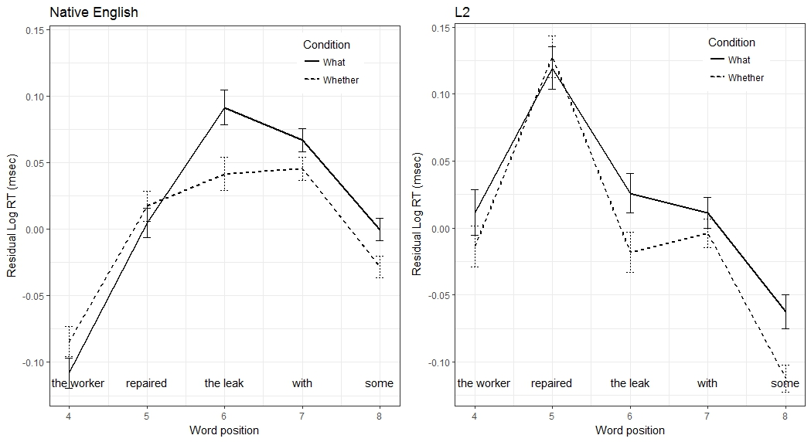
Figure SC.2
Log residual reading times for position 6 in the wh-condition as a function of the number of what sentences seen, for the native English and L2 groups.
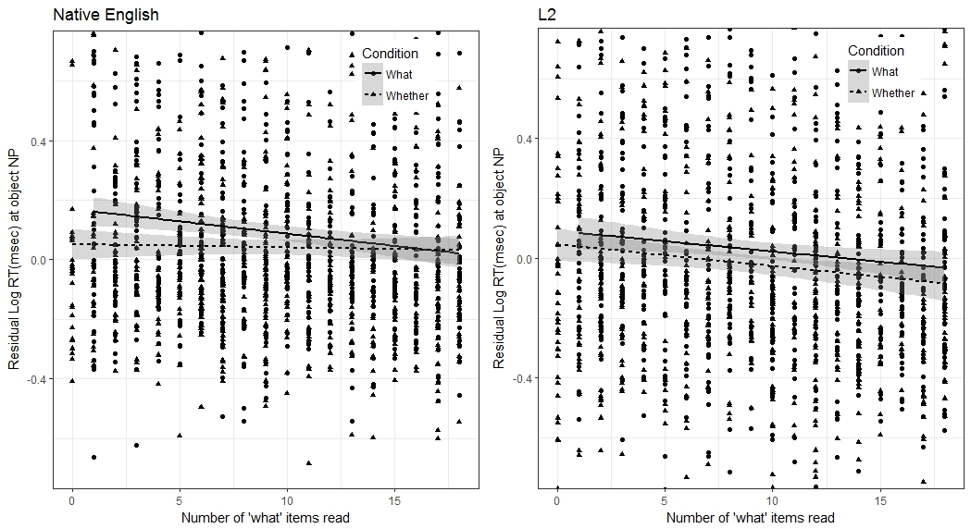

Table S7. Results from the linear mixed effects model using log residual reading times with a liberal cutoff, critical word position, wh-conditions
 | Estimate | SE | T-value | p-value
(Intercept) | 0.037 | 0.016 | 2.279 | 0.025*
Condition | 0.052 | 0.016 | 3.249 | 0.002**
Number of What seen | -0.043 | 0.014 | -3.102 | 0.003**
Language Group | -0.060 | 0.027 | -2.226 | 0.029*
Condition × Nr. of What seen | -0.047 | 0.022 | -2.163 | 0.035*
Condition × Language Group | -0.009 | 0.030 | -0.308 | 0.759
Nr. of What seen × Language Group | -0.022 | 0.025 | -0.871 | 0.386
Condition × Nr. of What seen × Language Group | 0.052 | 0.039 | 1.338 | 0.182
Note: Nr. of What seen: number of preceding what sentences, log transformed. Model: RT ~ Condition * Nr. of What seen * Language Group + (1 + Condition * Nr. of What seen | Subject) + (1 + Condition * Nr. of What seen | Item); 79 subjects; 36 items ; Log-Likelihood: -1060.1. In this and other tables, P-values were determined by lmerTest. *** p < 0.001, ** p < 0.01, * p < 0.05, ⁺p < 0.1.

Table S8. Results from the linear mixed effects model for the native English group, wh-conditions
 | Estimate | SE | T-value | p-value
(Intercept) | 0.067 | 0.015 | 4.424 | 0.000***
Condition | 0.054 | 0.021 | 2.525 | 0.016*
Number of What seen | -0.036 | 0.018 | -1.956 | 0.059⁺
Condition × Nr. of What seen | -0.067 | 0.032 | -2.074 | 0.043*
Model: RT ~ Condition * Nr. Of What seen + (1 + Condition * Nr. Of What seen | Subject) + (1 + Condition * Nr. Of What seen | Item); 40 subjects; 36 Items; Log-Likelihood: -453.7.

Table S9. Results from the linear mixed effects model for the L2 group, wh-conditions
 | Estimate | SE | T-value | p-value
(Intercept) | 0.006 | 0.026 | 0.228 | 0.820
Condition | 0.051 | 0.023 | 2.282 | 0.027*
Number of What seen | -0.052 | 0.019 | -2.797 | 0.009**
LexTale | 0.001 | 0.002 | 0.504 | 0.617
Condition × Nr. of What seen | -0.023 | 0.029 | -0.790 | 0.431
Condition × LexTale | -0.001 | 0.002 | -0.451 | 0.654
Nr. of What seen× LexTale | 0.002 | 0.002 | 1.448 | 0.156
Condition × Nr. of What seen × LexTale | -0.002 | 0.003 | -0.680 | 0.497
Model: RT ~ Condition * Nr. Of What seen + (1 + Condition * Nr. Of What seen | Subject) + (1 + Condition * Nr. Of What seen | Item); 39 subjects; 36 Items; Log-Likelihood: -593.6.

References

Box, G. E., & Cox, D. R. (1964). An analysis of transformations. Journal of the Royal Statistical Society Series B (Methodological), 26, 211-252.
Fine, A. B., Jaeger, T. F., Farmer, T. A., & Qian, T. (2013). Rapid expectation adaptation during syntactic comprehension. PLoS ONE, 8, 1-18. doi:10.1371/journal.pone.0077661

