Online appendix

Scores for all indicators
Case | MOS |  |  |  | UNSOS |  |  | POL |  |  | RES
 | Consumer-facing | Private regulation | Supply chain | High conc. | No leg. proposal | No elite allies | Perceived closed. | Expert group | Salience | Focusing event | Financial resources (euros)
eggs_uk1 | 1 | 1 | 0 | 0.67 | 1 | 1 | 0 | 0.15 | 0.04 | 0 | 1913000
eggs_uk2 | 1 | 1 | 1 | 0.67 | 1 | 1 | 1 | 0.15 | 0.29 | 0 | 34106000
eggs_uk3 | 1 | 1 | 0 | 0.67 | 1 | 1 | 1 | 0.15 | 0.29 | 0 | 926257
eggs_uk4 | 1 | 1 | 1 | 0.67 | 1 | 0 | 0 | 0.15 | 0.01 | 0 | 8056000
antib_uk1 | 1 | 1 | 1 | 0.67 | 0 | 0 | 0 | 0.11 | 0 | 0.67 | 8500000
antib_uk2 | 1 | 1 | 1 | 0.67 | 1 | 1 | 0 | 0.11 | 0.55 | 0.67 | 1217000
antib_uk3 | 0 | 1 | 1 | 0.67 | 0 | 0 | 1 | 0.11 | 0.55 | 0 | 100000
plas_uk1 | 1 | 0 | 0 | 1 | 0 | 0 | 0 | 0.99 | 0.85 | 0.67 | 1009000
plas_uk2 | 1 | 0 | 0 | 1 | 0 | 1 | 0 | 0.99 | 0.83 | 0.67 | 19000000
plas_uk3 | 1 | 0 | 0 | 1 | 0 | 0 | 0 | 0.99 | 0.52 | 0.67 | 2460000
plas_uk4 | 1 | 0 | 0 | 1 | 0 | 0 | 0 | 0.99 | 0.02 | 0.67 | 6500000
digi_uk1 | 1 | 0 | 0 | 1 | 1 | 1 | 1 | 0.64 | 0 | 0 | 460000
digi_uk2 | 0 | 0 | 0 | 1 | 1 | 0 | 1 | 0.64 | 0.97 | 0 | 500000
digi_uk3 | 0 | 0 | 0 | 1 | 1 | 0 | 1 | 0.64 | 0 | 0 | 2483000
eggs_it1 | 1 | 1 | 1 | 0 | 1 | 1 | 0 | 0.15 | 0.32 | 0 | 500000
eggs_it2 | 1 | 1 | 1 | 0 | 1 | 1 | 1 | 0.15 | 0.62 | 0 | 166000
antib_it1 | 0 | 1 | 1 | 0 | 1 | 1 | 0 | 0.11 | 0.53 | 0 | 500000
antib_it2 | 1 | 1 | 1 | 0 | 1 | 1 | 0 | 0.11 | 0.53 | 0 | 5000000
plas_it1 | 1 | 0 | 0 | 1 | 1 | 1 | 1 | 0.99 | 0.29 | 0.67 | 8345907
plas_it2 | 1 | 0 | 0 | 1 | 1 | 0 | 0 | 0.99 | 0.11 | 0.67 | 500000
plas_it3 | 1 | 0 | 0 | 1 | 1 | 0 | 0 | 0.99 | 0.29 | 0.67 | 9500000
plas_it4 | 1 | 0 | 0 | 1 | 1 | 0 | 0 | 0.99 | 0.08 | 0.67 | 5200000
digi_it1 | 0 | 0 | 0 | 1 | 1 | 1 | 1 | 0.64 | 0.99 | 0 | 300000
digi_it2 | 1 | 0 | 0 | 1 | 1 | 0 | 1 | 0.64 | 1 | 1 | 5000000

2. Calibration (histograms)

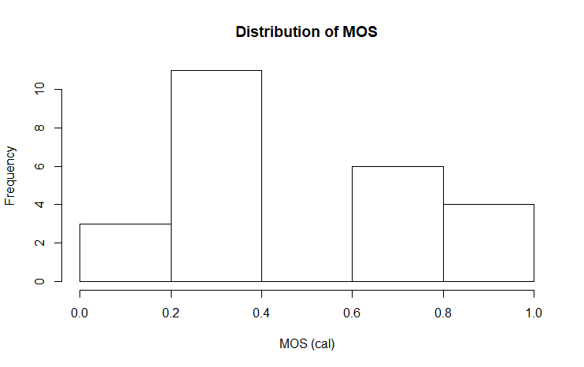
MOS

UNSOS
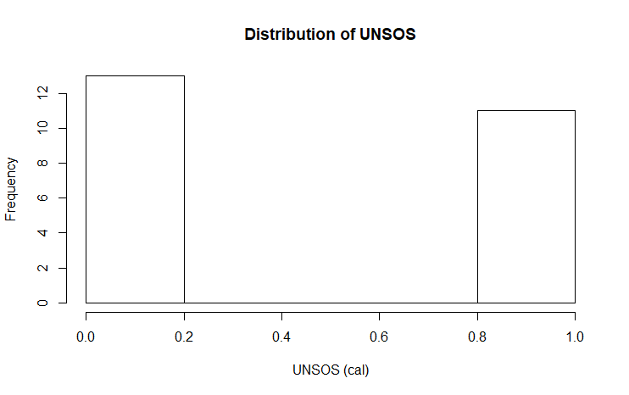

RES

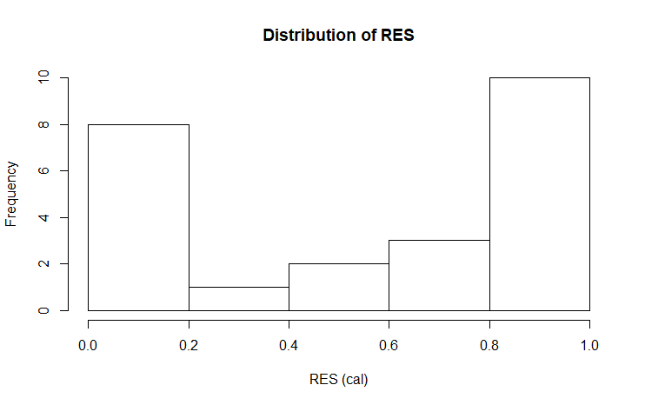

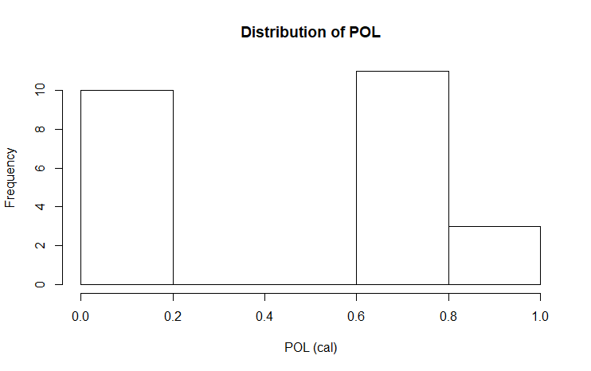
POL

MARKET&COMB
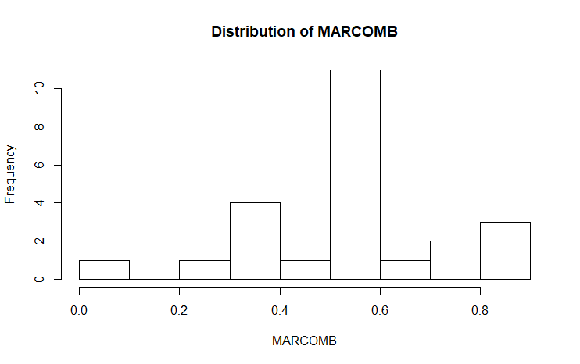

STATE&COMB
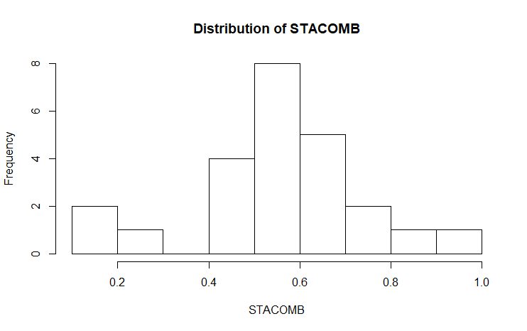

2. Truth tables and solution expressions

STATE (~MARKET&COMB)

MOS | UNSOS | POL | RES | OUT | n | incl | PRI | cases
0 | 0 | 1 | 1 | 1 | 4 | 0.83 | 0.72 | plas_uk2,plas_uk3, plas_uk4,plas_it4
0 | 1 | 1 | 1 | 1 | 4 | 0.80 | 0.61 | digi_uk3,plas_it1, plas_it3,digi_it2
0 | 0 | 1 | 0 | 1 | 2 | 1.00 | 1.00 | plas_uk1,plas_it2
0 | 1 | 0 | 0 | 1 | 2 | 0.85 | 0.59 | digi_uk1,antib_it1
0 | 1 | 1 | 0 | 1 | 2 | 0.80 | 0.56 | digi_uk2,dig_it1
1 | 0 | 1 | 1 | 0 | 2 | 0.79 | 0.51 | antib_uk1,antib_uk2
1 | 0 | 0 | 1 | 0 | 3 | 0.64 | 0.24 | eggs_uk1,eggs_uk4, antib_it2
1 | 1 | 0 | 0 | 0 | 2 | 0.73 | 0.15 | eggs_uk3,eggs_it2
1 | 0 | 0 | 0 | 0 | 2 | 0.68 | 0.32 | antib_uk3,eggs_it1
1 | 1 | 0 | 1 | 0 | 1 | 0.73 | 0.15 | eggs_uk2
0 | 0 | 0 | 0 | ? | 0 | - | -
0 | 0 | 0 | 1 | ? | 0 | - | -
0 | 1 | 0 | 1 | ? | 0 | - | -
1 | 0 | 1 | 0 | ? | 0 | - | -
1 | 1 | 1 | 0 | ? | 0 | - | -
1 | 1 | 1 | 1 | ? | 0 | - | -
Solution expressions cover 14 cases.
Conservative solution
~MOS*POL + ~MOS*UNSOS*~RES + ~UNSOS*POL*RES ~MARKET&COMB
Expression | inclS | PRI | CovS | CovU | Cases
~MOS*POL | 0.82 | 0.69 | 0.60 | 0.47 | plas_uk1, plas_uk2, plas_uk3, plas_uk4, plas_it1, plas_it2, plas_it3, plas_it4, digi_uk2, digi_uk3, digi_it1, digi_it2
~MOS*UNSOS*~RES | 0.69 | 0.45 | 0.24 | 0.11 | antib_it1, digi_uk1, digi_uk2, digi_it1
Whole expression | 0.78 | 0.62 | 0.72

Parsimonious and intermediate solutions
~MOS ~MARKET&COMB
Expression | inclS | PRI | CovS | Cases
~MOS | 0.77 | 0.59 | 0.79 | antib_it1, plas_uk1, plas_uk2, plas_uk3, plas_uk4, plas_it1, plas_it2, plas_it3, plas_it4, digi_uk1, digi_uk2, digi_uk3, digi_it1, digi_it2
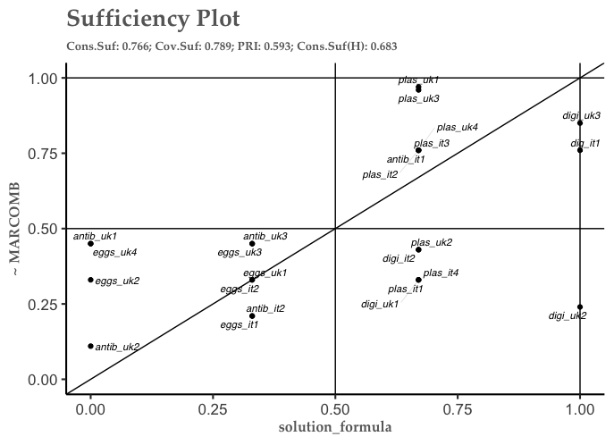

MARKET&COMB
Truth table
MOS | UNSOS | POL | RES | OUT | n | incl | PRI | cases
1 | 0 | 0 | 1 | 1 | 3 | 0.78 | 0.54 | eggs_uk1,eggs_uk4,antib_it2
1 | 1 | 0 | 0 | 1 | 2 | 0.91 | 0.72 | eggs_uk3,eggs_it2
1 | 0 | 0 | 0 | 1 | 2 | 0.81 | 0.59 | antib_uk3,eggs_it1
1 | 1 | 0 | 1 | 1 | 1 | 0.86 | 0.56 | eggs_uk2
0 | 1 | 1 | 1 | 0 | 4 | 0.64 | 0.32 | digi_uk3,plas_it1,plas_it3,digi_it2
0 | 0 | 1 | 1 | 0 | 4 | 0.52 | 0.23 | plas_uk2,plas_uk3,plas_uk4,plas_it4
0 | 1 | 0 | 0 | 0 | 2 | 0.78 | 0.41 | digi_uk1,antib_it1
0 | 1 | 1 | 0 | 0 | 2 | 0.75 | 0.44 | digi_uk2,dig_it1
1 | 0 | 1 | 1 | 0 | 2 | 0.74 | 0.40 | antib_uk1,antib_uk2
0 | 0 | 1 | 0 | 0 | 2 | 0.39 | 0.00 | plas_uk1,plas_it2
0 | 0 | 0 | 0 | ? | 0 | - | -
0 | 0 | 0 | 1 | ? | 0 | - | -
0 | 1 | 0 | 1 | ? | 0 | - | -
1 | 0 | 1 | 0 | ? | 0 | - | -
1 | 1 | 1 | 0 | ? | 0 | - | -
1 | 1 | 1 | 1 | ? | 0 | - | -
Solution terms cover 8 cases. Zero deviant cases in consistency.
Conservative, intermediate and parsimonious solutions
MOS*~POL MARKET&COMB
Expression | inclS | PRI | CovS | Cases
MOS*~POL | 0.83 | 0.60 | 0.65 | eggs_uk1, eggs_uk2, eggs_uk3, eggs_uk4, eggs_it1, eggs_it2, antib_uk3, antib_it2
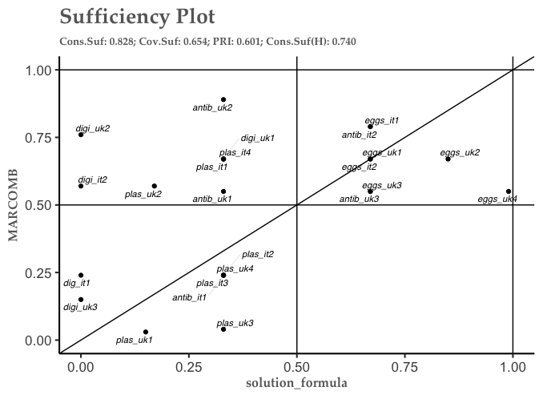

MARKET (~STATE&COMB)
Necessary conditions
MOS (inclN 0.90, RoN 0.80, covN 0.73)
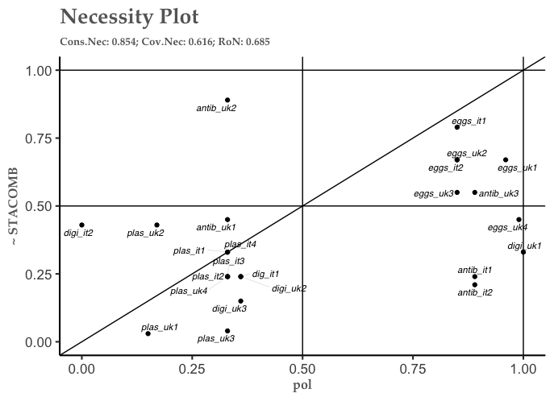
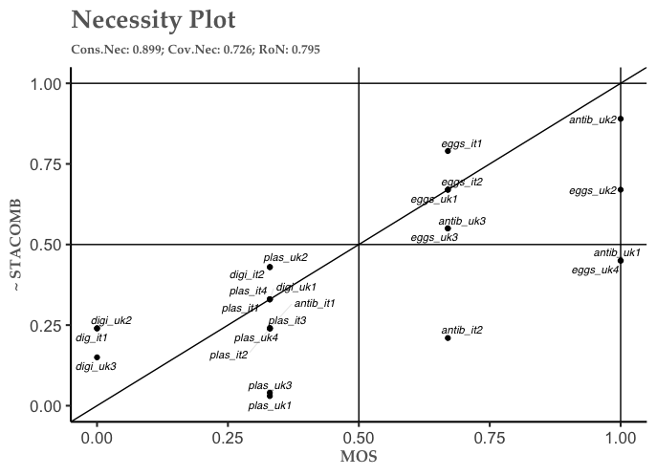
~POL (inclN 0.85, RoN 0.69, covN 0.62)

Truth table
MOS | UNSOS | POL | RES | OUT | n | incl | PRI | cases
1 | 1 | 0 | 0 | 1 | 2 | 0.91 | 0.72 | eggs_uk3,eggs_it2
1 | 0 | 0 | 0 | 1 | 2 | 0.81 | 0.59 | antib_uk3,eggs_it1
1 | 1 | 0 | 1 | 1 | 1 | 0.86 | 0.56 | eggs_uk2
0 | 1 | 1 | 1 | 0 | 4 | 0.47 | 0 | digi_uk3,plas_it1, plas_it3,digi_it2
0 | 0 | 1 | 1 | 0 | 4 | 0.37 | 0 | plas_uk2,plas_uk3, plas_uk4,plas_it4
1 | 0 | 0 | 1 | 0 | 3 | 0.65 | 0.28 | eggs_uk1,eggs_uk4, antib_it2
1 | 0 | 1 | 1 | 0 | 2 | 0.71 | 0.32 | antib_uk1,antib_uk2
0 | 1 | 0 | 0 | 0 | 2 | 0.63 | 0 | digi_uk1,antib_it1
0 | 1 | 1 | 0 | 0 | 2 | 0.55 | 0 | digi_uk2,dig_it1
0 | 0 | 1 | 0 | 0 | 2 | 0.39 | 0 | plas_uk1,plas_it2
0 | 0 | 0 | 0 | ? | 0 | - | -
0 | 0 | 0 | 1 | ? | 0 | - | -
0 | 1 | 0 | 1 | ? | 0 | - | -
1 | 0 | 1 | 0 | ? | 0 | - | -
1 | 1 | 1 | 0 | ? | 0 | - | -
1 | 1 | 1 | 1 | ? | 0 | - | -
5 cases covered by solution expressions.

Conservative solution
MOS*UNSOS*~POL + MOS*~POL*~RES ~STATE&COMB
Expression | inclS | PRI | CovS | CovU | Cases
MOS*UNSOS*~POL | 0.86 | 0.62 | 0.32 | 0.13 | eggs_uk2, eggs_uk3, eggs_it2
MOS*~POL*~RES | 0.85 | 0.63 | 0.44 | 0.25 | eggs_uk3, eggs_it1, eggs_it2, antib_uk3
Whole expression | 0.84 | 0.61 | 0.57

Parsimonious solution
Model 1: MOS*UNSOS + MOS*~RES STATE&COMB
Model 2: MOS*UNSOS + ~UNSOS*~POL*~RES ~STATE&COMB
Model 3: MOS*~RES + UNSOS*~POL*RES ~STATE&COMB
Expression | inclS | PRI | CovS | Cases
MOS*UNSOS | 0.84 | 0.56 | 0.35 | eggs_uk2, eggs_uk3, eggs_it2
MOS*~RES | 0.83 | 0.60 | 0.56 | eggs_uk3, eggs_it1, eggs_it2, antib_uk3
~UNSOS*~POL*~RES | 0.75 | 0.53 | 0.26 | eggs_it1, antib_uk3
UNSOS*~POL*RES | 0.79 | 0.42 | 0.19 | eggs_uk2
Model 1 | 0.81 | 0.56 | 0.62
Model 2 | 0.80 | 0.54 | 0.62
Model 3 | 0.81 | 0.55 | 0.61

Intermediate solutions (model ambiguity)
From parsimonious model 1:
MOS*UNSOS + MOS*~RES ~STATE&COMB
Expression | inclS | PRI | CovS | CovU | Cases
MOS*UNSOS | 0.84 | 0.55 | 0.36 | 0.16 | eggs_uk2, eggs_uk3, eggs_it2
MOS*~RES | 0.83 | 0.60 | 0.46 | 0.26 | eggs_uk3, eggs_it1, eggs_it2, antib_uk3
Whole expression | 0.81 | 0.56 | 0.62

From parsimonious model 2:
MOS*UNSOS + MOS*~POL*~RES ~STATE&COMB
Expression | inclS | PRI | CovS | CovU | Cases
MOS*UNSOS | 0.84 | 0.55 | 0.36 | 0.17 | eggs_uk2, eggs_uk3, eggs_it2
MOS*~POL*~RES | 0.85 | 0.63 | 0.44 | 0.25 | eggs_uk3, eggs_it1, eggs_it2, antib_uk3
Whole expression | 0.83 | 0.57 | 0.60

From parsimonious model 3:
MOS*~RES + MOS*UNSOS*~POL ~STATE&COMB
Expression | inclS | PRI | CovS | CovU | Cases
MOS*~RES | 0.83 | 0.60 | 0.46 | 0.27 | eggs_uk3, eggs_it1, eggs_it2, antib_uk3
MOS*UNSOS*~POL | 0.86 | 0.62 | 0.32 | 0.13 | eggs_uk2, eggs_uk3, eggs_it2
Whole expression | 0.82 | 0.59 | 0.59
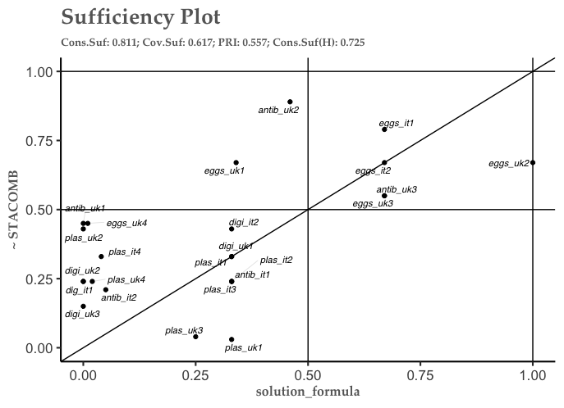

STATE&COMB
Truth table
MOS | UNSOS | POL | RES | OUT | n | incl | PRI | cases
0 | 0 | 1 | 1 | 1 | 4 | 0.97 | 0.95 | plas_uk2,plas_uk3, plas_uk4,plas_it4
0 | 1 | 1 | 1 | 1 | 4 | 0.96 | 0.93 | digi_uk3,plas_it1, plas_it3,digi_it2
0 | 0 | 1 | 0 | 1 | 2 | 1 | 1 | plas_uk1,plas_it2
0 | 1 | 0 | 0 | 1 | 2 | 1 | 1 | digi_uk1,antib_it1
0 | 1 | 1 | 0 | 1 | 2 | 1 | 1 | digi_uk2,dig_it1
1 | 0 | 1 | 1 | 1 | 2 | 0.82 | 0.59 | antib_uk1,antib_uk2
1 | 0 | 0 | 1 | 0 | 3 | 0.77 | 0.52 | eggs_uk1,eggs_uk4, antib_it2
1 | 1 | 0 | 0 | 0 | 2 | 0.73 | 0.15 | eggs_uk3,eggs_it2
1 | 0 | 0 | 0 | 0 | 2 | 0.68 | 0.32 | antib_uk3,eggs_it1
1 | 1 | 0 | 1 | 0 | 1 | 0.73 | 0.15 | eggs_uk2
0 | 0 | 0 | 0 | ? | 0 | - | -
0 | 0 | 0 | 1 | ? | 0 | - | -
0 | 1 | 0 | 1 | ? | 0 | - | -
1 | 0 | 1 | 0 | ? | 0 | - | -
1 | 1 | 1 | 0 | ? | 0 | - | -
1 | 1 | 1 | 1 | ? | 0 | - | -
Solution expressions cover 16 cases.
Conservative solution
~MOS*POL + ~MOS*UNSOS*~RES + ~UNSOS*POL*RES STATE&COMB
Expression | inclS | PRI | CovS | CovU | Cases
~MOS*POL | 0.98 | 0.96 | 0.59 | 0.23 | plas_uk1, plas_uk2, plas_uk3, plas_uk4, plas_it1, plas_it2, plas_it3, plas_it4, digi_uk2, digi_uk2, digi_it1, digi_it1
~MOS*UNSOS*~RES | 0.90 | 0.81 | 0.26 | 0.13 | antib_it1, digi_uk1, digi_uk2, digi_it1
~UNSOS*POL*RES | 0.83 | 0.72 | 0.27 | 0.05 | antib_uk1, antib_uk2, plas_uk2, plas_uk3, plas_uk4, plas_it4
Whole expression | 0.89 | 0.81 | 0.76

Parsimonious solution
~MOS + POL => STATE&COMB
Expression | inclS | PRI | CovS | CovU | Cases
~MOS | 0.92 | 0.87 | 0.78 | 0.19 | antib_it1, plas_uk1, plas_uk2, plas_uk3, plas_uk4, plas_it1, plas_it2, plas_it3, plas_it4, digi_uk1, digi_uk2, digi_uk3, digi_it1, digi_it2
POL | 0.88 | 0.79 | 0.66 | 0.07 | antib_uk1, antib_uk2, plas_uk1, plas_uk2, plas_uk3, plas_uk4, plas_it1, plas_it2, plas_it3, plas_it3, digi_uk2, digi_uk3, digi_it1, digi_it2
Whole expression | 0.85 | 0.75 | 0.85

Intermediate solution
~MOS + ~UNSOS*POL STATE&COMB
Expression | inclS | PRI | CovS | CovU | Cases
~MOS | 0.92 | 0.87 | 0.78 | 0.49 | antib_it1, plas_uk1, plas_uk2, plas_uk3, plas_uk4, plas_it1, plas_it2, plas_it3, plas_it4, digi_uk1, digi_uk2, digi_uk3, digi_it1, digi_it2
~UNSOS*POL | 0.85 | 0.76 | 0.36 | 0.06 | antib_uk1, antib_uk2, plas_uk1, plas_uk2, plas_uk3, plas_uk4, plas_it2, plas_it4
Whole expression | 0.87 | 0.78 | 0.84

Two deviant cases in consistency remain: eggs_uk1 and antib_uk2. Eggs_uk1 is a campaign using market strategies only, and is covered by the solution for MARKET&COMB below. Antib_uk2 was a bit of a different campaign, as it was run by an NGO specialising in shareholder action; the campaign therefore focuses on shareholder actions and resolutions and did not use any other actions. This peculiarity can explain why the case is not covered by any solution expression.
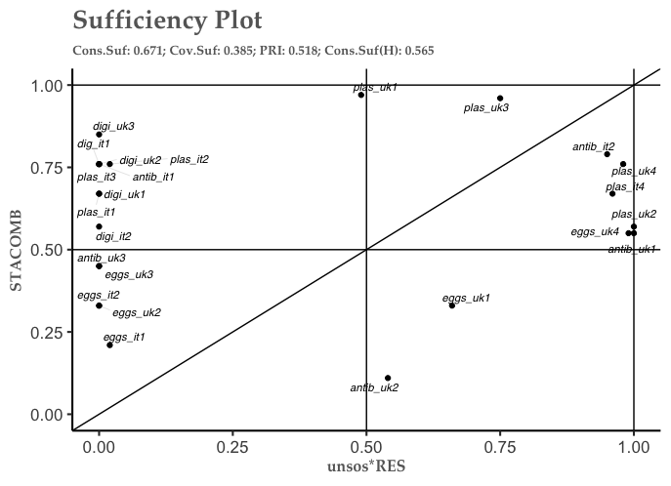
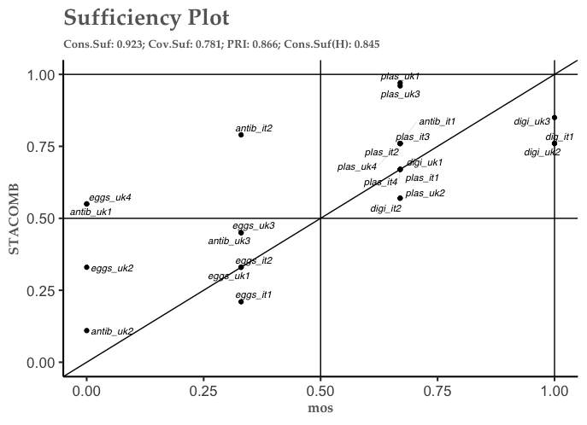

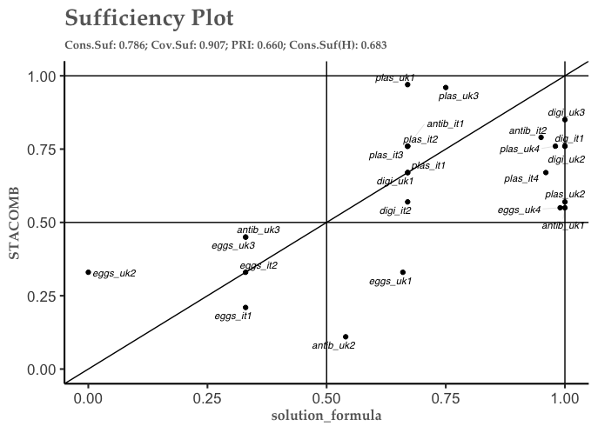

3. List of interviews
- UK environmental NGO, 07/05/2018, phone.
- UK animal welfare NGO, 09/05/2018, Skype.
- UK animal welfare NGO, 18/05/2018, Skype.
- UK animal welfare NGO, 28/05/2018, phone.
- UK animal welfare charity, 29/05/2018, phone.
- UK animal welfare NGO, 30/05/2018, phone.
- UK animal welfare NGO, 31/05/2018, Skype.
- UK charity, 19/06/2018, Skype.
- UK environmental NGO, 25/07/2018, Skype.
- UK digital rights NGO, 27/07/2018, Skype.
- UK human rights NGO, 20/08/2018, Skype.
- Italian environmental NGO, 11/09/2018, phone.
- UK environmental NGO, 10/10/2018, Skype.
- Italian animal welfare NGO, 11/10/2018, Rome.
- Italian environmental NGO, 11/10/2018, Rome.
- Italian consumer organisation, 16/10/2018, Skype.
- Italian environmental NGO, 24/10/2018, Skype.

