Supplementary Information

Recurrent Selection for Dicamba in the Field:
The field experiment was conducted to study the effect of sublethal selection under a production environment. Results of the field study suggested that three consecutive years of dicamba treatment can result in reduced susceptibility to dicamba in field Palmer amaranth populations. The LD₅₀ for the 2011 soil seedbank was 81 g ae ha⁻¹ compared to an LD₅₀ of 119 g ae ha⁻¹ for the 2015 soil seedbank (Supplementary Fig. 1). Thus, the 2015 soil seedbank was 1.5-fold less susceptible to dicamba, showing a progressive increase over three consecutive generations in Palmer amaranth survival under commercial field conditions. Similarly, there was also a >1.6-fold increase in the LD₉₀ value for the 2015 soil seedbank.
Readers must be cognizant of the limitations of this field study while interpreting the results. A non-treated control could not be maintained practically in the field study because of the likelihood for pollen and seed inflow from other susceptible populations in the vicinity. Selection of a population away from the study site was not appropriate due to the likelihood for inherent genetic differences. As a result, the shift in susceptibility was compared directly between the soil samples collected in 2011 and 2015. Results show that the rate of selection was much slower in the field study compared to that of the greenhouse study. It is likely that the differences observed here could be influenced by year effects, pollen movement, etc., in addition to the effect of recurrent dicamba selection. Nevertheless, findings of this study illustrate that the degree of sublethal selection under field conditions can be variable compared to potential rates (determined under ideal conditions in the greenhouse) due to a number of other factors, including year effects, herbicide program used, pollen and propagule movement, among others.

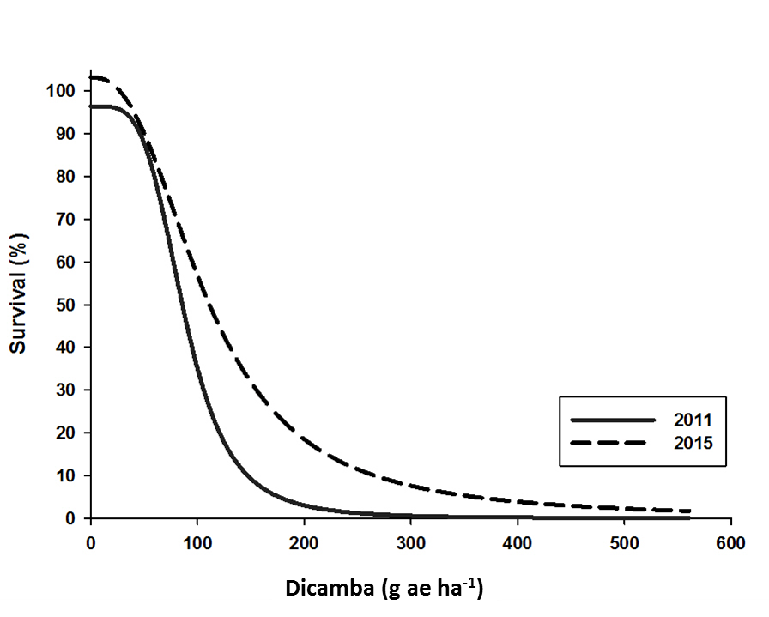
Supplementary Figure 1. Dose-response curves using dicamba for Palmer amaranth individuals grown from the 2011 and 2015 soil samples under greenhouse conditions. Lines are the predicted values for percentage survival.

