**Electronic Supplemental Figure 1A.** Principal component analysis applied using the average differential expression of genes (p<0.05) on the microarray for dry seeds and seeds of leafy spurge germinated for 1and 3 days at a constant temperature of 20°C and an alternating temperature of 20:30°C.



Dry seed

1 d constant

3 d constant

3 d alternating

1 d alternating

Y

X

**Electronic Supplemental Figure 1B.** Venn diagram showing the distribution of the differentially expressed (p<0.05) unique and common genes between constant (20°C) and alternating temperature (20:30°C) after 1 and 3 days imbibition of leafy spurge seeds.

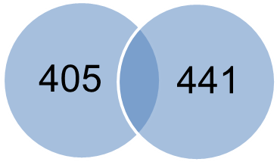

91

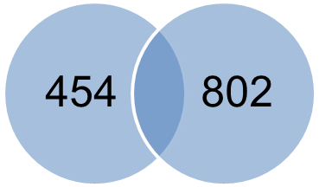

130

Constant

temperature

Alternating

temperature

1 day

3 day

Dry seed

vs.