**LATE QUATERNARY (≥MIS3 TO MIS1) STRATIGRAPHIC TRANSITIONS IN A HIGHLAND BERINGIAN LANDSCAPE ALONG THE KUSKOKWIM RIVER, ALASKA**

**SUPPLEMENTAL MATERIALS**

**Radiocarbon – Background Results**

The upper limiting range of radiocarbon age calculation (or detection limit) is generally between 40,000 and 60,000 14C yr BP, which can vary from lab to lab (Taylor and Yosef, 2014). Sources of error can be compounded near the detection limit of radiocarbon causing ages that have actual ages that are older than the detection limit (or *infinite* in age) to be estimated as younger than they actually are and as finite ages. Sources of error range from *in situ* sample replacement of the primary carbon by secondary carbon in a deposit, insufficient removal of exogenous contaminants during the pretreatment process, introduction of atmospheric carbon into as sample during the pretreatment and graphitization process, and analytical uncertainties during AMS measurement (Hatté et al. 2001; Pigati et al., 2007; Taylor and Bar-Yosef, 2014). For ages between 40,000 and ≥50,000 14C yr BP, the introduction of ≤1% of modern carbon into a sample can have a ~8,000 to 15,000 year difference between the actual age of the sample and the approximated younger age (Taylor and Bar-Yosef, 2014:139). While we recognize that sources of error can occur, in this supplement section on radiocarbon, we are solely interested in our study’s definitions of finite and infinite ages based on the quoted age estimates themselves from the radiocarbon laboratory. We have not pursued a study on exogenous contamination of the samples we have chosen for this study to radiocarbon date.

Finiteages are considered age calculations that are younger than and can be statistically distinguished (usually by at least at a 95% confidence interval) from a calculation of a background value (Stuiver and Polach 1977), which is produced from a known standard with no radiocarbon in it. Infinite ages are those whose age calculations are equal to or statistically indistinguishable from a background value.

Here, we provide a summary and analysis of the radiocarbon ages for our project produced by the Center for Applied Isotope Studies (CAIS) at the University of Georgia, with particular reference to those ages that are beyond 40,000 14C yr BP. CAIS defines finite ages as those that are distinguishable from background values at a 95% confidence interval (following Stuiver and Polach 1977). In turn, infinite ages are statistically similar to background values. We provide the background results from standards that were analyzed simultaneously with each of our radiocarbon ages (Table S1). We compare the percent modern carbon (pMC) of each radiocarbon assay to the associated standard pMC measruments to test if they are statistically similar using pairwise tests (χ2 test) of contemporaneity protocols outlined by Ward and Wilson (1978) (Table S1).

We also have provided a statistical comparison between the pMC of each radiocarbon assay and a long-term background average of 0.125+/-0.026 pMC that we calculated based on 20 radiocarbon measurements of the background over the last year (Table S1). We also look at the age ranges for each radiocarbon age compared to the age ranges of their associated standard result at both 68.5% (1σ) and 95.4% (2σ) confidence intervals looking for areas of potential overlap in ranges (Figures S1 and S2). These ages were run on the AMS on seven different dates between 2013-2017 (Table S3).

All of the background results are greater than 50,000 14C yr BP (Table S1). Of the 17 radiocarbon samples submitted to CAIS for this project, twelve radiocarbon ages fall within a span of 40,000 to 55,000 14C yr BP (Tables S1 and S3). Four radiocarbon ages are 50,000 14C yr BP or greater in age (Table S2): UGAMS#15794, UGAMS#15795, UGAMS#16488, and UGAMS#16737. Two of these >50,000 14C yr BP ages, UGAMS#15795 and UGAMS#16737, are statistically indistinguishable from their associated background results. Four >50,000 14C yr BP ages, UGAMS#15794, UGAMS#15795, UGAMS#16737, and UGAMS#16488 are statistically indistinguishable from the long-term background average.

When viewing the pMC ranges, only two of the results overlap at 68.5% confidence interval: UGAMS#15795 and UGAMS#16737 (Figure S1). Three radiocarbon age ranges overlap at 68.5% confidence interval with the long-term background average: UGAMS#15794, UGAMS#15795 and UGAMS#16737 (Figure S1). Four pMC ranges overlap at 95.4% confidence interval: UGAMS#16488, UGAMS#16737, UGAMS#15794, and UGAMS#15795 (Figure S2). These same four pMC ranges overlap at 95.4% confidence interval with the long-term background average: UGAMS#15794, UGAMS#15795, UGAMS#16737 and UGAMS#16488 (Figure S2).

As noted above, UGAMS#15794 and UGAMS#16737 were found to be statistically indistinguishable from their associated background results, and, along with UGAMS#15795 and UGAMS#16488, they were also statistically indistinguishable from the long-term background average. For these reasons, and for conservatism in our age interpretations within this study, we consider these four ages to be potentially non-finite numerical ages using the radiocarbon dating technique and refer to them in the main text of this article with a “≥” symbol, a standard reference to reflect the non-finite nature of radiocarbon ages.

UGAMS#16488 is much more complicated in that the radiocarbon age was statistically distinguishable from its associated background results but not the long-term background measurement. Its 68.5% age range is separated from its associated background result range and the range of the long-term background measurement. At 95.4% confidence interval, it overlaps the associated background value and the long-term background measurement. The radiocarbon age of 50,680±830 14C yr BP (UGAMS-16488) at the Sue Creek section was statistically distinguishable from its associated background measurement but not from the long-term average of the background measurements (Table S1). It is also stratigraphically associated with UGAMS#16489, which is statistically similar to UGAMS#16488 *(t=*1.003; χ2(0.05)=3.84; *df*= 1; p=0.317). UGAMS#16489 is statistically different from its associated background value and the long-term average measurement (Table S1), and it does not overlap with the 68.5% and 95.4% ranges for the background measurements (Figures S1 and S2). We suggest that the radiocarbon ages, UGAMS#16488 and UGAMS#16489, may in fact be similar in age with both dating to the MIS3, even though we have conservatively defined UGAMS#16488 as an infinite age and quote it in the main document as ≥50,680 14C yr BP because of its similarity to the long-term background measurement.

As a matter of course, we cannot discount that with future radiocarbon dating of samples from these sections and lower deposits that older or infinite ages will be obtained because issues in dating samples that have true age values at near, at, or older than the detection limits of radiocarbon. And like any study, the geologic and paleoenvironmental interpretations may change with new information. Future radiocarbon dating of samples from these sections and lower deposits may also corroborate the ages that we have chosen within this study to remain as finite ages, and, in turn, support our interpretations.

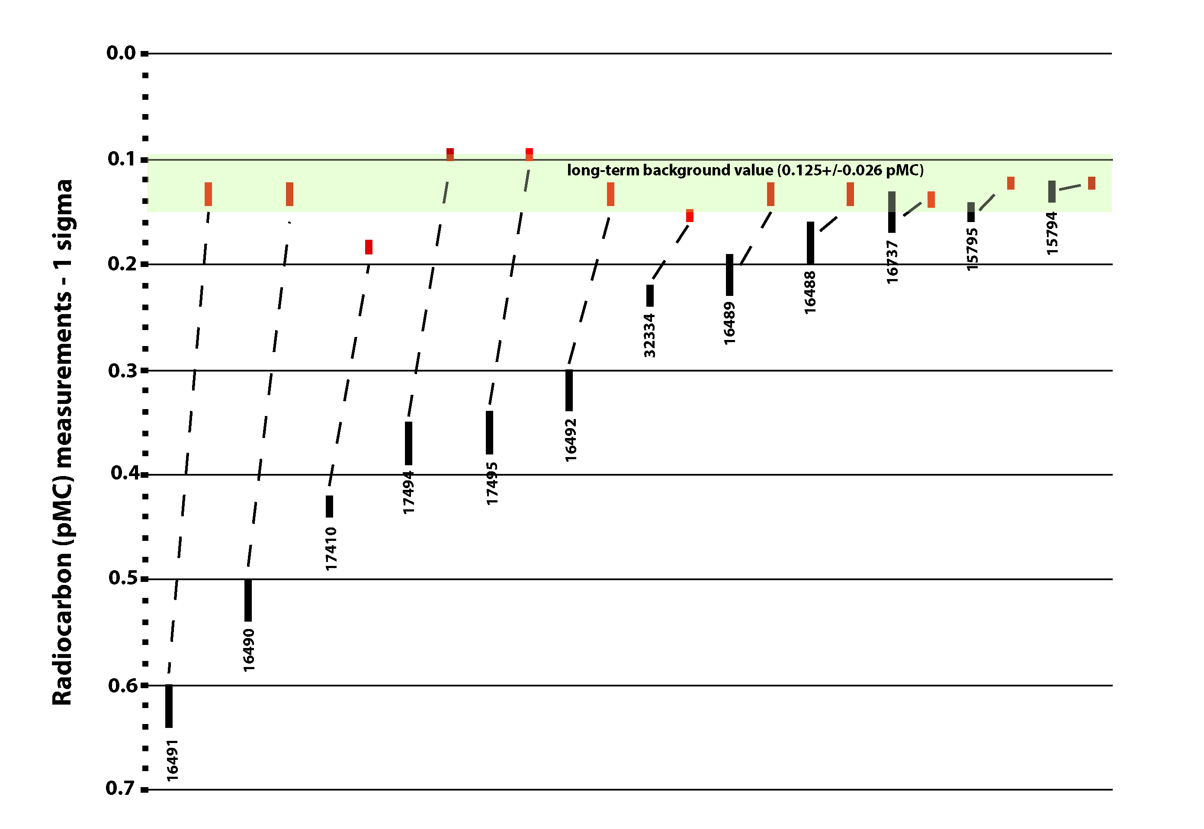

Figure S1. Graph of UGAMS radiocarbon pMC measurements (68.3%) ranges (black bars) greater than 40,000 14C yr BP, their paired background results (red bars), and the long-term background average (green bar).

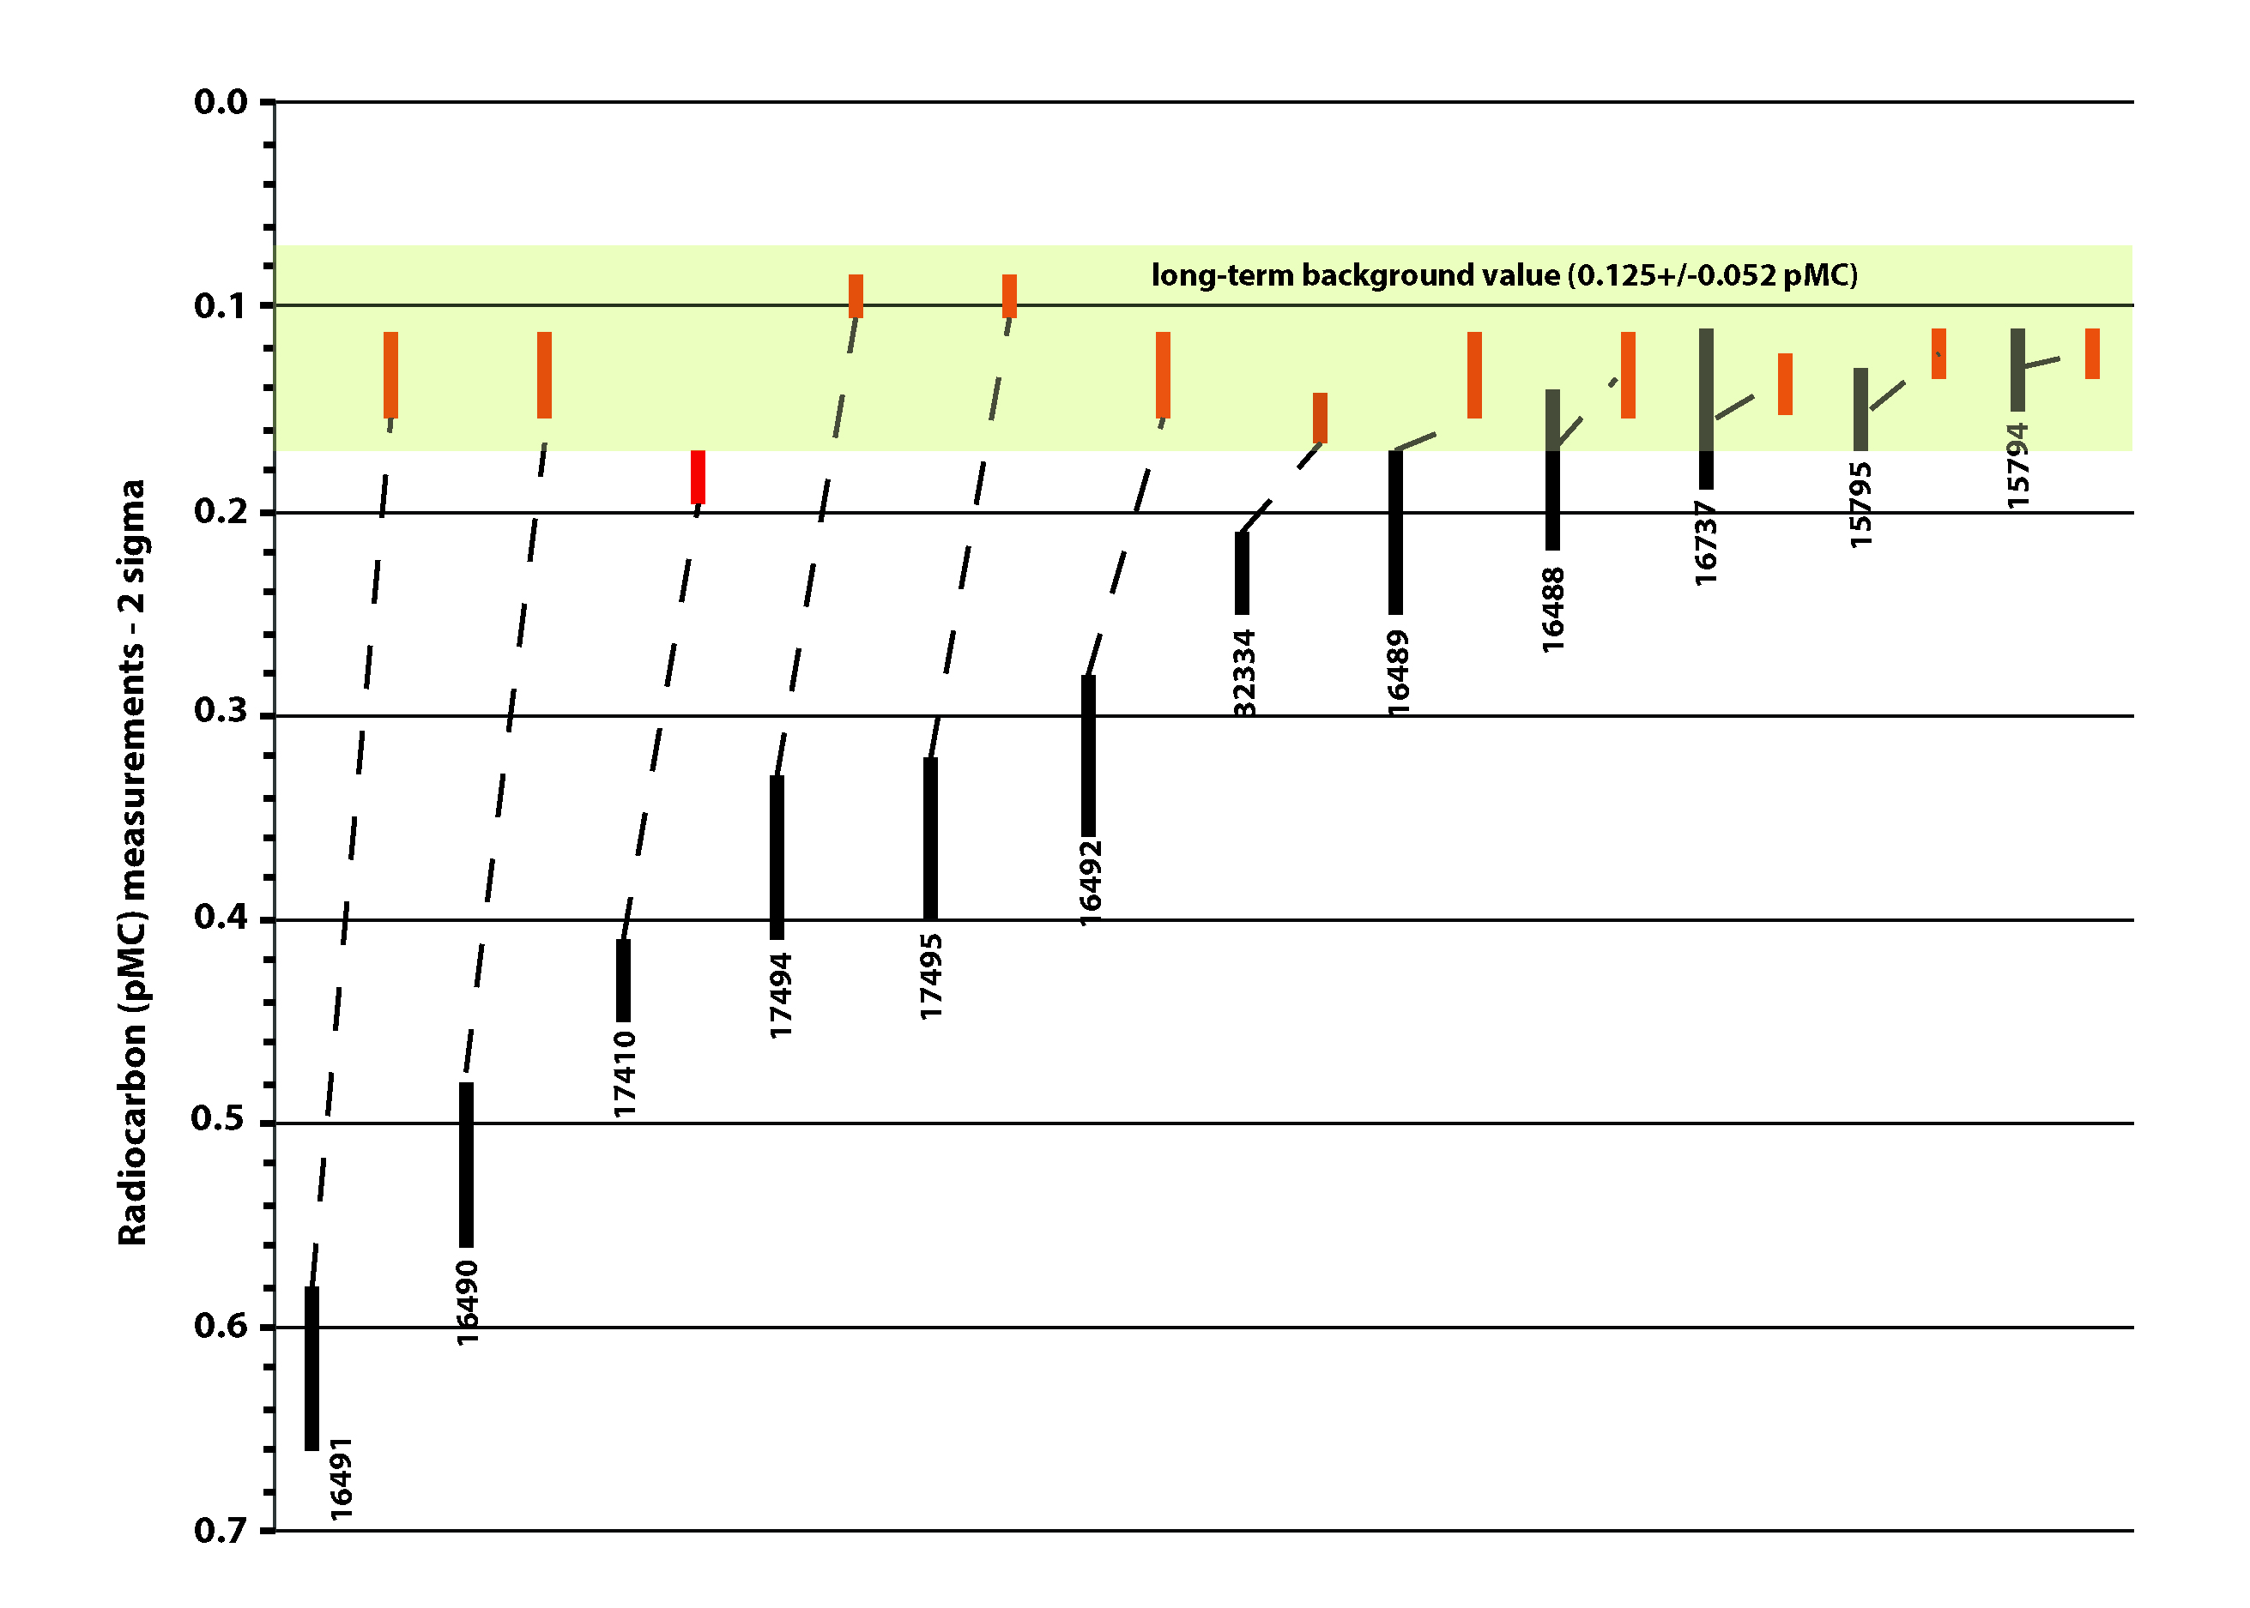

Figure S2. Graph of UGAMS radiocarbon pMC measurements (95.4%) ranges (black bars) greater than 40,000 14C yr BP, their paired background results (red bars), and the long-term background average (green bar).

Table S1. Radiocarbon ages from the Kolmakof, Sue Creek and VABM Kuskokwim sections, and corresponding background results, from the Center for Applied Isotope Studies, University of Georgia. (χ2= 3.84; *df*= 1; p= <0.05)

|  |  |  |  |  |  |  |  |  |
| --- | --- | --- | --- | --- | --- | --- | --- | --- |
| **Lab number**  **(UGAMS#)** | **Date run** | **Material** | **δ13C values (‰)** | **14C yr BP — 68.3%**  **(pMC)** | **Background results – 68.3%**  **(pMC)** | **Statistical difference**  **between 14C yr BP and background result** | **Statistical Difference**  **Between 14C yr BP and average pMC of background results**  **(0.125+/-0.026)** | **Finite/**  **infinite age interpretation for this study** |
| *VABM Kuskokwim Section* | | | | | | | | |
| 16740 | January 7, 2014 | Plant fragment | -26.4 | 11930±40  (22.65±0.11) | 52900±444 (0.138±0.00744) | *Significantly different*  *(t=* 41692; p= <0.00001) | *Significantly different*  *(t= 39713*; p= <0.00001) | finite |
| 16739 | January 7, 2014 | Plant fragment | -26.9 | 12000±40  (22.46±0.11) | 52900±444 (0.138±0.00744) | *Significantly different*  *(t=* 40991; p= <0.00001) | *Significantly different*  *(t= 39046*; p= <0.00001) | finite |
| 20531 | March 26, 2015 | Seeds | -30.4 | 13650±45  (18.28±0.10) | 53769±531  (0.124±0.00851) | *Significantly different*  *(t=* 32727; p= <0.00001) | *Significantly different*  *(t= 616910*; p= <0.00001) | finite |
| 32334 | December 12, 2017 | Wood | -27.9 | 48660±420  (0.23±0.01) | 52017±321  (0.154±0.00604) | *Significantly different*  *(t=* 42.32; p= <0.00001) | *Significantly different*  *(t=* 14.21; p= 0.000163) | finite |
| 15795 | November 13, 2013 | Mammoth ivory (collagen) | -21.9 | 52250±520  (0.15±0.01) | 53820±403  (0.123±0.00602) | *Significantly different*  *(t=5.35*; p= 0.020722) | ***Statistically similar***  ***(t=* 0.81; p= 0.36812)** | **infinite** |
| 15794 | November 13, 2013 | Mammoth ivory (collagen) | -21.8 | 53110±630  (0.13±0.01) | 53820±403  (0.123±0.00602) | ***Significantly different***  ***(t= 0.36*; p= 0.548506)** | ***Statistically similar***  ***(t=* 0.81; p= 0.36812)** | **infinite** |
| *Kolmakof Section* | | | | | | | | |
| 16735 | January 7, 2014 | Fingernail Clam Shell (*Sphaerium sp.)* | -5.2 | 19960±60  (8.33±0.06) | 52900±444 (0.138±0.00744) | *Significantly different*  *(t=* 18359; p= <0.00001) | *Significantly different*  *(t= 15744*; p= <0.00001) | finite |
| 16736 | January 7, 2014 | Wood | -26.8 | 35460±170  (1.21±0.03) | 52900±444 (0.138±0.00744) | *Significantly different*  *(t=* 1202; p= <0.00001) | *Significantly different*  *(t= 746*; p= <0.00001) | finite |
| 17194 | March 4, 2014 | Plant fragments | -29.3 | 44890±380  (0.37±0.02) | 55886±486  (0.0952±0.00559) | *Significantly different*  *(t= 175*; p= <0.00001) | *Significantly different*  *(t= 55*; p= <0.00001) | finite |
| 17195 | March 4, 2014 | Plant fragments | -29.1 | 45130±510  (0.36±0.02) | 55886±486  (0.0952±0.00559) | *Significantly different*  *(t= 162*; p= <0.00001) | *Significantly different*  *(t=* 51.32; p= <0.00001) | finite |
| 16737 | January 7, 2014 | Plant fragments | -27.0 | 52120±920  (0.15±0.02) | 52900±444 (0.138±0.00744) | ***Statistically Similar***  ***(t= 0.32; p= 0*.571608*)*** | ***Statistically Similar***  ***(t= 0.58; p= 0*.446312*)*** | **infinite** |
| *Sue Creek Section* | | | | | | | | |
| 16491 | December 16, 2013 | Charcoal | -28.1 | 40780±330  (0.62±0.02) | 53199±653 (0.133±0.0104) | *Significantly different*  *(t= 466.72*; p= <0.00001) | *Significantly different*  *(t=* 227; p= <0.00001) | finite |
| 16490 | December 16, 2013 | Charcoal | -25.9 | 42320±360  (0.52±0.02) | 53199±653 (0.133±0.0104) | *Significantly different*  *(t= 294.73*; p= <0.00001) | *Significantly different*  *(t= 145.00*; p= <0.00001) | finite |
| 17410 | April 11, 2014 | Charcoal | -28.5 | 43770±250  (0.43±0.01) | 50615±291  (0.183±0.00653) | *Significantly different*  *(t=* 427.71; p= <0.00001) | *Significantly different*  *(t=* 119.88; p= <0.00001) | finite |
| 16492 | December 16, 2013 | Wood | -27.9 | 46190±550  (0.32±0.02) | 53199±653 (0.133±0.0104) | *Significantly different*  *(t=* 68.81; p= <0.00001) | *Significantly different*  *(t=* 35.34; p= <0.00001) | finite |
| 16489 | December 16, 2013 | Wood | -28.2 | 49490±850  (0.21±0.02) | 53199±653 (0.133±0.0104) | *Significantly different*  *(t=* 11.67; p= 0.000635) | *Significantly different*  *(t=*6.71; p= 0.009587) | finite |
| 16488 | December 16, 2013 | Wood | -26.6 | 50680±830  (0.18±0.02) | 53199±653 (0.133±0.0104) | *Significantly different*  *(t=* 4.35; p= 0.037009) | ***Statistically Similar***  ***(t=* 2.81; p= 0.093678)** | **infinite** |

Table S2. Summary of AMS measurements and background corrected measurements on ≥40,000 14C yr BP ages from the Center for Applied Isotope Studies, University of Georgia. pMC = percent modern carbon.

|  |  |  |  |  |  |  |
| --- | --- | --- | --- | --- | --- | --- |
| **UGAMS #** | **no background correction** | **background corrected** | | | **Anthracite background results** | |
| **14C yr BP** | **pMC** | **14C yr BP** | **pMC** | **14C yr BP** | **pMC** |
| 16491 | 39261±242 | 0.75±0.02 | 40780±330 | 0.62±0.02 | 53199±653 | 0.133±0.01040 |
| 16490 | 40486±255 | 0.65±0.02 | 42320±360 | 0.52±0.02 | 53199±653 | 0.133±0.01040 |
| 17410 | 40944±151 | 0.61±0.01 | 43770±250 | 0.43±0.01 | 50615±291 | 0.183±0.00653 |
| 17194 | 43103±284 | 0.47±0.02 | 44890±380 | 0.37±0.02 | 55886±486 | 0.095±0.00559 |
| 17195 | 43294±388 | 0.46±0.02 | 45130±510 | 0.36±0.02 | 55886±486 | 0.095±0.00559 |
| 16492 | 43410±329 | 0.450±0.0181 | 46190±550 | 0.32±0.02 | 53199±653 | 0.133±0.0103 |
| 32334 | 44616±217 | 0.387±0.0104 | 48660±420 | 0.23±0.01 | 52017±321 | 0.154±0.00604 |
| 16489 | 45588±445 | 0.343±0.0185 | 49490±850 | 0.21±0.02 | 53199±653 | 0.133±0.0103 |
| 16488 | 46281±378 | 0.315±0.0145 | 50680±830 | 0.18±0.02 | 53199±653 | 0.133±0.0103 |
| 16737 | 46945±418 | 0.29±0.01 | 52120±920 | 0.15±0.02 | 52900±444 | 0.138±0.00744 |
| 15795 | 47418±251 | 0.273±0.0084 | 52250±630 | 0.15±0.01 | 53820±402 | 0.123±0.00602 |
| 15794 | 47880±259 | 0.258±0.0082 | 53110±630 | 0.13±0.01 | 53820±402 | 0.123±0.00602 |

Table S3. Summary of background results and radiocarbon ages from AMS runs from the Center for Applied Isotope Studies, University of Georgia.

|  |  |  |  |  |  |  |  |
| --- | --- | --- | --- | --- | --- | --- | --- |
| **Analysis date** | **Background results for run** | **Number of ages for run** | **Number of ages between 40,000-45,000 14C yr BP** | **Number of ages between 45,000-50,000 14C yr BP** | **Number of ages over 50,000 14C yr BP** | **Statistically similar to background results** | **Statistically similar to long-term background average** |
| November 13, 2013 | 53820±403 | 2 | 0 | 0 | 2 | 1 | 2 |
| December 16, 2013 | 53199±653 | 5 | 2 | 2 | 1 | 0 | 0 |
| January 7, 2014 | 52900±444 | 5 | 0 | 0 | 1 | 1 | 1 |
| March 4, 2014 | 55886±486 | 2 | 1 | 1 | 0 | 0 | 0 |
| April 11, 2014 | 50615±291 | 1 | 1 | 0 | 0 | 0 | 0 |
| March 26, 2015 | 53769±531 | 1 | 0 | 0 | 0 | 0 | 0 |
| December 12, 2017 | 52017±321 | 1 | 0 | 1 | 0 | 0 | 1 |
| **Total** | **-** | **17** | **4** | **4** | **4** | **2** | **4** |

**Tephras – Protocols and Results**

Tephra samples were processed in the U.S. Geological Survey Alaska Tephra Laboratory & Data Center in Anchorage, Alaska. Fine-grained samples (<2 mm in diameter) were wet sieved into three size fractions (>250, 125, and 63 microns) mainly to remove fine-grained ash from the surfaces of the coarser material. Material in the size fraction ≥0.125 mm was used to make bulk grain mounts for electron probe microanalysis (EPMA). Standard polished probe mounts were made professional by Mann Petrographics, New Mexico. Major-element glass analyses were con­ducted using wavelength dispersive techniques with a 5-spectrometer JEOL 8900R electron probe microanalyzer (EPMA) at the USGS in Menlo Park, Calif.

Concentra­tions were determined with the CIT-ZAF reduction scheme (Armstrong, 1995). Glass analyses used a 5-μm-diameter beam with 5 nA current and 15 kV accelerating potential. Reported glass compositions are the averages of 25–30 spot analyses or fewer if multiple populations were found within a single sample; background intensities were determined 1‒3 times for each grain. Count times were 10 s for Na (which was analyzed first to reduce Na-loss), 10 s for S and Cl, and 30 s for all other elements. During analysis, sets of 5–10 replicate analyses of glass standards RLS-75 (rhyolite glass) and VG-2 (basaltic glass) (Jarosewich et al. 1979) were performed to monitor instrument drift. Natural glass and mineral standards were used for calibration: RLS-132 for Si; basaltic glass VG-2 for Fe, Mg, and Ca; Orthoclase 1 for K and Al; Tiburon albite for Na; Mn2O3 for Mn; TiO2 for Ti; sodalite for Cl; and Wilberforce apatite for P. Standard deviations of averages of multiple spot analyses for single unknown samples are gener­ally within those listed for working standards. Point data for all glass analyses as well as a summary of normalized averaged data are given in excel tables accompanying the Supplementary Materials. Geochemical correlations using normalized glass compositions were based on the degree of similarity using the SIMAN similarity coefficient (Borchardt et al., 1972) with the weighting option of Borchardt (1974).

**Luminescence Dating**

*Sample preparation* -- Samples were collected with opaque cylinders and capped in the field. Infrared stimulated luminescence (IRSL), which targets feldspars, was used to determine equivalent dose (De), which is a measure of the dose absorbed since the last zeroing event and is derived by calibrating the natural signal against signals induced by laboratory irradiation. Dividing De (in Gy, the SI unit of absorbed dose) by the time-averaged natural dose rate (Gy per unit time) produced each age estimate, while correcting for anomalous fading.

Because of scarcity of coarse material, analysis was performed on 1-8µm grains. Grains less than 106 µm were obtained by sieving. A portion of this material was ground gently using an agate mortar and pestle, then treated with HCl, and settled in acetone for 2 and 20 minutes to separate the 1-8 µm fraction. This is settled onto a maximum of 72 stainless steel discs.

*Dose Rate Calculation* -- To determine the dose rate, sample radioactivity was first measured in the lab by alpha counting, in conjunction with atomic emission for 40K. Samples for alpha counting were crushed in a mill to flour consistency, packed into plexiglass containers with ZnS:Ag screens, and sealed for one month before counting. The pairs technique was used to separate the U and Th decay series. For atomic emission measurements, samples were dissolved in HF and other acids and analyzed by a Jenway flame photometer. K concentrations for each sample were determined by bracketing between standards of known concentration. Conversion to 40K was by natural atomic abundance. Radioactivity was also measured, as a check, by beta counting, using a Risø low-level beta GM multicounter system. About 0.5 g of crushed sample was placed on each of four plastic sample holders. All were counted for 24 hours. The average was converted to dose rate following Bøtter-Jensen and Mejdahl (1988) and compared with the beta dose rate calculated from the alpha counting and flame photometer results. Cosmic radiation was determined after Prescott and Hutton (1994). Moisture content was measured from the current water content of the samples, determined by the weight as received and dividing by weight obtained after several days drying at 50°C. Radioactivity concentrations were translated into dose rates following Guérin et al. (2011).

*Equivalent Dose Calculation --* Single-aliquot dating was employed for all samples. Each single-aliquot contained 1000’s of fine grains. IRSL is measured on a Risø TL-DA-15 automated reader stimulating for 100 s at 60°C with 880nm diodes (122 mW/cm2). Detection is through a blue-filter pack, allowing transmission in the 350-450nm range. A preheat of 250°C for 1 minute at 5°C/s proceeded each measurement. From the 100 s exposure the first 5 s was used for analysis and the last 15 s for background.

Equivalent dose (De) was determined using the single-aliquot regenerative dose (SAR) protocol (Murray and Wintle 2000), and as applied to feldspars by Auclair et al. (2003). The SAR method measures the natural signal and the signal from a series of regeneration doses on a single aliquot. The method uses a small test dose to monitor and correct for sensitivity changes brought about by preheating, irradiation or light stimulation. SAR consists of the following steps: 1) preheat, 2) measurement of natural signal (OSL or IRSL), L(1), 3) test dose, 4) preheat, 5) measurement of test dose signal, T(1), 6) regeneration dose, 7) preheat, 8) measurement of signal from regeneration, L(i), 9) test dose, 10) preheat, 11) measurement of test dose signal, T(i), 12) repeat of steps 6 through 11 for i regeneration doses. A growth curve is constructed from the L(i)/T(i) ratios and the equivalent dose is found by interpolation of L(1)/T(1). A zero regeneration dose and a repeated regeneration dose are employed to insure the procedure is working properly.

Test doses for the SAR were about 4 Gy. Doses were delivered by a 90Sr beta source, which provides about 0.08 Gy/s to 1-8 µm grains, and which was calibrated using quartz irradiated by a gamma source at Battelle Laboratory in Hanford, Washington. An advantage of single-grain dating is the opportunity to remove from analysis aliquots with unsuitable characteristics by establishing a set of criteria grains must meet. Aliquots are eliminated from analysis if they (1) had poor signals (as judged from net natural signals not at least three times above the background standard deviation), (2) did not produce, within 20 percent, the same signal ratio (often called recycle ratio) from identical regeneration doses given at the beginning and end of the SAR sequence, suggesting inaccurate sensitivity correction, (3) yielded natural signals that did not intersect saturating growth curves, or (4) had a signal larger than 10 percent of the natural signal after a zero dose.

A dose recovery test was performed on some aliquots. The luminescence was first removed by exposure to 100 s of 880nm diodes. A dose of known magnitude was then administered. The SAR procedure was then applied to see if the known dose could be obtained. Successful recovery is an indication that the procedures are appropriate.

Anomalous fading was measured using the procedures of Auclair et al. (2003) on single aliquots. Age was corrected following Huntley and Lamothe (2001). Storage times after irradiation of up to 3-5 days were employed. A fading-corrected age was obtained for each aliquot. Because of varying precision and other factors, the same value is not obtained for each aliquot even if all reflect the same true age. Instead a distribution is produced. The common age model and central age model of Galbraith (Galbraith and Roberts 2012) are statistical tools that were used in evaluation of age distributions. The common age model controls for differential precision by computing a weighted average using log values. The central age model is similar except rather than assuming a single true value it assumes a natural distribution of estimated age values, even for true single-aged samples, because of non-statistical sources of variation that are not accounted for in the estimations, such as variation of luminescence properties among aliquots or heterogeneity in dose rate. It computes an over-dispersion parameter (σb) interpreted as the relative standard deviation (or coefficient of variance) of the true age estimates, or, in other words, that deviation beyond what can be accounted for by measurement error. Over-dispersion will be higher for samples that are not single-aged because of partial bleaching or post-depositional mixing.

*Alpha effectiveness* -- Alpha effectiveness is measured by the b-value system (Aitken, 1985). The b-value for IRSL is determined by giving an alpha dose to aliquots whose luminescence have been drained by exposure to light. An equivalent dose is determined by SAR using beta irradiation, and the beta/alpha equivalent dose ratio is taken as the b-value.

*Age Calculations --* Ages are determined using a laboratory spreadsheet based on Aitken (1985). Ages are quoted with 1-sigma errors and using 2015 as the reference for before present designations.

**Results**

*Dose rate --* The dose rate was mainly determined using alpha counting and flame photometry. The beta dose rate calculated from these measurements was compared with the beta dose rate measured directly by beta counting. These differed slightly, perhaps due to some disequilibrium in the decay chains. As a more direct measure, the beta dose rate from beta counting was used in the age calculation. Moisture content was estimated from current measurements, which were a rather high 36.8%. An error term of 10% was included to cover changes through time. Table S3 gives the relevant data, while Table S4 gives the total dose rates.

Table S3. Radionuclide concentrations

|  |  |  |  |  |  |
| --- | --- | --- | --- | --- | --- |
| *Sample* | *238U*  *(ppm)* | *233Th*  *(ppm)* | *K*  *(%)* | *Beta dose rate (Gy/ka)* | |
| ß-counting | α-counting/flame photometry |
| UW3000 | 1.94±0.15 | 5.53±0.94 | 1.63±0.06 | 2.09±0.18 | 1.77±0.06 |

Table S4. Dose rates (Gy/ka)*

|  |  |  |  |  |  |
| --- | --- | --- | --- | --- | --- |
| *Sample* | *alpha* | *beta* | *gamma* | *cosmic* | *total* |
| UW3000 | 0.18±0.02 | 1.43±0.17 | 0.63±0.06 | 0.05±0.01 | 2.28±0.18 |

* The beta dose rate differs than that given in Table 2 due to moisture correction.

*Equivalent Dose Results* -- Equivalent dose was measured on 1-8 µm fine grains. Because quartz is generally not sensitive in Alaska, stimulation was with infrared diodes to which only feldspars are responsive. Because feldspars may suffer from loss of signal through time – a phenomenon called anomalous fading – a correction for this is applied. Equivalent dose was measured on 36 aliquots, using the SAR method. Five aliquots did not produce suitable signals because the natural signal did not intersect the growth curve. Fading was corrected individually for each aliquot. Two aliquots were rejected because the fading correction produced an infinite age, suggesting the fading rate has changed through time. That left 29 aliquots with a usable signal.

The median fading rate (g-value) was 3.2 % per decade (where a decade is a power of 10). The average was 4.7 ± 0.9 %. Fading rate was negatively correlated with equivalent dose, as shown in Figure S3, the red line being a linear regression fit. This would be expected for a single-aged sample.

Figure S3. Plot showing the fading rate (g-value) and the equivalent dose rate.



A dose recovery test was performed on four aliquots. The ratio of derived dose to administered dose was 1.01 ± 0.05, which suggests no bias in the procedures. To correct for alpha efficiency, a b-value of 0.46 ± 0.02 Gy µm2, which is rather low for feldspar, was calculated. Such a value is more consistent with quartz. It is uncertain why infrared stimulation produced such a low value, but it must have to do with the composition of the fine grains.

*IRSL Age Estimates --* The central age model was applied to the corrected ages from each aliquot. This produced an age of 26.4 ± 1.7 ka with an over-dispersion of 14 ± 9 %. The over-dispersion is caused mainly by one high-precision low outlier. When this is removed, the over-dispersion disappears, and the age becomes 26.7 ± 1.6 ka, nearly the same as the previous value. This argues for a single-age sample, which would be expected for a sample zeroed by the heat from the volcano. Figure S4 is a radial graph of the age distribution, the yellow shaded area encompassing all points within two standard errors of the central age value.

The tephra was thought to be related to the Old Crow tephra, which dates around 100 ka. The age derived here does not support this view. The tephra belongs to a much younger eruption.

Figure S4. A radial graph plots precision against the age, standardized to the number of standard errors the value is from a reference point. The reference point in all graphs is from the central age model. Yellow shading encompasses all points within two standard errors of the reference. A line drawn from the origin through any point intersects the curved log-scale on the right at the derived age.

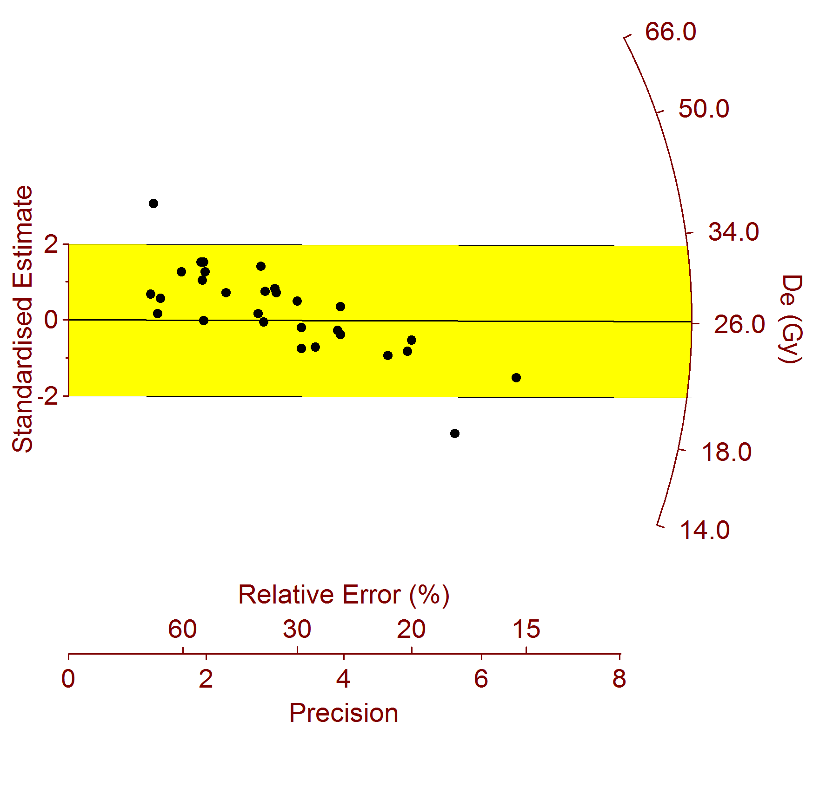

**Supplemental Materials References**

Aitken, M.J., 1985. *Thermoluminescence dating*. Academic Press: London.

Auclair, M., Lamothe, M., Hout, S., 2003. Measurement of anomalous fading for feldspar IRSL using SAR. *Radiation Measurements* 37, 487-492.

Borchardt, G.A., 1974. The SIMAN coefficient for similarity analysis. *Classification Society Bulletin* 3(2), 1-8.

Borchardt, G.A., Aruscavage, P.J., Millard, H.T., Jr., 1972. Correlation of the Bishop ash, a Pleistocene marker bed, using instrument activation analysis. *Journal of Sedimentary Petrology* 42, 301-306.

Bøtter-Jensen, L., Mejdahl, V., 1988. Assessment of beta dose-rate using a GM multi-counter system. *Nuclear Tracks and Radiation Measurements* 14, 187-191.

Galbraith, R.F., Roberts, R.G., 2012. Statistical aspects of equivalent dose and error

calculation and display in OSL dating: an overview and some recommendations. *Quaternary Geochronology* 11, 1-27.

Guérin, G., Mercier, N., Adamiec, G., 2011. Dose-rate conversation factors: update. *Ancient TL* 29, 5-8.

Hatté, C., Morvan, J., Noury, C., Paterne, M., 2001. Is classical acid-alkali-acid treatment responsible for contamination? An alternative proposition. *Radiocarbon* 43(2A), 177-182.

Huntley, D.J., Lamothe, M., 2001. Ubiquity of anomalous fading in K-feldspars, and measurement and correction for it in optical dating. *Canadian Journal of Earth Sciences*

38, 1093-1106.

Jarosewich, E., Nelen, J.A., Nordberg, J.A., 1979. Electron-microprobe reference samples for standard analysis. *Smithsonian Contributions to the Earth Sciences* 22, 68-72.

Murray, A.S., Wintle, A.G., 2000. Luminescence dating of quartz using an improved single-aliquot regenerative-dose protocol. *Radiation Measurements* 32, 57-73.

Pigati, J.S., Quade, J., Wilson, J., Jull, A.J.T., Lifton, N.A., 2007. Development of low-background vacuum extraction and graphitization systems for 14C dating of old (40-60 ka) samples. *Quaternary International* 166, 4-14.

Prescott, J.R., Hutton, J.T., 1994. Cosmic ray contributions to dose rates for luminescence and ESR dating: large depths and longtime durations. *Radiation Measurements* 23, 497-500.

Stuiver, M., Polach, H.A., 1977. Discussion: reporting of C-14 data. *Radiocarbon* 19(3), 355-363.

Taylor, R.E., Bar-Yosef, O., 2014. *Radiocarbon dating: an archaeological perspective*. Second edition. Left Coast Press: Walnut Creek.

Ward, G.K, Wilson, S.R. 1978. Procedures for comparing and combining radiocarbon age determinations: A critique. *Archaeometry* 20, 19-31.