Late Quaternary vertebrates from the Upper Gunnison Basin, Colorado, and Small-mammal Community Resilience to Climate Change since the Last Glacial Maximum

Steven D. Emslie and David J. Meltzer
Supplementary Material

Modern Flora and Fauna of the Upper Gunnison Basin
Historic records indicate that the Upper Gunnison Basin (UGB) habitats have remained relatively unchanged since the area was first explored and surveyed by the U.S. Government in 1853 (Beckwith, 1854). Recent human use and modification has occurred primarily along the valley bottom, including Blue Mesa Dam which flooded a large portion of the valley between the upriver entrance to the Black Canyon of the Gunnison to near the modern town of Gunnison. The majority of forested areas are variously dominated by a diversity of conifers (spruce and pines), spruce (Picea pungens), Douglas fir (Pseudotsuga menziesii), aspen (Populus tremuloides), lodgepole (Pinus contorta), ponderosa (P. ponderosa), bristlecone (P. aristata) and limber (P. flexilis) pines. Juniper (Juniperus scopulorum) woodland and sagebrush shrub (Artemisia spp.) dominate the floor of the basin (Barrell, 1969; Emslie et al., 2005; Fall, 1997).
Except for those species that have been extirpated from the basin, or unable to colonize it due to geographic barriers despite suitable habitat and communities at similar elevations within, the contemporary fauna of the UGB is quite diverse. This diversity is supported by the large elevational gradient and variety of forested and open habitats, wetlands, and streams that characterize the UGB today. Thus, the mammalian fauna is comprised of many species typical of southern Rocky Mountain environments that includes numerous ungulates (Antilocapra americana, Ovis canadensis, Odocoileus hemionus, Cervus Canadensis), rabbits (Ochotona princeps, Lepus townsendii, L. americanus, Sylvilagus spp.), voles and mice (Microtus and Peromyscus spp.), sciurids (Neotamias spp., Urocitellus elegans, Callospermophilus lateralis, Tamiasciurus hudsonicus, Marmota flaviventris, Cynomys gunnisoni), pocket gopher (Thomomys talpoides), beaver (Castor canadensis) and muskrat (Ondatra zibethicus; Johnston et al. 2001; Reed and Metcalf 1999; Stiger 2001, 2006; Armstrong et al. 2011). Carnivores include mountain lion (Puma concolor), bobcat (Lynx rufus), coyote (Canis latrans), gray wolf (Canis lupus), red fox (Vulpes vulpes), black bear (Ursus americanus), and numerous mustelids including pine marten (Martes americana), long-tailed and short-tailed weasels (Mustela frenata and M. erminea), mink (Neovison vison), wolverine (Gulo gulo), and American badger (Taxidea taxus).

Excavation history and methods at Haystack, Cement Creek, and Signature Caves
Haystack Cave
Haystack Cave was first recorded in 1939 as a ‘jasper mine’ near Iola by Betty H. and Harold A. Huscher for the Colorado Museum of Natural History (Euler and Stiger, 1981). At that time, the archaeological significance of the site was its lithic raw materials (jasper veins) present in the volcanic Sapinero Mesa Tuff in which the cave was formed. In July 1976, the cave was recorded as site 5GN189 as part of an archaeological inventory for the Curecanti National Recreation Area, though the cave is located on Bureau of Land Management (BLM) property just outside the boundary of the Recreation Area. Lithics and bone fragments were observed on the surface when it was recorded in this survey, as well as potholes caused by looting.
The National Park Service completed the first scientific excavations of the site in 1978. Two 1x1 m pits were excavated near the center of the cave and extended to bedrock, or approximately 1.6 m in depth (Euler and Stiger, 1981). These excavations produced 612 potentially cultural artifacts including one Olivella shell bead found in the upper levels of the deposits. An extensive collection of vertebrate remains also was recovered and subsequent analysis indicated the presence of at least 31 taxa, including two extinct mammals (Emslie, 1986). In addition, five other species identified in this assemblage no longer occur in the vicinity of the cave, with most representing a more alpine tundra or subalpine forest environment. Two conventional radiocarbon dates were completed on unidentifiable bone fragments from two levels in the cave and produced ages of 12,154 ± 1700 and 14,935 ± 610 ¹⁴C yr BP (Emslie, 1986) and verified that some of the deposits dated to the late Pleistocene.
Further research at Haystack Cave did not take place until 1986-1987 when D. Nash, then a Ph.D. candidate in the Department of Anthropology, University of New Mexico, completed extensive excavations to determine if early human (pre-Clovis) artifacts were associated with the late Pleistocene vertebrate remains in the cave (Nash, 1987). A trench was placed on the west side of the cave and extended 15 m towards the rear. A 1 m² grid system was established, designated by letters A-P from the entrance to the back of the cave, and numbered 1-4 from left to right (Fig. 1). The grids were further subdivided into quarters, labeled a-d (see Nash, 2000). Over 20 m² in total was excavated to bedrock in 3-10 cm levels over two field seasons with careful stratigraphic controls. All sediments were sifted through 0.64 and 0.32 cm² screens to recover biological and cultural materials (Nash, 1987, 2000). These investigations resulted in the recovery of thousands of bones and lithics. Subsequent analyses of the bones added more vertebrate taxa to the faunal list from this cave, including three additional extinct species. A full description and analysis of this collection, however, was never completed.
Since 1987, disturbances in the cave caused considerable sloughing of in situ sediments into previously excavated areas resulting in loss of stratigraphic information (see below) and context of fossil material. In 1998, the senior author salvaged the slumped sediments that had fallen into the trench excavated by Nash. To obtain more detailed stratigraphic information, one additional small section (0.5x1.4 m) of in situ sediment was excavated in Nash’s grid K3/4 (Fig. 1). Level 1 had a sloping surface and was excavated to 10-cm depth while the remainder of the section was excavated in 5-cm levels. Except for rodent fecal and midden deposits in Level 1, no stratigraphic layering was apparent throughout these deposits except for a slightly compacted and finely stratified lens of sediments encountered at a depth of 0.55-0.60 m (Level 11) below the surface. Otherwise, fine cave dust and rock spalls dominated the deposits to the bedrock floor at a depth of 1.4 m. Considerable rodent disturbance and burrows were found in the eastern side of the pit against the east wall of the cave beginning at Level 10. These sediments were screened separately from the undisturbed sediments excavated on west side of the pit to Level 16. After Level 16, only the west side of the pit was excavated to Level 27 where bedrock was encountered. All excavated in situ as well as the slumped sediments were screened through three stacked screens with mesh sizes of 0.64, 0.32, and 0.025 cm².
Following this excavation, the remaining in situ deposits in the cave were covered with plastic sheeting and stabilized using plywood to construct a support wall against the exposed side of the sediments so that additional sloughing would not occur. Support beams (2x4 inches) extending from the west side of the cave were placed against the plywood wall as an additional measure to prevent collapse. Foam insulation, which expands upon drying, was sprayed into the remaining gaps between the plastic covering the in situ sediments and the plywood wall. After drying, the foam thus formed a support that molded to the contours of these sediments and prevents further sloughing. In addition, this foam can be easily cut away to re-expose the sediments if future excavations are considered. This structure has been inspected with occasional visits to the cave, the last in summer August 2018, and it remains intact and essentially unchanged with no disturbances or collapses since installation.
Haystack Cave is now protected with a gate, installed by the Bureau of Land Management (BLM), to prevent vandals from disturbing the fragile deposits. In 1998, this gate was repaired and new locks were installed. However, individuals were able to break through this gate and it was eventually replaced by the BLM in 2016. All fossils from the Nash excavations and those conducted by the senior author in 1998 are deposited at the BLM Anasazi Heritage Center, Dolores, Colorado. Also in 1998, the senior author nominated this site to the State Register of Historic Properties in Colorado and it was included in this Register by the Colorado Historical Society in September 1998.

Cement Creek Cave

Test excavations were first conducted in this cave by the senior author in June 1998 to assess packrat midden and fossil deposits under a permit from the U.S. Forest Service, Gunnison National Forest (Emslie, 1998). Cave #3 is entered through a small round opening (~1 m diameter) on a south-facing vertical face of the limestone outcrop. A larger opening, ~1 m higher and ~1.5 m in diameter, is not as easily accessed for entry into the cave. Both of these entrances lead immediately into a small room where one can stand, and from here the cave divides into several passages. Passages to the east and west from the entrance end abruptly within 3-4 m. One other passage extending northwest from the entrance slopes downward for approximately 15 m until reaching a small room where sediments, fossils, and plant remains from loosely compacted packrat midden have accumulated, primarily as a result of downslope movement of material (Fig. 2). The cave passage continues from this room to the northeast and in 1998 was nearly clogged with sediments.
A 50x50 cm test pit (TP1) was placed in the floor of this room immediately before the clogged crawlway and excavated in 10-cm arbitrary levels to a depth of 1.30 m (Levels 1 - 13). The top ~60 cm of this deposit consisted of loose to degraded packrat midden (advanced organic decay giving the sediments an orange-brown color with depth). Below 60 cm, the sediments changed to a lighter brown color and consisted of fine sediments, rock spalls, and bone. Excavations ceased at Level 13 and the test pit was refilled with rock and screened sediments after covering the bottom with plastic. The unexpected depth of these deposits and the small size of the test pit prevented excavations from continuing to the bedrock floor of the cave. All sediment from these lower levels (below 60 cm) was washed through 0.64, 0.32, and 0.025 cm² mesh screens. Thousands of bones were recovered and sorted from the sediments using a magnifying lamp and a low-power stereomicroscope. Numerous species of shrews recovered and identified from this assemblage were reported by Emslie (2002).
In summer 2007, excavations were renewed at Cement Creek Cave by the authors with a four-person field crew and assistance from a local volunteer, D. Yeager. A 1x1 m pit, designated as test pit 2 (TP 2) to distinguish it from the 1998 pit (TP1), was excavated adjacent to TP 1 (Fig. 2). The surface sediments were loose and disturbed and removed as Level 1 to 20 cm depth using a temporary datum point placed in the floor of the cave to the southeast of the pit. Later, a permanent datum (an aluminum nail) was hammered into a crack in the cave wall above TP2 and the clogged crawlway. Excavations then proceeded in 5-cm levels beginning with Level 2 with all sediments sifted through three 0.64, 0.32, and 0.025 cm² mesh screens. The top screen was sifted and sorted in the cave over a plastic tarp to recover bone and plant remains while leaving the heavier sediment and rock spalls in the cave; sediments in the lower screens were placed in large sediment bags and transported to the lab for screen washing. Historic debris and rodent disturbances were observed in all levels to Level 15 when a travertine layer, sloping slightly to the north, was encountered. Light brown fossiliferous sediments appeared below this travertine layer and continued to Level 22; a disturbed area in the southwest corner of the pit appeared to be a rodent burrow and sediment from this area was separated from the undisturbed portion of the levels where it occurred.
At this point, a new section was opened to expand the excavation area, test pit 2 northeast extension (TP2 NE, 50x50 cm). The 1998 backfilled pit also was relocated on the north side of TP2 and cleaned out and its backfill removed. The addition of TP2 NE expanded the total excavated area to 1x1.5 m. The surface sediments of TP2 NE also were loose and disturbed and were removed to the top of unsolidified packrat midden at 27 cm depth. Level 1 began at this depth with excavations again proceeding in 5 cm levels. This midden, as well as some rodent disturbance, continued to Level 12 where light brown fossiliferous sediments were encountered to Level 24 (146 cm depth). A thin travertine layer was found at Level 18, at 111-115 cm depth (Fig. 3). Numerous rock spalls also characterized the sediments in Levels 12-24. Excavations beginning at Level 25 now included intact sediments below the bottom of TP1 as well as those in TP2 NE. A second travertine layer was encountered at Level 30, or 160 cm depth (Fig. 3). The excavations continued to Level 40 at a depth of 2.2 m, or 1 m deeper than the excavations of TP1 in 1998. The cave floor was never located, but probing indicated that the sediments probably extend at least 15-20 cm below level 40. The unexpected depth of the sediments, time limitations in the field, and concerns about wall collapse led us to stop excavations here and backfill the pit, after mapping the exposed profile and collecting 13 sediment and pollen samples at various depths. Because so much sediment had been removed from the pit for screen washing, we used stacked empty plastic bins to backfill the pit and then covered these with the coarse sediments and rock spalls that had been screened in the cave.
In July 2011, a third test pit (TP3) was placed in the front chamber of the cave, just inside the entrance and the passage to the east, to assess fossil deposits there. The pit was 0.8 m² in size and disturbed surface sediments were removed and screened in the cave. The disturbed sediments and historic debris characterized the entire deposit to at least 85 cm depth so excavations were stopped, and the pit backfilled, as the area appeared to be too disturbed to provide any stratigraphic context for fossil material.

Signature Cave
In July 2009, the senior author and two undergraduate students from UNCW, with occasional assistance from the junior author and A. Boehm, excavated a 0.7x0.7 m test pit in the cave approximately 10-15 m from the entrance and at a point where the passage diverges in two directions (Fig. 4). One passage bends abruptly to the east and ends in a small crawlway that is too constricted for further exploration. The other trends to the northwest and ends in a small circular domed room with rock and breakdown covering the floor. We chose to place our test pit where these two passages diverge as sediments here appeared to be deep and at a point where natural accumulation of sediments and bone would occur. In addition, there were several bones of large mammals on the surface here.
One datum point was established with a large aluminum nail on the cave surface above the test pit (TP1) and against the north wall of the cave passage. The surface of the test pit measured from 24 – 40 cm below this datum, so Level 1 was excavated to 40 cm depth to level it out for stratigraphic control. Level 2 and subsequent levels were then excavated in 5 cm intervals as determined from the measurements below the datum. Later, a permanent datum (another aluminum nail) was hammered into a crack in the cave wall on the north side of TP1. Sediments from each level were measured for volume using a 13 l bucket, then dry screened in the cave onto a plastic tarp through 0.64, 0.32, and 0.025 cm² mesh screens. The top screen containing sticks, rocks, and bone was sorted in the cave for all organic remains. Sediments captured in the lower two screens were placed in a large sediment bag and transported to the laboratory for screen washing. These sediments, after drying, were then sorted for fossil material using a low-power magnifying lamp or stereomicroscope.
Excavations continued to Level 35 (210 cm depth), or when clay and silt containing little or no bone was encountered (Fig. 5). At this point, only the northeast corner of the pit was excavated to determine the depth of this clay and this continued to Level 42, or 245 cm depth. A probe with a metal rod at Level 42 indicated the sediments were at least another 50 cm deep, with no evidence that more fossil material or the cave floor would be encountered with additional excavations. Thus, the test pit was lined with plastic sheeting and backfilled using ten empty plastic bins. A large plywood board was then placed over the pit. In summer 2010, the pit was reopened by the authors and a soil auger was employed to assess the depth of the clay layers. The first auger attempt (AH 2010.1) began at Level 35. Seven auger buckets were filled to an additional depth of 1.4 m below Level 35. Most of the sediments in these samples consisted of clay and silt, with little bone. A second auger (AH 2010.2) was completed several weeks later, again starting at Level 35, but in a different location than the first auger hole. Fourteen auger samples were collected to a depth of 363 cm. All the sediments consisted of clay and clay silt except at 265-307 cm (auger samples 7 and 8) when loose and darker sediments were encountered. These sediments contained small rocks and bone fragments and possibly came from fill in an old rodent burrow. More rock was encountered at the bottom of the auger hole before it became too deep to continue. The pit was relined with plastic sheeting and backfilled again with the plastic bins.
In summer 2011, a second test pit (TP 2) was opened in the back room of the cave, at the end of the passage that diverges to the northwest, by the senior author and one undergraduate student from UNCW (Fig. 4), and again with assistance from the junior author and A. Boehm. The pit was placed against the west wall of this room and measured 80x100 cm. A permanent datum point was placed against the cave wall from which the surface and subsequent excavated levels of the test pit could be measured. The first level of the pit was excavated to 20 cm below datum to remove loose surface sediments, rock spalls, and disturbed fill. Thereafter, each level was excavated in 5 cm intervals and all sediments were screened and transported for washing similar to TP1. Excavations proceeded to Level 15 at a depth of 85-90 cm before stopping. Here, the sediments were largely clay and silt again, with little bone or rock spalls within it and likely part of the same clay layer as encountered in the lower levels of TP1. To determine the depth of this clay in TP 2, we again used a bucket auger that sampled a 15 cm diameter area every 10-15 cm depth. We collected 11 samples (SC1-11, numbered from top to bottom in depth) below Level 15 with this auger to a depth of 226-230 cm before encountering presumed bedrock.
A profile of the north wall exposed in TP 2 indicated three major stratigraphic layers characterized these sediments (Fig. 5). The top layer consisted primarily of loose rock and historic debris to a depth of 15-20 cm below the surface. Below this, brown cave fill was encountered with some rock spalls and bone to a depth of 35-50 cm below surface. Below this layer, the sediments consisted primarily of the clay-silt with little bone or rock spalls. An orange-brown layer intermeshed between the brown cave fill above and clay-silt below may be an old rodent burrow. Three pollen samples were collected, one from each of these layers (see Fig. 5.), but subsequent analysis failed to produce countable pollen grains (Whitlock, C., personal commication, 2012).

Vertebrate Paleontology
All fossil identifications were completed using comparative skeletal and/or fossil collections at the U.S. National Museum, Smithsonian Institution (USNM), the University of California Museum of Paleontology, Berkeley (UCMP), and the Denver Museum of Nature and Science (DMNH). Most fossils from the three caves reported here do not have catalogue numbers from the respective institutions where they are housed and are identified by their excavation unit and level as described above. Bones and teeth of young (juvenile) animals are indicated by (juv.). Upper versus lower dentition is indicated by capital versus low cap letters, respectively, for incisors (I/i), canines (C/c), premolars (P/p), and molars (M/m) followed by the tooth number (e.g., the second upper molar is M2, third lower is m3, etc.).
For Haystack Cave, none of the fossil material reported by Emslie (1986) is included in the systematic paleontology given below, but all species identified from the cave are considered in the paleoecological interpretations. Selected taxa from the extensive excavations in 1986-1987 by D. Nash and those by Emslie in 1998 are included below. For Cement Creek Cave, all fossils from selected levels were identified and quantified by number of identifiable specimens and minimum number of individuals. Moreover, these identifications were only completed for TP2 NE as it had fewer disturbed layers from rodent activities than TP2. Consequently, levels 5, 9-15, 20, 26, 30, 35, and 40 were analyzed from TP2 NE to evaluate changes in small mammal communities through time. All other levels, including those in TP2, were sorted by taxonomic category and rare or unusual specimens (e.g., large mammals) were identified and are reported below. For Signature Cave, identification of all fossil material was completed for TP1 Level 34 (the lowest fossiliferous level in the deposits above the clay layers). For TP2, all fossils were identified from Levels 1-15 above the clay layers. Certain groups of mammals, such as lagomorphs and most rodents, were abundant throughout the deposits of these caves and their fossils are not detailed by level. Identification methods for these groups, however, are given below.
Arvicolinae: voles are the most abundant and diverse group of small mammals recovered from all three caves. They are especially abundant from Cement Creek Cave where each level excavated produced from dozens to hundreds of isolated teeth. These teeth were sorted and identified to genus and, when possible, species based on comparative studies with living taxa. Genera with rooted molars (Myodes and Phenacomys) are easily distinguished from Microtus and Lemmiscus. Myodes is further distinguished by its relatively smaller size and more rounded re-entrant angles that penetrate equally in depth on the lateral and medial sides. In Phenacomys, the teeth are larger than Myodes and the re-entrants are sharply angled and penetrate more deeply on the outer compared to inner sides of the lower jaw (Armstrong et al., 2011). Lemmiscus is distinguished from Microtus by its relatively small size and rounded re-entrant angles. In addition, Lemmiscus has relatively small dental lakes and the m3 is further separated from Microtus in having two transverse lakes and two median triangles (Hoffmann and Pattie, 1968). The M3 in Lemmiscus is distinct in having only four dental lakes with the most posterior being elongated, while there are up to six lakes in Microtus with the most posterior one not elongated but curved towards the internal side. While additional comparative studies would allow separation of Microtus species in the fossil material, the large number of isolated teeth coupled with difficulty in identifying these species with confidence precluded species identifications, though some species were distinguished in specific levels. For example, M. pennsylvanicus is more easily identified based on its relatively larger size and characters of the dental lakes and re-entrant angles compared to other Microtus. However, for quantification and analysis, all specimens were referred to Microtus sp.
Sciuridae: Yellow-bellied marmot (Marmota flaviventris) is common throughout the deposits in all three caves. This species is distinct by its large size compared to other sciurids and its abundant fossil remains are not listed here. The fossil material from Haystack and Cement Creek Caves does represent larger, more robust individuals compared to recent skeletal material.
Chipmunks (Neotamias spp.) and ground squirrels are moderately abundant in the fossil collections. Urocitellus elegans is particularly distinct from other genera by the relatively larger size of its teeth, especially compared to Callospermophilus lateralis. The former species has cheek teeth that are distinctly wider than long, while the latter has teeth that are about equal in length and width. The p4 and P4 are also quite distinct between these two species in shape and cusp patterns. Emslie (1986) originally referred fossil Urocitellus from Haystack Cave to Spermophilus richardsonii. However, the Wyoming ground squirrel (U. elegans) had only recently been recognized as a separate species at the southern end of its distribution including Colorado. Compared to U. richardsonii, the skull and teeth of U. elegans are relatively smaller and the m3 is easily distinguished (distinctly broader in U. richardsonii). As none of the material from Haystack or Cement Creek Cave show characteristics of U. richardsonii, all of the material from these sites is referred below to U. elegans. Neotamias is identifiable by its small size compared to other sciurids as well as characters of the cusps, but most were not identified to species. The distinctly smaller N. minimus (see Goodwin, 2004) was tentatively identified from Cement Creek Cave where isolated teeth were within the size range of this species, but no alveolar tooth rows were intact for measurement.
Lagomorpha: Most species of North American lagomorphs can be distinguished by morphological characters of the teeth and post-cranial elements as well as by relative size. The American pika (Ochotona princeps) is the smallest rabbit in North America and is quite distinct in its osteology and dentition from the leporids. Cottontail species (Sylvilagus spp.) are more difficult to distinguish from each other, but their size range and characters easily separate them from Lepus spp. Most, if not all of the fossils identifiable as Sylvilagus listed below probably represent the mountain cottontail (S. nuttallii), the only species that occurs in the UGB today. Of the larger hares and jackrabbits, the snowshoe hare (L. americanus) is distinctly smaller than White-tailed Jackrabbit (L. townsendii) and both species can be identified by size as well as osteological and dental characteristics.
Soricidae: see Emslie (2002) for characters used to identify the various species of Sorex recovered from the fossil deposits. Shrews occur throughout the deposits in all three caves and are distinguished by relative size as well as dental characters.

SYSTEMATIC PALEONTOLOGY
Class Aves
Order Anseriformes
Family Anatidae
Teal
Anas sp.
Referred material: Cement Creek Cave: furculum, TP2 Level 26.
Description: The fossil is distinguished as teal by its size and characters and compares most closely to Green-winged Teal (Anas crecca).
Anatidae, Indet.
Referred material: Cement Creek Cave: proximal end left carpometacarpus, TP2 Level 21.
Order Falconiformes
Family Accipitridae
Red-tailed Hawk
Buteo cf. B. jamaicensis
Referred material: Cement Creek Cave: distal left tarsometatarsus, TP2 Level 19.
Hawk
Buteo sp.
Referred material: Signature Cave: left tibiotarsus missing ends, TP1 Level 15.
Family Falconidae
Prairie or Peregrine Falcon
Falco mexicanus or F. peregrinus
Referred material: Cement Creek Cave: right coracoid, TP2 NE Level 23.
Description: This specimen is within the size range of female Falco peregrinus and F. mexicanus and cannot be assigned to either species. It is larger than F. femoralis and distinctly smaller than F. rusticolus.
Order Galliformes
Family Phasianidae
Centrocercus sp.
Sage-grouse
Referred material: Haystack Cave: right tarsometatarsus missing ends, H3b Level 5.
Description: This specimen compares well in size and characters to a male Centrocercus urophasianus, USNM 601637, but is too fragmentary to determine if it represents this species or the recently recognized C. minimus (Young et al., 2000), the only species to occur in the UGB today. Regardless, this is the first fossil record of sage-grouse from the UGB and is the oldest dated specimen from Haystack Cave.
White-tailed Ptarmigan
Lagopus leucurus
Referred material: Cement Creek Cave: premaxilla, left carpometacarpus missing distal end, TP2 NE Level 39; distal right humerus, TP2 NE Level 27; left humerus, TP2 Level 18; distal left humerus, proximal left humerus, TP2 Level 6; proximal right carpometacarpus, TP2 Level 30; proximal right carpometacarpus, TP2 NE Level 34; distal right carpometacarpus, TP2 NE Level 32; left carpometacarpus, TP2 Level 10; left carpometacarpus missing proximal end, TP2 SW Quad Levels 11-15; proximal half left carpometacarpus, TP2 Level 12; medial furculum, TP2 Level 3; proximal right tibiotarsus, TP2 NE Level 37; distal right tibiotarsus, TP2 NE Level 15; distal right tibiotarsus, TP2 Level 25; distal left tibiotarsus, distal right tarsometatarsus, TP2 NE Level 39; right tarsometatarsus missing distal end, distal half left tarsometatarsus, TP2 Level 32; left tarsometatarus, TP2 Level 17; distal left tarsometatarsus, TP2 NE Level 32; right tarsometatarsus with proximal end damaged, TP2 NE Level 27; distal right tarsometatarsus with end damaged, TP2 Level 29; left tarsometatarsus missing proximal end, TP2 NE Level 16; left tarsometatarus missing proximal end, TP2 Level 35; left tarsometatarsus missing proximal end, TP2 Level 18 rodent burrow fill; left tarsometatarsus, TP2 Level 36; distal half left tarsometatarus (juv.), TP2 Level 38; distal left tarsometatarsus, TP2 NE Level 32; distal left tarsometatarsus missing middle trochlea, TP2 NE Level 33; distal end left tarsometatarus missing trochlea, TP2 Level 21; proximal half and distal left tarsometatarsi, TP2 Level 28.
Ptarmigan
Lagopus sp.
Referred material: Haystack Cave: left carpometacarpus, J1d Level 7; synsacrum, slump, middle of cave.
Cement Creek Cave: left carpometacarpus, partial furculum, TP3 Level 1; distal left femur, digit 2 phalanx 1, TP2 NE Level 20; distal left tibiotarsus, TP2 Level 18 rodent burrow fill; proximal half right tarsometatarus, TP2 NE Level 15; right tarsometatarsus missing ends, TP2 Level 17; digit 2 phalanx 1, TP2 Level 33; left tarsometatarsus, TP3 Level 1.
Description: These specimens are all larger and more robust than Lagopus leucurus and compare well in size to L. lagopus; specimens of L. mutus were not available for comparison. Given that lemmings (Dicrostonyx sp.) were present in the UGB and far south of their current distribution in the Arctic, it is entirely feasible that these specimens represent the first records or Willow or Rock Ptarmigan in the U.S. south of Alaska. However, additional comparative material is needed as well as ancient DNA analysis to verify this record.
Blue Grouse
Dendragapus obscurus (Say, 1823)
Referred material: Haystack Cave: distal left ulna, slump, front of cave; left tibiotarsus missing ends, O2d-1-1, Level 1.
Cement Creek Cave: proximal right mandible, proximal half left carpometacarpus, left tarsometatarsus missing ends, TP2 NE Level 13; left humerus, TP2 SE Quad Level 15; left humerus, TP2 Level 25; left humerus, carina and manubrium of sterna, medial furculum, TP2 Level 3; left humerus, cervical vertebra two left and one right acetabulum, medial left coracoid, right distal carpometacarpus, right distal femur, TP 2 Level 12; proximal left humerus, sternal half right coracoid, TP2 Level 2; sternal end of left coracoid, phalanx 1 of digit 2, TP2 NE Level 31; distal left humerus, TP2 NE Level 40; distal half right humerus, TP2 NE Level 24; distal right ulna, TP2 SW Quad Levels 11-15; distal left ulna, TP2 Level 21 burrow fill; proximal right scapula, proximal left coracoid, right tibiotarsus with ends damaged, TP2 NE Level 12; left coracoid, humeral end left coracoid, left scapula, TP2 NE Level 11; medial right carpometacarpus, left coracoid missing ends, TP2 Level 9; left coracoid with ends damaged, TP2 NE Level 1; right coracoid with ends damaged, TP2 Level 15; humeral end right coracoid, TP2 NE Level 10; sternal end right coracoid, TP2 NE Level 9; left scapula with ends damaged, TP2 NE Level 3; humeral half right scapula, TP2 Level 14; manubrium of sternum, TP2 Level 16; carina of sternum, TP2 Level 13; medial synsacrum, TP2 Level 7; left femur with ends damaged, TP2 Level 10; shaft of left femur, TP2 NE Level 8; left femur missing ends, distal shaft right femur, TP2 Level 23; distal half right femur, TP2 Level 21; right tibiotarsus missing ends, TP2 Level 6; right tarsometatarsus, TP3 Level 1; left tarsometatarsus with ends missing, TP2 Level 1.
Signature Cave: fragment of furculum, humeral end left scapula, distal right tibiotarsus, TP2 Level 5; left coracoid, TP2 Level 6; left scapula, TP2 Level 1; proximal left humerus, TP2 Level 9; distal left humerus, TP2 Level 10.
Order Strigiformes
Family Strigidae
Great Horned Owl
Bubo virginianus
Referred material: Cement Creek Cave: premaxilla, TP2 NE Level 11.
Long-eared or Short-eared Owl
Asio sp.
Referred material: Cement Creek Cave: distal left humerus, TP2 Level 9.
Order Piciformes
Family Picidae
Northern Flicker
Colaptes auratus
Referred material: Cement Creek Cave: proximal right humerus, TP2 Level 17 burrow fill; distal half left humerus, TP2 NE Level 11.
Signature Cave: right ulna, TP2 Level 11.
Order Passeriformes
Family Corvidae
Black-billed Magpie
Pica hudsonia
Referred material: Haystack Cave: distal left humerus, N2c Level 13.
Common Raven
Corvus corax Linnaeus, 1758
Referred material: Haystack Cave: distal left tarsometatarsus, O2d Level 1.
Clark’s Nutcracker
cf. Nucifraga columbiana
Referred material: Cement Creek Cave: right tarsometatarsus, TP2 Level 9.
Description: This specimen is slightly larger and more robust than modern Nucifraga columbiana, but closest in characters to this species. The fossil is distinctly larger than Perisoreus canadensis and much smaller than Pica hudsonia. The tarsometatarsus of Cyanocitta stelleri is much longer and more slender than the fossil.
Family Fringillidae
Brown-capped Rosy-Finch
Leucosticte atrata
Referred material: Cement Creek Cave: premaxilla, TP2 NE Level 25.
Pine Grosbeak
Pinicola enucleator
Referred material: Cement Creek Cave: left mandible, TP2 NE Level 12.
Purple or Cassin’s Finch
Carpodacus purpureus or C. cassinii
Referred material: Haystack Cave: left mandible with symphysis, I3c Level 7.
Description: The fossil compares well in size and characters to both of these species; Carpodacus mexicanus is larger and more robust.

Mammalia
Order Rodentia
Family Sciuridae
Prairie Dog
Cynomys sp.
Referred material: Cement Creek Cave: left p4, TP2 NE Level 11.
Description: This specimen compares well with Cynomys gunnisoni except in having a slightly more robust protoconid. It is distinguished from ground squirrels (Callispermophilus, Urocitellus) by its larger size, but is distinctly smaller than Marmota.
Family Castoridae
American Beaver
Castor canadensis
Referred material: Signature Cave: right mandible with i1, p4-m3, surface.
Cement Creek Cave: right P4, TP2 Level 2.
Family Cricetidae
Lemming
Dicrostonyx sp.
Referred material: Haystack Cave: left mandible with i1, m1-m3, L2b/M2d, 82 cm below datum (Fig. 6); left mandible with i1, m1, J2d Level 8, 125-135 cm below datum (Fig. 6).
Description: These specimens are distinct by their relatively large size compared to other vole species and the lack of cementum on the teeth, characteristic of Dicrostonyx. They were compared to D. rubricatus, D. richardsoni, D. nelsoni, D. groenlandicus, D. kilangmiutak, D. hudsonicus, and D. unalascensis specimens at USNM. Of these taxa, the first three are distinctly smaller, while the last is distinctly larger, than the fossil specimens. Specimen J2d compares well in size and characters to D. groenlandicus, D. kilangmiutak, and D. hudsonicus. Specimen L2b/M2d compares well to D. hudsonicus except for a slightly larger m1. The specimens were also compared to the paratype left mandible (USNM 22833) of D. torquatus from the late Pleistocene of Alaska. This fossil is smaller than L2b/M2d and has a slightly smaller diastema between i1 and m1 than in either specimen from Haystack Cave.
These specimens may represent two species of Dicrostonyx, but additional comparative material of both living and fossil taxa is needed. Most fossil records for this genus in the lower 48 states have been referred to D. torquatus (western U. S.) or D. hudsonicus (eastern U. S.; Mead and Mead, 1989). A review of these records by Mead and Mead (1989) concludes that these species are associated with non-analog faunas typical of the late Pleistocene and, while the living counterparts inhabit steppe tundra environments, the fossil species may not be strict indicators of that environment in the past. The sagebrush steppe and tundra environment represented in the UGB supports this conclusion.
Family Erethizontidae
North American Porcupine
Erethizon dorsatum
Referred material: Cement Creek Cave: left M2, TP2 NE Level 15; left M, TP2 SE Quad Level 15.
Signature Cave: fragment of RM1 or 2, TP1 Level 34; right mandible with p4-m3, TP2 Level 8; humeral end of right scapula, TP2 Level 3.

Order Soricomorpha
Family Soricidae
Masked Shrew
Sorex cinereus
Referred material: Cement Creek Cave: left mandible with i1, m1-3, TP2 NE Level 15; right mandible with m1-2, TP2 NE Level 14; distal right mandible with i1 and m1, TP2 NE Level 40.
Signature Cave: left mandible with i1, p4-m3, medial left mandible with m1, TP1 Level 24; left mandible with i1, p3-m3, left mandible with m1-3, TP1 Level 34; medial right mandible with m1-3, TP1 Level 31; proximal half right mandible with m1-3, TP1 Level 35.
Pygmy Shrew
Sorex hoyi
Referred material: Signature Cave: left mandible with i1, p4-m3, TP1 Level 34; right mandible with p4-m3, TP1 Level 33.
Merriam’s Shrew
Sorex merriami
Referred material: Haystack Cave: right mandible with p4-m3, slump.
Signature Cave: left mandible with i1, p4-m3, left mandible with p4-m3, TP1 Level 26; left mandible with i1, p4-m3, TP1 Level 34; medial left mandible with m1-3, TP1 Level 25.
Montane Shrew
Sorex monticolus
Referred material: Cement Creek Cave: left mandible with i1-m3,TP2 NE Level 7; left mandible with i1-m3, TP2 NE Level 18; left mandible with m1, TP2 NE Level 26; left mandible with m1-3, TP2 NE Level 40; proximal half left mandible with m1, TP2 NE Level 15; left mandible with i1, p4-m3, right mandible with i1-m3, left mandible with i1, m1-3, TP2 Level 15; left mandible with i1, m1-2, right mandible with m1-3, TP2 NE Level 14; right mandible with i1, p4-m3, right mandible with m1-2, TP2 NE Level 13; right mandible with i1, m1-3, TP2 NE Level 11; right mandible with p4-m3, TP2 NE Level 15; right mandible with m1-2, right M1, medial right maxilla with P4, M2, medial right maxilla with P4, TP2 NE Level 26; medial right mandible with m3, TP2 NE Level 35.
Signature Cave: right M1, TP1 Level 34; left mandible with i1, m1-2, TP1 Level 23; left mandible with i1, m1-3, TP2 Level 4; left mandible with p3-m3, TP2 Level 10; left mandible with i1, p4-m3, right mandible with i1, m1-2, TP1 Level 27; left mandible with p4-m3, TP1 Level 30; proximal left mandible with m1, TP2 NE Level 32; medial right mandible with m1-3, TP1 Level 24; medial right mandible with m2-3, TP1 Level 25.
Dwarf Shrew
Sorex nanus
Referred material: Haystack Cave: left mandible with p4-m3, left mandible with m1-2, slump.
Cement Creek Cave: right mandible with m1, TP2 NE Level 26.
Signature Cave: left mandible with m1-3, left mandible with i1, m1-3, TP1 Level 33; medial left mandible with m1-3, TP1 Level 17; medial right mandible with m1-3, TP1 Level 31.
American Water Shrew
Sorex palustris
Referred material: Cement Creek Cave: left maxilla with P4-M1, medial left maxilla with M1, TP2 NE Level 35; left maxilla with P4-M2, right mandible with m1-2, TP2 NE Level 17; proximal right mandible with m2-3, medial right mandible with m1-3, TP2 NE Level 18; left mandible with no teeth, TP2 Level 19; medial left mandible with m1-2, TP2 NE Level 29; medial left mandible with p4-m2, medial left mandible with m1-3, TP2 NE Level 30; left and right mandibles with no teeth, TP2 NE Level 20; right mandible with p4-m2, TP2 NE Level 11; right mandible with m1 and m3, TP2 NE Level 27; medial right mandible with m1, TP2 NE Level 15; medial right mandible with m1, TP2 NE Level 30.
Signature Cave: left mandible with i1, m1-3, TP1 Level 25; medial left maxilla with M1-2, TP1 Level 34; left mandible with p4-m2, TP1 Levels 16-21 fill; left mandible with i1-m3, TP1, Level 26; medial left mandible with p4-m3, TP1 Level 20; left mandible with i1, p4-m3, TP1 Level 33; proximal left mandible with m2-3, right mandible with i1-m3, medial right mandible with m1 and m3, TP1 Level 27; right mandible with i1, c1-m3, TP1 Level 17; right mandible with p4-m1, m3, right mandible with m1-3, left maxilla with P4-M2, TP1 Level 22; right mandible with m1, TP2 NE Level 36; right mandible with m1-3, left mandible with m1, TP2 NE Level 34; right mandible with i1, c1-m3, right mandible with i1-m1, TP1 Level 24; right mandible with i1, p4-m3, TP2 Level 1.
Preble’s Shrew
Sorex preblei
Referred material: Cement Creek Cave: right mandible with m1-3, TP2 NE Level 14; right mandible with p4-m3, left mandible with i1, c1-m1, TP2 NE Level 27.
Shrew
Sorex sp.
Referred material: Cement Creek Cave: right I1, i1, TP2 NE Level 40; proximal half left mandible with no teeth, TP2 NE Level 29; medial left mandible with m2, right P4, TP2 NE Level 30; right m1, left m1, medial left mandible with damaged m1-3, left mandible with no teeth, TP2 NE Level 35; left mandible with m1, medial right mandible with m1-2, TP2 NE Level 33.
Signature Cave: left maxilla with U1-M3, TP1 Level 22; right P4, TP1 Level 25; medial left mandible with m1-2, TP1 Level 30; right i1, TP1 Level 23; right maxilla with U3-4, TP1 Level 33.
Order Chiroptera
Family Vespertilionidae
Yuma Myotis
Myotis cf. M. yumanensis
Referred material: Haystack Cave: skull with RM2, O2c Level 13.
Description: This specimen was compared to skulls of Eptesicus, Myotis, Parastrellus, Corynorhinus, Androzous, and Lasionycteris and found to compare most closely in size and characters to Myotis. Specifically, the fossil was smaller than M. volans, M. thysanodes, M. lucifugus; M. californianus and M. ciliolabrum differ by the size and position of openings in the palate and in being slightly narrower anteriorly. The fossil compares well in characters, but is slightly smaller than, male M. yumanensis. Thus, the specimen is tentatively referred to this species.
cf. Myotis sp.
Referred material: Cement Creek Cave: right maxilla with P3 and M2, TP2 SW Quad Levels 11-15; right mandible with no teeth, TP2 NE Level 15; left mandible with p1, p3-m3, TP2 NE Level 14; right mandible with m2-3, TP2 NE Level 21.

Order Carnivora
Family Felidae
Mountain Lion
Felis concolor Linnaeus, 1758
Referred material: Haystack Cave: right 3rd metacarpal, H2d-13-17 Level 13.
Description: This specimen compares well in size and characters to the living species.
Family Canidae
Referred material: Haystack Cave: left maxilla with P3, N2a Level 16; right premaxilla with no teeth, J2b Level 2.
Description: These two specimens are similar to Vulpes vulpes in characters, but larger in size and may represent a small Canis latrans.
Coyote
Canis latrans
Referred material: Haystack Cave: right mandible with p3-m2, right second metacarpal, slump.
Signature Cave: left frontal of skull (juv.), TP2 Level 3; left mandible with no teeth, surface; right tibia (juv.), TP2 Level 1; right scapula, left radius missing epiphyses (juv.), TP2 Level 5; left pelvis, distal epiphysis of tibia and femur, TP2 Level 4; proximal epiphysis of left tibia, TP2 Level 10.
Description: The fossil mandible from Haystack Cave is slightly more robust than modern specimens.

Red Fox
Vulpes vulpes
Referred material: Haystack Cave: left maxilla with P4-M2, N2a Level 14; medial left mandible with p2-3, I4a Level 6.
Cement Creek Cave: RP3, TP2 Level 17; right M1, TP2 Level 23.
Signature Cave: left P4, M1 and M2, TP1 Level 6; left c1, TP1 Level 30; left m1, TP1 Level 31.
Family Ursidae
Black Bear
Ursus americanus
Referred material: Cement Creek Cave: right I3, TP2 NE Level 40; left I3, TP2 SW Quad Levels 11-15; left tibia, TP2 Level 12; right I2, TP2 Level 16; metacarpal, TP2 Level 17.
Ursus cf. U. arctos
Referred material: Cement Creek Cave: first phalange, TP2 NE Level 26.
Description: This specimen compares well with Ursus arctos (USNM 283629). The fossil is slightly larger and likely represents this species based on relative size and robustness.
Family Mustelidae
Pine Marten
Martes americana
Referred material: Haystack Cave: medial right mandible with m1, K3 Level 18.
Cement Creek Cave: right M1, TP2 Level 18; right M1, TP2 NE Level 36; left P4, TP2 NE Level 33; left maxilla with P2-P4, TP2 Level 8; medial right mandible with p4, m1, right m1 (juv.), TP2 NE Level 31; right p3, TP2 Level 22; left m1, m2, and two m3, two right m1, right m2, three right Rm3, TP2 NE Level 14.
Signature Cave: skull missing anterior half and maxilla, TP2 Level 11; right auditory bulla, TP2 Level 13; right maxilla with P3-4, TP1 Level 30; left maxilla with P4-M1, TP2 Level 12; right P4, TP1 Level 34; right p4,TP2 Level 4.
Description: These specimens compare well in size and characters to the living species, though the specimen form Haystack Cave is slightly more robust. One fossil species was described from the late Pleistocene of western North America, Martes nobilis (Anderson, 1970), but this species was synonymized with M. americana as the two species differed primarily in size only (Youngman and Schueler, 1991). It is now considered a larger subspecies, M. a. nobilis that was not sympatric with living subspecies but was up to 30% larger (Hughes, 2009). While all of the fossil material from Cement Creek and Signature Caves fall within the size range of living M. americana, the specimen from Haystack Cave has an m1 that measures length, 9.8 mm, and breadth, 4.7 mm. These measurements are still below the range found in M. a. nobilis (Hughes, 2009) and the specimen is not considered representative of this extinct subspecies.
Least Weasel
Mustela nivalis
Referred material: Cement Creek Cave: right mandible with m1, TP2 Level 4.
Description: The specimen is smaller than Mustela frenata and M. erminea and compares well in size and characters with DMNH specimens.
Short-tailed Weasel
Mustela erminea
Referred material: Haystack Cave: right mandible with m1, K3/4 Level 21.
Cement Creek Cave: skull with right and left P2-M1, TP2 NE Level 16; left P4, right P4, right mandible with m1, right p4, medial left mandible with p3-4, TP2 NE Level 30; medial right mandible with m1, TP2 Level 14; right mandible with m1, TP2 Level 4; right mandible with m1, TP2 NE Level 15; left mandible with p4-m1, TP2 NE Level 31; left mandible with m1, TP2 NE Level 16.
Description: These specimens are smaller than Mustela frenata and within the size range of M. erminea. The least weasel (M. nivalis) is smaller than the fossils.
Long-tailed Weasel
Mustela frenata
Referred material: Haystack Cave: right mandible with p3-m2, I4a Level 4; left mandible with p1, m1-2, H3b Level 5.
Cement Creek Cave: left P4, TP2 NE Level 32; right P4, TP2 NE Level 34; right maxilla with P4-M1, right mandible with p4, TP2 Level 13; right mandible with p2-m2, TP2 Level 6; left mandible with p3, m1, TP2 Level 1; left mandible with p4-m1, left mandible with m1-2, TP2 NE Level 11; medial left mandible with p4, m1, TP2 NE Level 29; medial left mandible with p4, m1, TP2 NE Level 40; distal left mandible with c1, p2, TP2 NW Quad Level 15; medial right mandible with p3-m2, TP2 SW Quad Levels 11-15; left mandible with m1, TP2 Level 20; left p4, TP2 Level 23; left P4, TP2 NE Level 26; left P4, TP2 Level 27; right P4, TP2 Level 35.
Signature Cave: medial right mandible with m1-2, TP1 Level 20.
Description: The left mandible from Haystack Cave is slightly larger and more robust than modern specimens.

Black-footed Ferret
Mustela nigripes
Referred material: Haystack Cave: distal half left mandible with fragment of p3 and m1, slump (Fig. 7).
Description: This species is distinct from other mustelids by its relatively robust mandible and long narrow m1. It is larger than Mustela frenata and the m1 of M. vison is shorter and broader than M. nigripes; Martes americana is larger and more robust than M. nigripes as well. The m1 measures length, 8.0 mm; breadth, 2.9 mm. A piece of the proximal end of this specimen was removed and submitted for AMS radiocarbon analysis, but failed to provide sufficient collagen for a date.
Discussion: This specimen is the first record of this species from the UGB. In Colorado, it also has been identified from the late Pleistocene Chimney Rock Animal Trap and early Pleistocene Porcupine Cave (Kurtén and Anderson, 1980; Anderson, 2004). This species currently occupies open grassland environments where it feeds primarily on prairie dogs (Cynomys spp.). Interestingly, there are no fossil records of prairie dog from Haystack Cave, though C. gunnisoni currently occurs in lower elevations of the basin not far from the cave.
Weasel
Mustela sp.
Referred material: Cement Creek Cave: medial right maxilla with P4-M1, TP2 SW Quad Levels 11-15; right and left P4, distal right mandible with p2-4, TP2 NE Level 33; right mandible with p4-m1, TP2 Level 16; right mandible with m1, left p3 and p4, TP2 NE Level 11; right mandible with p3, fragment of m1, TP2 NE Level 30; left mandible with m1, TP2 NE Level 19; left mandible with p4-m2, TP2 NE Level 23.
Signature Cave: medial left mandible with m1, TP1 Level 10; medial right mandible with p3-m1, TP2 Level 12; left p4, TP1 Level 25; left C1, TP1 Level 20.
Description: Most of these specimens are too worn or fragmentary for positive identification. The medial left mandible from Signature Cave is from a very small weasel with m1 length and greatest breadth at 4.1 and 1.4 mm, respectively. It is smaller than Mustela nigripes and within the size range of M. nivalis and may represent that species.
American Badger
Taxidea taxus
Referred material: Haystack Cave: left P4, K3/4 Level 24.
Family Mephitidae
Short-faced Skunk
Brachyprotoma cf. B. brevimala Heaton, 1985
Referred material: Cement Creek Cave: RM1 (DMNH 69303), TP2 NE Level 40; left mandible missing proximal end with p4-m2 (DMNH 69302; Fig. 8A), TP2 Level 19; partial left mandible with c1, p4-m1 (DMNH 69301: Fig. 8B), TP2 Level 38; partial right mandible with c1-m1 (DMNH 69300), TP2 NE Level 27.
Description: These specimens compare well to other fossil mandibles of Brachyprotoma sp. from Cumberland Cave, Maryland, housed at USNM. Specifically, they are relatively short with crowded premolars and large lower canine. USNM 12045 is similar in size to DMNH 69301 except in having a slightly more robust p4, with a more triangular shape from a greater protrusion of the labial side. USNM 12046 and 8165 also are similar to DMNH 69301 except for slight size variations including an overall greater length of the m1 (Table 1). The three mandibles from Cement Creek Cave are identical to each other except for slight size variations (Table 1). DMNH 69300 also has a fragmented m1.
Discussion: Although several species in this extinct genus have been described (Kurtén and Anderson, 1980), only two valid species are recognized today: B. obtusata ranging in age from the early to late Pleistocene of North America, and B. brevimala described from only one late Pleistocene locality in Utah (Kurtén and Anderson, 1980; Heaton, 1985). Heaton (1985) described B. brevimala from Crystal Ball Cave, Utah. Unfortunately, this species is known only from an anterior skull with right P4 and cannot be compared to the material from Cement Creek Cave which we tentatively refer to this species. Heaton’s comparative studies with material of B. obtusata indicate that B. brevimala was up to 15% smaller, with narrower teeth, than B. obtusata. In addition, he found the size and dental character differences between these species to be outside the variation found in a large series (N = 73) of Spilogale putorius skulls, the most closely related living taxon to Brachyprotoma. Thus, Heaton’s description of B. brevimala is considered valid and, given that the mandibles from Cement Creek Cave also have smaller and narrower teeth than those of B. obtusata, they are tentatively referred here to Brachyprotoma cf. B. brevimala.
Anderson (1996, 2004) reported numerous skull fragments and four mandibles of Brachyprotoma obtusata from the late Irvingtonian (~400 ka) of Porcupine Cave, Colorado. This site is at an elevation (2900 m) similar to Cement Creek Cave, but just outside the Upper Gunnison Basin to the east in Park County. While Anderson (1996: 272) provided no comparative measurements of this material, she stated that the specimens did measure “within the range of those from other Irvingtonian sites.” The anterior skull (DMNH 11014) and three mandibles from this site (DMNH 11013, 21471, and 27050) were compared here to the specimens from Cement Creek Cave; a left mandible with p4-m1 (DMNH 36672) could not be located in the DMNH collections. The RM1 (DMNH 69303) from Cement Creek Cave compares well in morphology with DMNH 11014 except for its slightly smaller size in the former. DMNH 69303 measures 3.0 and 4.47 mm, length and breadth respectively, while DNMH 11014 is 4.24 and 5.27 mm, respectively. Measurements of the Porcupine Cave mandibles also indicate that they are slightly to distinctly more robust than those from Cement Creek Cave (Table 1).
Hockett and Dillingham (2004) recovered a single mandible of Brachyprotoma from Mineral Hill Cave, Nevada, that they refer to B. obtusata based on consultation with E. Anderson. However, their mandible also is smaller and narrower than specimens of B. obtusata (Table 1) and closely matches the specimens from Cement Creek Cave in size. Although Anderson (1996, 2004) preferred to refer all specimens of Brachyprotoma in North America (Irvingtonian to Rancholabrean in age) to B. obtusata, it appears now that a smaller, more gracile species occurred in the Rancholabrean of western North America. Thus, the specimen from Mineral Hill Cave likely represents B. brevimala as well, but additional study is needed.
Order Perissodactyla
Family Equidae
Equus sp.
Referred material: Haystack Cave: tarsal, slump; third phalange, K3/4 Level 16.
Cement Creek Cave: left i1 (juv.), TP2 NE level 30; left astragalus, TP2 NE Level 22.

Order Artiodactyla
Family Cervidae
American Elk
Cervus canadensis
Referred material: Signature Cave: right I3, carpal, TP2 Level 1; fragment of left maxilla with M1, TP2 Level 8.
Mule Deer
Odocoileus hemionus
Referred material: Signature Cave: right P2 (deciduous), TP2 NE Level 34; left P4 and p2, TP2 Level 11; right frontal of skull (juv.), TP2 Level 2; left P2, TP2 level 8; right p3, TP1 Level 33; left astragalus, TP2 Level 1; distal end of metatarsal, TP2 Level 10.
Cement Creek Cave: right astragalus, TP2 Level 3.
Family Antilocapridae
Pronghorn
Antilocapra americana
Referred material: Haystack Cave: distal left humerus, slump.
Family Bovidae
Bison sp.
Referred material: Cement Creek Cave: right second phalange, TP2 Level 15.
Bighorn Sheep
Ovis canadensis
Referred material: Haystack Cave: left scapula, K3/4 Level 23; distal epiphysis of metapodial, K3/4 Level 4; distal metacarpal, left metacarpal missing distal end, left tibia missing proximal end, three astragali, proximal left calcaneum, three second phalanges, proximal second phalange, slump; first phalange, K3/4 Level 13; first phalange, K3/4 Level 15; first phalange, K3/4 Level 18; first and third phalanges, K3/4 Level 16; second phalange, K3/4 Level 21.
Cement Creek Cave: fragmented left maxilla with P3-M3, TP2 Level 38; right m1, TP2 Level 28; distal left mandible, TP2 Level 17; right humerus missing proximal epiphysis (juv.), TP2 NE Level 36; humeral end right scapula, TP2 NE Level 21; atlas vertebra, TP2 Level 21; astragalus, TP2 Level 25; fragment of left acetabulum, TP2 Level 30; right calcaneum missing distal epiphysis, TP2 Level 22; calcaneum fragment, TP2 NW corner Level 14; cuneiform--ulnar carpal, TP2 NE Level 20; first phalange, TP2 Level 35; lunate or intermediate carpal, TP2 NE Level 26; right ulnar carpal, TP2 NE Level 24.
Signature Cave: fragment of right mandible with worn p4, TP2 Level 1; first phalange, TP2 Level 7.
Shrub-ox
Euceratherium collinum Furlong and Sinclair, 1904
Referred material: Haystack Cave: proximal half right calcaneum, I3c Level 12; two proximal halves left calcanea, H3d Level 9 and K3 slump; distal half 1st phalange, J1d Level 6; 2nd phalange, J1d Level 2.
Cement Creek Cave: first phalange, TP2 Level 17.
Description: The 2nd phalange compares well in size and features to UCMP 9431 and 10020 from Samwel Cave and a specimen from Musk Ox Cave, New Mexico (USNM, uncatalogued).
cf. Euceratherium collinum
Referred material: Haystack Cave: left maxilla fragment with P4 (partial) and M1, K1b Level 5; right fused central and 4th tarsal, H3d Level 3.
Description: A fragment of a left maxilla with a partial P4 and complete but worn M1, K1b-5-3, was compared to the type skull for Euceratherium collinum from Samwel Cave (UCMP 8751), as well as to several uncatalogued and isolated M1 and M2 from this site in the collections at UCMP. The teeth from Haystack Cave are much more worn than the type and the M1 has a length nearly equal to its width (21.3 and 22.2 mm, respectively), giving it a more square-shape than the M1 from Samwel Cave which is distinctly longer than wide (21.5 and 18.9 mm, respectively).
Harlan’s or Helmeted Muskox
Bootherium bombifrons (Harlan, 1825)
Referred material: Haystack Cave: distal epiphysis of metapodial, I3b Level 14; partial centroquartal, I3b/I4a; distal end of 1st phalange, H2d Level 11; two partial 2nd phalanges, F3d Level 6 and L1b Level 9; two third phalanges, L1d Level 6 and K2d/K3c.
Description: These specimens, most collected by D. Nash in the 1986/1987 excavations of Haystack Cave, were originally assigned to this species by J. MacDonald and re-examined here. They were compared to specimens of Euceratherium, Bootherium (including specimens originally referred to Symbos; McDonald and Ray, 1989) and Bison at USNM and UCMP. The 2nd phalanges are larger and much more robust than the specimens of Euceratherium also from Haystack Cave (see above). The distal metapodial is much larger than Euceratherium and differs from Bison by shape of condyles with relatively deeper notches and more pointed edges of symphyses on the dorsal side as found in Bootherium. Two other specimens were too fragmentary or could not be compared directly to known material and are tentatively identified as cf. Bootherium: a fragment of the proximal end of a 2nd phalange, G3c Level 3, and a fragment of a distal humerus with lateral epicondyle recovered from the 1978 excavation (0S2W Level 5, FS 16).
Discussion: Ancient DNA analyses of fossil Bootherium, Eurceratherium, and Praeovibos have revealed a close relationship between the first two species, though they remain generically distinct (Campos et al., 2010). Specimens originally assigned to Symbos, with those of Bootherium, are believed by McDonald and Ray (1989) to represent males and females of the same taxon, respectively, but this relationship remains equivocal (Campos et al., 2010). Haystack Cave is now the only site in North America where both Euceratherium and Bootherium have been recovered from the same deposits, suggesting that the UGB formed a zone of ecological transition between the more northerly distributed Bootherium and southern Euceratherium. This transition zone is feasible as the former species is believed to have evolved in eastern Beringia and is associated with grassland and alpine meadow habitats (Campos et al., 2010). Euceratherium, however, appeared in North America in the early Pleistocene and browsed on a variety of plants but especially sagebrush (Artemisia tridentata), rabbit brush (Chrysothamnus spp.), and oak (Quercus sp.; Kropf et al., 2007). The sagebrush steppe-tundra that existed in the UGB during the late Pleistocene probably served as suitable habitat for both Euceratherium and Bootherium, but increasingly more sagebrush grassland to the south seems to have favored the former species over the latter. Whether or not these two species co-existed in the UGB is uncertain. One date on a Euceratherium calcaneum is slightly older (20330 +/- 45 ¹⁴C yr BP) than three dates on Bootherium with the oldest at 19620 +/- 90 ¹⁴C yr BP.
cf. Bootherium bombifrons
Referred material: Haystack Cave: distal right humerus, 0S/2W Level 5; 2nd phalange, G3c Level 3.
Artiodactyla, Indet.
Referred material: Cement Creek Cave: two tooth fragments, TP2 Level 12; two tooth fragments, TP2 Level 21; medial rib fragment, TP2 Level 16; distal right humerus (juv.), second phalange, TP2 Level 19; distal half right humerus missing epiphysis, TP2 NE Level 37; left radius missing distal end, TP2 Level 30; fragment of proximal right radius, TP2 Level 27; partial distal epiphysis of metapodial, TP2 Level 29; partial distal epiphysis of metapodial, fragment of acetabulum, tooth fragment, TP2 NE Level 32; partial distal epiphysis of metapodial, TP2 NE Level 35; proximal epiphysis of first phalange, TP2 NE Level 27; proximal epiphysis of first phalange, TP2 Level 37; distal end first phalange, TP2 Level 3; distal end first phalange, second phalange, TP2 Level 23.
Signature Cave: thoracic and lumbar vertebrae, TP2 Level 5; three vertebra fragments, shaft of femur, TP2 Level 1; three thoracic vertebrae, TP2 Level 7; thoracic vertebrate (juv.), right medial scapula (juv.), tooth fragment, TP2 Level 10; tooth fragment, distal right humerus, proximal shaft of metatarsal, fragment of lumbar vertebra, three pelvis fragments, TP2 Level 2; medial shaft of femur, third phalange, TP2 Level 4.

REFERENCES CITED
Anderson, E., 1970. Quaternary evolution of the genus Martes (Carnivora, Mustelidae). Acta Zoologica Fennica 130: 1-130.
Anderson, E., 1996. A preliminary report on the Carnivora of Porcupine Cave, Park County, Colorado. In: Stewart, K. M., Seymour, K. L. (Eds.), Palaeoecology and Palaeoenvironments of Late Cenozoic Mammals. University of Toronto Press, Canada, pp. 259-282.
Anderson, E., 2004. The carnivore from Porcupine Cave. In: Barnosky, A. (Ed.), Biodiversity Response to Climate Change in the Middle Pleistocene. University of California Press, Berkeley, pp. 141-154.
Armstrong, D.M., Fitzgerald, J.P., Meaney, C.A., 2011. Mammals of Colorado, 2nd Ed. University Press of Colorado, Boulder.
Barrell, J., 1969. Flora of the Gunnison Basin. Natural Land Institute, Rockford, Illinois.
Beckwith, E.G., 1854. Report of explorations for a route for the Pacific railroad. Report to War Department, U. S. Government, Washington, D. C.
Campos, P. E., Sher, A., Mead, J. I., Tikhonov, A., Buckley, M., Collins, M., Willerslev, E., Gilbert, M. T. P., 2010. Clarification of the taxonomic relationship of the extant and extinct ovibovids, Ovibos, Praeovibos, Euceratherium and Bootherium. Quaternary Science Reviews 29: 2123-2130.
Emslie, S. D., 1986. Late Pleistocene vertebrates from Gunnison County, Colorado. Journal of Paleontology 60: 170-176.
Emslie, S. D., 1998. Report of excavations at Haystack and Cement Creek Caves, Gunnison County, Colorado. Report submitted to Bureau of Land Management, Gunnison, Colorado.
Emslie, S. D., 2002. Fossil shrews (Insectivora: Soricidae) from the late Pleistocene of Colorado. Southwestern Naturalist 47: 62-69.
Emslie, S. D., Stiger, M., Wambach, E., 2005. Packrat middens and late Holocene environmental change in southwestern Colorado. Southwestern Naturalist 50: 209-215.
Euler, R.T., Stiger, M.A., 1981. 1978 test excavations at five archeological sites in Curecanti National Recreation Area, Intermountain Colorado. Midwest Archeological Center, Lincoln, Nebraska.
Fall, P., 1997. Timberline fluctuations and late Quaternary paleoclimates in the southern Rocky Mountains, Colorado. GSA Bulletin 109: 1306-1320.
Goodwin, H. T., 2004. Systematics and faunal dynamics of fossil squirrels from Porcupine Cave. In: Barnosky, A. (Ed.), Biodiversity Response to Climate Change in the Middle Pleistocene. University of California Press, Berkeley, pp. 172-192.
Heaton, T. H., 1985. Quaternary paleontology and paleoecology of Crystal Ball Cave, Millard County, Utah: with emphasis on mammals and description of a new species of fossil skunk. Great Basin Naturalist 45: 337-390.
Hockett, B., Dillingham, E., 2004. Paleontological Investigations at Mineral Hill Cave. Contribution to the Study of Cultural Resources, Technical Report No. 18, Bureau of Land Management, Nevada.
Hoffmann, R. S., Pattie, D. L., 1968. A guide to Montana mammals. University of Montana, Missoula.
Hughes, S. S., 2009. Noble marten (Martes americana nobilis) revisited: its adaptation and extinction. Journal of Mammalogy 90: 74-92.

Johnston, B. C., L. Huckaby, T. J. Hughes, and J. Pecor, 2001. Ecological types of the Upper Gunnison Basin: Vegetation-soil-landform-geology-climate-water land classes for natural resource management. Technical Report R2-RR-2001-01, 858 pp. Lakewood, CO: USDA Forest Service, Rocky Mountain Region.
Kropf, M., Mead, J. I., Anderson, R. S., 2007. Dung, diet, and the paleoenvironment of the extinct shrub-ox (Euceratherium collinum) on the Colorado Plateau, USA. Quaternary Research 67: 143-151.
Kurtén, B., Anderson, E., 1980. Pleistocene Mammals of North America. Columbia University Press, New York.
McDonald, J. N., Ray, C. E., 1989. The autochthonous North American musk oxen Bootherium, Symbos, and Gidleya (Mammalia: Artiodactyla: Bovidae). Smithsonian Contributions to Paleobiology 66: 1-77.
Mead, E. M., Mead, J. I., 1989. Quaternary zoogeography of the Nearctic Dicrostonyx lemmings. Boreas 18: 323-332.
Nash, D. T., 1987. Archaeological investigations at Haystack Cave, central Colorado. Current Research in the Pleistocene 4: 114-116.
Nash, D. T., 2000. Project summary for 1986/1987 excavations at Haystack Cave (5GN189), Gunnison County, Colorado. Report submitted to Bureau of Land Management, Dolores, Colorado.
Reed, A. and M. Metcalf, 1999. Colorado prehistory: a context for the northern Colorado River basin. Colorado Council of Professional Archaeologists, Denver.
Stiger, M., 2001. Hunter-Gatherer Archaeology of the Colorado High Country. University Press of Colorado, Boulder.
Stiger, M., 2006. A Folsom structure in the Colorado mountains. American Antiquity 71: 321- 351.
Young, J. R., Braun, C. E., Oyler-McCance, S. J., Hupp, J. W., Quinn, T. W., 2000. A new species of sage-grouse from Southwestern Colorado. Wilson Bulletin 112: 445-453.
Youngman, P. M., Schueler, F. W., 1991. Martes nobilis is a synonym of Martes americana, not an extinct Pleistocene- Holocene species. Journal of Mammalogy 72: 567-577.

Table 1. Measurement (in mm) of Brachyprotoma sp. from Cumberland Cave, Maryland, catalogued with USNM numbers compared to the specimen from Cement Creek Cave.
 | p4 | p4 | m1 | m1 | p2-m2 | jaw depth
Specimen | length | width | length | width | length | below p4
USNM 12045 | 3.64 | 2.62 | 6.9 | 3 | 15.1 | 6.4
USNM 12046 | 3.03 | 2.6 | 7.1 | 2.9 | 14.8 | 5.1
USNM 8165 | 3.04 | 2.8 | 7.1 | 3.2 |  | 5.4
USNM 8214 | 3.06 | 2.7 | 7.3 | 3.2 | 15.4 | 6.1
DMNH 11013 | - | - | 6.8 | 2.92 | 13.3 | 5.9
DMNH 27050 | 3.19 | 2.65 | - | - | - | 6.7
DMNH 21471 | - | - | 6.72 | 3.11 | 15.4 | -
Cement Creek Cave  TP2 level 19 | 3.24 | 2.24 | 5.95 | 2.65 | 12.7 | 6.5
Cement Creek Cave  TP2 NE level 27 | 3.08 | 2.43 | 6.3 | 3.1 | 13.7 | 6.7
Cement Creek Cave  TP2 level 38 | 3.26 | 2.17 | 6.5 | 2.7 | 14.5 | 6.7

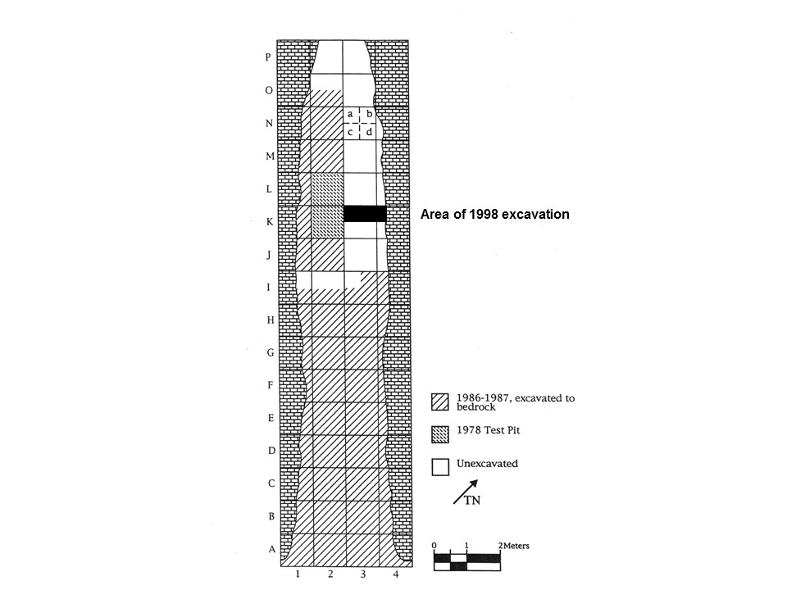
Figure 1. Plan view of Haystack Cave showing excavation units from the 1978, 1986/1987, and 1998 (shown in solid black) excavations. The grid system was devised by Nash (2000) with the entrance to the cave at the bottom. This figure was modified from Nash (2000, figure 1).

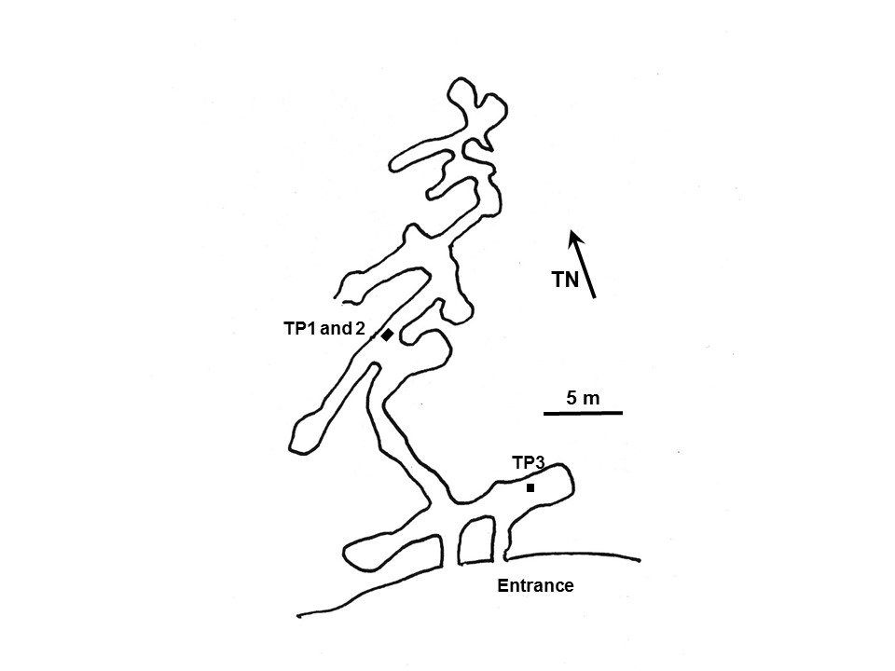
Figure 2. Plan view of Cement Creek Cave showing the locations of test pits (TP) 1-3. Arrow refers to true north (TN). Figure adapted from Medville (1994, cave #3).

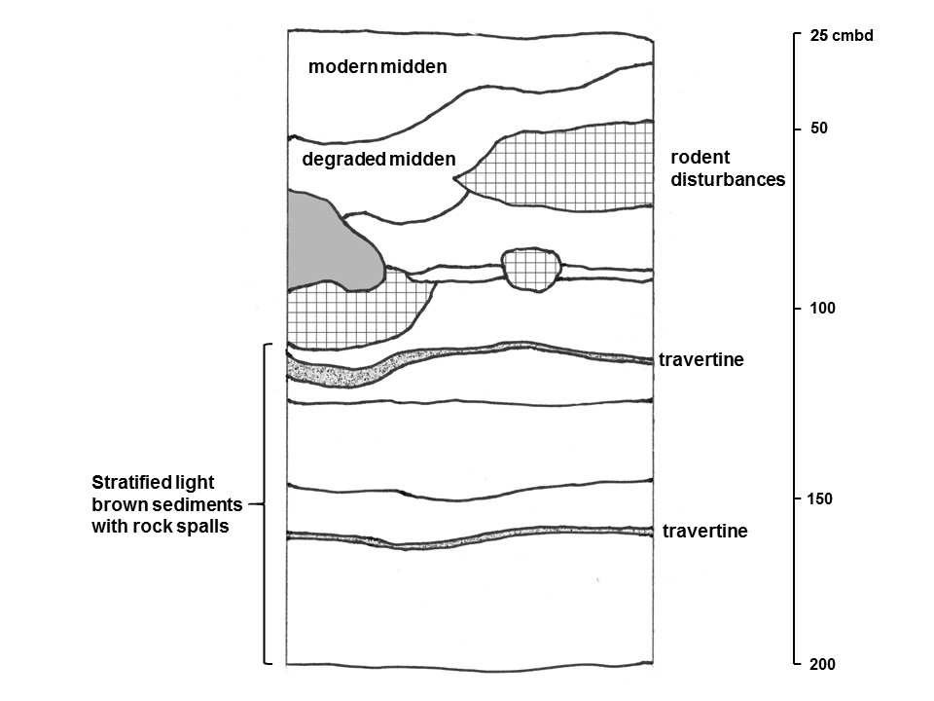

Figure 3. Profile of the east face of test pit 2 northeast extension (TP2 NE) in Cement Creek Cave showing the location of rodent disturbances and travertine layers. Scale is in cm below datum (cmbd) and profile begins after surface disturbed soils were removed to top of Level 1 at 25 cmbd. The lower part of the profile extends to 220 cmbd (Level 40, not shown) but does not change in texture or color below the travertine layer at 160 cmbd.

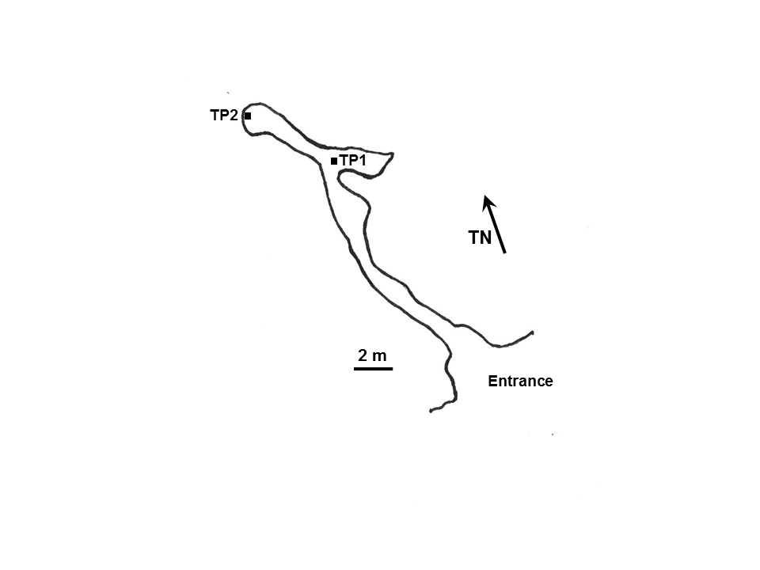
Figure 4. Plan view of Signature Cave showing the locations of test pits 1 (TP1) and 2 (TP2). Figure adapted from Medville (1995).

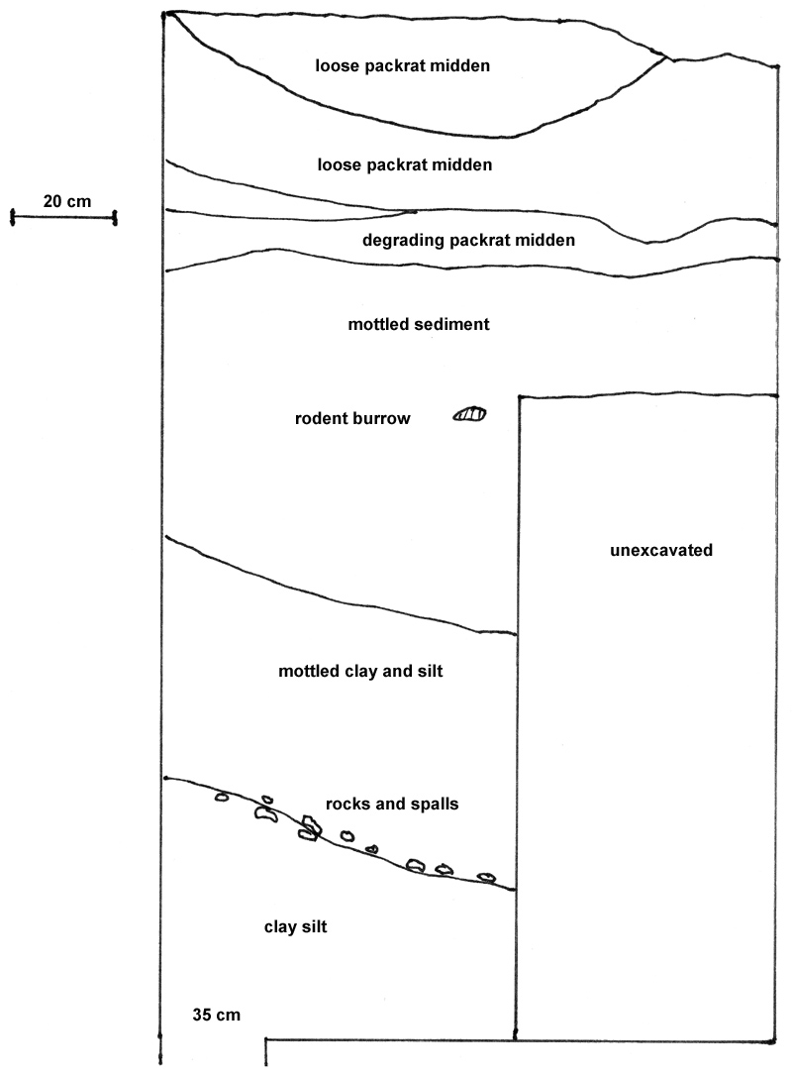
Figure 5. Signature Cave profile from west wall of TP1. The lower deposits were dominated by clay and silt with little or no organic remains.

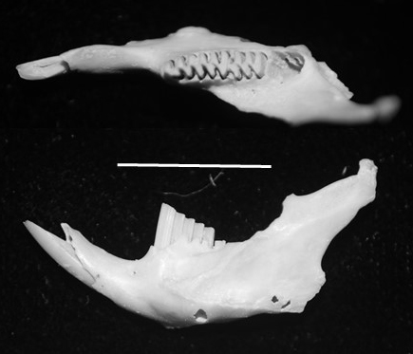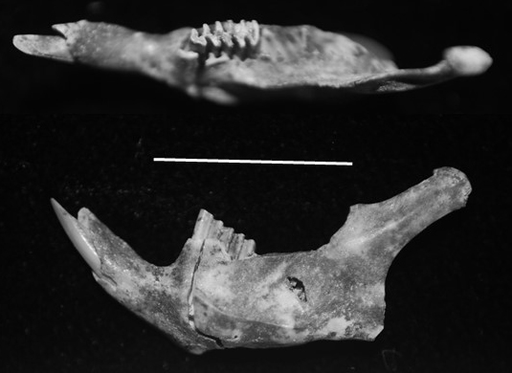
Figure 6. Dorsal and lateral views of left mandible with i1, m1-m3, Grid L2b/M2d (top), and left mandible with i1 and m1, Grid J2d Level 8 (bottom), of Dicrostonyx sp. from Haystack Cave. Scale = 1 cm.

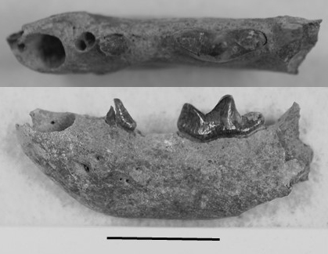
Figure 7. Distal half of left mandible with fragment of p3 and m1, slump, of Mustela nigripes from Haystack Cave in dorsal (top) and lateral (bottom) views. Scale = 1 cm.

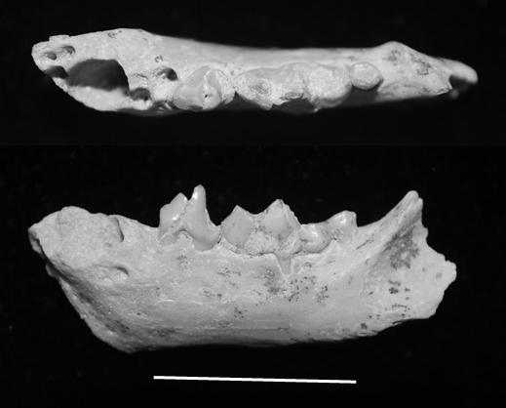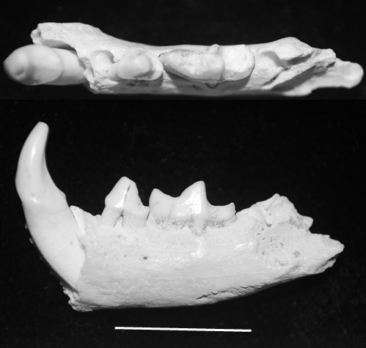
Figure 8. Dorsal and lateral views of left mandible missing proximal end with p4-m2 (top, DMNH 69302), TP2 Level 19, and partial left mandible with c1, p4-m1 (bottom, DMNH 69301), TP2 Level 38, of Brachyprotoma cf. B. brevimala from Cement Creek Cave. Scale = 1 cm.

