Supplementary Material

Description of the Lithic Artifacts Recovered from the Chinchihuapi I Site (CH-I) in 2017-2018

Two hundred and three stone specimens were recovered from limited 2017 and 2018 excavations at the Chinchihuapi I site (CH-I). Of these, only three fail to conform to eight descriptive categories established previously at the site by Collins (1997; see Dillehay, 1997; Dillehay et al., 2015). The three non-conforming pieces are small core fragments of obsidian from the early Holocene period (US-3). The vast majority of the current sample is of raw material available in nearby geologic contexts whereas a small minority (n=22) is of lithologies that do not occur locally. The present sample is closely similar to those previously described for CH-I except it is dominated by knapping debris (flakes and shatter), accounting for 187 specimens.

Group 1, Bifaces (N=5; Fig. 5, SFig. 7). Three fragmented Paijan-like projectile points made of rhyolite were recovered from US-2 in CH-I. A heavily ground and polished medial fragment of another probable bifacial point made of basalt was excavated in US-1. The medial section of a rhomboidal biface made of an exotic white quartz was recovered from US-3 in the lower middle part of MV-7. This section is similar in manufacture, form, and size to the rhomboidal, bipointed projectile point fragments excavated at the MV-II site, all of which date ~14,500 cal yr BP.

Group 5f, Flakes (N=157; SFigs. 3-5 and 7-8). Eighteen primary flakes, 46 secondary flakes, and 23 terciary flakes, 1 of which is a well-made end scraper, were excavated in US-1. Eight of the secondary flakes are of obsidian. Fourteen primary, 31 secondary, 17 terciary flakes were found in US-2. Four primary flakes and 3 secondary flakes, one of which is a unifacial perforator were recovered from US-3. One secondary flake of local rhyolite was recovered from a deeper level dated around 20,100 cal yr BP.

Group 5s, Shatter (N=30; SFig. 4). Twenty-two and 8 shattered pieces were found in US-1 and US-2, respectively. These pieces were primarily of local basalt and secondarily of exotic obsidian and chalcedony. Fifteen pieces are angular. Others lack clear flake attributes.

Group 19, Manos or Grinding Stones (N=3). Three grinding stone fragments, probably used for plant food preparation, were retrieved, one from each use-surface. These are made of local granites.

Group 21, Spherical Stones (N=4; SFig. 6): Three spherical stones, two of basalt and one of granite, were recovered in US-3. One of basalt was found at the 1.41 cm level below US-3. the basalt spheroid form US-3 is very spherical (index of 0.981) and deliberately pecked, ground, and polished. It has an impact scar suggesting it was possibly used as a sling stone (SFig. 6). One of the granite stones (index of 0.911) is heavily polished by water and likely is a manuport, if cultural. The other has a muted or matte-like surface suggesting that any natural polish may have been deliberately removed, presumably to increase the index of sphericity of the stone (see Collins [1998] for a description of this process by using wet sand in grooved wooden slats to produce this type of surface.) the size and sphericity stones do not appear naturally at these levels.

Group 22, Subspherical Stones (N=4). One subspherical stone was from US-1, two from US-2, and one from US-3. Two are well-rounded pebbles of basalt and andesite (index sphericity of 0.901 and 0.912) with a smoothed but pitted worked surfaces. Two seem natural and may be manuports. Their indexes of sphericity, at 0.901 and 0.887, are within the subspherical range. Such stones comprised nearly 2% of one sample of Chinchihuapi Creek gravel from non-cultural contexts but in the context of the site, they are likely manuports that could have served as sling stones without modification or possibly have been ground to a higher degree of sphericity. Collins (1998) has previously described the macro- and micro-characteristics of possible sling stones at the MV-II site.

In summary, a small but morphologically heterogeneous lithic assemblage from the three use-surfaces was retrieved in 2017 and 2018 which contained a few bifacial tools and several unifacial flakes and debris. The lithic materials consist mostly of unretouched flakes, including a few unifacially edge-trimmed pebble flakes. A partial ground and polished bifacial tool also was found. Some flake tools recovered in 2013 and 2017/2018 at sites MV-I, CH-I, and CH-2 reveal clear striking platforms and bulbs of percussion and edge-trimming, if not retouch. Other stones show clear bulbs of percussion and often striking platforms, as well as signs of use on the edges (SFig. 7).

In our preliminary functional study of the artifacts reported here, we have noted use traces from working soft and hard materials of organic and inorganic origin (Benson et al., 2018). This study suggests that the simple tools and unmodified flakes had limited micro-usewear indicating sparse use while the thoroughly prepared and modified tools (i.e., scraper, perforator) were more intensively and longer utilized.

The chrono-stratigraphic position of the lower, pre-14,500 cal yr BP unifacial flakes and tools within the Monte Verde site complex is at present still uncertain. However, the increasing number of morphologically characteristic types of lithics and occasionally burned features found in levels dating before ~16,000 cal yr BP is meaningful and might indicate the presence of people predating the currently oldest stratified and dated contexts of ~14,500-15,000 cal yr BP (see Dillehay 1997).

References

Collins, M.B., 1997. The Lithics from Monte Verde, a Descriptive-Morphological Analysis. In: Dillehay, T.D. (Ed.), Monte Verde, a Late Pleistocene Settlement in Chile, Vol. 2: The Archaeological Context and Interpretation. Smithsonian Institution Press, Washington, D.C., pp. 383-506.

Dillehay, T.D., 1997. Monte Verde: A Late Pleistocene Settlement in Chile. Volume II: The Archaeological Context. Smithsonian Institution Press, Washington, D.C.

Dillehay, T.D., Ocampo, C., Saavedra, J., Sawakuchi, A.O., Vega, R.M., Pino, M., Collins, M.B., Cummings, L.S., Arregui, I., Villagran, X.S., et al. 2015. New Archaeological Evidence for an Early Human Presence at Monte Verde, Chile. PloS ONE 10(11), e0141923, DOI:10.1371/journal.pone.0141923.

SFig. 1. Schematic correlation of strata and use-surfaces in Units 3, 7 and 8. Although stratum MV-2 is not present in Units 7 and 8, Use-Surface 3 (US-3) is in the same stratigraphic position in stratum MV-7 in all units. The absence of stratum MV-2 in Units 7 and 8 makes the three use-surfaces in these two units more shallow in depth from the reference datum at ground level (~88-95 cm) than they are in Unit 3 (~1.30-1.35 cm), which contains stratum MV-2.

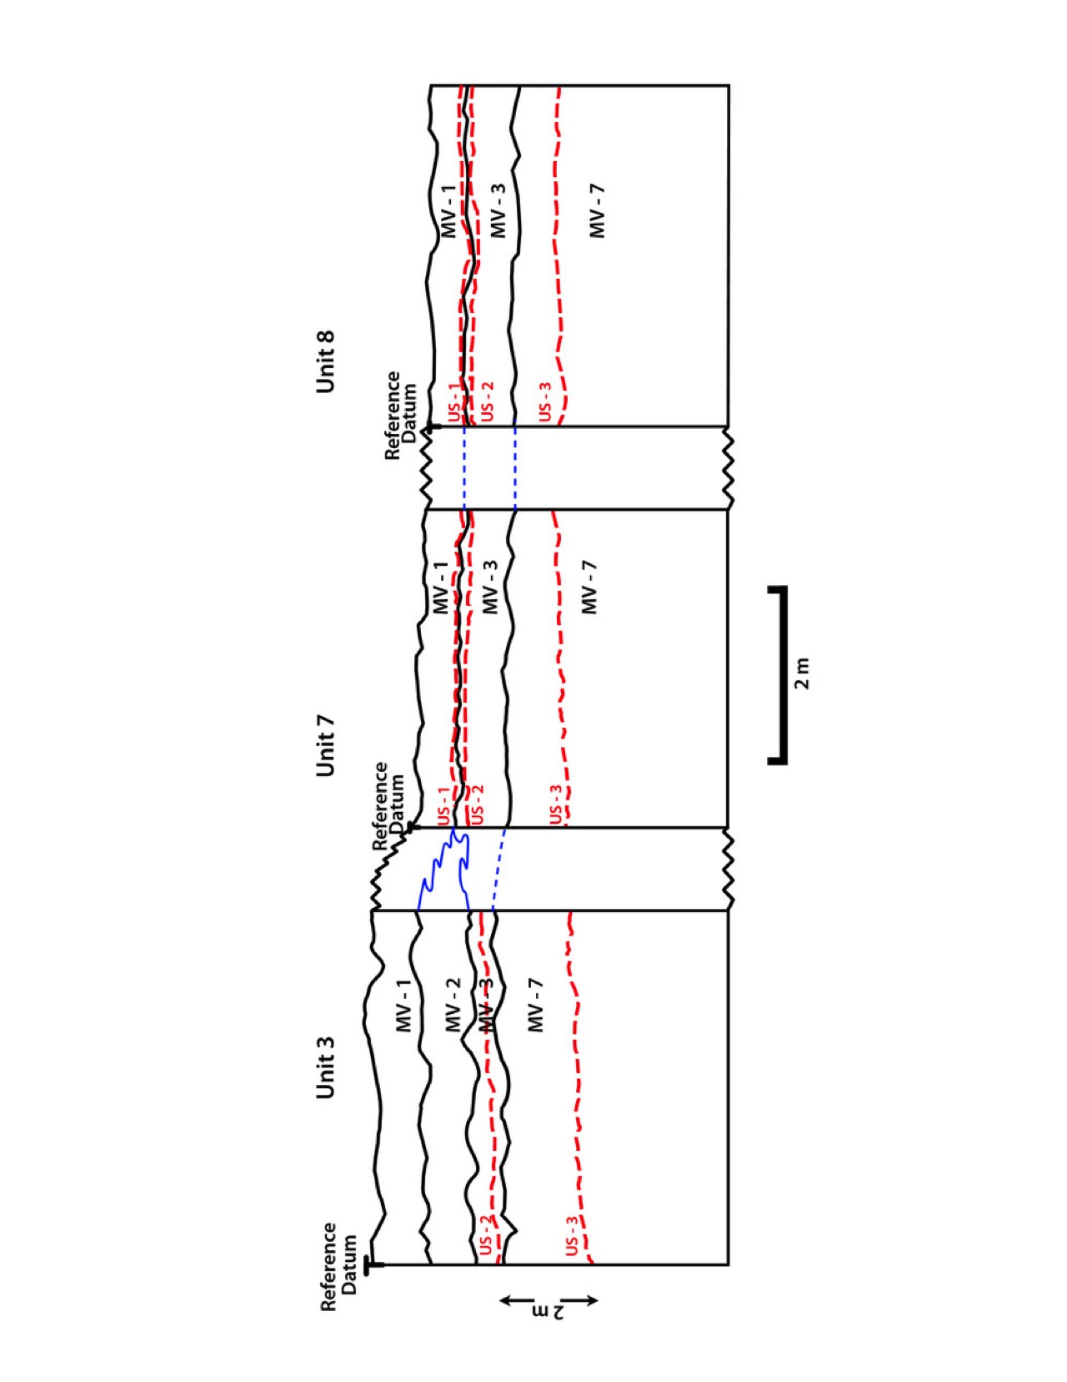

SFig. 2. Profile of south wall of Unit 3, excavated in 2013, showing strata MV-1, MV-2, MV-3 and MV-7 (marked on right side) and use-surfaces US-2 and US-3. US-1 is not present in this unit.

SFig. 3. End scraper made of green chalcedony from US-1.

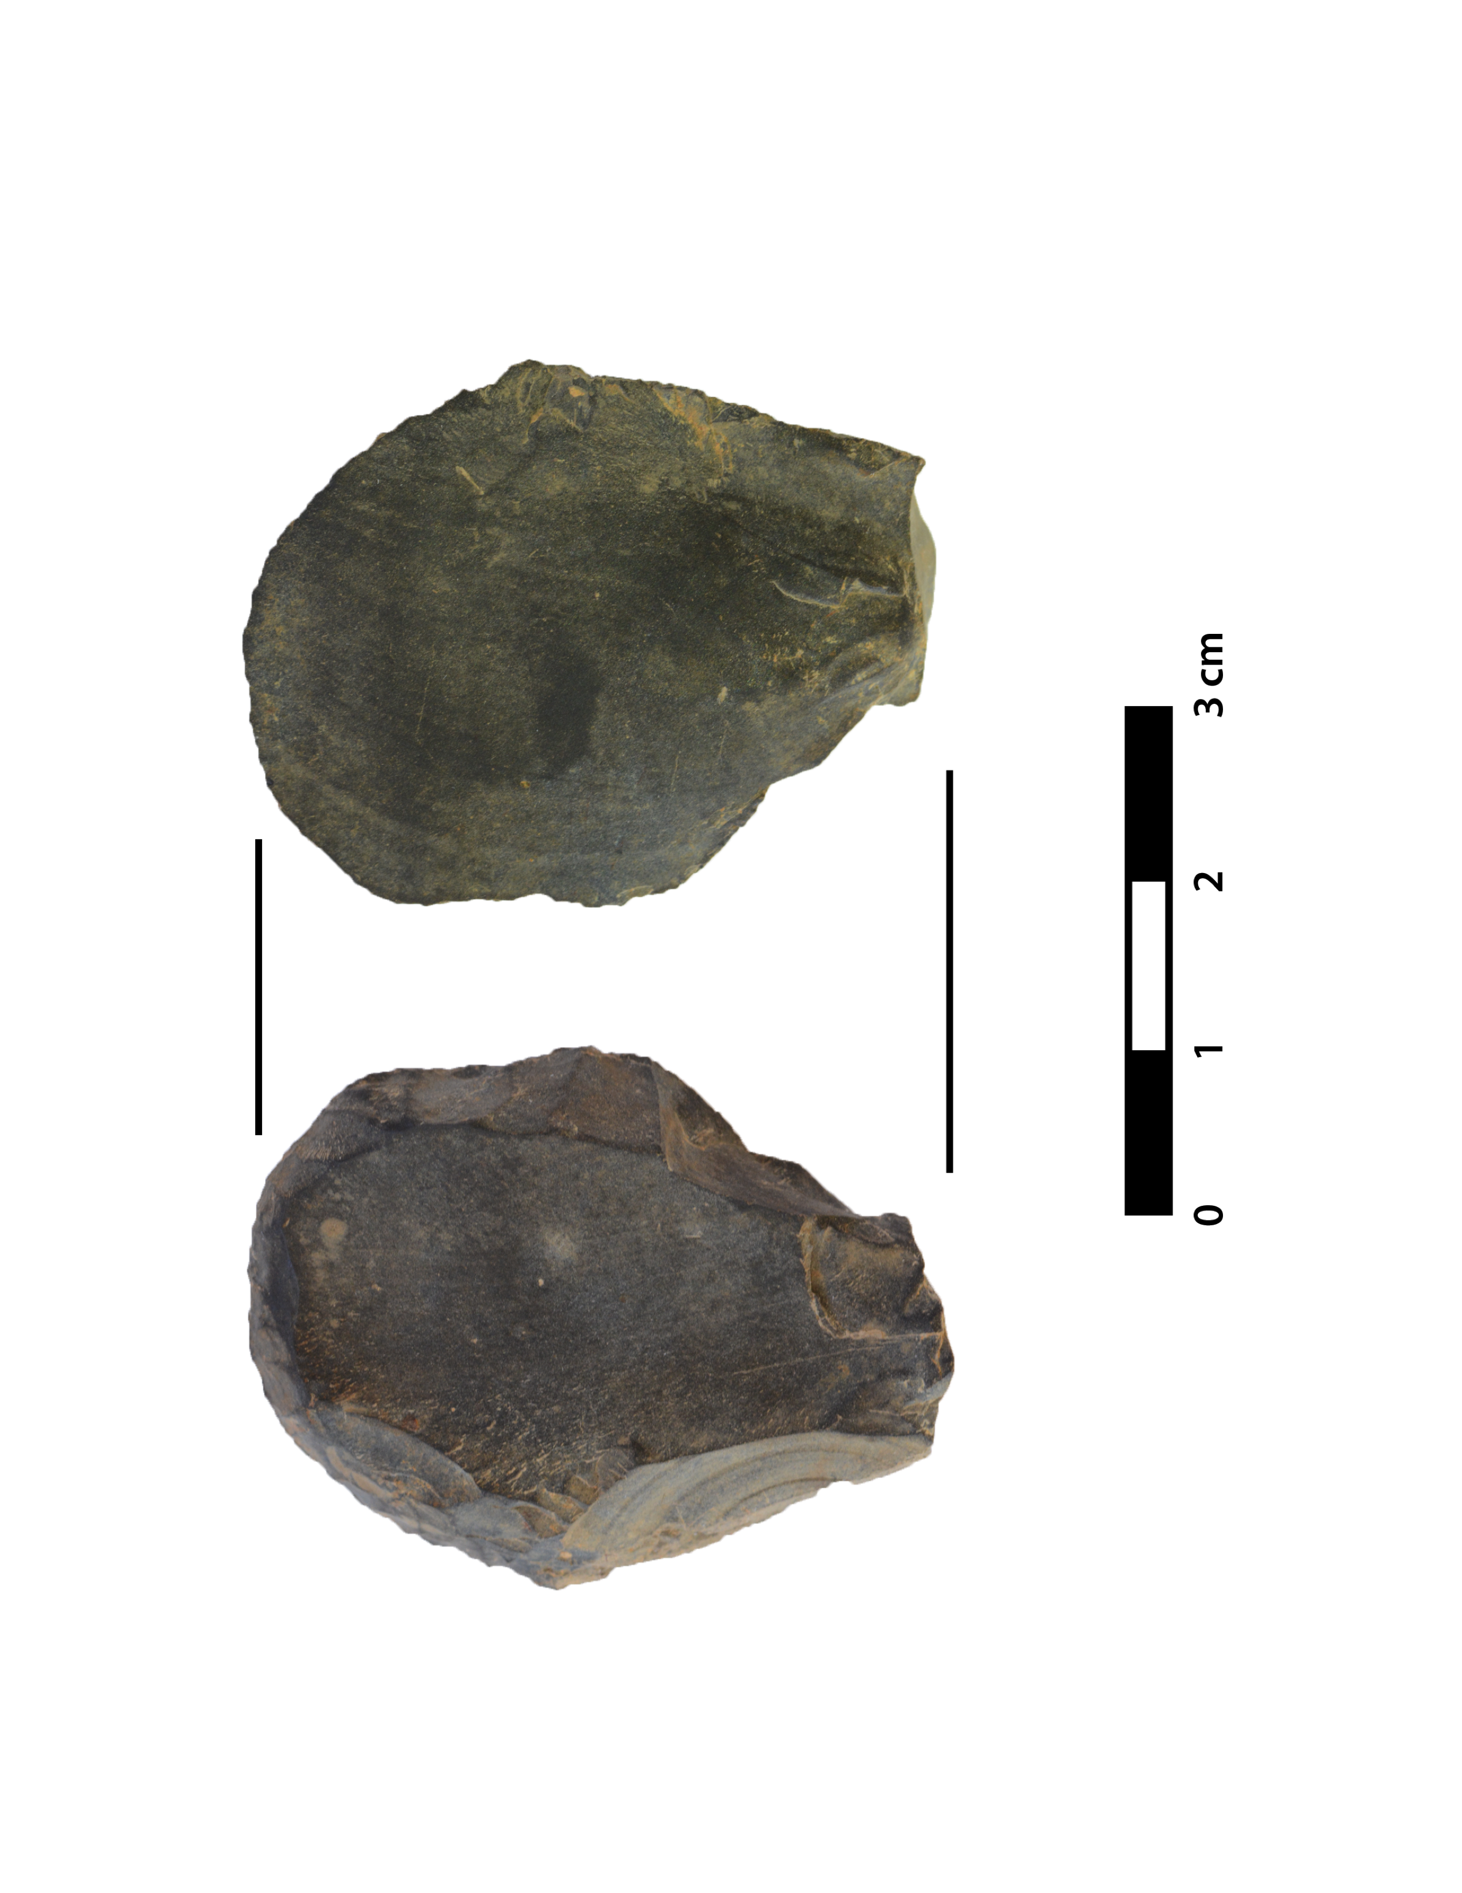

SFig. 4. Various lithic flake tools, shatter and other debris of rhyolite, basalt and exotic chalcedony and obsidian from US-2.

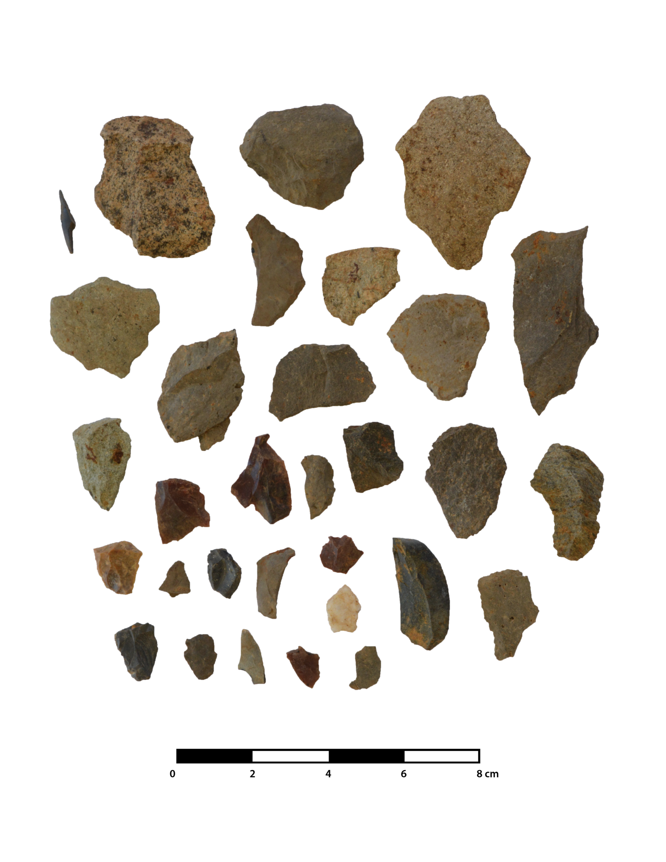

SFig 5. Secondary flake of rhyolite from a deeper level below US-3.

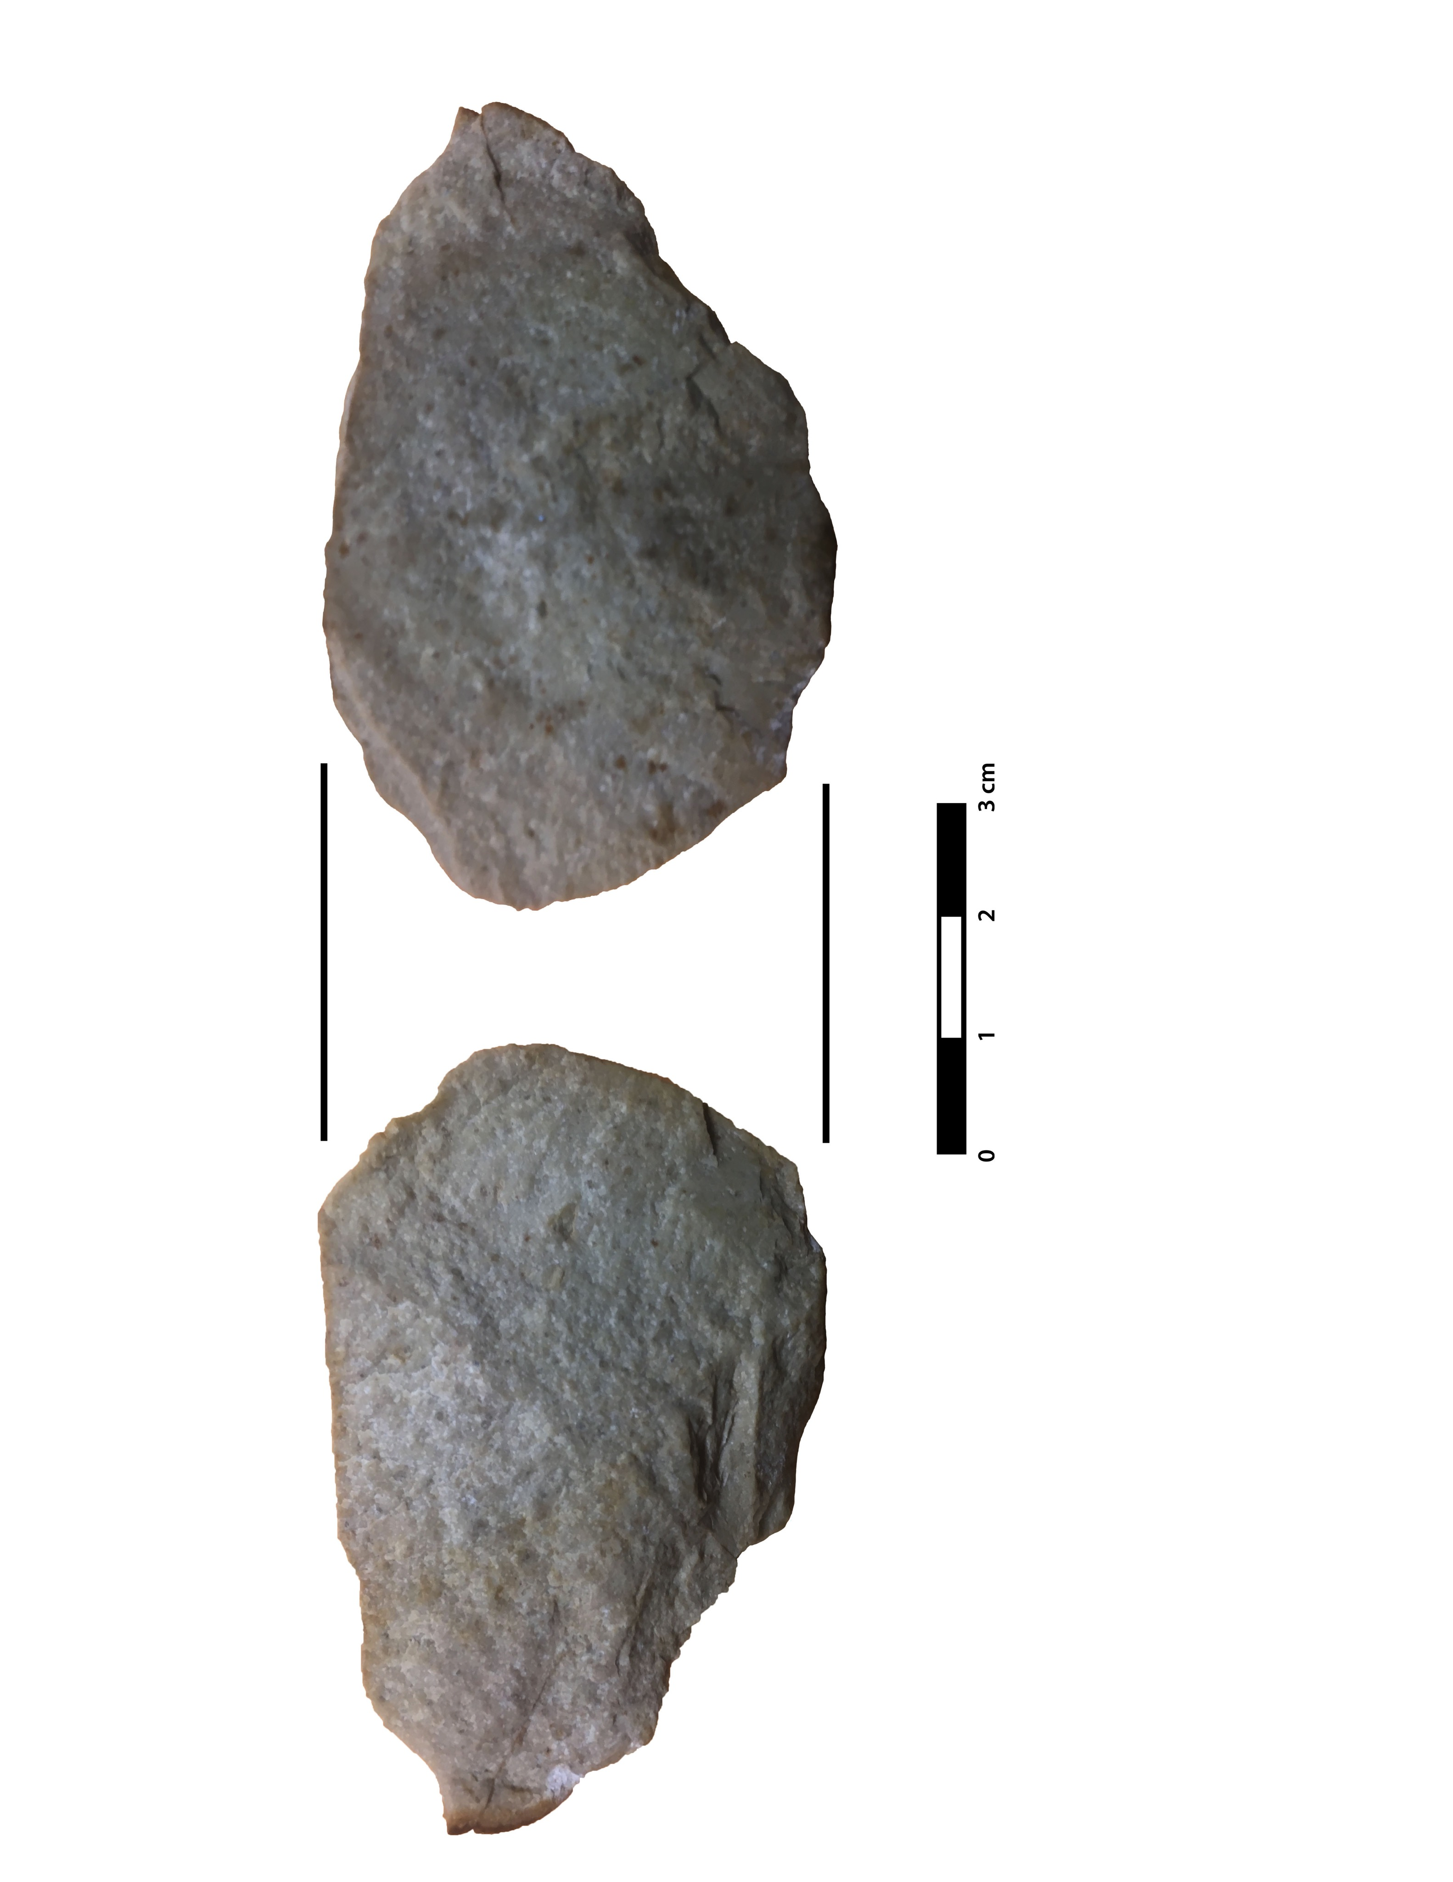

SFig 6. Spheroids from US-3 (left side is granite; right side is basalt).

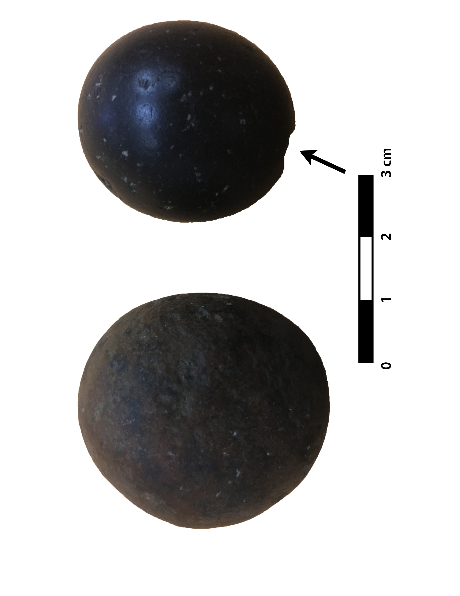

SFig. 7. Lithics recovered during the 2013 field season. a. Paijan-like projectile point from CH-I dated ~10,200 cal yr BP; b-i. unifacial stone tolls of various local and exotic raw materials from site MV-I, CH-I, and CH-II dated between ~15,000 and 18,500 cal yr BP. Dark lines show microscopic use wear. Arrows point to striking platform and bulbs of percussion (see Dillehay et al., 2015).

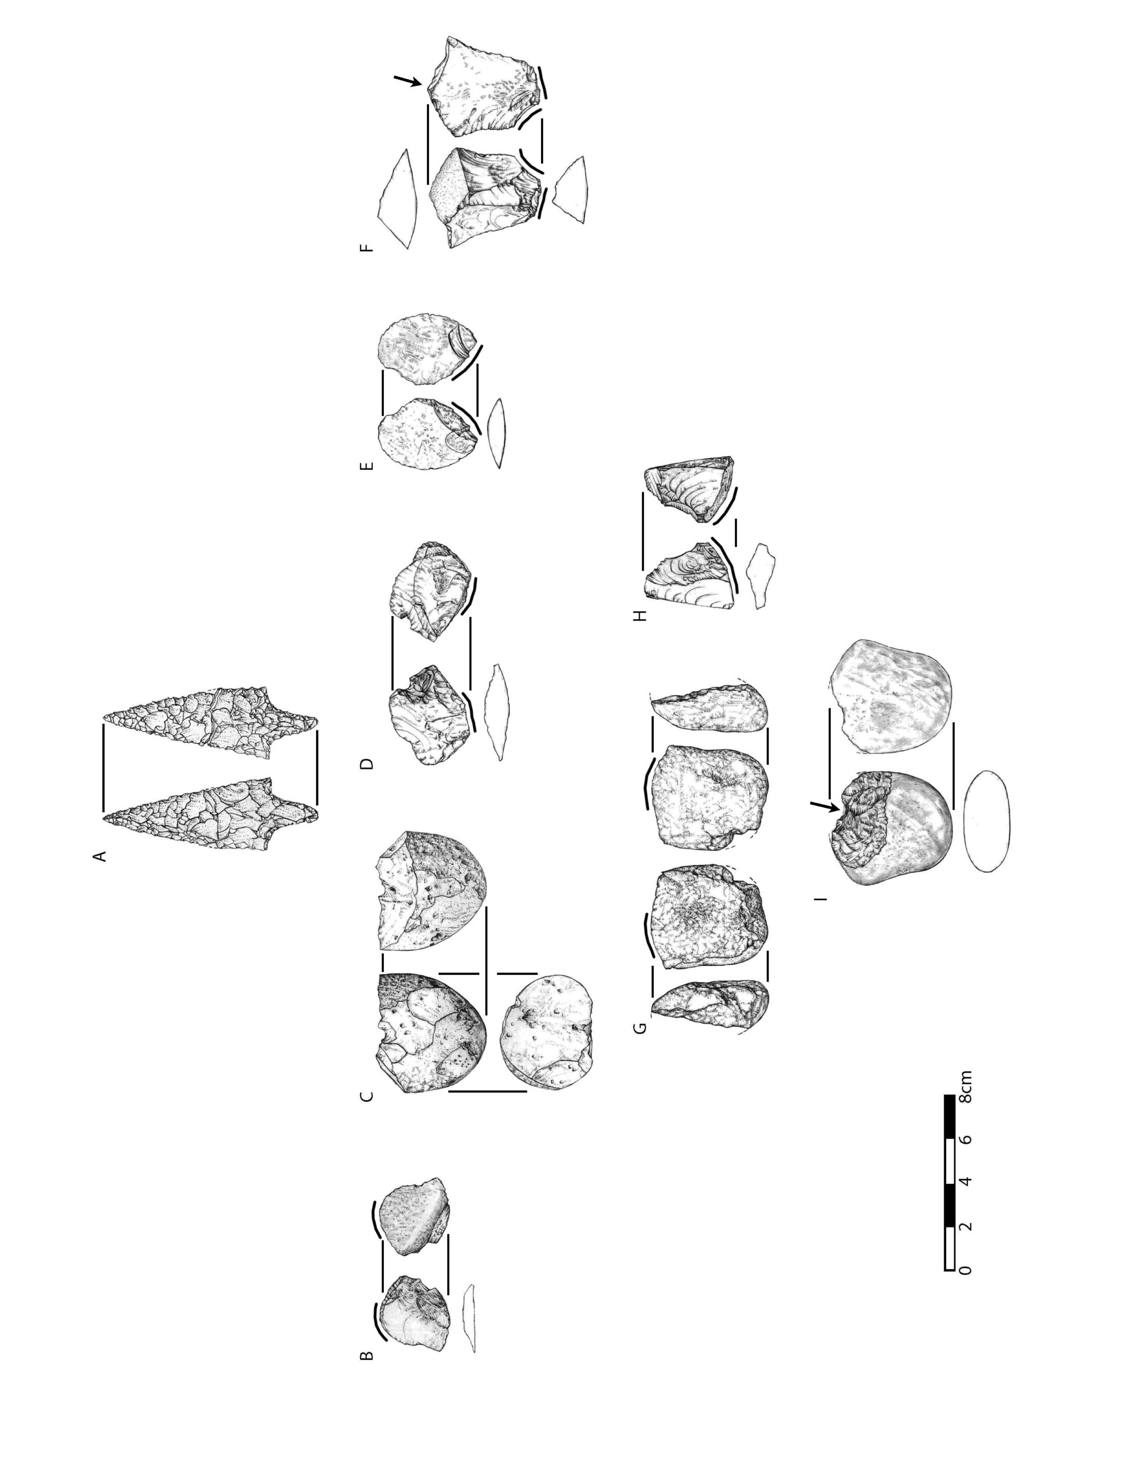

SFig. 8. Perforator of rhyolith (A) and secondary flake of exotic greenish black chalcedony (B) from US-3.

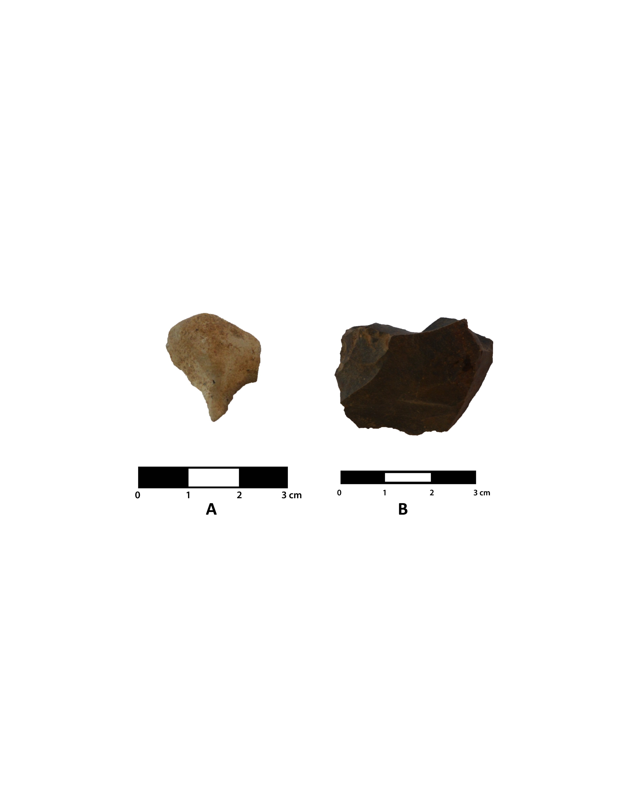

SFig. 9. Micro-usewear (50X) on extreme tip of perforator shown in SFig. 8. Note step and hinge fractures and slight to moderate polish.

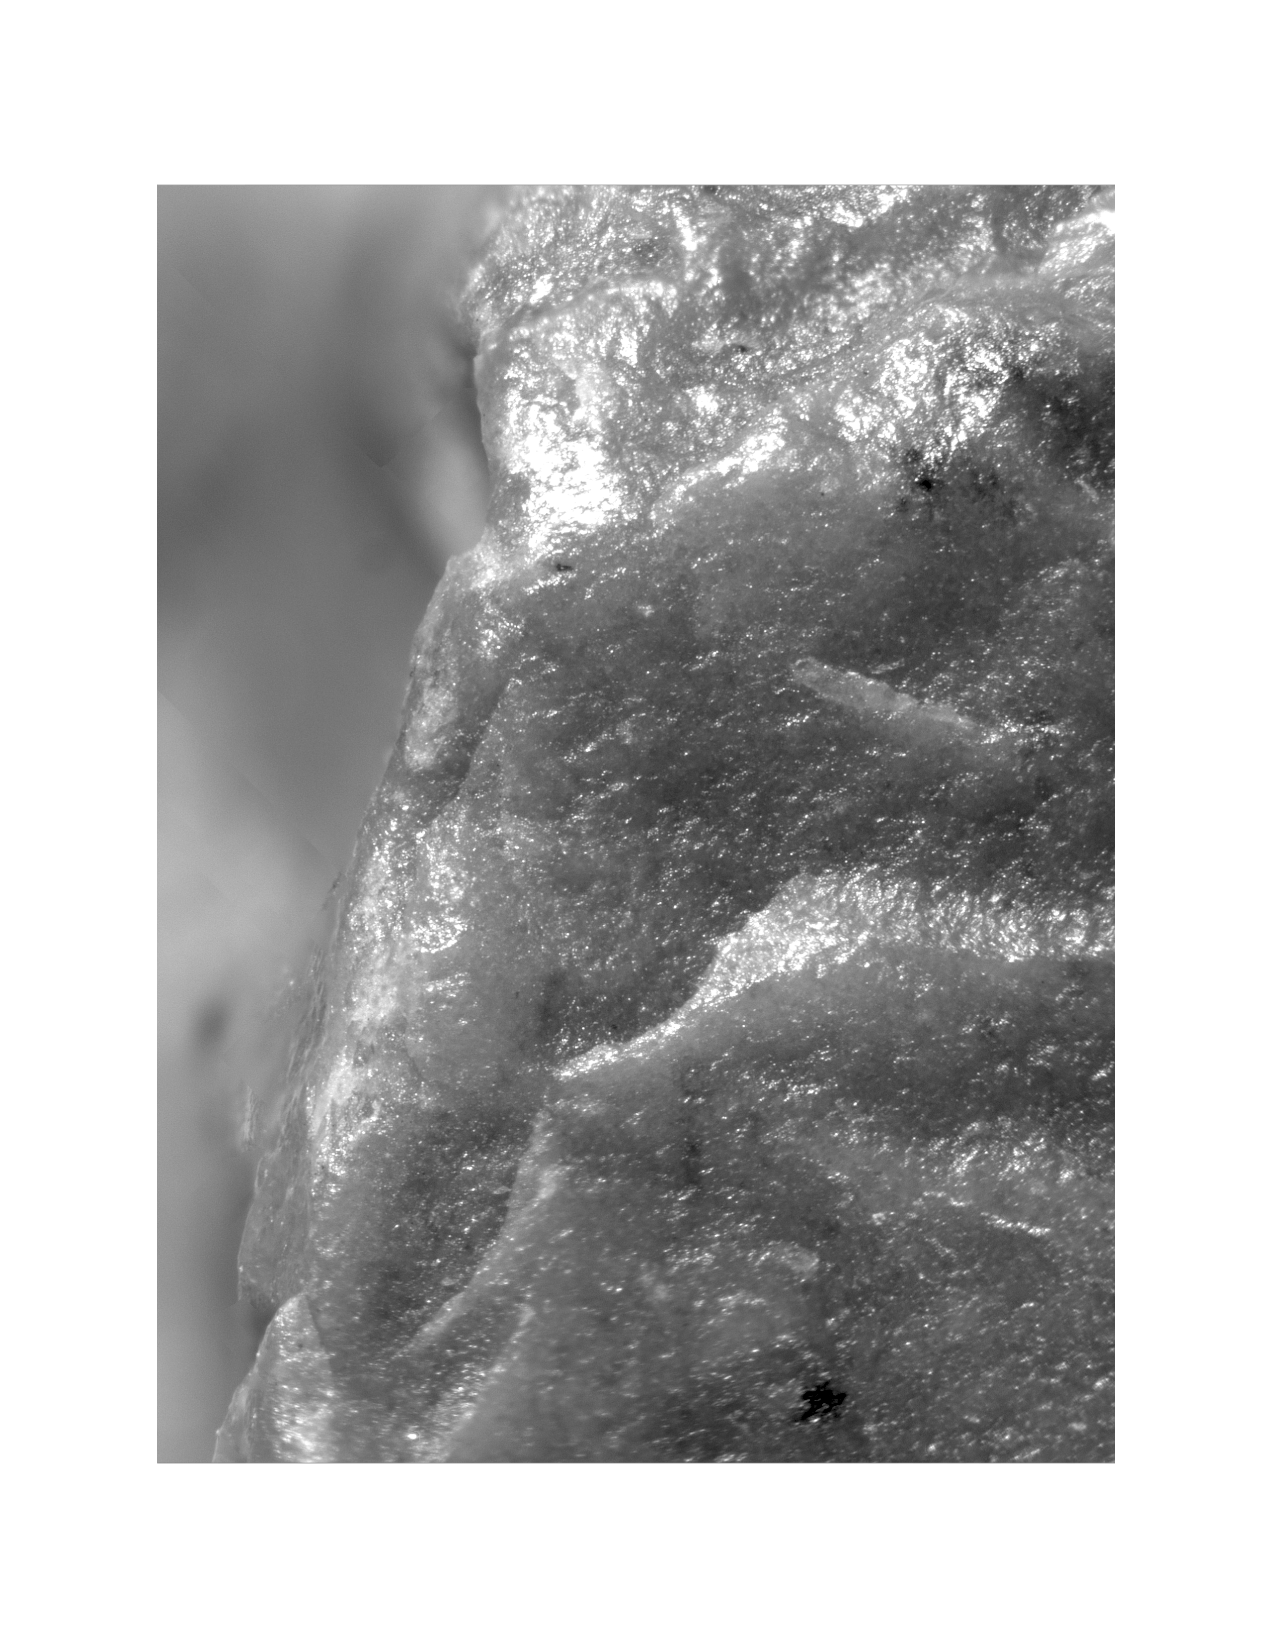

SFig. 10. Burned feature in US-3 that contained carbonized chestnut seeds and hull fragments.
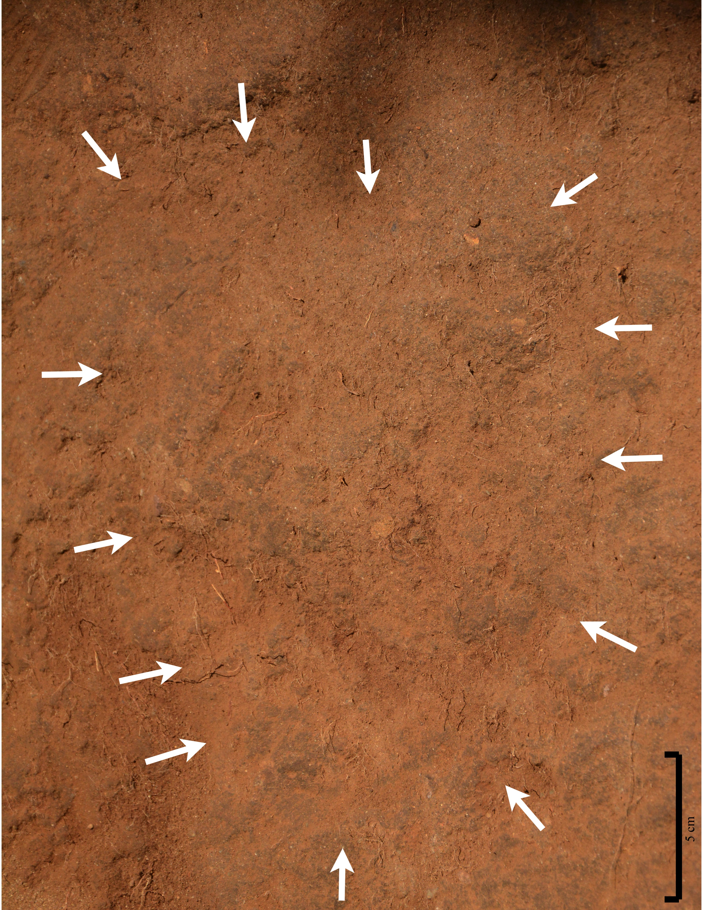

SFig. 11. Burned chestnut seeds from US-3 that dated ~14,200-14,800 cal BP.
