**Supplementary Material for “Episodic deposition of Illinois Valley Peoria Silt in association with Lake Michigan Lobe fluctuations during the Last Glacial Maximum”**

Thomas Andrew Nash Jessica L. Conroy, David A. Grimley, William R. Guenthner, and Ben Brandon Curry

**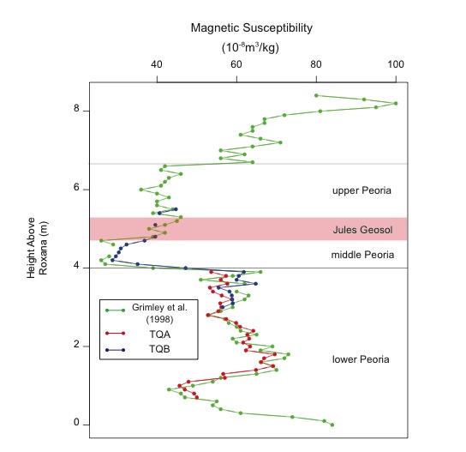**

Figure S1: Magnetic susceptibility values for Thomas Quarry A (red), Thomas Quarry B (blue), and data from Grimley et al. (1998) (green). Curves were correlated to create a common depth scale for the sections so that other data, including particle size and shell isotope values, could be combined into one composite stratigraphic section.

Microsoft HD:Users:jconro:Documents:NashQR2017:NashFS2.pdf

Figure S2: Two models for estimation of the age of the top of the Peoria Silt based on accumulation rates of the upper Peoria (Constant Rate) and of the Jules Geosol (“Jules” Rate). The red line is the weighted mean age that has been interpolated through the modern soil. The black lines are the maximum age range calculated by the bacon age model, which has also been interpolated through the modern soil.

Microsoft HD:Users:jconro:Documents:NashQR2017:NashFS3.pdf

Figure S3: Averaged histograms for particle size measurements from A) New Cottonwood School for the upper Peoria, Jules Geosol, and middle Peoria and B) Thomas Quarry, for the upper Peoria, Jules Geosol, middle Peoria, and lower Peoria.

Microsoft HD:Users:jconro:Documents:MATLAB:382_2010_904_MOESM2_ESM:NashFS4.pdf

Figure S4: Bartlein et al. (2011) mean warmest month temperature anomalies for eastern North America in °C. Grid outlined in black represents the closest grid overlapping our study sites.



Table S1: Gastropod species counts for New Cottonwood School Section. Depths refer to midpoints of sampling intervals.



Table S2: Gastropod species counts for Thomas Quarry Section. Depths refer to midpoints of sampling intervals.

|  |  |  |  |  |
| --- | --- | --- | --- | --- |
| Zones | Difference in median 18O (‰ VPDB) | p | Difference in median 13C (‰ VPDB) | p |
| upper Peoria Silt - Jules Geosol | -0.12 | 0.73 | 0.34 | 0.39 |
| middle Peoria Silt - Jules Geosol | 0.21 | 0.15 | 0.74 | 0.19 |
| lower Peoria Silt - Jules Geosol | **1.64** | **<0.01** | 0.54 | 0.11 |
| upper Peoria Silt - middle Peoria Silt | -0.34 | 0.50 | -0.40 | 0.09 |
| lower Peoria Silt - middle Peoria Silt | **1.43** | **<0.01** | -0.20 | 0.84 |
| lower Peoria Silt - upper Peoria Silt | **1.76** | **<0.01** | 0.20 | 0.27 |

Table S3: Test for significant difference between median 18O and  13C gastropod carbonate values between different zones of the Peoria Silt using the Wilcoxan rank-sum test. Values are combined from NCS and TQ sites. Bold values indicate medians are significantly different at the 95% confidence level.