OSL Data and Methods for Mesa Verde Samples

**Mesa Verde Loess Samples**  
Collected 10/12/2010

Bulk samples for elemental concentrations were collected from same levels as OSL samples

**MV-1**  
37.16120, -108-46848 (WGS84) 6850’ (from Google Earth ;1780 m) southern Chapin Mesa  
Dug into small outcrop of loess; two loess units  
  
0-95 cm upper loess unit  
 -carbonate throughout; stage I to 50 cm, weak stage II 50-95 cm  
 -**OSL from 53 cm, 85 cm**  
  
95-135 cm lower loess unit  
 -base of unit 2 (135 cm) contains bedrock clasts mixed with loess

-stage II+ carbonate; secondary Mn; silty clay loam?  
 -**OSL from 120 cm**

**MV-2**37.25484, -108.50223 (WGS84) 8050’ (from Google Earth; 2455 m) northern Chapin Mesa  
Dug into small outcrop ~150 cm  
No carbonate in this profile

0-130 cm upper loess unit  
 -clean, pure loess  
 **-OSL from 73 cm and 121 cm**

130-150 cm lower loess unit; overlies weathered sandstone  
 -loess and sand (from wx’d bedrock) mixed throughout  
 **-OSL from 145 cm**

**Mesa Verde samples**

At least 5 cm of sediment was removed from both ends of the OSL sampling tube under “safe light” (sodium vapor lighting) conditions in the luminescence laboratory. The ends of the samples were dried in an oven at 30 °C and used to calculate field and saturation moisture potentials (within a 10% error). The middle portion of the sample was leached in 4N HCl (10% HCl) for 24 hours, 30% H2O2 for 24 hours, and then sieved for 80 mesh, 100 mesh, 120 mesh, and 170 mesh (177, 149, 125, and 88 µm, respectively) sized grains. The coarser grained size (250-90 µm) quartz fractions were separated from the feldspars and any most heavy minerals using a Franz magnetic separator (for samples with a large mica or dark mineral concentrations) and heavy liquids (lithium heteropolytungstate or LST) (density=2.58 gcm-3). To remove feldspars and to isolate pure quartz from the selected sand fraction, we centrifuged the sand sequentially in the LST. The sink from 2.58 was subjected to a 50% solution of HF acid for 40 minutes while in an ultrasonic bath. After pouring off the HF solution, we put the sample was placed in 8N HCl for ten minutes (still in the ultrasonic bath) and finally re-sieved to winnow out broken feldspar grains. Steel target discs were sprayed with silica spray and a single grain thick layer of quartz grains was dispersed onto steel discs at a 1 to 2 mm mask to be used in measurements of equivalent dose.

***Determining the quartz OSL parameters for equivalent dose analyses (De):***

For this project, the quartz samples were dated using one general OSL technique: the single-aliquot (SAR) approach (for sand-sized grains). An aliquot consists of several tens to several hundred grains on a single metal disc. The preferred component for SAR dating is the ‘fast’ component (Murray and Wintle, 2000; Wintle and Murray, 2006), a signal usually released in the first 0.8 seconds of typical blue diode stimulation. A dating precision of ~ at least 10% (sometimes better) can be attained routinely with multigrain SAR quartz methods (Murray and Olley, 2002) when applied to sediments that have had either eolian or shallow fluvial origins. With SAR, each aliquot yields a distinct equivalent dose value, and thus a distinct age estimate. The main SAR parameters included use of the 40-second blue-diode wash step of Murray and Wintle (2003) at the same temperature as the preheat temperature. The choice of preheating temperature for each sample was based on preliminary tests and the experiences of the USGS lab methods previously used with samples of similar age and lithology. Signals in the multigrain SAR experiments were recorded with automated Riso Model DA15 OSL-reader systems, an EMI 9235Q PMT1, and blue light-emitting-diode (LED) stimulation.

The 250-180 μm grain-diameter fraction of quartz extracts was used for the SAR experiments. After HF acid treatment, representative multigrain portions of each sample were tested for the possible presence of residual (contamination) feldspar by running an IRSL “wash” on the a Riso Luminescence reader. No samples showed any sign of feldspar contamination.

Several quality-control criteria were employed to reject OSL signals and resultant SAR equivalent dose values. Data rejection criteria were similar to those in common practice (e.g., Wintle and Murray, 2006) as follows: We accepted data having recycle ratios within 10% of 1.0 (equivalent to the criterion of Ballarini et al., 2007a), recuperation ratios (e.g., Aitken, 1998) within 2% of zero when recuperation was >20% of the normalized natural signal (Lx/Tx ratio), and test-dose-signal errors were <15%. We forced dose-response curves through the origin and fit them with an exponential curve. For statistical analysis, we used the R-Luminescence package1 for the programming language using the functions Calc_mindose3 and calc_mindose4 (Kreutzer et al., 2012; Dietze, et al., 2013). We employed the minimum and central age models of Galbraith et al. (1999) and Galbraith and Roberts (2012) with a modification to their criteria (i.e. scatter >30% required use of the minimum age model while scatter <30% was acceptable for a central age model). RStudio Version 0.98.501 was the programming environment used. Radial plots were generated with RadialPlotter 6.1 by Pieter Vermeesch (London Geochronology Centre, http://radialplotter.london-geochron.com).[1]

***References Cited***

Aitken, M.J., 1998. An Introduction to Optical Dating. Oxford, Oxford University Press, 267 p.

Ballarini, M., Wallinga, J., Wintle, A.G., and Bos, A.J.J., 2007. A modified SAR protocol for optical dating of individual grains from young quartz samples. Radiation Measurements 42, 360-369.

Dietze, M., Kreutzer, S., Fuchs, M.C., Burow, C., Fischer, M., and Schmidt, C., 2013. A practical guide to the R package Luminescence. Ancient TL 31, 11-18.

Galbraith, R.F., Roberts, R.G., Laslett, G.M., Yoshida, H., and Olley, J.M., 1999. Optical dating of single and multiple grains of quartz from Jinmium rock shelter, northern Australia, part 1: Experimental design and statistical models. Archaeometry 41, 339-364.

Galbraith, R.F., and Roberts, R.G., 2012. Statistical aspects of equivalent dose and error calculation and display in OSL dating: An overview and some recommendations. Quaternary Geochronology 11, 1–27.

Kreutzer, S., Schmidt, C., Fuchs, M.C., Dietze, M., Fischer, M., Fuchs, M., 2012. Introducing an R package for luminescence dating analysis. Ancient TL 30, 1-8.

Murray, A.S., and Wintle, A.G., 2003. The single aliquot regenerative dose protocol: Potential for improvements in reliability. Radiation Measurements 37, 377–381.

Murray, A.S., and Olley, J.M., 2002. Precision and accuracy in the optically stimulated luminescence dating of sedimentary quartz―A status review. Geochronometria 21, 1–16.

Wintle, A.G., and Andrew S. Murray, 2006, A review of quartz optically stimulated luminescence characteristics and their relevance in single-aliquot regeneration dating protocols: Radiation Measurements 41, 369-391.

Luminescence parameters used in preparation and analyses of samples for quartz OSL for single aliquots

|  |  |
| --- | --- |
| *Equivalent Dose Measurement Parameters:* |  |
| Machine | Automated Risø TL/OSL-DA-15 |
| Mineral; grain size | quartz: 250-180 m |
| Stimulation Source | blue LED diodes, emission centered on 470 nm |
| Power Delivered to Aliquot | 18 mW/cm2 (85% power) |
| Duration of Stimulation | 40 seconds of continuous wave |
| Photomultiplier Type (PMT) | Thorn-EMI 9235QA |
| Background PMT evaluation | black body counts <30 ct/sec, BG counts <40 ct/sec |
| Aliquot Temperature | 125 °C |
| Detection filter | two Hoya U340 filters |
| Preheat temperature | 240 °C for 10 secs |
| Delay before measurement | 120 sec |
| Riseo Beta Source rate | 0.063 Gray/second |
| Equivalent Dose Evaluation | OSL single aliquot regeneration1 |
| *Dose Rate Measurement Parameters:* |  |
| Method of Elemental Concentration: | Neutron activation analyses2 |

1(*Murray and Wintle, 2003*)

2(USGS TRIGA reactor) (*Budahn and Wandless, 2002*)

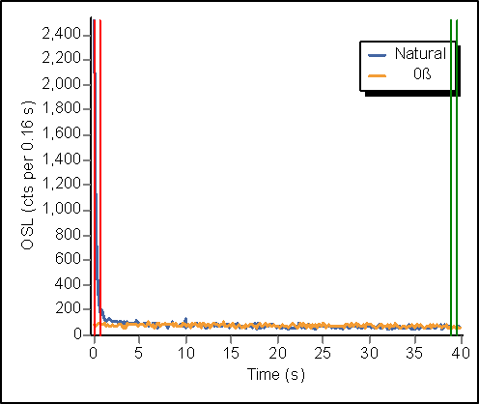  

**c**

**b**

**a**

**Supplemental Figure S1**: Decay curves from quartz OSL. A). is MV-1 53 cm (Disc 4), B). MV-1 85 cm (Disc 11), and C). MV-1 120 cm (Disc 6).

  

**a**

**c**

**b**

**Supplemental Figure S2**: Growth curves from quartz OSL. A). is MV-1 53 cm (Disc 4), B). MV-1 85 cm (Disc 11), and C). MV-1 120 cm (Disc 6).

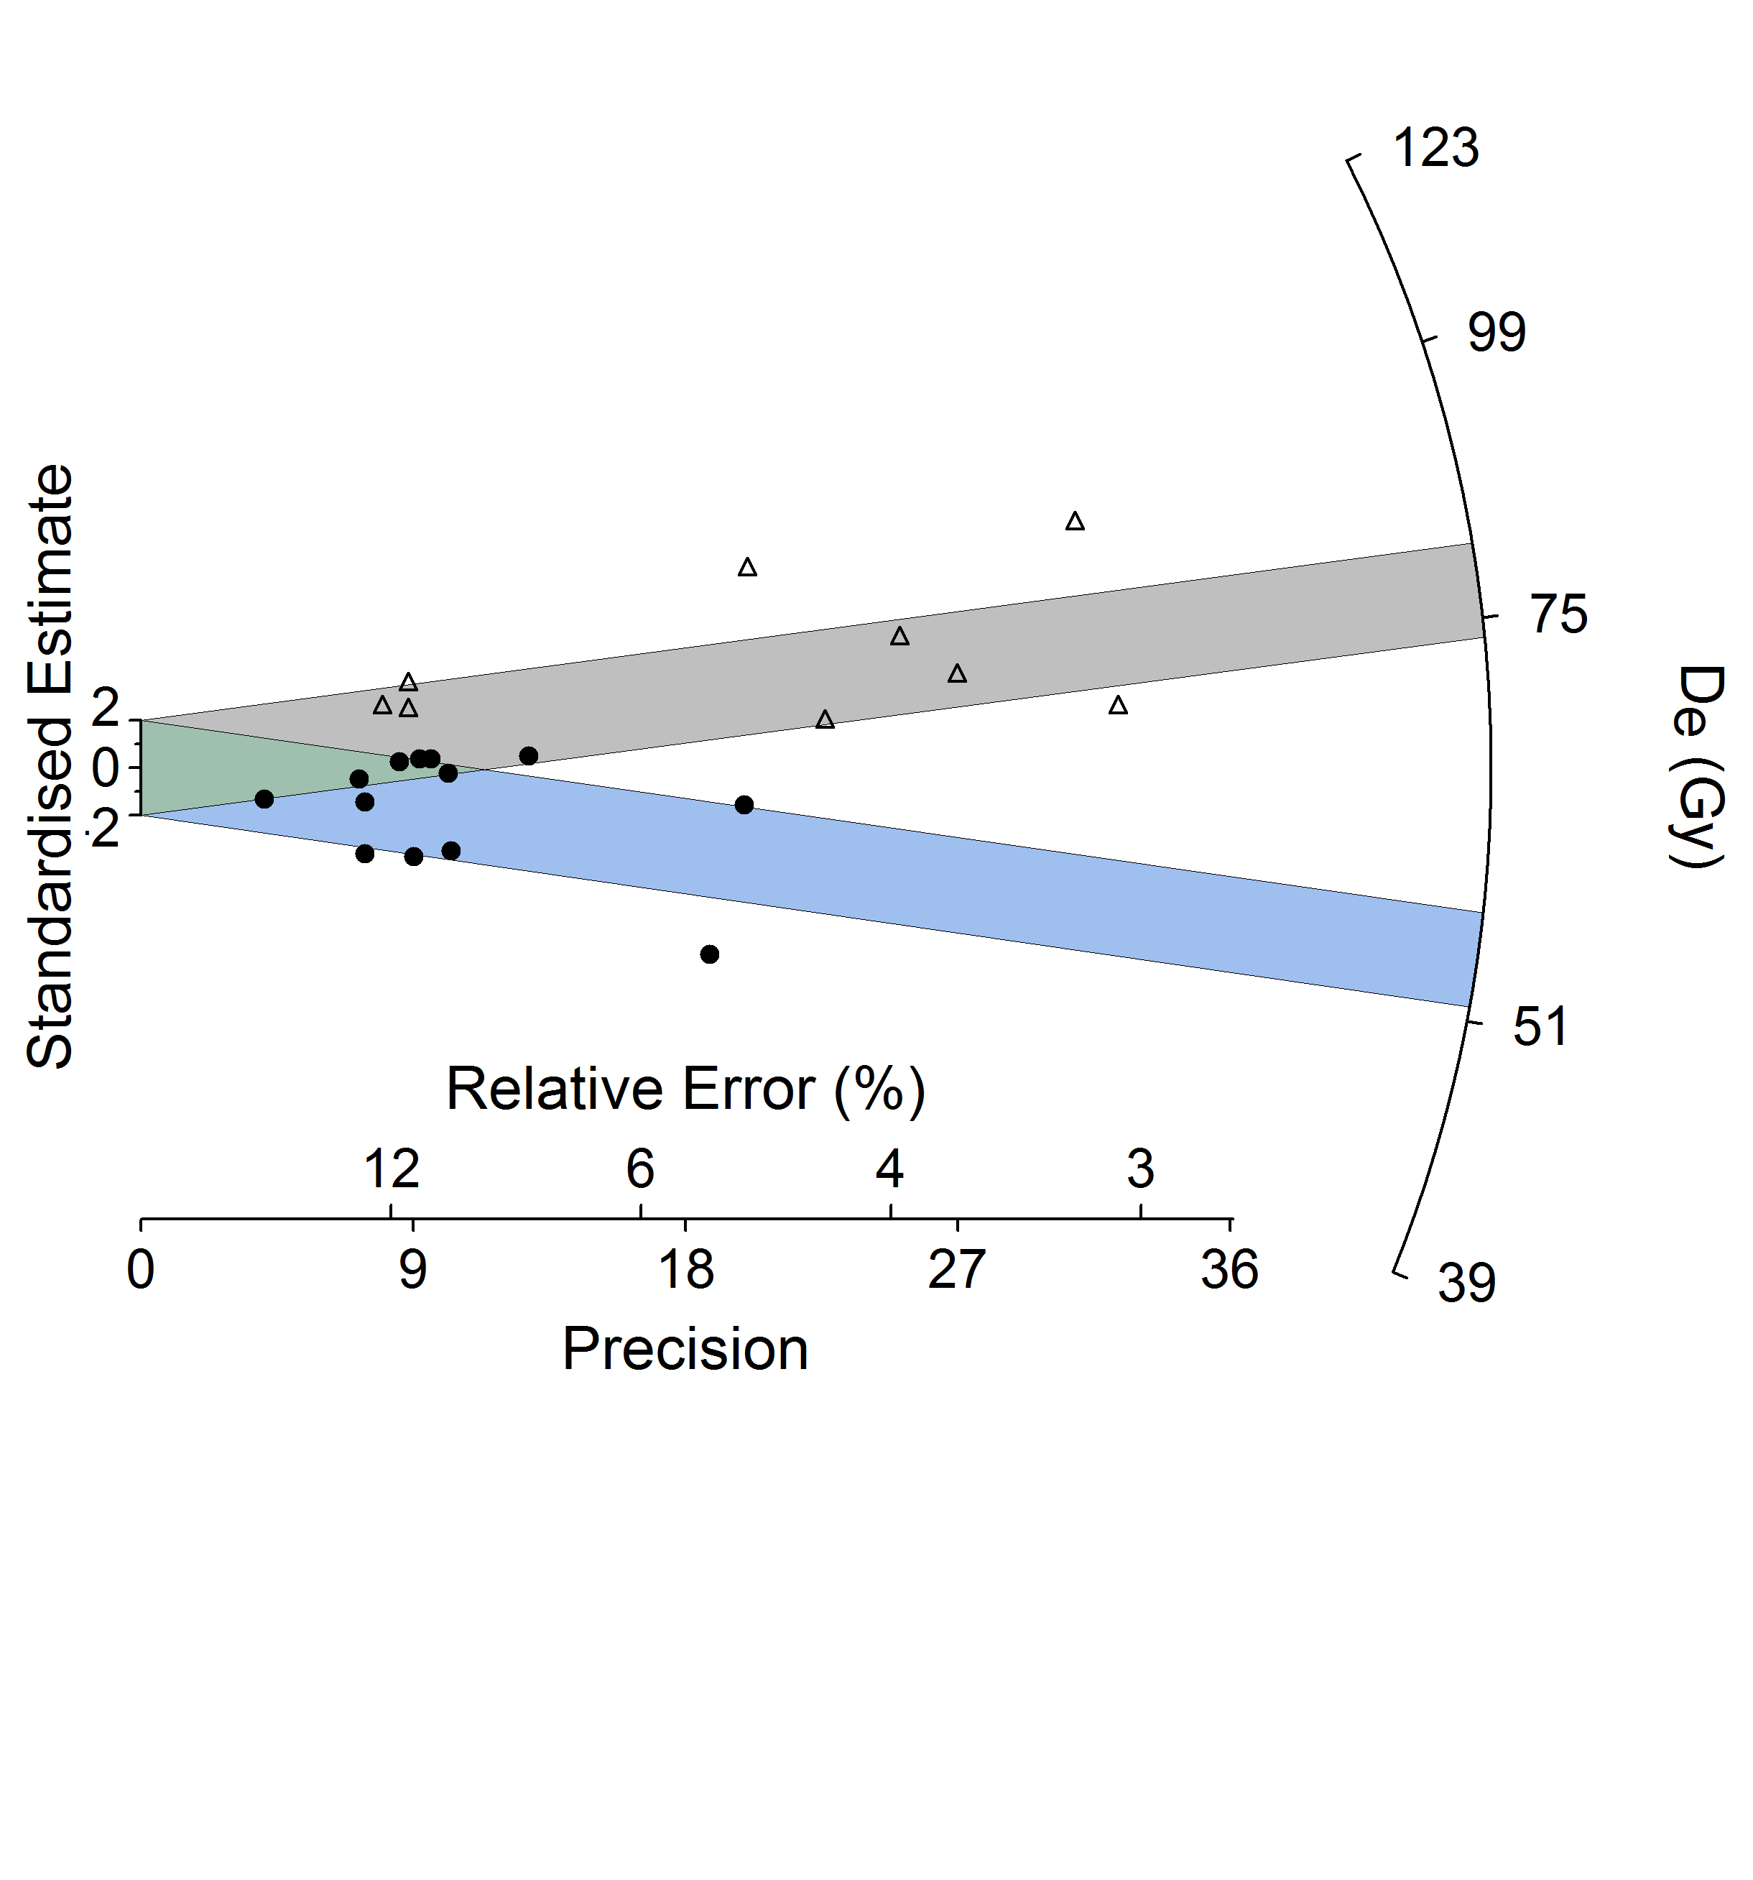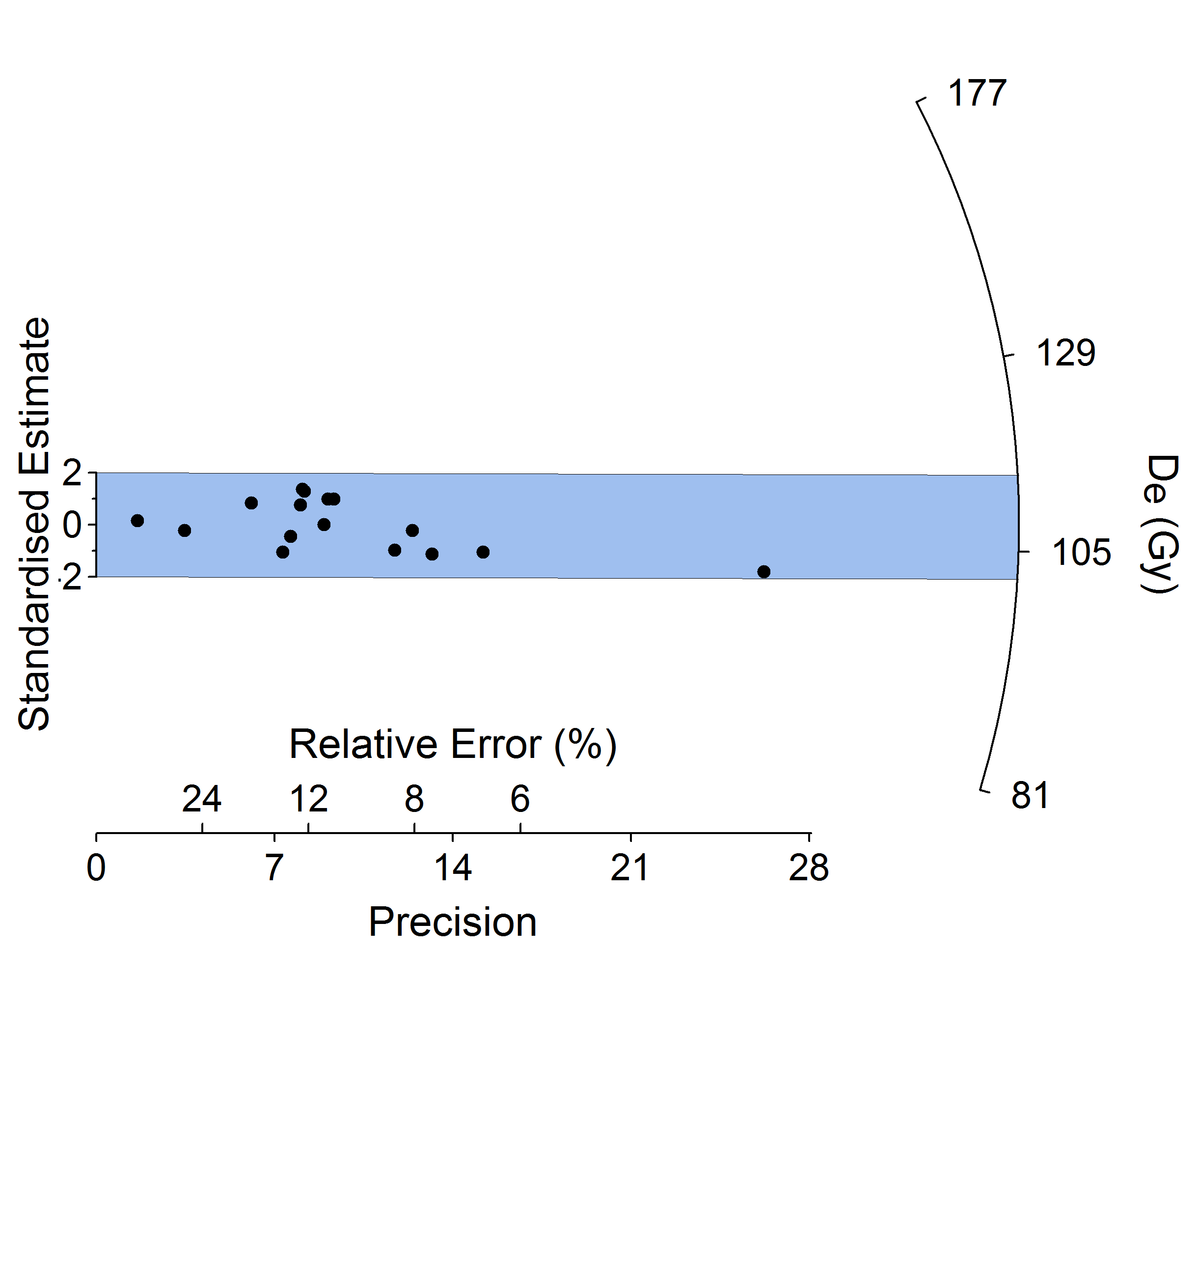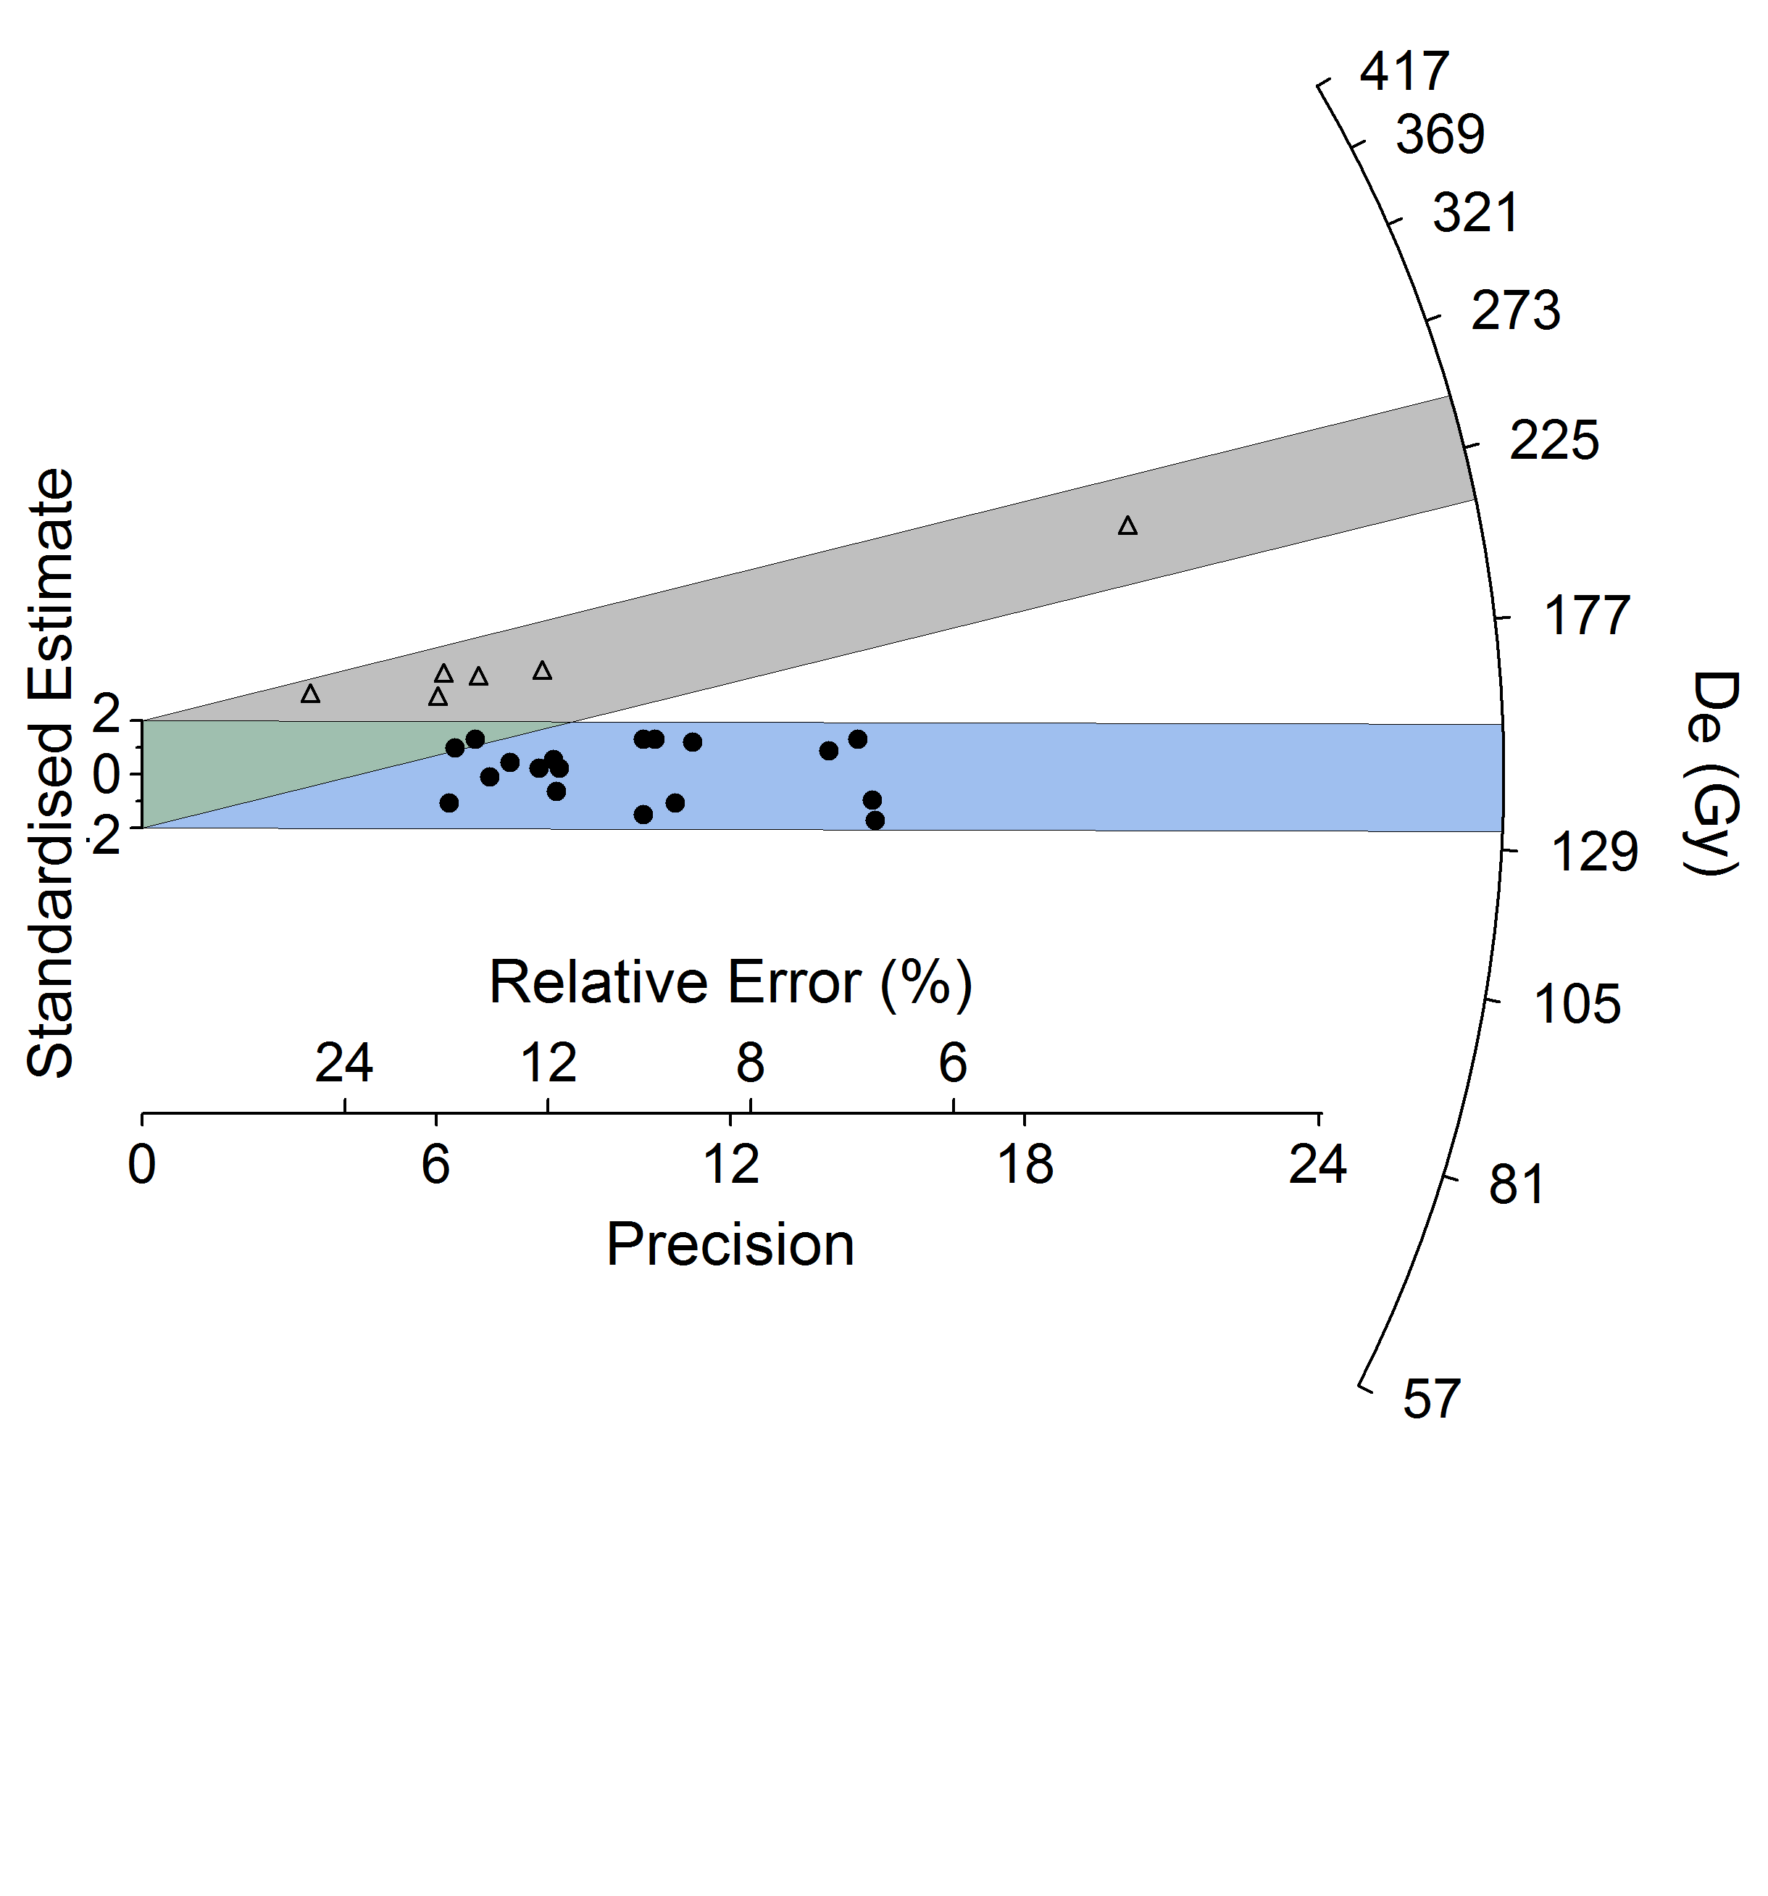

**c**

**b**

**a**

**Supplemental Figure S3**: Radial plots of equivalent dose values from quartz OSL. A). is MV-1 53 cm (n=22), B). MV-1 85 cm (n=16), and C). MV-1 120 cm (n=24). Blue and Grey color fills show the value of populations for the samples. Populations were chosen based on fit within 2 sigma.

  

**b**

**a**

**c**

**Supplemental Figure S4**: Decay curves from quartz OSL. A). is MV-2 73 cm (Disc 31), B). MV-2 121 cm (Disc 48), and C). MV-2 145 cm (Disc 35).

  

**b**

**c**

**a**

**Supplemental Figure S5**: Growth curves from quartz OSL. A). is MV-2 73 cm (Disc 31), B). MV-2 121 cm (Disc 48), and C). MV-2 145 cm (Disc 35).

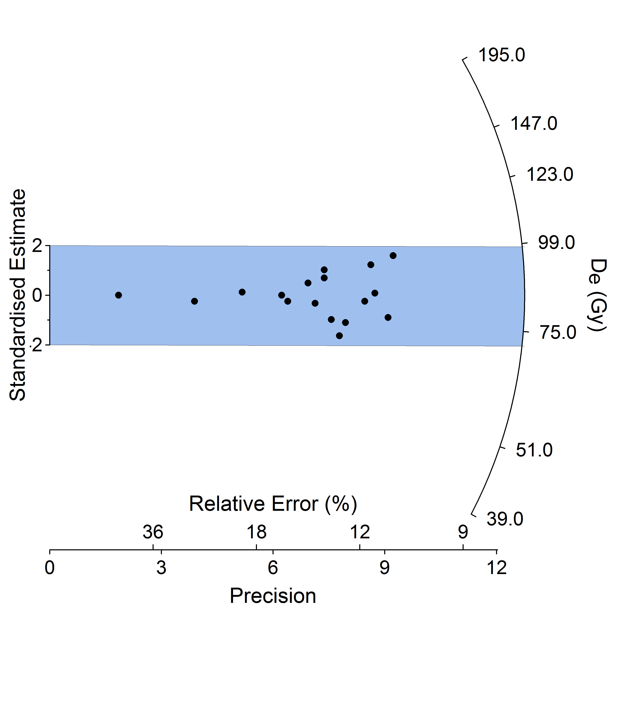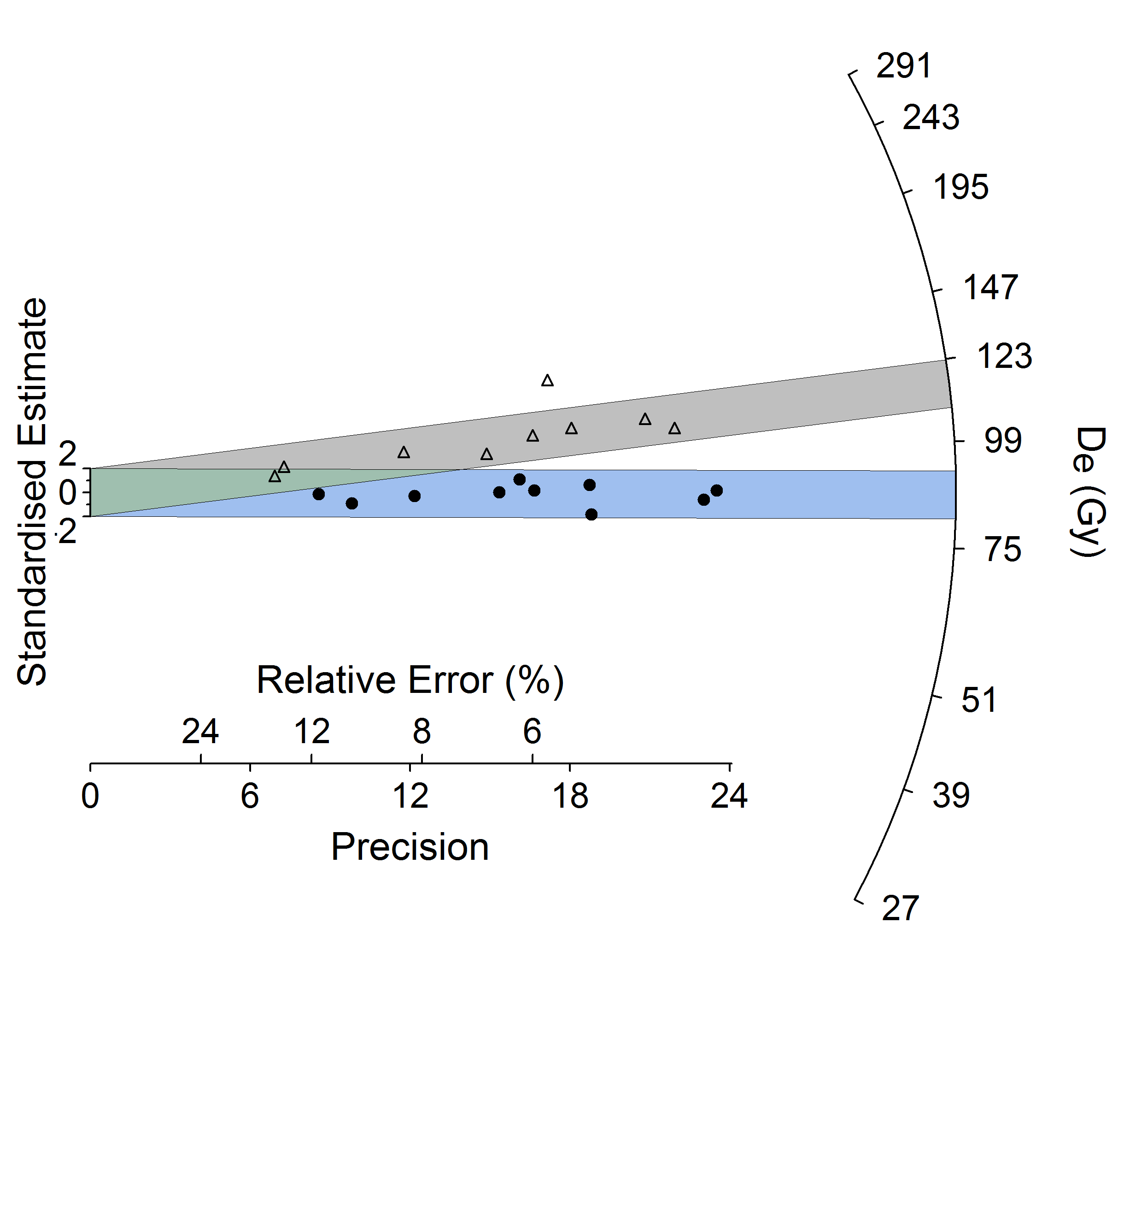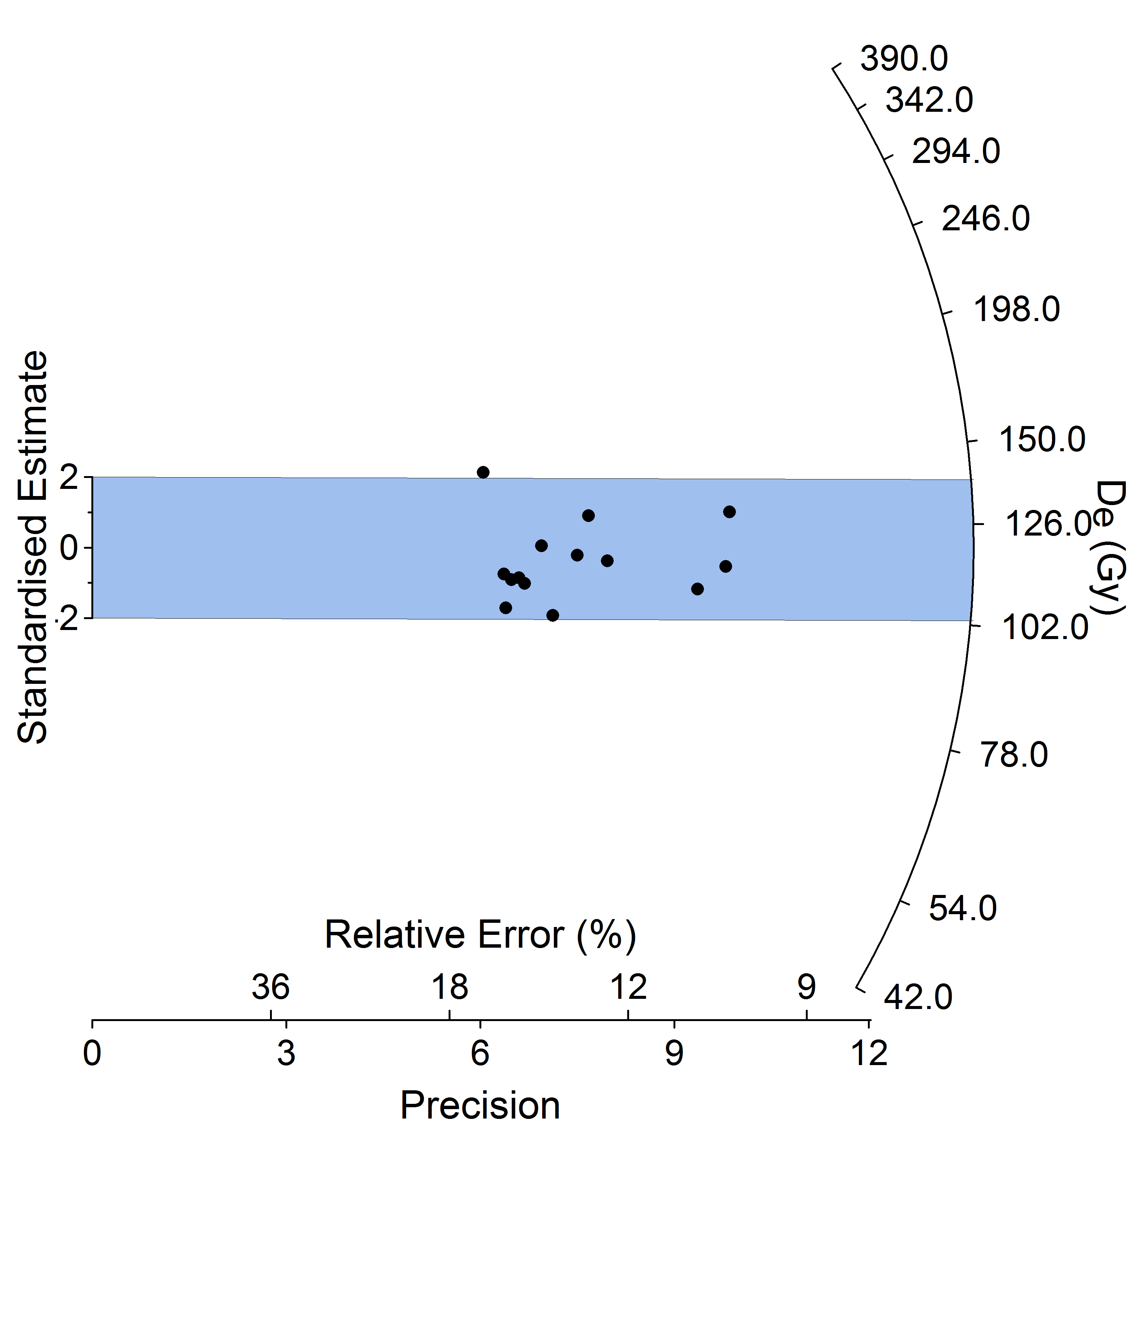

**c**

**b**

**a**

**Supplemental Figure S6**: Radial plots of equivalent dose values from quartz OSL. A). is MV-2 73 cm (n=17), B). MV-2 121 cm (n=19), and C). MV-2 145 cm (n=20). Blue and Grey color fills show the value of populations for the samples. Populations were chosen based on fit within 2 sigma.

1. Any use of trade, product, or firm names is for descriptive purposes only and does not imply endorsement by the U.S. Government.