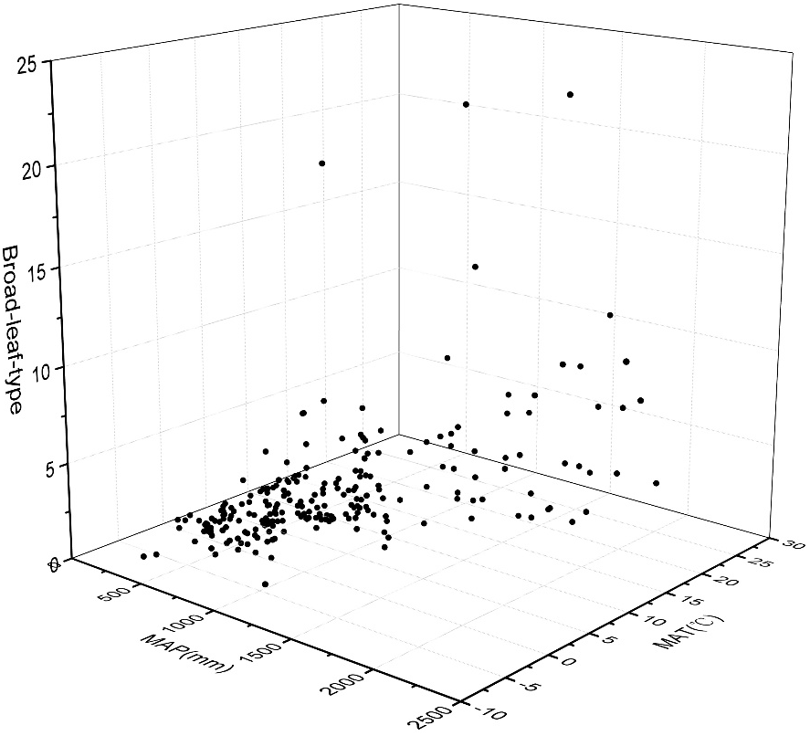
Figure 1 The percentage of broad-leaf-type phytolith in Chinese surface soil samples under different temperature and precipitation

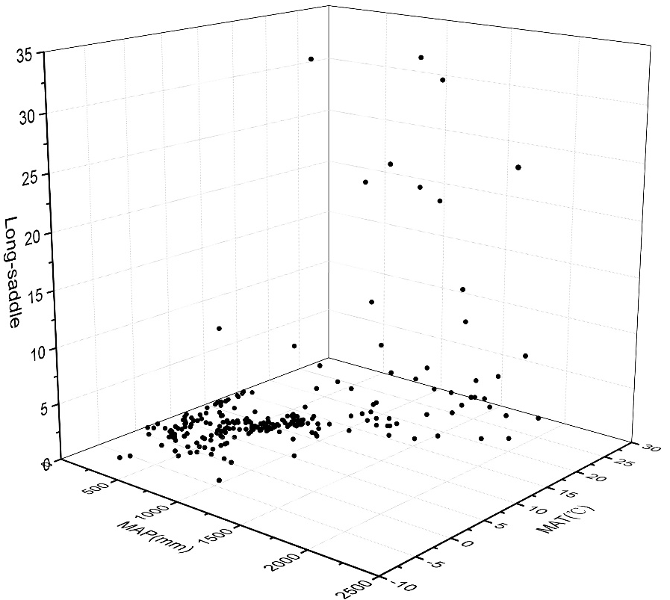
Figure 2 The percentage of long saddle in Chinese surface soil samples under different temperature and precipitation

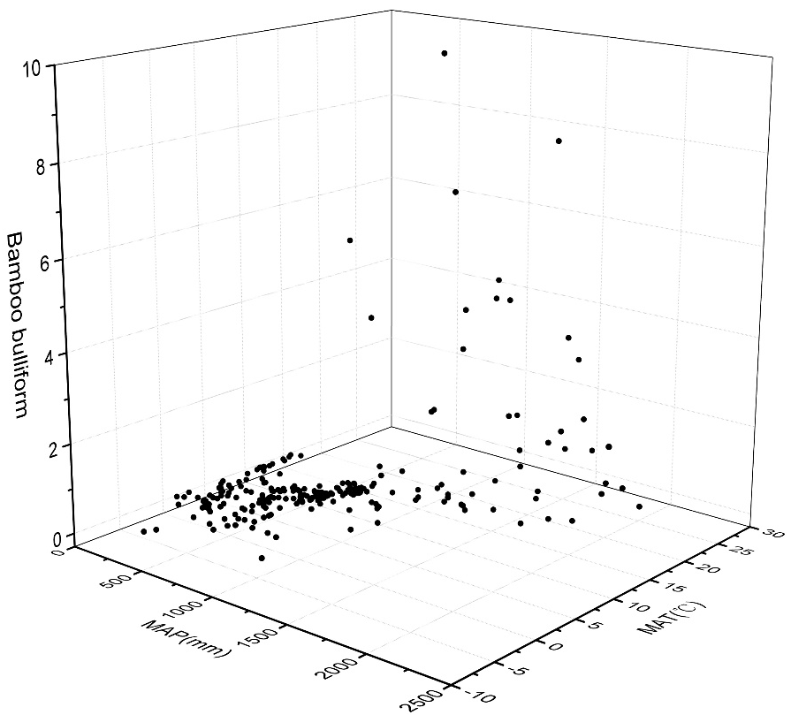
Figure 3 The percentage of bamboo bulliform in Chinese surface soil samples under different temperature and precipitation

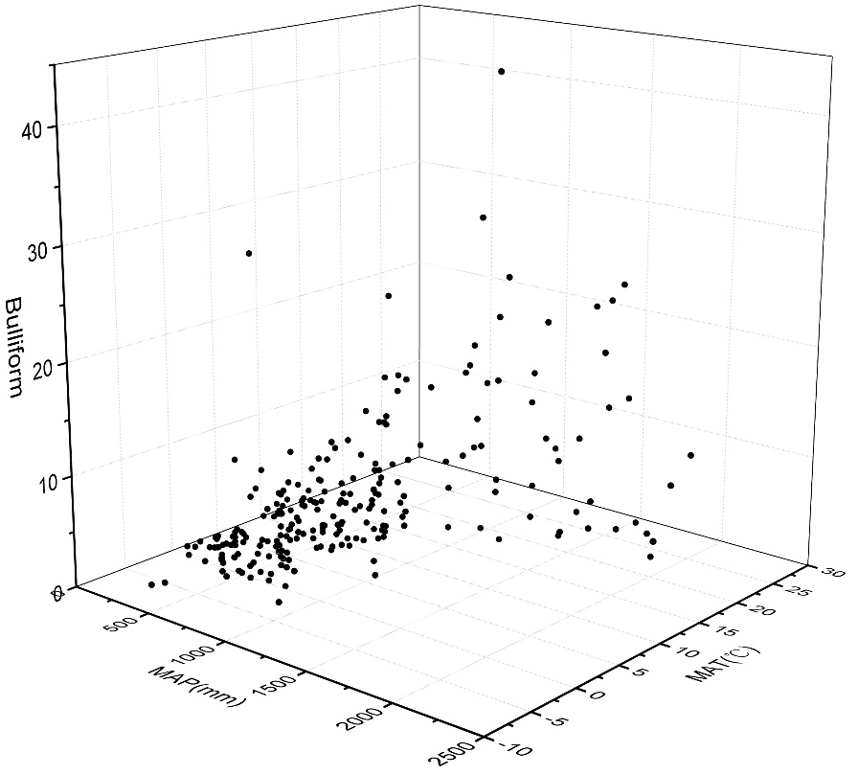
Figure 4 The percentage of bulliform in Chinese surface soil samples under different temperature and precipitation

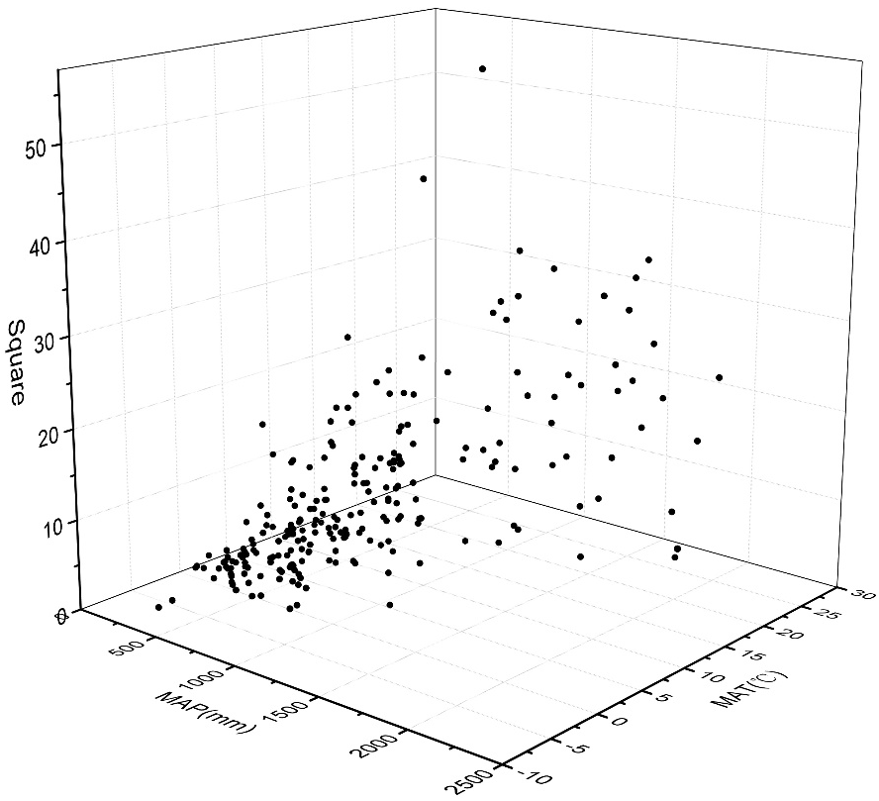
Figure 5 The percentage of square in Chinese surface soil samples under different temperature and precipitation

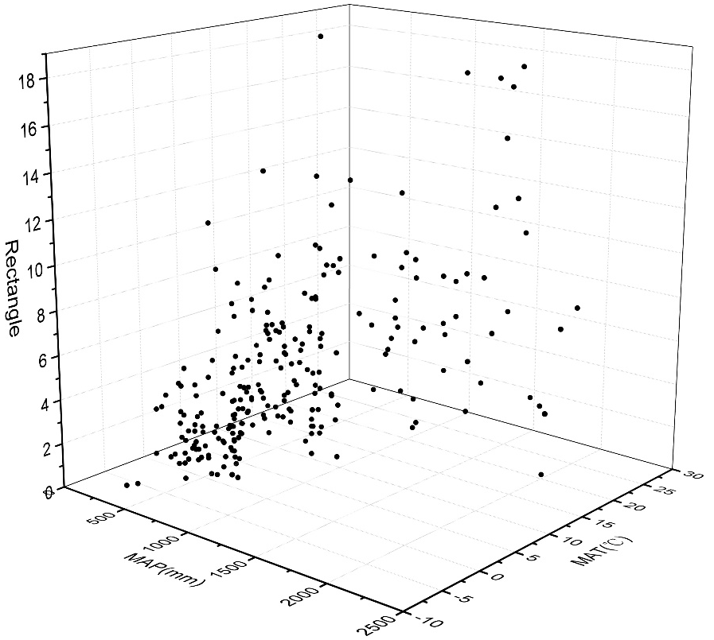
Figure 6 The percentage of rectangle in Chinese surface soil samples under different temperature and precipitation

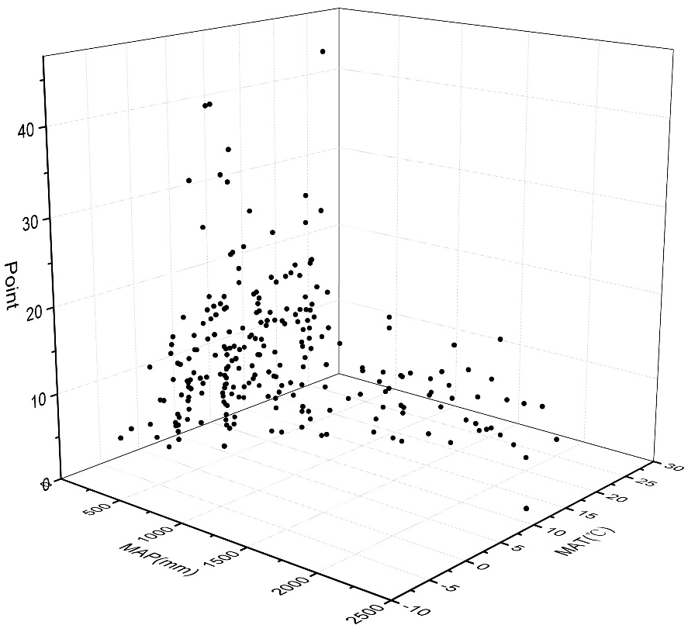
Figure 7 The percentage of point in Chinese surface soil samples under different temperature and precipitation
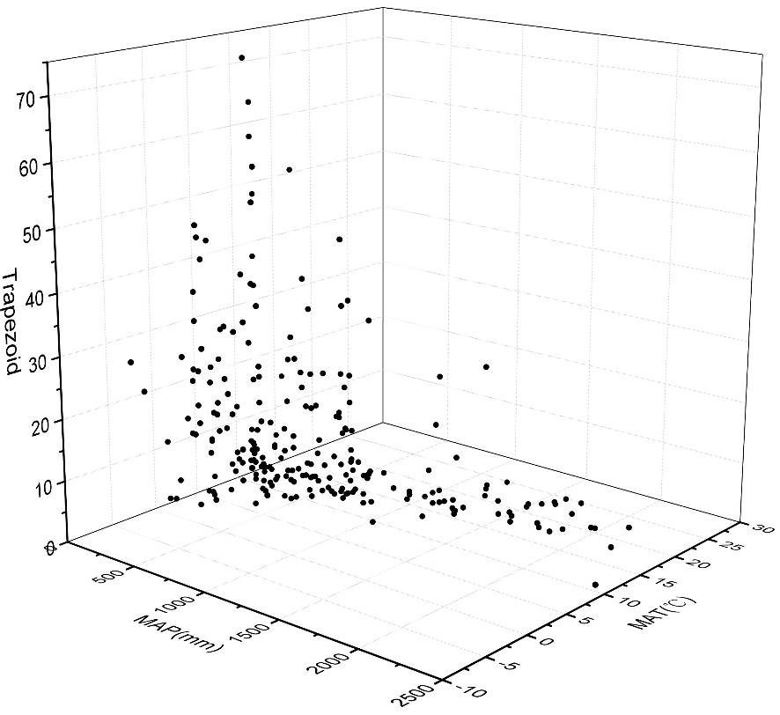
Figure 8 The percentage of trapezoid in Chinese surface soil samples under different temperature and precipitation

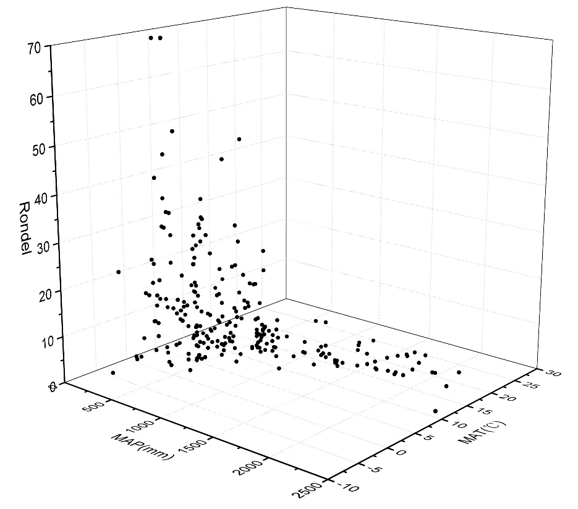
Figure 9 The percentage of rondel in Chinese surface soil samples under different temperature and precipitation
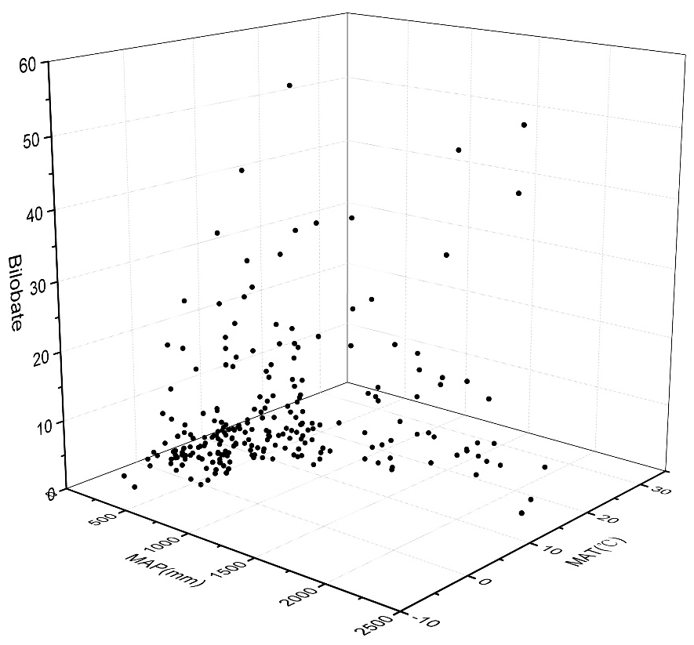
Figure 10 The percentage of bilobate in Chinese surface soil samples under different temperature and precipitation

