Supplementary material
1. D_{e} distributions
Since all our measurements are based on small aliquot (100-300 grains on each aliquot), and most of the OSL signals are usually from only a small fraction of grains (Duller et al., 2000), the D_{e} distribution could be used to check whether the sediment is well reset prior to deposition. Supplementary Figure 1 shows the D_{e} distributions of selected samples. It is observed that samples from shoreline S1-S5, S15, S17 and S20 show normal distribution and most of their D_{e} values fall into a single population in the radial-plots (D_{e} within the shaded region (<2σ) is represented by filled points). Combining with the well sorted sand layer found on these shorelines, it is thus suggested that these samples are well bleached. This is further supported by the fact that a zero age is obtained from the modern shore sample S20-1 (Supplementary Table S1).
It is observed that samples from shoreline S6-S13 have produced large D_{e} scatters (e.g., S10-1 in Supplementary Figure 1). These shorelines contain no pure sand layer. The sediment samples collected are sands mixed with pebbles (Fig. 3). These round- or dish-shaped pebbles suggest a high energy beach sedimentary environment and imply that sands deposited among pebbles probably only underwent limited sunlight exposure prior to deposition. Combining with the fact that no pure sands deposits were found from shoreline S6-S12, we thus suggest that for these shorelines, they are not suitable for OSL technique and their ages are not discussed in this work. Sample S13-1 was also collected within the mixture of sands and pebbles (Fig. 3). But these pebbles are moderately sorted and have smaller size compared to S6-S12. This suggests that paleo-shoreline S13 was formed in a relative moderate-high-energy beach sedimentary environment, and its bleaching could be better than samples from paleo-shoreline S6-S12. Correspondingly, D_{e} value of S13-1 shows a normal distribution and quite a small scatters in radial plot (Supplementary Figure 1). Based on these observations, sample S13-1 is adopted in this study though its confidence is lower than other ages.
In the dose recovery test, the natural signals from 24 aliquots were bleached by blue light at 125°C for 100 s, and then a beta dose close to their natural D_{e} values of ~30 and ~16 Gy were given to S1-3 and S5-1, respectively. The SAR protocol was conducted to measure the D_{e} value. The ratios of measured dose to given dose are in the range of 1.0±0.1, confirming the reliability of SAR protocol for our samples.

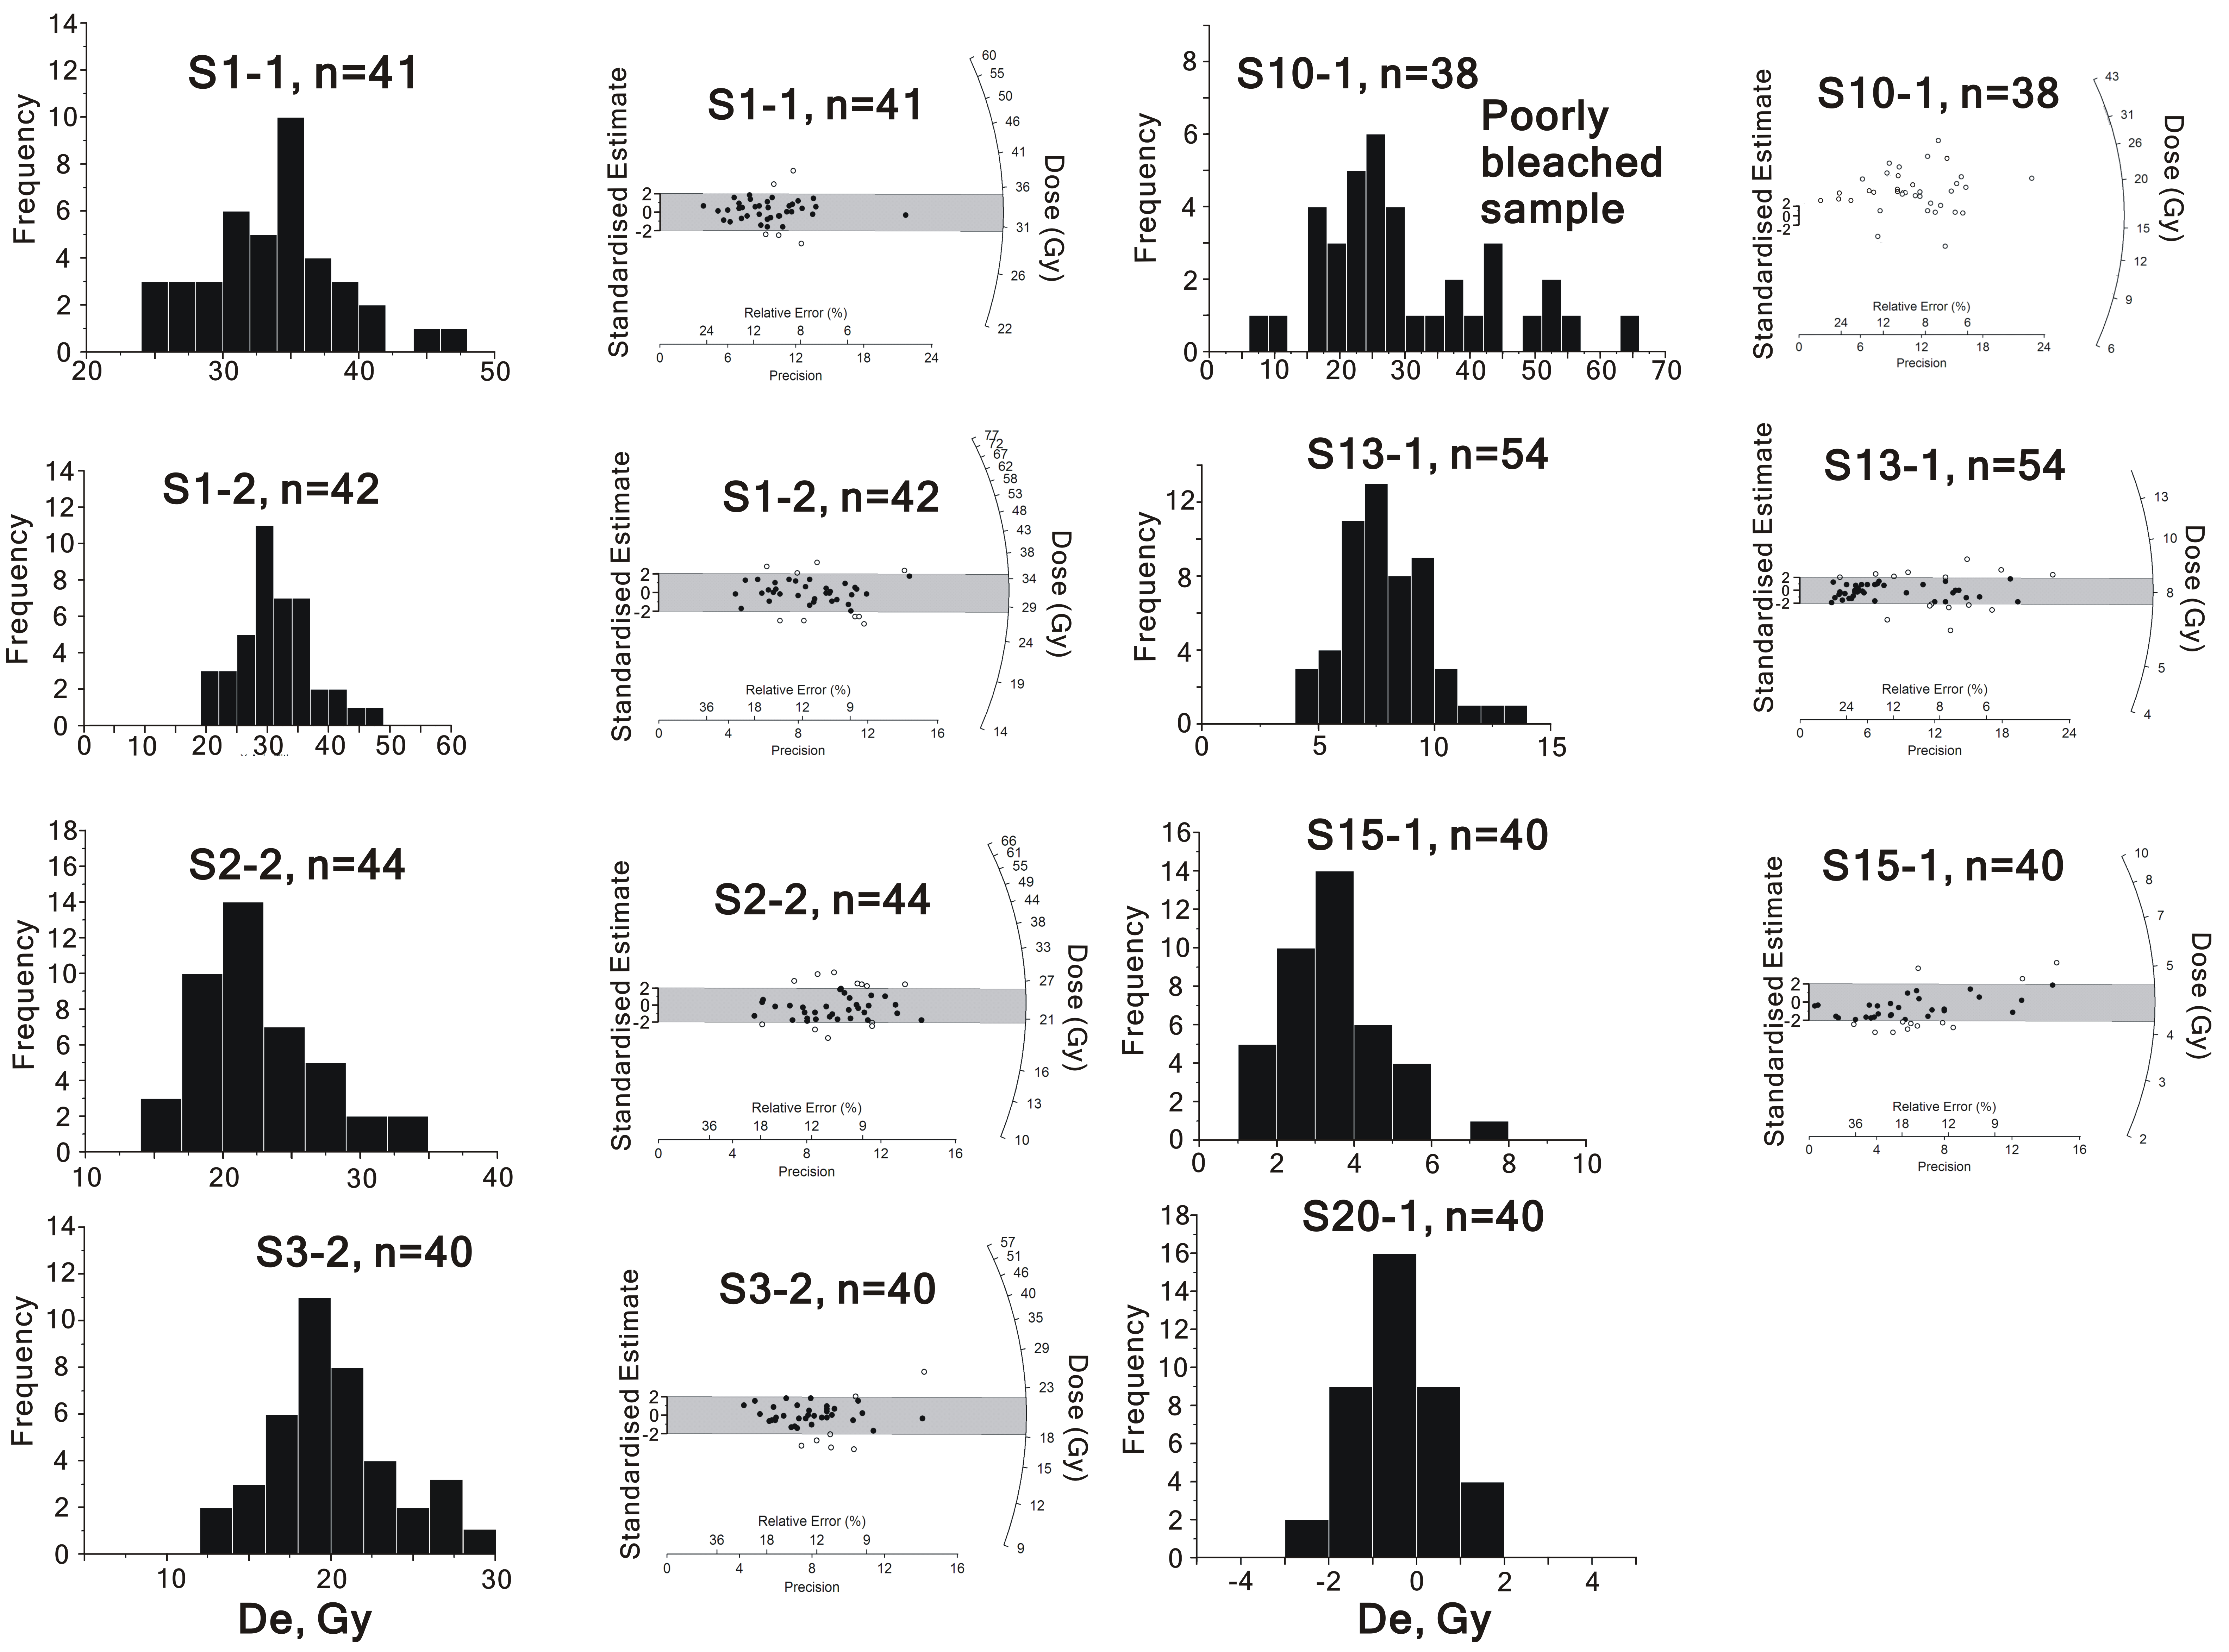
Supplementary Figure 1. The D_{e} distributions shown in histograms and radial plots of several selected samples (see text). For radial plots, D_{e} values within ± 2σ standard error band (shaded region) of the weighted mean are represented by filled points.
2. Luminescence dating result
In total, 22 samples are collected from 11 paleo-shorelines and among them, 18 samples give reliable ages for 8 paleo-shorelines. All the dating results are summarized in Supplementary Table S1.
Supplementary Table S1. Paleo-shoreline altitude and sample OSL ages
 | Samples | Alpha counting rate ª | K content ^{b} (%) | Water content (%) | Cosmic ray ^{c} (Gy/ka) | Equivalent dose (Gy) | Dose rate (Gy/ka) | Age (ka)
S1  128.2 m | S1-1 | 13.64±0.27 | 1.84 | 5±2 | 0.425 | 33.64±3.30 | 4.01±0.15 | 8.40±0.88
S1  128.2 m | S1-2 | 13.60±0.27 | 1.90 | 5±2 | 0.425 | 31.24±3.41 | 4.06±0.15 | 7.70±0.89
S1  128.2 m | S1-3 | 13.12±0.26 | 1.93 | 5±2 | 0.425 | 32.14±3.73 | 4.02±0.15 | 8.00±0.98
S1  128.2 m | S1-4 | 15.44±0.24 | 1.80 | 5±2 | 0.425 | 36.03±3.66 | 4.22±0.16 | 8.55±0.93
S2  94.0 m | S2-1 | 15.70±0.24 | 1.90 | 5±2 | 0.425 | 24.03±2.81 | 4.34±0.16 | 5.53±0.68
S2  94.0 m | S2-2 | 15.87±0.27 | 1.85 | 5±2 | 0.425 | 23.35±2.38 | 4.25±0.16 | 5.49±0.60
S2  94.0 m | S2-3 | 16.02±0.27 | 1.95 | 5±2 | 0.425 | 23.69±3.13 | 4.43±0.17 | 5.34±0.73
S2  94.0 m | S2-4 | 14.54±0.25 | 2.00 | 5±2 | 0.425 | 23.11±2.34 | 4.28±0.16 | 5.40±0.58
S3  79.9 m | S3-1 | 14.86±0.21 | 1.99 | 5±2 | 0.419 | 18.97±2.48 | 4.30±0.16 | 4.41±0.60
S3  79.9 m | S3-2 | 13.47±0.19 | 1.99 | 5±2 | 0.419 | 20.25±2.39 | 4.12±0.16 | 4.92±0.61
S5  64.4 m | S5-1 | 15.52±0.21 | 1.90 | 5±2 | 0.413 | 16.21±2.04 | 4.31±0.16 | 3.76±0.49
S5  64.4 m | S5-2 | 15.11±0.20 | 1.95 | 5±2 | 0.413 | 16.73±2.13 | 4.30±0.16 | 3.89±0.52
S13  21.9 m | S13-1 | 11.63±0.21 | 1.99 | 5±2 | 0.413 | 7.94±0.76 | 3.86±0.15 | 2.06±0.21
S15  20.7 m | S15-1 | 14.14±0.23 | 1.74 | 5±2 | 0.431 | 4.29±0.23 | 3.99±0.15 | 1.08±0.07
S15  20.7 m | S15-2 | 13.76±0.23 | 1.79 | 5±2 | 0.431 | 3.77±0.70 | 3.98±0.15 | 0.95±0.18
S17  14.0 m | S17-1 | 13.67±0.21 | 1.68 | 5±2 | 0.431 | 2.99±0.65 | 3.87±0.14 | 0.77±0.17
S17  14.0 m | S17-2 | 15.21±0.22 | 1.55 | 5±2 | 0.431 | 2.41±0.74 | 3.96±0.15 | 0.61±0.19
S20 (0m) | S20-1 | 15.88±0.22 | 1.85 | 5±2 | 0.437 | -0.54±1.07 | 4.33±0.16 | 0 ^{d}
ª The alpha counting rate is for a 42-mm-diameter ZnS screen and is given in units of counts per kilosecond.
^{b} The error for the XRFS analyses are estimated to be ± 2% (relative).
^{c} The error for the cosmic rays dose rate is estimated at ±0.02Gy/ka.
^{d} The age of the modern shoreline sample S20-1 was taken as 0 because it gave an D_{e} value of -0.54±1.07 Gy.

Reference
Duller, G.A.T., Botter-Jensen, L., Murray, A.S., 2000. Optical dating of single sand-sized grains of quartz: sources of variability. Radiation Measurement 32, 453-457.

