Figure 1-supple. Location and dates of the samples RES-1, -3 and -4, obtained from polished bedrock surfaces in the Aguas Limpias Valley and the Respumoso Cirque.
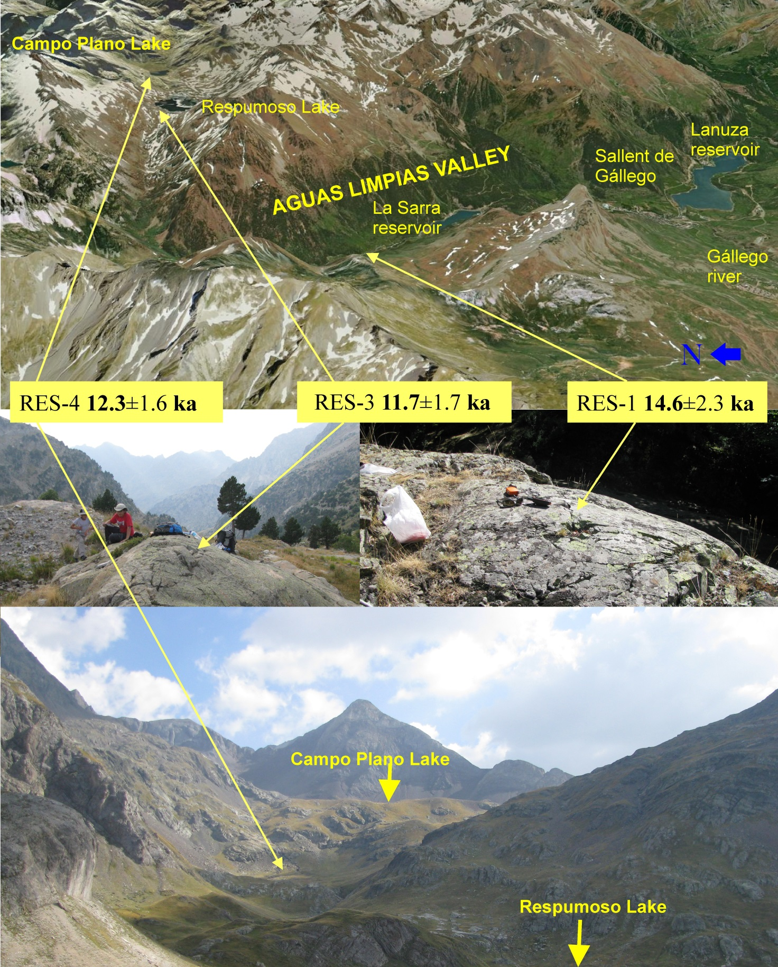
Figure 2-supple. Small moraines and rock glaciers of the Piniecho Cirque, showing the location of the sampled boulders and their cosmogenic exposure ages.
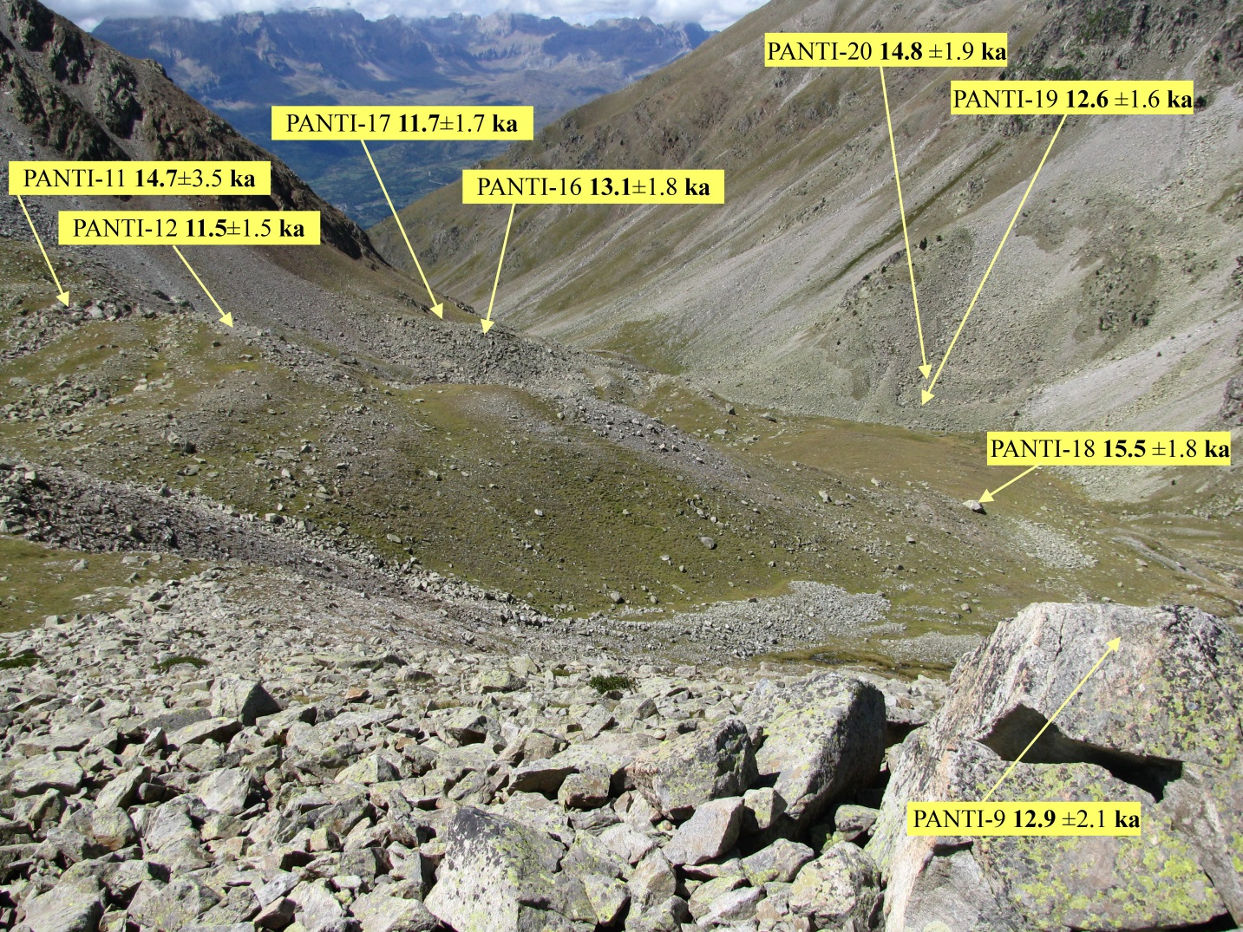

Figure 3-supple. The older Piniecho moraine and the sampled boulder (PANTI-18), showing surrounding younger moraines and rock glaciers.
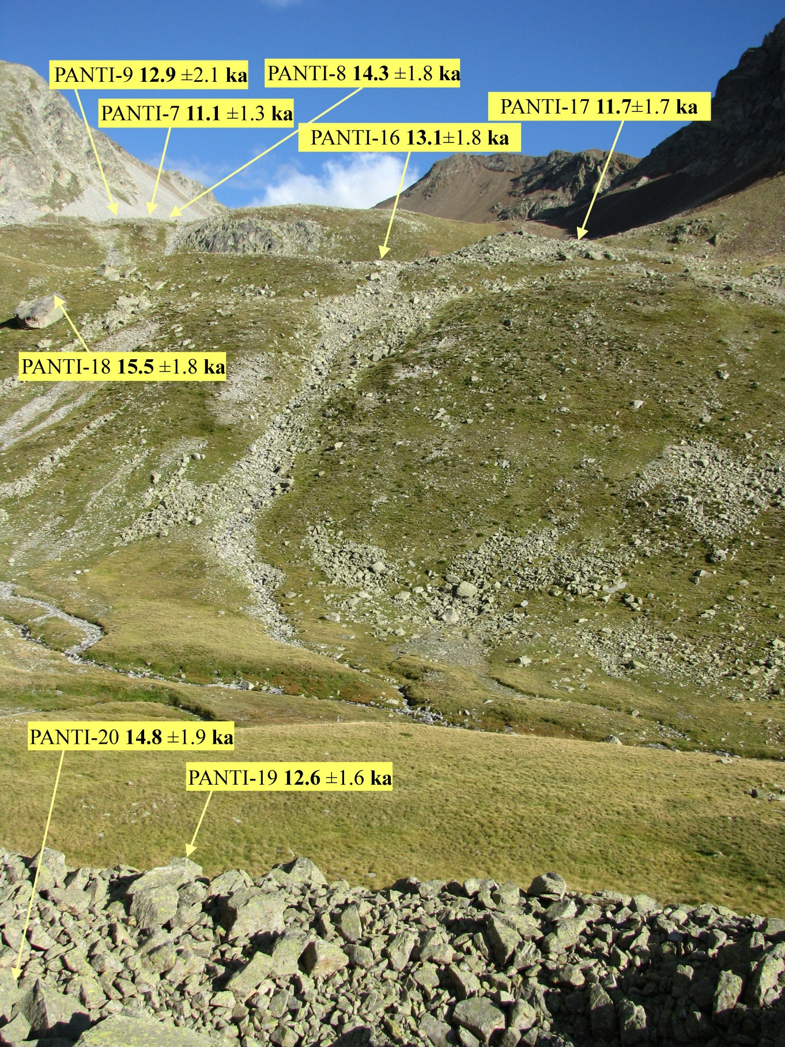

Figure 4-supple. The Catieras Cirque, showing the location of the sampling points and their cosmogenic exposure ages.
