Supplementary information

Lysozyme’s Lectin-like Characteristics Facilitates its Immune Defense Function

Ruiyan Zhang^{1,2}, Lisha Wu³, Thomas Eckert^{4,5}, Monika Burg-Roderfeld⁵, Miguel A. Rojas-Macias⁵, Thomas Lütteke⁵, Vadim B. Krylov⁶, Dmitry A. Argunov⁶, Aritreyee Datta⁷, Philipp Markart^{8,9}, Andreas Günther¹⁰, Bengt Norden³, Roland Schauer⁹, Anirban Bhunia⁷, Mushira Abdelaziz Enani¹¹, Martin Billeter^{12*}, Axel J. Scheidig²*, Nikolay E. Nifantiev⁶*, Hans-Christian Siebert¹*

¹RI-B-NT Research Institute of Bioinformatics and Nanotechnology, Franziusallee 177, 24148 Kiel, Germany. ²Institute of Zoology, Department of Structural Biology, Christian-Albrechts-University, Am Botanischen Garten 1-9, 24118 Kiel, Germany. ³Department of Chemical and Biological Engineering, Chalmers University of Technology, 41296 Gothenburg, Sweden. ⁴Clinic of Obstetrics, Gynecology and Andrology for Small and Large Animals, Justus-Liebig-University, Justus-Liebig-University Giessen, Frankfurter Str. 106, 35392 Giessen, Germany. ⁵Institute for Veterinary Physiology and Biochemistry, Justus-Liebig-University, Frankfurter Str.100, 35392 Giessen, Germany. ⁶Laboratory of Glycoconjugate Chemistry, N.D. Zelinsky Institute of Organic Chemistry, Russian Academy of Sciences, Leninsky prospect 47, 119991 Moscow, Russian Federation. ⁷Department of Biophysics, Bose Institute, P-1/12 CIT Scheme VII (M), Kolkata 700054, India. ⁸Pneumology, Heart-Thorax-Center Fulda, Pacelliallee 4 - 36043 Fulda, Germany. ⁹Institute of Biochemistry, Christian-Albrechts-University, Olshausenstrasse 40, 24098 Kiel, Germany. ¹⁰Medical Clinic II, Justus-Liebig-University, Klinikstraße 33, 35392 Giessen, Germany. ¹¹Infectious Diseases Division, Department of Medicine, King Fahad Medical City, PO Box 59046, Riyadh 11525, Kingdom of Saudi Arabia. ¹²Department of Chemistry and Molecular Biology, University of Gothenburg, 40530 Gothenburg, Sweden.
*e-mail: martin.billeter@chem.gu.se; axel.scheidig@strubio.uni-kiel.de; nen@ioc.ac.ru; hcsiebert@aol.com

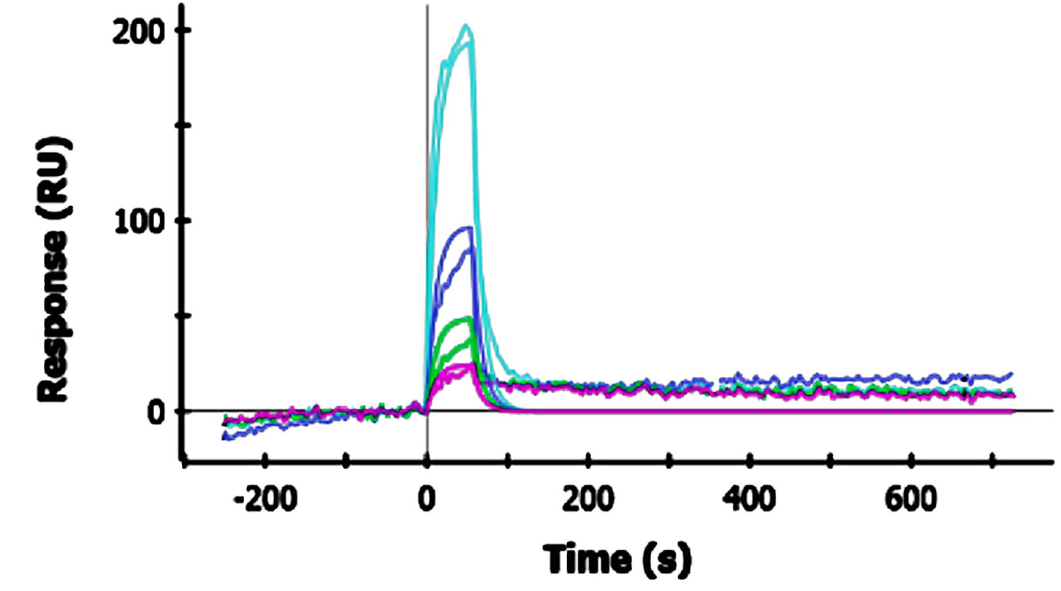 | k_{a} (M⁻¹ s⁻¹) = 2.16 ×10²  k_{d} (s⁻¹) = 8.86 ×10⁻²  K_{D} (M) = 4.10 × 10⁻⁴
Figure S1. SPR data of human lysozyme interacting with LPS from K. pneumoniaeO1. Five channels (A1 - A5) are used with different concentrations of LPS. Channel six was used for the running buffer only. The K. pneumoniae LPS concentrations are as follows: A1: 100 μl, A2: 80 μl, A3: 40 μl, A4: 20 μl, A5: 10 μl (k_{a} - association constant, k_{d} – dissociation constants).

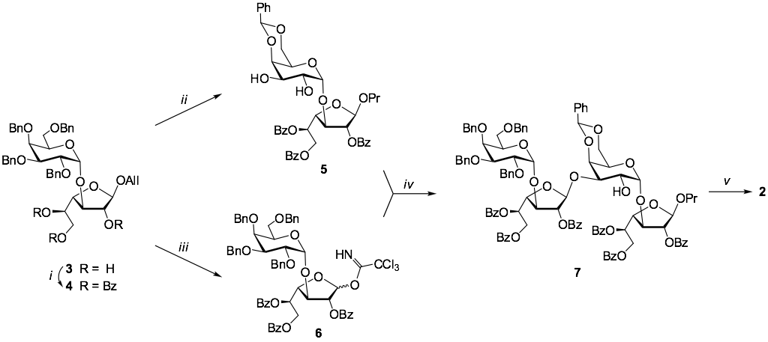

Scheme S1. The synthesis of disaccharide 1¹ was performed with the use of described¹ synthetic block 3 (scheme 1) which was prepared with the use of recently discovered pyranoside-into-furanoside rearrangement (Krylov et al. 2014; Krylov et al. 2016). Thus, the benzoylation of 3 (→4) and subsequent O-debenzylation, reduction of allyl group and 4’,6’-O-benzylidenation produced diol 5. On the other hand, removal of allyl-aglycon in 3 and further introduction of imidate group gave the glycosyl donor 6. TMSOTf promoted coupling of disaccharide derivatives 5 and 6 proceeded with regioselective (1→3)-bond formation to give tetrasaccharide product 7. Its deblocking afforded to the desire tetrasaccharide 2. Its structure, and particularly β-(1→3)-structure of newly formed bond was determined on the basis of characteristic (Gerbst et al. 2015) values of J_{H1”,H2”} coupling constant (<2.0 Hz) in ¹H NMR spectrum and characteristic low-field chemical shift of C3’ (77.52 ppm) in ¹³C NMR spectrum. Reagents and conditions: i. BzCl, Py, rt, 90%; ii. 1) H₂, Pd/C, EtOAc, rt, 2) PhCH(OMe)₂, CSA, CH₃CN, rt, 70% (2 steps); iii. 1) PdCl₂, MeOH, rt, 2) CCl₃CN, DBU, CH₂Cl₂, -30 ºC, 59% (2 steps); iv. TMSOTf, CH₂Cl₂, -40 ºC, 68%; v. 1) H₂, Pd(OH)₂/C, EtOAc-MeOH, rt, 2) NaOH, MeOH-H₂O, rt, 85% (2 steps).

Table S1. Titrating resonances in HL upon pH variation in the range 3.8-8.5.
Residue | Atom | Shift changeª (ppm) | Comment
Titrations with pKa 6.8 near Glu 35 and/or on helices b or d
Leu31 | HN | 0.09 | helix b
Leu31 | Hβ | 0.13 | helix b
Leu31 | Hγ | 0.12 | helix b
Lys33 | HN | 0.10 | helix b
Glu35 | HN | 0.17 | catalytic residue
Glu35 | Hβ | 0.21 | catalytic residue
Glu35 | Hβ’ | 0.14 | catalytic residue
Glu35 | Hγ | 0.08 | catalytic residue
Ser36 | HN | 0.13 | helix b
Tyr38 | HN | 0.08 | helix b
Gln58 | HN | 0.08 | on β-domain, in Trp 109 plane
Ile59 | HN | 0.12 | on β-domain, in Trp 109 plane
Val100 | HN | 0.10 | in Trp 109 plane
Ala108 | HN | 0.07 | in Trp 109 plane
Trp109 | Hβ | 0.32 | Trp side chain in binding cleft
Trp109 | H1 | 0.28 | Trp side chain in binding cleft
Trp109 | Hε1 | 0.48 | Trp side chain in binding cleft
Val110 | HN | 0.12 | helix d, shift change also at pH 3.8
Ala111 | HN | 0.84 | helix d
Trp112 | Hε1 | 0.13 | helix d
Arg113 | HN | 0.21 | helix d
Asn114 | HN | 0.13 | helix d
Arg115 | HN | 0.11 | helix d, interacts with helix b
Other titrations
Leu79 | HN | 0.08 | pKa 7.1
Asn75 | Hδ | 0.08 | pKa 7.1
Trp34 | Hε1 | - | pKa >7.5
Asn39 | Hα | - | pKa >7.5
Thr40 | HN | - | pKa >7.5
Gly127 | HN | - | pKa >7.5
Asp91 | HN | - | pKa <4.0
ª Shift changes exceeding 0.07 ppm are listed; this corresponds to twice the digital resolution after zero filling.
Figure S2. Titration curves for the resonances listed in the top part of Table S1 determined from 2D spectra recorded at various pH values (see Fig. 3). The vertical axis shows normalized chemical shifts δN_{norm} [δN_{norm} = (δN - δN(pH5)) / (δN(pH8.1) - δN(pH5)), where δN(pH5) is the shift measured at pH 5 and δN(pH8.1) is the shift measured at pH 8.1, respectively]. Thus, for all curves the chemical shifts are set to unit-less values between 0 (at pH5) and 1 (at pH8.1).
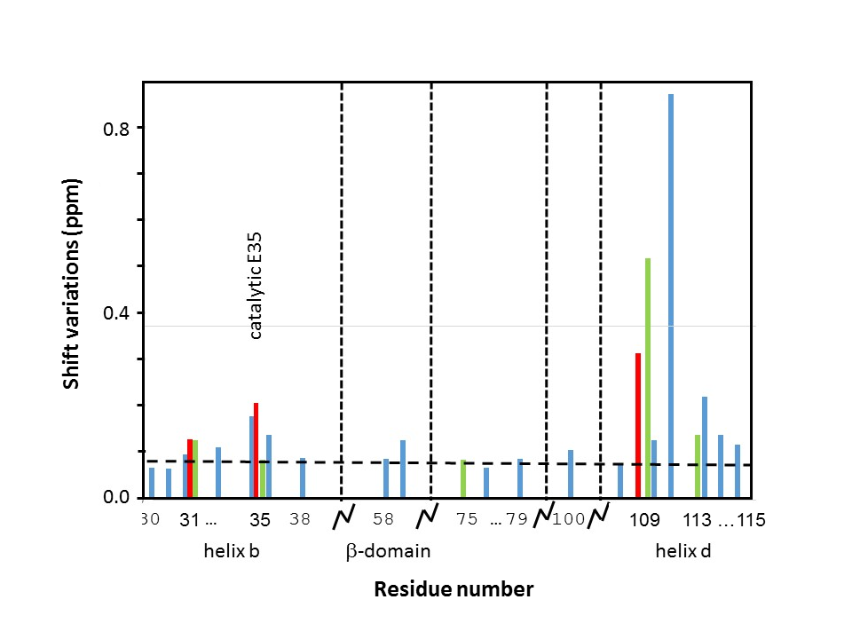
Figure S3. Measured shift deviations with a pKa of 6.8 (or 7.1) versus selected sequence fragments in HL. Colour code: blue for H_{N}, red for Hβ and green for other side chain protons. Dotted vertical lines separate sequence fragments; the dashed horizontal line corresponds to the chosen cut-off of 0.07 ppm.

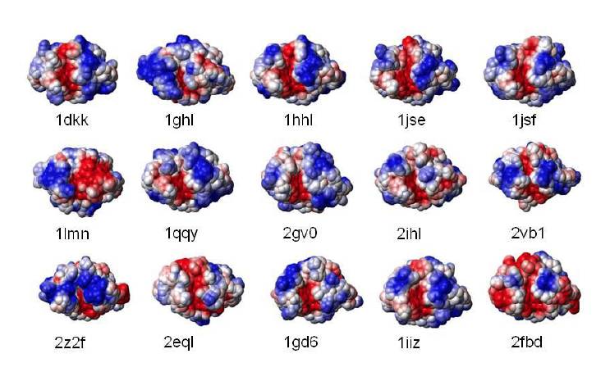
Figure S4. Electrostatic surface potentials for 15 c-type lysozyme. Electrostatic potentials where calculated with MOLMOL using charged Asp, Glu, Arg, Lys and uncharged His residues; the surfaces represent the centre positions of a solvent molecule rolling on the protein atoms. Below every figure, the PDB code is given. The different lysozymes are: 1dkk, bobwhite quail; 1ghl, pheasant egg white, 1hhl, guinea fowl; 1jse, turkey; 1jsf, human; 1lmn, rainbow trout; 1qqy, canine milk; 2gv0, soft shell turtle; 2ihl, Japanese quail egg white; 2vb1, hen egg white; 2z2f, bovine stomach; 2eql, equine milk; 1gd6, bombyx mori; 1iiz, tasar silkworm; 2fbd, musca domestica.

Table S2. Data collection and refinement statistics.

PDB entry | 5LSH
Data collection
Synchrotron X-ray source | PETRAIII (DESY)
Detector | Pilatus
Wave length (Å) | 0.9762
Temperature (K) | 100
Resolution range (Å) | 29.05 - 1.061 (1.099 - 1.061)
Space group | P 2(1)2(1)2(1)
Unit cell a, b, c (Å) | 33.1, 56.0, 60.5
Total reflections ª | 567827 (34483)
Unique reflections ª | 47721 (3498)
Multiplicity ª | 11.9 (9.8)
Completeness (%) ª | 92 (69)
Mean(I)/σ(I) ª | 17.06 (1.52)
R_{p.i.m.}(%) ^{a, b} | 7.6 (108.8)
CC(1/2) (%) ^{a, c} | 100 (63.3)
CC* (%) ^{a, c} | 100 (88.0)
Wilson B-factor (Å²) | 9.80
Refinement
Reflections used in refinement | 47429 (3498)
Reflections used for R-free | 2372 (175)
R-work (%) ^{d} | 18.1 (32.4)
R-free (%) ^{e} | 20.4 (33.6)
CC-work(%) ^{a, c} | 96.9 (69.4)
CC-free (%) ^{a, c} | 95.2 (70.1)
B-factors (Å²) (No. of nonhydrogen atoms)
All | 11.4 (1414)
Main chain | 9.3
Side chain | 11.4
Sodium ion | 17.3 (1)
Chlorid ion | 13.2 (3)
Ligand KTS | 16.6 (90)
Water molecules | 20.9 (160)
Estimated coordinate error (Å) ^{f} | 0.007
rmsd (bonds) (Å) | 0.013
rmsd (angle) (°) | 1.58
Molprobity all-atom clashscore | 7,47
Rotamer outliers (%) | 1.7
Ramachandran plot statistics (%)
Favoured | 97.0
Allowed | 2.8
Outliers | 0.0

ª | Values in parentheses are for the high-resolution bin.
^{b} | 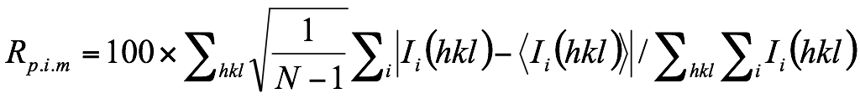
 | where I_{i}(hkl) is the intensity of the ith individual measurement of the reflection with Miller indices hkl and <I_{i}(hkl)> is the mean intensity of all measurements of I(hkl), calculated for I ≥ 3σ(I); N is the redundancy or multiplicity of the observed reflection (Weiss 2001; Diederichs et al.1997).
^{c} | CC(1/2), percentage of correlation between intensities from random half datasets. Correlation significant at the 0.1 % level. CC*, the CC of the full dataset against the true intensities (Karplus et al, 2012).
^{d} | 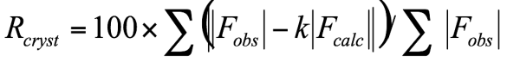
 | where F_{obs} and F_{calc} are the observed and calculated structure-factor amplitudes, respectively.
^{e} | R_{free} is equivalent to R_{cryst} but calculated with reflections (5 %) omitted from the refinement process (Brunger et al. 1992; Tickle et al. 2000).
^{f} | Calculated based on a Luzzati plot using the program SFCHECK (Vaguine et al. 1999).

Table S3. Interactions of tetrasaccharide 2 (KTS) within the binding cleft of human lysozyme.
Residue-Atom | Atom (KTS) | Ring | Distance (Å) | Type of bond
D-Galf-I
Ala76-CB | C | 1 | 3.8 | Hydrophobic
Arg98-NH2 | O1 | 1 | 3.1 | Hydrogen Bond
Arg98-NH2:HOH-O | O | 1 | 2.9 | Bridged H-Bond ª
Asp102-OD2 | O1 | 1 | 2.8 | Hydrogen Bond
Tyr63-OH:HOH-O | O3 | 1 | 3.3 | Bridged H-Bond ª
D-Galp-II
Asp102-OD2 | O20 | 2 | 2.6 | Hydrogen Bond
Tyr63-OH | O7 | 2 | 2.5 | Hydrogen Bond
Gly105-O/N/Val99-O:HOH-O | O20 | 2 | 2.7 | Bridged H-Bond ª
Gln104-NE2 | O9 | 2 | 3.3 | Hydrogen Bond
Gly105-O/N/Val99-O:HOH-O | O9 | 2 | 2.8 | Bridged H-Bond ª
D-Galf-III
Trp64-NE1 | O19 | 3 | 2.9 | Hydrogen Bond
Ala108-O:HOH-O | O13 | 3 | 3.3 | Bridged H-Bond ª
Asn60-OD1/O:HOH-O | O11 | 3 | 2.8 | Bridged H-Bond ª
Asp49-OD2:HOH-O | O11 | 3 | 3.2 | Bridged H-Bond ª
Gly105-O/N/Val99-O:HOH-O | O19 | 3 | 2.7 | Bridged H-Bond ª
Asn60-OD1/Asp49-OD2:HOH-O | O11 | 3 | 3.2 | Bridged H-Bond ª
D-Galp-IV
Trp109-CA | C20 | 4 | 3.9 | Hydrophobic
Trp109-CD1 | C19 | 4 | 3.3 | Hydrophobic
Trp109-CE2 | C18 | 4 | 3.7 | Hydrophobic
Trp109-CG | C19 | 4 | 3.7 | Hydrophobic
Gln58-O | O16 | 4 | 3.1 | Hydrogen Bond
Asn60-CB | C16 | 4 | 3.8 | Hydrophobic
Asn60-N | O15 | 4 | 2.8 | Hydrogen Bond
Trp64-CD1 | C18 | 4 | 3.9 | Hydrophobic
Asp53-OD2:HOH-O | O16 | 4 | 2.6 | Bridged H-Bond ª
Asp53-OD2:HOH-O | O17 | 4 | 2.6 | Bridged H-Bond ª
Asp53-OD2:HOH-O | O18 | 4 | 3.5 | Bridged H-Bond ª
Glu35-OE2/Val110-N/Ala111-N:HOH-O | O17 | 4 | 2.6 | Bridged H-Bond ª
Glu35-OE1:HOH-O | O16 | 4 | 2.6 | Bridged H-Bond ª
Asn60-OD1:HOH-O | O18 | 4 | 3.1 | Bridged H-Bond ª

- The given distance for bridged hydrogen bonds is the distance of the bridging water oxygen to the next atom of the tetrasaccharide 2.

References
Briinger, A. T. (1992). Free R value: a novel statistical quantity for assessing the accuracy of crystal structures. Nature, 355, 472-475.
Diederichs, K., & Karplus, P. A. (1997). Improved R-factors for diffraction data analysis in macromolecular crystallography. Nature structural biology, 4, 269-275.
Gerbst, A. G., Krylov, V. B., Vinnitskiy, D. Z., Dmitrenok, A. S., Shashkov, A. S., & Nifantiev, N. E. (2015). 13C-NMR glycosylation effects in (1→3)-linked furanosyl-pyranosides. Carbohydrate research, 417, 1-10.
Karplus, P. A., & Diederichs, K. (2012). Linking crystallographic model and data quality. Science, 336, 1030-1033.
Krylov, V. B., Argunov, D. A., Vinnitskiy, D. Z., Gerbst, A. G., Ustyuzhanina, N. E., Dmitrenok, A. S., & Nifantiev, N. E. (2016). The Pyranoside-into-Furanoside Rearrangement of Alkyl Glycosides: Scope and Limitations. Synlett, 27, 1659-1664.
Krylov, V. B., Argunov, D. A., Vinnitskiy, D. Z., Verkhnyatskaya, S. A., Gerbst, A. G., Ustyuzhanina, N. E., Dmitrenok, A.S., Huebner, J., Holst, O., Siebert H.-Ch, & Nifantiev, N. E. (2014). Pyranoside‐into‐Furanoside Rearrangement: New Reaction in Carbohydrate Chemistry and Its Application in Oligosaccharide Synthesis. Chemistry–A European Journal, 20, 16516-16522.
Tickle, I. J., Laskowski, R. A., & Moss, D. S. (2000). Rfree and the Rfree ratio. II. Calculation of the expected values and variances of cross-validation statistics in macromolecular least-squares refinement. Acta Crystallographica Section D: Biological Crystallography, 56, 442-450.
Vaguine, A. A., Richelle, J., & Wodak, S. J. (1999). SFCHECK: a unified set of procedures for evaluating the quality of macromolecular structure-factor data and their agreement with the atomic model. Acta Crystallographica Section D: Biological Crystallography, 55, 191-205.
Weiss, M. S. (2001). Global indicators of X-ray data quality. Journal of Applied Crystallography, 34, 130-135.

