**Supplementary material -- Examining pathways between genetic liability for schizophrenia and patterns of tobacco and cannabis use in adolescence**

## Supplementary Methods

### Participants

The sample consisted of participants from the Avon Longitudinal Study of Parents and Children (ALSPAC) longitudinal birth cohort which recruited 14,541 pregnant women residing in the former Avon Health Authority area with an expected delivery date between April 1991 and December 1992. Of the initial 14,541 pregnancies, 14,062 were live births and 13,988 were alive at 1 year (Boyd *et al.*, 2013, Fraser *et al.*, 2013). When the oldest children were approximately 7 years of age, an attempt was made to bolster the initial sample with eligible cases who had failed to join the study originally resulting in an additional 913 children being enrolled. The total sample size for analyses using any data collected after the age of 7 years is therefore 15,454 pregnancies, resulting in 15,589 fetuses. Of these 14,901 were alive at 1 year of age. Collection of a range of measures from ALSPAC mothers and their children is still ongoing and details of available data are accessible through a fully searchable data dictionary and variable search tool (<http://www.bris.ac.uk/alspac/researchers/data-access/data-dictionary>). Ethical approval for the study was obtained from the ALSPAC Ethics and Law Committee and the Local Research Ethics Committees (<http://www.bristol.ac.uk/alspac/researchers/research-ethics/>). Consent for biological samples has been collected in accordance with the Human Tissue Act (2004). Informed consent for the use of data collected via questionnaires and clinics was obtained from participants following the recommendations of the ALSPAC Ethics and Law Committee at the time.

### Genetic data

Avon Longitudinal Study of Parents and Children (ALSPAC) participants genetic data were acquired using the Illumina HumanHap550 quad genome-wide single nucleotide polymorphism (SNP) genotyping platform from 9912 participants. Individuals were excluded from further analysis on the basis of gender mismatches, minimal or excessive heterozygosity, disproportionate levels of individual missingness (>3%), evidence of cryptic relatedness (>10% of alleles identical by descent), and being of non-European ancestry (assessed by multidimensional scaling analysis including HapMap 2 individuals). SNPs with a minor allele frequency (MAF) of < 1%, Impute2 information quality metric of < 0.8, a call rate of < 95% or evidence for violations of Hardy-Weinberg equilibrium (*p* value < 5 x 10-7) were removed. Imputation of the target data was performed using Impute V2.2.2 against the 1000 genomes reference panel (Phase 1, Version 3; all polymorphic SNPs excluding singletons), using 2,186 reference haplotypes (including non-Europeans). Following quality control assessment and imputation and restricting to 1 young person per family, genetic data was available for 7,977 ALSPAC individuals.

### Polygenic scores

Polygenic scores for schizophrenia were constructed for each ALSPAC individual using data from the most recent schizophrenia GWAS based on 40,675 cases and 64,643 controls (Pardiñas *et al.*, 2018) as a training set. Polygenic scores were calculated using the PLINK (v1.9)(Chang *et al.*, 2015, Purcell *et al.*, 2007) ‘score’ command following the methodology described by the International Schizophrenia Consortium (ISC) (Purcell *et al.*, 2009). Prior to construction of scores, SNPs were removed from the analysis if they had a minor allele frequency less than 0.01, an imputation quality less than 0.8 or if there was allelic mismatch between samples. Due to the high linkage disequilibrium (LD) within the extended major histocompatibility complex (MHC; chromosome 6: 25-34Mb) only a single SNP was included to represent this region. SNPs were pruned for LD using the PLINK ‘clump’ command to remove SNPs in LD (*r*2 > 0.25) with a more significant SNP in the training set. Windows of 500kb were used to assess inter-SNP LD for pruning.

### Repeated measures of cigarette and/or cannabis use

Measures taken at approximate age 14 years, 16 years and 18 years were collected as part of ALSPAC assessment clinics using a computerized interview. Measures taken at approximate age 15 years, 17 years and 19 years were collected via ALSPAC postal questionnaires. For each time point, individuals were deemed as cigarette users if they were current smokers who smoked at least 1-3 in the previous 6 months (age 14 years), who smoked less that once a week, weekly or daily (age 15 and 16 years), had smoked less that once a week, weekly or daily in the last 30 days (age 16, 18 and 19 years). Individuals were deemed as non-cigarette users if they had never smoked a cigarette, if they had only tried cigarettes once or twice (age 15 and 17 years) or if they had not smoked in the last 6 months (age 14 years) or last 30 days (age 16, 18 and 19 years). For each time point, individuals were deemed as cannabis users if they had used or taken cannabis at least 1-3 times in the past 6 months (age 14 years), currently take cannabis less than weekly, weekly or daily (age 15, 16 and 17 years) or at least monthly or less in the last 12 months (age 18 and 19 years). Individuals were deemed as non-cannabis users if they had never tried cannabis, if they had only ever tried cannabis once or twice or if they used to sometimes use or take cannabis but had since stopped.

For generation of longitudinal latent classes, cigarette and cannabis use data were then combined into a 3-category nominal variable for each time point: “Non-users”, “Cigarette-only users” and “Cannabis users (either with or without cigarettes)” as previously described (Jones *et al.*, 2018).

To assess the associations between polygenic scores for schizophrenia and frequency of cigarette and cannabis use, responses to one or more questions at each time point were used to derive two 3-level ordinal variables for cigarette use and cannabis use: “Non-user”, “Occasional user” (typically less than once per week) and “Frequent user” (typically once a week or more) as previously described (Howe *et al.*, 2017, Taylor *et al.*, 2017).

### Association analyses

Multinomial logistic regression was used to assess whether polygenic scores predicted latent class membership. Associations were assessed using a manual implementation of the bias-adjusted three-step method in MPlus (see Heron *et al.* (2015) for more detail and example of code). The latent classes were first derived without the presence of the predictor. The resulting logit parameters defining the relationship between modal and latent classes were used as constraints allowing odds ratios (ORs) and confidence intervals (CIs) for the associations to be calculated without influencing latent class membership. Association analyses were conducted using individuals who had cigarette and cannabis use data present for 3 or more time points and genetic data.

### Potential mediators

A number of potential mediators were examined: IQ at age 8 years (assessed via the Wechsler Intelligence Scale for Children (Wechsler *et al.*, 1992); this measure was standardized [mean =0, standard deviation = 1] before use), victimization at age 8 years (a dichotomous measure relating to whether individual experienced relational or overt victimization, assessed via a modified version of the Bullying and Friendship Interview Schedule (Wolke *et al.*, 2000) at age 8 years), Strengths and Difficulties Questionnaire (SDQ) (Goodman, 1999) score at age 9 years relating to emotional symptoms (total scores assessed via parental-completed questionnaire when child was age 9 years with higher score indicating emotional difficulties), antisocial behavior (a dichotomous measure relating to whether individual engaged in any antisocial activities, assessed via a short structured interview at age 10 years), impulsivity (assessed using the number of incorrect stop signal trials at a 150ms delay during the stop signal task (Handley *et al.*, 2004) administered at age 10 years with a higher score indicating a higher level of impulsivity), friendship quality score (total score based on 5 items from the Cambridge Friendship Questionnaire (Baron-Cohen and Wheelwright, 2003) at age 12 years with a higher score indicating worse friendship quality), and psychotic experiences (a dichotomous measure relating to whether individual experienced hallucinations (visual and auditory), delusions (spied on, persecution, thoughts read, reference, control, grandiosity, other) and experiences of thought interference (broadcasting, insertion and withdrawal), assessed via the semi-structured Psychosis-Like Symptom Interview (PLIKSi) (Horwood *et al.*, 2008) at age 12 years).

## Supplementary References

**Baron-Cohen, S. & Wheelwright, S.** (2003). The friendship questionnaire: an investigation of adults with Asperger syndrome or high-functioning autism, and normal sex differences. *Journal of Autism and Developmental Disorders* **33**, 509-17.

**Boyd, A., Golding, J., Macleod, J., Lawlor, D. A., Fraser, A., Henderson, J., Molloy, L., Ness, A., Ring, S. & Davey Smith, G.** (2013). Cohort Profile: the 'children of the 90s' - the index offspring of the Avon Longitudinal Study of Parents and Children. *International Journal of Epidemiology* **42**, 111-27.

**Chang, C. C., Chow, C. C., Tellier, L. C. A. M., Vattikuti, S., Purcell, S. M. & Lee, J. J.** (2015). Second-generation PLINK: rising to the challenge of larger and richer datasets. *Gigascience* **4**.

**Fraser, A., Macdonald-Wallis, C., Tilling, K., Boyd, A., Golding, J., Davey Smith, G., Henderson, J., Macleod, J., Molloy, L., Ness, A., Ring, S., Nelson, S. M. & Lawlor, D. A.** (2013). Cohort Profile: the Avon Longitudinal Study of Parents and Children: ALSPAC mothers cohort. *International Journal of Epidemiology* **42**, 97-110.

**Goodman, R.** (1999). The extended version of the strengths and difficulties questionnaire as a guide to child psychiatric caseness and consequent burden. *Journal of Child Psychology and Psychiatry, and Allied Disciplines* **40**, 791-799.

**Handley, S. J., Capon, A., Beveridge, M., Dennis, I. & Evans, J. S. T.** (2004). Working memory, inhibitory control and the development of children's reasoning. *Thinking & Reasoning* **10**, 175-195.

**Heron, J. E., Croudace, T. J., Barker, E. D. & Tilling, K.** (2015). A comparison of approaches for assessing covariate effects in latent class analysis. *2015* **6**, 15.

**Horwood, J., Salvi, G., Thomas, K., Duffy, L., Gunnell, D., Hollis, C., Lewis, G., Menezes, P., Thompson, A., Wolke, D., Zammit, S. & Harrison, G.** (2008). IQ and non-clinical psychotic symptoms in 12-year-olds: results from the ALSPAC birth cohort. *British Journal of Psychiatry* **193**, 185-91.

**Howe, L. J., Trela-Larsen, L., Taylor, M., Heron, J., Munafò, M. R. & Taylor, A. E.** (2017). Body mass index, body dissatisfaction and adolescent smoking initiation. *Drug and Alcohol Dependence* **178**, 143-149.

**Jones, H. J., Gage, S. H., Heron, J., Hickman, M., Lewis, G., Munafo, M. R. & Zammit, S.** (2018). Association of combined patterns of tobacco and cannabis use in adolescence with psychotic experiences. *JAMA Psychiatry* **75**, 240-246.

**Pardiñas, A. F., Holmans, P., Pocklington, A. J., Escott-Price, V., Ripke, S., Carrera, N., Legge, S. E., Bishop, S., Cameron, D., Hamshere, M. L., Han, J., Hubbard, L., Lynham, A., Mantripragada, K., Rees, E., MacCabe, J. H., McCarroll, S. A., Baune, B. T., Breen, G., Byrne, E. M., Dannlowski, U., Eley, T. C., Hayward, C., Martin, N. G., McIntosh, A. M., Plomin, R., Porteous, D. J., Wray, N. R., Caballero, A., Geschwind, D. H., Huckins, L. M., Ruderfer, D. M., Santiago, E., Sklar, P., Stahl, E. A., Won, H., Agerbo, E., Als, T. D., Andreassen, O. A., Bækvad-Hansen, M., Mortensen, P. B., Pedersen, C. B., Børglum, A. D., Bybjerg-Grauholm, J., Djurovic, S., Durmishi, N., Pedersen, M. G., Golimbet, V., Grove, J., Hougaard, D. M., Mattheisen, M., Molden, E., Mors, O., Nordentoft, M., Pejovic-Milovancevic, M., Sigurdsson, E., Silagadze, T., Hansen, C. S., Stefansson, K., Stefansson, H., Steinberg, S., Tosato, S., Werge, T., GERAD1 Consortium, CRESTAR Consortium, Collier, D. A., Rujescu, D., Kirov, G., Owen, M. J., O'Donovan, M. C. & Walters, J. T. R.** (2018). Common schizophrenia alleles are enriched in mutation-intolerant genes and in regions under strong background selection. *Nature Genetics* **50**, 381-389.

**Purcell, S., Neale, B., Todd-Brown, K., Thomas, L., Ferreira, M. A., Bender, D., Maller, J., Sklar, P., de Bakker, P. I., Daly, M. J. & Sham, P. C.** (2007). PLINK: a tool set for whole-genome association and population-based linkage analyses. *Am J Hum Genet* **81**, 559-75.

**Purcell, S. M., Wray, N. R., Stone, J. L., Visscher, P. M., O'Donovan, M. C., Sullivan, P. F., Sklar, P. & International Schizophrenia Consortium** (2009). Common polygenic variation contributes to risk of schizophrenia and bipolar disorder. *Nature* **460**, 748-52.

**Taylor, M., Collin, S. M., Munafò, M. R., MacLeod, J., Hickman, M. & Heron, J.** (2017). Patterns of cannabis use during adolescence and their association with harmful substance use behaviour: findings from a UK birth cohort. *Journal of Epidemiology and Community Health*.

**Wechsler, D., Golombok, S. & Rust, J.** (1992). *Wechsler Intelligence Scale for Children – Third Edition UK Manual*. The Psychological Corporation: Sidcup, UK.

**Wolke, D., Woods, S., Bloomfield, L. & Karstadt, L.** (2000). The association between direct and relational bullying and behaviour problems among primary school children. *Journal of Child Psychology and Psychiatry* **41**, 989-1002.

## Supplementary Tables

Supplementary Table 1. Associations between polygenic score for cigarette smoking initiation and cannabis use initiation and subsequent cigarette and/or cannabis use as compared to non-use (N = 3925)

|  |  |  |  |  |  |
| --- | --- | --- | --- | --- | --- |
| *P*T | Early cigarette only users | Early cannabis with/without cigarette users | Late cigarette only users | Late cannabis with/without cigarette users |  |
| OR (95% CI) 1 | OR (95% CI) 1 | OR (95% CI) 1 | OR (95% CI) 1 | *P* |
| **Cigarette smoking initiation polygenic score associations** | | | | | |
| 0.5 | 1.68  (1.34, 2.10) | 1.33  (1.03, 1.71) | 1.46  (1.25, 1.70) | 1.23  (1.05, 1.45) | <0.001 |
| **Cannabis use initiation polygenic score associations** | | | | | |
| 0.5 | 1.16  (0.94, 1.44) | 1.15  (0.93, 1.42) | 1.13  (0.98, 1.32) | 1.42  (1.24, 1.62) | <0.001 |

**Note:** SNPs, single nucleotide polymorphisms; OR, odds ratio; 95% CI, 95% confidence interval; P, omnibus P-value for association between polygenic score and cigarette/cannabis use classes; *P*T, p-value threshold for inclusion of SNPs into the cigarette use and cannabis use polygenic scores.

1 Compared to all other classes combined.

Supplementary Table 2. Associations between polygenic risk score for schizophrenia minus the CHRNA5-CHRNA3-CHRNB4 gene cluster on chromosome 15 and cigarette and/or cannabis use as compared to non-use

|  |  |  |  |  |  |
| --- | --- | --- | --- | --- | --- |
| *P*T | Early cigarette only users | Early cannabis with/without cigarette users | Late cigarette  only users | Late cannabis with/without cigarette users |  |
|  | OR (95% CI) 1 | OR (95% CI) 1 | OR (95% CI) 1 | OR (95% CI) 1 | *P* |
| 0.5 | 1.13  (0.93, 1.37) | 1.08  (0.88, 1.32) | 0.87  (0.75, 1.00) | 1.25  (1.09, 1.44) | 0.004 |
| 0.05 | 1.13  (0.94, 1.36) | 1.08  (0.87, 1.33) | 0.87  (0.76, 1.00) | 1.23  (1.08, 1.41) | 0.004 |
| 1e-5 | 1.00  (0.82, 1.22) | 1.20  (0.98, 1.47) | 0.93  (0.81, 1.08) | 1.03  (0.90, 1.18) | 0.344 |
| 5e-8 | 0.96  (0.75, 1.23) | 1.14  (0.92, 1.41) | 1.10  (0.94, 1.29) | 1.00  (0.87, 1.16) | 0.632 |

**Note:** OR, odds ratio; 95% CI, 95% confidence interval; P, omnibus P-value for association between polygenic risk score and substance use classes; *P*T, p-value threshold for inclusion of SNPs into the schizophrenia polygenic score.

1 Compared to non-use class.

Supplementary Table 3. Associations between polygenic score for schizophrenia and cigarette and/or cannabis use as compared to non-use

|  |  |  |  |  |  |
| --- | --- | --- | --- | --- | --- |
| *P*T | Early cigarette only users | Early cannabis with/without cigarette users | Late cigarette only users | Late cannabis with/without cigarette users |  |
|  | OR (95% CI) 1 | OR (95% CI) 1 | OR (95% CI) 1 | OR (95% CI) 1 | *P* |
| 0.5 | 1.13  (0.93, 1.37) | 1.08  (0.88, 1.32) | 0.87  (0.75, 1.00) | 1.25  (1.09, 1.44) | 0.003 |
| 1e-5 | 0.99  (0.81, 1.21) | 1.19  (0.97, 1.47) | 0.94  (0.81, 1.09) | 1.03  (0.91, 1.18) | 0.377 |
| 5e-8 | 0.95  (0.74, 1.21) | 1.14  (0.92, 1.41) | 1.12  (0.95, 1.31) | 1.01  (0.87, 1.16) | 0.562 |

**Note:** SNPs, single nucleotide polymorphisms; OR, odds ratio; 95% CI, 95% confidence interval; P, omnibus P-value for association between polygenic score and cigarette/cannabis use classes; *P*T, p-value threshold for inclusion of SNPs into the schizophrenia polygenic score.

1 Compared to non-use class.

Supplementary Table 4. Logistic regression associations between polygenic score for schizophrenia and cigarette and/or cannabis use after reparameterization of classes into a 2-category outcome (N = 3925)

|  |  |  |  |  |  |
| --- | --- | --- | --- | --- | --- |
| *P*T | Early cigarette only users | Early cannabis with/without cigarette users | Late cigarette only users | Late cannabis with/without cigarette users |  |
| OR (95% CI) 1 | OR (95% CI) 1 | OR (95% CI) 1 | OR (95% CI) 1 | *P* |
| **Unadjusted** | | | | | |
| 0.05 | 1.07  (0.88, 1.31) | 1.10  (0.88, 1.36) | 0.89  (0.77, 1.02) | 1.20  (1.05, 1.37) | 0.032 |
| **Adjusted 2** | | | | | |
| 0.05 | 1.06  (0.86, 1.3) | 1.09  (0.87, 1.35) | 0.87  (0.75, 1.01) | 1.19  (1.04, 1.37) | 0.040 |

**Note:** SNPs, single nucleotide polymorphisms; OR, odds ratio; 95% CI, 95% confidence interval; P, omnibus P-value for association between polygenic score and cigarette/cannabis use classes; *P*T, p-value threshold for inclusion of SNPs into the schizophrenia polygenic score.

1 Compared to all other classes combined.

2 Adjusted for polygenic scores for cigarette smoking initiation and cannabis use initiation (*P*T = 0.5).

Supplementary Table 5. Associations between polygenic score for schizophrenia and cannabis and cigarette use (ever versus never) at single time-points

|  |  |  |  |  |  |  |
| --- | --- | --- | --- | --- | --- | --- |
|  | OR (95% CI) for cigarette ever versus never use | | | | | |
| ***P*T** | 14 years  (N = 4567) | 15 years  (N = 4150) | 16 years  (N = 1896) | 17 years  (N = 3579) | 18 years  (N = 3043) | 19 years  (N = 2402) |
| 0.5 | 1.10  (1.02, 1.18) | 1.08  (1.01, 1.16) | 0.94  (0.86, 1.04) | 1.12  (1.05, 1.20) | 1.13  (1.05, 1.21) | 1.08  (1.00, 1.17) |
| 0.05 | 1.08  (1.01, 1.17) | 1.10  (1.03, 1.18) | 0.95  (0.86, 1.05) | 1.09  (1.02, 1.16) | 1.11  (1.03, 1.19) | 1.05  (0.97, 1.14) |
| 1e-5 | 1.07  (0.99, 1.15) | 1.07  (0.99, 1.14) | 1.03  (0.94, 1.14) | 1.06  (1.00, 1.14) | 1.06  (0.98, 1.13) | 1.04  (0.96, 1.13) |
| 5e-8 | 1.07  (0.99, 1.15) | 1.06  (0.98, 1.13) | 1.00  (0.91, 1.10) | 1.02  (0.95, 1.09) | 1.06  (0.99, 1.14) | 0.98  (0.91, 1.07) |
|  | OR (95% CI) for cannabis ever versus never use | | | | | |
| ***P*T** | 14 years  (N = 4551) | 15 years  (N = 4164) | 16 years  (N = 3957) | 17 years  (N = 3580) | 18 years  (N = 3015) | 19 years  (N = 2405) |
| 0.5 | 1.18  (1.03, 1.35) | 1.13  (1.02, 1.26) | 1.17  (1.09, 1.25) | 1.16  (1.08, 1.25) | 1.19  (1.10, 1.28) | 1.17  (1.08, 1.27) |
| 0.05 | 1.15  (1.00, 1.31) | 1.12  (1.01, 1.25) | 1.18  (1.10, 1.27) | 1.13  (1.05, 1.22) | 1.14  (1.06, 1.23) | 1.13  (1.04, 1.23) |
| 1e-5 | 1.19  (1.04, 1.36) | 1.09  (0.98, 1.22) | 1.09  (1.01, 1.17) | 1.08  (1.01, 1.17) | 1.02  (0.95, 1.10) | 1.1 0  (1.01, 1.19) |
| 5e-8 | 1.12  (0.98, 1.28) | 1.06  (0.96, 1.18) | 1.05  (0.97, 1.12) | 1.02  (0.95, 1.1) | 1.02  (0.95, 1.10) | 1.01  (0.93, 1.10) |

**Note:** *P*T, p-value threshold for inclusion of SNPs into the schizophrenia polygenic score; OR, odds ratio; 95% CI, 95% confidence interval.

Supplementary Table 6. Associations between polygenic score for schizophrenia and frequency of cannabis and cigarette use (non-use, occasional use, frequent use) at single time-points

|  |  |  |  |  |  |  |
| --- | --- | --- | --- | --- | --- | --- |
|  | OR (95% CI) for increasing frequency of cigarette use | | | | | |
| ***P*T** | 14 years  (N = 3578) | 15 years  (N = 3403) | 16 years  (N = 3400) | 17 years  (N = 3105) | 18 years  (N = 2714) | 19 years  (N = 2166) |
| 0.5 | 1.14  (0.91, 1.41) | 0.96  (0.83, 1.12) | 1.02  (0.93, 1.12) | 1.06  (0.97, 1.16) | 1.06  (0.98, 1.16) | 1.09  (1.00, 1.20) |
| 0.05 | 1.15  (0.92, 1.43) | 0.95  (0.81, 1.10) | 1.05  (0.95, 1.15) | 1.07  (0.98, 1.17) | 1.04  (0.95, 1.13) | 1.08  (0.98, 1.18) |
| 1e-5 | 1.01  (0.81, 1.26) | 0.94  (0.81, 1.10) | 1.01  (0.92, 1.11) | 0.97  (0.89, 1.06) | 1.01  (0.93, 1.1) | 1.08  (0.98, 1.18) |
| 5e-8 | 1.04  (0.84, 1.30) | 0.97  (0.84, 1.13) | 1.01  (0.92, 1.10) | 1.00  (0.91, 1.09) | 1.02  (0.94, 1.11) | 1.02  (0.93, 1.12) |
|  | OR (95% CI) for increasing frequency of cannabis use | | | | | |
| ***P*T** | 14 years  (N = 3557) | 15 years  (N = 3388) | 16 years  (N = 3373) | 17 years  (N = 3098) | 18 years  (N = 2690) | 19 years  (N = 2160) |
| 0.5 | 1.19  (0.99, 1.44) | 1.00  (0.80, 1.25) | 1.10  (0.98, 1.24) | 1.23  (1.10, 1.39) | 1.11  (1.01, 1.23) | 1.22  (1.09, 1.37) |
| 0.05 | 1.13  (0.94, 1.37) | 1.01  (0.81, 1.27) | 1.11  (0.98, 1.25) | 1.21  (1.08, 1.36) | 1.10  (1.00, 1.22) | 1.20  (1.07, 1.34) |
| 1e-5 | 1.19  (0.99, 1.44) | 1.04  (0.82, 1.31) | 1.08  (0.96, 1.21) | 1.02  (0.91, 1.15) | 1.06  (0.96, 1.17) | 1.04  (0.93, 1.17) |
| 5e-8 | 1.11  (0.92, 1.34) | 0.99 (0.79, 1.24) | 1.06  (0.94, 1.19) | 1.00  (0.89, 1.13) | 1.00  (0.91, 1.10) | 0.94  (0.84, 1.06) |

**Note:** *P*T, p-value threshold for inclusion of SNPs into the schizophrenia polygenic score; OR, odds ratio; 95% CI, 95% confidence interval.

Supplementary Table 7. Total effect, direct effect and indirect effect of schizophrenia polygenic score (*P*T = 0.05) on late-onset cannabis with/without cigarette use as compared to all other classes combined (after class reparameterization) through a range of potential mediators

|  |  |  |  |  |
| --- | --- | --- | --- | --- |
| Mediator | N | Total Effect | Direct Effect | Indirect Effect via mediator |
| OR (95% CI) | OR (95% CI) | OR (95% CI) |
| IQ  at age 8 years | 3468 | 1.20  (1.03,1.39) | 1.22  (1.05,1.41) | 0.98  (0.97,1.00) |
| Victimization  at age 8 years | 3371 | 1.18  (1.04,1.33) | 1.18  (1.04,1.33) | 1.00  (1.00,1.01) |
| Emotional symptoms  at age 9 years | 3522 | 1.18  (1.02,1.36) | 1.18  (1.02,1.36) | 1.00  (0.99,1.00) |
| Antisocial behavior  at age 10 years | 3533 | 1.22  (1.06,1.40) | 1.21  (1.05,1.40) | 1.00  (1.00,1.01) |
| Impulsivity  at age 10 years | 3344 | 1.17  (1.02,1.35) | 1.17  (1.02,1.35) | 1.00  (1.00,1.00) |
| Friendship quality  at age 12 years | 3542 | 1.22  (1.06,1.41) | 1.22  (1.06,1.41) | 1.00  (0.99,1.00) |
| Psychotic experiences at age 12 years | 3572 | 1.22  (1.08,1.37) | 1.22  (1.08,1.38) | 1.00  (1.00,1.00) |

**Note:** OR, odds ratio; 95% CI, 95% confidence interval; *P*T, p-value threshold for inclusion of SNPs into polygenic score. Within the mediation models, higher emotional, impulsivity and friendship quality scores indicate more emotional problems, a higher level of impulsivity and worse friendship quality, respectively.

Supplementary Table 8. Unadjusted and adjusted associations between cigarette and/or cannabis use and psychotic experiences at age 18 years (N = 2923)

|  |  |  |  |  |
| --- | --- | --- | --- | --- |
|  | Definite PE (4.48% definite PEs versus 95.52% suspected PEs or none) | | | |
|  | Unadjusted | | Adjusted 1 | |
|  | OR (95% CI) 2 | *P* | OR (95% CI) 2 | *P* |
| **Early-onset cigarette-only** | 2.98 (1.14, 7.78) | <0.001 | 2.96 (1.14, 7.69) | <0.001 |
| **Early-onset cannabis** | 3.28 (1.35, 7.97) | 3.28 (1.35, 7.95) |
| **Late-onset cigarette-only** | 0.58 (0.16, 2.05) | 0.59 (0.17, 2.06) |
| **Late-onset cannabis** | 2.76 (1.49, 5.11) | 2.75 (1.48, 5.10) |

**Note:** PE, psychotic experiences; OR, odds ratio; 95% CI, 95% confidence interval; *P*, omnibus *P* value for association between cigarette/cannabis use classes and psychotic experiences at age 18 years.

1 Adjusted for schizophrenia polygenic risk score (*P*T = 0.05).

2 Compared to non-use class.

## Supplementary Figures



Supplementary Figure 1. Five-class model of cigarette/cannabis use patterns from a sample of 5,300 individuals (Jones *et al*., 2018). The probability axis represents the probability of a class member being a non-user, a cigarette-only user or a cannabis with/without cigarette user at each time point. Class proportions are show as percentages (%) after each class description.

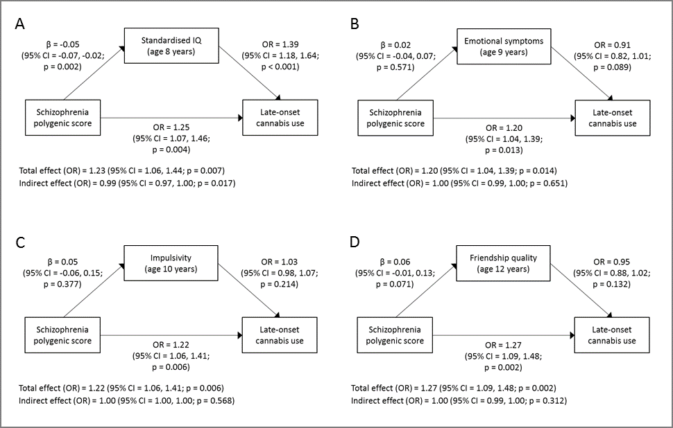

Supplementary Figure 2. Total effect, direct effect and indirect effects of schizophrenia polygenic score (*P*T = 0.05) on late-onset cannabis with/without cigarette use as compared to non-use through the following continuous mediators: a) IQ, b) emotional symptoms, c) impulsivity, and d) friendship quality. Note that higher emotional, impulsivity and friendship quality scores indicate more emotional problems, a higher level of impulsivity and worse friendship quality, respectively.

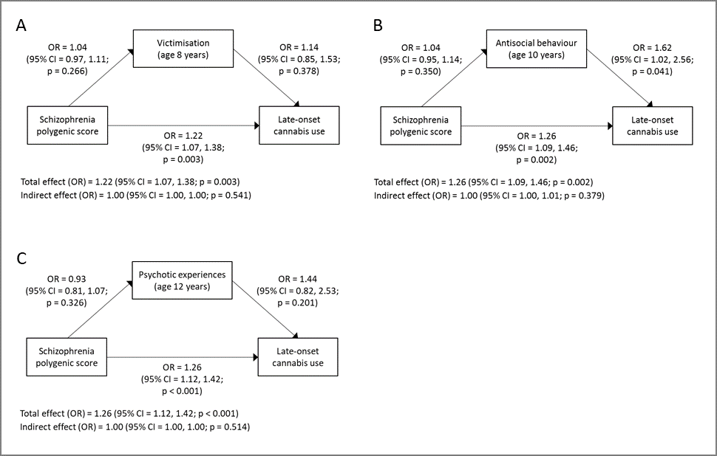

Supplementary Figure 3. Total effect, direct effect and indirect effects of schizophrenia polygenic score (*P*T = 0.05) on late-onset cannabis with/without cigarette use as compared to non-use through dichotomous measures of a) experiencing victimization, b) participating in antisocial behavior, and c) experiencing psychotic experiences.