Supplemental Materials for
Neural Connectivity Biotypes: Associations with Internalizing Problems throughout Adolescence

Rajpreet Chahal, PhD^{ab}, David G. Weissman, PhD^{c}, Michael N. Hallquist^{d}, PhD, Richard W. Robins, PhDe, Paul D. Hastings, PhD^{be}, & Amanda E. Guyer, PhD^{ab}

ªDepartment of Human Ecology, University of California, Davis, One Shields Avenue, Davis, CA 95618; ^{b}Center for Mind and Brain, University of California, Davis, 267 Cousteau Place, Davis, CA 95616; ^{c}Department of Psychology, Harvard University, Cambridge, MA 02138
^{d}Department of Psychology, Pennsylvania State University, 309 Moore Building, University Park, PA 16802; ^{e}Department of Psychology, University of California, Davis, One Shields Avenue, Davis, CA 95618

METHOD
fMRI Data Preprocessing
As described in previous work (Weissman et al., 2018, 2015), preprocessing was conducted using the FMRIB Software Library (FSL) (Smith et al., 2004) and Analysis of Functional NeuroImaging (AFNI) software (Cox, 1996). Preprocessing steps consisted of slice timing correction, rigid body motion correction with six degrees of freedom, and spatial smoothing with a 6 mm half-maximum Gaussian kernel. “Denoising” of the data was accomplished through independent component analysis using FSL’s MELODIC, with components rated as either signal or noise using criteria for visual inspection described by Kelly and colleagues (2010). The noise components were then filtered out of the functional data using voxelwise regression. Each participant’s functional data were then co-registered with their brain-extracted structural images and normalized to Montreal Neurological Institute (MNI) stereotaxic space using FSL’s two-stage registration method via FLIRT and FNIRT. Alignment was visually confirmed for all participants. AFNI was then used for de-spiking, band-pass filtering above 0.1 Hz. and below 0.01 Hz., and censoring of volumes with head motion greater than 0.3 mm from the previous volume.

Regions of Interest
Brain regions were selected to match those examined by Price and colleagues (2017), which were chosen based on meta-analytic coordinates exhibiting altered resting state connectivity in depression (Price et al 2017, Kaiser et al., 2015, Greicius et al., 2003). Similar to Price et al. (2017), we created 8mm radius spherical masks around peak coordinates of (1) cognitive control network (CCN) regions including dorsal anterior cingulate cortex (dACC), bilateral posterior parietal cortex (PPC), and left dorsolateral prefrontal cortex (dlPFC); (2) ventral affective network (VAN) nodes including bilateral nucleus accumbens (NA), bilateral anterior insula, bilateral ventrolateral PFC (VLPFC), bilateral amygdala, and the subgenual ACC (sgACC); and (3) default mode network (DMN) regions including posterior cingulate cortex (PCC) and perigenual ACC (pgACC). The peak coordinates in MNI space for each region are listed:
 | Region | X | Y | Z
1 | dACC | 0.07 | 16.5 | 30.8
2 | pgACC | 0.12 | 43.7 | 4.98
3 | sgACC | -0.05 | 22.6 | -9.23
4 | LvlPFC | -36.2 | 29.5 | -13.5
5 | RvlPFC | 40.9 | 31 | -13.3
6 | LdlPFC | -30 | 23.4 | -0.8
7 | LAmy | -23.5 | -2 | -18.5
8 | RAmy | 27.1 | -0.6 | -18.8
9 | PCC | -13 | -50 | 33
10 | LPPC | -42 | -52 | 48
11 | RPPC | 46 | -54 | 46
12 | LNACC | -11 | 9 | -11
13 | RNACC | 10 | 10 | -12
14 | LIns | -42 | 4 | -1
15 | RIns | 44 | 4 | 0

S-GIMME
In S-GIMME, a series of parameter fitting steps are run iteratively to arrive at a best-fitting path model of pairwise connections between regions per individual. Directed paths between regions are fitted based on how activity in one region statistically predicts activity in another (controlling for other regions and lagged auto-regressions) contemporaneously and after a one TR time-lagged interval to examine time-dependent influences among brain regions. The GIMME-created networks included both contemporaneous (instantaneous) and lagged (separated in time) relations between brain regions because the inclusion of different temporal interactions “ensures that all time-based information in dynamic data is reflected in the network” (Beltz and Gates, 2017). Additionally, research shows that the validity of connectivity maps are impacted by auto- and cross-correlations (time-lagged correlations of a signal with itself or other signals), producing “inaccurate parameter values and even spurious connections” (Beltz and Molenaar, 2015; Christova et al., 2011; Kaneoke et al., 2012; Arbabshirani et al., 2014). Therefore, we accounted for all possible sequential dependencies (contemporaneous and lagged correlations within and between brain regions) in estimating connectivity maps and included significant paths. Both types of paths are included in the vector autoregressive framework, however significant paths are based on individual tests of contemporaneous and lagged coefficients. Given this consideration of temporal dynamics, GIMME has been shown to “detect more true edges and fewer spurious edges than 38 other undirected and directed functional connectivity approaches, ranging from partial correlations and coherence analyses to Granger causality inferred from autoregressive models and a variety of Bayesian net methods (Smith et al., 2011)” (Beltz and Gates, 2017). It is worth noting that a path between regions is only included if the overall model fit to the individual is improved. Thus, not all pairs of regions share regression paths. At the level of the entire group, S-GIMME determines a map of lagged and contemporaneous connections based on similarities in connections among all individual maps. Then, the walktrap community detection algorithm (Pons & Latapy, 2006) is used on a similarity matrix of individual connection estimates to assess the presence of subgroups based on similarity in functional connectivity estimates. Walktrap has been shown to be robust against common issues of clustering (e.g., latent class approaches) and does not rely on a predefined number of subgroups, as is commonly used in other methods (Gates et al., 2017). Subgrouping occurs only when clusters of individuals show similarity within group (based on the direction, temporal pattern, and magnitude of connections between ROIs) and heterogeneity across groups. Individual-, subgroup-, and group-level functional connectivity maps are created for examining associations with external variables. Further details about S-GIMME are available in work by Gates, Molenaar, and colleagues (Gates & Molenaar, 2012; Gates et al., 2014).

TABLES AND FIGURES
Supplemental Figure 1. Raw and winsorized internalizing problems factor score distributions. Int = internalizing problems latent factor score. Age of assessment is indicted in parentheses.

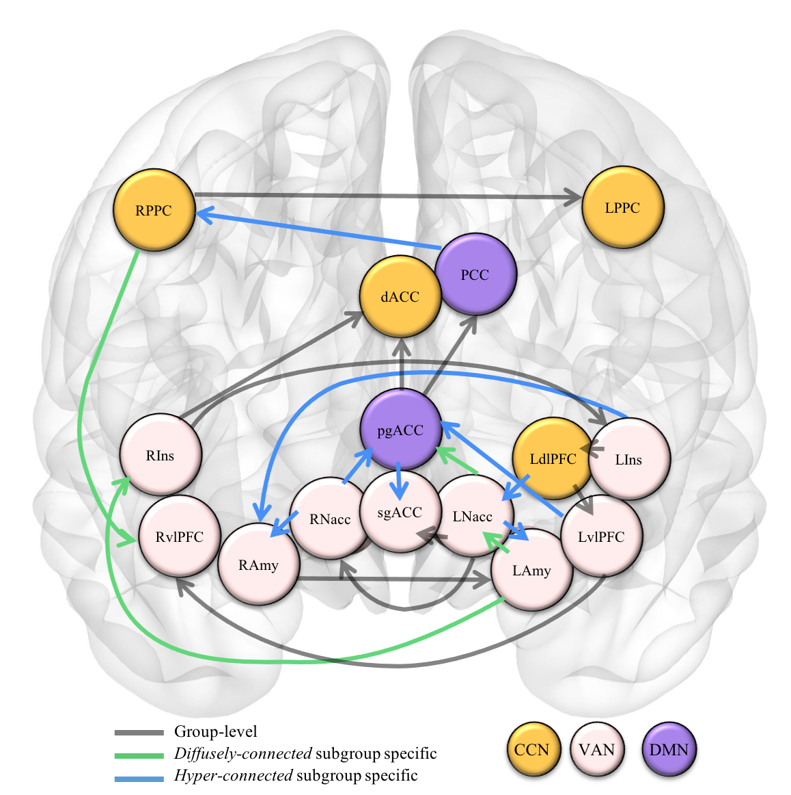
Supplemental Figure 2. Directed connectivity paths present in all participants (grey), unique to the Diffusely-connected biotype (green), and unique to the Hyper-connected biotype (blue). All paths are contemporaneous with positive beta-weights. Lagged autoregressive paths were found for every ROI as well. The LdlPFC->LvlPFC path was found to show increased connectivity in the Hyper-connected biotype (blue star). Nodes of the cognitive control network (CCN) are presented in gold; ventral affective network (VAN) in pink; default mode network (DMN) in purple. L=left; R=right; PPC=posterior parietal cortex; dlPFC= dorsolateral prefrontal cortex; vlPFC=ventrolateral PFC; PCC=posterior cingulate cortex; Ins=insula; Amy=amygdala; Nacc=nucleus accumbens; sgACC=subgenual anterior cingulate cortex (ACC); pgACC=perigenual ACC; dACC=dorsal ACC.
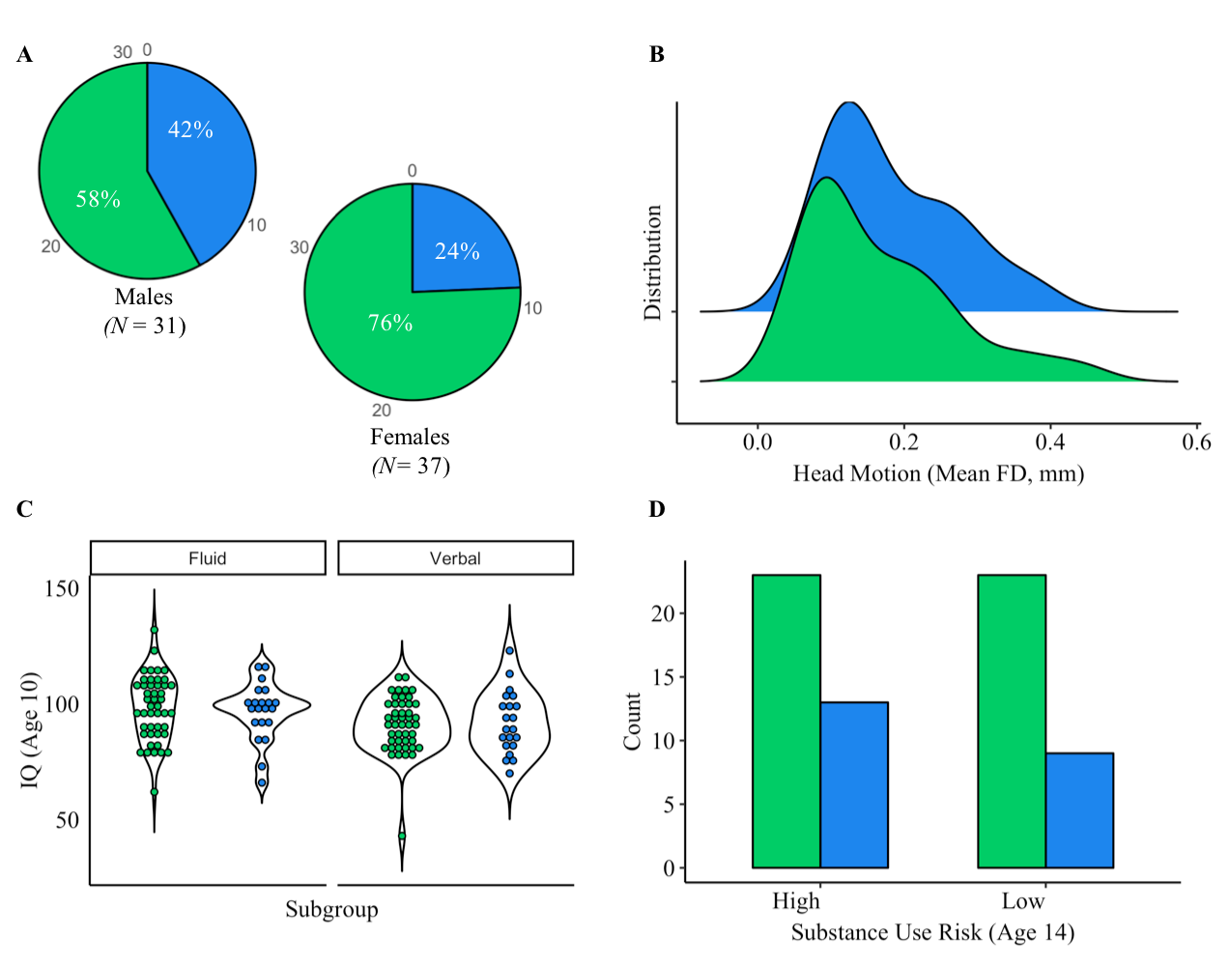
Supplemental Figure 3. Sample characteristics per connectivity-based biotype. Green indicates Diffuse-connected biotype and blue indicates Hyper-connected biotype. Biotypes did not differ on (B) head movement (mean framewise displacement in mm), (C) fluid and verbal IQ at age 10, or (D) substance use risk score at age 14.
Diffuse-connected
Hyper-connected
Supplemental Table 1. Biotype differences in network level connectivity paths
Pathway | Diffusely-connected |  | Hyper-connected
 | M | SD | M | SD | W | p | FDR p
DMN -> VAN | .41 | .65 | 1.45 | .76 | 163 | .00* | 0.00*
DMN -> CCN | .41 | .75 | 1.95 | .22 | 76 | .00* | 0.00*
VAN -> VAN | 3.72 | 1.29 | 4.05 | 1.82 | 375.5 | .23 | 0.22
VAN -> DMN | 2.26 | 1.99 | 3.45 | .95 | 183.5 | .00* | 0.00*
CCN -> VAN | 1.85 | .87 | 2.15 | .81 | 381 | .22 | 0.22

Note: Connectivity-based biotype differences in significant pathways (excluding auto-regressive paths, including lagged paths). Unpaired two-samples Mann-Whitney U tests were used as data were shown to be non-normally distributed. False Discovery Rate (FDR) corrected p values are included where significant. Cognitive control network (CCN) nodes: dACC, LdlPFC, LPPC, RPPC; Default mode network (DMN) nodes: pgACC, PCC; Ventral affective network (VAN) nodes: LAmy, RAmy, LNacc, RNacc, LIns, RIns, LvlPFC, RvlPFC, sgACC.

Supplemental Figure 4. Apparent sex differences in connectivity-based biotype associations with internalizing problems at ages 16 and 18. (A) Though the interaction of gender and biotype was not significant, females in the Hyper-connected biotype exhibited greater differences in internalizing problems at age 16 relative to the Diffusely-connected biotype, while males exhibited little biotype-related differences in internalizing problems. (B) Females in the Hyper-connected biotype exhibited larger increases in internalizing problems from age 16 to 18 relative to the Diffusely-connected biotype, while males exhibited less biotype-related changes.

B
A
Diffusely-connected
Hyper-connected
Supplemental Figure 5. Connectivity-based biotype associations with internalizing problems trajectories. (A) The Hyper-connected biotype exhibited a higher internalizing problems intercept (derived from longitudinal model estimates) compared to the Diffusely-connected biotype. (B) The Hyper-connected biotype exhibited an average decrease (i.e., negative slope) in internalizing problems across time that significantly differed from the Diffusely-connected biotype. This decrease in internalizing problems over time in the Hyper-connected group may be due the initially high internalizing scores that lessened, yet remained higher than the Diffusely-connected biotype.
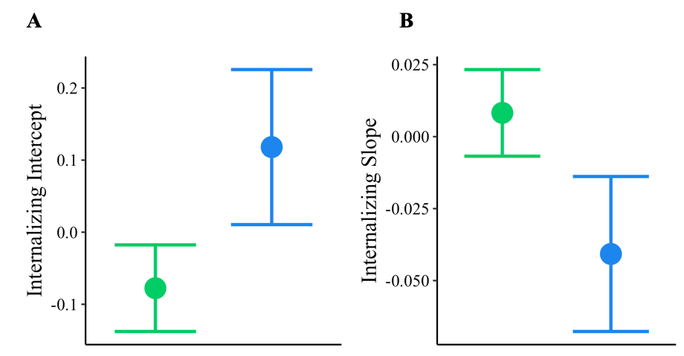
Diffusely-connected
Hyper-connected

Supplemental Table 2. Associations between network level paths and internalizing problems in adolescence

Effects | Int (14)  F | p | Int (16)  F | p | Int (18)  F | p
DMN->VAN | 2.777 | .101 | 1.263 | .266 | 4.172 | .046*
DMN->VAN x Gender | 2.863 | .096 | 5.022 | .029* | 1.757 | .190
DMN->CCN | 7.749 | .007* | 6.186 | .015* | 8.199 | .005*
DMN->CCN x Gender | 1.375 | .245 | 1.345 | .251 | 6.587 | .013*
VAN->DMN | 0.106 | .745 | 0.113 | .737 | 2.049 | .157
VAN->DMN x Gender | 0.005 | .943 | 0.356 | .547 | 8.306 | .005*
Gender | 5.605 | .021* | 6.754 | .011* | 4.033 | .049*

Note: * indicates p < .05. Int (Age) = internalizing problems factor score. F = F value. One MANOVA model was used to test network path associations with internalizing problems (age 14-18; 3 outcome measures), which included main effects of 3 significant network types and interaction with gender. Covariate of motion (mean framewise displacement) was included. Cognitive control network (CCN) nodes: dACC, LdlPFC, LPPC, RPPC; Default mode network (DMN) nodes: pgACC, PCC; Ventral affective network (VAN) nodes: LAmy, RAmy, LNacc, RNacc, LIns, RIns, LvlPFC, RvlPFC, sgACC.

