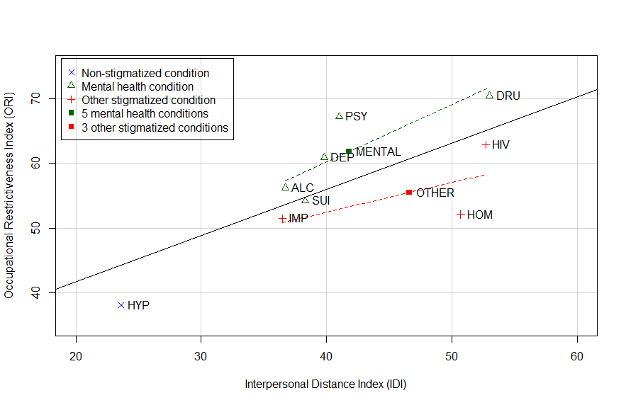
Figure S1. Correlation of the Interpersonal Distance Index (IDI) and the Occupational Restrictiveness Index (ORI)ª for 9 target conditions among 2424 community-based respondents in Ningxia, China.

ª Indices generated using data from Interpersonal Distance Scale and the Occupational Restrictiveness scale (described in the methods section).
The solid black line and the dashed green and red lines are the regression lines for all 9 conditions, for the 5 mental health conditions and for the 3 other stigmatized conditions, respectively
ALC, prior alcohol abuse HIV, current HIV carrier HYP, current hypertension
DEP, prior serious depression HOM, homosexuality
DRU, prior drug abuse IMP, prior imprisonment
PSY, prior psychiatric hospitalization OTHER, summary of 3 other stigmatized conditions
SUI, prior suicide attempt
MENTAL, summary of 5 mental health conditions

