SUPPLEMENTARY MATERIALS

S1. PREDICTING COGNITIVE EVOLUTION WITH CANTAB SCORES AT BASELINE
Generalized linear models were used in order to assess the utility of the CANTAB tests included in the present paper for predicting the cognitive evolution of the participants. In this regard, classification at the second follow-up stage was included as the response variable in the regression models. Given that it is a multiclass classification problem (i. e., with categories SCC-Stable, MCI-Stable, and MCI-Worsened group), multinomial logistic models were employed. In all models, either simple or multiple, coefficients’ estimates were reported as odds ratios (OR). Area under the curve (AUC) was used as a performance indicator of the generalized models. AUC greater than 0.7 would indicate a good performance, whereas values greater than 0.8 would indicate a very good predictive capacity.

A. PAIRED ASSOCIATES LEARNING (PAL). PAL total errors adjusted 6 shapes
Table S1.1. Summary of multinomial logistic model predicting cognitive evolution by means of PAL total errors adjusted 6 shapes at baseline after controlling for age. Coefficients are reported as relative risks ratios. The category of reference was SCC-Stable. AUC for this model was 0.78.
Dependent variable | MCI-Worsened | MCI-Stable
 | (1) | (2)
Age at Baseline | 2.489 | 1.364
 | (0.375) | (0.267)
PAL total errors adjusted 6 shapes | 1.035*** | 1.028***
 | (0.007) | (0.006)
Intercept | 0.016 | 0.059
 | (0.591) | (0.380)
Akaike Inf. Crit. | 237.549 | 237.549
Note: ***p< 0.01

B. PATTERN RECOGNITION MEMORY (PRM)
Table S1.2. Summary of multinomial logistic model predicting cognitive evolution by means of PRM scores at baseline after controlling for age. Coefficients are reported as relative risks ratios. The category of reference was SCC-Stable. AUC for this model was 0.79.
Dependent Variable | MCI-Worsened | MCI-Stable
 | (1) | (2)
Age at Baseline | 2.224*** | 1.411***
 | (0.358) | (0.260)
PRM Percentage Correct at Baseline | 0.874*** | 0.898***
 | (0.027) | (0.022)
Intercept | 3,967.146*** | 1,116.616***
 | (2.071) | (1.764)
Akaike Inf. Crit. | 234.454 | 234.454
Note: ***p< 0.01

C. DELAYED MATCHING TO SAMPLE (DMS)
Table S1.3. Summary of multinomial logistic model predicting cognitive evolution by means of DMS scores at baseline after controlling for age. Coefficients are reported as relative risks ratios. The category of reference was SCC-Stable. AUC for this model was 0.71.
Dependent variable: | MCI-Worsened | MCI-Stable
 | (1) | (2)
Age at Baseline | 3.210*** | 1.750***
 | (0.353) | (0.262)
DMS Percentage Correct at Baseline | 0.918*** | 0.939***
 | (0.028) | (0.023)
Intercept | 65.139*** | 25.626***
 | (2.056) | (1.773)
Akaike Inf. Crit. | 264.082 | 264.082
Note: ***p< 0.01

D. SPATIAL SPAN (SSP)
Table S1.4. Summary of multinomial logistic model predicting cognitive evolution by means of SSP scores at baseline after controlling for age. Coefficients are reported as relative risks ratios. The category of reference was SCC-Stable. AUC for this model was 0.71.
Dependent variable: | MCI-Worsened | MCI-Stable
 | (1) | (2)
Age at Baseline | 3.838** | 2.196***
 | (0.396) | (0.239)
Spatial Span at Baseline | 0.116*** | 0.749***
 | (0.428) | (0.253)
Intercept | 912.406*** | 0.804***
 | (1.705) | (1.236)
Akaike Inf. Crit. | 241.133 | 241.133
Note: **p< 0.05; ***p< 0.01

E. ALL CANTAB SCORES
Table S1.5. Summary of multinomial logistic model predicting cognitive evolution by means of all CANTAB tests scores at baseline after controlling for age. Coefficients are reported as relative risks ratios. The category of reference was SCC-Stable. AUC for this model was 0.86.
Dependent variable | MCI-Worsened | MCI-Stable
 | (1) | (2)
Age at Baseline | 1.776*** | 1.006***
 | (0.465) | (0.309)
PAL Total Errors at Baseline | 1.021*** | 1.021***
 | (0.009) | (0.007)
PRM Percentage Correct at Baseline | 0.915*** | 0.918***
 | (0.032) | (0.025)
DMS Percentage Correct at Baseline | 0.982*** | 0.951***
 | (0.036) | (0.028)
Spatial Span at Baseline | 0.183** | 1.301***
 | (0.497) | (0.313)
Intercept | 206,857.900*** | 925.270***
 | (3.794) | (2.839)
Akaike Inf. Crit. | 200.258 | 200.258
Note: **p< 0.05; ***p< 0.01

Figure S1.1. Effects plots for multinomial logistic model including PAL scores as the predictor of cognitive evolution at the last follow-up stage.
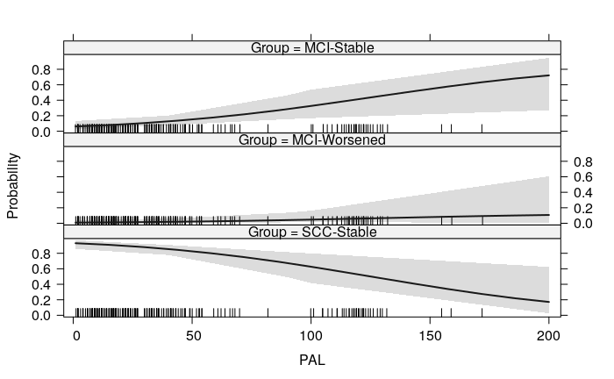

Figure S1.2. Effects plots for multinomial logistic model including PRM scores as the predictor of cognitive evolution at the last follow-up stage.
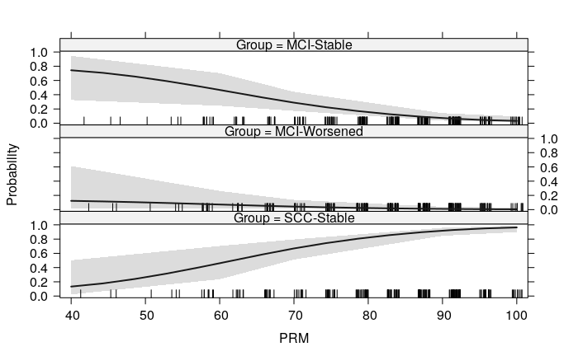

Figure S1.3. Effects plots for multinomial logistic model including DMS scores as the predictor of cognitive evolution at the last follow-up stage.
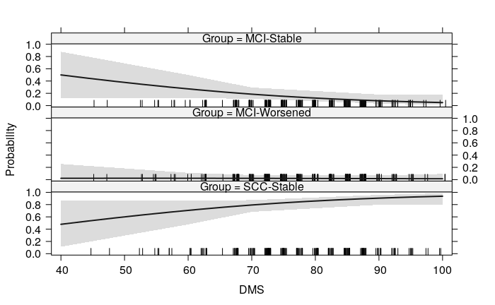

Figure S1.4. Effects plots for multinomial logistic model including SSP scores as the predictor of cognitive evolution at the last follow-up stage.
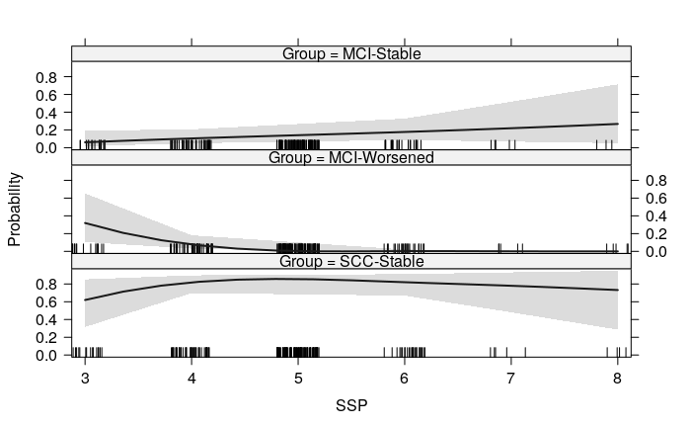
S2. TRAJECTORIES IN COGNITIVE INDICATORS IN THE STUDIED GROUPS

A. MINIMENTAL STATE EXAMINATION (MMSE)
Table S2.1. Summary of model comparison for MMSE scores. All models include random effects for intercepts and age at baseline as covariate. Model 1 is the null mixed model (i. e., random intercepts and age covariate only); Model 2 is the mixed model with main effects; and Model 3 is the mixed model with main effects and interactions. Coefficients and standard errors (in parentheses).
 | Dependent variable: MMSE
 | Model 1 | Model 2 | Model 3
Age at baseline | -0.674***  (0.108) | -0.416***  (0.011) | -0.413***  (0.103)
Evaluation Time |  | -0.167**  (0.069) | -0.111  (0.071)
MCI-Worsened |  | -5.148***  (0.437) | -2.188***  (0.764)
MCI-Stable |  | -3.254***  (0.339) | -2.452***  (0.709)
Evaluation Time x MCI-Worsened |  |  | -1.777***  (0.395)
Evaluation Time x MCI-Stable |  |  | -0.410  (0.316)
Intercept | 27.759***  (0.105) | 28.452***  (0.173) | 28.340***  (0.178)
Observations | 587 | 587 | 587
Log Likelihood | -1,223.150 | -1,152.311 | -1,143.838
Akaike Inf. Crit. | 2,458.300 | 2,322.621 | 2,309.676
Bayesian Inf. Crit. | 2,484.530 | 2,361.919 | 2,357.669
Note: **p< 0.05; ***p< 0.01

Figure S2.1. Estimated means according to the fittest model for MMSE scores in the three times of the study.
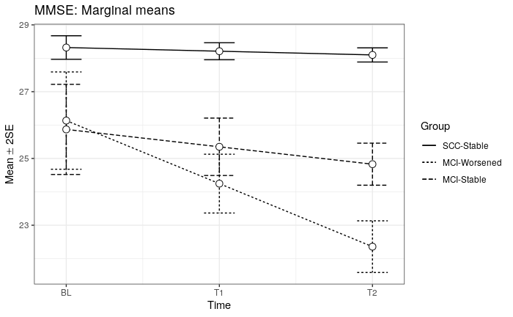

Pairwise comparisons
Table S2.2. Summary of pairwise comparisons between groups along the three times of the study for MMSE scores. FWER corrections based on Tukey’s procedure were carried out to estimate statistical significance in multiple comparisons.
Contrast | Time | Estimate | SE | df | t | p-value
SCC-Stable - MCI-Worsened | BL | 2.19 | 0.76 | 204 | 2.87 | 0.013
SCC-Stable - MCI-Stable | BL | 2.45 | 0.71 | 204 | 3.46 | 0.002
MCI-Worsened - MCI-Stable | BL | 0.26 | 1.00 | 204 | 0.26 | 0.962
SCC-Stable - MCI-Worsened | T1 | 3.97 | 0.47 | 204 | 8.43 | <0.001
SCC-Stable - MCI-Stable | T1 | 2.86 | 0.46 | 204 | 6.25 | <0.001
MCI-Worsened - MCI-Stable | T1 | -1.10 | 0.62 | 204 | -1.79 | 0.176
SCC-Stable - MCI-Worsened | T2 | 5.74 | 0.41 | 204 | 13.89 | <0.001
SCC-Stable - MCI-Stable | T2 | 3.27 | 0.34 | 204 | 9.60 | <0.001
MCI-Worsened - MCI-Stable | T2 | -2.47 | 0.50 | 204 | -4.97 | <0.001

B. CAMBRIDGE COGNITIVE EXAMINATION (CAMCOG-R)

Table S2.3. Summary of model comparison for CAMCOG-R scores. All models include random effects for intercepts and age at baseline as covariate. Model 1 is the null mixed model (i. e., random intercepts and age covariate only); Model 2 is the mixed model with main effects; and Model 3 is the mixed model with main effects and interactions. Coefficients and standard errors (in parentheses) .
 | Dependent variable: CAMCOG-R
 | Model 1 | Model 2 | Model 3
Age at baseline | -5.789***  (0.577) | -3.466***  (0.490) | -3.456***  (0.501)
Evaluation Time |  | 0.724***  (0.196) | 0.946***  (0.204)
MCI-Worsened |  | -17.759***  (1.751) | -11.410***  (2.677)
MCI-Stable |  | -11.878***  (1.361) | -6.995***  (1.998)
Evaluation Time x MCI-Worsened |  |  | -3.926***  (1.280)
Evaluation Time x MCI-Stable |  |  | -2.508***  (0.741)
Intercept | 87.001***  (0.570) | 88.740***  (0.649) | 88.297***  (0.671)
Observations | 587 | 587 | 587
Log Likelihood | -1,923.838 | -1,855.360 | -1,844.848
Akaike Inf. Crit. | 3,859.677 | 3,728.720 | 3,711.696
Bayesian Inf. Crit. | 3,885.906 | 3,768.018 | 3,759.690
Note: ***p< 0.01

Figure S2.2. Estimated means according to the fittest model for CAMCOG-R scores in the three times of the study.
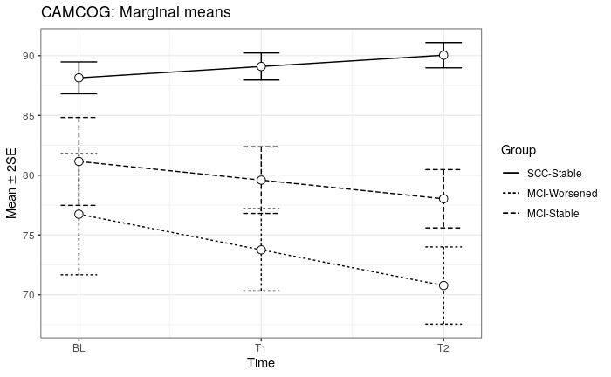

Table S2.4. Summary of pairwise comparisons between groups along the three times of the study for CAMCOG-R scores. FWER corrections based on Tukey’s procedure were carried out to estimate statistical significance in multiple comparisons.
Contrast | Time | Estimate | SE | df | t | p-value
SCC-Stable - MCI-Worsened | BL | 11.41 | 2.68 | 204 | 4.26 | <0.001
SCC-Stable - MCI-Stable | BL | 6.99 | 2.00 | 204 | 3.50 | 0.002
MCI-Worsened - MCI-Stable | BL | -4.42 | 3.14 | 204 | -1.41 | 0.340
SCC-Stable - MCI-Worsened | T1 | 15.34 | 1.87 | 204 | 8.21 | <0.001
SCC-Stable - MCI-Stable | T1 | 9.50 | 1.54 | 204 | 6.15 | <0.001
MCI-Worsened - MCI-Stable | T1 | -5.83 | 2.20 | 204 | -2.65 | 0.023
SCC-Stable - MCI-Worsened | T2 | 19.26 | 1.76 | 204 | 10.96 | <0.001
SCC-Stable - MCI-Stable | T2 | 12.01 | 1.37 | 204 | 8.76 | <0.001
MCI-Worsened - MCI-Stable | T2 | -7.25 | 2.00 | 204 | -3.62 | 0.001

