Online supplement
Recruitment and determination of eligibility
The cutoff score of > 56 points was calculated using the formula for uneven distributions between normal and clinical populations as stipulated by (Jacobson & Truax, 1991). Norm data from normal and clinical populations for worry was based on two previous studies (Brown et al., 1992; Gillis et al., 1995).
The applicants were asked if they had received any previous psychiatric diagnoses in the online screening battery and also during the telephone interview.

Interventions
General description of the two active treatments
Participants were notified by an automated SMS when they had a new message in the treatment platform from their therapist. Participants could log in any time of the day and all questions and homework assignments were answered within 36 hours on weekdays. The main role of the therapist was to provide feedback on homework exercises, answer questions, and coach the participant to proceed with the treatment. Participants who had been inactive for four or more days were contacted by their therapist via telephone or SMS. The therapists in this trial were ten clinical psychology students who had completed their clinical training. The students attended a five year programme with four full time semesters of clinical psychology which included advanced training in behaviour analysis on fictive patient cases, two semesters of weekly supervision with clients and 13 weeks of internship. The therapists were closely supervised and monitored daily by the principal investigator with weekly meetings throughout the trial and also on-demand supervision within 12 hours.

Internet-based Extinction Therapy (IbET)
The theoretical approach of IbET is mainly based on research findings indicating that worriers are mostly unsuccessful in reassuring themselves despite their use of various information-seeking strategies (e.g. Davey et al., 1992) as well as studies showing that operant safety behaviors play a key role in reinforcing catastrophic thoughts and threat perception (Deacon & Maack, 2008; Gangemi et al., 2012; Olatunji et al., 2011; Radomsky & Alcolado, 2010). For the patient, the IbET treatment presents worry as a covert behavior chain where the worrier ineffectively tries to alleviate catastrophic thoughts with an excessive use of comforting thoughts. The catastrophic thinking is instead reinforced because it enables relief by using comforting thoughts (following the (Premack, 1959) principle of second order reinforcement). This “tennis game”, i.e. constantly jumping back and forth between catastrophic- and comforting thoughts, accelerates gradually and the individual may experience the worry as uncontrollable (Andersson et al., 2017).
In order to stop worrying, the patient needs to stop using comforting thoughts by using three different extinction techniques: (1) mindfulness-stance to catastrophic thoughts, i.e., describing the catastrophic thoughts in a non-evaluating style, (2) thinking the worst thought, i.e., responding to the catastrophic thoughts with even worse thoughts, and (3) acceptance of uncertainty, i.e., responding to catastrophic thoughts with the fatalistic stance that the feared outcome may very well happen and is essentially not under the patient’s control. All these operant extinction techniques have the joint goal of decreasing thought suppression (i.e. extinguishing comforting thoughts), which is hypothesized to mediate reduction of worry.
The main outline in the treatment is the following: Module 1-2 contains psychoeducation about worry. Modules 3-5 introduce the three different operant extinction techniques. Modules 6-7 provides case examples, common obstacles and how to solve them. After module 5, the patient is encouraged to continue practicing the technique(s) that he/she thinks is the most effective in extinguishing the catastrophic thoughts. Module 8 includes a relapse prevention program. More detailed information is shown in eTable 1 below and is also available in Andersson et al. (2017).

Active comparator (CTRL)
Similar to the IbET treatment, modules 1-2 contains psychoeducation about worry and the main rationale of the treatment model is introduced. Modules 3-5 consist of progressive muscle relaxation techniques followed by release-only relaxation that the patient practises on a daily basis. In modules 5-8 the patient practise conditioning a relaxed state to a verbal and visual cue, and also applying rapid relaxation in distressing situations. Different types of stress-management strategies including activity scheduling, structured problem-solving, and increasing recuperating activities, are also consecutively introduced to the patient in chapter 5-8. As in the IbET treatment, the last module consists of a relapse prevention program.

Waiting-list
None of the data collected from the waiting-list participants were used after primary endpoint (10 weeks).

eTable 1: IbET treatment content

Module | Content
1 | Introduction to the IbET treatment. The patient is provided with examples on different types of worry. A basic overview of excessive worry is provided with a rationale of catastrophic- and comforting thoughts. The homework consists of a quiz about worry and its evolutionary function. The patient is also instructed to conduct daily worry diary registrations in the online treatment platform.
2 | The patient is provided with detailed information about the operant model of worry where comforting thoughts mimic a “tennis game” which can lead to temporarily relief which in turn becomes a reinforced process (catastrophic thought → comforting thought → temporary relief/ catastrophic thought → etc.). Thus, the worry is maintained through the use of comforting thoughts (Premack’s principle). The homework in module 2 is quiz about the operant model of worry. The patient is instructed to fill out his/her own ”tennis game” and to continue to register worrisome thoughts in the online registration worksheet.
3 | The patient is provided a rationale for extinction i.e., in order to stop worry, the patient needs to perform a competing response that blocks the temporary relief coming from the comforting thought. This competing response will eventually extinguish the catastrophic thoughts, consequently decreasing the amount of worry. The first extinction technique that is taught is a mindfulness where the rationale is to systematically describe the catastrophic thoughts. By describing the catastrophic thoughts, the use of comforting thoughts are blocked as they are incompatible behaviors to think comforting thoughts. The homework is to do mindfulness exercises during worry episodes on a daily basis. and use this technique for any worry episode during the day. The patient also answers a quiz about extinction and competing responses.
4 | The second extinction technique is “think the worst thought”. The rationale for this intervention is that when the patient has a catastrophic thought, he/she can block the temporary relief from a comforting thought by using an even worse thought (e.g. catastrophic thought “I might stutter during my presentation” should be countered with “Yes, I will probably also faint and puke during the presentation as well”). By doing this, the catastrophic thoughts does not receive any reinforcing contingencies. The homework in this module is to practice this extinction technique for one week.
5 | The third and last extinction technique is “Fatalism”, which is a technique aiming to counter catastrophic thoughts with full acceptance that the catastrophic thoughts may become true and that the patients just needs to take their chance and hope that it does not come true. This aim of this technique is to extinguish catastrophic thoughts by not providing them with any reinforcing contingencies (i.e. blocking the temporary relief from the comforting thoughts). Similar to the previous techniques, homework in this module is to practice this extinction technique for one week.
6 | Modul 6 repeats the IbET rationale and extinction techniques. Case examples are given on how to handle different kind of problems during treatment. After completing this module, the patient can use any of the extinction techniques that he/she had worked during treatment and to report progression to the therapist.
7 | Modul 7 consists of different case examples and how to expand the extinction exercises further to different worry topics. Common difficulties during treatment are highlighted and how to solve them. The homework is the same as in module 6.
8 | The last module consists of a relapse prevention program. The patient makes a plan for relapse prevention and to continue the exercises.

Assessment points and outcomes
eTable 2: List of measures and assessment points

Timeline  Measure | Baseline | During treatment | Post-treatment | 4FUP | 12FUP
PSWQ | X | Weekly | X | X | X
TC |  | Week 3 (not the WL) | X
WAI |  | Week 5 (not the WL) | X
CAQ | X |  | X | X | X
MADRS-S | X |  | X | X | X
IUS | X |  | X | X | X
BBQ | X |  | X | X | X
AE |  | Week 3 and 8 | X | X | X
TIC-P | X |  | X | X | X
EQ-5D | X |  | X | X | X
CAQ-TS | X | Weekly | X
MAIA-SR | X | Weekly | X
PHQ2 | X | Weekly | X

WL=Waiting-list. PSWQ=Penn State Worry Questionnaire. CAQ=Cognitive Avoidance Questionnaire. MADRS-S=Montgomery Asberg Depression Rating Scale – Self report. IUS=Intolerance of Uncertainty Scale. BBQ=Brunnsviken Brief Quality of life Questionnaire. AE=Adverse Events. TIC-P = Trimbos/iMTA Questionnaire for Costs associated with Psychiatric illness. EQ-5D = Euroqol. 4FUP=4-month follow-up. 12FUP=12-month follow-up. CAQ-TS=Cognitive Avoidance Questionnaire Thought Supression subscale. MAIA-SR=Multidimensional Assessment of Interoceptive Awareness Self-Regulation subscale. PHQ2=Patient Health Questionnaire-2

All costs were estimated using the national tariffs in Sweden and then exchanged to Euros (€). We used the human capital approach which means that costs related to work loss were estimated based on the average gross earnings in Sweden. Domestic loss hourly tariff was based on Smit et al. (2006). We used the visit tariff of a clinical psychologist and multiplied this figure by the total time the therapist spent on each participant.

Statistical analyses
We also exploratory investigated the number of participants who had minimal symptoms defined as a score below 45 on the PSWQ (Behar et al., 2003). Cohen’s d between-group effect sizes were calculated using the the m_effectsize command in Stata, developed by Matteo Bottai and available at www.imm.ki.se/biostatistics/stata.
In the health-economical analyses, we first estimated the incremental cost-effectiveness ratio (ICER). ICER is a measure of the incremental cost of achieving one additional case of improvement in the experimental treatment (IbET) against CTRL or WL. The ICER analysis answers the question ”What is the net cost of one additional responder when offering IbET instead of active comparator or no treatment”. The ICER was estimated according to the following formula: (Δ^{C1} – Δ^{C2})/(Δ^{E1} – Δ^{E2}), where Δ^{C1} – Δ^{C2} is the difference in cost change (from pre- to post-treatment) between the two conditions and Δ^{E1} – Δ^{E2} is the difference in clinical outcome (Drummond et al., 2005). This was subsequently bootstrapped in cost-effectiveness planes, providing a probabilistic measure of the cost-effectiveness. We also estimated the cost-effectiveness depending on different societal willingness-to-pay values for one unit of improvement (Drummond et al., 2005). The net benefit of each individual in this trial was calculated according to the following formula: (λ x E) – Δ^{C} where λ is the willingness to pay (i.e. the different values that the society is willing to pay for one additional responder or QALY). We calculated individual net benefits by for different values for λ using bootstrapping which was plotted in cost-effectiveness acceptability curves (eFigures 4 & 5).
The statistical analyses of outcomes were done in STATA 15.1 (StataCorp). The mediation analyses were conducted in R 3.4. In the cost-effectiveness analysis, costs change from baseline to post-treatment were interpolated in the regression model, i.e., we assumed a linear change in costs from baseline to post-treatment. The cost-effectiveness analyses were conducted in R 3.4.

Results

There were three cases of personality disorders (emotionally unstable personality disorder in all three cases) who applied for the study but these individuals were concurrently excluded due to the depression exclusion criteria of moderate-to-severe depression earlier in the pre-selection screening phase. Three of the included participants had previously been diagnosed with ADD/ADHD and three participants had received an Autism diagnosis.

Twenty nine (22%) participants in the IbET group had a PSWQ score below 45. The corresponding figure was 18 (13%) in the CTRL group and one case in the WL group (3%). When using the reliable change index, 68% in the IbET group were classified as treatment responders compared to 53% in the CTRL group (RR=1.3, 95% CI 1.06-1.57, p<.05) and 17% in WL condition.

eTable 3: Module completion

 | Module 1 | Module 2 | Module 3 | Module 4 | Module 5 | Module 6 | Module 7 | Module 8
IbET | 3.6% | 2.1% | 8.6% | 6.4% | 10.0% | 16.4% | 19.3% | 30.7%
CTRL | 1.4% | 6.5% | 2.9% | 10.1% | 8.6% | 16.6% | 23.0% | 29.5%

IbET=Internet-based extinction therapy. CTRL=Control condition (active comparator).

eTable 4: Between-group interaction effects
 | β | Z | p | Cohen´s d (95% CI)
IbET vs. WL
PSWQ | 1.25 | 11.28 | <.001 | 1.34 (1.00-1.66)
CAQ | 12.00 | 3.26 | .001 | 0.61 (0.33-0.90)
MADRS-S | 4.85 | 4.42 | <.001 | 0.75 (0.42-1.08)
IUS | 13.06 | 3.97 | <.001 | 0.62 (0.31-0.92)
BBQ | 7.25 | 2.30 | .022 | 0.36 (0.06-0.65)
CTRL vs. WL
PSWQ | .89 | 9.12 | <.001 | 0.98 (0.68-1.28)
CAQ | 6.41 | 2.23 | .026 | 0.32 (0.06-0.58)
MADRS-S | 3.77 | 3.39 | .001 | 0.56 (0.24-0.88)
IUS | 8.26 | 2.50 | .012 | 0.39 (0.08-0.71)
BBQ | 5.20 | 1.59 | .112 | 0.24 (-0.04-0.52)
IbET vs. CTRL
PSWQ | .36 | 5.67 | <.001 | 0.38 (0.09-0.67)
CAQ | 5.73 | 2.76 | .006 | 0.29 (0.08-0.49)
MADRS-S | 1.08 | 1.59 | .113 | 0.16 (-0.04-0.37)
IUS | 4.80 | 2.40 | .016 | 0.23 (0.04-0.42)
BBQ | 2.05 | 1.02 | .306 | 0.10 (-0.08-0.28)

IbET=Internet-based Extinction Therapy. CTRL=Control condition (active comparator). WL=Waiting-list. PSWQ=Penn State Worry Questionnaire. CAQ=Cognitive Avoidance Questionnaire. MADRS-S=Montgomery Asberg Depression Rating Scale – Self report. IUS=Intolerance of Uncertainty Scale. BBQ=Brunnsviken Brief Quality of life Questionnaire.

Per protocol analyses

Per protocol analyses showed a significant between-group interaction effect on the PSWQ (p<.001) and IUS (p=.03) but not on any other secondary measure.

eFigure 1: Weekly ratings (participants completing all treatment modules)

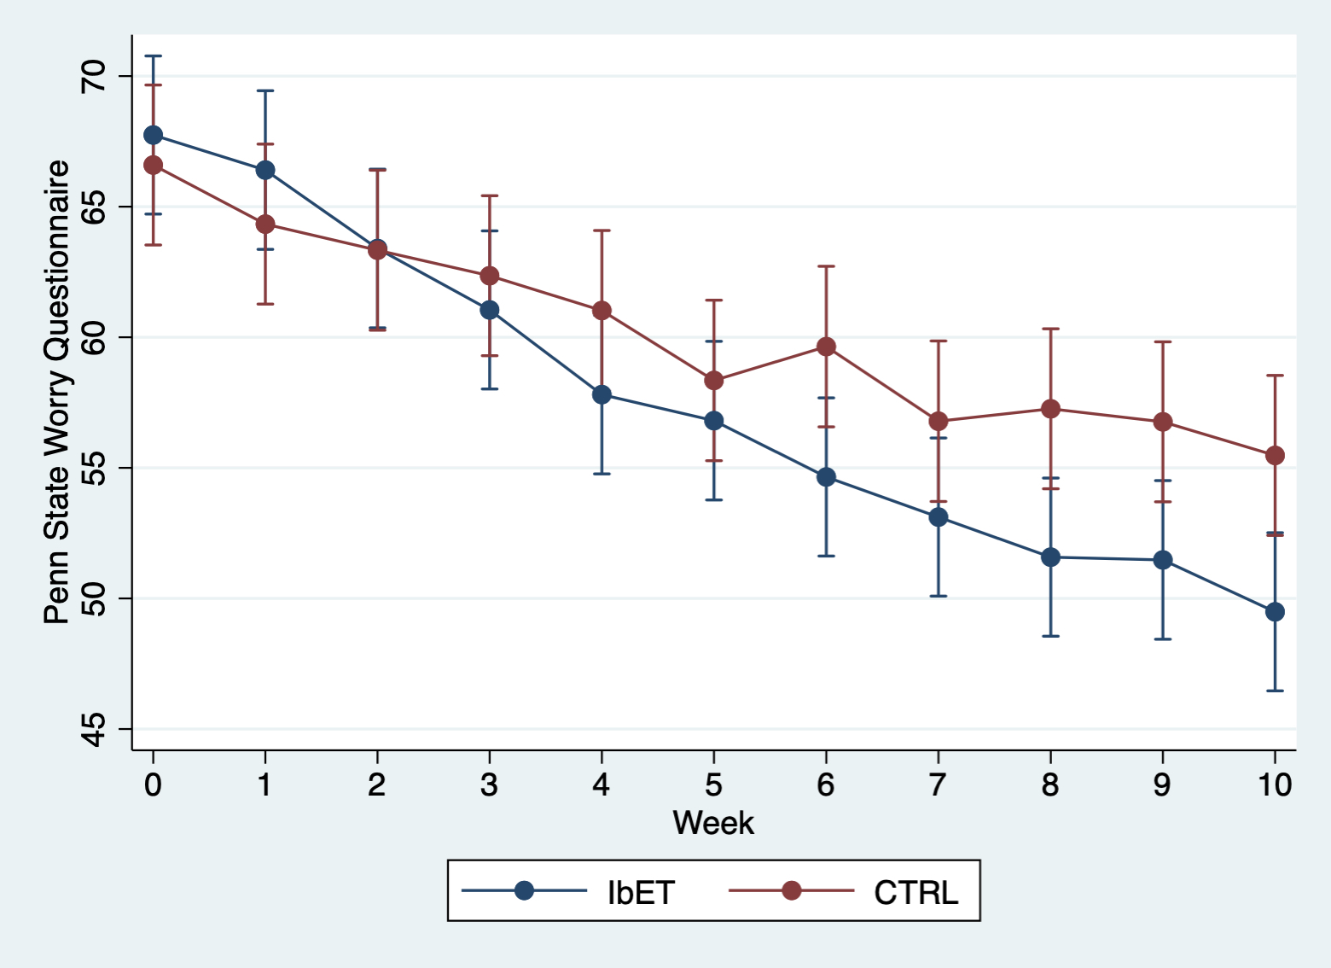

IbET=Internet-based Extinction Therapy. CTRL=Control condition (active comparator).

eFigure 2: Sub-group analyses on participants fulfilling diagnostic criteria for a psychiatric disorder

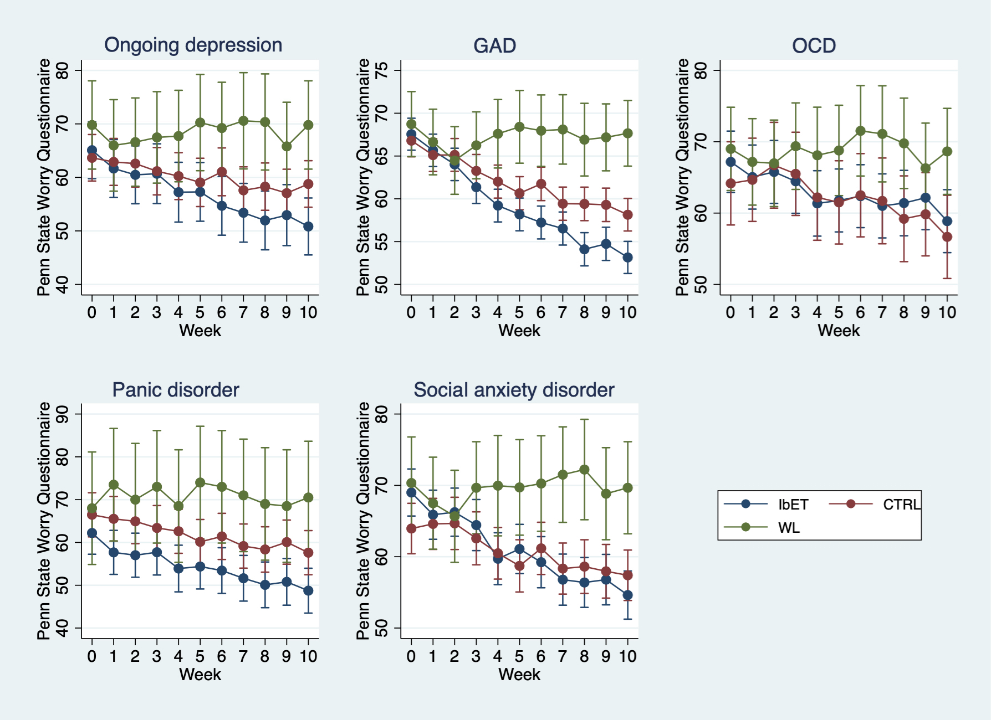

IbET=Internet-based Extinction Therapy. CTRL=Control condition (active comparator). WL=Waiting list.

eFigure 3: Sub-group analyses on number of psychiatric diagnoses as moderator variable

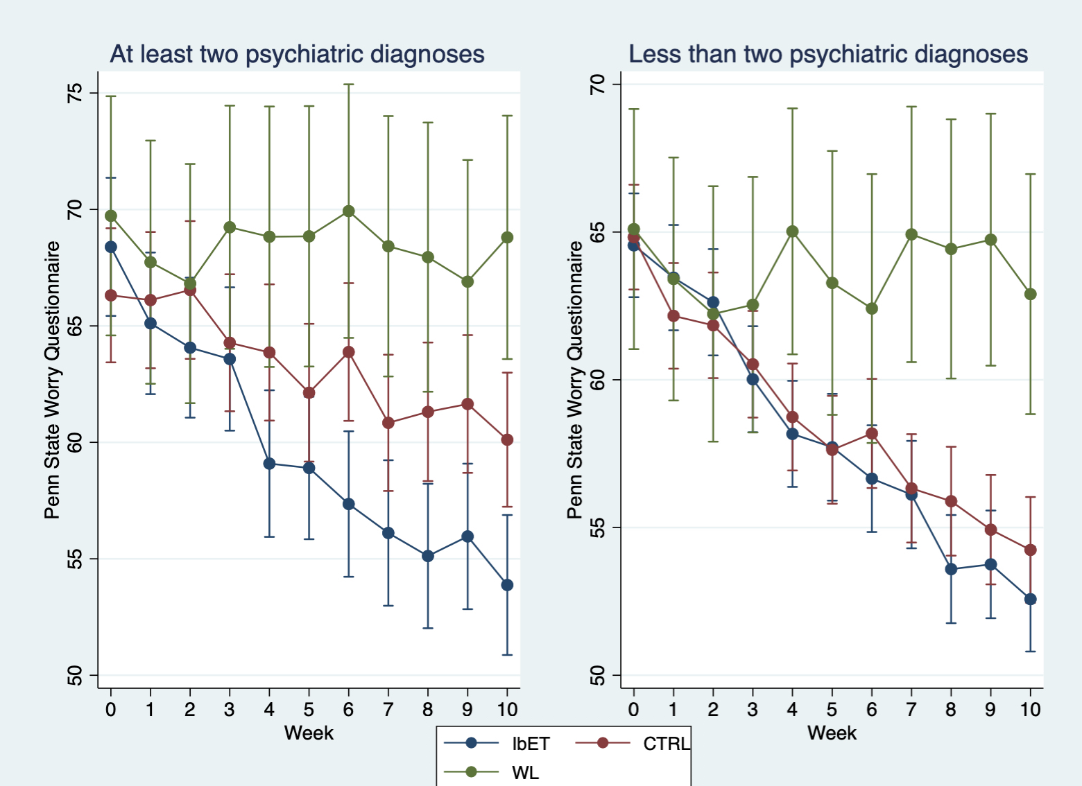

IbET=Internet-based Extinction Therapy. CTRL=Control condition (active comparator). WL=Waiting list.

eTable 5: Means and standard deviation of non-specific factors

 | IbET |  | CTRL
Variable | m | SD | m | SD | p-value
TC
Week 2 | 34.58 | 7.96 | 34.26 | 8.09 | .694
WAI
Week 5 | 65.76 | 12.68 | 62.67 | 12.80 | .073
Received messages
Week 0-10 | 22.44 | 8.73 | 21.76 | 7.47 | .485
Sent messages
Week 0-10 | 19.98 | 10.50 | 18.76 | 9.01 | .297

IbET=Internet-based Extinction Therapy. CTRL=Control condition (active comparator). TC=Treatment Credibility scale. WAI=Working Alliance Inventory.

eTable 6: Adverse events
Adverse Event | IbET | CTRL
Gastrointestinal symptoms | 1 | 0
Concentration difficulties | 2 | 0
Vision impairments | 1 | 0
Shoulder pain | 1 | 0
Dizziness | 1 | 0
Increased depressive symptoms | 5 | 3
Increased anxiety | 0 | 3
Sleep difficulties | 2 | 0
IbET=Internet-based extinction therapy. CTRL=Control condition (active comparator)

eTable 7: Means and standard deviation of mediators

 | IbET |  | CTRL
Variable | m | SD | m | SD
CAQ-TS Week 0 | 17.00 | 4.96 | 16.29 | 4.86
CAQ-TS Week 1 | 17.02 | 5.02 | 16.52 | 5.21
CAQ-TS Week 2 | 16.72 | 5.08 | 16.08 | 4.64
CAQ-TS Week 3 | 15.90 | 5.18 | 15.98 | 4.69
CAQ-TS Week 4 | 15.60 | 5.10 | 15.75 | 4.68
CAQ-TS Week 5 | 14.76 | 5.03 | 15.37 | 4.91
CAQ-TS Week 6 | 14.13 | 5.22 | 15.44 | 5.03
CAQ-TS Week 7 | 13.54 | 5.49 | 15.03 | 5.04
CAQ-TS Week 8 | 13.68 | 5.37 | 14.80 | 5.03
CAQ-TS Week 9 | 13.50 | 5.42 | 14.79 | 4.77
CAQ-TS Week 10 | 13.66 | 5.24 | 15.07 | 4.93
MAIA-SR Week 0 | 6.02 | 3.57 | 6.78 | 3.97
MAIA-SR Week 1 | 6.88 | 4.43 | 6.65 | 4.07
MAIA-SR Week 2 | 7.81 | 4.48 | 8.12 | 4.28
MAIA-SR Week 3 | 8.11 | 4.82 | 8.32 | 4.12
MAIA-SR Week 4 | 8.57 | 4.75 | 9.29 | 4.11
MAIA-SR Week 5 | 9.38 | 4.77 | 9.69 | 4.11
MAIA-SR Week 6 | 9.96 | 4.99 | 10.66 | 4.21
MAIA-SR Week 7 | 9.92 | 4.77 | 10.46 | 4.39
MAIA-SR Week 8 | 10.22 | 4.94 | 10.54 | 4.57
MAIA-SR Week 9 | 10.50 | 5.00 | 11.19 | 4.34
MAIA-SR Week 10 | 10.21 | 5.14 | 10.89 | 4.77
PHQ2 Week 1 | 2.17 | 1.44 | 2.18 | 1.48
PHQ2 Week 2 | 1.89 | 1.33 | 2.01 | 1.59
PHQ2 Week 3 | 1.74 | 1.35 | 1.95 | 1.41
PHQ2 Week 4 | 1.80 | 1.51 | 1.65 | 1.42
PHQ2 Week 5 | 1.61 | 1.29 | 1.70 | 1.48
PHQ2 Week 6 | 1.34 | 1.29 | 1.72 | 1.69
PHQ2 Week 7 | 1.49 | 1.24 | 1.55 | 1.60
PHQ2 Week 8 | 1.39 | 1.36 | 1.37 | 1.59
PHQ2 Week 9 | 1.29 | 1.28 | 1.43 | 1.67
PHQ2 Week 10 | 1.37 | 1.28 | 1.62 | 1.62

IbET=Internet-based Extinction Therapy. CTRL=Control condition (active comparator). CAQ-TS=Cognitive Avoidance Questionnaire Thought Supression subscale. MAIA-SR=Multidimensional Assessment of Interoceptive Awareness Self-Regulation subscale. PHQ2=Patient Health Questionnaire-2.

eTable 8: Monthly mean costs (standard deviations shown in parenthesis)
 | Baseline |  |  | Post-treatment |  |  | 4-month follow-up |  | 12-month follow-up
 | IbET | CTRL | WL | IbET | CTRL | WL | IbET | CTRL | IbET | CTRL
Direct medical costs | 132 (189) | 152 (221) | 120 (180) | 92 (153) | 113 (157) | 99 (142) | 110 (182) | 83 (128) | 156 (220) | 130 (178)
Health care visits | 128 (187) | 148 (219) | 117 (178) | 87 (149) | 111 (156) | 95 (139) | 105 (177) | 79 (127) | 149 (211) | 125 (174)
Medications | 4 (7) | 3 (7) | 3 (6) | 5 (12) | 2 (5) | 4 (7) | 5 (20) | 4 (13) | 7 (19) | 4 (13)
Direct non-medical costs | 6 (32) | 4 (23) | 4 (12) | 1 (8) | 2 (10) | 3 (10) | 1 (6) | 1 (5) | 3 (10) | 2 (8)
Indirect non-medical costs | 323 (539) | 213 (326) | 202 (478) | 224 (421) | 239 (451) | 334 (586) | 90 (209) | 109 (264) | 183 (410) | 236 (412)
Sickleave | 105 (382) | 72 (218) | 100 (427) | 78 (275) | 93 (278) | 209 (573) | 28 (110) | 33 (103) | 104 (368) | 79 (299)
Workloss | 171 (324) | 108 (196) | 57 (127) | 122 (252) | 119 (253) | 110 (247) | 45 (132) | 58 (203) | 57 (132) | 134 (240)
Domestic loss | 47 (83) | 33 (57) | 44 (103) | 24 (51) | 27 (66) | 15 (27) | 17 (37) | 17 (39) | 22 (63) | 24 (50)
Total costs | 462 (628) | 369 (433) | 326 (538) | 224 (421) | 239 (451) | 334 (587) | 201 (298) | 193 (303) | 342 (526) | 367 (498)

IbET=Internet-based extinction therapy. CTRL=Control condition (active comparator). WL=Waiting-list.

eFigure 4: Cost-effectiveness acceptibility curves on responder outcome
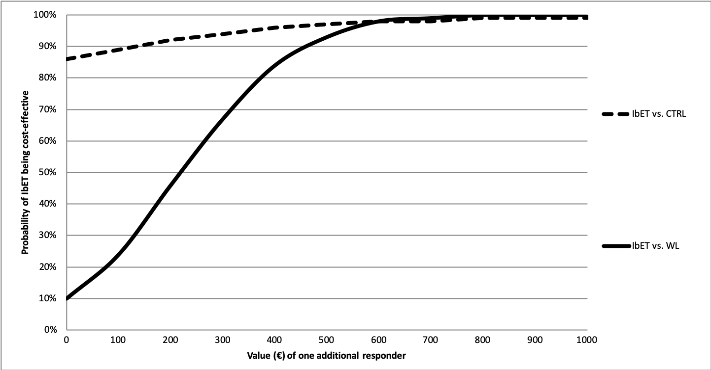
The cost for delivering IbET was estimated to 313€ (SD=212) and the corresponding cost for CTRL was 271€ (SD=174). The cost for WL was zero. The difference in costs between IbET and CTRL was -77€. The difference in effect was ·14. This equals an average ICER of -550€. The difference in costs between IbET and WL was 118€. The difference in effect was ·53. This equals an average ICER of 222€.

eFigure 5: Cost-effectiveness acceptibility curves on QALY outcome
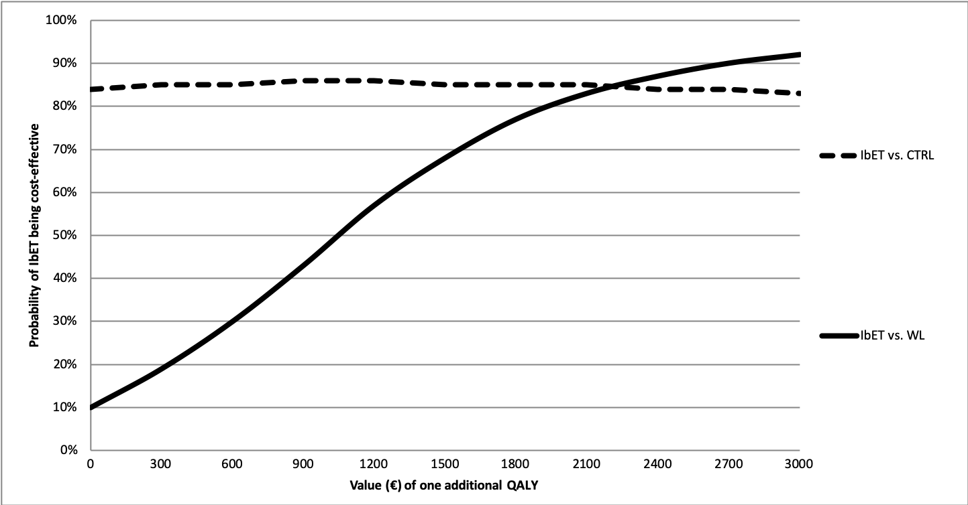
When analysising outcome on the EQ5D, the difference in costs between IbET and CTRL was -73€. The difference in effect was ·01. This equals an average ICER of -7300€. The difference in costs between IbET and WL was 118€. The difference in effect was ·12. This equals an average ICER of 983€.

eTable 9: Means on EQ-5D
 | IbET |  | CTRL |  | WL
Variable | m | SD | m | SD | m | SD
EQ-5D
Pre-treatment | .68 | .23 | .70 | .23 | .63 | .24
Post-treatment | .79 | .18 | .79 | .19 | .65 | .22
4FUP | .79 | .20 | .80 | .19
12FUP | .79 | .22 | .81 | .20

IbET=Internet-based extinction therapy. CTRL=Control condition (active comparator). 4FUP=4-month follow-up. 12FUP=12-month follow-up.

References

Andersson, E., Hedman, E., Wadstrom, O., Boberg, J., Andersson, E. Y., Axelsson, E., Bjureberg, J., Hursti, T., & Ljotsson, B. (2017). Internet-Based Extinction Therapy for Worry: A Randomized Controlled Trial. Behavior Therapy, 48(3), 391-402. 10.1016/j.beth.2016.07.003

Behar, E., Alcaine, O., Zuellig, A. R., & Borkovec, T. D. (2003). Screening for generalized anxiety disorder using the Penn State Worry Questionnaire: a receiver operating characteristic analysis. Journal of Behavior Therapy and Experimental Psychiatry, 34(1), 25-43.

Brown, T. A., Antony, M. M., & Barlow, D. H. (1992). Psychometric properties of the Penn State Worry Questionnaire in a clinical anxiety disorders sample. Behaviour Research and Therapy, 30(1), 33-37. 10.1016/0005-7967(92)90093-v

Davey, G. C. L., Hampton, J., Farrell, J., & Davidson, S. (1992). Some characteristics of worrying: Evidence for worrying and anxiety as separate constructs. Personality and Individual Differences, 13(2), 133-147. https://doi.org/10.1016/0191-8869(92)90036-O

Deacon, B., & Maack, D. J. (2008). The effects of safety behaviors on the fear of contamination: an experimental investigation. Behaviour Research and Therapy, 46(4), 537-547. 10.1016/j.brat.2008.01.010

Drummond, M. F., Sculpher, M. J., Torrence, G. W., O'Brien, B. J., & Stoddart, G. L. (2005). Methods for the evaluation of health care programmes. Oxford University Press.

Gangemi, A., Mancini, F., & van den Hout, M. (2012). Behavior as information: "If I avoid, then there must be a danger". Journal of Behavior Therapy and Experimental Psychiatry, 43(4), 1032-1038. 10.1016/j.jbtep.2012.04.005

Gillis, M. M., Haaga, D. A. F., & Ford, G. T. (1995). Normative values for the Beck Anxiety Inventory, Fear Questionnaire, Penn State Worry Questionnaire, and Social Phobia and Anxiety Inventory. Psychological Assessment, 7(4), 450-455. 10.1037/1040-3590.7.4.450

Jacobson, N. S., & Truax, P. (1991). Clinical significance: a statistical approach to defining meaningful change in psychotherapy research. Journal of Consulting and Clinical Psychology, 59(1), 12-19. 10.1037//0022-006x.59.1.12

Olatunji, B. O., Etzel, E. N., Tomarken, A. J., Ciesielski, B. G., & Deacon, B. (2011). The effects of safety behaviors on health anxiety: an experimental investigation. Behaviour Research and Therapy, 49(11), 719-728. 10.1016/j.brat.2011.07.008

Premack, D. (1959). Toward empirical behavior laws. I. positive reinforcement. Psychol Review, 66(4), 219-233. 10.1037/h0040891

Radomsky, A. S., & Alcolado, G. M. (2010). Don't even think about checking: mental checking causes memory distrust. Journal of Behavior Therapy and Experimental Psychiatry, 41(4), 345-351. 10.1016/j.jbtep.2010.03.005

Smit, F., Willemse, G., Koopmanschap, M., Onrust, S., Cuijpers, P., & Beekman, A. (2006). Cost-effectiveness of preventing depression in primary care patients: randomised trial. British Journal of Psychiatry, 188, 330-336. 10.1192/bjp.188.4.330

