Supplementary Figure SF1. Changes in irritability among participants with and without aggressive behaviors in the EMBARC study.
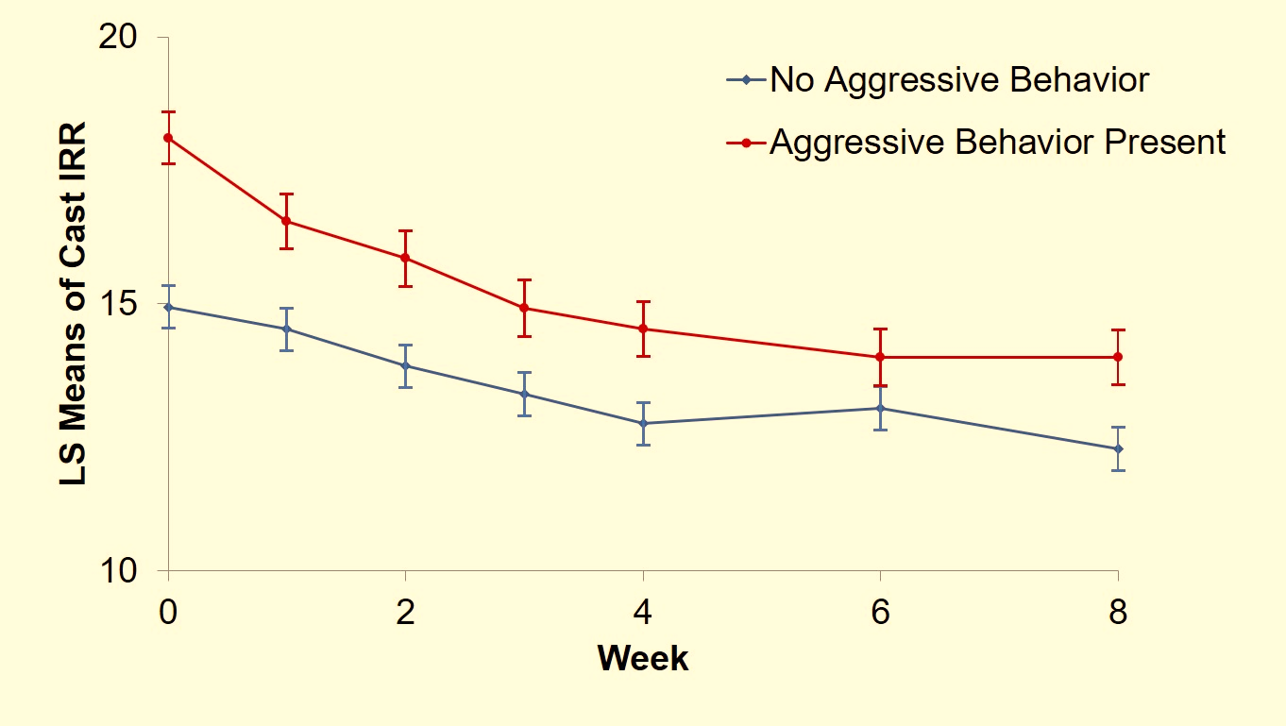
Legends: EMBARC is the Establishing Moderators and Biosignatures of Antidepressant Response for Clinical Care study. LS means are least square means obtained from repeated measures mixed model analyses. CAST IRR is irritability domain of Concise Associated Symptom Tracking scale.

Supplementary table ST1. Levels of irritability and anxiety at baseline in EMBARC study based on frequency of anger attacks in past 1 month (n=108*)
 | N | Mean | SD
Irritability domain of CAST
1-2 anger attacks in past 1 month | 44 | 16.95 | 3.71
3-4 anger attacks in past 1 month | 31 | 18.00 | 2.92
5-8 anger attacks in past 1 month | 19 | 19.84 | 2.85
≥9 anger attacks in past 1 month | 14 | 20.29 | 2.81
Anxiety domain of CAST
1-2 anger attacks in past 1 month | 44 | 8.59 | 2.36
3-4 anger attacks in past 1 month | 31 | 9.19 | 2.86
5-8 anger attacks in past 1 month | 19 | 11.00 | 1.86
≥9 anger attacks in past 1 month | 14 | 10.00 | 2.94
*Among participants of Establishing Moderators and Biosignature of Antidepressant Response in Clinical Care (EMBARC) study with anger attacks (n=109), one participant with 3-4 anger attacks in the past 1 month had missing data for irritability and anxiety domains of Concise Associated Symptom Tracking scale (CAST).

Supplementary table ST2. Mixed model analyses of changes in depression, anxiety, and irritability with acute-phase antidepressant treatment based on presence of aggressive behaviors at baseline (n=293)
 | Depression |  | Anxiety |  | Irritability
 | F value (df) | p* | F value (df) | p* | F value (df) | p*
Aggressive behavior | 0.05 (1, 286) | >0.99 | 1.43 (1, 286) | >0.99 | 19.79 (1, 288) | <0.001
Week | 94.48 (6, 1494) | <0.001 | 18.89 (6, 1430) | <0.001 | 49.33 (1, 1431) | <0.001
Week-by-aggressive behavior | 0.56 (6, 1494) | >0.99 | 0.71 (6, 1430) | >0.99 | 3.63 (6, 1431) | 0.013
p* is p value after Bonferroni adjustment (three independent variables of interest in these three mixed model analyses). All mixed model analyses were adjusted for age, sex, race, ethnicity, and site.

