Supplemental Table 1. Results of Latent Class Growth Models for Multisite ASD Study

N classes | AIC | BIC | Adj. BIC | Entropy | Mean Posterior Probability (SD; Range) | LMR-LRT p value | % in smallest class
1 | 24843.15 | 24873.08 | 24854.023 | 1 | 1 | N/A | 100.00%
2 | 23634.431 | 23684.316 | 23652.553 | 0.924 | 0.965 (0.028; 0.945-0.984) | < .0001 | 14.36%
3 | 23244.461 | 23314.299 | 23269.832 | 0.862 | 0.923 (0.047; 0.870-0.956) | 0.0004 | 7.68%
4 | 23097.024 | 23186.815 | 23129.644 | 0.875 | 0.898 (0.084; 0.790-0.973) | 0.022 | 6.60%
5 | 22992.226 | 23101.971 | 23032.095 | 0.836 | 0.877 (0.053; 0.801-0.929) | 0.0491 | 3.85%
6 | 22895.392 | 23025.091 | 22942.51 | 0.844 | 0.854 (0.058; 0.783-0.931) | 0.4111 | 3.67%

Note. AIC = Alkaike Information Criterion; BIC = Bayesian Information Criterion; LMR-LRT = Lo-Mendel-Rubin adjusted likelihood ratio test; SD = Standard Deviation. Models included linear and quadratic growth terms. Five hundred random sets of starting values were used for the initial stage, and 20 final stage optimizations were used in each analysis. Each analysis ran without error.

Supplemental Table 2. Results of Latent Class Growth Models for JTOPS

 | AIC | BIC | Adj. BIC | Entropy | Mean Posterior Probability (SD; Range) | LMR-LRT p value | % in smallest class
1 | 14769.81 | 14797.41 | 14778.358 | 1 | 1 | N/A | 100.00%
2 | 14338.619 | 14384.618 | 14352.864 | 0.77 | 0.919 (0.032; 0.896-0.941) | 0.0162 | 26.42%
3 | 14196.421 | 14260.819 | 14216.364 | 0.749 | 0.864 (0.058; 0.802-0.917) | 0.0008 | 12.30%
4 | 14143.84 | 14226.637 | 14169.481 | 0.673 | 0.809 (0.076; 0.696-0.857) | 0.0264 | 10.28%
5 | 14100.959 | 14202.156 | 14132.298 | 0.777 | 0.845 (0.053; 0.782-0.910) | 0.1673 | 2.26%
6 | 14070.443 | 14190.039 | 14107.48 | 0.731 | 0.800 (0.068; 0.726-0.909) | 0.2233 | 2.48%

Note. AIC = Alkaike Information Criterion; BIC = Bayesian Information Criterion; LMR-LRT = Lo-Mendel-Rubin adjusted likelihood ratio test; SD = Standard Deviation. Models included linear and quadratic growth terms. Five hundred random sets of starting values were used for the initial stage, and 20 final stage optimizations were used in each analysis. Each analysis ran without error.

Supplemental Table 3. Results of Latent Class Growth Models for TCOM

N classes | AIC | BIC | Adj. BIC | Entropy | Mean Posterior Probability (SD; Range) | LMR-LRT p value | % in smallest class
1 | 2950.538 | 2969.493 | 2950.493 | 1 | 1 | N/A | 100.00%
2 | 2835.422 | 2867.013 | 2835.346 | 0.887 | 0.947 (0.043; 0.916-0.977) | 0.3103 | 14.60%
3 | 2773.595 | 2817.822 | 2773.489 | 0.86 | 0.931 (0.076; 0.844-0.988) | 0.1213 | 7.43%
4 | 2744.835 | 2801.698 | 2744.699 | 0.875 | 0.933 (0.054; 0.875-0.997) | 0.3634 | 3.38%
5 | 2728.361 | 2797.86 | 2728.195 | 0.871 | 0.934 (0.062; 0.833-0.999) | 0.2524 | 2.72%
6 | 2716.602 | 2798.737 | 2716.405 | 0.866 | 0.920 (0.088; 0.755-0.996) | 0.2976 | 2.45%

Note. AIC = Alkaike Information Criterion; BIC = Bayesian Information Criterion; LMR-LRT = Lo-Mendel-Rubin adjusted likelihood ratio test; SD = Standard Deviation. Models included linear and quadratic growth terms. Five hundred random sets of starting values were used for the initial stage, and 20 final stage optimizations were used in each analysis. Each analysis ran without error.

Supplemental Table 4. Results of Latent Class Growth Models for Ohio-MVA

N classes | AIC | BIC | Adj. BIC | Entropy | Mean Posterior Probability (SD; Range) | LMR-LRT p value | % in smallest class
1 | 6028.534 | 6050.491 | 6031.464 | 1 | 1 | N/A | 100.00%
2 | 5671.365 | 5707.96 | 5676.249 | 0.923 | 0.973 (0.010; 0.966-0.980) | 0.0087 | 17.49%
3 | 5588.877 | 5640.109 | 5595.714 | 0.885 | 0.894 (0.067; 0.844-0.970) | 0.1308 | 7.51%
4 | 5554.093 | 5619.964 | 5562.884 | 0.881 | 0.897 (0.058; 0.819-0.956) | 0.1503 | 6.68%
5 | 5531.795 | 5612.304 | 5542.54 | 0.842 | 0.895 (0.082; 0.757-0.974) | 0.6922 | 2.53%
6 | 5509.164 | 5604.311 | 5521.862 | 0.805 | 0.824 (0.102; 0.698-0.934) | 0.2357 | 2.79%

Note. AIC = Alkaike Information Criterion; BIC = Bayesian Information Criterion; LMR-LRT = Lo-Mendel-Rubin adjusted likelihood ratio test; SD = Standard Deviation. Models included linear and quadratic growth terms. Five hundred random sets of starting values were used for the initial stage, and 20 final stage optimizations were used in each analysis. Each analysis ran without error.

Supplemental Table 5. Results of Latent Class Growth Models for Zurich ICU

N classes | AIC | BIC | Adj. BIC | Entropy | Mean Posterior Probability (SD; Range) | LMR-LRT p value | % in smallest class
1 | 2768.656 | 2785.431 | 2766.461 | 1 | 1 | N/A | 100.00%
2 | 2647.563 | 2675.521 | 2643.905 | 0.908 | 0.960 (0.030; 0.938-0.981) | 0.0026 | 17.81%
3 | 2626.581 | 2665.723 | 2621.459 | 0.892 | 0.931 (0.069; 0.851-0.973) | 0.2044 | 8.08%
4 | 2605.104 | 2655.428 | 2598.518 | 0.905 | 0.923 (0.092; 0.788-0.983) | 0.4995 | 4.44%
5 | 2590.621 | 2652.128 | 2582.571 | 0.914 | 0.936 (0.051; 0.869-0.997) | 0.2267 | 2.70%
6 | 2582.776 | 2655.467 | 2573.264 | 0.775 | 0.899 (0.094; 0.789-0.999) | 0.5557 | 2.69%

Note. AIC = Alkaike Information Criterion; BIC = Bayesian Information Criterion; LMR-LRT = Lo-Mendel-Rubin adjusted likelihood ratio test; SD = Standard Deviation. Models included linear and quadratic growth terms. Five hundred random sets of starting values were used for the initial stage, and 20 final stage optimizations were used in each analysis. Each analysis ran without error.

Supplemental Table 6. Results of Latent Class Growth Models for Amsterdam Cortisol

N classes | AIC | BIC | Adj. BIC | Entropy | Mean Posterior Probability (SD; Range) | LMR-LRT p value | % in smallest class
1 | 15350.254 | 15382.367 | 15360.14 | 1 | 1 | N/A | 100.00%
2 | 14530.114 | 14580.577 | 14545.649 | 0.944 | 0.970 (0.028; 0.950-0.989) | 0.0061 | 12.73%
3 | 14221.964 | 14221.964 | 14243.148 | 0.921 | 0.944 (0.035; 0.909-0.978) | 0.0004 | 4.44%
4 | 14054.522 | 14141.686 | 14081.355 | 0.85 | 0.907 (0.037; 0.853-0.934) | 0.0612 | 3.85%
5 | 13968.255 | 14073.768 | 14000.736 | 0.856 | 0.881 (0.058; 0.812-0.935) | 0.1931 | 3.19%
6 | 13911.184 | 14035.048 | 13949.315 | 0.847 | 0.844 (0.067; 0.784-0.933) | 0.1141 | 3.19%

Note. AIC = Alkaike Information Criterion; BIC = Bayesian Information Criterion; LMR-LRT = Lo-Mendel-Rubin adjusted likelihood ratio test; SD = Standard Deviation. Models included linear and quadratic growth terms. Five hundred random sets of starting values were used for the initial stage, and 20 final stage optimizations were used in each analysis. Each analysis ran without error.

Supplemental Table 7. Growth terms and descriptive data for participants with most likely membership in each trajectory from each dataset

 |  | Growth Terms - Estimate (SE) |  |  |  | Observed Means
 |  | Intercept | Slope | Quadratic |  | <1 mo | 1 mo | 3 mos | 6 mos | 9 mos | 12 mos
Multisite ASD (N = 1084)
 | Low (n = 779, 71.9%) | 10.75 (.46)*** | .18 (.28) | -.03 (.02) |  | 10.95 | -- | 10.99 | -- | -- | 9.21
 | Remitting (n = 88, 8.1%) | 44.34 (4.74)*** | -5.72 (2.50)* | .31 (.18) |  | 43.36 | -- | 29.34 | -- | -- | 19.92
 | Delayed-onset (n = 149, 13.7%) | 16.66 (1.55)*** | 9.51 (1.35)*** | -.57 (.11)*** |  | 21.70 | -- | 41.12 | -- | -- | 49.10
 | High (n = 68, 6.3%) | 55.21 (3.02)*** | 8.08 (1.98)*** | -.53 (.14)*** |  | 60.87 | -- | 74.43 | -- | -- | 76.75
JTOPS (N = 735)
 | Low (n = 292, 39.7%) | 43.54 (2.83)*** | -9.59 (1.00)*** | .64 (.08)*** |  | -- | 33.34 | -- | 8.58 | 7.17 | --
 | Remitting (n = 139, 18.9%) | 71.31 (2.64)*** | -2.12 (1.87) | -.18 (.21) |  | -- | 69.02 | -- | 52.92 | 37.26 | --
 | Fast remitting (n = 229, 31.1%) | 79.87 (3.28)*** | -15.48 (1.84)*** | .97 (.15)*** |  | -- | 68.20 | -- | 22.38 | 19.88 | --
 | High (n = 75, 10.2%) | 88.39 (3.80)*** | -.57 (1.63) | -.12 (.17) |  | -- | 90.40 | -- | 81.08 | 73.83 | --
TCOM (N = 174)
 | Low (n = 137, 78.7%) | 13.61 (1.43)*** | -.89 (.50) | .02 (.04) |  | -- | 12.82 | -- | 9.13 | -- | 6.00
 | Remitting (n = 25, 14.4%) | 46.99 (7.01)*** | -4.02 (1.79)* | .17 (.12) |  | -- | 43.76 | -- | 29.78 | -- | 23.94
 | Delayed-onset (n = 6, 3.4%) | 21.04 (13.16) | 4.55 (4.10) | -.13 (.22) |  | -- | 24.83 | -- | 43.50 | -- | 57.33
 | High (n = 6, 3.4%) | 53.76 (19.63)** | 3.47 (4.66) | -.08 (.27) |  | -- | 60.00 | -- | 71.33 | -- | 84.67
Ohio-MVA (N = 287)
 | Low (n = 230, 80.1%) | 19.00 (1.34)*** | -1.49 (.40)*** | .07 (.03)* |  | -- | 18.27 | -- | 12.57 | -- | 11.05
 | Remitting (n = 23, 8.0%) | 61.29 (11.38)*** | -3.52 (3.29) | .08 (.22) |  | -- | 61.04 | -- | 45.31 | -- | 30.85
 | Delayed-onset (n = 16, 5.6%) | 32.12 (5.99)*** | -.96 (2.92) | .22 (.22) |  | -- | 29.88 | -- | 36.07 | -- | 52.67
 | High (n = 18, 6.3%) | 73.38 (4.44)*** | -2.77 (2.46) | .27 (.17) |  | -- | 72.61 | -- | 66.79 | -- | 78.00
Zurich ICU (N = 121)
 | Low (n = 88, 72.3%) | 18.14 (1.45)*** | -2.59 (.41)*** | .16 (.03)*** |  | 16.38 | -- | -- | 7.99 | -- | 9.75
 | Remitting (n = 19, 15.7%) | 36.70 (7.18)*** | -1.80 (1.64) | .05 (.09) |  | 36.58 | -- | -- | 26.59 | -- | 21.71
 | Delayed-onset (n = 5, 4.4%) | 36.94 (18.35)* | -7.55 (3.69)* | .74 (.25)** |  | 32.60 | -- | -- | 17.60 | -- | 53.20
 | High (n = 9, 7.4%) | 31.49 (7.09)*** | 4.99 (2.16)* | -.32 (.14)* |  | 33.67 | -- | -- | 49.89 | -- | 44.78
Amsterdam Cortisol (N = 726
 | Low (n = 491, 67.6%) | 13.47 (.77)*** | -1.33 (.23)*** | .07 (.02)*** |  | -- | 12.54 | 8.98 | 8.22 | -- | 7.68
 | Moderate-low (n = 153, 21.1%) | 33.11 (2.68)*** | -1.75 (.79)* | .07 (.05) |  | -- | 33.52 | 29.23 | 25.76 | -- | 23.09
 | Moderate (n = 54, 7.4%) | 50.97 (6.12)*** | -.02 (2.39) | -.02 (.17) |  | -- | 53.00 | 48.16 | 50.94 | -- | 48.52
 | High (n = 28, 3.9%) | 76.48 (4.90)*** | 2.36 (1.72) | -.12 (.12) |  | -- | 79.38 | 81.00 | 86.43 | -- | 88.00
Note: * p < .05, ** p < .01, *** p < .001
Supplemental Table 8. Descriptive statistics for the All Other trajectories versus Low trajectory. Chi-square tests were conducted to assess for significant variation across studies on all covariates.
 | Low | All Other | p value
Age Quartile |  |  | χ²₃=24.83; p<0.001
<27 | 501 (25.2%) | 253 (23.1%)
27-37 | 476 (24%) | 313 (28.6%)
38-48 | 451 (22.7%) | 295 (26.9%)
>48 | 559 (28.1%) | 235 (21.4%)
Gender |  |  | χ²₁=91.54; p<0.001
Male | 1400 (70.5%) | 582 (53.1%)
Female | 587 (29.5%) | 514 (46.9%)
Race |  |  | χ²₂=10.44; p=0.005
White | 1491 (75%) | 877 (80%)
Non-White | 233 (11.7%) | 97 (8.9%)
Missing | 263 (13.2%) | 122 (11.1%)
Education |  |  | χ²₂=21.87; p<0.001
Secondary or Greater | 1542 (77.6%) | 818 (74.6%)
Less than Secondary | 361 (18.2%) | 186 (17%)
Missing | 84 (4.2%) | 92 (8.4%)
Marital Status |  |  | χ²₂=16.34; p<0.001
Married/living with partner | 953 (48%) | 491 (44.8%)
Single/not living with partner | 953 (48%) | 523 (47.7%)
Missing | 81 (4.1%) | 82 (7.5%)
Prior Trauma |  |  | χ²₃=24.19; p<0.001
No prior trauma | 297 (14.9%) | 174 (15.9%)
Prior non-interpersonal trauma | 700 (35.2%) | 296 (27%)
Prior interpersonal trauma | 848 (42.7%) | 522 (47.6%)
Missing | 142 (7.1%) | 104 (9.5%)
Trauma Type |  |  | χ²₂=100.81; p<0.001
MVA | 1449 (72.9%) | 840 (76.6%)
Other accidents | 472 (23.8%) | 143 (13%)
Assaults (intentional harm) | 66 (3.3%) | 113 (10.3%)

Supplemental Table 9. Descriptive statistics for the Low versus Delayed trajectory. Chi-square tests were conducted to assess for significant variation across studies on all covariates.
 | Low | Delayed | p value
Age Quartile |  |  | χ²₃=13.02; p=0.005
<27 | 501 (25.2%) | 42 (24.9%)
27-37 | 476 (24%) | 36 (21.3%)
38-48 | 451 (22.7%) | 58 (34.3%)
>48 | 559 (28.1%) | 33 (19.5%)
Gender |  |  | χ²₁=0.24; p=0.621
Male | 1400 (70.5%) | 116 (68.6%)
Female | 587 (29.5%) | 53 (31.4%)
Race |  |  | χ²₂=11.11; p=0.004
White | 1491 (75%) | 114 (67.5%)
Non-White | 233 (11.7%) | 16 (9.5%)
Missing | 263 (13.2%) | 39 (23.1%)
Education |  |  | χ²₂=13.05; p=0.001
Secondary or Greater | 1542 (77.6%) | 124 (73.4%)
Less than Secondary | 361 (18.2%) | 26 (15.4%)
Missing | 84 (4.2%) | 19 (11.2%)
Marital Status |  |  | χ²₂=6.09; p=0.048
Married/living with partner | 953 (48%) | 72 (42.6%)
Single/not living with partner | 953 (48%) | 83 (49.1%)
Missing | 81 (4.1%) | 14 (8.3%)
Prior Trauma |  |  | χ²₃=35.02; p<0.001
No prior trauma | 297 (14.9%) | 22 (13%)
Prior non-interpersonal trauma | 700 (35.2%) | 31 (18.3%)
Prior interpersonal trauma | 848 (42.7%) | 110 (65.1%)
Missing | 142 (7.1%) | 6 (3.6%)
Trauma Type |  |  | χ²₂=13.42; p=0.001
MVA | 1449 (72.9%) | 129 (76.3%)
Other accidents | 472 (23.8%) | 26 (15.4%)
Assaults (intentional harm) | 66 (3.3%) | 14 (8.3%)

Supplemental Table 10. Descriptive statistics for the High versus Remitting trajectory. Chi-square tests were conducted to assess for significant variation across studies on all covariates.

 | High | Remitting | p-value
Age Quartile |  |  | χ²₃=11.63; p=0.009
<27 | 37 (18.6%) | 145 (27.8%)
27-37 | 59 (29.6%) | 158 (30.3%)
38-48 | 65 (32.7%) | 114 (21.9%)
>48 | 38 (19.1%) | 104 (20%)
Gender |  |  | χ²₁=0.00; p<0.948
Male | 98 (49.2%) | 258 (49.5%)
Female | 101 (50.8%) | 263 (50.5%)
Race |  |  | χ²₂=10.64; p=0.005
White | 147 (73.9%) | 441 (84.6%)
Non-White | 21 (10.6%) | 34 (6.5%)
Missing | 31 (15.6%) | 46 (8.8%)
Education |  |  | χ²₂=23.86; p<0.001
Secondary or Greater | 118 (59.3%) | 404 (77.5%)
Less than Secondary | 55 (27.6%) | 72 (13.8%)
Missing | 26 (13.1%) | 45 (8.6%)
Marital Status |  |  | χ²₂=1.11; p=0.575
Married/living with partner | 90 (45.2%) | 222 (42.6%)
Single/not living with partner | 88 (44.2%) | 252 (48.4%)
Missing | 21 (10.6%) | 47 (9%)
Prior Trauma |  |  | χ²₃=30.90; p<0.001
No prior trauma | 19 (9.5%) | 115 (22.1%)
Prior non-interpersonal trauma | 45 (22.6%) | 150 (28.8%)
Prior interpersonal trauma | 111 (55.8%) | 182 (34.9%)
Missing | 24 (12.1%) | 74 (14.2%)
Trauma Type |  |  | χ²₂=6.87; p=0.032
MVA | 143 (71.9%) | 415 (79.7%)
Other accidents | 22 (11.1%) | 54 (10.4%)
Assaults (intentional harm) | 34 (17.1%) | 52 (10%)

Supplemental Table 11. Multinomial Logistic Regression results for Low (reference) vs Delayed vs High. Chi-squared likelihood ratio tests compare models constraining each predictor separately to be equal across outcomes with an unconstrained model where predictors’ effects were allowed to vary.

Variable | Delayed | High | χ² | p
Intercept | 0.18*** [0.1-0.35] | 0.01*** [0-0.02]
Age Quartile: |  |  | 43.09 | <0.0001
27-37 | 1.08 [0.65-1.77] | 1.65* [1.03-2.64]
38-48 | 1.66* [1.04-2.65] | 2.3** [1.42-3.73]
>48 | 0.96 [0.56-1.64] | 0.94 [0.55-1.62]
Gender: Female | 1.42 [0.98-2.06] | 2.65*** [1.91-3.67] | 39.09 | <0.0001
Race: |  |  | 38.98 | <0.0001
Non-White | 0.93 [0.45-1.92] | 2.59* [1.35-4.97]
Missing | 0.74 [0.46-1.2] | 1.42 [0.8-2.5]
Education: |  |  | 52.42 | <0.0001
Less than Secondary | 0.74 [0.46-1.18] | 2.82*** [1.92-4.14]
Missing | 2.08 [0.86-5.05] | 5.03** [1.98-12.76]
Marital Status: |  |  | 44.05 | <0.0001
Single/not living with partner | 1.02 [0.7-1.48] | 0.94 [0.66-1.34]
Missing | 0.7 [0.24-2.06] | 0.71 [0.24-2.08]
Prior Trauma: |  |  | 37.12 | <0.0001
Prior non-interpersonal | 0.56 [0.31-1.03] | 1.56 [0.86-2.84]
Prior interpersonal | 1.23 [0.74-2.05] | 3.25*** [1.85-5.69]
Missing | 0.41 [0.05-3.27] | 3.7* [1.51-9.08]
Trauma Type: |  |  | 38.26 | <0.0001
Other accidents | 0.5* [0.31-0.79] | 0.62 [0.38-1.03]
Assaults (intentional harm) | 2.5* [1.26-4.93] | 4.99*** [3.02-8.26]
Study: |  |  | 173.9 | <0.0001
JTOPS | 0 [0-Inf] | 3.98*** [2.43-6.52]
TCOM | 0.28* [0.09-0.83] | 0.39 [0.13-1.16]
Ohio-MVA | 0.33** [0.18-0.59] | 1.23 [0.65-2.33]
Zurich ICU | 0.87 [0.09-8.18] | 1.62 [0.53-4.97]
Amsterdam Cortisol | 0 [0-Inf] | 0.91 [0.54-1.55]

Note: * p < .05, ** p < .01, *** p < .001

Supplemental Table 12. Multinomial Logistic Regression results for High (reference) vs Low vs Remitting. Chi-squared likelihood ratio tests compare models constraining each predictor separately to be equal across outcomes with an unconstrained model where predictors’ effects were allowed to vary.

Variable | Low | Remitting | χ² | p
Intercept | 114.9*** [52.43-251.82] | 5.87*** [2.44-14.11]
Age Quartile: |  |  | 198.7 | <0.0001
27-37 | 0.65 [0.41-1.03] | 0.59* [0.36-0.98]
38-48 | 0.44** [0.27-0.71] | 0.49* [0.29-0.83]
>48 | 0.99 [0.58-1.67] | 0.78 [0.44-1.39]
Gender: Female | 0.36*** [0.26-0.5] | 0.76 [0.54-1.09] | 150.8 | <0.0001
Race: |  |  | 140.4 | <0.0001
Non-White | 0.37* [0.19-0.71] | 0.58 [0.23-1.48]
Missing | 0.72 [0.41-1.27] | 1.23 [0.63-2.41]
Education: |  |  | 137.5 | <0.0001
Less than Secondary | 0.36*** [0.25-0.53] | 0.47** [0.3-0.73]
Missing | 0.21** [0.09-0.5] | 0.27* [0.1-0.71]
Marital Status: |  |  | 166.9 | <0.0001
Single/not living with partner | 1.02 [0.72-1.45] | 1.14 [0.77-1.7]
Missing | 1.23 [0.46-3.32] | 1.78 [0.61-5.17]
Prior Trauma: |  |  | 137.2 | <0.0001
Prior non-interpersonal | 0.66 [0.37-1.19] | 0.67 [0.37-1.24]
Prior interpersonal | 0.31*** [0.18-0.54] | 0.41* [0.23-0.72]
Missing | 0.34* [0.15-0.8] | 0.62 [0.26-1.45]
Trauma Type: |  |  | 147.9 | <0.0001
Other accidents | 1.68* [1.02-2.77] | 1.71 [0.95-3.08]
Assaults (intentional harm) | 0.22*** [0.13-0.36] | 0.39** [0.23-0.65]
Study: |  |  | 590.5 | <0.0001
JTOPS | 0.24*** [0.15-0.39] | 3.23*** [1.84-5.67]
TCOM | 2.58 [0.88-7.56] | 3.87* [1.06-14.18]
Ohio-MVA | 0.8 [0.42-1.51] | 0.83 [0.38-1.83]
Zurich ICU | 0.51 [0.17-1.53] | 0.84 [0.26-2.75]
Amsterdam Cortisol | 1.1 [0.65-1.87] | 0 [0-Inf]

Note: * p < .05, ** p < .01, *** p < .001

Supplemental Figure 1. Odds ratio and 95% confidence intervals of predictors for being in the Low versus All Other Trajectory in the pooled ICPP dataset (in blue) and in a subset where each study was removed from the combined dataset in turn and a logistic model fit in the remaining studies.

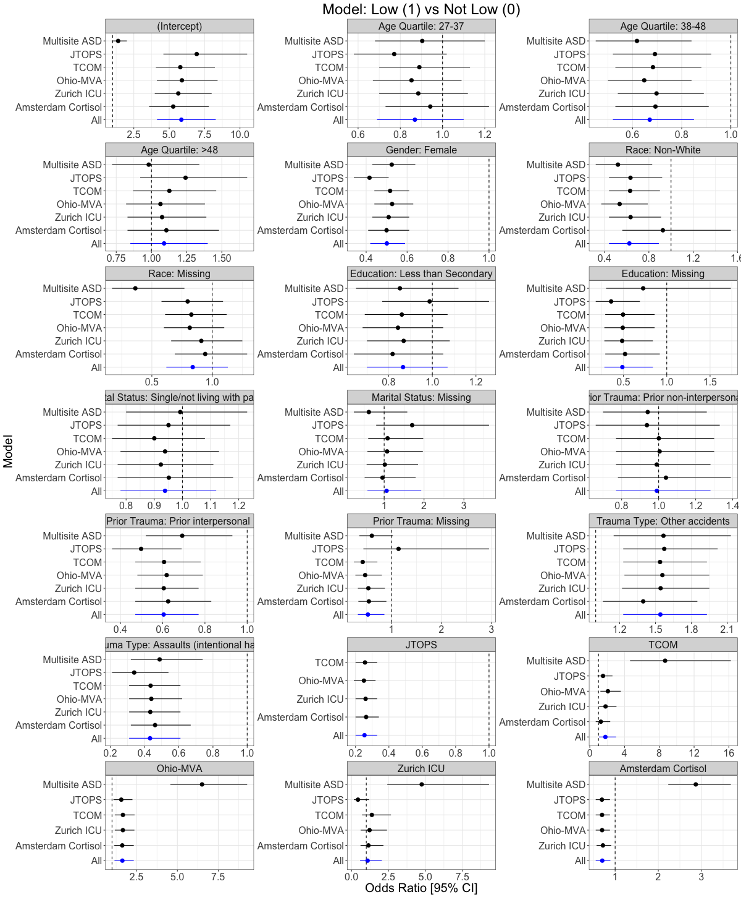

Supplemental Figure 2. Odds ratio and 95% confidence intervals of predictors for being in the Low versus the Delayed Trajectory in the pooled ICPP dataset (in blue) and in a subset where each study was removed from the combined dataset in turn and a logistic model fit in the remaining studies.

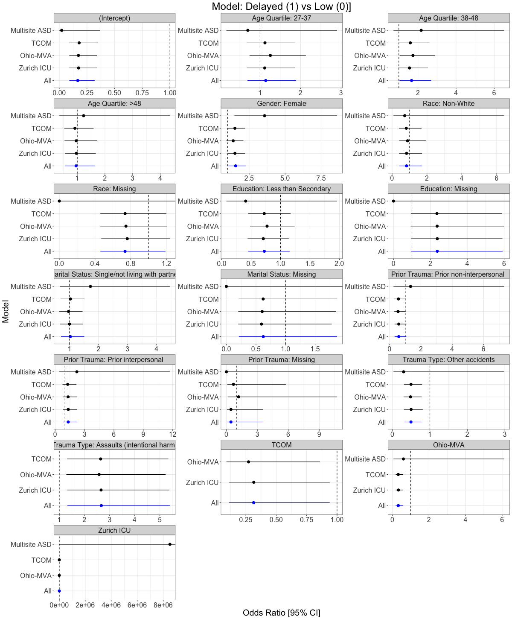

Supplemental Figure 3. Odds ratio and 95% confidence intervals of predictors for being in the Remitting versus the High Trajectory in the pooled ICPP dataset (in blue) and in a subset where each study was removed from the combined dataset in turn and a logistic model fit in the remaining studies.

