Normalization of mediotemporal and prefrontal activity, and mediotemporal-striatal connectivity, may underlie antipsychotic effects of cannabidiol in established psychosis

Aisling O'Neill¹, Robin Wilson¹, Grace Blest-Hopley¹, Luciano Annibale¹, Marco Colizzi¹, Mick Brammer², Vincent Giampietro², Sagnik Bhattacharyya¹*

Supplementary Material Table of Contents

Normalization of mediotemporal and prefrontal activity, and mediotemporal-striatal connectivity, may underlie antipsychotic effects of cannabidiol in established psychosis 1
Methods 3
Power analysis 3
Inclusion criteria for patients with psychosis: 3
Study design 3
XBAM v4.1 4
Functional connectivity analysis 6
Results 7
CBD plasma levels 7
Daily 8
More than once a week 8
Missing 8
(n) (Current use) 8
Main effect of encoding and recall in the HC group 9
Between group comparison: Difference in brain activation between HC and PSY-PLB 9
Hippocampal-striatal functional connectivity during recall 11
CBD plasma levels correlations 11
Discussion 11
Limitations 11
References 13

Methods

Power analysis
When we set out to conduct this study, in the absence of previous data on effect of CBD on brain activation in patients with psychosis, our sample size estimation was based on data that was available at that point of time. Power calculation based on data from a previous study investigating the acute effect of CBD on functional brain activation in healthy controls suggested that a sample of n=15 would be adequate to detect differences between a placebo and CBD condition in a repeated-measures, within-subject comparison in healthy individuals, with an alpha (α) of 0.05 at 90% power, and an SD of 0.04, and an anticipated minimal difference in means of 0.0366(Bhattacharyya et al., 2010). Given its potential antipsychotic effects(Rohleder, Muller, Lange, & Leweke, 2016), we therefore determined that the effect of CBD on brain activation to be greater in those with psychosis.
In order to estimate the sample size necessary to detect differences in functional activation between the patients and healthy controls during a memory task, we used data reported by Rasetti et al(2014). Based on the difference in hippocampal activation between those with psychosis (-0.05±0.1) and healthy volunteers (0.1±0.1), we determined that a sample size of n=9 per arm would be required to detect differences between the psychosis and healthy groups on memory-related functional activation, with an alpha (α) of 0.05 at 80% power.

Inclusion criteria for patients with psychosis:
- diagnosis of psychotic mental illness (meeting criteria for schizophrenia, schizophreniform, or brief psychotic disorder – but no other Axis I diagnoses), (2) within 5 years of onset of illness, (3) receiving a stable dose of antipsychotic medication for ≥3weeks and stable enough to comply with neuroimaging, (4) engaged with early-intervention services

Study design

eTable 1: Experimental timeline for both study days
SAME BOTH VISITS | Informed consent | UDS | Physical exam | Drug admin. | Plasma Δ9-THC/CBD | Vital signs | Psycho-pathological scales | fMRI
Baseline (T1) | X | X | X |  | X | X | X
0 mins |  |  |  | X
60 mins (T2) |  |  |  |  | X | X | X
180 mins |  |  |  |  |  |  |  | X
270 mins (T3) |  |  |  |  | X | X | X

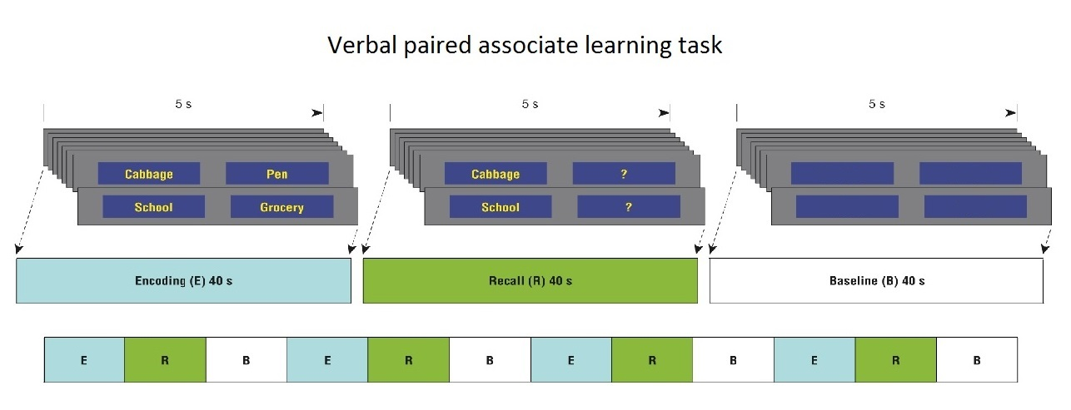
eFigure 1: Verbal paired associate learning task(Bhattacharyya et al., 2009)

XBAM v4.1
The data obtained from the VPA task were then analysed using the non-parametric XBAM v4.1 software. The non-parametric, permutation-based approaches employed by XBAM provide advantages over parametric approaches, in particular the avoidance of any assumption of normality of the data, which is often not tested in fMRI analysis. As the effects of non-normality on parametric hypothesis testing are unclear, permutation-based inference and cluster or parcel level, rather than voxel level inference, are recommended for greater robustness and minimal assumptions(Hayasaka & Nichols, 2003; Thirion et al., 2007). This is important in fMRI analysis because the distribution of data may not necessarily follow a normal Gaussian distribution(Brammer et al., 1997; Thirion et al., 2007). Use of medians rather than averages as a test statistic makes XBAM less sensitive to the effects of outlier values that may bias distribution of the data(Hayasaka & Nichols, 2003). The test statistic in this approach uses robust permutation-based methods, and is computed by standardizing for individual differences in residual noise before embarking on a second- level, multi-subject testing, employing a mixed-effects approach to deal with the issue of non-normality. The use of a mixed effects approach addresses the issue of inequality of individual residual variances by effectively “down weighting” responses with large residual variances. The significance of the resulting reweighted responses at group level is then tested by data permutation to avoid assumptions of normality.
As the fMRI paradigm that we employed involved a clustered acquisition sequence to allow online recording of verbal responses during the silent period, it is challenging to account for this using other established software packages. On the other hand, we have analysed the same task using XBAM with replicable results in various participants samples(Bhattacharyya et al., 2009; Bhattacharyya, Wilson, Appiah-Kusi, & et al., 2018; Brittain et al., 2014; Salvan et al., 2014).
The fMRI data was first processed to minimise motion related artifacts, by realigning images to correct for head motion(E. T. Bullmore, Brammer, et al., 1999). Correction of head movement involved the computation of a 3D volume consisting of the average intensity at each voxel over the whole experiment. This was then used as a template. Subsequently, the 3D image volume at each time-point was realigned to this template by calculating the combination of rotations (around the x, y and z axes) and translations (in x, y and z) that maximised the correlation between the image intensities of the volume in question and the template 3D volume (rigid body registration). Following realignment, the data was smoothed by the application of a 5 mm full-width-at-half-maximum Gaussian filter to average the relative intensities of neighbouring voxels and to increase the signal-to-noise ratio. Slice timing correction was then applied and the residual effects of motion were regressed out from the time series (using the estimated motion parameters) before fitting a general linear model.
To model the blood oxygen level dependent haemodynamic (BOLD) response signal, the experimental design was convolved with 2 gamma-variate functions, at 4 and 8 seconds to allow for variability in haemodynamic delay. Using the constrained BOLD effects model, a best fit between the weighted sum of these convolutions and the change over time at each voxel was then computed (Friman, Borga, Lundberg, & Knutsson, 2003) to reduce the possibility of the model-fitting procedure giving rise to mathematically plausible, but physiologically implausible results. Following the least squares fitting of this model to the data, the sum of squares (SSQ) ratio (ratio of the SSQ of deviations from the mean image intensity due to the model component over the whole-time series to the SSQ of deviations due to the residuals) was estimated for each voxel, for each block and condition. Data were then permuted using a wavelet-based method described and characterized previously(E. Bullmore et al., 2001), which permits data-driven calculation of the null distribution of SSQ under the assumption of no experimentally-determined response. This distribution was then be used to threshold the activation maps at any desired Type 1 error rate. Subsequently, activated voxels were grouped into clusters using a previously described method(E. T. Bullmore, Suckling, et al., 1999) shown to give excellent cluster-wise Type I error control. In this method, clusters are defined as groups of significant voxels that are spatially contiguous in three dimensions. We then computed the sum of voxel statistics within each cluster for each randomisation (n=50), which were combined to form an overall distribution of cluster mass under the null hypothesis. Subsequently, the number of clusters that would be expected by chance alone in the randomised data was calculated to assess the statistical significance at the cluster level. The cluster level p-value was then set at a threshold for significance that provided the expected number of false positive clusters to be less than one.
Subsequently, the sum of squares (SSQ) ratio maps for each individual at each separate block and for each condition obtained as above were transformed into standard stereotactic space(Talairach & Tournoux, 1988) using a two-stage warping procedure(Brammer et al., 1997). As part of this, an average image intensity map for each individual at each separate block over the course of the experiment was computed (i.e. realignment target used above). We then computed the transformations required to map this image to the structural scan for each individual and then from ‘structural space’ to Talairach space. The SSQ ratio and BOLD effect size maps were then transformed into Talairach space using these transformations.

Functional connectivity analysis
For the functional connectivity analysis, the hippocampal cluster identified during the recall condition in the within-group comparison of activation (PSY-PLB vs PSY-CBD) was selected as a seed (TAL: -25, -22, -16, cluster size = 27 voxels). The average time series over the whole of the seed cluster was then extracted for each subject, for the recall condition, in each subject's individual brain space. Each subject's average time series was then used as a model for a correlation analysis for the recall condition, producing maps of functional connectivity between each seed cluster and the rest of the whole-brain. These functional connectivity maps were transformed to standard Talairach space, and used to compute group connectivity maps by determining the median correlation coefficients (across subjects) at each voxel. An ROI mask of the striatum was created with XBAM v4.1, using Talairach labels and region definitions. Between group hippocampal-striatal functional connectivity comparisons were then performed, using non-parametric ANOVAs, through the XBAM v4.1 platform, with a voxel-wise threshold of p = 0.05, and a cluster-wise threshold adjusted for less than 1 false positive cluster across the brain volume, as before.

Regions of Interest
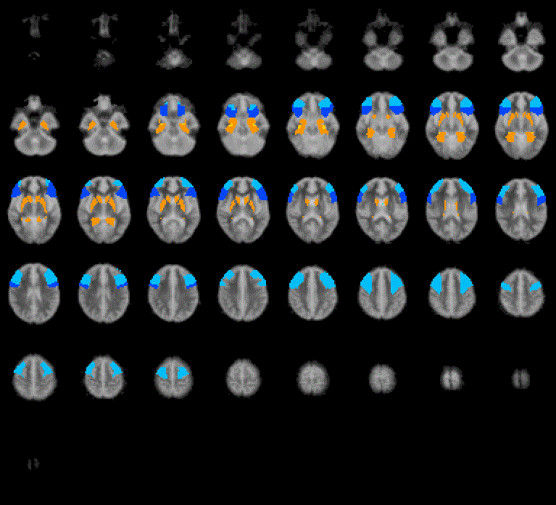
eFigure 2: Region of interest (ROI) Mask for activation analyses, encompassing the prefrontal cortex (middle and inferior frontal gyri), mediotemporal lobe (hippocampus and parahippocampal gyrus), and the whole striatum/pallidum (encompassing caudate, putamen and globus pallidus)
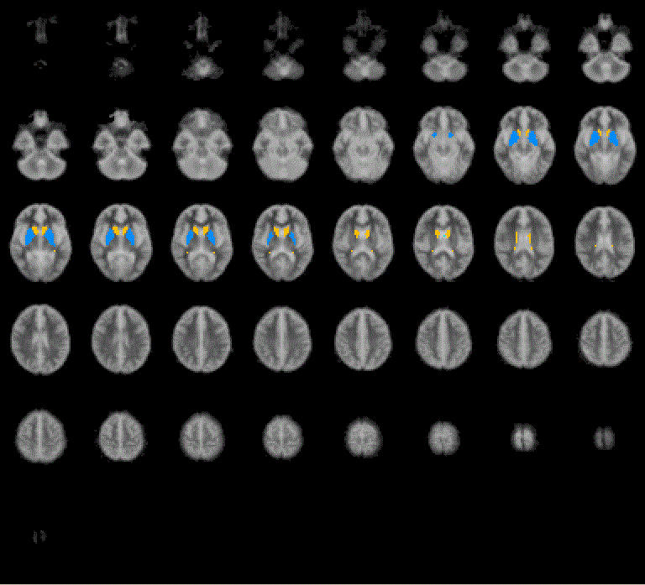
eFigure 3: Striatal mask for functional connectivity analysis, encompassing caudate, putamen and globus pallidus

Results

CBD plasma levels
eFigure 4: Plot showing CBD plasma levels in the PSY-PLB and PSY-CBD arms, at T1 (60mins before drug administration), T2 (60mins after drug administration), and T3 (270mins after drug administration). Error bars: +/- SE.

eTable 2: Participant socio-demographic and clinical characteristics at baseline
Characteristic | PSY (n = 15) |  | HC (n=19) | Statistics
Number of hospital admissions: mean (SD) | 1.54 (0.97) |  | -
Urine Drug screen (UDS) results: Clean | Visit 1 | Visit 2 | 19
 | 6 | 6
THC | 8 | 8 | -
Morphine | 0 | 0 | -
Benzodiazepines | 0 | 0 | -
PCP | 1 | 1 | -
Cannabis: Lifetime use  (n) (Current regular use) | 15 (9) |  | -
Frequency of cannabis use (past/present):
Daily | 6 |  | -
More than once a week | 4 |  | -
Once/twice monthly | 0 |  | -
Few times a year | 1 |  | -
Only once/twice lifetime | 4 |  | -
Alcohol: Lifetime use  (n) (Current use) | 11 (7) |  | 16 (16) | Difference in lifetime use – (HC vs PSY) P = 0.436
Frequency of alcohol use (past/present): |  |  |  | Difference in frequency –  (HC vs PSY) P = 0.073
Daily | 1 |  | 0
More than once a week | 3 |  | 7
Once/twice monthly | 3 |  | 6
Few times a year | 3 |  | 3
Never | 4 |  | 3
Missing | 1 |  | 0
Nicotine: Lifetime use  (n) (Current use) | 7 (6) |  | 3 (2) | Difference in lifetime use – (HC vs PSY) P = 0.05
Frequency of nicotine use (past/present): |  |  |  | Difference in frequency –  (HC vs PSY) P = 0.054
Daily | 6 |  | 2
More than once a week | 0 |  | 0
Once/twice monthly | 1 |  | 0
Few times a year | 0 |  | 0
Never | 8 |  | 0
Missing | 0 |  | 1
Carbon monoxide in breath mean ppm (%) | Visit 1 | Visit 2 | - | mean ppm: P = 0.642
 | 9.67 (2.21) | 9.21 (2.17)
All HC individuals had a lifetime cannabis use of less than 10 times. Significant differences are indicated in bold.

Main effect of encoding and recall in the HC group
HC participants displayed greater activation during the encoding condition relative to baseline in one cluster in the left inferior frontal gyrus (14 voxels, peak TAL: -47, 19, 0, P = 0.00089), and reduced activation relative to baseline in clusters in the right inferior frontal (60 voxels, peak TAL: 40, 37, 13, P = 0.00021) and left middle frontal (40 voxels, TAL: -38, 40, 13, P = 0.00021) gyri.
In contrast, activation was greater during the recall condition compared to baseline in a cluster in the left parahippocampal gyrus (11 voxels, peak TAL: -19, -25, -12, p= 0.0047), and reduced in clusters in the right middle frontal (33 voxels, peak TAL: 47, 37, 16, P = 0.0018) and inferior frontal (32 voxels, peak TAL: 51, 11, 30, P = 0.014) gyri.

Between group comparison: Difference in brain activation between HC and PSY-PLB
Figure 5: Significant differences in activation, during the encoding condition, between PSY-PLB and HC. Brain clusters showing greater activation in PSY-PLB compared to HC are depicted in red/yellow; and those showing lesser activation in PSY-PLB compared to HC are depicted in blue/green. Slice numbers (in terms of z coordinate) are displayed above each slice. The right side of the brain is shown on the right side of the images.

Figure 6: Significant differences in activation, during the recall condition, between PSY-PLB and HC. Brain clusters showing greater activation in PSY-PLB compared to HC are depicted in red/yellow; and those showing lesser activation in PSY-PLB compared to HC are depicted in blue/green. Slice numbers (in terms of z coordinate) are displayed above each slice. The right side of the brain is shown on the right side of the images.

Hippocampal-striatal functional connectivity during recall
eTable 3: Clusters of between-group hippocampal-striatal functional connectivity differences, during the recall condition
Recall | Direction of activation difference | Effect anatomy | Peak TAL coordinates |  |  | Cluster size | Cluster  p value*
 |  |  | X | Y | Z
 | PSY-PLB > HC | Caudate head | 11 | 11 | 0 | 136 | 0.000092
 |  | Caudate body | -11 | 7 | 0 | 153 | 0.000092
 | PSY-PLB > PSY-CBD | Caudate head | 11 | 11 | 0 | 4 | 0.012
 |  | Putamen | -14 | -7 | 7 | 4 | 0.0068
 |  | Caudate body | -11 | 11 | 10 | 6 | 0.0047
 | PSY-PLB > PSY-CBD > HC | Putamen | 29 | 7 | 0 | 86 | 0.000074
 |  | Caudate head | -7 | 7 | 0 | 78 | 0.000074
ROI = region of interest. PSY-PLB = psychosis patient group under placebo treatment, PSY-CBD = psychosis patient group under CBD treatment, HC = healthy controls. TAL = Talairach coordinate system. *Corrected to yield less than 1 false positive cluster per map.

CBD plasma levels correlations
Post-hoc testing indicated that T3 CBD level in the psychosis patients under CBD treatment were not significantly associated with activation in the any of the clusters identified in the within-group analyses (CBD vs Placebo comparisons), or in the 3 group linear relationship analyses.

Discussion

Limitations
It is worth noting psychosis patients were not comparable to HC in terms of their age, years of education and use of alcohol, and other drugs, especially cannabis. However, these effects are unlikely to have affected the results of the within-subject comparison (CBD vs placebo condition) in psychosis patients, which were broadly consistent with the 3-way comparisons involving HC, suggesting that differential exposure to alcohol and other drugs or differences in age and education are unlikely to have substantially influenced the general direction of the results presented here. Nevertheless, we cannot completely rule out this possibility. We also did not detect an effect of CBD on performance in the verbal paired associate learning task. However, it is important to note that the VPA task is relatively easy, and our study design was probably not sufficiently powered to demonstrate differences in task performance. Furthermore, although trend-level improvements in cognition with longer term CBD treatment have recently been observed in psychosis(McGuire et al., 2018), such performance differences are unlikely to be evident following a single dose.

References
Bhattacharyya, S., Fusar-Poli, P., Borgwardt, S., Martin-Santos, R., Nosarti, C., O'Carroll, C., . . . McGuire, P. (2009). Modulation of mediotemporal and ventrostriatal function in humans by Delta9-tetrahydrocannabinol: a neural basis for the effects of Cannabis sativa on learning and psychosis. Arch Gen Psychiatry, 66(4), 442-451. doi:10.1001/archgenpsychiatry.2009.17
Bhattacharyya, S., Morrison, P. D., Fusar-Poli, P., Martin-Santos, R., Borgwardt, S., Winton-Brown, T., . . . McGuire, P. K. (2010). Opposite effects of delta-9-tetrahydrocannabinol and cannabidiol on human brain function and psychopathology. Neuropsychopharmacology, 35(3), 764-774. doi:10.1038/npp.2009.184
Bhattacharyya, S., Wilson, R., Appiah-Kusi, E., & et al. (2018). Effect of cannabidiol on medial temporal, midbrain, and striatal dysfunction in people at clinical high risk of psychosis: A randomized clinical trial. JAMA Psychiatry. doi:10.1001/jamapsychiatry.2018.2309
Brammer, M. J., Bullmore, E. T., Simmons, A., Williams, S. C., Grasby, P. M., Howard, R. J., . . . Rabe-Hesketh, S. (1997). Generic brain activation mapping in functional magnetic resonance imaging: a nonparametric approach. Magn Reson Imaging, 15(7), 763-770.
Brittain, P. J., Froudist Walsh, S., Nam, K. W., Giampietro, V., Karolis, V., Murray, R. M., . . . Nosarti, C. (2014). Neural compensation in adulthood following very preterm birth demonstrated during a visual paired associates learning task. Neuroimage Clin, 6, 54-63. doi:10.1016/j.nicl.2014.08.009
Bullmore, E., Long, C., Suckling, J., Fadili, J., Calvert, G., Zelaya, F., . . . Brammer, M. (2001). Colored noise and computational inference in neurophysiological (fMRI) time series analysis: resampling methods in time and wavelet domains. Hum Brain Mapp, 12(2), 61-78.
Bullmore, E. T., Brammer, M. J., Rabe-Hesketh, S., Curtis, V. A., Morris, R. G., Williams, S. C., . . . McGuire, P. K. (1999). Methods for diagnosis and treatment of stimulus-correlated motion in generic brain activation studies using fMRI. Hum Brain Mapp, 7(1), 38-48.
Bullmore, E. T., Suckling, J., Overmeyer, S., Rabe-Hesketh, S., Taylor, E., & Brammer, M. J. (1999). Global, voxel, and cluster tests, by theory and permutation, for a difference between two groups of structural MR images of the brain. IEEE Trans Med Imaging, 18(1), 32-42.
Friman, O., Borga, M., Lundberg, P., & Knutsson, H. (2003). Adaptive analysis of fMRI data. Neuroimage, 19(3), 837-845.
Hayasaka, S., & Nichols, T. E. (2003). Validating cluster size inference: random field and permutation methods. Neuroimage, 20(4), 2343-2356.
McGuire, P., Robson, P., Cubala, W. J., Vasile, D., Morrison, P. D., Barron, R., . . . Wright, S. (2018). Cannabidiol (CBD) as an Adjunctive Therapy in Schizophrenia: A Multicenter Randomized Controlled Trial. Am J Psychiatry, 175(3), 225-231. doi:10.1176/appi.ajp.2017.17030325
Rasetti, R., Mattay, V. S., White, M. G., Sambataro, F., Podell, J. E., Zoltick, B., . . . Weinberger, D. R. (2014). Altered hippocampal-parahippocampal function during stimulus encoding: a potential indicator of genetic liability for schizophrenia. JAMA Psychiatry, 71(3), 236-247. doi:10.1001/jamapsychiatry.2013.3911
Rohleder, C., Muller, J. K., Lange, B., & Leweke, F. M. (2016). Cannabidiol as a Potential New Type of an Antipsychotic. A Critical Review of the Evidence. Front Pharmacol, 7, 422. doi:10.3389/fphar.2016.00422
Salvan, P., Froudist Walsh, S., Allin, M. P., Walshe, M., Murray, R. M., Bhattacharyya, S., . . . Nosarti, C. (2014). Road work on memory lane--functional and structural alterations to the learning and memory circuit in adults born very preterm. Neuroimage, 102 Pt 1, 152-161. doi:10.1016/j.neuroimage.2013.12.031
Talairach, J., & Tournoux, P. (1988). [Co-planar Stereotaxic Atlas of the Human Brain.]. New York: Thieme Medical
Thirion, B., Pinel, P., Meriaux, S., Roche, A., Dehaene, S., & Poline, J. B. (2007). Analysis of a large fMRI cohort: Statistical and methodological issues for group analyses. Neuroimage, 35(1), 105-120. doi:10.1016/j.neuroimage.2006.11.054

