Aguilar-Ortiz et al Supplementary Material
1. Results in the 1-back versus baseline contrast
Within group comparisons
The controls showed four clusters of signiﬁcant activation. A cluster of 14095 voxels was located in the left fronto-parietal cortex (peak at -4 2 60; z= 9.31; p 1.2 e-22) including the supplementary motor area, the DLPFC, the precentral gyrus, and the insular, parietal inferior and superior temporal cortex. A second cluster of 2413 voxels (peak 34 22 2; z=5.69; p=2.8e-06) was in the right insular and DLPFC. A third cluster of 1438 voxels was seen bilaterally in the gyrus rectus/orbitofrontal cortex (peak -12 32 -18; z=4.64; p=0.0003). A fourth cluster of 1131 voxels located in the right supramarginal/inferior parietal cortex. The final cluster of 750 voxels was in the left putamen and pallidum (peak -24 2 2 ; z=5.23; p=0.024).

A large cluster of de-activation was also seen (84194 voxels, peak at: 2 -50 36, z=10.6, p<0.001), extending from the medial frontal region to the superior occipital cortex and including the anterior, middle and posterior cingulate gyrus, as well as the precuneus/cuneus and the lingual and fusiform cortex. This cluster also included the temporal poles, extending to temporal superior and supramarginal and inferior parietal cortex. The cluster also extended subcortically to include bilateral amygdala, hippocampus and parahippocampal regions.

The pattern of activation and de-activation in the BDP patients was similar. A cluster of of 32786 voxels was located bilaterally in the fronto-parietal cortex (peak -2 6 54; z=9.42; p=1.59e-40) and included the supplementary motor area, the DLPFC, the insular and left inferior parietal cortex and the bilateral basal ganglia (caudate, putamen and pallidum). A second cluster of 3418 voxels was seen in the right occipito-temporal cortex (peak at 46 -80 -2; z=5.66, p=5.96e-08). A third cluster of 2045 was located in the right inferior parietal cortex (peak 38 -46 46; z=6.13, p=1.61e-05).

There were four clusters of de-activation in the BDP patients. A cluster of 28081 voxels placed in the posterior cingulate cortex (peak -2 -52 30; z=9.07; p=1.89e-36), extending to the cuneus/precuneus, the calcarine and the lingual cortex and to the amygdala, hippocampus and parahippocampal region. The second cluster of 10490 voxels was located bilaterally in anterior cingulate cortex and other parts of the medial frontal cortex (peak 2 60 2; z=7.17; p=2.03e-18). The third cluster of 1348 voxels (peak -58 -6 -20; z=5.42; p=0.0006) was in the left middle and inferior temporal cortex. Finally, a cluster of 807 voxels was seen in the right middle and injferior temporal cortex (peak 62 -110 -16; z=5.15; p=0.0167).

Between-groups comparison
There were no clusters of reduced activation in the patients compared to controls. However, there were six clusters of relatively greater activation (all representing failure of de-activation in the patients compared to healthy subjects). One, of 5952 voxels, was located in the lingual cortex bilaterally (peak at 16 -68 0; z =4.41; p=2.64e-12). A second cluster (3000 voxels) involved the temporal pole and supramarginal cortex (peak at 60 10 -16; z=5.18, p=1.79e-07). Another cluster (2294 voxels) was located bilaterally in the middle cingulate cortex extending to the precuneus (peak at 12 -24 36; z =4.96; p=4.89e-06). The third cluster (1318 voxels) affected the left putamen, superior temporal and insular cortex (peak at -30 -14 0; z = 4.44; p=0.0007). A fourth cluster of 1155 voxels was located in the left temporal middle cortex (peak at -72 -34 -14, z = 3.6; p=0.002). Finally, a cluster of 739 voxels was seen in the left postcentral cortex (peak at -46 -38 66; z = 4.01, p=0.03).

Figure S1. Within-group activations (red) and de-activations (blue) in the 1-back vs baseline contrast for (a) the healthy controls and (b) the BPD patients. Clusters of significant difference between the patients and the controls are shown in the bottom panel (c). Images are displayed in neurological convention (right is right).

2. 2-back vs baseline contrast

Figure S2. Boxplots of ROIs based on mean activations in the two clusters of difference between the BPD patients and the healthy controls in the 2-back vs baseline contrast.

3. Melodic ICA + dual regression analysis on the n-back data
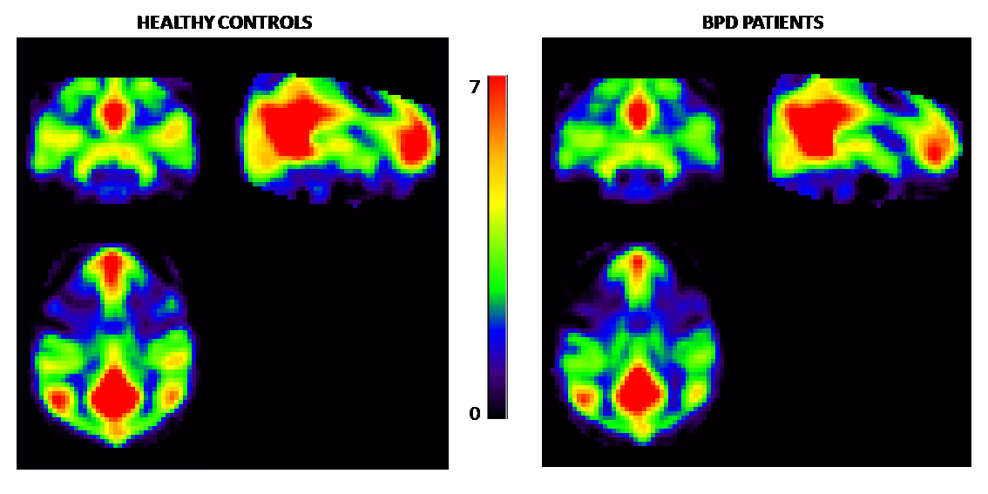FIGURE S3: Mean images of the independent component corresponding to the default mode network as indentified by the group MELODIC probabilistic independent component analysis (ICA) in the n-back data. Images are averages of individual volumes from both groups extracted in the second step of the dual regression. Voxel size is 4x4x4 mm (i.e. the actual size used in the ICA analyses).

4. Relationship to history of major depression
Table S1. Mean differences between BPD patients with and without a lifetime history of depression in the significant clusters of activation (4) and de-activation (2) found in the 2-back vs 1-back comparison between patients and controls

 |  | Without history of depression | with history of depression | t | p
Activation | Cluster 1 | 12±50 | 12.1±5.20 | 0.067 | 0.95
 | Cluster 2 | 9.84±3.60 | 8.50±3.09 | 1.65 | 0.10
 | Cluster 3 | 10.15±3.65 | 9.81±3.76 | 0.36 | 0.71
 | Cluster 4 | 12.10±5.39 | 10.46±4.13 | 1.40 | 0.16
De-activation | Cluster 1 | -14.80±7.41 | -14.58±7.16 | 0.12 | 0.90
 | Cluster 2 | -13.36±8.52 | -13.08±5.92 | 0.16 | 0.88

