**Supplement**

**Psychiatric diagnoses**

|  |  |  |
| --- | --- | --- |
| **eTable 1. Diagnosis codes of substance use disorders, anxiety-related disorders and depressive disorders** | |  |
| **ICD-10 code** | **Diagnosis** | **N (%)** |
| F10 | Alcohol use disorder | 87,350 (2.9) |
| F11 | Opioid use disorder | 10,983 (0.4) |
| F12 | Cannabis use disorder | 14,520 (0.5) |
| F13 | Sedative, hypnotic, or anxiolytic-related disorders | 15,235 (0.5) |
| F14 | Cocaine-related disorders | 11,429 (0.4) |
| F15 | Other stimulant-related disorders | 11,429 (0.4) |
| F16 | Hallucinogen-related disorders | 2,709 (0.1) |
| F18 | Inhalant-related disorders | 2,709 (0.1) |
| F19 | Other psychoactive substance-related disorders (polydrug) | 30,676 (1.0) |
| F32 | Major depressive disorder, single episode | 153,941 (5.1) |
| F33 | Major depressive disorder, recurrent | 153,941 (5.1) |
| F34 | Persistent mood disorders | 10,091 (0.3) |
| F38 | Mixed/Other mood-related disorders | 7,400 (0.2) |
| F39 | Mood disorder, not otherwise specified | 7,400 (0.2) |
| F40.0 | Agoraphobia | 7,705 (0.3) |
| F40.1 | Social phobia | 19,955 (0.7) |
| F40.2 | Specific phobias | 3,483 (0.1) |
| F40.8 | Other phobic anxiety disorders | 2,235 (0.1) |
| F40.9 | Phobic anxiety disorder, not otherwise specified | 2,235 (0.1) |
| F40.1 | Panic disorder | 35,831 (1.2) |
| F41.1 | Generalized anxiety disorder | 20,435 (0.7) |
| F41.2 | Mixed anxiety and depression | 54,940 (1.8) |
| F41.3 | Other mixed anxiety disorders | 54,940 (1.8) |
| F41.8 | Other anxiety disorders | 75,875 (2.6) |
| F41.9 | Anxiety disorder, not otherwise specified | 75,875 (2.6) |
| F42 | Obsessive-compulsive disorder | 20,213 (0.7) |
| F43.1 | Post-traumatic stress disorder | 10,881 (0.4) |

Note: N = frequency, % = prevalence; Frequencies for the following diagnostic categories were combined: F14 + F15, F16 + F18, F32 + F33, F38 + F39, F40.8 + F40.9, F41.8 + F41.9

**Factor analysis**

Anxiety-related disorders, such as generalized anxiety disorder (GAD), and depression reflect a higher order internalizing dimension of psychopathology (Caspi *et al*., 2014; Lahey *et al*., 2017). Thus, GAD and depression may be seen as different manifestations of a latent factor characterized by distress. Similarly, other specific anxiety-related disorders (e.g. specific phobias) are likely to correlate because of an underlying latent factor structure (Kendler *et al*., 2003). To reduce the number of exposure-outcome associations to be analyzed, we used exploratory factor analysis to identify latent factors among the ICD-10 anxiety/depression and SUD diagnoses and substance-related criminal convictions. By using variables representing a latent factor structure, we aimed to maximize the use of available diagnostic data (e.g. NOS diagnoses that are rarely used in research) while reducing multiple testing by using fewer variables.



**eFigure 1. Parallel analysis scree plots**

eFigure 1 shows the scree plots from the parallel analysis. In the parallel analysis, random correlation matrices were simulated and factor analyzed, after which the resulting eigenvalues were compared to the eigenvalues of the observed data. We decided to test solutions with one to four factors based on the point of inflection, the eigenvalue greater than one rule, and examination of the curves for large drops in the actual data. Before the exploratory factor analysis, cocaine use disorder (F14) was combined with stimulant use (F15), and inhalant use (F18) with hallucinogens (F16), since they were relatively rare in the present sample. Other and NOS anxiety (F41.8-F41.9), other and NOS phobic anxiety disorders (F40.8-F40.9), and depressive diagnoses (F32-F33 and F38-F39) were also combined, respectively.

A non-orthogonal factor structure was expected, and thus maximum likelihood extraction with oblimin rotation was used in all analyses. A tetrachoric correlation matrix (eFigure 2) was then used to fit models with one to four factors. As shown in eTable 2, a four-factor solution provided best fit for the data. The four factors consisted of one factor (referred to as substance misuse) where all SUDs and substance-related crimes loaded, and three anxiety/depression factors representing depression and generalized anxiety, specific phobias and OCD, and panic disorder and social/agoraphobia, respectively. Because the between-factor correlations and within factor loadings were high, a bi-factor structure was also tested, where all items loaded on a general factor in addition to the four specific factors (eFigure 3). In this model, maximum likelihood extraction with Promax rotation was used. Promax was chosen because it has the advantage of being conceptually simple, and thus fast in finding oblique solutions for complex factor models. The model fit and structure of item loadings were virtually the same in both four-factor models.

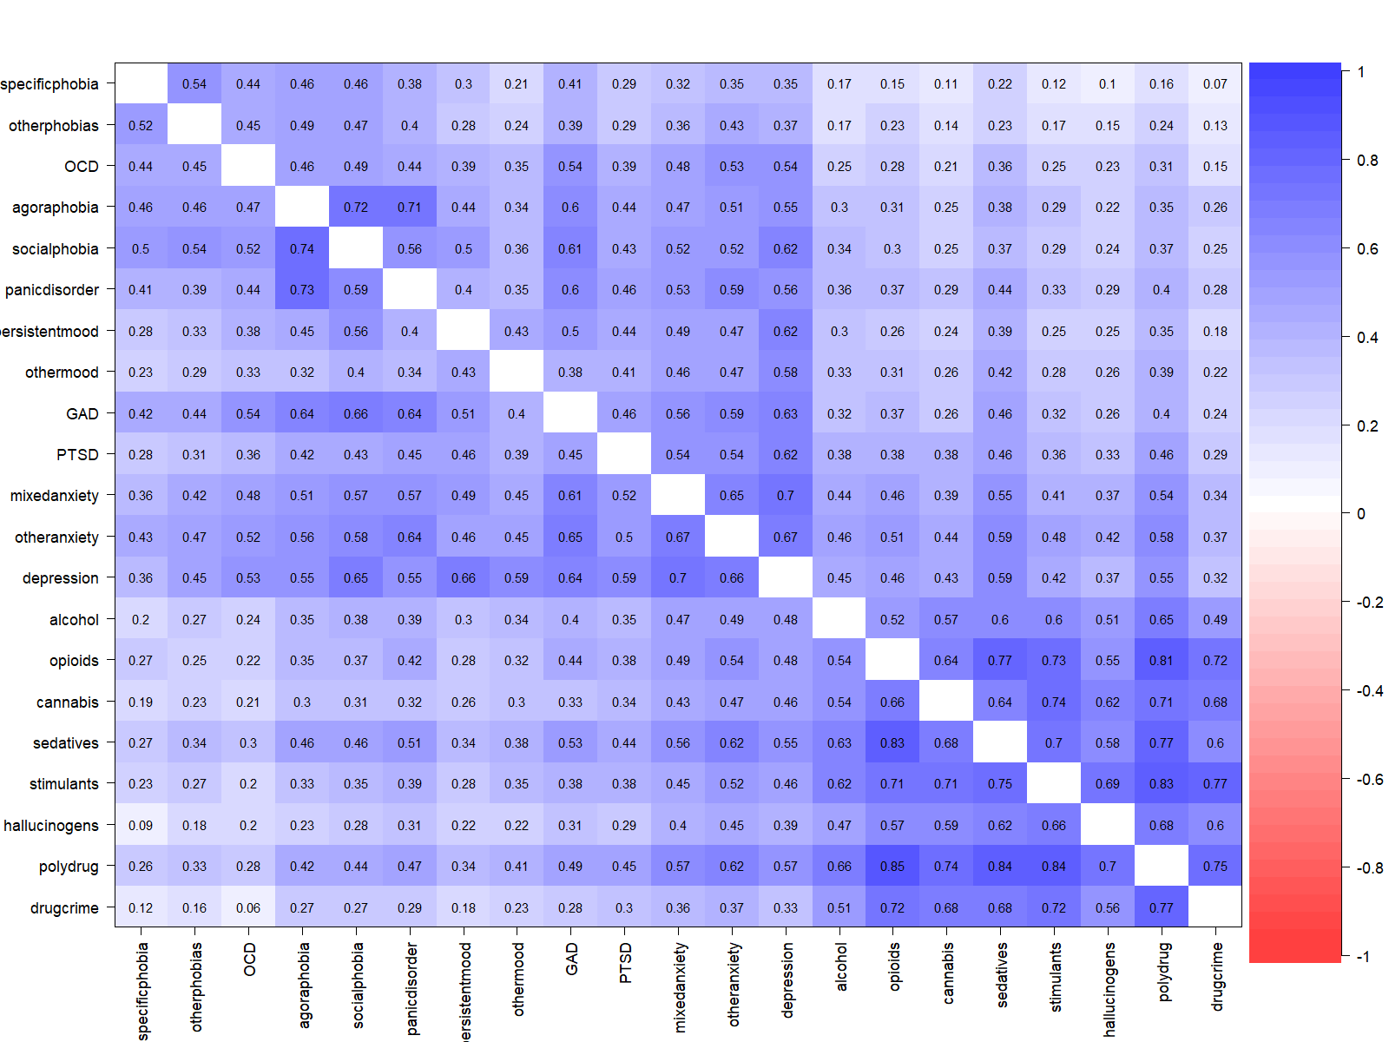

p

p

**eFigure 2. Tetrachoric correlation matrix describing the associations between substance misuse and anxiety/depression in men (below diagonal) and women (above diagonal)**. OCD = Obsessive-compulsive disorder; Persistent mood = Persistent mood disorders (F34); Other mood = Mixed/Other mood-related disorders & Mood disorder, not otherwise specified; GAD = Generalized anxiety disorder; PTSD = Post-traumatic stress disorder; Mixed anxiety = Mixed anxiety and depression; Other anxiety = Anxiety disorder, not otherwise specified & Other anxiety disorders; Stimulants = Cocaine use disorder & stimulant use disorder; Hallucinogens = Inhalant use disorder & hallucinogen use disorder; Polydrug = Other psychoactive substance-related disorders (poly drug use); Drug crime = Substance-use related criminal convictions.

|  |  |  |  |  |  |
| --- | --- | --- | --- | --- | --- |
| **eTable 2. Fit statistics of different factor solutions** | | | |  |  |
| **Model** | **X2** | **df** | **RMSEA (95% CI)** | **SRMR** | **TLI** |
| One-factor model | 16519842 | 189 | 0.171 (0.171–0.171) | 0.15 | 0.602 |
| Two-factor model | 4130666 | 169 | 0.090 (0.090–0.090) | 0.04 | 0.889 |
| Three-factor model | 2420093 | 150 | 0.073 (0.073–0.073) | 0.03 | 0.927 |
| Four-factor model | 1722744 | 132 | 0.066 (0.066–0.066) | 0.02 | 0.941 |
| Bi-factor model with 4 factors | 1722744 | 132 | 0.066 (0.066–0.066) | 0.02 | - |

Note: X2 = Chi square, df = Degrees of freedom, RMSEA = The root mean square error of approximation, SRMR = Standardized root mean square residual, TLI = Tucker-Lewis Index

|  |  |  |  |  |  |  |
| --- | --- | --- | --- | --- | --- | --- |
| **eTable 3. Variance explained by each factor in different factor solutions** | | | | | | |
|  |  | F1 | F2 | F3 | F4 | G |
| One-factor model | | 0.43 |  |  |  |  |
| Two-factor model | | 0.25 | 0.30 |  |  |  |
| Three-factor model | | 0.26 | 0.16 | 0.18 |  |  |
| Four-factor model | | 0.10 | 0.26 | 0.18 | 0.09 |  |
| Bi-factor model with 4 factors | | 0.05 | 0.27 | 0.08 | 0.05 | 0.58 |

Note: Two-factor model: F1 = substance misuse, F2 = anxiety/depression; Three-factor model: F1 = substance misuse, F2 = anxiety disorders, F3 = depressive disorders; Four-factor models: F1 = Panic disorder & agora/social phobia, F2 = substance misuse, F3 = generalized anxiety/depression, F3 = phobias/OCD; G = General factor

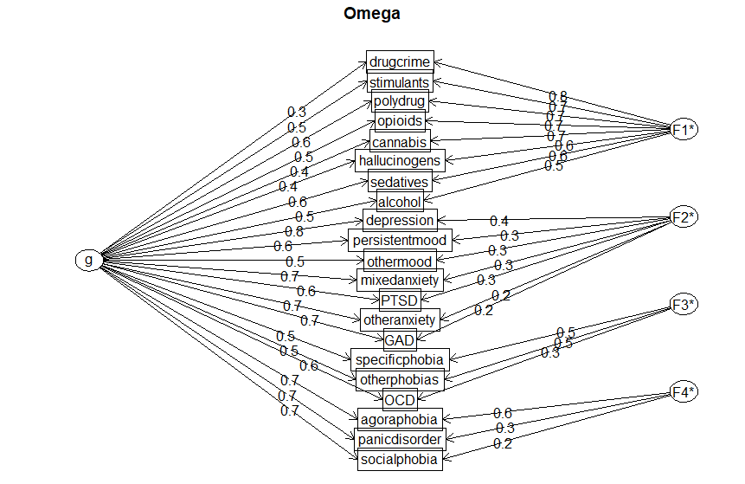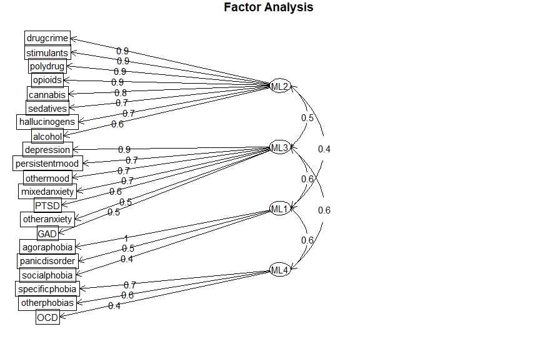

**eFigure 3. Bi-factor (top) and correlated four-factor (bottom) solutions with standardized factor loadings.** OCD = Obsessive-compulsive disorder; Persistent mood = Persistent mood disorders (F34); Other mood = Mixed/Other mood-related disorders & Mood disorder, not otherwise specified; GAD = Generalized anxiety disorder; PTSD = Post-traumatic stress disorder; Mixed anxiety = Mixed anxiety and depression; Other anxiety = Anxiety disorder, not otherwise specified & Other anxiety disorders; Stimulants = Cocaine use disorder & stimulant use disorder; Hallucinogens = Inhalant use disorder & hallucinogen use disorder; Polydrug = Other psychoactive substance-related disorders (poly drug use); Drugcrime = Substance-use related criminal convictions.

**Sex differences in the associations between substance misuse and anxiety/depression**

|  |  |  |
| --- | --- | --- |
| **eTable 4. Tetrachoric correlations (95% CIs) of substance misuse with anxiety/depression dimensions stratified by sex** | | |
|  | Men | Women |
| Generalized anxiety/depression | 0.49 (0.48–0.49) | 0.54 (0.54–0.55) |
| Panic disorder and  agora/social phobia | 0.39 (0.38–0.39) | 0.41 (0.40–0.42) |
| Phobias/OCD | 0.19 (0.18–0.20) | 0.28 (0.27–0.29) |
|  |  |  |

Note: OCD = Obsessive-compulsive disorder

**Quantitative genetic models**

|  |  |  |  |  |  |  |
| --- | --- | --- | --- | --- | --- | --- |
| **eTable 5. Fit statistics of the quantitative genetic models** | | | | |  |  |
|  | Model | ep | -2LL | df | AIC | p |
| Substance misuse - | ACE | 13 | 14341.38 | 39975 | -65608.62 | |
| Generalized anxiety/depression | AE | 10 | 14344.76 | 39978 | -65611.24 | .337 |
|  | CE | 10 | 14377.45 | 39978 | -65578.55 | <.001 |
|  | E | 7 | 14867.08 | 39981 | -65094.92 | <.001 |
| Substance misuse - | ACE | 13 | 8901.39 | 39975 | -71048.62 | |
| Panic disorder & agora/social phobia | AE | 10 | 8904.39 | 39978 | -71051.61 | .392 |
|  | CE | 10 | 8925.43 | 39978 | -71030.57 | <.001 |
|  | E | 7 | 9220.25 | 39981 | -70741.75 | <.001 |
| Substance misuse - | ACE | 13 | 7963.61 | 39975 | -71986.39 | |
| Phobias/OCD | AE | 10 | 7968.23 | 39978 | -71987.75 | .200 |
|  | CE | 10 | 7979.17 | 39978 | -71976.83 | .001 |
|  | E | 7 | 8234.97 | 39981 | -71727.03 | <.001 |

Note: ep = Estimated parameters, -2LL = Log-likelihood value, df = Degrees of freedom, AIC = Akaike information criterion value, p = p-value (for comparison with ACE model fit for AE and CE models, comparison with AE model for E models); A = Additive genetic, C = Shared environment, E = Non-shared environment

**Mutually adjusted regression models**

Model 2 was mutually adjusted by including all the anxiety/depression dimension variables simultaneously as predictors (eTable 4). Model 3 shows Risk Ratios for the associations between substance misuse and different anxiety/depression dimensions adjusted for personality disorders. Personality disorders were included as dichotomous variables representing “cluster A” (F60.0–60.1), “cluster B” (F60.3–F60.5, F60.81), “cluster C” (F60.5–F60.7), and other personality disorders (F60.89–F60.9).

|  |  |  |  |  |  |  |  |  |
| --- | --- | --- | --- | --- | --- | --- | --- | --- |
| **eTable 6. Risk ratios (95% CIs) between anxiety/depression (exposure) and substance misuse (outcome)** | | | | | | | | |
|  | | Generalized anxiety/depression  – Substance misuse | | | | Panic disorder – Substance misuse | Phobias/OCD – Substance misuse | |
| Model 1 | |  | |  | | |  | |
| Total | | 4.45 (4.41–4.49) | | 3.60 (3.55–3.66) | | | 2.51 (2.44–2.58) | |
| Men | | 3.69 (3.65–3.73) | | 3.11 (3.06–3.17) | | | 2.05 (1.97–2.12) | |
| Women | | 6.05 (5.96–6.15) | | 4.34 (4.24–4.44) | | | 3.13 (3.01–3.25) | |
| Model 2 | |  | |  | | |  | |
| Total | | 4.15 (4.11–4.20) | | 1.46 (1.43–1.48) | | | 0.97 (0.95–1.00) | |
| Men | | 3.49 (3.45–3.53) | | 1.40 (1.37–1.43) | | | 0.89 (0.85–0.92) | |
| Women | | 5.57 (5.48–5.67) | | 1.52 (1.49–1.56) | | | 1.05 (1.01–1.09) | |
| Model 3 | |  | |  | | |  | |
| Total | | 3.94 (3.90–3.98) | | 2.60 (2.55–2.64) | | | 1.63 (1.58–1.68) | |
| Men | | 3.45 (3.41–3.49) | | 2.54 (2.49–2.60) | | | 1.54 (1.49–1.61) | |
| Women | | 5.01 (4.93–5.10) | | 2.62 (2.55–2.70) | | | 1.69 (1.62–1.76) | |
| Note: Model 1 adjusted for covariates; Model 2 mutually adjusted for all anxiety/depression dimensions and covariates; Model 3 adjusted for personality disorders (but not anxiety/depression) and covariates; Panic disorder = Panic disorder and agora/social phobia dimension | | | | | | | | |

**Regression models for the association between anxiety/depression and alcohol use disorder**

|  |  |  |  |  |  |  |  |
| --- | --- | --- | --- | --- | --- | --- | --- |
| **eTable 7. Risk ratios (95% CIs) between alcohol use disorder (exposure) and anxiety/depression (outcome)** | | | | | | | |
|  | | Alcohol use disorder - Generalized anxiety/depression | | | Alcohol use disorder – Panic disorder | Alcohol use disorder – Phobias/OCD | |
| Model 1 | |  |  | | |  | |
| Total | | 4.79 (4.74–4.84) | 5.38 (5.23–5.54) | | | 3.45 (3.31–3.58) | |
| Men | | 5.56 (5.47–5.64) | 5.80 (5.60–6.00) | | | 3.68 (3.46–3.91) | |
| Women | | 4.22 (4.17–4.28) | 4.68 (4.53–4.83) | | | 3.31 (3.13–3.50) | |
| Model 2 | |  |  | | |  | |
| Total | | 2.81 (2.77–2.85) | 2.98 (2.89–3.07) | | | 2.24 (2.14–2.35) | |
| Men | | 2.95 (2.89–2.03) | 3.00 (2.87–3.14) | | | 2.40 (2.23–2.58) | |
| Women | | 2.69 (2.64–2.74) | 2.93 (2.81–3.06) | | | 2.14 (1.99–2.29) | |
| Note: Model 1 adjusted for covariates; Model 2 mutually adjusted for all substance use disorders and covariates | | | | | | | |

|  |  |  |  |  |  |  |  |
| --- | --- | --- | --- | --- | --- | --- | --- |
| **eTable 8. Risk ratios (95% CIs) between anxiety/depression (exposure) and alcohol use disorder (outcome)** | | | | | | | |
|  | | Generalized anxiety/depression –  Alcohol use disorder | | | Panic disorder – Alcohol use disorder | Phobias/OCD – Alcohol use disorder | |
| Model 1 | |  |  | | |  | |
| Total | | 6.35 (6.26–6.43) | 4.82 (4.72–4.92) | | | 3.21 (3.10–3.33) | |
| Men | | 6.52 (6.40–6.64) | 5.10 (4.96–5.61) | | | 3.34 (3.16–3.52) | |
| Women | | 6.10 (5.98–6.23) | 4.51 (4.37–4.65) | | | 3.10 (2.95–3.27) | |
| Model 2 | |  |  | | |  | |
| Total | | 5.81 (5.72–5.90) | 1.59 (1.56–1.63) | | | 1.02 (0.98–1.05) | |
| Men | | 5.96 (5.83–6.08) | 1.60 (1.55–1.66) | | | 1.01 (0.95–1.07) | |
| Women | | 5.60 (5.47–5.72) | 1.57 (1.52–1.63) | | | 1.03 (0.98–1.08) | |
| Note: Model 1 adjusted for covariates; Model 2 mutually adjusted for all anxiety/depression dimensions and covariates | | | | | | | |

**Regression models for the association between anxiety/depression and substance misuse diagnosis counts**

|  |  |  |  |
| --- | --- | --- | --- |
|  | | | |
| **eTable 9. Incidence rate ratios (95% CIs) between substance misuse count (exposure) and anxiety/depression count (outcome)** | | | |
|  | Substance misuse – Generalized anxiety/depression | Substance misuse – Panic disorder | Substance misuse – Phobias/OCD | |
| Individual level models |  |  |  | |
| Model 1 | 1.90 (1.89–1.90) | 1.86 (1.85–1.87) | 1.62 (1.60–1.64) | |
| Model 2 | 1.81 (1.80–1.82) | 1.76 (1.75–1.77) | 1.56 (1.54–1.58) | |
| Within-family models |  |  |  | |
| Half-siblings | 1.82 (1.78–1.86) | 1.70 (1.63–1.78) | 1.51 (1.41–1.62) | |
| Full siblings & DZ twins | 1.93 (1.91–1.96) | 1.81 (1.76–1.86) | 1.55 (1.49–1.62) | |
| MZ twins | 1.46 (1.26–1.69) | 1.35 (0.93–1.97) | 1.10 (0.66–1.82) | |
| Sex-stratified |  |  |  | |
| Men | 1.81 (1.80–1.82) | 1.77 (1.75–1.78) | 1.52 (1.49–1.54) | |
| Women | 1.80 (1.79–1.81) | 1.75 (1.73–1.77) | 1.62 (1.59–1.64) | |
| Note: Model 1 adjusted for sex and birth year; Model 2 adjusted for sex, birth year, socioeconomic  covariates, and parental psychopathology; Within-family and sex-stratified models adjusted for  sex, birth year, socioeconomic covariates, and parental psychopathology. Substance misuse = Substance  use disorders and substance-related criminal convictions; Panic disorder = Anxiety/depression dimension  including panic disorder and agora/social phobia; OCD = Obsessive-compulsive disorder; DZ = Dizygotic;  MZ = Monozygotic | | | | | |

|  |  |  |  |
| --- | --- | --- | --- |
|  | | | |
| **eTable 10. Incidence rate ratios (95% CIs) between anxiety/depression count (exposure) and substance misuse count (outcome)** | | | |
|  | Generalized anxiety/depression – Substance misuse | Panic disorder – Substance misuse | Phobias/OCD – Substance misuse | |
| Individual level models |  |  |  | |
| Model 1 | 2.38 (2.36–3.39) | 3.07 (3.03–3.10) | 3.06 (2.97–3.15) | |
| Model 2 | 2.22 (2.21–2.23) | 2.69 (2.66–2.73) | 2.73 (2.65–2.82) | |
| Within-family models |  |  |  | |
| Half-siblings | 2.16 (2.10–2.21) | 2.24 (2.11–2.37) | 2.14 (1.92–2.40) | |
| Full siblings & DZ twins | 2.19 (2.16–2.22) | 2.32 (2.25–2.40) | 2.34 (2.19–2.49) | |
| MZ twins | 1.96 (1.53–2.52) | 1.99 (1.03–3.86) | 1.27 (0.34–4.76) | |
| Sex-stratified |  |  |  | |
| Men | 2.18 (2.17–2.20) | 2.62 (2.57–2.62) | 2.53 (2.42–2.64) | |
| Women | 2.26 (2.24–2.27) | 2.79 (2.74–2.84) | 2.95 (2.84–3.07) | |
| Note: Model 1 adjusted for sex and birth year; Model 2 adjusted for sex, birth year, socioeconomic  covariates, and parental psychopathology; Within-family and sex-stratified models adjusted for  sex, birth year, socioeconomic covariates, and parental psychopathology. Substance misuse = Substance  use disorders and substance-related criminal convictions; Panic disorder = Anxiety/depression dimension  including panic disorder and agora/social phobia; OCD = Obsessive-compulsive disorder; DZ = Dizygotic;  MZ = Monozygotic | | | | | |

**Association between substance misuse and anxiety/depression in primary care patients**

The NPR does not capture cases from primary care where many SUD and anxiety/depression patients are diagnosed and treated. For disorders such as GAD, in the absence of other comorbidities it is uncommon for the symptoms to be so severe that the patient is treated in inpatient/outpatient psychiatry. Consequently, treatment policies may influence the observed associations between different types of disorders. As a further sensitivity analysis, we estimated the associations between substance misuse and anxiety/depressive disorders in primary care to examine whether a similar correlational pattern would emerge as in the NPR.

ICD-10 diagnoses on drug and alcohol use disorders (F10–F16, F18–F19), anxiety disorders (F40–F43), and depressive disorders (F32–F34, F38–F39) were collected from primary care register data of Stockholm County from years 2003-2015, and linked to the study cohort via the personal identity number. eFigure 4 shows the tetrachoric correlation matrix describing the associations between substance misuse and anxiety/depression diagnoses in primary care.

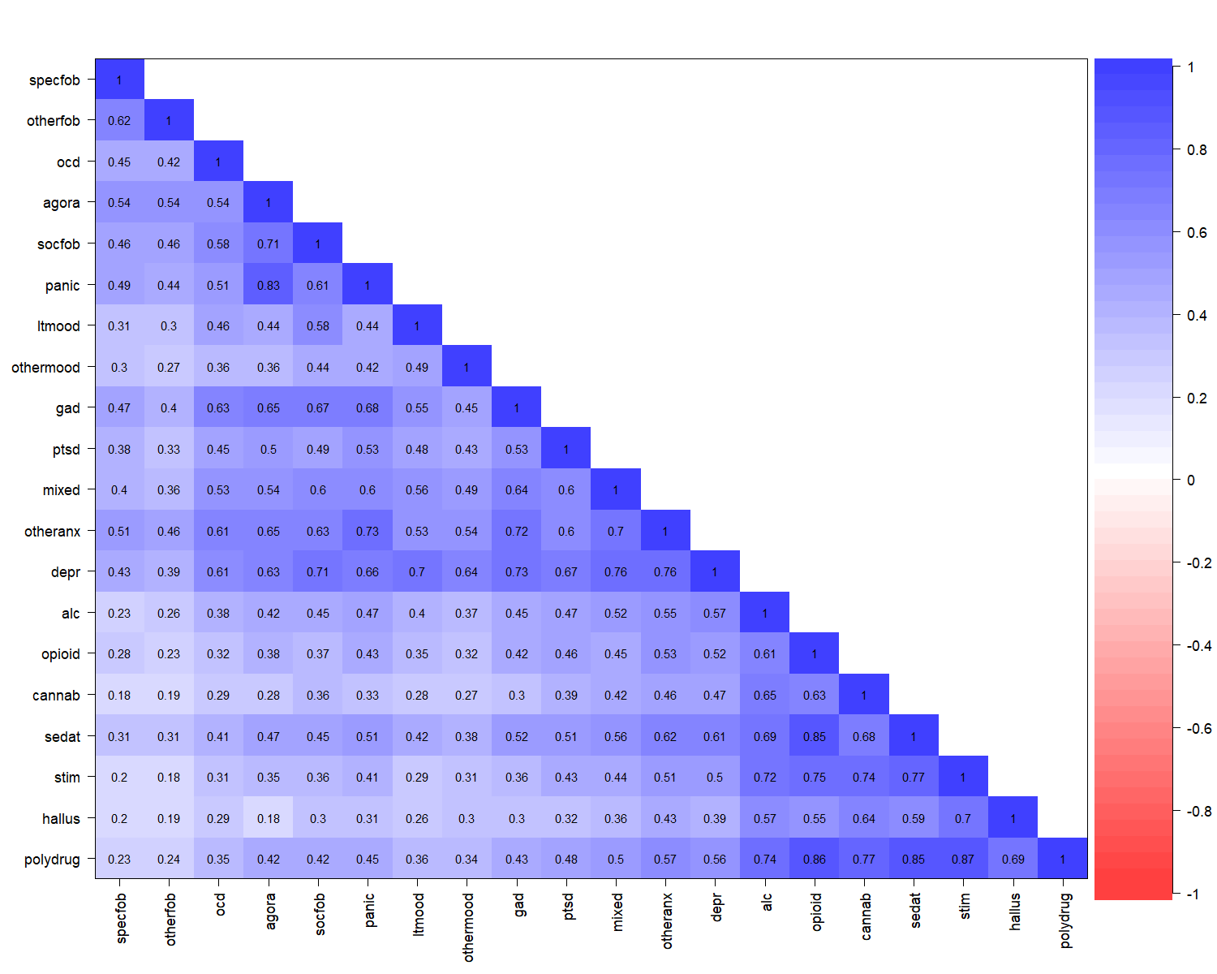

**eFigure 4. Tetrachoric correlation matrix describing the associations between substance misuse and anxiety/depression.** Specfob = Specific phobia; Otherfob = Other phobias; OCD = Obsessive-compulsive disorder; Agora = Agoraphobia; Socfob = Social phobia; Panic = Panic disorder; Ltmood = Persistent mood disorders (F34); Other mood = Mixed/Other mood-related disorders & Mood disorder, not otherwise specified; GAD = Generalized anxiety disorder; PTSD = Post-traumatic stress disorder; Mixed = Mixed anxiety and depression; Otheranx = Anxiety disorder, not otherwise specified & Other anxiety disorders; Depr = Depression; Alc = Alcohol use disorder; Opioid = Opioid use disorder; Cannab = Cannabis use disorder; Sedat = Sedative use disorder; Stim = Cocaine use disorder & stimulant use disorder; Hallus = Inhalant use disorder & hallucinogen use disorder; Polydrug = Other psychoactive substance-related disorders (poly drug use)

**References**

**Caspi A, Houts RM, Belsky DW, Goldman-Mellor SJ, Harrington H, Israel S and Moffitt TE** (2014) The p factor: one general psychopathology factor in the structure of psychiatric disorders?. *Clinical Psychological Science* **2**, 119-137.

**Lahey BB, Krueger RF, Rathouz PJ, Waldman ID and Zald DH** (2017) A hierarchical causal taxonomy of psychopathology across the life span. *Psychological Bulletin* **143**, 142-186.

**Kendler KS, Prescott CA, Myers J and Neale MC** (2003) The structure of genetic and environmental risk factors for common psychiatric and substance use disorders in men and women. *Archives of General Psychiatry* **60**, 929-937.