SUPPLEMENTARY MATERIALS
Table 1. IRT parameters and factor loadings for general worry items in derivation sample.
General worry items | Factor loading | a | b1 | b2 | b3 | b4
I’ve been worrying a lot * | 0.92 | 3.09 | -1.27 | -0.33 | 0.67 | 1.59
In my mind I have been going over problems again and again * | 0.85 | 2.97 | -1.06 | 0.12 | 0.69 | 1.64
I kept thinking about all the things that could go wrong in my life | 0.82 | 2.91 | -0.61 | 0.23 | 1.04 | 1.77
My days have felt taken over by worry | 0.74 | 4.28 | -0.07 | 0.55 | 1.33 | 1.93
I’ve worried about everything | 0.79 | 3.24 | 0.08 | 0.89 | 1.55 | 2.12
I have worried too much | 0.91 | 3.00 | -0.77 | -0.02 | 0.80 | 1.76
Mistakes, dangers, and disasters have been on my mind | 0.60 | 2.20 | -0.48 | 0.43 | 1.18 | 2.07
My worrying has felt out of control | 0.77 | 4.88 | 0.09 | 0.56 | 1.29 | 1.80
There was little I could do to stop worrying * | 0.79 | 3.62 | -0.24 | 0.54 | 1.17 | 1.98
Worry has caused me to feel upset * | 0.83 | 3.36 | -0.60 | 0.10 | 0.93 | 1.78
Worry has made me feel stressed * | 0.94 | 3.56 | -0.77 | -0.08 | 0.78 | 1.59
I have felt sick with worrying | 0.60 | 2.70 | 0.30 | 0.95 | 1.85 | 2.23
Worry has made me feel anxious * | 0.85 | 3.33 | -0.52 | 0.18 | 0.96 | 1.97
Worry has made me feel hopeless * | 0.73 | 3.23 | -0.15 | 0.46 | 1.10 | 1.92
Worry has stopped me focussing on important things in my day * | 0.78 | 2.95 | -0.35 | 0.33 | 1.15 | 1.97
Worry has stopped me sleeping * | 0.69 | 1.62 | -0.44 | 0.57 | 1.66 | 3.03
I have been worrying even though I didn’t want to * | 0.89 | 3.24 | -0.68 | 0.02 | 0.91 | 1.68
Fears have been playing on my mind | 0.80 | 3.14 | -0.49 | 0.22 | 1.01 | 2.02
I felt driven to keep thinking about the things that worry me | 0.77 | 3.27 | -0.25 | 0.43 | 1.16 | 2.09
My mind could not rest because of all my worries | 0.79 | 4.28 | -0.35 | 0.29 | 1.08 | 1.79
Worry has got in the way of my relationships with friends and family | 0.65 | 2.52 | 0.00 | 0.54 | 1.53 | 2.28
Items excluded from IRT analysis
I’ve been a worrier | 0.97
Worrisome thoughts kept going round in my head | 0.87
I have spent a lot of time worrying about the worst happening to me | 0.69
I’ve been thinking about how things will go wrong | 0.78
Even small things made me worry | 0.73
It didn’t take much to get me worried | 0.79
Worrying has been making my problems seem bigger than they are | 0.90
I’ve been thinking about problems but without arriving at any solutions | 0.77
Once I started worrying it has been hard to stop | 0.85
My worries have taken control of me | 0.67
Worry has been causing me to be anxious | 0.89
I’ve been anxious with worry | 0.85
I have felt fed up of worrying | 0.88
Worrying has made me tense | 0.90
Worry has made me feel sad | 0.84
It has been hard to concentrate because of worrying | 0.85
I could not manage my tasks because my mind kept coming back to my worries | 0.77
Worry has stopped me working efficiently | 0.72
Upsetting images have been playing on my mind ¹ | /
Note: a = discrimination, b = difficulty parameters at the category thresholds between 0-1 (b1), 1-2 (b2), 2-3 (b3) and 3-4 (b4).
¹ item deleted from EFA due to cross-loading over 0.3 with paranoid worry factor

Table 2. IRT parameters and factor loadings for paranoia worry items in derivation sample.
Paranoia worry items | Factor loading | a | b₁ | b₂ | b₃ | b₄
I’ve been worrying about someone trying to harm me * | 0.90 | 6.39 | 0.71 | 1.03 | 1.46 | 1.84
Anything and everything has set my mind thinking about people trying to upset me * | 0.85 | 6.24 | 0.70 | 1.04 | 1.44 | 1.80
I’ve not been able to stop thinking about people getting at me. | 0.97 | 10.0 | 0.68 | 1.02 | 1.34 | 1.67
It has been hard to clear my head of suspicions * | 0.71 | 4.33 | 0.56 | 0.94 | 1.27 | 1.75
I have been thinking a lot about someone being hostile towards me. | 0.80 | 4.70 | 0.41 | 0.89 | 1.37 | 1.88
I have been thinking a lot about the attacks on me. | 0.97 | 8.38 | 0.78 | 1.10 | 1.47 | 1.78
Worries about someone trying to harm me have been really hard to control * | 1.00 | 9.57 | 0.80 | 1.13 | 1.36 | 1.81
Thinking about the possible attacks on me has made me feel stressed. * | 0.94 | 7.05 | 0.76 | 0.99 | 1.41 | 1.74
Fears about harm from another person have been going round and round my mind. | 0.97 | 8.29 | 0.73 | 1.04 | 1.44 | 1.68
Items excluded from IRT analysis
My mind has been full of thoughts of someone getting at me | 0.82
Thoughts about someone threatening me have been going round my mind | 0.89
Suspicions have been going around my head | 0.68
Worries about what someone is doing to me have been really upsetting me | 0.82
I have been thinking a lot about bad rumours about me. | 0.62
It’s been hard to sleep because of thinking about my fears ¹ | /
Whether others will be nasty to me has been in my thoughts a lot ¹ | /
Note: a = discrimination, b = difficulty parameters at the category thresholds between 0-1 (b1), 1-2 (b2), 2-3 (b3) and 3-4 (b4).
¹ item deleted from EFA due to cross-loading over 0.3 with paranoid worry factor

 | DWQ |  |  | PSWQ |  |  | PWQ |  |  | GPTS
ID | Pre | Post | RCI | Pre | Post | RCI | Pre | Post | RCI | Pre | Post | RCI
1 | 29 | 7 | -10.4* | 55 | 39 | -4.07* | 15 | 6 | -6.33* | 65 | 26 | -13.0*
2 | 28 | 22 | -2.82* | 67 | 62 | -1.27 | 12 | 6 | -4.22* | 51 | 38 | -4.32*
3 | 28 | 28 | 0.00 | 51 | 56 | 1.27 | 15 | 15 | 0.00 | 61 | 66 | 1.66
4 | 31 | 35 | 1.88 | 71 | 70 | -0.25 | 19 | 18 | -0.70 | 72 | 72 | 0
5 | 39 | 21 | -8.47* | 80 | 54 | -6.62* | 20 | 11 | -6.33* | 77 | 64 | -4.32*
6 | 27 | 9 | -8.47* | 54 | 50 | -1.02 | 13 | 6 | -4.93* | 67 | 55 | -3.99*
7 | 29 | 17 | -5.65* | 69 | 56 | -3.31* | 13 | 10 | -2.11* | 43 | 45 | 0.66
8 | 24 | 21 | -1.41 | 52 | 42 | -2.55* | 15 | 9 | -4.22* | 60 | 35 | -8.30*
9 | 35 | 33 | -0.94 | 59 | 53 | -1.52 | 20 | 10 | -7.04* | 64 | 45 | -6.31*
10 | 19 | 37 | 8.47* | 55 | 49 | -1.53 | 11 | 8 | -2.11* | 64 | 25 | -13.0*
11 | 31 | 25 | -2.82* | 69 | 63 | -1.53 | 15 | 12 | -2.11* | 71 | 62 | -2.99*
12 | 28 | 19 | -4.24* | 67 | 54 | -3.31* | 10 | 8 | -1.41 | 54 | 31 | -7.64*
Reliable change index (RCI)
Table 3. RCIs of the difference between baseline and 8-week follow up for participants who received the worry intervention.
* RCI greater than +/- 1.96 indicates a significant change in score (p<.05) between the two time points given the reliability of each measure.
ROC analysis
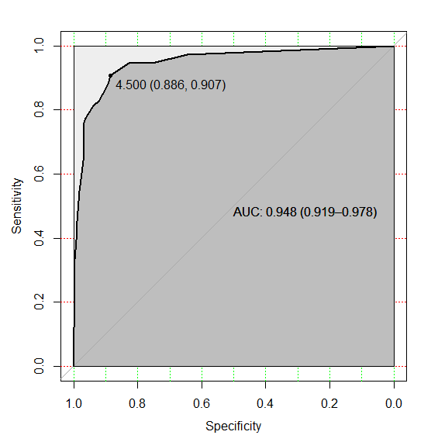
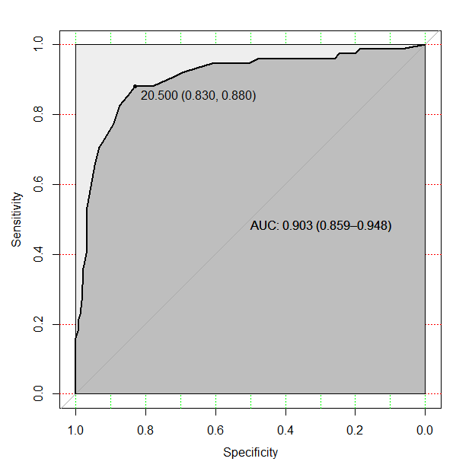
Figure 1. ROC curves for a) Dunn Worry Questionnaire and b) Paranoia Worries Questionnaire. The area under the curve (AUC) is shown with 95% CIs. The optimal cut-off threshold is marked at the upper left of each curve with specificity and sensitivity in parentheses.

sTable 4. Sensitivity and specificity for different total score cut-offs for the GWS and SWS. Optimal cut-offs in bold and 95% confidence intervals in parentheses.
Total Score | Sensitivity (Se) | Se 95% CI | Specificity | 95% CI
Dunn Worry Questionnaire
19 | 0.91 | 0.84-0.96 | 0.72 | 0.65-0.78
20 | 0.88 | 0.80-0.95 | 0.78 | 0.73-0.83
21 | 0.88 | 0.81-0.95 | 0.83 | 0.78-0.87
22 | 0.85 | 0.77-0.93 | 0.85 | 0.80-0.90
23 | 0.83 | 0.73-0.91 | 0.87 | 0.83-0.92
Paranoia Worries Scale
4 | 0.95 | 0.90-0.99 | 0.84 | 0.79-0.88
5 | 0.94 | 0.87-0.99 | 0.86 | 0.81-0.90
6 | 0.92 | 0.86-0.97 | 0.88 | 0.84-0.92
7 | 0.90 | 0.82-0.96 | 0.89 | 0.85-0.92
8 | 0.90 | 0.83-0.96 | 0.89 | 0.86-0.93

