Supplementary Material

Ethical Approval

The FemNAT-CD study (Freitag, 2014; www.femnat-cd.eu) was conducted in accordance with legal
regulations outlined by the European Union, national legislation and the Declaration of Helsinki.
Study protocols were approved by ethical committees relevant to each site prior to data collection:
RWTH Aachen University Hospital (EK027/14) for the Aachen site, the Ethics Commission
Northwest and Central Switzerland (EKNZ: 336/13) for the Basel site, and the University
Ethics Committee (ERGO Number: 18970) and the National Health Service Research Ethics
Committee (NRES Committee West Midlands, Edgbaston; REC Reference 13/WM/0483) for the two
UK sites (Birmingham and Southampton).

Site qualification procedure for MRI data
Acquiring magnetic resonance imaging (MRI) data across multiple centres can introduce significant variability in the data and analysis (e.g., different image quality). Functional, structural and diffusion MRI scans were acquired using a Phillips 3T (Birmingham: Achieva) and Siemens 3T (Southampton: Tim Trio; Basel, and Aachen: PRISMA) scanners with actively shielded magnetic field gradients (maximum amplitude 40 mT/m), using a 32 (Southampton and Birmingham) or 20 (Aachen and Basel) channel head coils. Therefore, to ensure comparability of structural and diffusion MRI data between the four sites, each site standardised their protocol for image acquisition and went through a site qualification procedure. The procedure included the scanning of two phantoms: an American College of Radiology phantom (to assess structural MRI sequences), as well as scanning a human volunteer. Once collected, the images were reviewed by the same, experienced MRI physicist (based in Birmingham), and each site adjusted the scanning parameters according to the physicist’s recommendations until the protocols were equivalent and if necessary, scanning artefacts had been corrected. The sites were not allowed to start data acquisition until they had successfully passed this site qualification.
The total sample of participants of the FemNAT-CD study that underwent a diffusion MRI scan were 325 children and adolescents (UOS=98, UOB=82, UKAACHEN=86, UNIBAS=59) aged 9-18 years. However, due to previous findings showing brain anatomical changes as well as changes in white matter integrity during childhood and adolescence especially in fronto-limbic regions (Casey et al., 2008) , this study excluded children age 9 to 12 (n = 57), leaving a sample of 268. Data were then inspected for image quality and to ensure that whole brain coverage was achieved. This led us to exclude a further 9 participants. Further, residuals to the tensor fit were inspected for outlying data points (described below), and those with significant artefacts (e.g., head movement) visible in their scans were excluded from the analysis (n = 19).
Match is a computer program that facilitates the process of matching large group of items and participants in large data sets. Match is a fully automated command-line program that operates through an algorithm (van Casteren & Davis, 2007). Thus, we further used Match to select an IQ-, age- and gender-matched sample by excluding participants with high and low values of IQ and age from each group (CD and HC). Following this procedure, we ended up with a final sample of 200 adolescents: 101 with conduct disorder (52 females) and 99 healthy controls (50 females).

Table S1. Distribution of participants and numbers in each group across the four sites
Note: CD; Conduct disorder, HC; healthy controls, UOS; University of Southampton, UOB; University of Birmingham, GU; Goethe University Frankfurt, UKAACHEN; University Hospital Aachen, and UNIBAS, University of Basel. Differences between sites were tested using a Chi Square test.
 | UKAACHEN  (n=54) | UOS  (n=64) | UNIBAS  (n=46) | UOB  (n=36) | Total  (n=200) | X2=27.80 (0.001)
CD males | 14 | 18 | 4 | 13 | 49
HC males | 14 | 18 | 4 | 13 | 49
CD females | 14 | 14 | 19 | 5 | 52
HC females | 12 | 24 | 19 | 5 | 50

Table S2 Sex-by-diagnosis interaction on measures of white-matter structural connectivity
Key: FA, fractional anisotropy; HMOA, hindrance modulated orientational anisotropy; SGC, subgenual cingulum; RSC, retrosplenial cingulum; PHC, parahippocampal cingulum and UF, uncinate fasciculus; N/A, not applicable.
S.D. ×10−3mm2/s.
 |  |  | Healthy Controls |  | Conduct Disorder
 | Parameter |  | Male (Mean ± SD)  n=49 | Female (Mean ± SD)  n=50 | Male  n=49 | Female  n=52 | T | P | pFDR | ηp²
SGC | FA | Right | 0.433±0.039 | 0.420±0.043 | 0.431±0.036 | 0.4170±0.038 | -0.176 | 0.861 | 0.88 | 0.0001
 | HMOA |  | 0.103±0.016 | 0.098±0.019 | 0.102±0.016 | 0.096±0.016 | -0.215 | 0.83 | 0.90 | 0.0002
 | FA | Left | 0.412±0.048 | 0.404±0.04 | 0.414±0.045 | 0.407±0.043 | 0.157 | 0.875 | 0.88 | 0.001
 | HMOA |  | 0.091±0.017 | 0.087±0.014 | 0.092±0.018 | 0.088±0.016 | 0.12 | 0.905 | 0.90 | 0.001
RSC | FA | Right | 0.520±0.033 | 0.500±0.030 | 0.505±0.031 | 0.507±0.028 | 2.755 | 0.006 | 0.05 | 0.038
 | HMOA |  | 0.132±0.018 | 0.121±0.015 | 0.125±0.018 | 0.124±0.016 | 2.7 | 0.038 | 0.21 | 0.022
 | FA | Left | 0.491±0.038 | 0.484±0.030 | 0.484±0.027 | 0.487±0.027 | 1.29 | 0.199 | 0.60 | 0.009
 | HMOA |  | 0.116±0.018 | 0.110±0.014 | 0.110±0.014 | 0.112±0.010 | 1.995 | 0.047 | 0.21 | 0.02
PHC | FA | Right | 0.418±0.041 | 0.425±0.028 | 0.420±0.037 | 0.419±0.029 | -0.814 | 0.417 | 0.75 | 0.003
 | HMOA |  | 0.076±0.011 | 0.076±0.008 | 0.078±0.010 | 0.076±0.009 | -0.793 | 0.429 | 0.55 | 0.003
 | FA | Left | 0.420±0.040 | 0.424±0.031 | 0.413±0.041 | 0.423±0.028 | 0.632 | 0.528 | 0.79 | 0.002
 | HMOA |  | 0.079±0.012 | 0.078±0.009 | 0.087±0.064 | 0.078±0.008 | -0.859 | 0.391 | 0.55 | 0.004
UF | FA | Right | 0.414±0.029 | 0.417±0.032 | 0.421±0.028 | 0.411±0.028 | -1.55 | 0.12 | 0.56 | 0.012
 | HMOA |  | 0.076±0.010 | 0.076±0.010 | 0.078±0.009 | 0.074±0.008 | -1.8 | 0.07 | 0.22 | 0.017
 | FA | Left | 0.43±0.024 | 0.422±0.024 | 0.428±0.026 | 0.416±0.024 | -1.04 | 0.30 | 0.68 | 0.006
 | HMOA |  | 0.081±0.008 | 0.078±0.008 | 0.082±0.009 | 0.076±0.008 | -1.54 | 0.13 | 0.28 | 0.012
Fornix | FA | N/A | 0.414±0.022 | 0.413±0.016 | 0.417±0.023 | 0.413±0.015 | -0.354 | 0.724 | 0.88 | 0.001
 | HMOA |  | 0.099±0.012 | 0.100±0.010 | 0.102±0.013 | 0.099±0.009 | -1.066 | 0.288 | 0.52 | 0.006
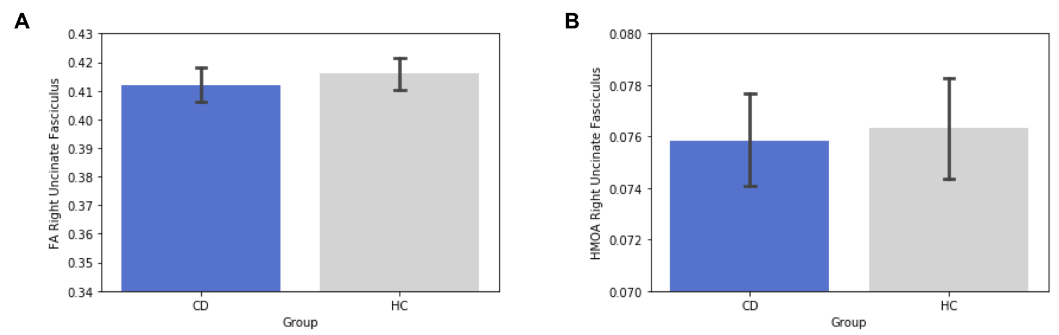
Figure S1. Main effects of diagnosis in the right Uncinate Fasciculus after factoring out ADHD symptoms. A) Main effects of diagnosis in Fractional Anisotropy values of the right Uncinate Fasciculus. B) Main effect of diagnosis in the hindrance Modulated Orientational Anisotropy values of the right Uncinate Fasciculus. Error bars show 95% confidence intervals of the mean. HC, healthy control; CD, conduct disorder; ADHD, attention deficit hyperactivity disorder.

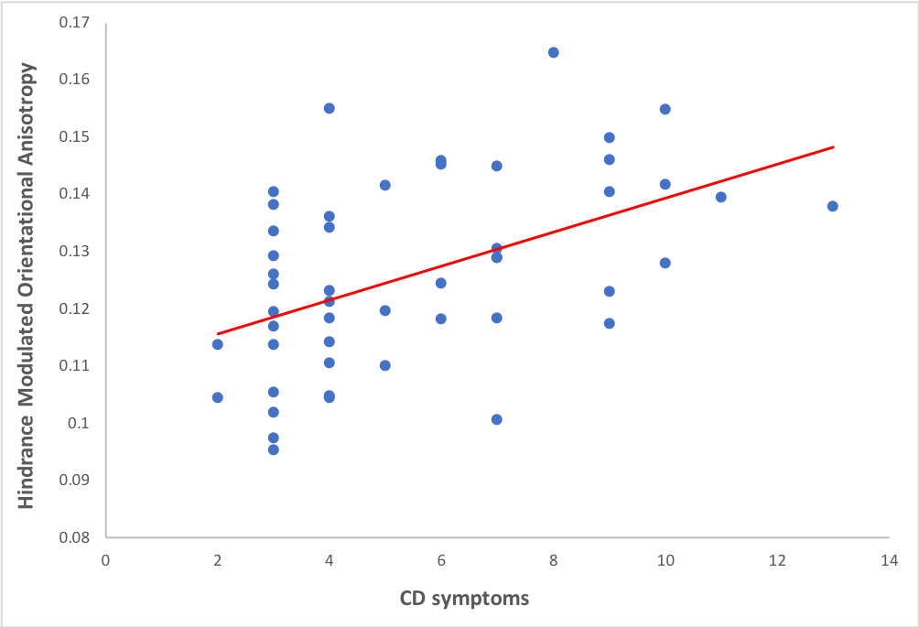
Figure S2. Association between CD symptoms and hindrance modulated orientational anisotropy (HMOA) in the right retrosplenial cingulum in the male CD group. There was a significant positive correlation between CD symptoms and HMOA values in the right retrosplenial cingulum tract.

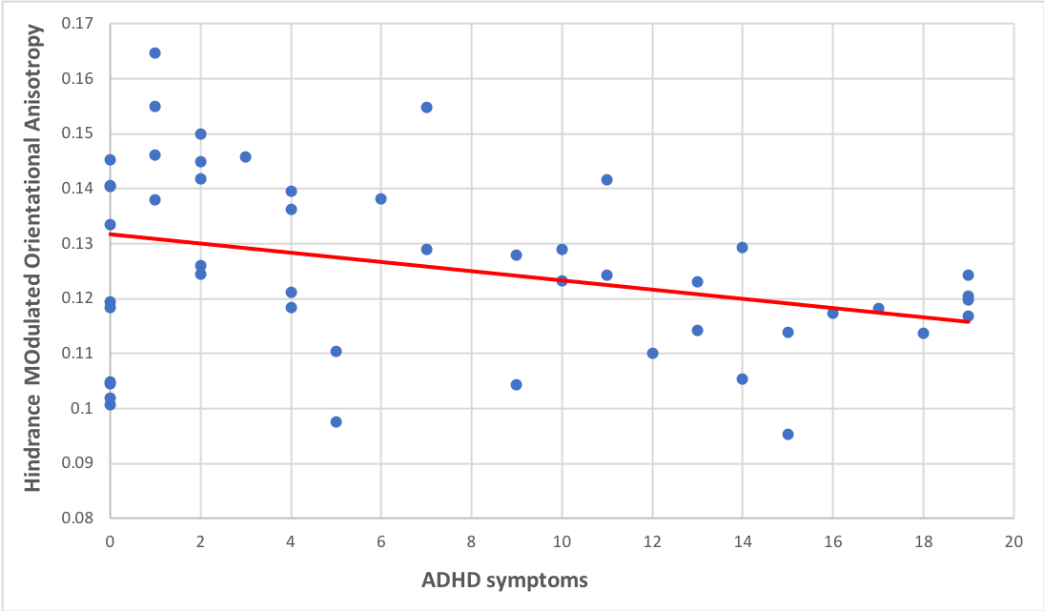
Figure S3. Association between ADHD symptoms and hindrance modulated orientational anisotropy (HMOA) in the right retrosplenial cingulum in the male CD group. There was a significant negative correlation between CD symptoms and HMOA values in the right retrosplenial cingulum tract.

