Supplementary figure 1: Kaplan-Meier Survival curves for all-cause and CVD mortality, stratified by sex.
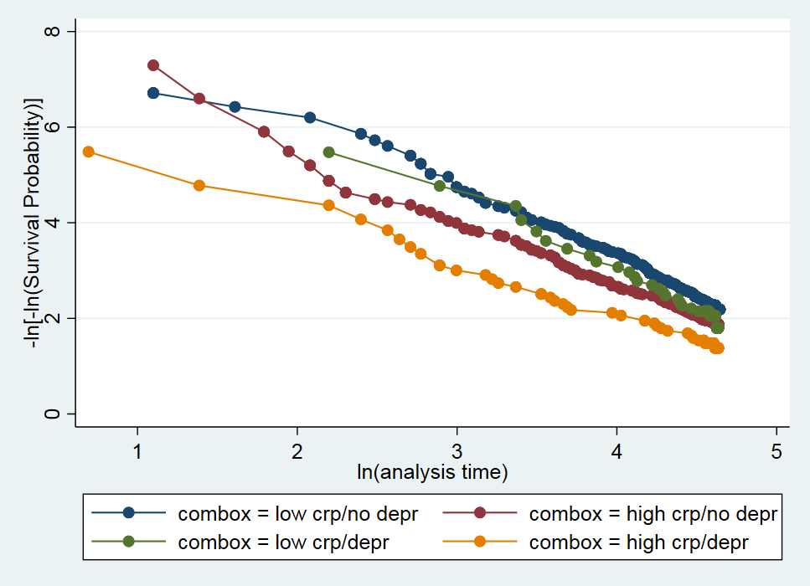
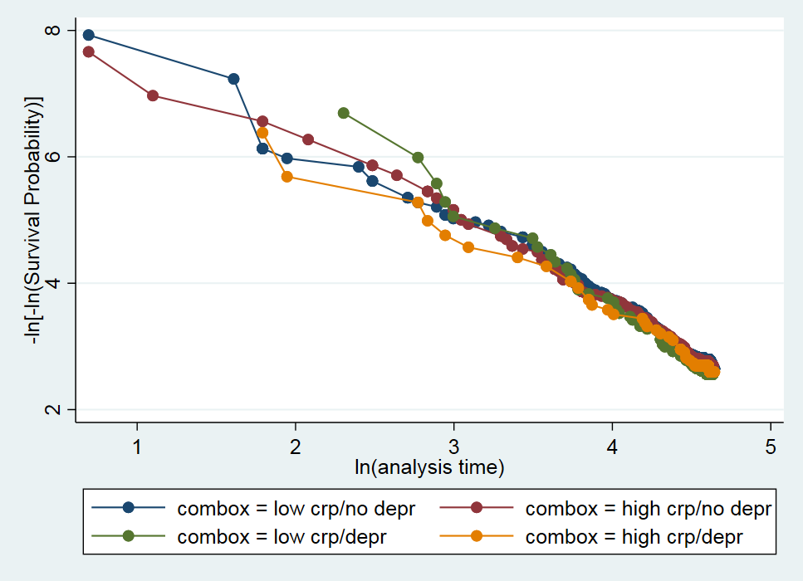
(A) (B)

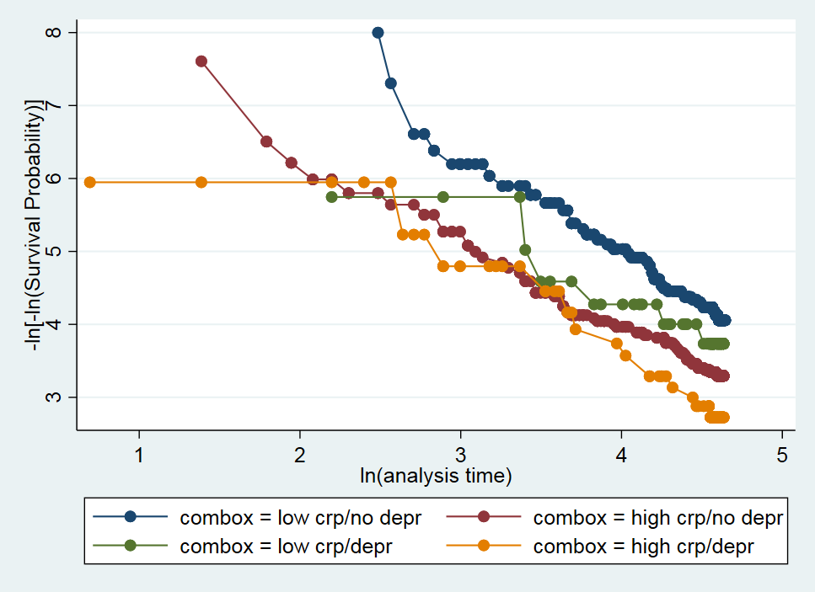
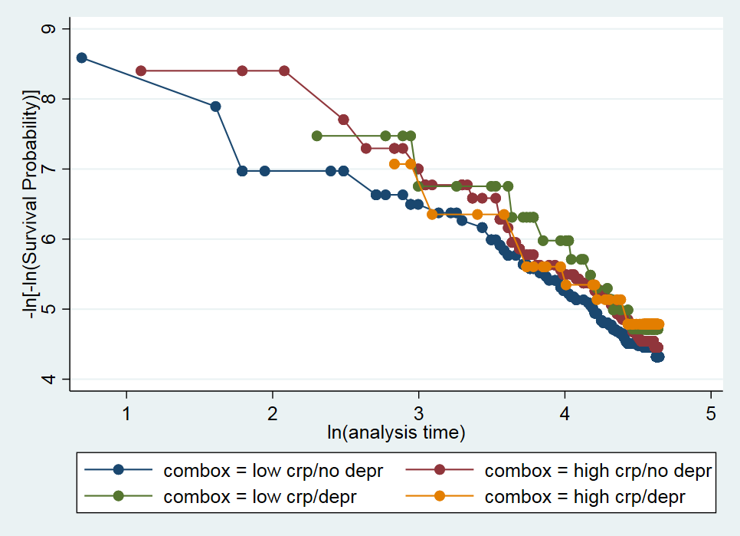
(C) (D)

CRP = C-reactive protein; depr = depressive symptoms; CVD = cardiovascular disease. (A) = all-cause mortality in men; (B) = all-cause mortality in women; (C) = CVD mortality in men; (D) = CVD mortality in women.

