SUPPLEMENTAL GRAPHS FOR THESE OUTCOMES ON FOLLOWING PAGES:

- Average of DRSP Core Emotional Symptoms
- Anhedonia
- Depression
- Anxiety
- Mood Swings
- Emotional Overwhelm
- Physical Symptoms
- Rejection Sensitivity
- Shame
- Anger/Irritability
- Anger Rumination

SUPPLEMENTAL GRAPH: AVERAGE CORE EMOTIONAL SYMPTOMS

PANEL A

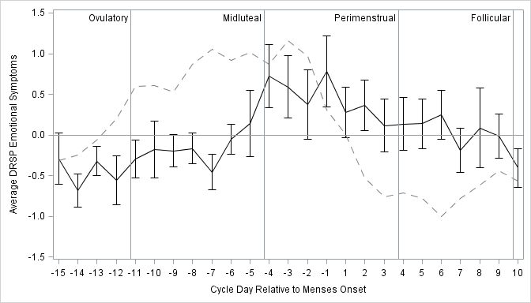

PANEL B

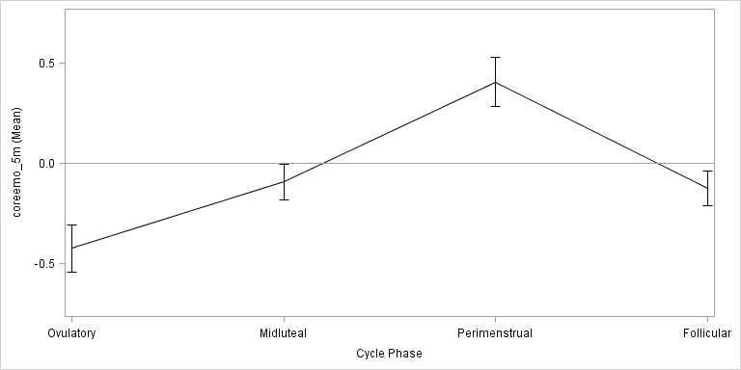

Person-Standardized Progesterone (dashed line) and Average Emotional Symptoms Across Menstrual Cycle Day (Panel A) and Person-Standardized Emotional Symptoms Across Cycle Phase (Panel B) in 15 People with BPD.

SUPPLEMENTAL GRAPH: ANHEDONIA

PANEL A

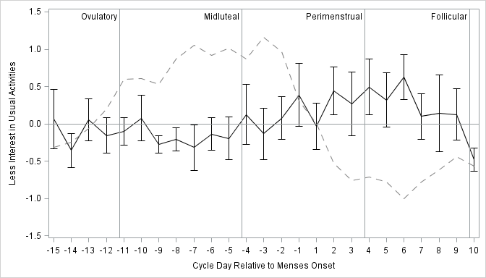

PANEL B

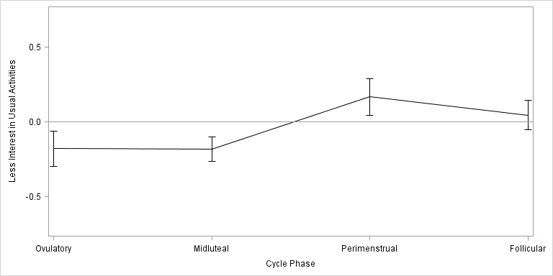

Person-Standardized Progesterone (dashed line) and Anhedonia Across Menstrual Cycle Day (Panel A) and Person-Standardized Anhedonia Across Cycle Phase (Panel B) in 15 People with BPD.

SUPPLEMENTAL GRAPH: DEPRESSION

PANEL A

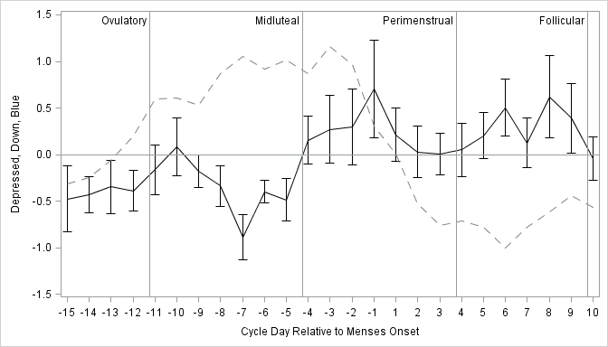

PANEL B

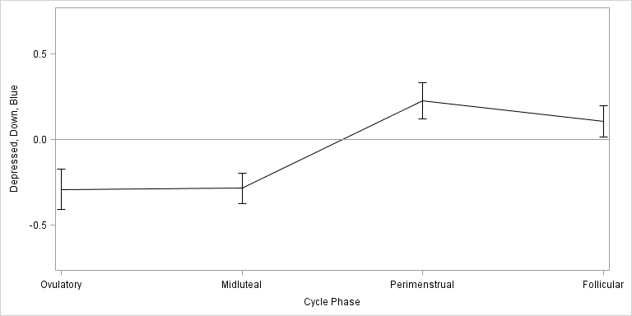

Person-Standardized Progesterone (dashed line) and Depression Across Menstrual Cycle Day (Panel A) and Person-Standardized Depression Across Cycle Phase (Panel B) in 15 People with BPD.

SUPPLEMENTAL GRAPH: ANXIETY

PANEL A

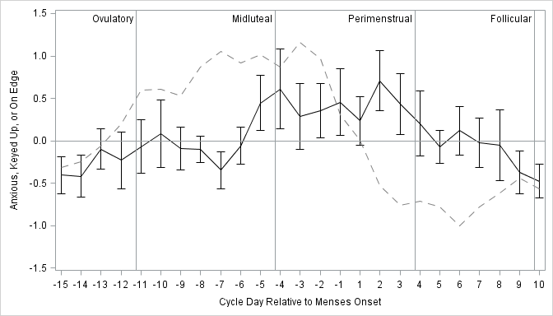

PANEL B

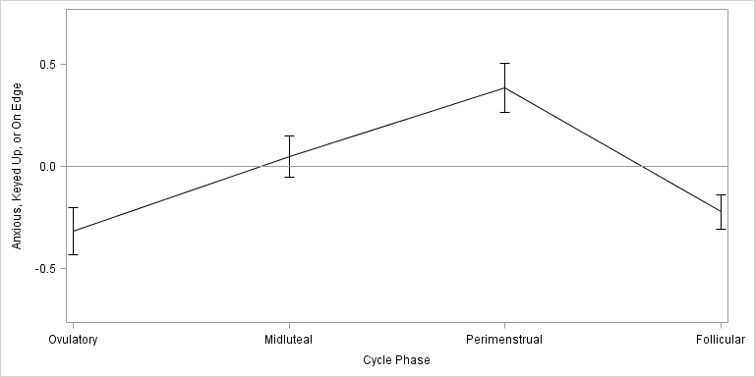

Person-Standardized Progesterone (dashed line) and Anxiety Across Menstrual Cycle Day (Panel A) and Person-Standardized Anxiety Across Cycle Phase (Panel B) in 15 People with BPD.

SUPPLEMENTAL GRAPH: MOOD SWINGS

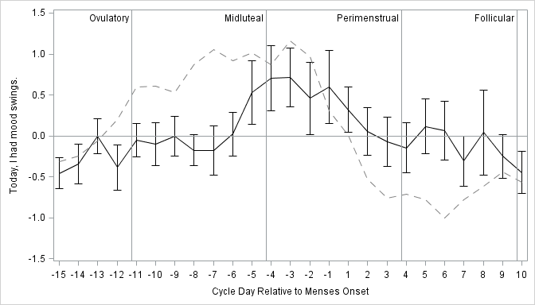
PANEL A

PANEL B

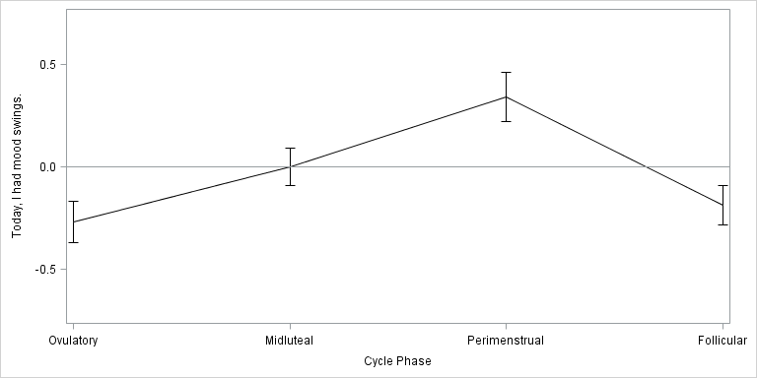

Person-Standardized Progesterone (dashed line) and Mood Swings Across Menstrual Cycle Day (Panel A) and Person-Standardized Mood Swings Across Cycle Phase (Panel B) in 15 People with BPD.

SUPPLEMENTAL GRAPH: EMOTIONAL OVERWHELM

PANEL A

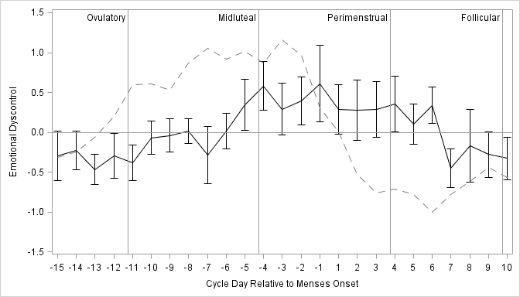

PANEL B

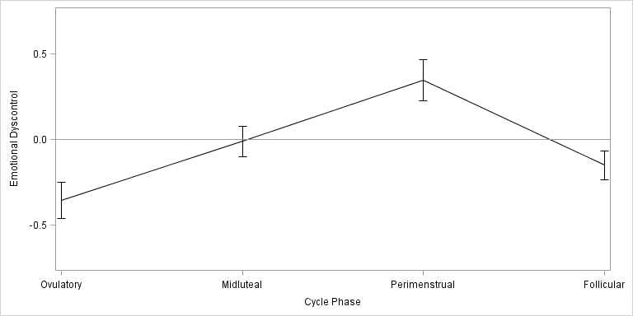

Person-Standardized Progesterone (dashed line) and Emotional Dyscontrol Across Menstrual Cycle Day (Panel A) and Person-Standardized Emotional Dyscontrol Across Cycle Phase (Panel B) in 15 People with BPD.

SUPPLEMENTAL GRAPH: PHYSICAL SYMPTOMS

PANEL A

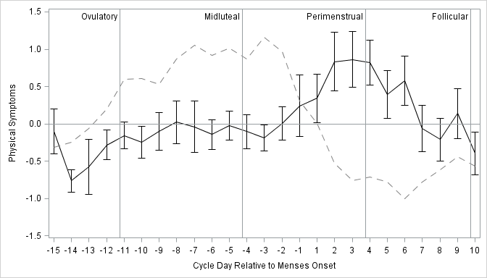

PANEL B

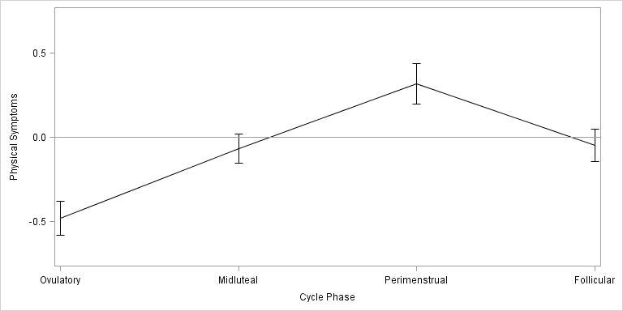

Person-Standardized Progesterone (dashed line) and Physical Symptoms Across Menstrual Cycle Day (Panel A) and Person-Standardized Physical Symptoms Across Cycle Phase (Panel B) in 15 People with BPD.

SUPPLEMENTAL GRAPH: REJECTION SENSITIVITY

PANEL A

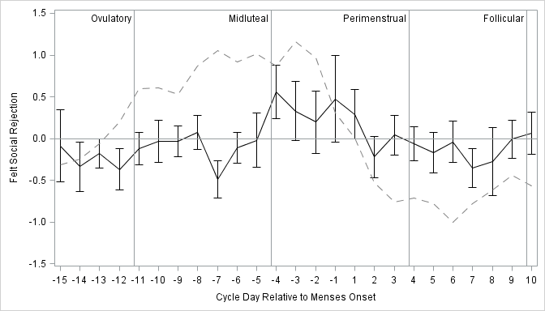

PANEL B

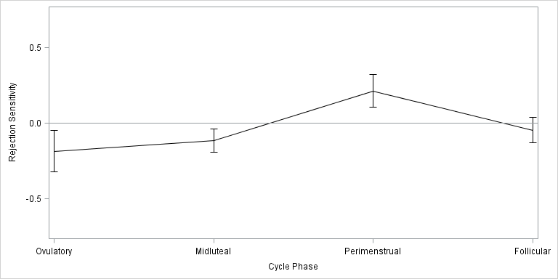

Person-Standardized Progesterone (dashed line) and Rejection Sensitivity Across Menstrual Cycle Day (Panel A) and Person-Standardized Rejection Sensitivity Across Cycle Phase (Panel B) in 15 People with BPD.

SUPPLEMENTAL GRAPH: SHAME

PANEL A

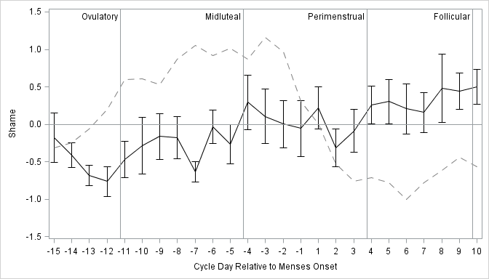

PANEL B

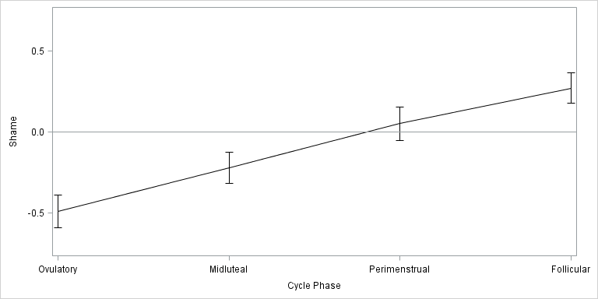

Person-Standardized Progesterone (dashed line) and Shame Across Menstrual Cycle Day (Panel A) and Person-Standardized Shame Across Cycle Phase (Panel B) in 15 People with BPD.

SUPPLEMENTAL GRAPH: ANGER/IRRITABILITY

PANEL A

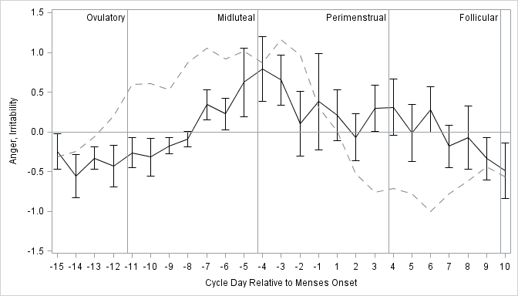

PANEL B

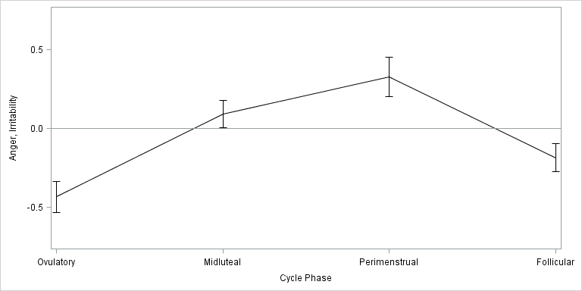

Person-Standardized Progesterone (dashed line) and Anger/Irritability Across Menstrual Cycle Day (Panel A) and Person-Standardized Anger/Irritability Across Cycle Phase (Panel B) in 15 People with BPD.

SUPPLEMENTAL GRAPH: ANGER RUMINATION

PANEL A

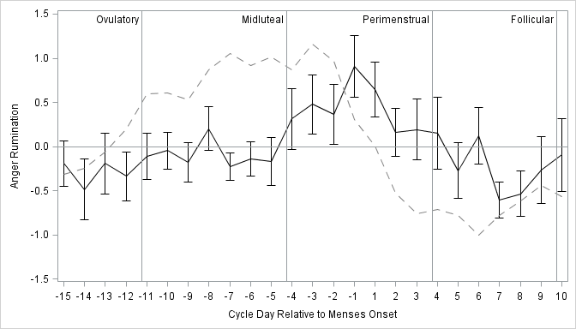

PANEL B

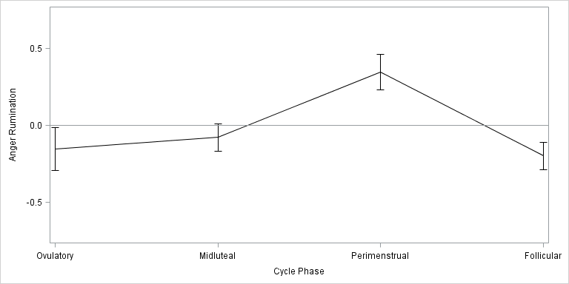

Person-Standardized Progesterone (dashed line) and Anger Rumination Across Menstrual Cycle Day (Panel A) and Person-Standardized Anger Rumination Across Cycle Phase (Panel B) in 15 People with BPD.

