Table S1. Modularity in patients with schizophrenia and healthy controls
Modules in healthy controls
Module 1 | Module 2 | Module 3 | Module 4 | Module 5
Precentral_L  Precentral_R  Frontal_Sup_L  Frontal_Sup_R  Frontal_Sup_Orb_L  Frontal_Sup_Orb_R  Frontal_Mid_L  Frontal_Mid_R  Frontal_Mid_Orb_L  Frontal_Inf_Oper_L  Frontal_Inf_Oper_R  Frontal_Inf_Tri_L  Frontal_Inf_Tri_R  Frontal_Inf_Orb_L  Frontal_Inf_Orb_R  Rolandic_Oper_L  Rolandic_Oper_R  Supp_Motor_Area_L  Supp_Motor_Area_R  Frontal_Sup_Medial_L  Frontal_Sup_Medial_R  Frontal_Med_Orb_L  Insula_L  Insula_R  Cingulum_Ant_L  Cingulum_Ant_R  Cingulum_Mid_L  Cingulum_Mid_R  Lingual_L  Parietal_Sup_R  Paracentral_Lobule_L  Paracentral_Lobule_R  Heschl_L  Heschl_R  Temporal_Sup_L | Olfactory_L  Olfactory_R  Frontal_Med_Orb_R  Rectus_L  Rectus_R  Hippocampus_L  Hippocampus_R  ParaHippocampal_L  ParaHippocampal_R  Amygdala_L  Amygdala_R  Fusiform_L  Fusiform_R  Caudate_L  Caudate_R  Temporal_Pole_Sup_L  Temporal_Pole_Sup_R  Temporal_Mid_L  Temporal_Mid_R  Temporal_Pole_Mid_L  Temporal_Pole_Mid_R  Temporal_Inf_L  Temporal_Inf_R | Calcarine_L  Calcarine_R  Cuneus_L  Cuneus_R  Lingual_R  Occipital_Sup_L  Occipital_Sup_R | Frontal_Mid_Orb_R  Cingulum_Post_L  Cingulum_Post_R  Occipital_Mid_L  Occipital_Mid_R  Occipital_Inf_L  Occipital_Inf_R  Postcentral_L  Postcentral_R  Parietal_Sup_L  Parietal_Inf_L  Parietal_Inf_R  SupraMarginal_L  SupraMarginal_R  Angular_L  Angular_R  Precuneus_L  Precuneus_R  Temporal_Sup_R | Putamen_L  Putamen_R  Pallidum_L  Pallidum_R  Thalamus_L  Thalamus_R

Modules in patients with schizophrenia
Module 1 | Module 2 | Module 3 | Module 4 | Module 5 | Module 6 | Module 7
Frontal_Inf_Oper_L  Frontal_Inf_Oper_R  Frontal_Inf_Tri_L  Frontal_Inf_Tri_R  Frontal_Inf_Orb_L  Rolandic_Oper_L  Rolandic_Oper_R  Frontal_Sup_Medial_L  Cingulum_Post_L  Cingulum_Post_R  Occipital_Mid_L  Occipital_Inf_L  Fusiform_L  Postcentral_L  Postcentral_R  Parietal_Inf_L  Parietal_Inf_R  SupraMarginal_L  SupraMarginal_R  Angular_L  Angular_R  Precuneus_L  Precuneus_R  Heschl_L  Heschl_R  Temporal_Sup_R  Temporal_Mid_R  Temporal_Inf_L  Temporal_Inf_R | Precentral_L  Precentral_R  Frontal_Sup_L  Frontal_Sup_Orb_R  Frontal_Mid_L  Frontal_Mid_R  Frontal_Mid_Orb_L  Frontal_Mid_Orb_R  Frontal_Inf_Orb_R  Supp_Motor_Area_L  Frontal_Sup_Medial_R  Frontal_Med_Orb_L  Frontal_Med_Orb_R  Cingulum_Ant_R  Cingulum_Mid_L  Cingulum_Mid_R  Calcarine_L  Calcarine_R  Cuneus_L  Cuneus_R  Lingual_L  Lingual_R  Occipital_Sup_L  Occipital_Sup_R  Occipital_Mid_R  Occipital_Inf_R  Fusiform_R  Paracentral_Lobule_L  Paracentral_Lobule_R  Temporal_Sup_L | Parietal_Sup_L  Parietal_Sup_R | Caudate_L  Caudate_R | Putamen_L  Putamen_R  Pallidum_L  Pallidum_R | Thalamus_L  Thalamus_R | Frontal_Sup_R  Frontal_Sup_Orb_L  Supp_Motor_Area_R  Olfactory_L  Olfactory_R  Rectus_L  Rectus_R  Insula_L  Insula_R  Cingulum_Ant_L  Hippocampus_L  Hippocampus_R  ParaHippocampal_L  ParaHippocampal_R  Amygdala_L  Amygdala_R  Temporal_Pole_Sup_L  Temporal_Pole_Sup_R  Temporal_Mid_L  Temporal_Pole_Mid_L  Temporal_Pole_Mid_R

Supplemental Section: Effect of antipsychotics on topological properties

A number of observations from experimental animal studies⁴ and human observational studies from adults with schizophrenia ^{5–8} have indicated that certain antipsychotics may contribute to progressive loss of brain tissue. The evidence is less conclusive for atypical antipsychotics ^{7,9}. In the current sample, all patients received atypical antipsychotics.
Cumulative exposure to antipsychotics is likely to be more influential on the brain morphology than the current stable dose. In the current study, we did not have the longitudinal information on the exact cumulative dose prescription or intake before the scans. Further, we also lacked any data on the individual concordance levels of the prescribed antipsychotics. Therefore, in line with our previous studies^{11,12}, we approximated the cumulative antipsychotic exposure, using a product of define daily dose (DDD) and duration of illness since the time of first presentation with psychotic episode, determined from patients’ case notes. This index can be taken as an approximate measure of lifetime antipsychotic exposure (ALAE).
We sought to study the relationship between structural covariance and cumulative antipsychotic dose exposure (ALAE) using a liberal threshold of p=0.1, with no correction for multiple testing.
To further delineate the effect of approximate lifetime exposure of antipsychotics on topology of covariance, we constructed two association matrices for patient sample thresholded at minimum density for full connectivity. The first association matrix was obtained without adjusting for the effect of approximate lifetime exposure of antipsychotic dose. The second matrix was obtained after linearly adjusting for the effect of approximate lifetime exposure of antipsychotic dose (i.e. regressing out across-subject differences in ALAE in the patient sample and using residuals to compute 90*90 correlation matrix). From these two change matrices, we derived a differential matrix (∆r) by subtracting one from the other. Of the 4005 cells (90*89/2), less than 5% had a difference in coefficients >0.1, suggesting that the effect of lifetime antipsychotic exposure on structural covariance affects a small number of associations.

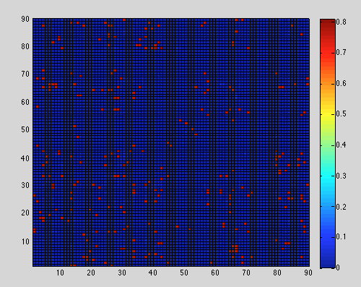
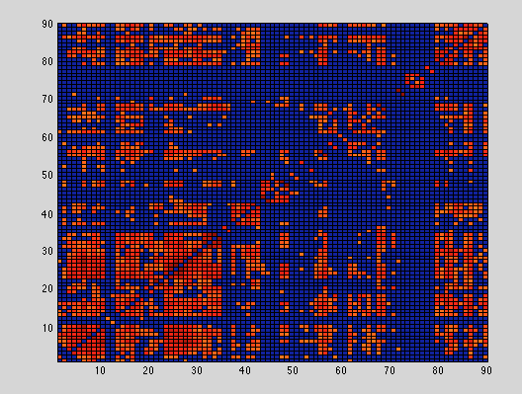
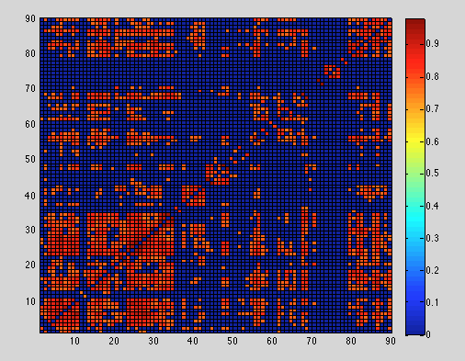
C
B
A

Figure S1: Effect of approximate lifetime exposure of antipsychotics on topology of covariance: Correlation matrices for patient sample thresholded at minimum density for full connectivity. A) Association matrix without adjusting for the effect of approximate lifetime exposure of antipsychotic dose. B) Matrix linearly adjusted for the effect of approximate lifetime exposure of antipsychotic dose. Colour bar indicates absolute correlation coefficients (varying from 0 to 1). C) Absolute matrix obtained from subtracting A and B (∆r).

Though a large number of pairwise correlations were relatively unaffected by ALAE, to further clarify if this subtle effect of antipsychotic exposure has indeed any effect on the topological properties of the covariance matrix, we obtained the global network topological measures at the minimum density of full connectivity for both ALAE-adjusted and non-adjusted networks. Comparison of these values using the same permutation approach described in the manuscript did not reveal any significant differences between the two networks for small-worldness, mean global and global efficiency, clustering coefficient, and targeted and random attack metrics (all p>0.39). These comparisons were undertaken without FDR correction to enable detection of even weak effects.

Table S2: Effect of antipsychotics on topological properties

 | Network unadjusted for ALAE | Network linearly adjusted for ALAE
Measures of Segregation
Clustering Coefficient | 0.7463 | 0.7476
Measures of Integration
Global Efficiency | 0.6176 | 0.6207
Measures of resilience
Targeted Attack
Mean relative size of remaining large component | 37.5% | 36.7%
Mean relative global efficiency | 22.3% | 22.2%
Random Attack
Mean relative size of remaining large component | 47.9% | 47.8%
Mean relative global efficiency | 31.8% | 31.5%

In summary, the negative results despite our extensive approach to relate available antipsychotic treatment data to covariance of longitudinal changes suggests that the reported topology of covariance is unlikely to be due antipsychotic use. Of note, while a number of rigorous studies have examined the effect of antipsychotics on structural changes in schizophrenia, to our knowledge there are no reports on how cumulative antipsychotic exposure affects the structural covariance among various brain regions in schizophrenia.

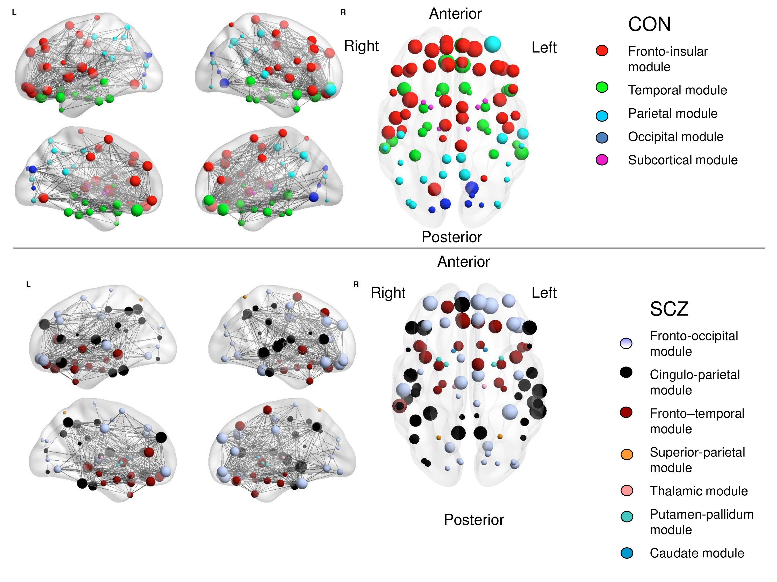

Figure S2: Graphical representation of gray matter connectomes. Connectomes in controls and schizophrenic patients are visualized using BrainNet viewer (www.nitrc.org/projects/bnv). The modules are color-coded separately for each network in the online version of this image. The size of the nodes is proportional to the nodal degree (number of edges) within each connectome.

Supplemental Section: Voxel Based Morphometric Differences between controls and patients with schizophrenia
The whole-brain grey matter VBM analyses revealed 13 clusters which were reduced in patients with schizophrenia compared to healthy controls using an uncorrected threshold of p < .01 with a cluster extent of 100 voxels. Largest clusters were found in the cingulate gyrus, thalamus, inferior frontal gyrus, insula and hippocampus. Other regions of reduced grey matter were also found in temporal regions, parahippocampal gyrus and also the postcentral gyrus. These results are summarized in Table S3 and Figure S3 below.
Table S3. VBM results for grey matter volume differences between schizophrenia patients and healthy controls (p < .01 (uncorrected), k=100).There were no regions with significant tissue increase in patients compared to controls.

Peak region | L/R | Peak MNI coordinates (mm) |  |  | Cluster extent (voxels) | Peak T value
 |  | x | y | z
Middle cingulate gyrus | L | -3 | -33 | 38 | 12284 | 4.51
Thalamus | L | -2 | -15 | 5 | 648 | 3.5
Inferior frontal gyrus | L | -41 | 29 | -6 | 896 | 3.44
Insula | R | 51 | 12 | -2 | 1047 | 3.38
Middle temporal gyrus | L | -53 | -60 | 14 | 345 | 3.38
Superior frontal gyrus | R | 17 | 56 | 24 | 504 | 3.32
Postcentral gyrus | L | -57 | -8 | 33 | 272 | 3.06
Hippocampus | L | -30 | -15 | -17 | 662 | 3.04
Superior temporal gyrus | L | -60 | -2 | 8 | 246 | 2.95
Parahippocampal gyrus | R | 20 | -3 | -29 | 438 | 2.89
Middle temporal gyrus | L | -50 | -59 | -3 | 236 | 2.89
Insula | L | -44 | -11 | 5 | 161 | 2.81
Superior temporal gyrus | R | 56 | -29 | 17 | 162 | 2.75

Figure S3. VBM results for grey matter volume differences between healthy controls> schizophrenia patients. For display purposes, regions surviving a threshold of p < .01 and cluster extent of k=100 are shown on selected slices of a T1 single subject template using MRICron.

References
Dorph-Petersen K-A, Pierri JN, Perel JM, Sun Z, Sampson AR, & Lewis DA (2005). The Influence of Chronic Exposure to Antipsychotic Medications on Brain Size before and after Tissue Fixation: A Comparison of Haloperidol and Olanzapine in Macaque Monkeys. Neuropsychopharmacology 30, 1649–1661.
Fusar-Poli P, Smieskova R, Kempton MJ, Ho BC, Andreasen NC, & Borgwardt S (2013). Progressive brain changes in schizophrenia related to antipsychotic treatment? A meta-analysis of longitudinal MRI studies. Neuroscience & Biobehavioral Reviews 37, 1680–1691.
Lieberman JA, Tollefson GD, Charles C, Zipursky R, Sharma T, Kahn RS, Keefe RSE, Green AI, Gur RE, McEvoy J, Perkins D, Hamer RM, Gu H, Tohen M, & for the HGDH Study Group (2005). Antipsychotic Drug Effects on Brain Morphology in First-Episode Psychosis. Archives of General Psychiatry 62, 361–370.
Navari S, & Dazzan P (2009). Do antipsychotic drugs affect brain structure? A systematic and critical review of MRI findings. Psychological Medicine 39, 1763–1777.
Palaniyappan L, Park B, Balain V, Dangi R, & Liddle P (2014). Abnormalities in structural covariance of cortical gyrification in schizophrenia. Brain structure & function 220, 2059-2071.
Roiz-Santiañez R, Suarez-Pinilla P, & Crespo-Facorro B (2015). Brain Structural Effects of Antipsychotic Treatment in Schizophrenia: A Systematic Review. Current Neuropharmacology 13, 422–434.
Smieskova R, Fusar-Poli P, Allen P, Bendfeldt K, Stieglitz RD, Drewe J, Radue EW, McGuire PK, Riecher-Rössler A, & Borgwardt SJ (2009). The effects of antipsychotics on the brain: what have we learnt from structural imaging of schizophrenia?--a systematic review. Current Pharmaceutical Design 15, 2535–2549.
Torres US, Duran FLS, Schaufelberger MS, Crippa JAS, Louzã MR, Sallet PC, Kanegusuku CYO, Elkis H, Gattaz WF, Bassitt DP, Zuardi AW, Hallak JEC, Leite CC, Castro CC, Santos AC, Murray RM, & Busatto GF (2016). Patterns of regional gray matter loss at different stages of schizophrenia: A multisite, cross-sectional VBM study in first-episode and chronic illness. NeuroImage : Clinical 12, 1–15.

